Supplemental file

Feasibility of Calculating aortic Pulse Wave Velocity from oscillometric upper Arm Pulse Waves using the Antares Algorithm

Artery Research

Johannes Baulmann^{1,2}*, Marcus Dörr^{3,4}, Elisabeth Genzel³, Alexander Stäuber⁵, Stefan Richter⁶, Marc-Alexander Ohlow⁷, Siegfried Eckert⁸
1 Praxis Dres. Gille/Baulmann, Keramikerstr. 61, D-53359 Rheinbach, Germany
2 Division of Cardiology, Medical University of Graz, Auenbruggerplatz 15, A-8036 Graz, Austria
3 Department of Internal Medicine B, University Medicine Greifswald, Ferdinand-Sauerbruch-Straße, D-17475 Greifswald, Germany
4 German Centre for Cardiovascular Research (DZHK), partner site Greifswald, Germany
5 Professorship of Sports Medicine / Sports Biology, Chemnitz University of Technology, Thüringer Weg 11, 09126 Chemnitz
6 Zentralklinik Bad Berka GmbH, Herzzentrum, Department of Cardiology, Robert-Koch-Allee 9, D-99437 Bad Berka, Germany
7 SRH Wald-Klinikum, Department of Cardiology, Strasse des Friedens 122, D-07548 Gera, Germany
8 Klinik für Allgemeine und Interventionelle Kardiologie/Angiologie, Universitätsklinik der Ruhr-Universität Bochum, Georgstraße 11, D-32545 Bad Oeynhausen, Germany

*Corresponding Author: jbaulmann@yahoo.com

Antares PWV versus Greve1 PWV

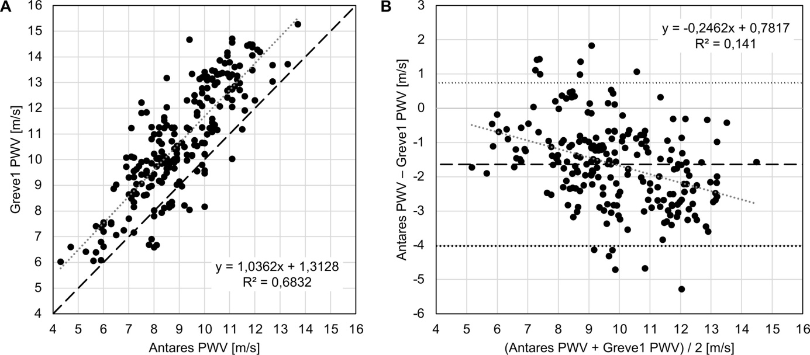

Figure S1: Relationship between pulse wave velocity (PWV) values (n=219) acquired by Antares algorithm (Antares PWV) and estimated pulse wave velocity (ePWV), based on age and mean blood pressure (Greve1). A) Scatter plot for Antares PWV and ePWV (Greve1). Grey dotted line: linear regression line. Black dashed line: identity line. R2, coefficient of determination. B) Bland-Altman plot for Antares PWV and ePWV (Greve1) with the representation of mean difference (black dashed line) and limits of agreement (black dotted line), from ±1.96SD. Mean difference ± SD: -1.64 ± 1.22 m/s. Grey dotted line: linear regression line.

Antares PWV versus Greve2 PWV

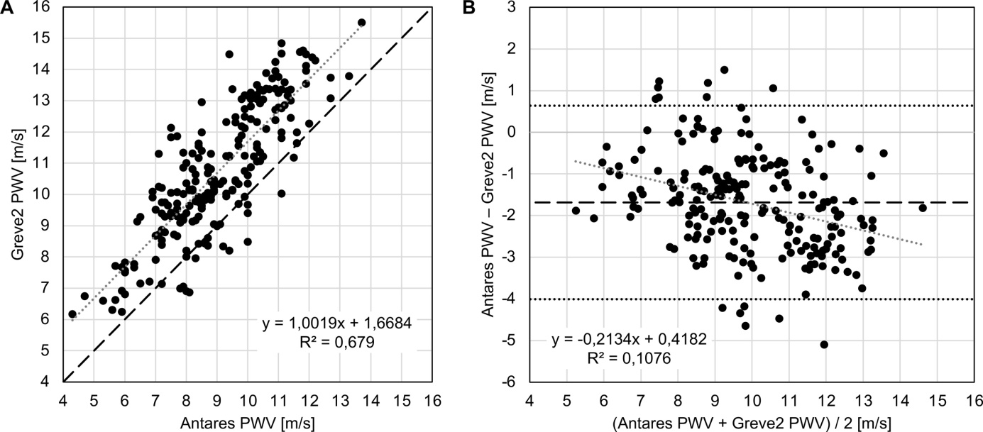

Figure S2: Relationship between pulse wave velocity (PWV) values (n=219) acquired by Antares algorithm (Antares PWV) and estimated pulse wave velocity (ePWV), based on age and mean blood pressure (Greve2). A) Scatter plot for Antares PWV and ePWV (Greve2). Grey dotted line: linear regression line. Black dashed line: identity line. R², coefficient of determination. B) Bland-Altman plot for Antares PWV and ePWV (Greve2) with the representation of mean difference (black dashed line) and limits of agreement (black dotted line), from ±1.96SD. Mean difference ± SD: -1.69 ± 1.18 m/s. Grey dotted line: linear regression line.

