Appendix A

Child-Rearing Sex-Role Attitude Scale (Adapted from Freeman, 2007)

Directions: Please indicate your opinion about each statement. Do you Strongly Agree, Strongly Disagree, or is your opinion somewhere in between these extremes? Mark one choice for each item.

Child-Rearing Sex-Role Attitude Scale
 | Strongly Agree | Agree | Undecided | Disagree | Strongly Disagree
Both boys and girls really need to develop social skills | ☐ | ☐ | ☐ | ☐ | ☐
Only boys should be permitted to play competitive sports | ☐ | ☐ | ☐ | ☐ | ☐
It is only healthy for boys to cry when they have been hurt | ☐ | ☐ | ☐ | ☐ | ☐
I would discourage my son from saying that he wants to be a nurse when he grows up | ☐ | ☐ | ☐ | ☐ | ☐
Boys who exhibit sissy behaviors will never be well adjusted | ☐ | ☐ | ☐ | ☐ | ☐
Parents should set different behavior standards for girls and boys | ☐ | ☐ | ☐ | ☐ | ☐
I feel upset when I see boys put on a dress when they play dress-up | ☐ | ☐ | ☐ | ☐ | ☐
I would buy my son a doll | ☐ | ☐ | ☐ | ☐ | ☐
I would not hire a male babysitter | ☐ | ☐ | ☐ | ☐ | ☐
Boys, more than girls, need competitive sports | ☐ | ☐ | ☐ | ☐ | ☐
Math and science are as necessary for girls as boys | ☐ | ☐ | ☐ | ☐ | ☐
I would feel disappointed if my daughter acted like a tomboy. | ☐ | ☐ | ☐ | ☐ | ☐

Appendix B

Fig.1

Toy Collection Presented to Children

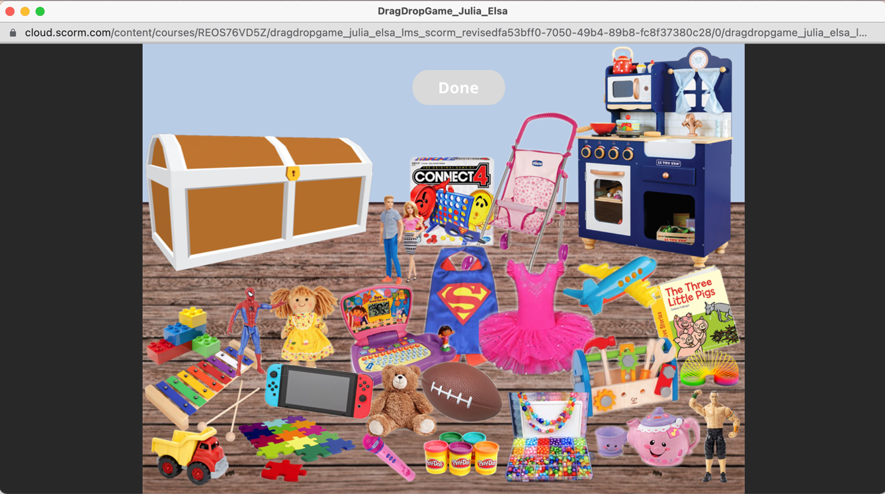

Fig. 2

Rosie with Toys Presented

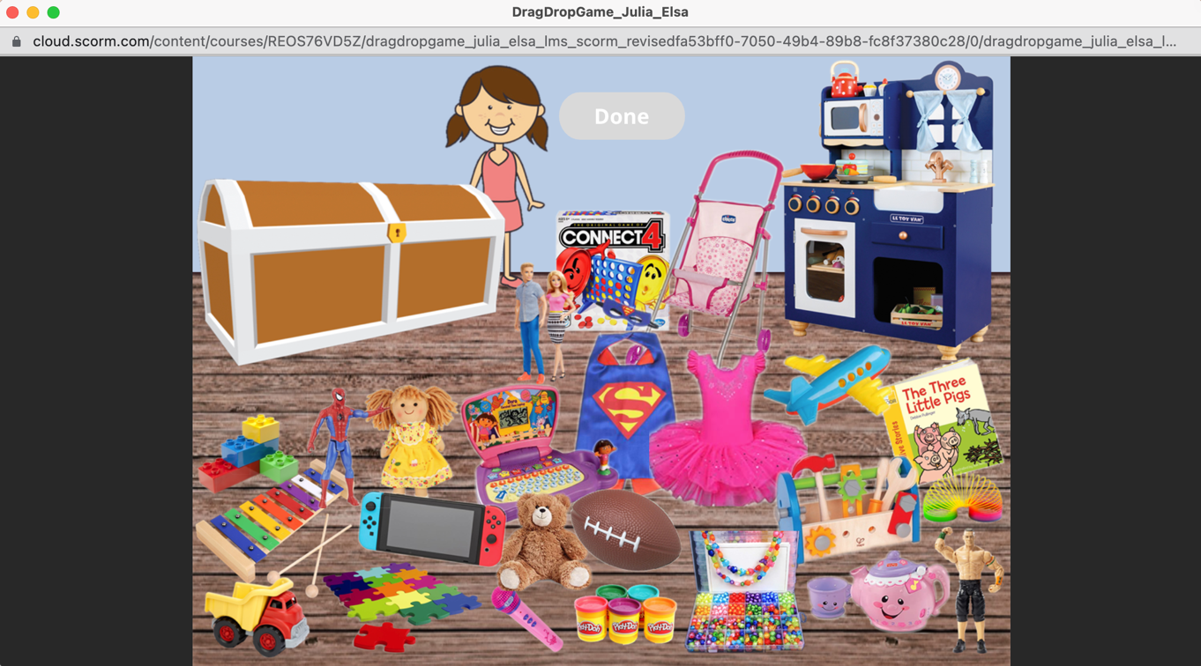

Fig. 3

Timmy with Toys Presented

