Supplementary Materials
Investigating the Negative Link Between Perfectionism and Emotional Divergent Thinking

Table S1. Correlational Matrix for the Main Variable of this Study
 | 1 | 2 | 3 | 4 | 5 | 6 | 7 | 8 | 9
1. Excellencism | --
2. Perfectionism | .46** | --
3. Concerns over mistakes | .10 | .19** | --
4. Doubts about actions | .22** | .42** | .59** | --
5. Openness to experience | .30** | .06 | -.01 | .04 | --
6. Empathy | .23** | -.03 | .12* | .08 | .43** | --
7. DT Originality AUT | .07 | -.06 | .13* | .10 | .22** | .26** | --
8. DT Fluency AUT | .07 | -.09 | .10 | .09 | .13* | .18** | .46** | --
9. DT Originality Emotional | .09 | -.12 | .01 | -.02 | .27** | .25** | .44** | .30** | --
10. DT Fluency Emotional | .02 | -.14* | .04 | .03 | .07 | .16** | .24** | .60** | .28**
Note. *p < .05, **p < .01.

Table S2. Indirects Effects From the Mediation Model with Doubts and Concerns
 | Excellencism →  Originality AUT | Perfectionism →  Originality AUT | Excellencism →  Originality Emotional | Perfectionism →  Originality Emotional
Total Effect | β = .17 [.04, .31]** | β = -.18 [-.31, -.05]** | β = .14 [.001, .26]* | β = -.11 [-.25, .03]
Concerns | β = .000 [-.01, .02] | β = .005 [-.03, .04] | β = .001 [-.01, .02] | β = .02 [-.01, .06]
Doubts | β = .001 [-.01, .02] | β = .01 [-.06, .07] | β = .003 [-.01, .03] | β = .03 [-.03, .10]
Direct Effect | β = .17 [.04, .31]** | β = -.20 [-.33, -.06]** | β = .13 [.002, .26]* | β = -.16 [-.30, -.02]*
Note. * p < .05. ** p < .01. n = 282. 95% Confidence Intervals Corrected for Bias are shown in brackets estimated with 5,000 resampling bootstraps.

Table S3. Indirects Effects From the Mediation Model with Openness to Experience and Empathy
 | Excellencism →  Originality Traditional | Perfectionism →  Originality Traditional | Excellencism →  Originality Emotional | Perfectionism →  Originality Emotional
Total Effect | β = .14 [.002, .26]* | β = -.11 [-.25, .03] | β = .17 [.04, .31]** | β = -.19 [-.32, -.05]**
Openness | β = .05 [.01, .11]* | β = -.01 [-.05, .002] | β = .07 [.03, .13]** | β = -.02 [-.06, .005]
Empathy | β = .06 [.02, .11]** | β = -.04 [-.08, -.008]** | β = .05 [.01, .09]* | β = -.03 [-.06, -.006]*
Direct Effect | β = .03 [-.10, .16] | β = -.06 [-.20, .08] | β = .06 [-.06, .19] | β = -.14 [-.27, -.003]*
Note. * p < .05. ** p < .01. n = 282. Openness = Openness to experience. 95% Confidence Intervals Corrected for Bias are shown in brackets estimated with 5,000 resampling bootstraps.

Table S4. Indirects Effects From the Mediation Model with Positive, Negative, and Worrisome Emotions
 | Excellencism →  Originality AUT | Perfectionism →  Originality AUT | Excellencism →  Originality Emotional | Perfectionism →  Originality Emotional
Total Effect | β = .18 [.04, .31]** | β = -.19 [-.31, -.04]** | β = .14 [.01, .27]* | β =-.11 [-.26, .02]
Positive | β = .01 [-.02, .05] | β = .04 [.01, .09]* | β = .00 [-.01, .03] | β = .01 [-.01, .05]
Negative | β = .11 [.04, .22]** | β = -.12 [-.23, -.06]** | β = .12 [.05, .24]** | β = -.14 [-.24, -.06]**
Worrisome | β = -.06 [ -.15, -.01]* | β = .06 [.02, .15]** | β = -.07 [-.16, -.02]** | β = .08 [.03, .18]**
Direct Effect | β = 0.12 [-.01, .26] | β = -.16 [-.29, -.02]* | β = .09 [-.04, .24] | β =-.07 [ -.22, .06]
Note. * p < .05. ** p < .01. n = 282. 95% Confidence Intervals Corrected for Bias are shown in brackets estimated with 5,000 resampling bootstraps.

Figure S1. A graphical representation of the association between non-strivers (individuals low [-1SD] on both, excellencism and perfectionism), excellence strivers (high [+1SD] on excellencism and low [-1SD] on perfectionism), and perfection strivers (high [+1SD] on both, excellencism and perfectionism) towards Openness to experience.
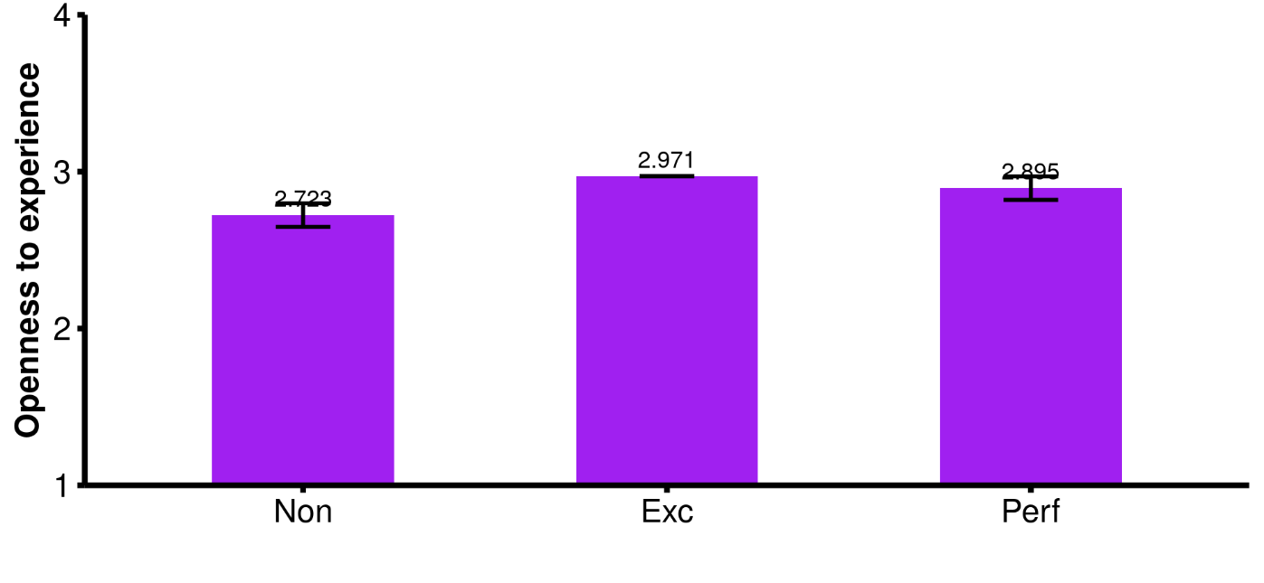
Note. n = 282. 83.4% Confidence Intervals are shown.

Figure S2. A graphical representation of the association between non-strivers (individuals low [-1SD] on both, excellencism and perfectionism), excellence strivers (high [+1SD] on excellencism and low [-1SD] on perfectionism), and perfection strivers (high [+1SD] on both, excellencism and perfectionism) towards Empathy.

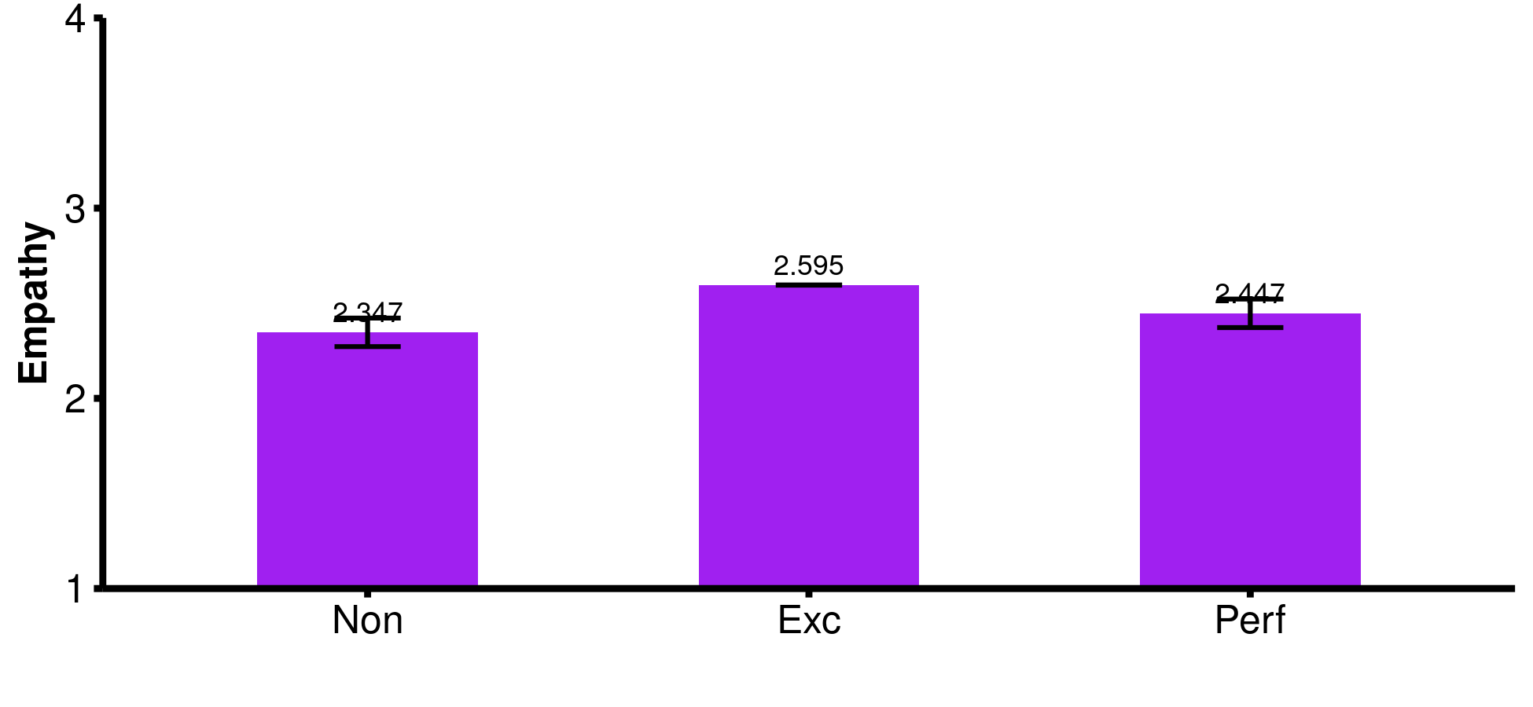
Note. n = 282. 83.4% Confidence Intervals are shown.

As shown in Gaudreau et al., (2023, supplementary file), the CI should be interpreted with caution because a difference can be significant even if two intervals are overlapping.

Interpretation: The difference between perfectionism and excellencism is non-significant with respect to Openness to experience (perfectionism is non-significantly associated with Openness to experience β = -0.024, p = .17; whereas excellencism is positively and significantly associated with openness to experience β = 0.157, p < .000). We can conclude that perfectionism is associated with more openness to experience than non-strivers, but has the same level of openness to experience than excellence strivers.

The difference between Excellencism and Perfectionism is small but significant for empathy (perfectionism predicts significantly and negatively empathy β = -0.047, p = .007; whereas excellencism is significantly and positively associated with empathy β = 0.14, p < .000). Hence, we can conclude that perfectionism is “detrimental” with respect to empathy compared to excellencism.

References
Gaudreau, P., Schellenberg, B.J.I., & Quesnel, M. (2023). From theory to research: Interpretational guidelines, statistical guidance, and a Shiny App for the Model of Excellencism and Perfectionism. https://doi.org/10.31234/osf.io/tvmb3

