"Materials" Supplements

1. Manipulation of incivility behavior through scenario

Condition 1: Turkish-Yes Apology
-You go to the market to do some shopping. After completing your shopping, you get in line at the checkout. At the checkout, a person named A does not follow the queue and cuts in front of you. Feeling uncomfortable with A's behavior, you warn them to follow the line. In response, A says, "I cut in your line, I’m sorry."

Condition 2: Turkish-No Apology
-You go to the market to do some shopping. After completing your shopping, you get in line at the checkout. At the checkout, a person named A does not follow the queue and cuts in front of you. Feeling uncomfortable with A's behavior, you warn them to follow the line. In response, A says, "I cut in your line, but there is nothing to apologize for."

Condition 3: Syrian -Yes Apology
-You go to the market to do some shopping. After completing your shopping, you get in line at the checkout. At the checkout, a person named A, who is known to be Syrian, does not follow the queue and cuts in front of you. Feeling uncomfortable with A's behavior, you warn them to follow the line. In response, A says, "I cut in your line, I’m sorry."

Condition 4: Syrian -No Apology
-You go to the market to do some shopping. After completing your shopping, you get in line at the checkout. At the checkout, a person named A, who is known to be Syrian, does not follow the queue and cuts in front of you. Feeling uncomfortable with A's behavior, you warn them to follow the line. In response, A says, "I cut in your line, but there is nothing to apologize for."

2. Identification measure

How much do you identify as TURKISH?

0 1 2 3 4 5 6
Not at all Very much

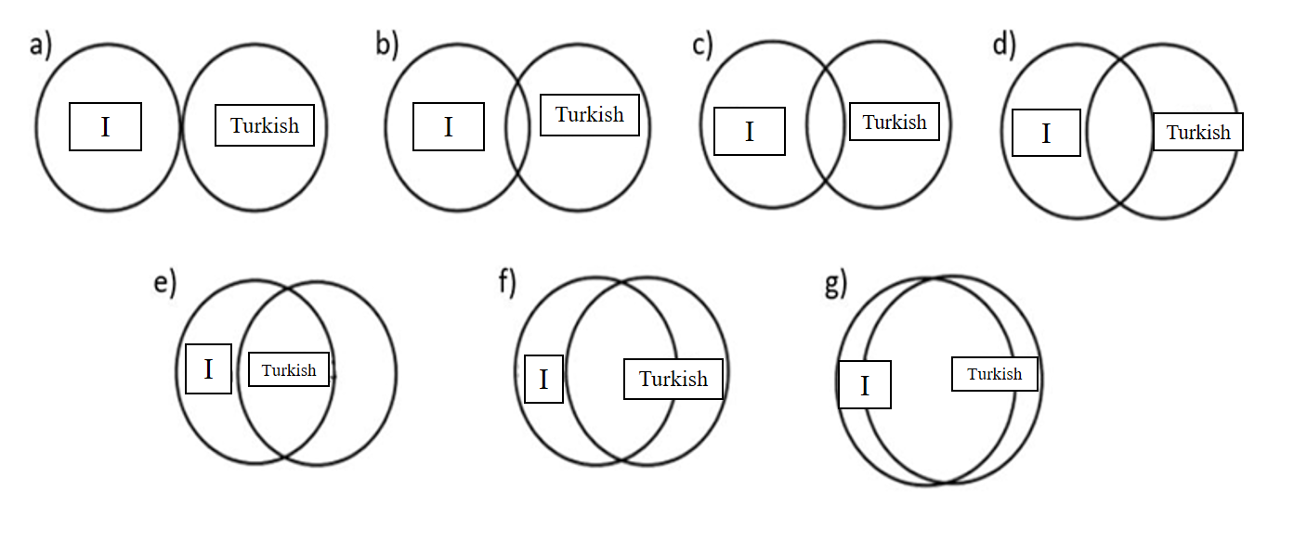

*Turkish=Turk

