Supporting Information

Table SI1. Sputter parameters for the Nb, Mo Ta and W targets, respectively.
Target | Power supply type | Deposition power  (W) | Center composition in ML  (at.%)
Nb | Radio frequency | 218 | 39
Mo | Direct current | 38 | 18
Ta | Radio frequency | 170 | 22
W | Direct current | 34 | 21

Table SI2. Inter-planer distance (d), lattice constants, crystallite size and the corresponding compositions along a bottom left (MA1) to top right (MA334) direction across the film.
Measurement area | Composition | 2θ [110]  (deg) | d_{hkl}[110] (nm) | a, b, c (nm) | Crystallite size D  (nm)
MA1 | Nb₂₃Mo₁₈Ta₄₃W₁₆ | 39.12(2) | 0.230(1) | 0.325(4) | 19.71(5)
MA28 | Nb₂₄Mo₁₉Ta₃₇W₂₀ | 39.18(3) | 0.229(7) | 0.324(9) | 19.01(8)
MA63 | Nb₂₅Mo₂₁Ta₃₄W₂₀ | 39.26(2) | 0.229(3) | 0.324(3) | 19.02(1)
MA103 | Nb₂₅Mo₂₀Ta₃₂W₂₃ | 39.38(5) | 0.228(6) | 0.323(3) | 19.34(1)
MA146 | Nb₂₅Mo₂₁Ta₂₉W₂₅ | 39.42(3) | 0.228(5) | 0.323(2) | 21.00(8)
MA189 | Nb₂₆Mo₂₂Ta₂₅W₂₇ | 39.52(4) | 0.227(8) | 0.322(2) | 21.01(4)
MA232 | Nb₂₅Mo₂₁Ta₂₂W₃₂ | 39.62(5) | 0.227(3) | 0.321(4) | 21.74(7)
MA272 | Nb₂₄Mo₂₂Ta₂₀W₃₄ | 39.68(6) | 0.227(1) | 0.321(1) | 22.14(1)
MA307 | Nb₂₃Mo₂₂Ta₁₈W₃₇ | 39.76(3) | 0.226(5) | 0.320(4) | 22.55(2)
MA334 | Nb₂₃Mo₂₀Ta₁₇W₄₀ | 39.84(6) | 0.226(1) | 0.319(7) | 23.43(5)

Table SI3. XRD peaks for elements of the HEA according to the Pauling File inorganic materials database.[26] These values are an average of multiple measurements, rounded to the first decimal.
Element | (110) [2θ] | (200) [2θ] | (211) [2θ] | (220) [2θ]
Nb | 38.1 | 55.1 | 69 | 81.9
Ta | 38.2 | 55.5 | 69.7 | 82.4
W | 40.1 | 58.1 | 73.2 | 87
Mo | 40.5 | 58.8 | 73.6 | 88.8

Table SI4. Atomic radius, melting point, crystal structure and lattice parameters for the elements of the Nb-Mo-Ta-W system.
Element | Atomic radius  [nm] | Molar volume  [cm³/mol] | Nominal resistivity [nΩ·m] | Melting point  [°C] | Structure | Lattice  parameter a [nm]
Nb[27] | 0.145 | 10.83 | 130 | 2477 | bcc | 0.3300
Ta[28] | 0.145 | 10.85 | 124 | 3017 | bcc | 0.3301
W[29] | 0.135 | 9.47 | 57 | 3422 | bcc | 0.3165
Mo[30] | 0.145 | 9.38 | 52 | 2623 | bcc | 0.3147

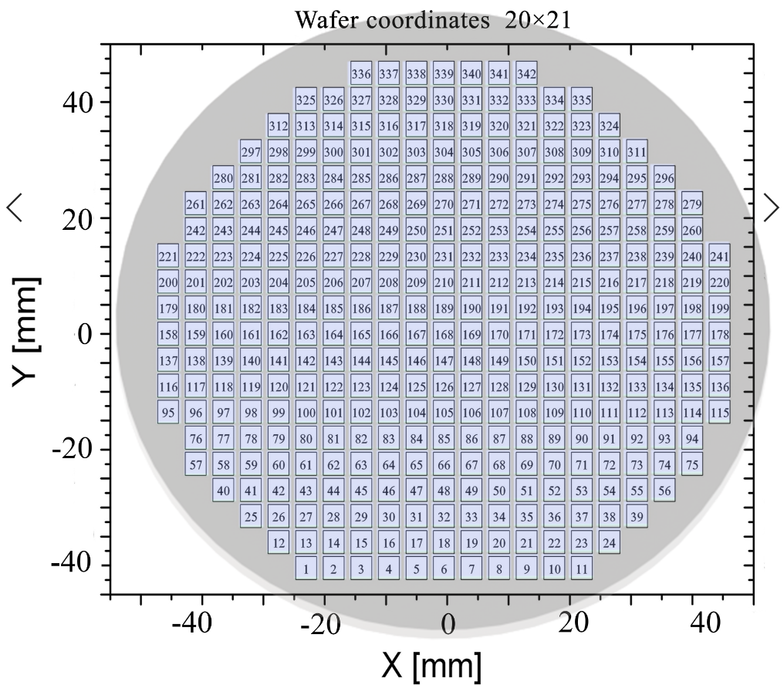
Figure SI1. 342 measurement areas (MAs) are arranged in a 20 × 21 matrix. Each MA has an area of 4.5 × 4.5 mm.
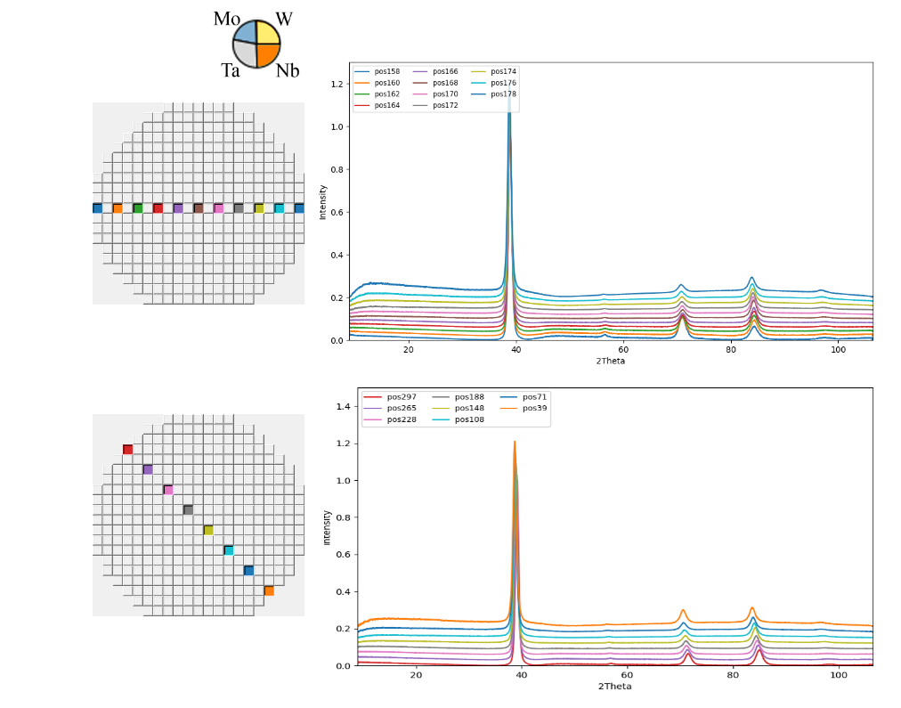
Figure SI2. View of XRD patterns across different directions along the materials library.

Figure SI3. 3D visualization of thickness mapping demonstrates the difference between peaks and valleys in the film surface.

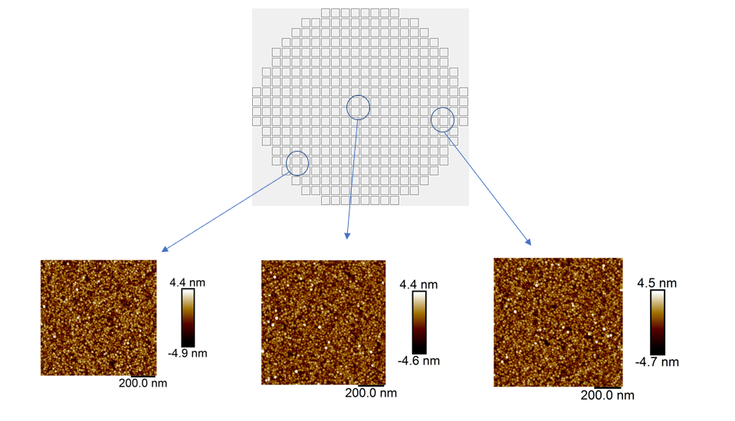
Figure SI4. AFM images and extracted roughness values for exemplary as-deposited films from the materials library.

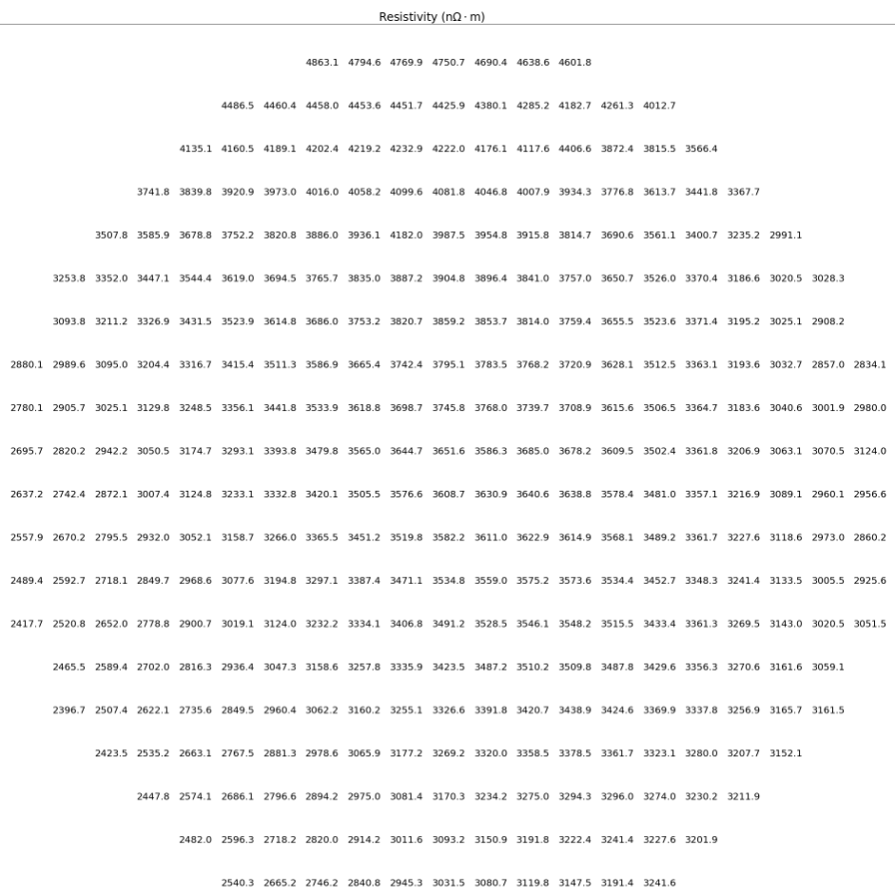

Figure SI5. Full set of resistivity values for each MA.

