Supplementary information on

High-temperature corrosion of high- and medium-entropy alloys CrMnFeCoNi and CrCoNi exposed to a multi-oxidant atmosphere H₂O-O₂-SO₂

Wencke Mohring ^{1,2}, Stephanos Karafiludis ^{1,3}, Anna M. Manzoni¹, Guillaume Laplanche⁴, Mike Schneider^{4,5}, Christiane Stephan-Scherb ^{1,3,6}

Additional information on the quantification of the elemental mappings in this article. The quantification can be read directly from the color bar in every figure.

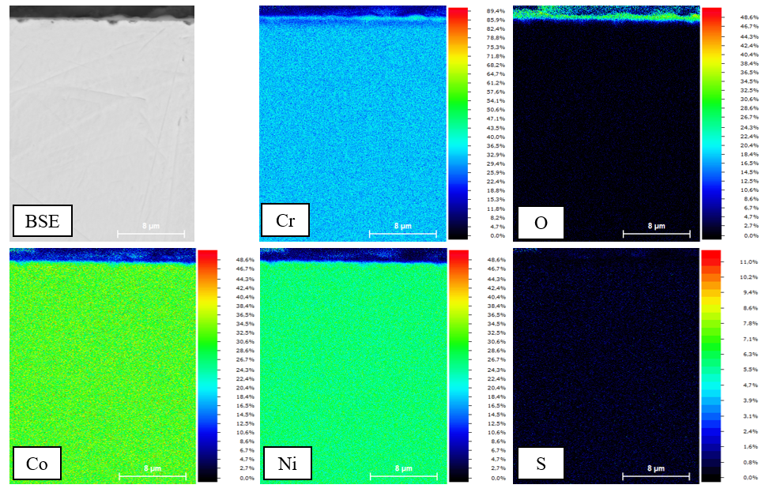
Figure S1: Quantified elemental maps of the CrCoNi alloy exposed to the exhaust atmosphere for 24 h. Quantification can be read directly from the color bar.
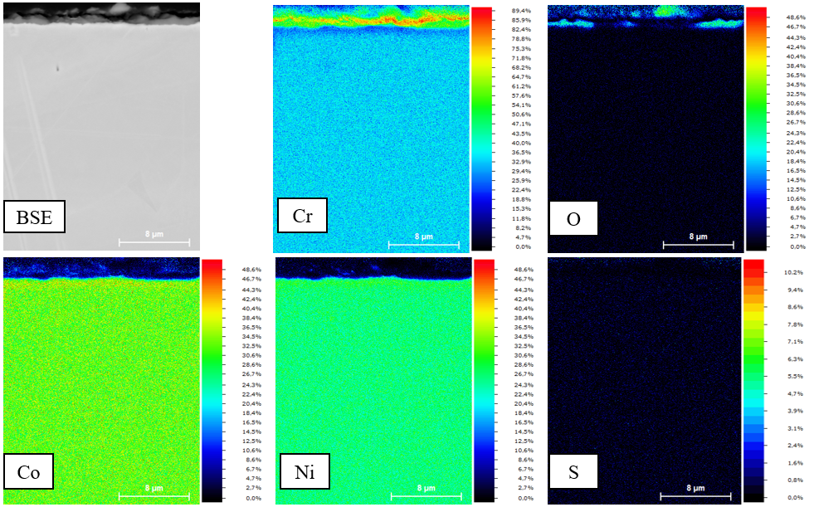
Figure S2: Quantified elemental maps of the CrCoNi alloy exposed to the exhaust atmosphere for 24 h. Quantification can be read directly from the color bar.
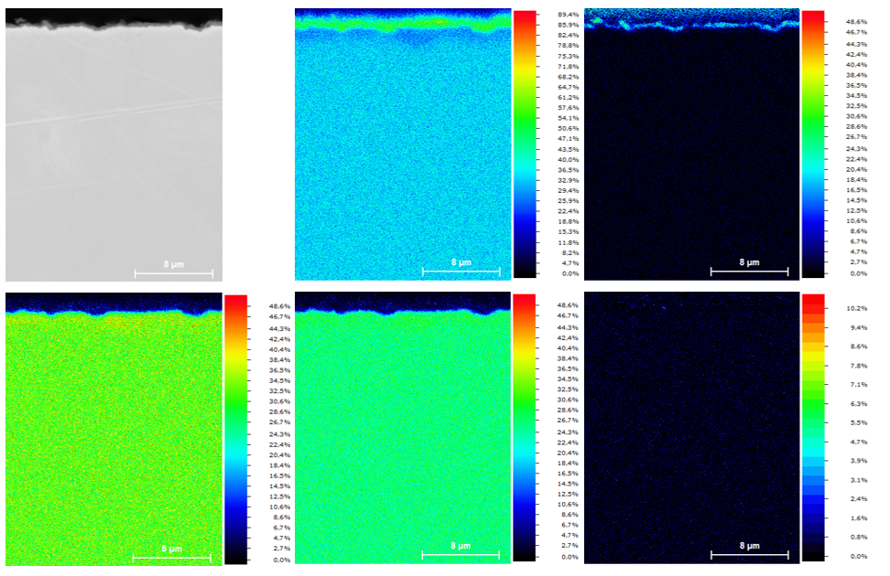
Figure S3: Quantified elemental maps of the CrCoNi alloy exposed to the exhaust atmosphere for 24 h. Quantification can be read directly from the color bar.

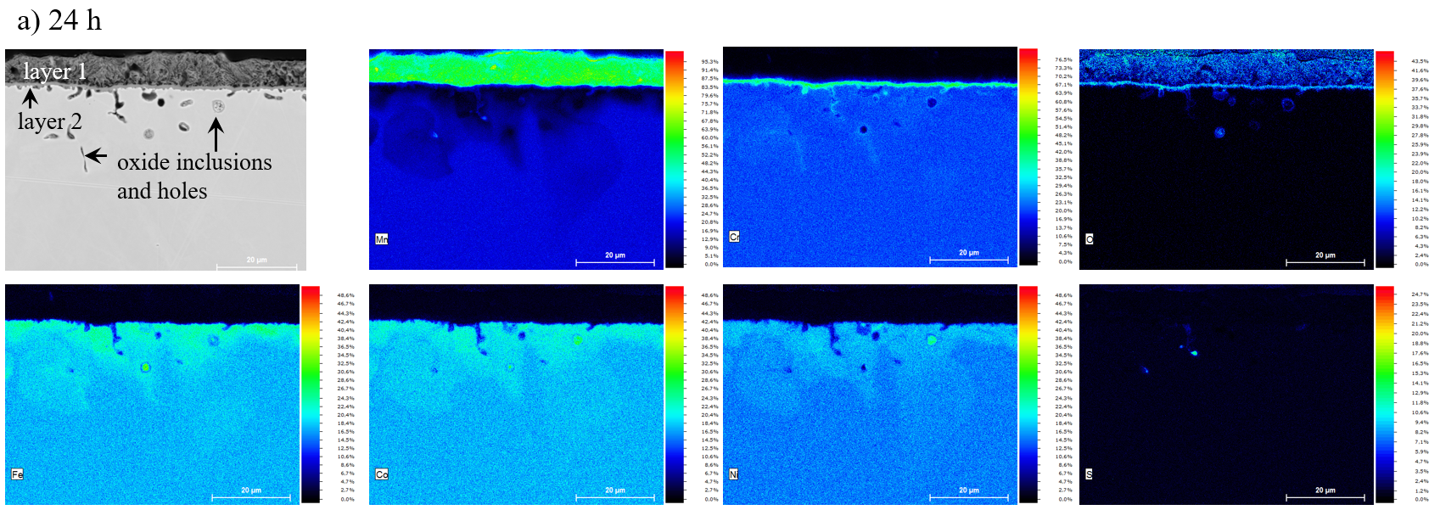
Figure S4: Quantified elemental maps of the CrMnFeCoNi alloy exposed to the exhaust atmosphere for 24 h. Quantification can be read directly from the color bar.
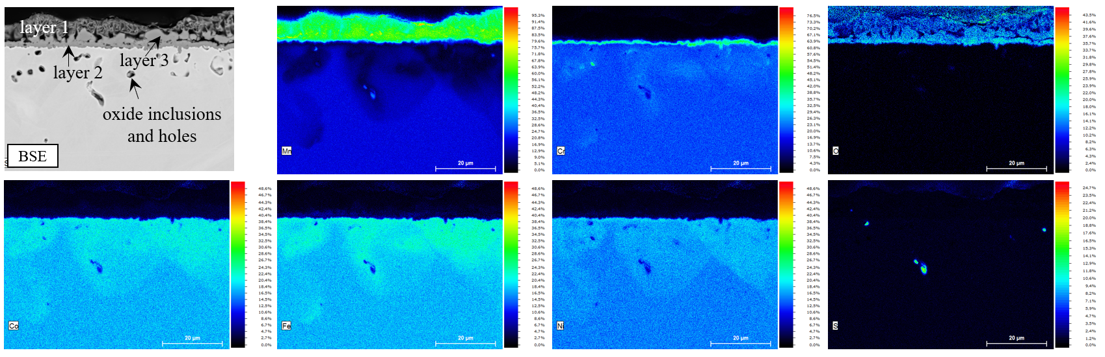
Figure S5: Quantified elemental maps of the CrMnFeCoNi alloy exposed to the exhaust atmosphere for 48 h. Quantification can be read directly from the color bar.

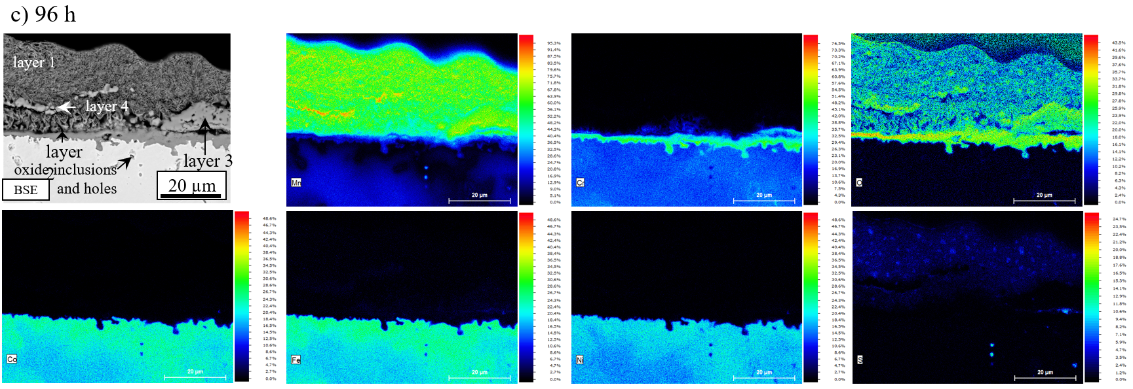
Figure S6: Quantified elemental maps of the CrMnFeCoNi alloy exposed to the exhaust atmosphere for 96 h. Quantification can be read directly from the color bar.

