Supplementary Information

Solid-phase extraction of palladium, platinum, and gold from water samples: comparison between a chelating resin and a chelating fiber with ethylenediamine groups

Misato IWASE†, Kota ISOBE, Linjie ZHENG, Shotaro TAKANO, and Yoshiki SOHRIN
Institute for Chemical Research, Kyoto University, Uji, Kyoto 611-0011, Japan

†To whom correspondence should be addressed.
iwase.misato.6v@kyoto-u.ac.jp

- Data on the optimization of eluents

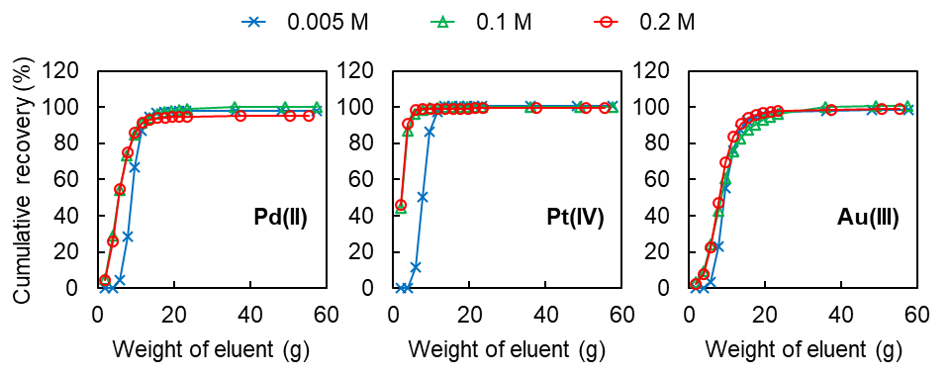
Fig. S1 Effect of NH₃ concentration and weight of eluent on the recovery of Pd(II), Pt(IV), and Au(III) by column extraction with TYP-en. Sample solution: 25 g of 0.1 M HCl solution containing 50 μmol/kg Pd(II), 25 μmol/kg Pt(IV), or 25 μmol/kg Au(III). Eluent: 0.005–0.2 M NH₃–0.001 M KCN (n = 1).

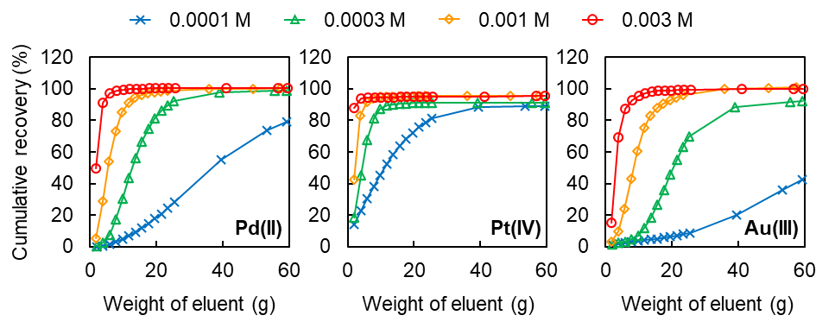
Fig. S2 Effect of KCN concentration and weight of eluent on the recovery of Pd(II), Pt(IV), and Au(III) by column extraction with TYP-en. Sample solution: 25 g of 0.1 M HCl solution containing 50 μmol/kg Pd(II), 25 μmol/kg Pt(IV), or 25 μmol/kg Au(III). Eluent: 0.1 M NH₃–0.0001–0.003 M KCN (n = 1).

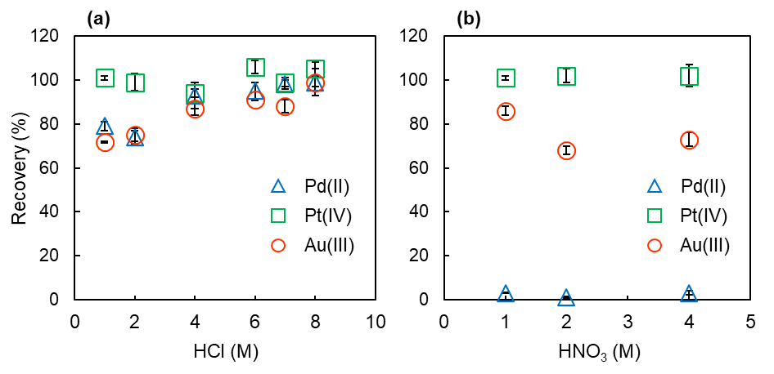
Fig. S3 Effect of (a) HCl or (b) HNO₃ concentration of eluent on the recovery percentage of Pd(II), Pt(IV), and Au(III) by column extraction with TYP-en. For elution with 1–2 M HCl and 1–4 M HNO₃, the samples used were 25 g of 0.07 M HCl containing 50 μmol/kg Pd(II), 25 μmol/kg Pt(IV), and 25 μmol/kg Au(III). For elution with 4–8 M HCl, the samples used were 25 g of seawater at pH 1.55 containing 50 μmol/kg Pd(II), 25 μmol/kg Pt(IV), and 25 μmol/kg Au(III). The amount of eluent was 90 g. Error bars show the standard deviation (n = 3 for 1–2 M HCl and 1–4 M HNO₃, n = 2 for 4–8 M HCl).

- Data on the effect of matrixes in river water

Table S1 Concentrations of elements in eluates after the column extraction of Pd, Pt, and Au by TYP-en from a spiked river water.
Eluent | Metal amount in eluate
Eluent | Fe (nmol) | Mn (nmol) | Pd (pmol) | Pt (pmol) | Au (pmol)
Eluent | ave ± sd | ave ± sd | ave ± sd | ave ± sd | ave ± sd
0.3 M NH₃–0.003 M KCN | not measured | not measured | 1.2 ± 0.1 | 0.11 ± 0.01 | 2.1 ± 0.1
1 M HCl | 2.7 ± 0.2 | 0.13 ± 0.01 | 0.9 ± 0.3 | 0.12 ± 0.16 | 1.4 ± 0.4
1 M HNO₃ | 0.4 ± 0.1 | 0.02 ± 0.01 | 0.8 ± 0.1 | 0.25 ± 0.15 | 2.7 ± 0.2
The sample was collected from the Uji River, filtered with a Sterivex filter unit with a pore size of 0.22 µm (Merck), and acidified to 0.07 M HCl. A portion of 607 g of the river water sample was spiked with 3.25 pmol Pd, 3.22 pmol Pt, and 3.21 pmol Au, which was applied for the column extraction with TYP-en in the same manner with that described in the manuscript. Then the metal ions were eluted successively with 60 g of 0.3 M NH₃–0.003 M KCN, 60 g of 1 M HCl, and 60 g of 1 M HNO₃. The concentrations of Fe, Mn, Pd, Pt, and Au in eluates were measured by ICP-MS (n = 2).
The data indicate that some parts of Fe and Mn in the river water were collected on TYP-en and eluted with 1 M HCl and 1 M HNO₃. Some parts of Pd, Pt, and Au were not eluted with 0.3 M NH₃–0.003 M KCN and were eluted with acid solutions concurrently with Fe and Mn.

