Molecular Symmetry Change of Perfluoro-n-alkanes in ‘Phase I’ Monitored by Infrared Spectroscopy
Taisuke Araki, Takayuki Oka, Nobutaka Shioya and Takeshi Hasegawa*
Laboratory of Chemistry for Functionalized Surfaces, Division of Environmental Chemistry, Institute for Chemical Research, Kyoto University, Gokasho, Uji, Kyoto 611-0011, Japan

Supplementary Information

*To whom correspondence should be addressed.
htakeshi@scl.kyoto-u.ac.jp

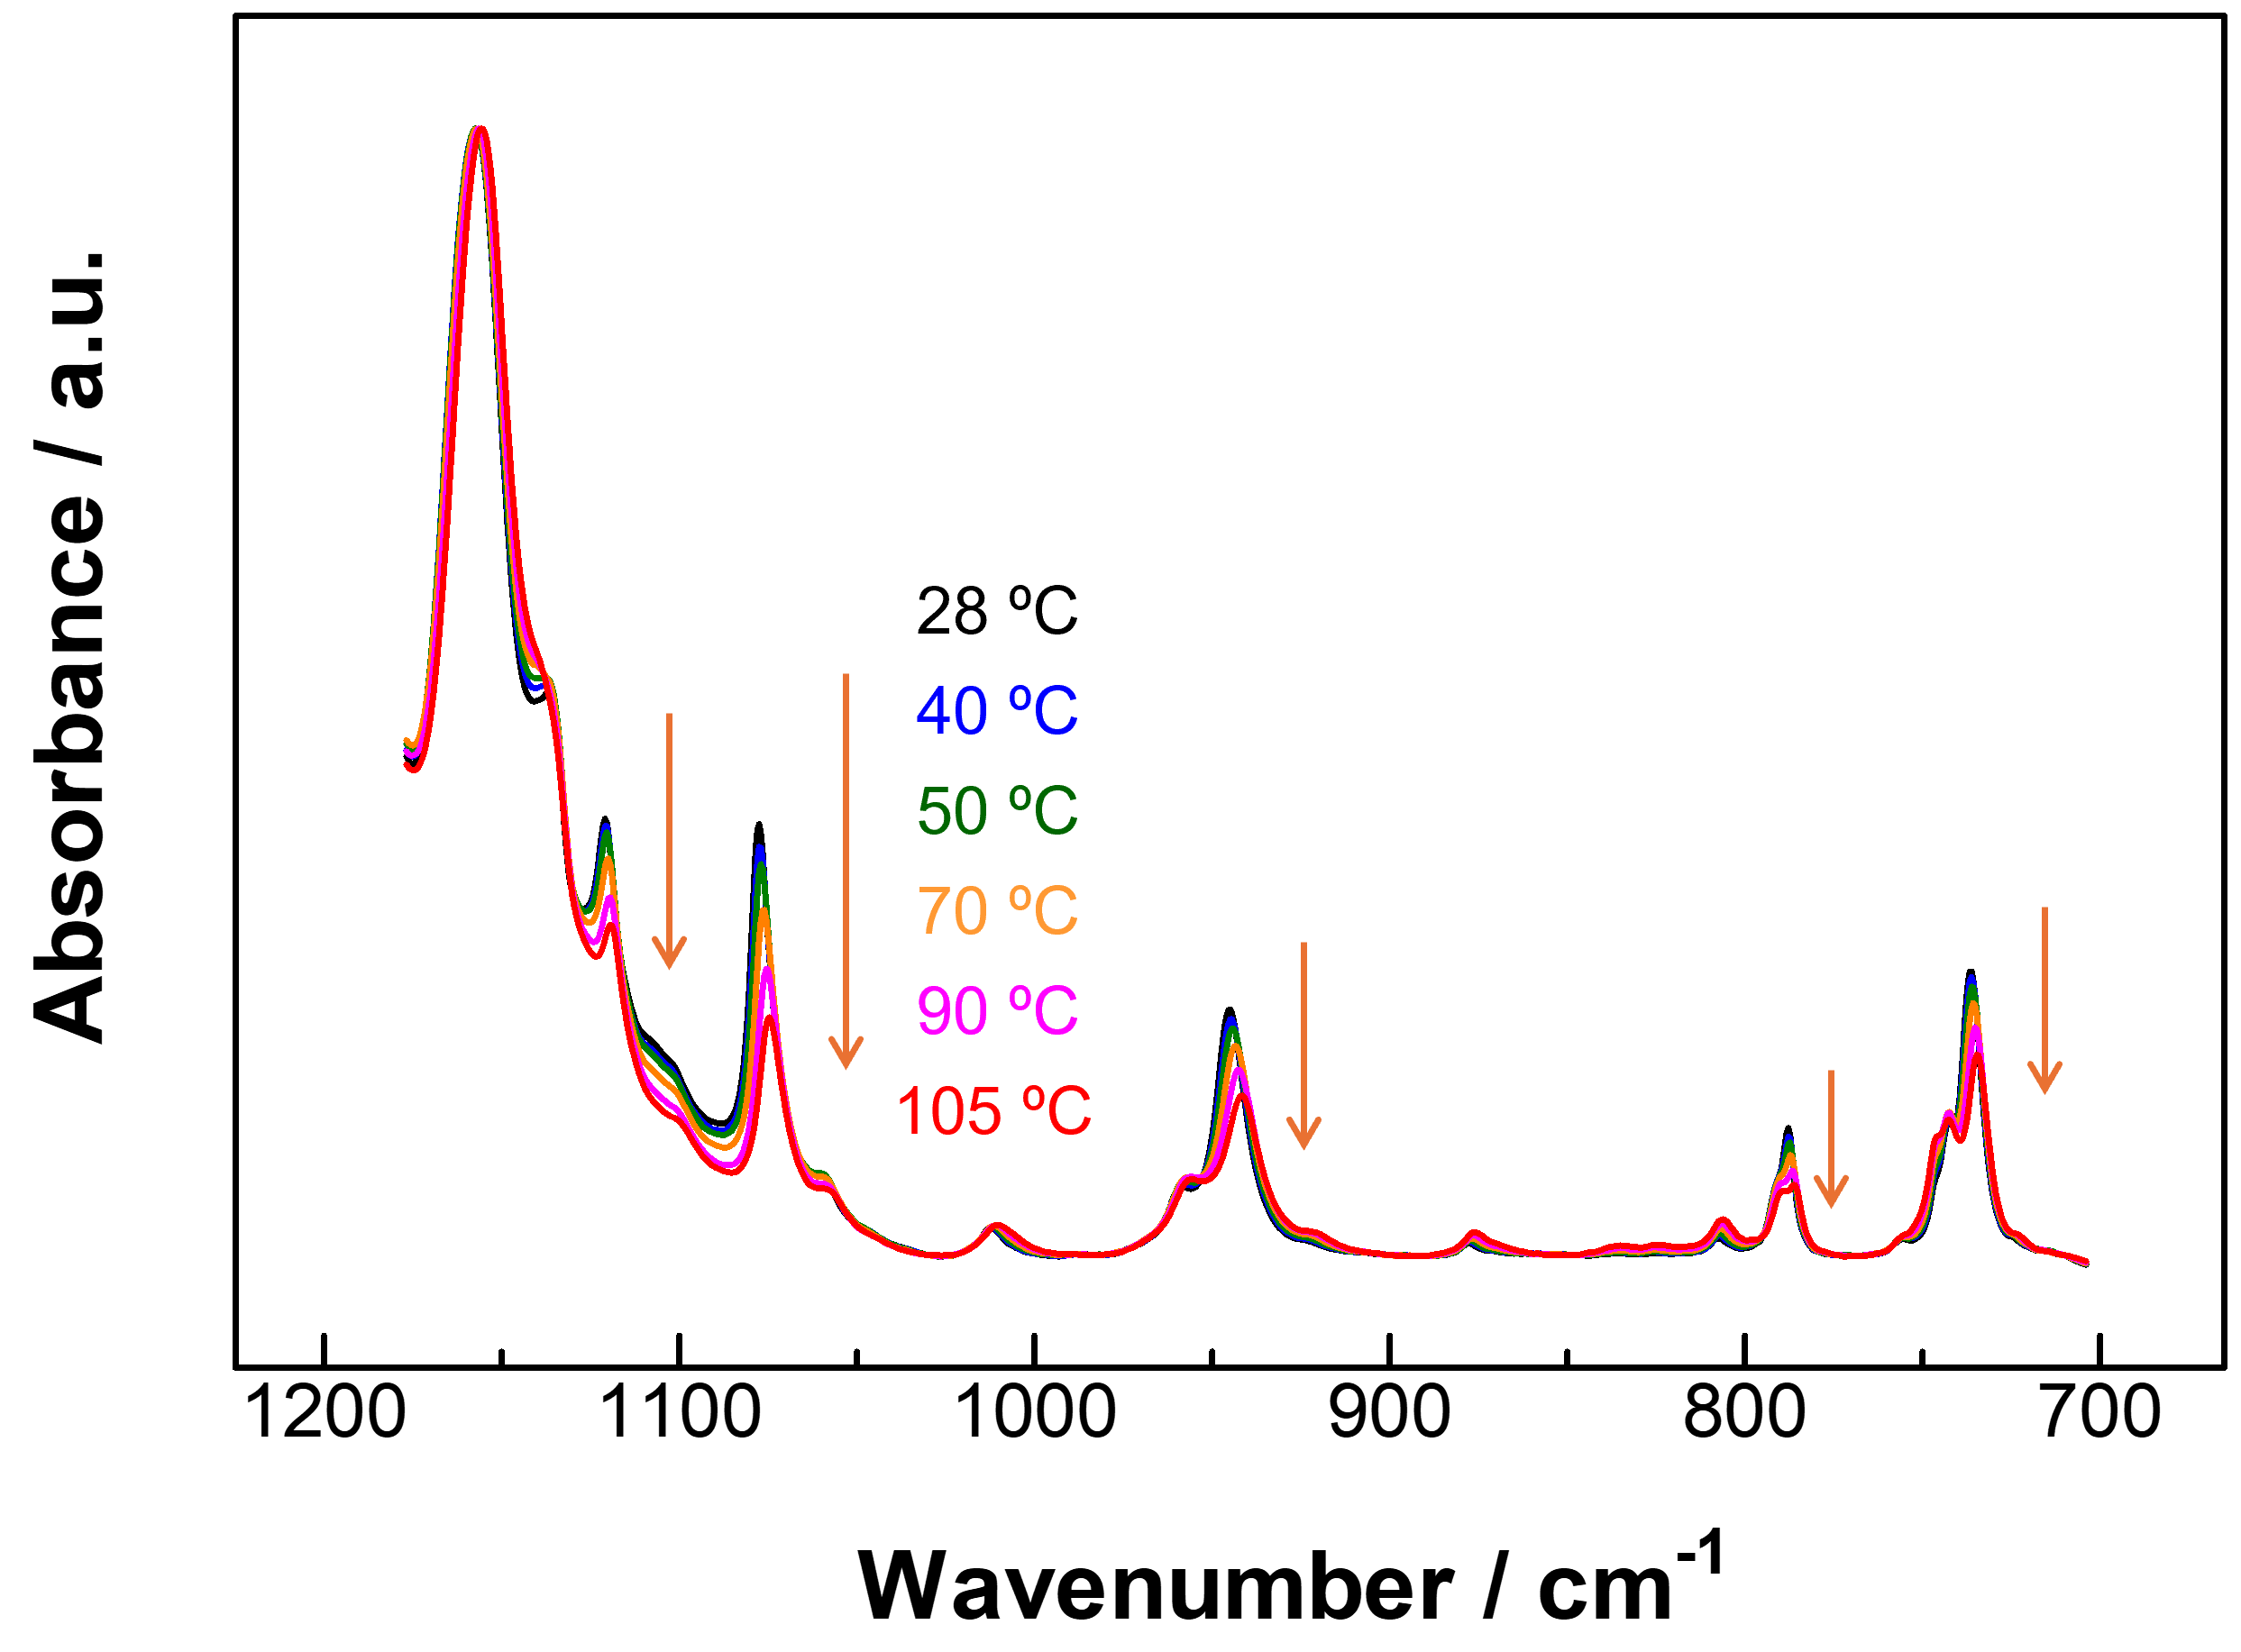

Figure S1. Six IR spectra of n-C₁₅F₃₂ in the heating process between 28 and 105ºC. The temperatures for the individual spectra are shown in the figure along an arrow.
Supplementary Information: Figure S1 presents temperature-dependent IR ATR spectra of the solid sample of n-C₁₅F₃₂ in the temperature range from T_{min} = 28ºC up to T_{max} = 105ºC. The experimental method and the conditions are the same as those for obtaining the spectra in Figure 3 except the number of accumulations. The accumulation was carried out 32 times for each spectrum.

