Supplementary Material
Note

The impact of initial cooling rates on cell preservation in frozen water-dimethyl sulfoxide media: A morphological study

Rinko Sabanai¹, Yoshifumi Suzuki², Takafumi Mizushige², Nobuo Uehara¹, Arinori Inagawa¹,*

1. School of Engineering, Utsunomiya University, 7-1-2, Yoto, Utsunomiya, Tochigi 321-8585, Japan.
2. School of Agriculture, Utsunomiya University, 350, Minemachi, Utsunomiya, Tochigi 321-8585, Japan

*Corresponding to: ainagawa@cc.utsunomiya-u.ac.jp (A. Inagawa)

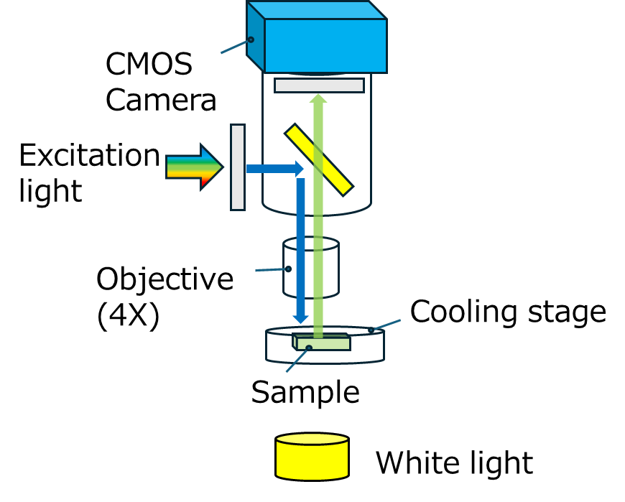
Figure S1. Schematic illustration of the microscopic setup

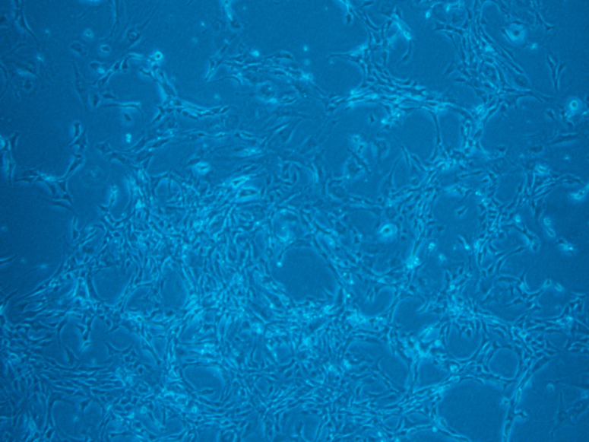
Figure S2. Transmission images of the C2C12 cells used for cell viability assays. The cells are adhered to the petri dish in this condition.

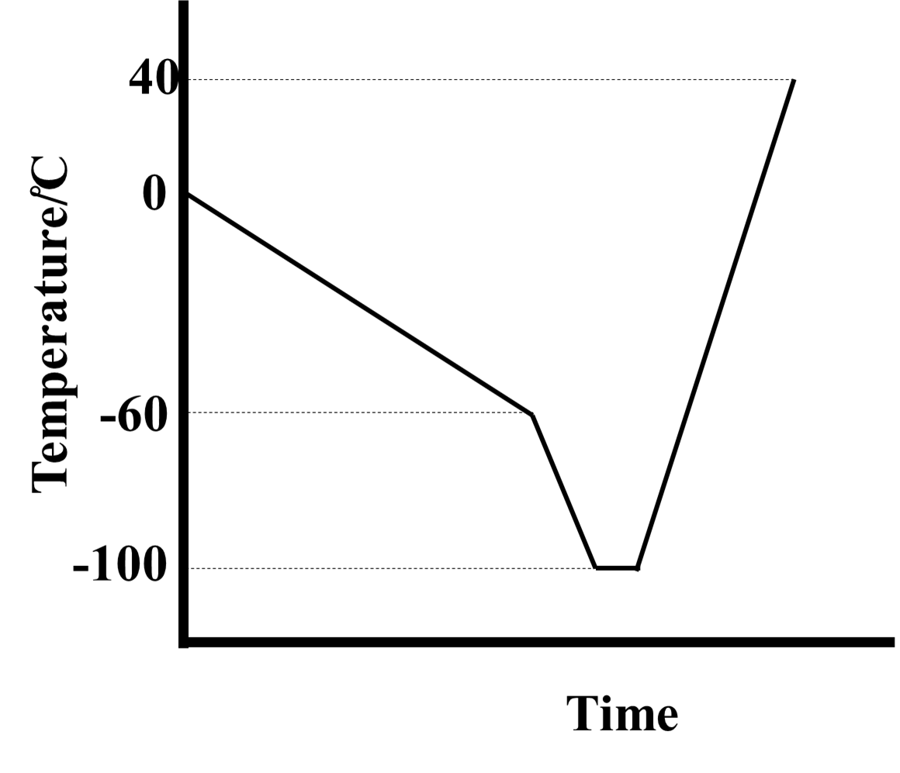
Figure S3. The schematic diagram of the temperature operation on cell viability assay.

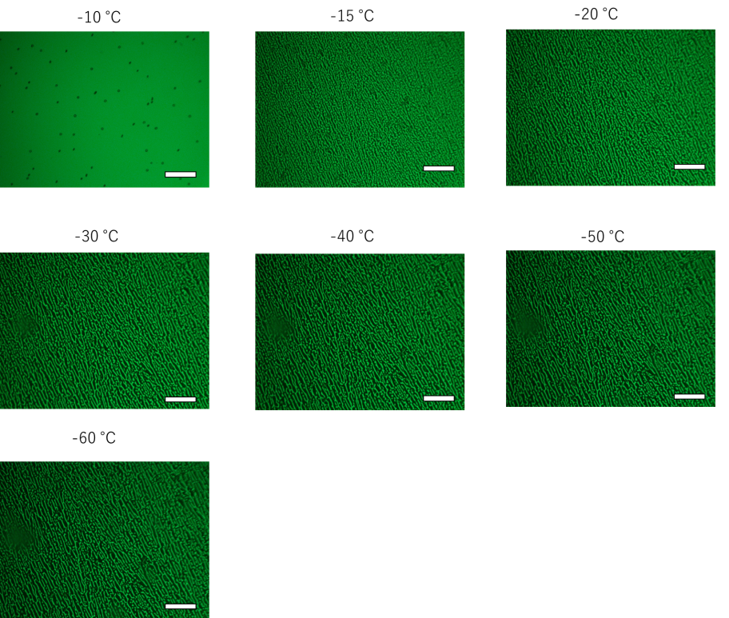
Figure S4. The fluorescence microscopic images of the FCS frozen at 10.0 ℃/min at every 10 ℃ during freezing processes.
10 wt.% aqueous DMSO solution containing 2 mM sodium fluorescein. Scale bar: 100 μm

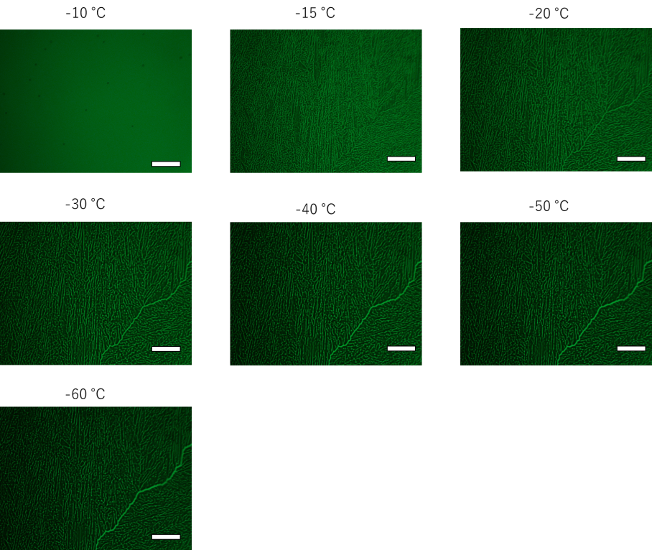
Figure S5. The representative morphological features of the FCS 30.0 ℃/min at every 10 ℃ during freezing processes.
10 wt.% aqueous DMSO solution containing 2 mM sodium fluorescein. Scale bar: 100 μm
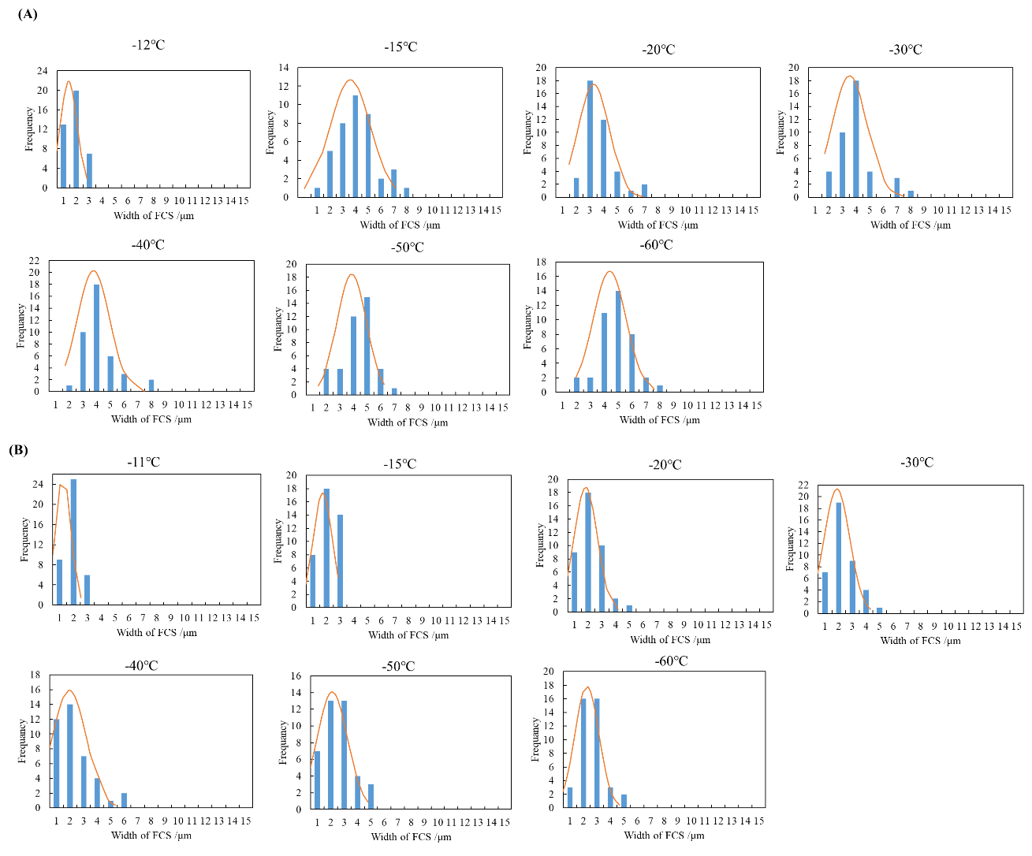
Figure S6. Histograms of FCS widths measured from the microscopic images at different 200 points at every 10 ℃ on freezing processes when frozen at 10.0 and 30.0 ℃/min.
(A)10.0 ℃/min (B) 30.0 ℃/min

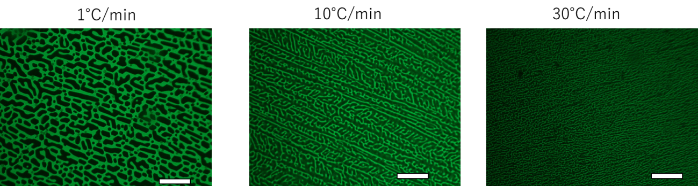
Figure S7. The fluorescence microscopic images of FCS when the initial concentration of DMSO was set to 20 wt.% at -60 ℃. Scale bar: 100 μm

