7. Appendix
Table A.1 Producer’s accuracy (PA) and user’s accuracy (UA) of single-date image classifications
 |  | PA |  |  |  |  | UA
Classifier | Dataset | LG | HG | CP | AL | WB | LG | HG | CP | AL | WB
KNN | SR20m | 0.59 | 0.94 | 0.48 | 0.74 | 0.72 | 0.63 | 0.66 | 0.88 | 0.93 | 0.75
KNN | SR10m | 0.66 | 0.93 | 0.48 | 0.82 | 0.61 | 0.63 | 0.75 | 0.67 | 0.94 | 0.97
KNN | SF20m | 0.56 | 0.92 | 0.44 | 0.81 | 0.80 | 0.73 | 0.68 | 0.73 | 0.92 | 0.76
KNN | SF10m | 0.57 | 0.92 | 0.21 | 0.88 | 0.91 | 0.70 | 0.73 | 0.87 | 0.89 | 0.63
RF | SR20m | 0.64 | 0.83 | 0.44 | 0.83 | 0.75 | 0.54 | 0.75 | 0.80 | 0.89 | 0.68
RF | SR10m | 0.58 | 0.88 | 0.45 | 0.90 | 0.86 | 0.63 | 0.77 | 0.86 | 0.90 | 0.81
RF | SF20m | 0.61 | 0.86 | 0.47 | 0.85 | 0.71 | 0.69 | 0.75 | 0.69 | 0.86 | 0.62
RF | SF10m | 0.58 | 0.91 | 0.47 | 0.83 | 0.77 | 0.66 | 0.70 | 0.88 | 0.92 | 0.76
MLC | SR20m | 0.67 | 0.88 | 0.31 | 0.81 | 0.53 | 0.55 | 0.73 | 0.76 | 0.90 | 0.89
MLC | SR10m | 0.73 | 0.88 | 0.31 | 0.88 | 0.50 | 0.57 | 0.80 | 0.76 | 0.91 | 0.97
MLC | SF20m | 0.58 | 0.88 | 0.56 | 0.79 | 0.51 | 0.69 | 0.67 | 0.70 | 0.91 | 0.90
MLC | SF10m | 0.58 | 0.90 | 0.57 | 0.81 | 0.47 | 0.72 | 0.69 | 0.69 | 0.92 | 0.92
MESMA | SR20m | 0.64 | 0.86 | 0.28 | 0.54 | 0.84 | 0.45 | 0.73 | 0.50 | 0.91 | 0.10
MESMA | SR10m | 0.67 | 0.89 | 0.27 | 0.56 | 0.95 | 0.47 | 0.78 | 0.47 | 0.93 | 0.11
MESMA | SF20m | 0.68 | 0.85 | 0.04 | 0.81 | 0.92 | 0.60 | 0.73 | 0.38 | 0.87 | 0.28
MESMA | SF10m | 0.67 | 0.88 | 0.04 | 0.83 | 0.95 | 0.63 | 0.74 | 0.36 | 0.88 | 0.32
*The classified land cover types are indicated as low greenery (LG), high greenery (HG), cropland (CP), artificial land cover (AL), and water body (WB), respectively.

Table A.2 Producer’s accuracy (PA) and user’s accuracy (UA) of single-date image classifications
 |  | PA |  |  |  |  | UA
Classifier | Dataset | LG | HG | CP | AL | WB | LG | HG | CP | AL | WB
KNN | TR20m | 0.60 | 0.93 | 0.43 | 0.75 | 0.68 | 0.58 | 0.67 | 0.99 | 0.92 | 0.86
KNN | TR10m | 0.59 | 0.94 | 0.39 | 0.89 | 0.80 | 0.61 | 0.76 | 0.99 | 0.93 | 0.94
KNN | TF20m | 0.52 | 0.93 | 0.45 | 0.84 | 0.81 | 0.76 | 0.67 | 0.99 | 0.91 | 0.80
KNN | TF10m | 0.52 | 0.94 | 0.42 | 0.86 | 0.88 | 0.78 | 0.68 | 1.00 | 0.93 | 0.80
RF | TR20m | 0.63 | 0.86 | 0.55 | 0.83 | 0.79 | 0.60 | 0.75 | 0.89 | 0.89 | 0.58
RF | TR10m | 0.63 | 0.86 | 0.50 | 0.92 | 0.87 | 0.66 | 0.82 | 0.85 | 0.89 | 0.63
RF | TF20m | 0.61 | 0.92 | 0.52 | 0.80 | 0.86 | 0.69 | 0.69 | 0.90 | 0.92 | 0.69
RF | TF10m | 0.69 | 0.88 | 0.57 | 0.84 | 0.84 | 0.58 | 0.78 | 0.91 | 0.92 | 0.73
MLC | TR20m | 0.67 | 0.86 | 0.55 | 0.82 | 0.59 | 0.64 | 0.76 | 0.87 | 0.85 | 0.86
MLC | TR10m | 0.66 | 0.87 | 0.60 | 0.90 | 0.58 | 0.64 | 0.83 | 0.78 | 0.89 | 0.97
MLC | TF20m | 0.60 | 0.89 | 0.63 | 0.81 | 0.69 | 0.74 | 0.69 | 0.83 | 0.91 | 0.93
MLC | TF10m | 0.60 | 0.93 | 0.65 | 0.82 | 0.59 | 0.77 | 0.70 | 0.84 | 0.93 | 0.92
MESMA | TR20m | 0.65 | 0.87 | 0.45 | 0.75 | 0.87 | 0.60 | 0.75 | 0.80 | 0.89 | 0.22
MESMA | TR10m | 0.68 | 0.90 | 0.45 | 0.78 | 0.97 | 0.63 | 0.81 | 0.81 | 0.92 | 0.21
MESMA | TF20m | 0.65 | 0.85 | 0.36 | 0.90 | 0.91 | 0.69 | 0.77 | 0.92 | 0.87 | 0.55
MESMA | TF10m | 0.66 | 0.87 | 0.36 | 0.91 | 0.96 | 0.71 | 0.78 | 0.92 | 0.88 | 0.57
*The classified land cover types are indicated as low greenery (LG), high greenery (HG), cropland (CP), artificial land cover (AL), and water body (WB), respectively.

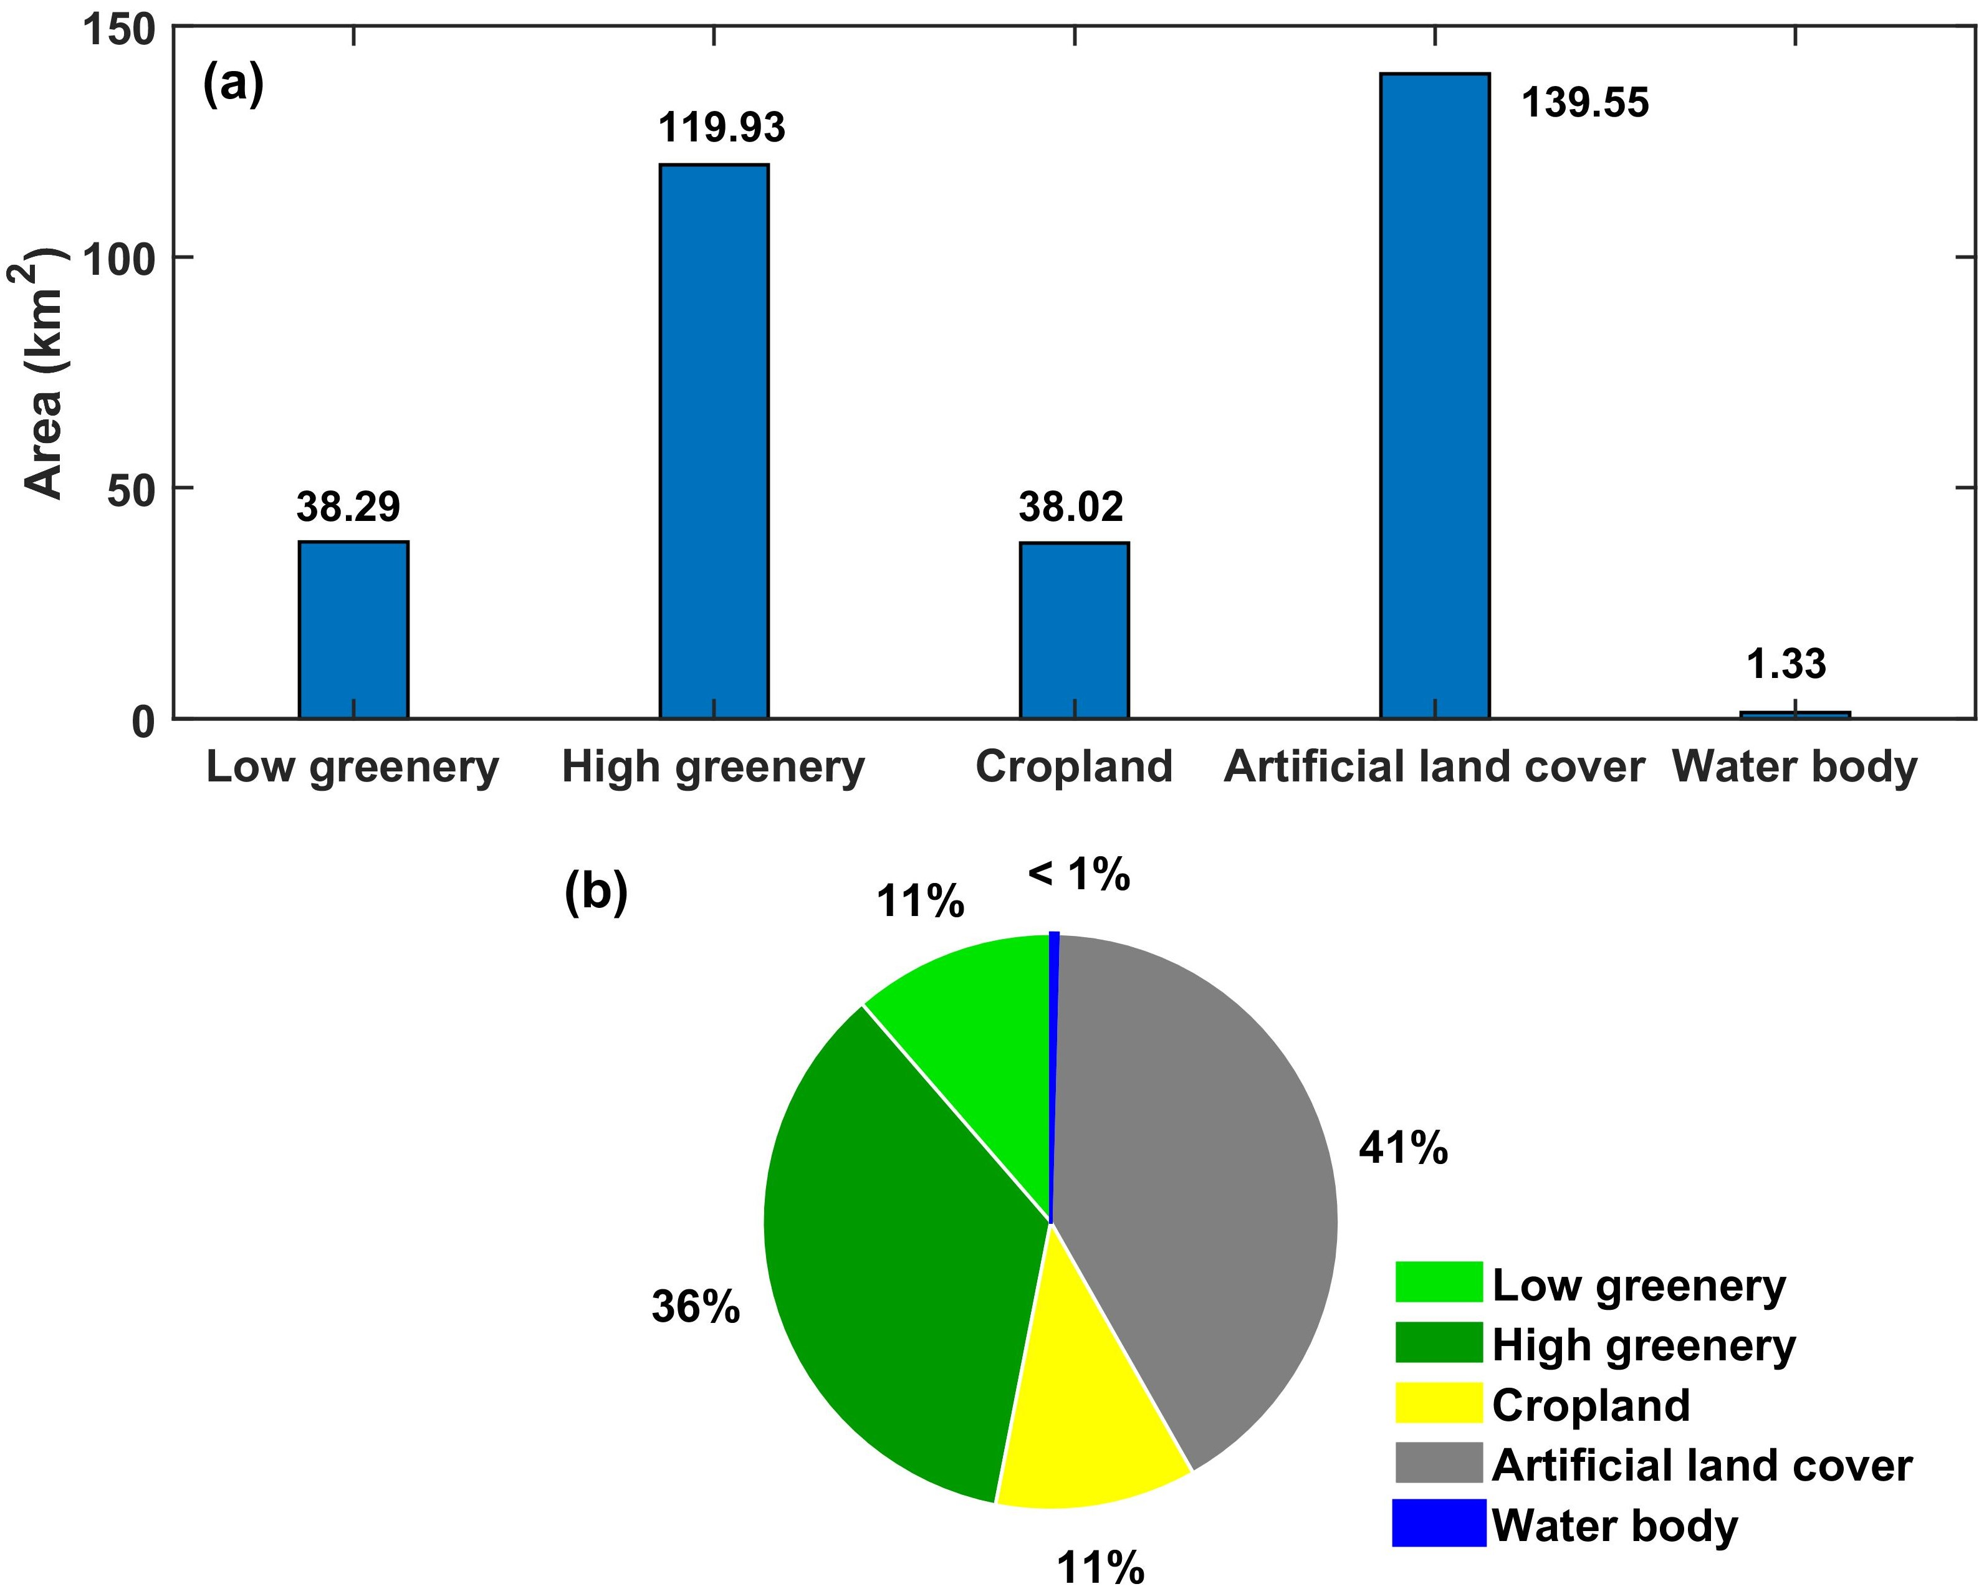
Figure A.1 Statistic information on the area of low green, high green, cropland, artificial land cover, and water body in the study area: (a) area bar plot of the five land cover types; (b) pie chart of percentage of area covered by each land cover type.
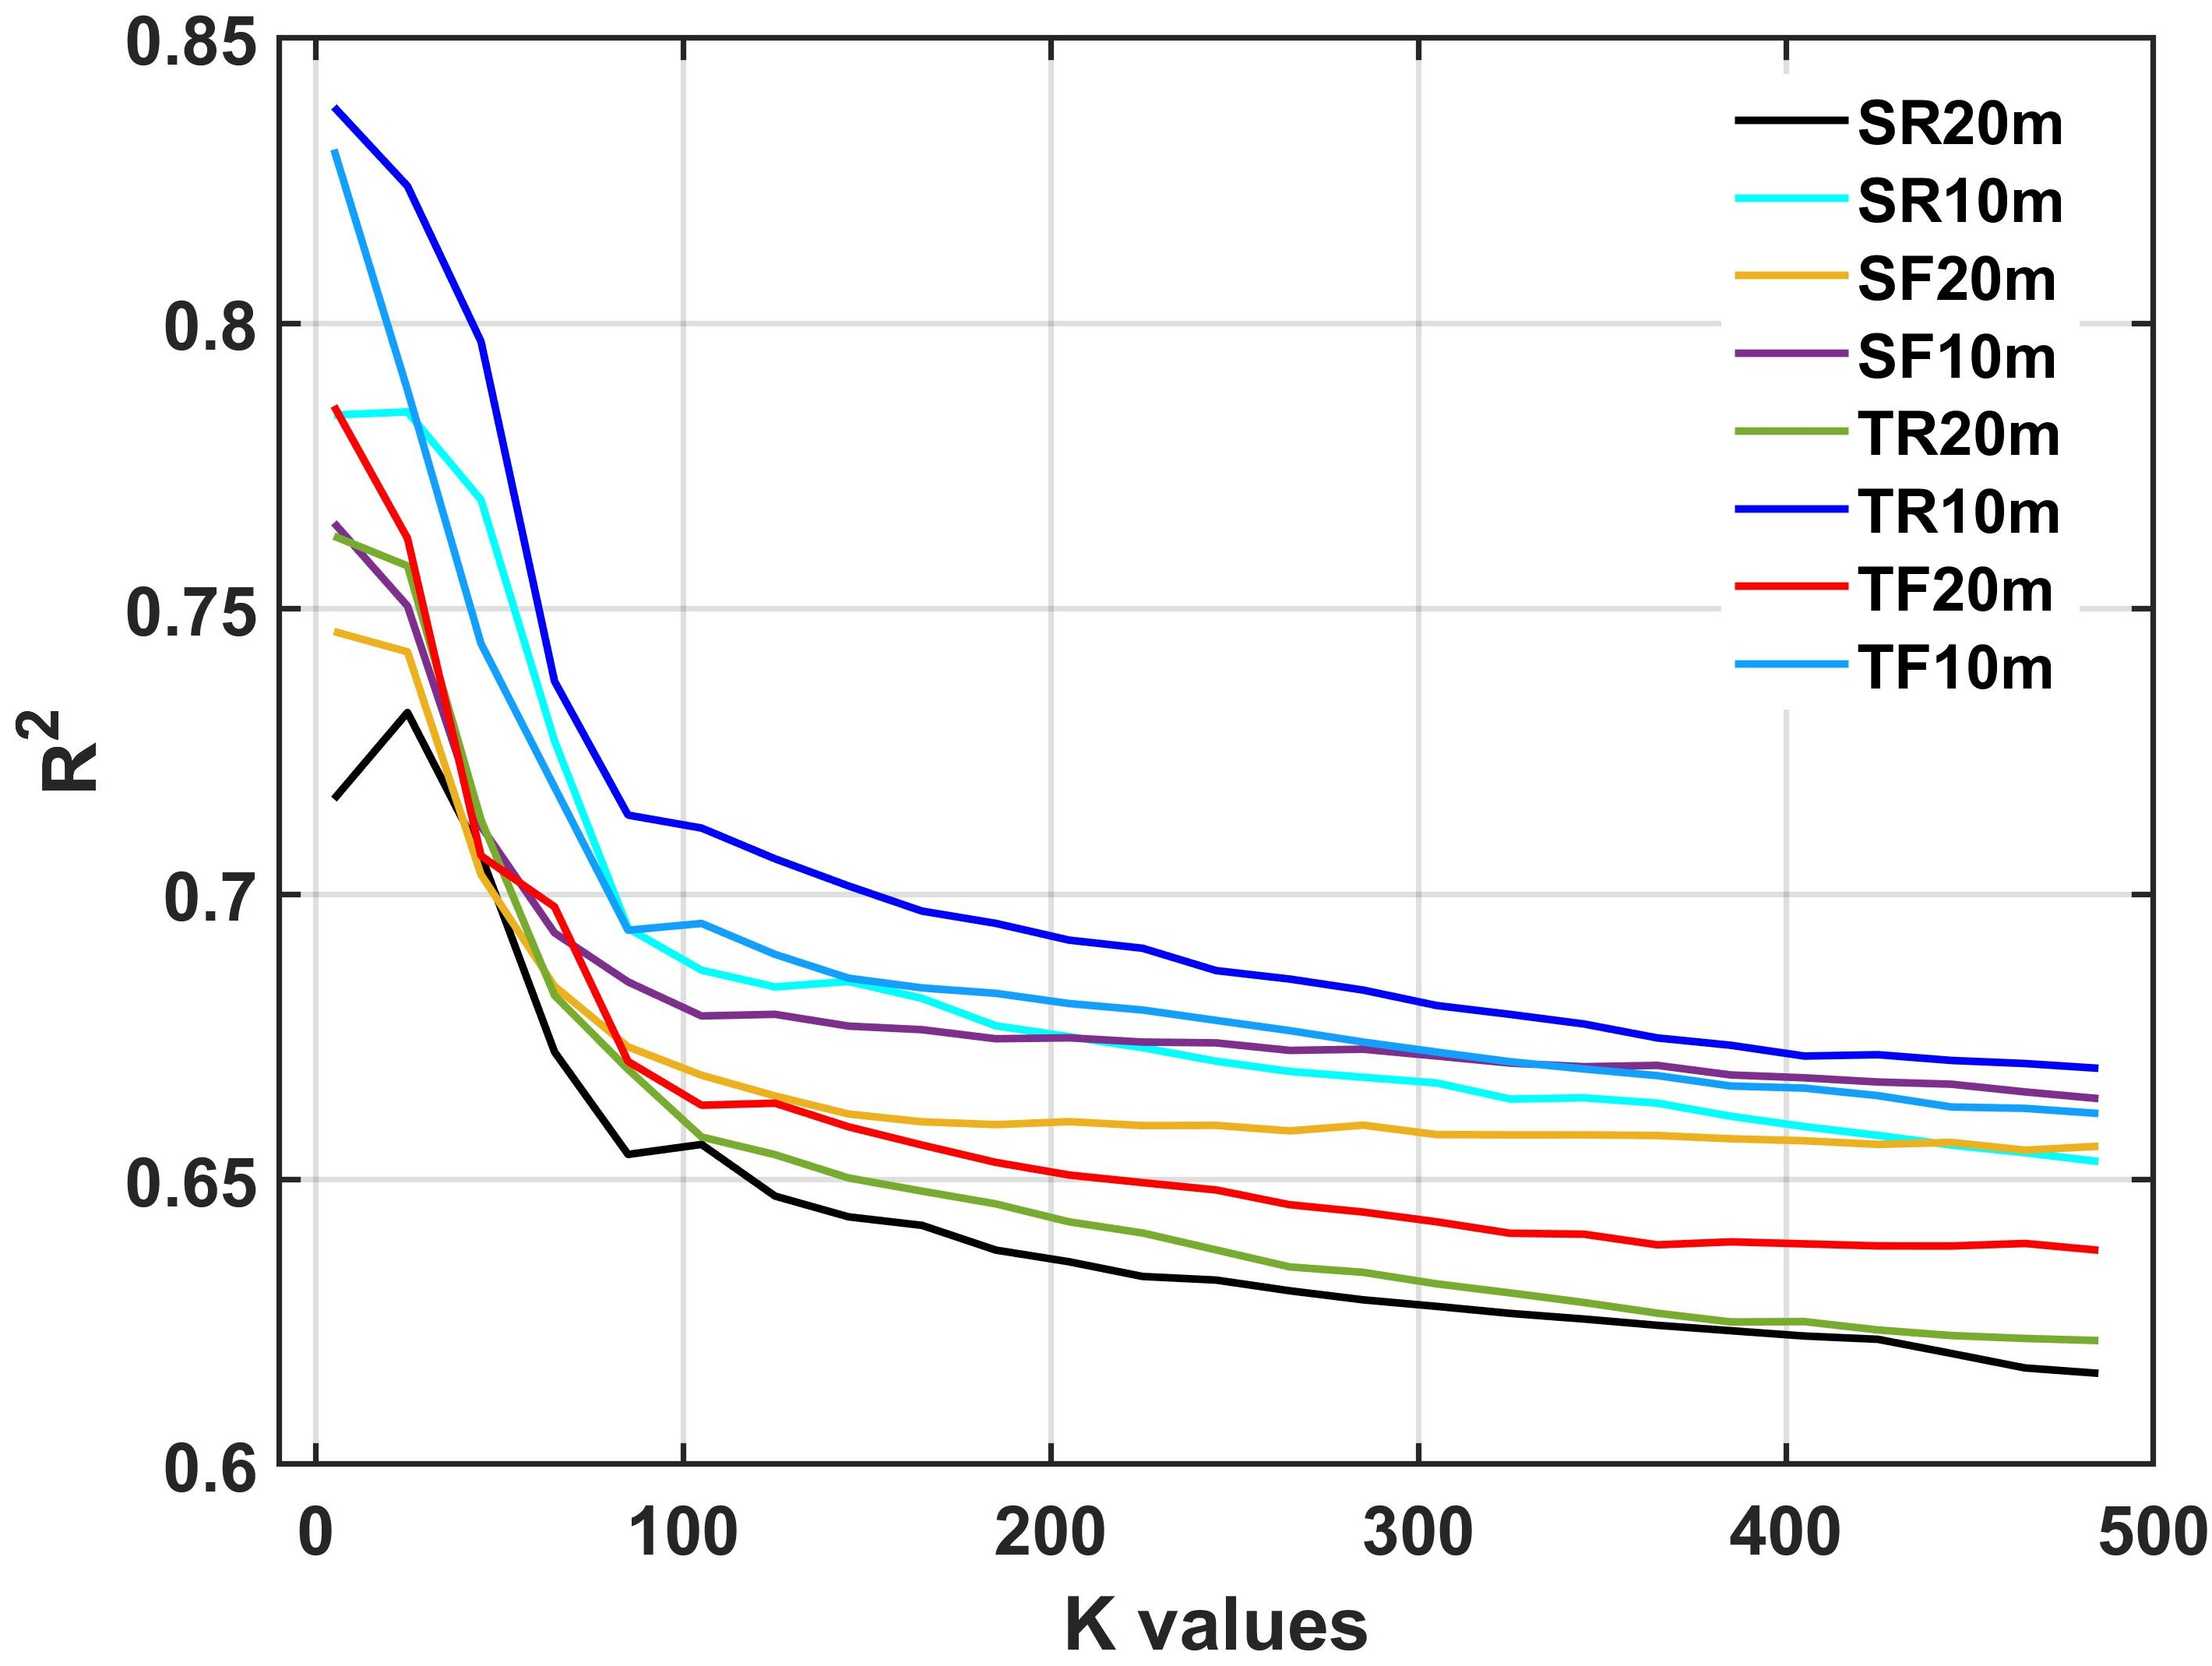
Figure A.2 The change in the coefficient of determination (R2) of the KNN model corresponding to the varying K values. In this test, all training samples (500 samples per land cover type) were used to train KNN models with different K values. We randomly selected validation samples with the same sample size in 12 validation areas (indicated in Figure 1) to calculate R². Note that we performed 10 independent samplings for validation samples to calculate an average R².
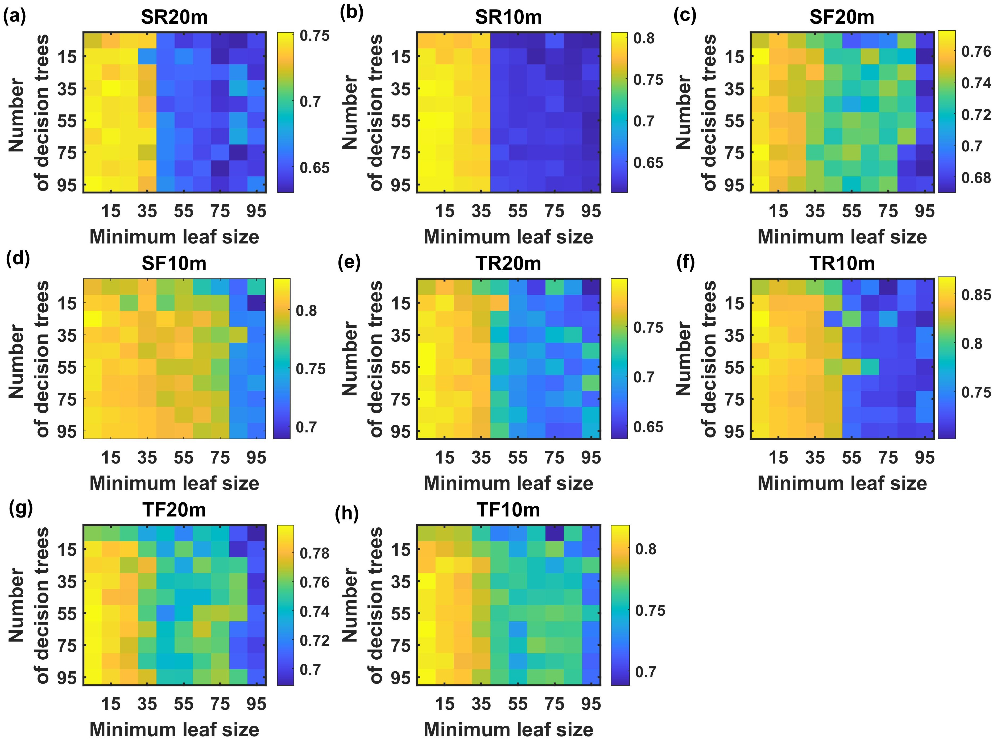
Figure A.3 The illustration of the coefficient of determination (R2) of the Random Forest model varying with the number of decision tree and the minimum leaf size for the classifications of (a) SR20m, (b) SR10m, (c) SF20m, (d) SF10m, (e) TR20m, (f) TR10m, (g) TF20m, and (h) TF10m. The range of values for R2 is rendered as dark blue to yellow. Note that this experiment's technical flow is the same as the one used to obtain Figure 4A.2; the only difference is that the classifier changes from KNN to RF.

