Exploring 3D Spatial Morphology Using Multilayered Space Syntax, Network Science and Wi-Fi Log Data

Supplementary Material (SM)

SM section 1: Related work
Space syntax has been widely applied in various fields, such as crime analysis (Nubani and Wineman, 2005), navigation and traffic planning (Hölscher et al., 2012; Jiang and Liu, 2011; Lerman et al., 2014), tourist behavior (Li et al., 2016), house price (Law et al., 2013), and other human-environment interaction relationship. This type of research explores the applicability of spatial syntax in different fields. At the same time, some studies aimed to develop modules to integrate space syntax into GIS and other models (Franz and Wiener, 2008; Jiang and Claramunt, 2002; Jiang and Liu, 2010; Penn and Turner, 2001), which promote the application of space syntax. For example, several studies aimed to combine space syntax with agent-based-modelling analysis (Cheliotis, 2020; Hu et al., 2017; Penn and Turner, 2001). As pointed out in (Cheliotis, 2020), its “principal tool is the graph representation in which aspects of space are represented as nodes and their relationships as edges connecting individual nodes, with derivative tools including the convex map, the axial map, and the visibility graph, all methodologies for capturing an aspect of space”. For example, Osmond, (2011) and Dawes and Ostwald, (2018) used convex space to represent urban structural unit (USU). The majority of space syntax studies are based on the concept of “visibility”, which means the representation of small spaces is based on the “visible” areas from a location. Jiang and his colleagues proposed that, at the scales of urban environment, the representation of space can be extended to “accessibility”, which can be modeled by decomposing the center lines of roads into axial lines (Jiang and Liu, 2010; Liu and Jiang, 2012).

SM section 2: Methodology illustration
In the past development of space syntax, several studies aimed to reflect and discuss on the pros and cons of the theoretical framework of space syntax from different perspectives (Batty, 2004; Hillier, 1999; Hillier and Tzortzi, 2006; Pafka et al., 2020; Penn, 2003; Yang, 2016; Zhang and Wang, 2004). As there has been a dilemma of definition and generation of axial lines in space syntax, some researchers propose alternative representations to replace the axial lines, such as segment lines (Hillier and Iida, 2005), road center lines (Turner, 2007), self-organized natural roads (Jiang et al., 2008), continuity lines (Figueiredo and Amorim, 2005) and path-centric lines (Chiaradia and Zhang, 2018). Space syntax analysis of the city as a movement economies has led researchers to care about uncovering the relationship between the societal and spatial nature of the city (Hillier, 1996; Pafka et al., 2020). For example, the correlation between the space syntax and complex network parameters with density, and urban vitality. This was an incentive to generate axial maps of space syntax from the point of view of accessibility rather than visibility, since human movement is restricted by walkable space, especially at the city level. Since in large urban environments such as cities or university campuses, the distances between buildings are not necessarily walkable space, it is not advantageous to rely on a perspective of the visibility to generate axial lines. Liu and his colleague proposed a method for redefining and generating axial lines by considering the walkability and drivability streets (Liu and Jiang, 2012). Meanwhile, Ratti pointed out several problems in space syntax (Ratti, 2004), e.g., it puts too much emphasis on spatial and geometric structures, but other information such as building height and land use are oversimplified or even neglected. In addition, although its theoretical basis is not limited to 2D space, the algorithm and application scenario of spatial syntax do not contain 3D space.
Urban space is defined as the open area where people can freely access, which can be regarded as the counterpart of obstacles such as buildings in a city. In essence, the urban space is large and continuous, which consists of numerous small spaces. A small space is an area which is visible from a location at one time, no matter where the location is in the area. On one hand, one cannot see or perceive the whole space at one time. On the other hand, there are numerous ways to break down the large and continuous space into small spaces. To quantify the differences of the large urban space, it is necessary to decompose it into reasonable and unique spatial units to perform quantitative analysis. Space syntax (Hillier et al., 1976; Hillier and Hanson, 1984) provides a set of theories and techniques to decompose the large and continuous geographic space (Figure S1) into a set of unique lines (axial lines, Figure S1-(b)). Each of the axial line represents a small space, based on which the spatial network can be used to quantify the difference of the large space using network analysis. There are two principles when generating the axial map: 1) the axial line is defined as the longest straight line representing the maximum extension of a point in space; and 2) the number of lines must be the least. Simply to say, the axial lines are the least number of longest lines in the space. There are different methods to generate axial lines, due to the limited length, please refer to related studies for more details (e.g., (Hillier and Hanson, 1984; Jiang and Liu, 2010; Liu and Jiang, 2012; Turner et al., 2005)). Turner et al. stated that graph measures obtained from axial maps are useful for analyzing pedestrian movement patterns and the effect of spatial configuration on pedestrian movement (Turner et al., 2005), whereas several empirical studies demonstrating that the morphological properties for the graph based on axial lines correlate significantly with human movement (Hillier et al., 1993; Jiang, 2009; Penn et al., 1998). Hillier and Iida proved that the topological and angular analysis are superior to the metric analysis (Hillier and Iida, 2005). In addition, the space syntax analysis was performed for a single floor to investigate the correlation between the space syntax parameters based on the topological and angular views. The podium level of the Hong Kong Polytechnic University (PolyU) campus is the only floor that connects all buildings on the PolyU campus. Therefore, the axial map generated from the podium level consists of axial lines of all buildings of PolyU. A depthmapX software was used for conducted analysis for podium level. The correlation of betweenness based on topological and angular floor is high (Figure S7), in which the value reaches 0.879. These results are consistent with the previous studies, and it is expected that if we use the space syntax parameters based on the angular view instead of the topological view.

SM section 3: Application of urban network analysis
Since we are surrounded by many networks, both in the real world (e.g., public transit networks, road networks, etc.) (Senousi et al., 2020; Zhao et al., 2017) and in cyberspace (e.g., online social networks) (Gentina et al., 2020), this has contributed significantly to the progress made in applying network analysis in various disciplines for a better understanding of different systems. It should be noted that network analysis has been used in many urban studies for various purposes, such as identifying urban structure (Guo et al., 2018; Liu et al., 2021; Roth et al., 2011; Zhong et al., 2014), exploring human mobility patterns (Jiang et al., 2017; Liu et al., 2015), and discovering the structure and properties of such networks. The existing studies on the discovery of the structure and properties of networks can be divided into two groups. The first group includes the studies interested in investigating and determining the scale of the network centralities (e.g., (Feng et al., 2016; Jiang et al., 2011; Tian et al., 2016; Wang et al., 2017). These studies were conducted to investigate the topology of public transport and road network structure, analyze the statistics and distribution of network centrality (e.g., degree, betweenness, closeness, etc.). The second group includes the studies that reveal the correlation between network centrality and passenger/traffic flow, such as the following articles (Kazerani and Winter, 2009a, 2009b; Pun et al., 2019; Senousi et al., 2020; Ye et al., 2016; Zhao et al., 2017). As a result of improvements and developments in network science that keep pace with the realization that the real systems around us do not operate in isolation, such as urban systems (i.e., railway system, bus system, traffic system, etc.) (Senousi et al., 2021). There are many studies that have applied or recommended the use of multilayer networks in various disciplines (Aleta et al., 2017; Ding et al., 2018; Gallotti and Barthelemy, 2015; Kivelä et al., 2014; Ma et al., 2016; Senousi et al., 2021). References (Ding et al., 2019) and (Kivelä et al., 2014) contain a comprehensive review of the application of complex network theory in urban traffic studies and provide a thorough discussion comparing the different types of multilayer networks, respectively.

Reference
Aleta A, Meloni S and Moreno Y (2017) A Multilayer perspective for the analysis of urban transportation systems. Scientific Reports 7(1). Nature Publishing Group: 1–9. DOI: 10.1038/srep44359.
Batty M (2004) A new theory of space syntax. (CASA Working Papers ). Centre for Advanced Spatial Analysis (UCL): London, UK. (2004). London, UK: Centre for Advanced Spatial Analysis (UCL).
Cheliotis K (2020) An agent-based model of public space use. Computers, Environment and Urban Systems 81. Elsevier Ltd: 101476. DOI: 10.1016/j.compenvurbsys.2020.101476.
Chiaradia A and Zhang L (2018) New Urban Design? Insights from Hong Kong Extreme Configurations. Architectural Worlds Magazine.
Dawes MJ and Ostwald MJ (2018) Space Syntax: Mathematics and the Social Logic of Architecture. In: Bharath Sriraman (ed.) Handbook of the Mathematics of the Arts and Sciences. Cham, Switzerland: Springer International Publishing, pp. 1–12. DOI: 10.1007/978-3-319-70658-0_6-1.
Ding R, Ujang N, Hamid H bin, et al. (2018) Detecting the urban traffic network structure dynamics through the growth and analysis of multi-layer networks. Physica A: Statistical Mechanics and its Applications 503. Elsevier B.V.: 800–817. DOI: 10.1016/j.physa.2018.02.059.
Ding R, Ujang N, Hamid H Bin, et al. (2019) Application of complex networks theory in urban traffic network researches. Networks and Spatial Economics. Springer US: 1–37. DOI: 10.1007/s11067-019-09466-5.
Feng S, Hu B, Nie C, et al. (2016) Empirical study on a directed and weighted bus transport network in China. Physica A: Statistical Mechanics and its Applications 441: 85–92. DOI: 10.1016/j.physa.2015.08.030.
Figueiredo L and Amorim L (2005) Continuity-lines Space Syntax. In: 5th International Space Syntax Symposium, Delft, 2005, pp. 161–174. TU Delft, Faculty of Architecture.
Franz G and Wiener JM (2008) From space syntax to space semantics: A behaviorally and perceptually oriented methodology for the efficient description of the geometry and topology of environments. Environment and Planning B: Planning and Design 35(4). Pion Limited: 574–592. DOI: 10.1068/b33050.
Gallotti R and Barthelemy M (2015) The multilayer temporal network of public transport in Great Britain. Scientific Data 2(1). Nature Publishing Groups: 1–8. DOI: 10.1038/sdata.2014.56.
Gentina E, Chen R and Yang Z (2020) Development of theory of mind on online social networks: Evidence from Facebook, Twitter, Instagram, and Snapchat. Journal of Business Research. Elsevier Inc. DOI: 10.1016/j.jbusres.2020.03.001.
Guo D, Jin H, Gao P, et al. (2018) Detecting spatial community structure in movements. International Journal of Geographical Information Science 32(7). Taylor & Francis: 1326–1347. DOI: 10.1080/13658816.2018.1434889.
Hillier B (1996) Cities as movement economies. Urban Design International 1(1). Palgrave: 41–60. DOI: 10.1057/udi.1996.5.
Hillier B (1999) Space Is the Machine: A Configurational Theory of Architecture. Cambridge: Cambridge University Press.
Hillier B and Hanson J (1984) The Social Logic of Space. Cambridge: Cambridge University Press. DOI: 10.1017/cbo9780511597237.
Hillier B and Iida S (2005) Network and psychological effects in urban movement. In: Cohn AG and Mark DM (eds) Spatial Information Theory. COSIT 2005. Lecture Notes in Computer Science. Berlin, Heidelberg: Springer, Berlin, Heidelberg, pp. 475–490. DOI: 10.1007/11556114_30.
Hillier B and Tzortzi K (2006) Space Syntax: The Language of Museum Space. In: Macdonald S (ed.) A Companion to Museum Studies. John Wiley and Sons, pp. 282–301. DOI: 10.1002/9780470996836.ch17.
Hillier B, Leaman A, Stansall P, et al. (1976) Space Syntax. Environment and Planning B: Urban Analytics and City Science 3(2). SAGE PublicationsSage UK: London, England: 147–185. DOI: 10.1068/b030147.
Hillier B, Penn A, Hanson J, et al. (1993) Natural movement: or, configuration and attraction in urban pedestrian movement. Environment & Planning B: Planning & Design 20(1). SAGE PublicationsSage UK: London, England: 29–66. DOI: 10.1068/b200029.
Hölscher C, Brösamle M and Vrachliotis G (2012) Challenges in multilevel wayfinding: A case study with the space syntax technique. Environment and Planning B: Planning and Design 39(1). Pion Limited: 63–82. DOI: 10.1068/b34050t.
Hu H, Luo Z, Chen Y, et al. (2017) Integration of Space Syntax into Agent­‐Based Pedestrian Simulation in Urban Open Space. In: 22nd Conference on Computer-Aided Architectural Design Research in Asia (CAADRIA), Suzhou, China, 2017, pp. 5–8.
Jiang B (2009) Ranking spaces for predicting human movement in an urban environment. International Journal of Geographical Information Science 23(7). Taylor & Francis : 823–837. DOI: 10.1080/13658810802022822.
Jiang B and Claramunt C (2002) Integration of space syntax into GIS: New perspectives for urban morphology. Transactions in GIS 6(3). Blackwell Publishing Ltd: 295–309. DOI: 10.1111/1467-9671.00112.
Jiang B and Liu X (2010) Automatic generation of the axial lines of urban environments to capture what we perceive. International Journal of Geographical Information Science 24(4). Taylor & Francis : 545–558. DOI: 10.1080/13658810902950351.
Jiang B and Liu X (2011) Computing the fewest-turn map directions based on the connectivity of natural roads. International Journal of Geographical Information Science 25(7). Taylor & Francis : 1069–1082. DOI: 10.1080/13658816.2010.510799.
Jiang B, Zhao S and Yin J (2008) Self-organized natural roads for predicting traffic flow: A sensitivity study. Journal of Statistical Mechanics: Theory and Experiment 2008(7). IOP Publishing: P07008. DOI: 10.1088/1742-5468/2008/07/P07008.
Jiang H, Li Q, Zhou X, et al. (2017) A collective human mobility analysis method based on data usage detail records. International Journal of Geographical Information Science 31(12). Taylor and Francis Ltd.: 2359–2381. DOI: 10.1080/13658816.2017.1370715.
Jiang J, Metz F, Beck C, et al. (2011) Double power-law degree distribution and informational entropy in urban road networks. International Journal of Modern Physics C 22(1): 13–20. DOI: 10.1142/S0129183111016075.
Kazerani A and Winter S (2009a) Can betweenness centrality explain traffic flow? In: Proceedings of the 12th AGILE International, 2009, pp. 1–9. DOI: Paper 111.
Kazerani A and Winter S (2009b) Modified betweenness centrality for predicting traffic flow. In: 10th International Conference on GeoComputation, Sydney, Australia, Sydney, Australia, 2009.
Kivelä M, Arenas A, Barthelemy M, et al. (2014) Multilayer networks. Journal of Complex Networks 2(3). Oxford University Press: 203–271. DOI: 10.1093/comnet/cnu016.
Law S, Karimi K, Penn A, et al. (2013) Measuring the influence of spatial configuration on the housing market in metropolitan London. In: The Ninth International Space Syntax Symposium (eds YO Kim, HT Park, and KW Seo), Seoul, 2013. Sejong University.
Lerman Y, Rofè Y and Omer I (2014) Using space syntax to model pedestrian movement in urban transportation planning. Geographical Analysis 46(4). Blackwell Publishing Inc.: 392–410. DOI: 10.1111/gean.12063.
Li Y, Xiao L, Ye Y, et al. (2016) Understanding tourist space at a historic site through space syntax analysis: The case of Gulangyu, China. Tourism Management 52. Elsevier Ltd: 30–43. DOI: 10.1016/j.tourman.2015.06.008.
Liu X and Jiang B (2012) Defining and generating axial lines from street center lines for better understanding of urban morphologies. International Journal of Geographical Information Science 26(8). Taylor & Francis : 1521–1532. DOI: 10.1080/13658816.2011.643800.
Liu X, Gong L, Gong Y, et al. (2015) Revealing Travel Patterns and City Structure with Taxi Trip Data. Journal of Transport Geography 43. Elsevier Ltd: 78–90. DOI: 10.1016/j.jtrangeo.2015.01.016.
Liu X, Huang J, Lai J, et al. (2021) Analysis of urban agglomeration structure through spatial network and mobile phone data. Transactions in GIS. John Wiley & Sons, Ltd: tgis.12755. DOI: 10.1111/tgis.12755.
Ma J, Han W, Guo Q, et al. (2016) Traffic dynamics on two-layer complex networks with limited delivering capacity. Physica A: Statistical Mechanics and its Applications 456. Elsevier B.V.: 281–287. DOI: 10.1016/j.physa.2016.03.092.
Nubani L and Wineman J (2005) The Role of Space Syntax in Identifying the Relationship Between Space and Crime. In: 5th Space Syntax Symposium on Space Syntax, Delft, 2005. TU Delft, Faculty of Architecture.
Osmond P (2011) The convex space as the ‘atom’ of urban analysis. The Journal of Space Syntax T 2(1): 97–114. Available at: http://www.journalofspacesyntax.org/ (accessed 7 June 2021).
Pafka E, Dovey K and Aschwanden GDPA (2020) Limits of space syntax for urban design: Axiality, scale and sinuosity. Environment and Planning B: Urban Analytics and City Science 47(3). SAGE Publications Ltd: 508–522. DOI: 10.1177/2399808318786512.
Penn A (2003) Space Syntax And Spatial Cognition: Or Why the Axial Line? Environment and Behavior. SAGE Publications. DOI: 10.1177/0013916502238864.
Penn A and Turner A (2001) Space syntax based agent simulation. In: 1st International Conference on Pedestrian and Evacuation Dynamics, University of Duisburg, Germany, 2001.
Penn A, Hillier B, Banister D, et al. (1998) Configurational Modelling of Urban Movement Networks: Environment and Planning B: Urban Analytics and City Science. SAGE PublicationsSage UK: London, England. DOI: 10.1068/B250059.
Pun L, Zhao P and Liu X (2019) A multiple regression approach for traffic flow estimation. IEEE Access 7. DOI: 10.1109/ACCESS.2019.2904645.
Ratti C (2004) Space syntax: Some inconsistencies. Environment and Planning B: Planning and Design 31(4). Pion Limited: 487–499. DOI: 10.1068/b3019.
Roth C, Kang SM, Batty M, et al. (2011) Structure of urban movements: Polycentric activity and entangled hierarchical flows. PLoS ONE 6(1). Public Library of Science: 15923. DOI: 10.1371/journal.pone.0015923.
Senousi AM, Liu X, Zhang J, et al. (2020) An Empirical Analysis of Public Transit Networks Using Smart Card Data in Beijing, China. Geocarto International. Taylor and Francis Ltd.: 1–21. DOI: 10.1080/10106049.2020.1768594.
Senousi AM, Zhang J, Shi W, et al. (2021) A Proposed Framework for Identification of Indicators to Model High-Frequency Cities. ISPRS International Journal of Geo-Information 10(5). Multidisciplinary Digital Publishing Institute: 317. DOI: 10.3390/ijgi10050317.
Tian Z, Jia L, Dong H, et al. (2016) Analysis of urban road traffic network based on complex network. Procedia Engineering 137. Elsevier: 537–546. DOI: 10.1016/J.PROENG.2016.01.290.
Turner A (2007) From axial to road-centre lines: A new representation for space syntax and a new model of route choice for transport network analysis. Environment and Planning B: Planning and Design 34(3). Pion Limited: 539–555. DOI: 10.1068/b32067.
Turner A, Penn A and Hillier B (2005) An algorithmic definition of the axial map. Environment and Planning B: Planning and Design 32(3). Pion Limited: 425–444. DOI: 10.1068/b31097.
Wang S, Zheng L and Yu D (2017) The improved degree of urban road traffic network: A case study of Xiamen, China. Physica A: Statistical Mechanics and its Applications 469. North-Holland: 256–264. DOI: 10.1016/j.physa.2016.11.090.
Yang T (2016) Thinking Aloud on Space Syntax Research. Urban Design 1(003): 22–31.
Ye P, Wu B and Fan W (2016) Modified betweenness-based measure for prediction of traffic flow on urban roads. Transportation Research Record: Journal of the Transportation Research Board 2563(1). SAGE PublicationsSage CA: Los Angeles, CA: 144–150. DOI: 10.3141/2563-19.
Zhang Y and Wang J (2004) Re-exploration of Space Syntax. The Architect 3: 33–44.
Zhao S, Zhao P and Cui Y (2017) A network centrality measure framework for analyzing urban traffic flow: A case study of Wuhan, China. Physica A: Statistical Mechanics and its Applications 478. Elsevier B.V.: 143–157. DOI: 10.1016/j.physa.2017.02.069.
Zhong C, Arisona SM, Huang X, et al. (2014) Detecting the dynamics of urban structure through spatial network analysis. International Journal of Geographical Information Science 28(11). Taylor & Francis: 2178–2199. DOI: 10.1080/13658816.2014.914521.

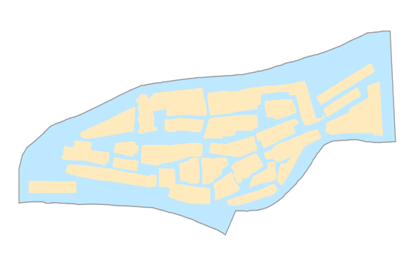  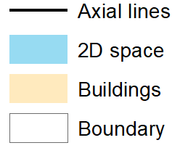 | 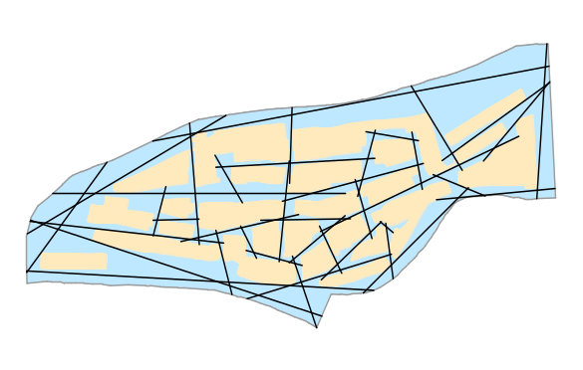
(a) | (b)
Figure S1. Space syntax example in 2D space: (a) Gassin town in south France, where the irregular polygons are buildings, and the counterpart geographic space in light blue, (b) the axial lines/map in black.
AP₂
L₁
L₂
L₃
L₄
L₅
AP₁
T₁
T₂

Figure S2. Estimation of route-based pedestrian flow in spatial network using Dijkstra algorithm. The geometrically and topologically shortest path between AP₁ and AP₂ is the dashed path in green.

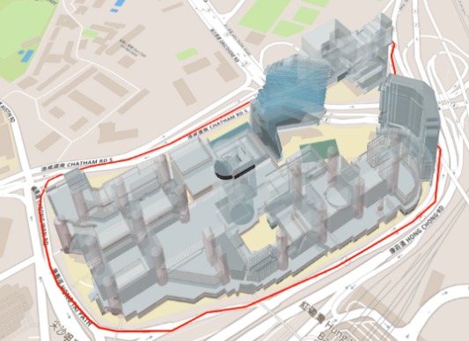 | 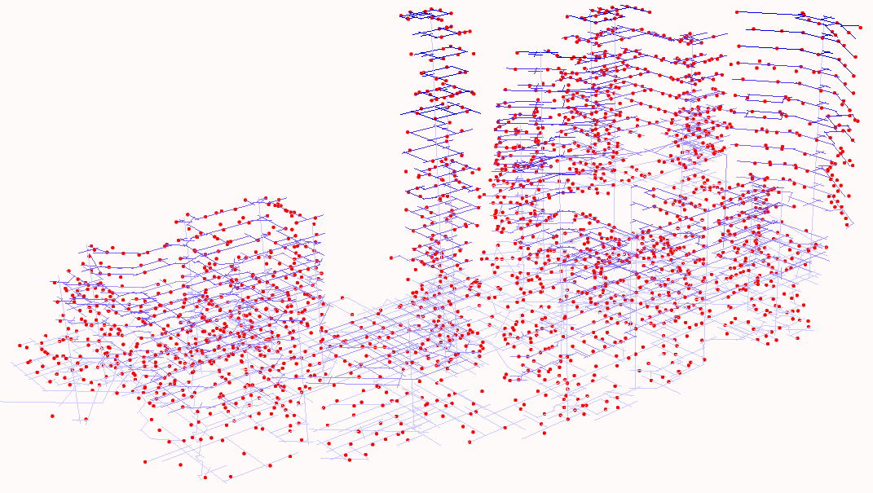  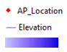  Low high
(a) | (b)
Figure S3. Study Area: (a) 3D Visualization of the University Campus; (b) Over 2,000 axial lines in 3D space. Note that the blue colors represent the elevations and red dots represent the Wi-Fi Access Points (Routers). The distribution of APs is not depicting human flows. The flows are visualized in Figure 2.

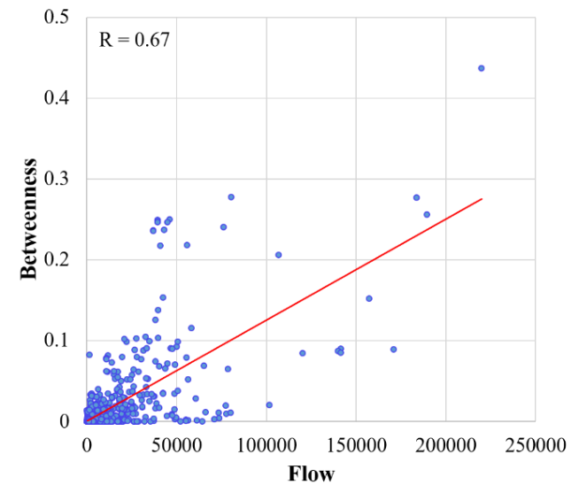 | 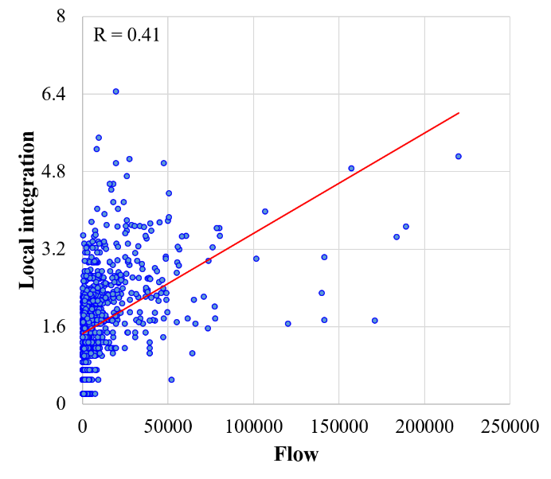
(a) | (b)
Figure S4. The relationships between network topological measures and route-based pedestrian flow (a) betweenness, and (b) local integration.

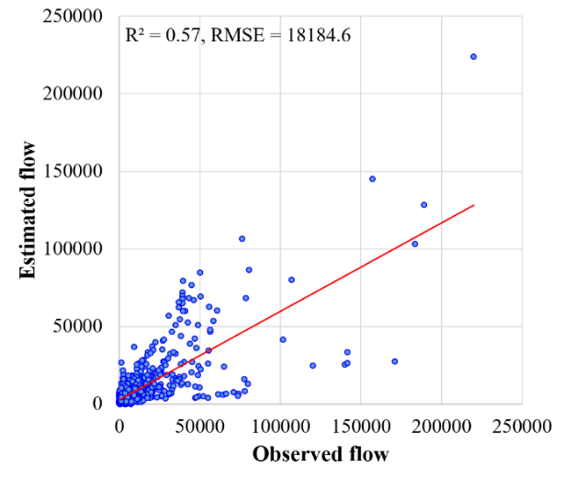
Figure S5. The relationships between observed pedestrian flow and estimated pedestrian flow.

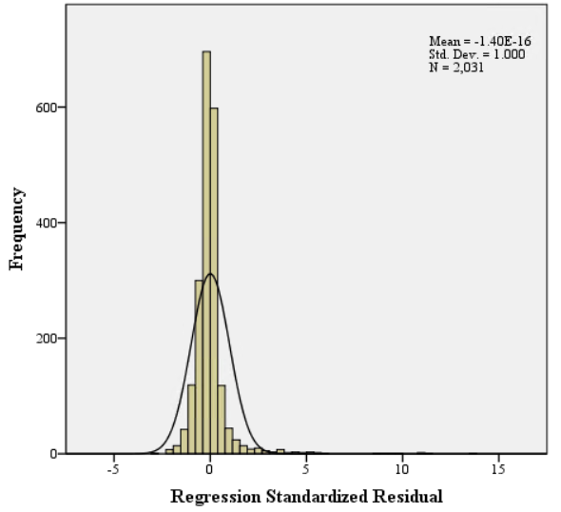 | 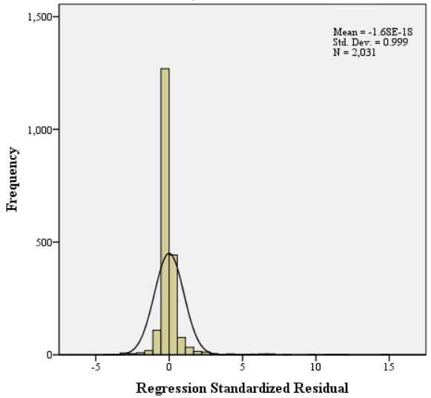
(a) | (b)
Figure S6. The distribution of the residuals in (a) Model 1 and (b) Model 2 of Table 4.

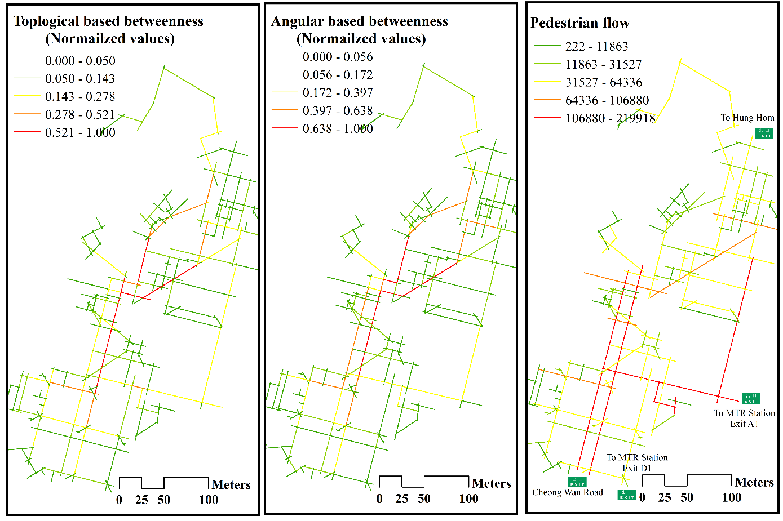
(a) | (b) | (c)
Figure S7. The spatial distribution of betweenness centrality in terms of (a) topological view, (b) angular view, and (c) the spatial distribution of route-based pedestrian flow.

