I. Data Collection

Table 1. Google Street View
a. Input Parameters for Google Street View API (Street View Static API, n.d.)
INPUT | PARAMETER | DESCRIPTION
geographic location | latitude and longitude | According to google map
field of view | (0, 360] | Zoom level
up or down angle | [0, 90) | Up or down angle of the camera, Default: 0
heading direction | [0, 360) | 0 = north, 90 = east, 180 = south and 270 = west
b. Output Parameters for Google Street View API (Street View Static API, n.d.)
OUTPUT | PARAMETER | DESCRIPTION
image size | 640 × 640 pixels | Maximum resolution for non-premium plan users
Image number | No limits | Free of charge with less than 250 dollars. (Street View Static API, n.d.)
c. Details of Google Street View image dataset
Level | Number of images | Obtain | Notes
Haji Lane | 48 images from 12 points | Retrieved by Google Street View API in April 2022 | Four Street View images are generated for each sample points to form an entire understanding of the space.
Kampong Glam district | 268 images from 67 junctions | Retrieved by Google Street View API in April 2022

Table 2. Details of Flickr image dataset
Hashtag | Number | Obtain | Notes
#Haji Lane | 4458 images | Retrieved by Flickr API in March 2022 | N.A.
#kampong gelam | 611 images | Retrieved by Flickr API in March 2022 | Images with #kampong gelam and #kampong glam are analysed together
#kampong glam | 4441 images | Retrieved by Flickr API in March 2022

Table 3. Twitter data and TripAdvisor data (Tripadvisor, n.d.; Twitter API, n.d.)
a. information about platform
Platform | Twitter | TripAdvisor
Official API | Twitter API | Content API
Limitation | Only latest posts can be obtained.  Up to 500k Tweets per month.  Up to 25 requests per 15 minutes | API is no longer available.
Data Content | Tweet id, username, screen name, postdate, tweet URL, comment, retweet, reply count, etc | Location ID, name, address, ranking, sub-ratings, attraction type, restaurant cuisine(s), etc
Geolocation | Depending on users’ settings | N.A.
Optional Ways | Third-party tools, such as Selenium, rely on Python or other coding platforms. | Chrome Cookies.  Third-party tools, such as Selenium, rely on Python or other coding platforms.

Table 4. Details of Twitter Tweets dataset
Hashtag | Number | Obtain | Notes
#Haji Lane | 1671 Tweets | Scratched by python in March 2022. | N.A.
#kampong gelam | 477 Tweets | Scratched by python in March 2022. | Tweets with #kampong gelam and #kampong glam are analysed together (353 Tweets )
#kampong glam | 242 Tweets | Scratched by python in March 2022.

Table 5. Details of TripAdvisor comments dataset
Place | Number | Obtain | Notes
Haji Lane | 706 comments | Scratched from website in May 2022. | N.A.
Kampong Glam district | 319 comments | Scratched from website in May 2022. | N.A.

II. Sample Data

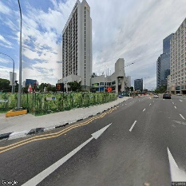a. 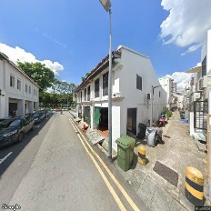 b. 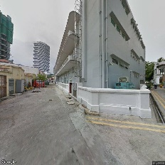 c. 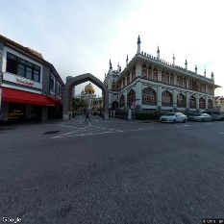 d.
a. Building, b. House, c. Composite material, d. Public space
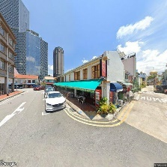e. 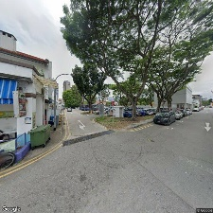 f. 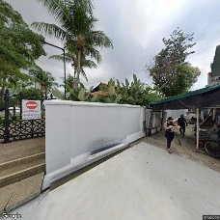 g. 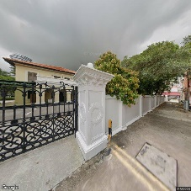 h.
e. Cloud, f. Plant, g. Arecales, h. Landscape
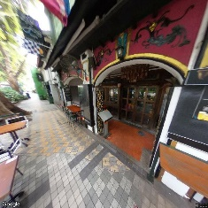i. 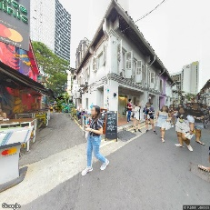 j. 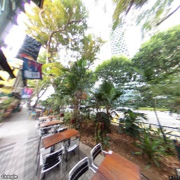 k.
i. Leisure, j. Travel, k. Table
Fig 1. Sample images of Kampong Glam with ‘space’(a-d), ‘nature’(e-h), ‘activity’(i-j), and ‘items’ labels(k)

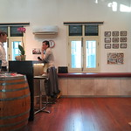a. 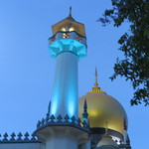b. 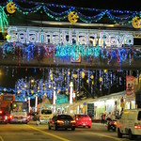c. 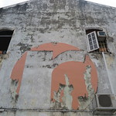d.
a. building b. façade c. public space d. brick
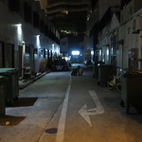e. 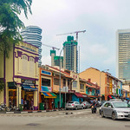f. 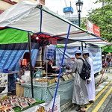g. 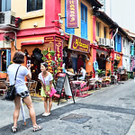h.
e. asphalt f. vehicle g. mode of transport h. sidewalk
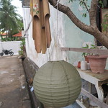 i. 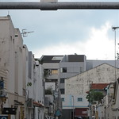j. 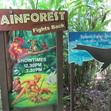k. l.
i. plant j. sky k. terrestrial animal l. flowering plant
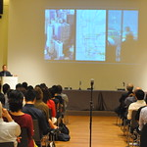m. 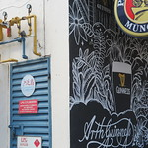n. 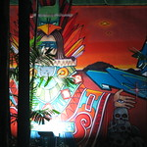o. 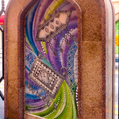p.
m. event n. art o. illustration p. creative art
Fig.2 Sample Flickr images of Kampong Glam labelled ‘space’ (a-d), ‘transport’(e-h), ‘nature’(i-l), ‘activity’(m-p)

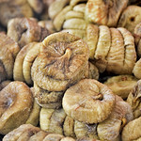a. 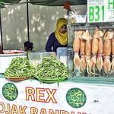 b. 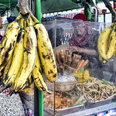 c. 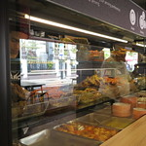 d.
a. cuisine b. ingredient c. natural foods d. fast food
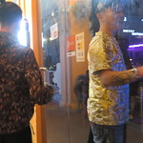e. fun 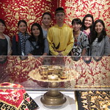 f. smile 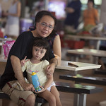 g. happy
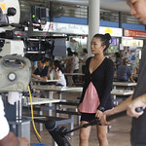h. 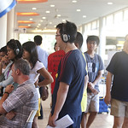 i.  j. 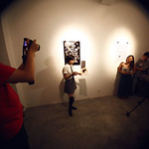 k.
h. thigh i. T-shirt j. Fictional character k. artist
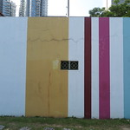l. 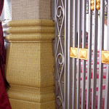 m. 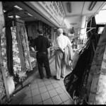 n. 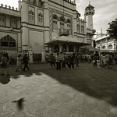 o.
l. rectangle m. pattern n. monochrome photography o. monochrome
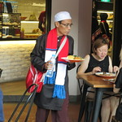p. 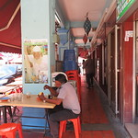 q. 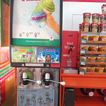 l.  m.
p. hat q. table l. shelving m. shelf
Fig 3. Sample Flickr images of Kampong Glam labelled ‘Food’ (a-d), ‘Emotion’(e-g), ‘People’(h-k), ‘Color & patterns’(l-o), ‘Items’(p-m)

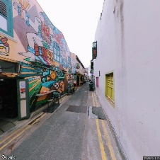 a. 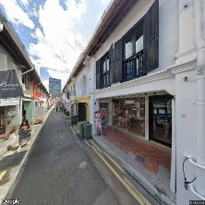 b. 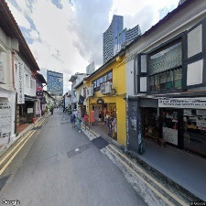 c. 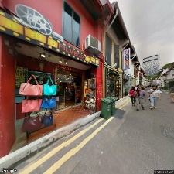 d.
a. Building b. Window c. Public space d. Door
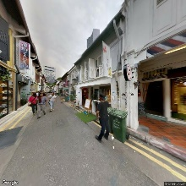 e. 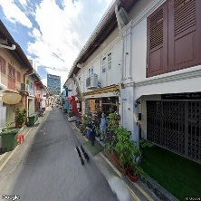 f. & h. 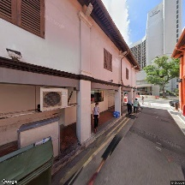 g.
e. Cloud f. Plant g. Tree h. Houseplant
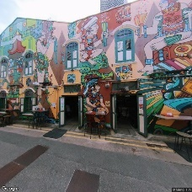 i. 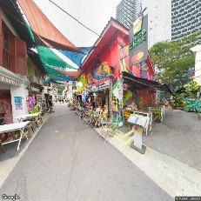 j. 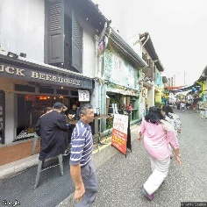 k. 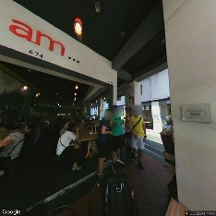 l.
i. Leisure j. Travel k. Street fashion l. Logo
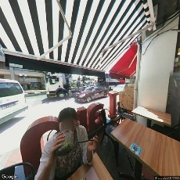 m. Table 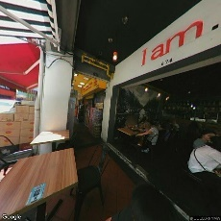 n. Machine
Fig 4. Sample images of Haji Lane labelled ‘space’(a-d), ‘nature’(e-h), ‘activity’(i-l), and ‘items’ (m-n)

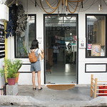 a. 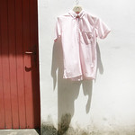 b. 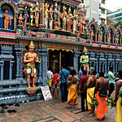 c. 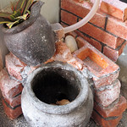 d.
a. Building b. Wood c. Temple d. Brick
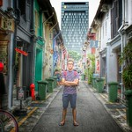 e. 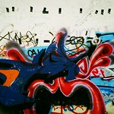 f. 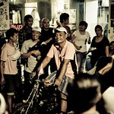 g. 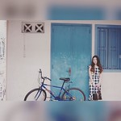 h.
e. Asphalt f. Vehicle g. Bicycles—Equipment and supplies h. Bicycle handlebar
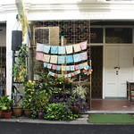 i. 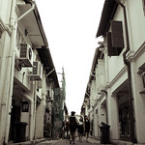 j.  k. 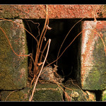 l.
i. Plant j. Sky k. Flower l. Twig
Fig.5 Sample images of Haji Lane labelled ‘Space’(a-d), ‘Transport’(e-h), ‘Nature’(i-l)

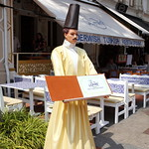 a. 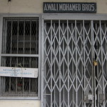 b. 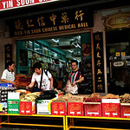 c.  d.
a. Event b. Font c. Market d. Creative arts
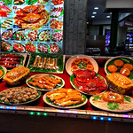 e. 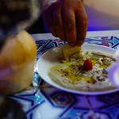 f.  g. 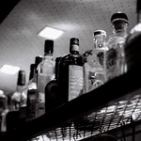 h.
e. Ingredient f. Cuisine g. Drink h. Drinkware
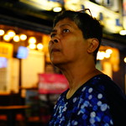 i.  j.  k. 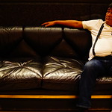 l.
i. Fun j. Smile k. Cool l. Comfort
Fig.6 Sample images of Haji Lane labelled ‘Activity’(a-d), ‘Food’(e-h), ‘Emotion’(i-l)

 a.  b. 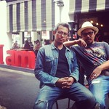 c. 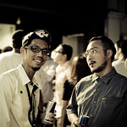 d.
a. Thigh b. Gesture c. Beard d. Formal wear
 e.  f.  g.  h.
e. Rectangle f. Tints and shades g. Symmetry h. Rim
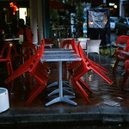 i.  j.  k.  l.
i. Table j. Tableware k. Picture frame l. Electronic device
Fig.7 Sample images with ‘People’(a-d), ‘Color & pattern’(e-h), ‘Items’(i-l) labels

The visual field is set to 120° with the relevant pitch angle at 0°, to ensure that the modelled peripheral vision and horizontal vision contain the majority of the street view. Each sampling view's heading angles include four directions: 0° (true north), 90° (true east), 180° (true south), and 270°. (true west)( Street View Static API” n.d.).

