Supporting Information for
Tunable vortex Majorana modes controlled by strain in homogeneous LiFeAs

Wenyao Liu, Quanxin Hu, Xiancheng Wang, Yigui Zhong, Fazhi Yang, Lingyuan Kong, Lu Cao, Geng Li, Kozo Okazaki,Takeshi Kondo, Changqing Jin, Jinpeng Xu*, Hong-Jun Gao*, and Hong Ding*

Correspondence to:

Email: dingh@sjtu.edu.cn, hjgao@iphy.ac.cn, xujp@iphy.ac.cn

This PDF file includes:

Supporting text
Figures S1 to S6
Tables S1
SI References

Supporting Information Text
Subhead. Type or paste text here. This should be additional explanatory text such as an extended technical description of results, full details of mathematical models, etc. Supporting information text for Brief Reports is limited to extended methods only.

Strained Device
Motivated by a previous experiment (1), the strain device shown in Fig. 2B is made of BeCu. There are two parts: one is fixed on the flat plate and the other is a sliding block which can be driven by a screw. A LiFeAs sample is glued to the substrate which is fixed on the top between the two parts. By reducing or increasing the space between the two parts, we can apply compressive or tensile strain to the substrate. In order to apply suitable strain, an original LiFeAs single crystal was cleaved many times until its thickness was reduced to around 0.1 mm, and was then glued to the substrate for measurements. To apply a uniform uniaxial strain effect, the substrate material should have good ductility at low temperatures, e.g., BaFe₂As₂ single crystal. In addition, the materials that have large deformation at low temperature should be avoided as the strained substrate, otherwise the sample will inevitably suffer the spontaneous ambient strain effect at different temperatures. To fit such strain device, we also add a tool to rotate the screw in the prepared chambers of our ARPES and STM equipment, thus we can continually change the applied strain on a single sample without taking it out of the vacuum chamber.

Statistic of MZM vortices in strained cases
To improve the reliability of our strained results, we have repeated the measurements of the strained vortices at different regions. Here, we excluded the cases where the vortex is involved with impurities which may induce the uncontrollable and unpredictable effect on the vortex states (ref 35, 41 in the main text). In the STM/S experiment, we totally checked 44 impurity-free vortices under strain and 21 impurity-free vortices without strain. Here, we append sixteen vortices cases which are typical ones in our strained experiment.

We plotted the dI/dV line-cuts plots (the left panel) and the waterfall-like plots (the right panel) from vortex#1 to vortex#16 in fig. S2. Detailly, vortex#1 - vortex#4 are weakly strained, vortex#5 - vortex#8 are intermediately strained, and vortex#9 - vortex#16 are strongly strained. Here, the quantification of the strained effect is be determined by the size of superconducting gaps. As shown in the main-text Fig. 4a, the stronger strain will induce the larger gap. Thus, although it is difficult to obtain the exact strength of the applied strain, we can still ensure to repeat the strained measurement in the different samples. As discussed in the main text, the strain effect will adjust the position of the Dirac point, which alters the intensity between the positive- and negative-energy vortex states (ref 26 in the main text). We found the tunable vortex MZMs can be observed universally and repeatably under the strained cases.

In addition, we summarized the probabilities of the vortex ZBCPs under the strained or unstrained cases, as shown in Table S1. Not surprisingly, no ZBCP can be observed in the impurity-free vortices without strain in our experiment, which once again indicates the unstrained LiFeAs is in the “trivial vortex region” phase (ref 32 in the main text). In all the strained cases, the probability of appearance of ZBCPs inside the impurity-free vortices is increased to 75 %. However, one would expect in principle that all impurity-free vortices will host MZMs when the LiFeAs is switched to the “Kitaev vortex region” (ref 31, 32 in the main text) under a suitable strain. In fact, all 12 impurity-free vortices under P2 strain case carry clear MZMs in our experiment, meaning the 100% appearance of MZM, while the probabilities are lower of P1 and P3 strain cases (as shown in the Fig. S3). Thus, we introduce several possible scenarios that may induce the strained vortex without MZM as below.

Firstly, although the strain is applied by a global method, the strained effect may not be completely homogenous on the whole sample surface, when some native defective structures, such as the point defects (ref 33 in the main text), wrinkles (ref 38 in the main text), and bulges (ref 36 in the main text), may influence the locally applied strength of strain. As a result, since P1 or P3 case is the smallest or strongest strain among the measured sequence, the chemical potential of local region under these two cases may not be enough changed or excessive altered to reach the “Kitaev vortex region” (ref 32 in the main text), which causes the absence of expected MZMs.

Secondly, under P1 and P3 strain, the chemical potential of material is probably located nearby the “hybrid vortex region” (ref 31, 32 in the main text). In this case, the fluctuation of chemical potential and invisible-defect scattering may be easily trivialized the hybrid vortices to become MZM-free at some regions. This offers a natural explanation for the observed missing-MZM in these strained vortices.

In addition, some defects in LiFeAs may also influence the distribution of vortices, which may cause an abnormal small distance between two adjacent vortices, and consequently suppress MZMs.

Line profile of ZBCPs

From previous work (ref 5,15,20,26 in the main text), the intensity of Majorana wave function can be written as

|u|² = C $\sum{{\left[J(\frac{E_{F}r}{D_{0}X_{0}})e^{-\frac{(r-r_{0})}{X_{0}}}\right]}^{2}}$ (Eq.S1)

where J(x) is the Bessel function, and E_{F} is the Fermi energy.

When the superconducting gap $∆$is a constant, the spatial profiles of the Majorana wave functions with different values of E_{F} are shown in fig. S4E. Here, we compared the Majorana wave functions with observed ZBCPs. The line profiles of the ZBCPs for the P1, P2, and P3 cases are respectively plotted in the figs. S3A to 3C. To improve the reliability of our results, each plotted curve is extracted by integrating the line profiles of ZBCPs from all vortices. The comparison of the line profiles of ZBCPs (as shown in fig. S4D) indicates that E_{F} is changed under different strained cases.

Crystal lattice deformation under strain

Generally, the atomically resolved topography could provide the direct observation of the crystal lattice of a material with the resolution limit ~ 0.1 Å. As expected, the deformation of the crystal lattice induced by the uniaxial compressive strain could be observed by the atomically resolved topography when the strained effect is strong enough. In our experiment, the real-space atomic resolution image and its corresponding Fast-Fourier transform (FFT) of the regions on the unstrained and strained LiFeAs are plotted in fig. S6. In the reciprocal space, the sharp first-order Bragg points (marked by blue/red circles) are related to the lattice constant a/b along the As-As direction. Note that the difference between a and b in the unstrained LiFeAs (figs. S6A to 6B) is caused by variations of different length scales associated with the picometer scale drift of the tip location (2). Therefore, it is difficult to accurately measure the strain-induced lattice deformation. However, the topography still clarifies the existence and the direction of the strain: Note that the spacing between different first-order Bragg points (marked by blue and red circles), indicating the inter-atom distance along the Fe-Fe direction, are typically C₄ symmetry in the unstrained regions, and become C₂ symmetry under the strain along the Fe-Fe direction.

Fig. S1 Band dispersion of LiFeAs with over-strain effect. (A) ARPES intensity plot of the strained LiFeAs along Γ-M at 24 K, with a laser delivering p-polarized 7-eV photons. The red line is the guide to the eye which indicates the band dispersion. (B) MDC second-derivative plot of (A). When the [110]-direction strain is strong enough, the Dirac point of the TI surface band is above E_{F}.

Fig. S2 MZMs in different strained vortices at different regions and different magnetic fields. (A) - (P) Intensity line-cut plots and waterfall-like plots of vortex bound states are respectively displayed in the left and right row. The colored background represents the similar strained section for the corresponding vortices. From the left to right colored background, the strain is enhanced. Vortex #2, vortex #6 and vortex#12 are the same vortices plotted in the main text.

Table S1. Statistics of the probability of MZMs in vortices on unstrained and strained LiFeAs. The statistics only consider the impurity-free vortices which are located far from obvious defects and do not show the impurity state in dI/dV spectra under 0 T.

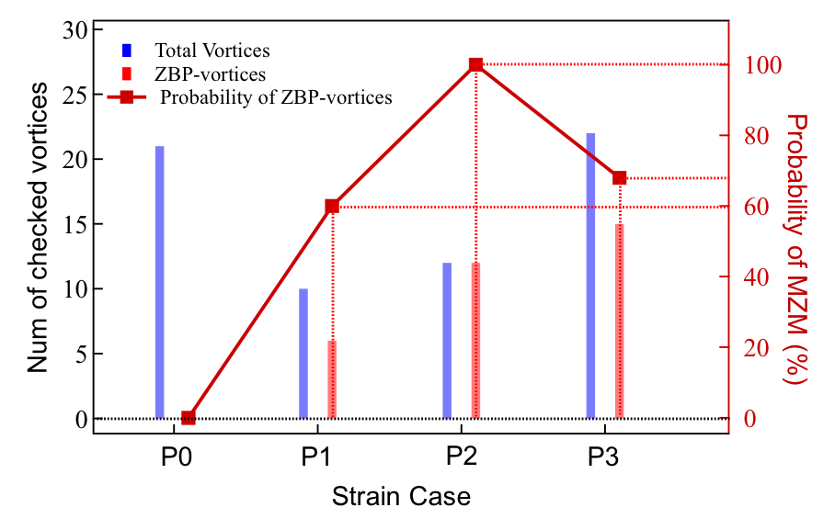

Fig. S3 Statistics of the probability MZMs in vortices. This statistics only considers the impurity-free vortices of different strain cases (P0 – P3). The number of measured vortices is 21, 10, 12, 22 for P0 (unstrained), P1, P2, and P3, respectively.

Fig. S4 ZBCP line profile in the vortices under different strain strengths. (A) – (C) Symbols: averaged dI/dV line profiles of ZBCPs are extracted from all free strained vortices with P1, P2, and P3 cases. The values of full width at half maximum (FWHM) are derived from an exponential type fit (solid-colored curves). (D) Overlap plot of the fitting curves from (A) – (C). When the maximum values of all fitting curves are normalized to ‘1’, the FWHM values could be used to scale the relative length of MZMs line profiles among three strained cases. (E) Analytical model plot of Majorana wave function used in previous studies. It shows that the MZM with a larger absolute value of Fermi level has a narrower spatial distribution.

Fig. S5 Examples of numerical analysis of vortices with MZMs under different strain strengths. (A) – (F) Multi-peak Gaussian fits of the dI/dV spectra measured at the center of the vortices shown in fig. S2, used in previous work. The tables list the energy positions and the ratios of CBSs. Here, ∆E is estimated as the mean value of E_{±1}. (G) Line-cut intensity plot of vortex #6, with the colored marked lines representing the discrete CBSs observed at different energies marked by L₀, L_{±1}, and L_{±2}, which are obtained from the multi-Gaussian fits for all spectra in Fig. 3D. (H) Second-derivative plot of (G) with the solid lines representing the corresponding average of each energy level. (I) Spatial line profile of the extracted ZBCP with an analytical Majorana wavefunction fit used previously. The parameters of the underlying topological bands are: ∆ = 2.5 meV; E_{F} = 3.8 meV. To exclude the influence of non-zero CBSs and background, the height of ZBCP is extracted by fitting each dI/dV spectrum with multi-Gaussian peaks.

Fig. S6 Atomic resolution STM topography of unstrained and strained LiFeAs. (A) - (B) Atomic resolution STM image and the corresponding FFT of the two different regions in the unstrained LiFeAs. Left panel: STM topography where the white arrows indicate the As-As direction; Right panel: FFT image where the red/blue circles mark the first-order Bragg points, and the white arrowed line mark the distance between two first-order Bragg points (blue and red). In the unstrained LiFeAs, both the lattice parameters (a = 3.71 Å, b = 3.75 Å for region #1; and a = 3.69 Å, b =3.73 Å for region #2) and the distances between the two first-order Bragg points obeys the C4 symmetry considering the measured errors. (C) - (D) same as (A) - (B) but in the region of the Fe-Fe-direction strained LiFeAs. Under the strained effect, the lattice parameters (a = 3.82 Å, b = 3.77 Å for region #3; and a = 3.84 Å, b =3.77 Å for region #4) remain the C₄ symmetry, however, the distances between the two first-order Bragg points are different, indicating that the lattice is compressed along the strain-applying direction, and stretched along the vertical direction.

SI References

- X. Lu, et al., Nematic spin correlations in the tetragonal state of uniaxial-strained BaFe_{2−x}NixAs₂. Science, 345, 657-660 (2014). DOI: 10.1126/science.1251853
- M. J. Lawler, et al., Intra-unit-cell electronic nematicity of the high-Tc copper-oxide pseudogap states, Nature, 466, 347–351 (2010). DOI:10.1038/nature09169

