Supporting Information
A Kagome-Derived Mosaic Lattice Family A₃V₉Te₁₃ (A = Cs, Rb) with Tunable Strong Electronic Correlations
Yusen Xiao^{1⊥}, Zhibin Qiu^{3,4⊥}, Qingchen Duan¹, Zhaoyi Li^{3,4}, Xiaotong Xu¹, Hengxin Tan², Shu Guo^{3,4*}, and Ruidan Zhong^{1,2*}
¹ Tsung-Dao Lee Institute, Shanghai Jiao Tong University, Shanghai 201210, People’s Republic of China.
² School of Physics and Astronomy, Shanghai Jiao Tong University, Shanghai 200240, People’s Republic of China.
³ Shenzhen Institute for Quantum Science and Engineering, Southern University of Science and Technology, Shenzhen 518055, China.
⁴ International Quantum Academy, Shenzhen 518048, China.
KEYWORDS: Kagome-Derived Mosaic Lattice, Geometrical Frustration, Strong Electronic Correlations, Phase Transition
*Correspondence should be addressed to Shu Guo (guos@sustech.edu.cn) and Ruidan Zhong (rzhong@sjtu.edu.cn)

Table of Contents
Table S1. Crystal Data and Structure Refinements for Cs₃V₉Te₁₃ (CVT) at 30, 100 and 300 K. | Page S3
Table S2. Fractional atomic coordinates and equivalent isotropic displacement parameters (Å²) or CVT at 300 K. | Page S3
Table S3. Crystal Data and Structure Refinements for Rb₃V₉Te₁₃ (RVT) at 300 K. | Page S4
Table S4. Fractional atomic coordinates and equivalent isotropic displacement parameters (Å²) for RVT at 300 K. | Page S4
Figure S1. Mosaic lattice details for CVT. | Page S5
Figure S2. X-ray diffraction pattern of the CVT single crystal and Rietveld refinement profile of polycrystalline sample. | Page S5
Figure S3. Temperature-dependent single X-ray diffraction patterns of CVT along different crystallographic directions. | Page S6
Figure S4. X-ray Photoelectron Spectroscopy (XPS) spectra for CVT single crystal. | Page S6
Figure S5. Temperature-dependent inverse magnetic susceptibility, (χ-χ₀)⁻¹, of CVT measured under μ₀H = 1 T with the field applied parallel to the ab-plane and the c-axis. | Page S7
Figure S6. Field-dependent magnetization of CVT, measured at various temperatures for the field applied parallel to the ab-plane and the c-axis. | Page S7
Figure S7. a, Temperature-dependent resistivity under zero magnetic field during heating and cooling cycles. b, Temperature-dependent resistivity under different magnetic fields. | Page S8
Figure S8. a, Temperature-dependent specific heat measured during heating and cooling cycles under zero magnetic field. b, Temperature dependence of the entropy change extracted by subtracting a polynomial fit background. | Page S8
Figure S9. X-ray diffraction pattern of the RVT single crystal. The inset shows an optical image of the RVT single crystals. | Page S9
Figure S10. Crystal structure of RVT. a, 3D framework of RVT. b, The V-based 2D Mosaic Lattice. c, Coordination environments for Rb and V atoms, respectively. d, The stacking form of V-based layers. e, Constituent triangular, square, and pentagonal units in a 2D Mosaic Lattice. | Page S9
Figure S11. a, Temperature-dependent magnetization of RVT, measured under different magnetic fields applied parallel to the ab-plane. b, Field-dependent magnetization of RVT at various temperatures for the field applied parallel to the ab-plane and the c-axis. | Page S10

Table S1. Crystal Data and Structure Refinements for Cs₃V₉Te₁₃ (CVT) at 30, 100 and 300 K.
Empirical formula | Cs₃V₉Te₁₃
Formula weight | 2516.09 | 2516.09 | 2516.09
Temperature/K | 30 | 100 | 300
Crystal system | Hexagonal | Hexagonal | Hexagonal
Space group | P-62m (189) | P-62m (189) | P-62m (189)
a/Å | 10.1371(5) | 10.1217(5) | 10.089(3)
c/Å | 8.1465(5) | 8.1481(7) | 8.212(3)
γ [°] | 120 | 120 | 120
volume/Å³ | 724.98(8) | 722.93(9) | 723.9(5)
Z | 1 | 1 | 1
ρ_{calc} /g/cm³ | 5.763 | 5.779 | 5.771
μ/mm⁻¹ | 19.286 | 19.341 | 19.315
F(000) | 1048 | 1048 | 1048
Mo Kα radiation/Å | 0.71073 | 0.71073 | 0.71073
2θ range for data collection/º | 4.64 to 52.99 | 4.65 to 53.94 | 4.66 to 54.95
Goodness-of-fit | 1.188 | 1.142 | 1.104
Largest diff peak and hole (e/A³) | 2.42 and -1.52 | 1.88 and -0.61 | 1.77 and −1.17
Final R indexes [I ≥ 2σ(I)] | R₁ = 0.0309,  wR₂ = 0.0869 | R₁ = 0.0180,  wR₂ = 0.0420 | R₁ = 0.0294,  wR₂ = 0.0685
Final R indexes [all data] | R₁ = 0.0314,  wR₂ = 0.0872 | R₁ = 0.0189,  wR₂ = 0.0427 | R₁ = 0.0304,  wR₂ = 0.0692

Table S2. Fractional atomic coordinates and equivalent isotropic displacement parameters (Å²) or CVT at 300 K.
Atom | x | y | z | U_{eq}
Cs1 | 0.36401(19) | 0.36401(19) | 0 | 0.0336(4)
Te1 | 2/3 | 1/3 | 0.25265(16) | 0.0194(3)
Te2 | 0 | 0.22819(10) | 0.71992(13) | 0.0168(3)
Te3 | 0.41185(15) | 0.41185(15) | 1/2 | 0.0343(5)
V1 | 0.1555(4) | 0.1555(4) | 1/2 | 0.0151(8)
V2 | 0.8210(3) | 0.2866(3) | 1/2 | 0.0172(6)

Table S3. Crystal Data and Structure Refinements for Rb₃V₉Te₁₃ (RVT) at 300 K.
Empirical formula | Rb₃V₉Te₁₃
Formula weight | 2373.67
Temperature/K | 298(2)
Crystal system | Orthorhombic
Space group | Cmcm (63)
a/Å | 17.5489(13)
b/Å | 10.1022(8)
c/Å | 15.8691(13)
volume/Å³ | 2813.3(4)
Z | 4
ρ_{calc}/g/cm³ | 5.604
μ/mm⁻¹ | 21.211
F(000) | 3976.0
Mo Kα radiation/Å | 0.71073
2θ range for data collection/º | 4.64 to 55.00
Goodness-of-fit on F² | 1.025
Largest diff peak and hole (e/A³) | 2.148 and -1.519
Final R indexes [I ≥ 2σ(I)] | R₁=0.0327, wR₂=0.0650
Final R indexes [all data] | R₁=0.0439, wR₂=0.0701

Table S4. Fractional atomic coordinates and equivalent isotropic displacement parameters (Å²) for RVT at 300 K.
Atom | x | y | z | U_{eq} | Occupancy
Te1 | 0.66640(3) | 0.33796(6) | 0.62023(3) | 0.02561(15) | 1
Te2 | 0.38528(3) | 0.72407(5) | 0.63700(3) | 0.01983(14) | 1
Te3 | 0 | 0.56919(7) | 0.86402(5) | 0.01993(18) | 1
Te4 | 0.79518(6) | 0.54361(10) | 0.77289(14) | 0.0463(9) | 0.5
Te5 | 1/2 | 0.42951(14) | 0.77332(16) | 0.0418(9) | 0.5
Rb1 | 1/2 | 1/2 | 1/2 | 0.0516(6) | 1
Rb2 | 0.82328(9) | 1/2 | 1/2 | 0.0465(4) | 1
V1 | 0.92399(11) | 0.41591(17) | 3/4 | 0.0186(4) | 1
V2 | 0.76591(11) | 0.28358(18) | 3/4 | 0.0188(4) | 1
V3 | 0.64462(11) | 0.51489(18) | 3/4 | 0.0184(4) | 1
V4 | 1/2 | 0.6867(2) | 3/4 | 0.0177(6) | 1
V5 | 0.41074(11) | 0.21761(18) | 3/4 | 0.0184(4) | 1
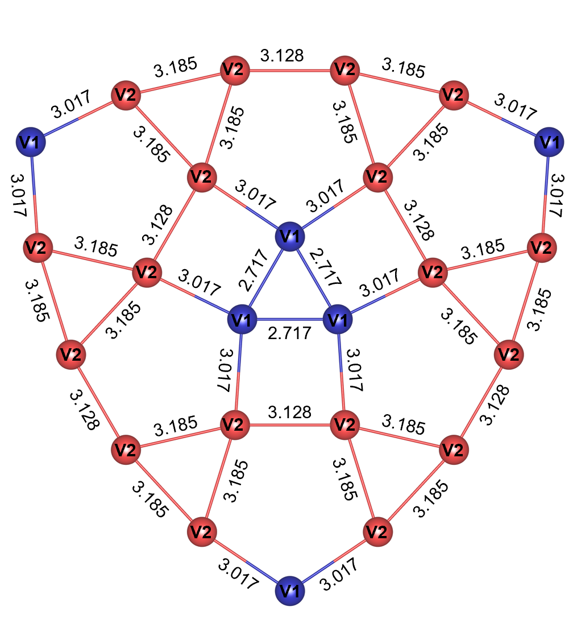
Figure S1. Mosaic lattice details for CVT.

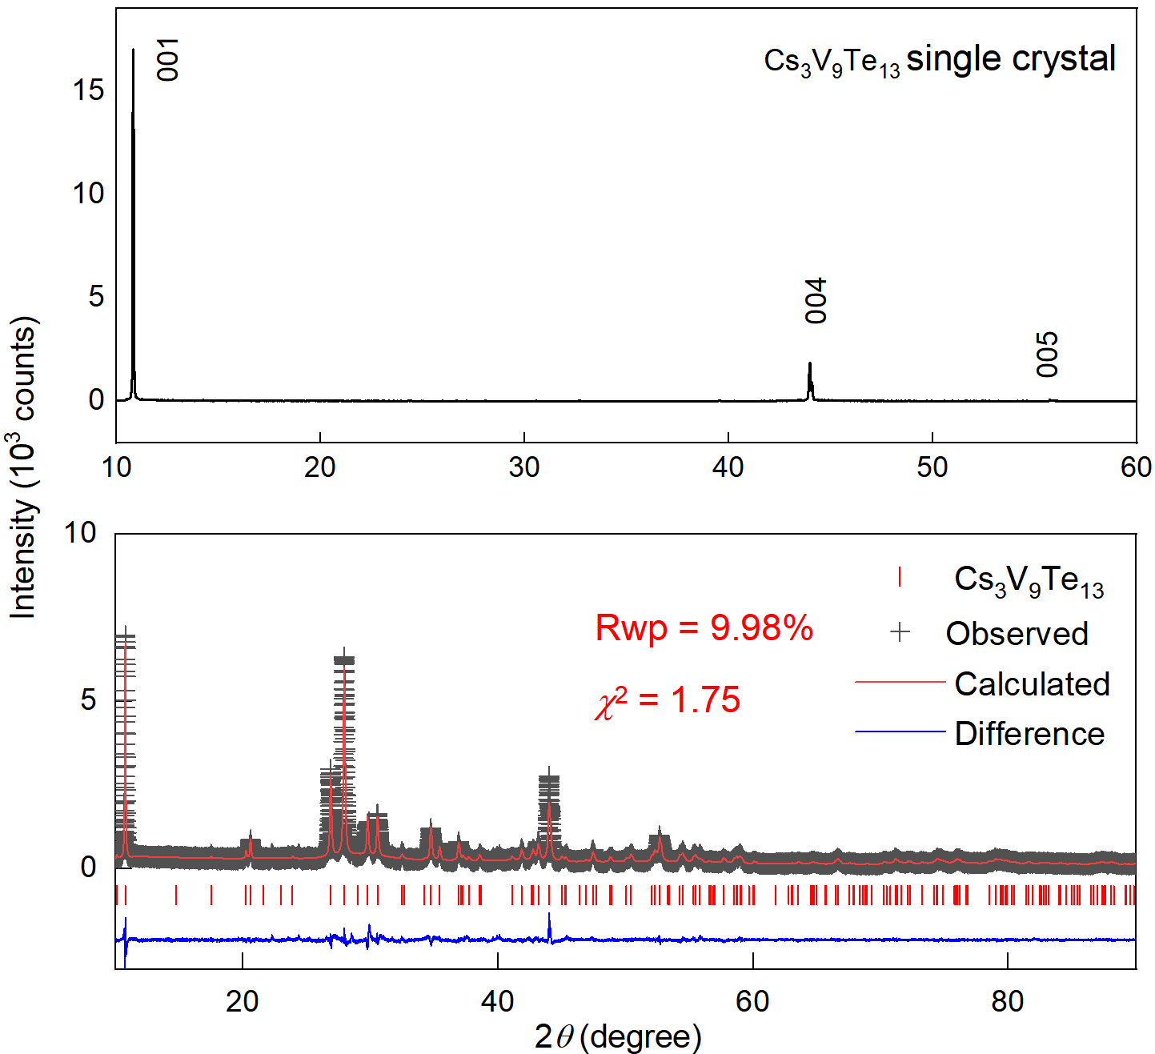
Figure S2. X-ray diffraction pattern of the CVT single crystal and Rietveld refinement profile of
polycrystalline sample.
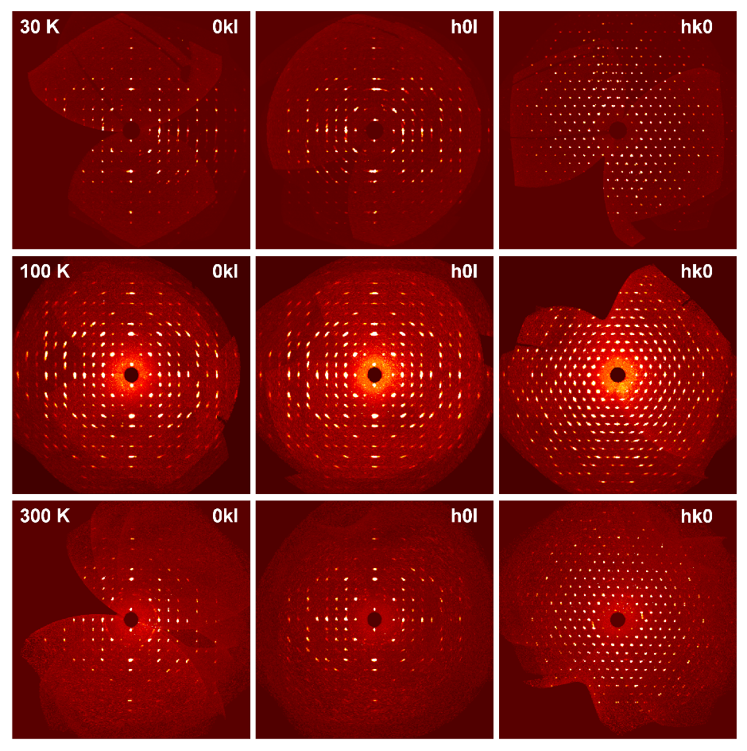
Figure S3. Diffracted reflections in reciprocal lattice planes (0kl), (h0l), and (hk0) determined from experimental data at temperatures of 300 K, 100 K, and 30 K.

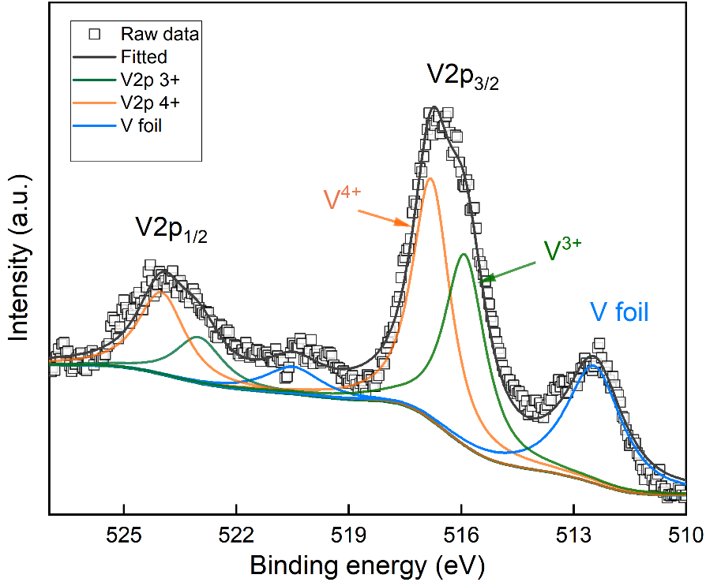
Figure S4. X-ray Photoelectron Spectroscopy (XPS) spectra for CVT single crystal.

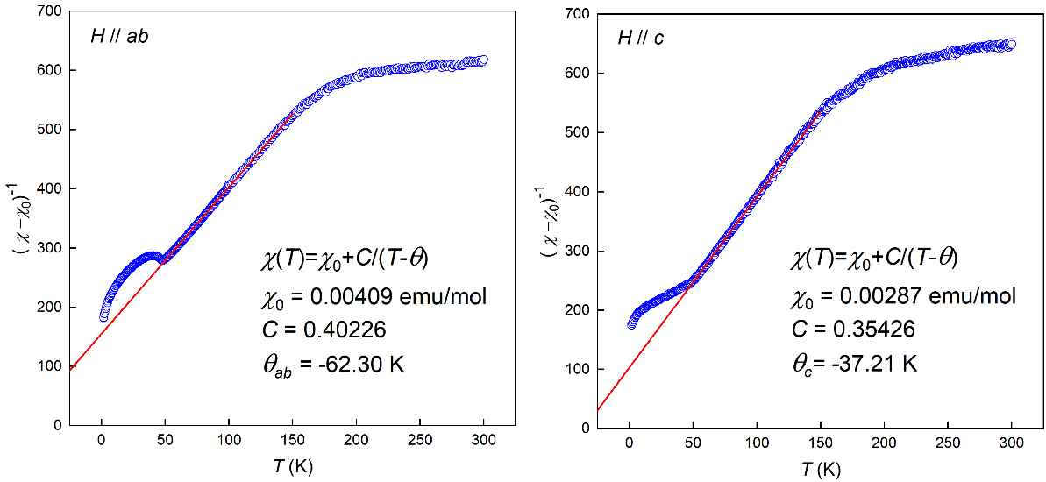
Figure S5. Temperature-dependent inverse magnetic susceptibility, (χ-χ₀)⁻¹, of CVT measured under μ₀H = 1 T with the field applied parallel to the ab-plane and the c-axis.

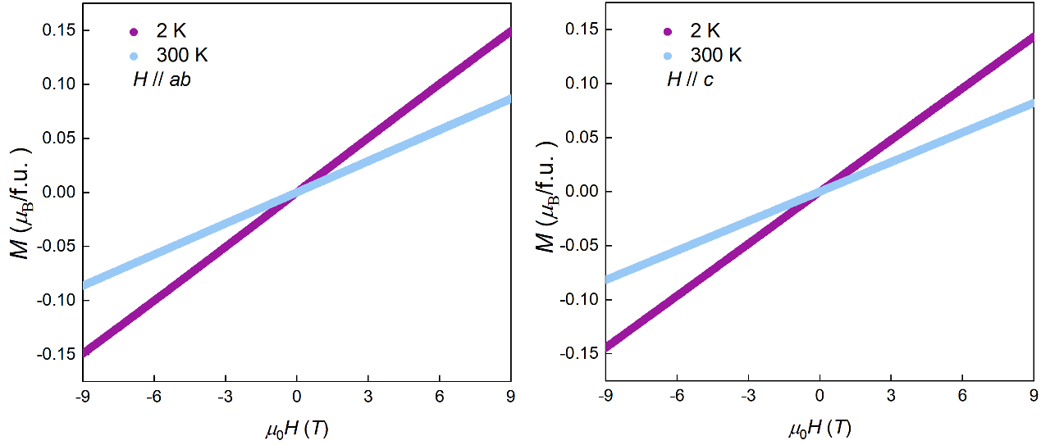
Figure S6. Field-dependent magnetization of CVT, measured at various temperatures for the field applied parallel to the ab-plane and the c-axis.

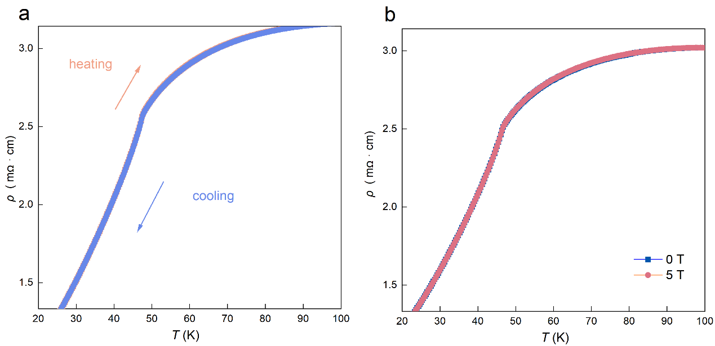
Figure S7. a, Temperature-dependent resistivity under zero magnetic field during heating and cooling cycles. b, Temperature-dependent resistivity under different magnetic fields.

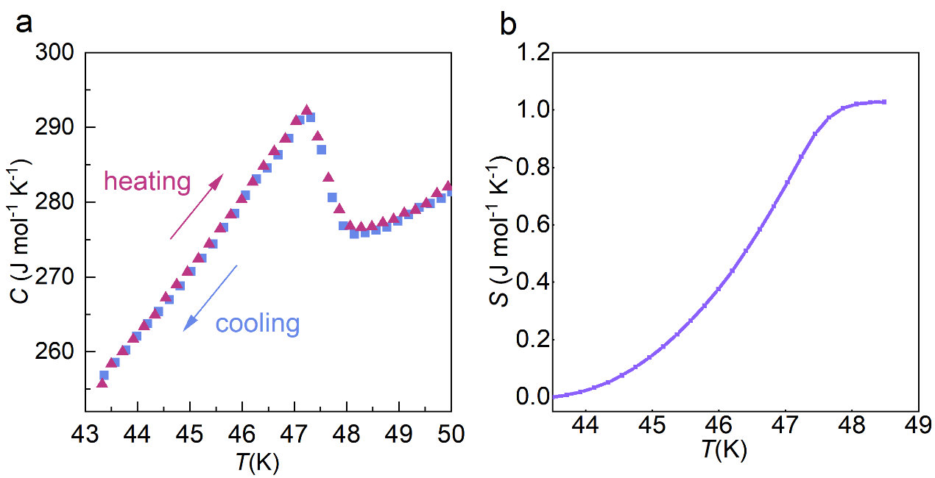
Figure S8. a, Temperature-dependent specific heat measured during heating and cooling cycles under zero magnetic field. b, Temperature dependence of the entropy change extracted by subtracting a polynomial fit background.

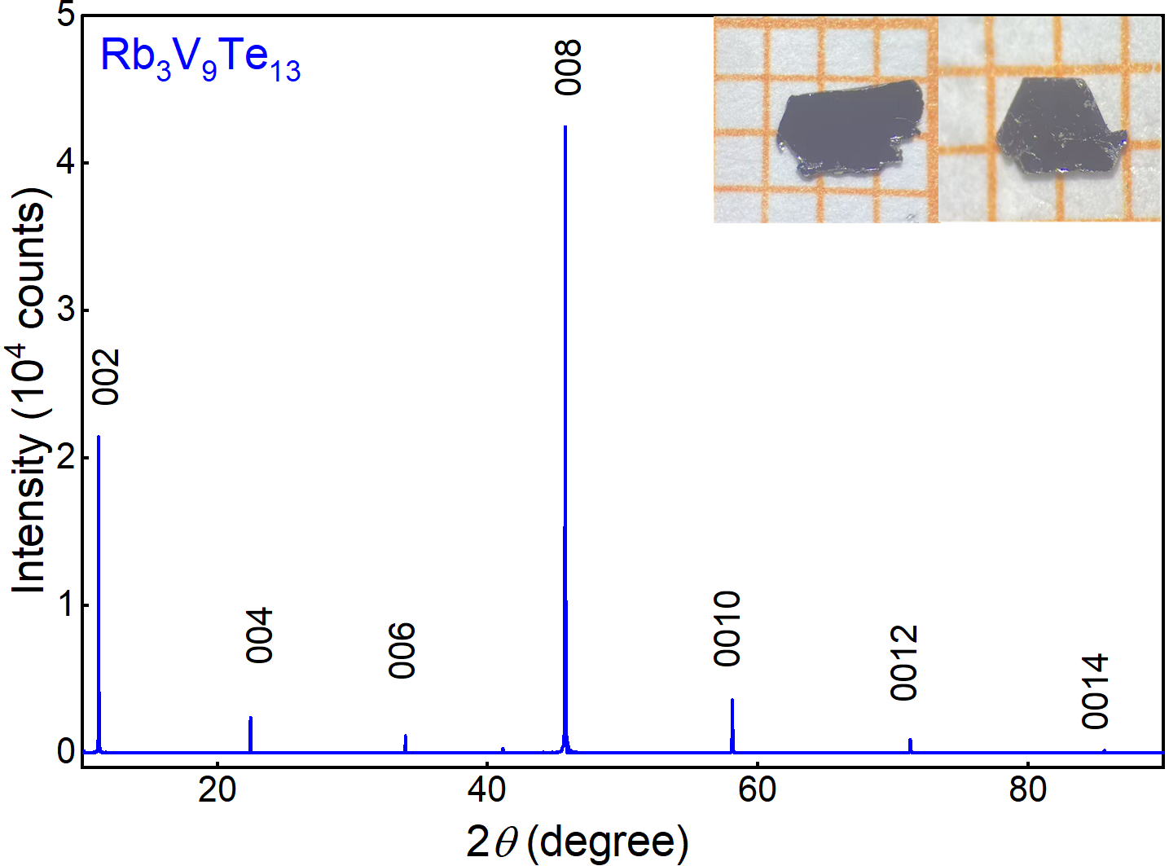
Figure S9 X-ray diffraction pattern of the RVT single crystal. The inset shows an optical image of the RVT single crystals.

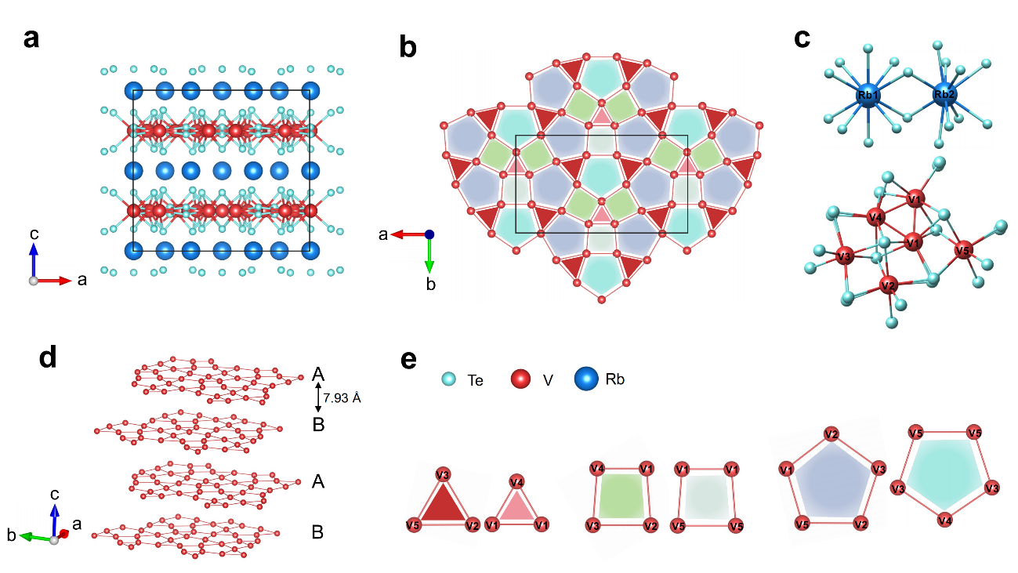
Figure S10. Crystal structure of RVT. a, 3D framework of RVT. b, The V-based 2D Mosaic Lattice. c, Coordination environments for Rb and V atoms, respectively. d, The stacking form of V-based layers. e, Constituent triangular, square, and pentagonal units in a 2D Mosaic Lattice.

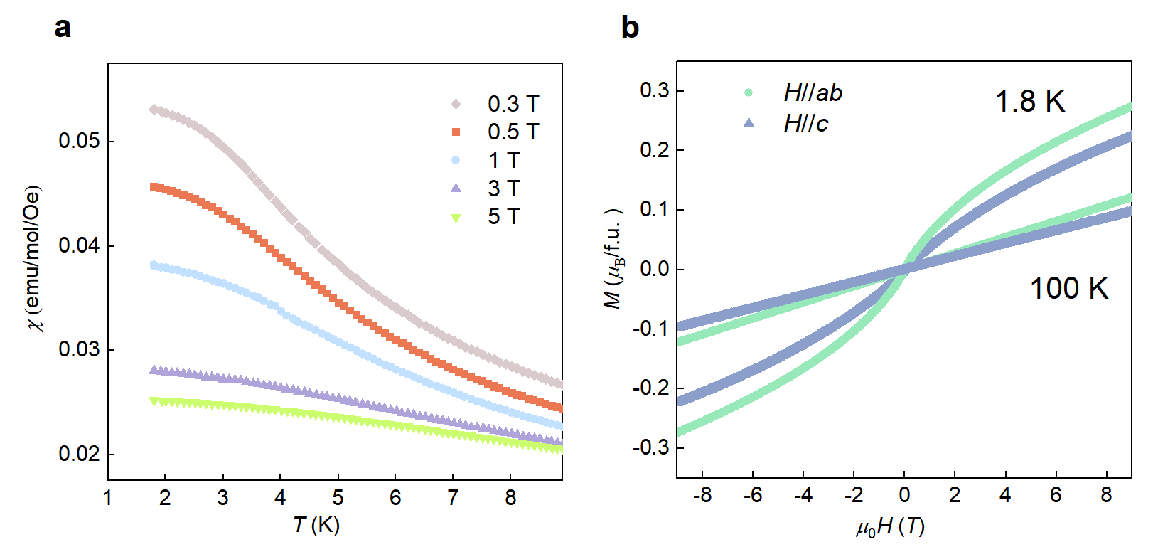
Figure S11. a, Temperature-dependent magnetization of RVT, measured under different magnetic fields applied parallel to the ab-plane. b, Field-dependent magnetization of RVT at various temperatures for the field applied parallel to the ab-plane and the c-axis.

