Appendix 3. Mathematical Formulation of the Simulation

1. Dynamic Systems Modeling

The interaction between US export controls (X(t)), China’s domestic technology investments (Y(t)), and the state of the global technology regime (Z(t)) is modeled using a set of coupled differential equations. These equations capture the feedback loops and the non-linear dynamics of the system:

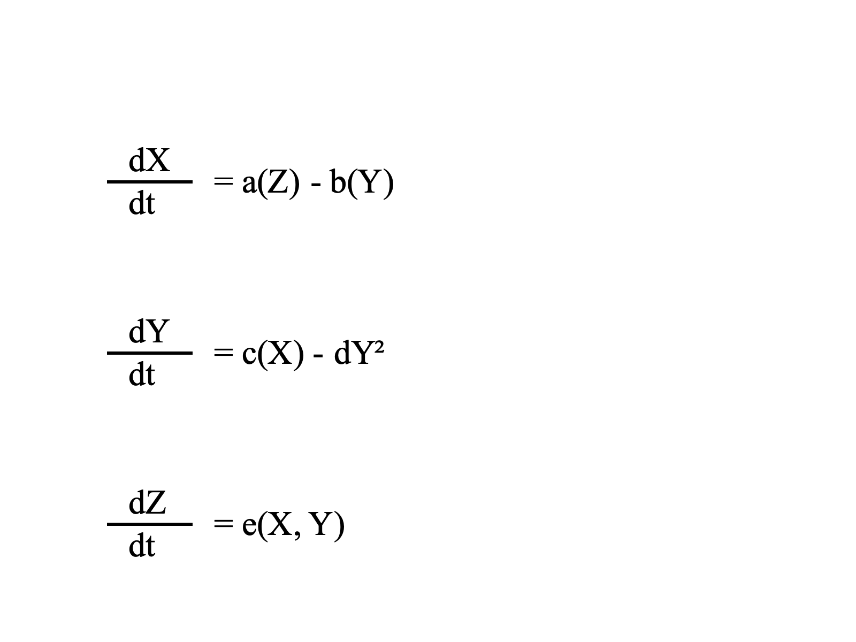
• a(Z): Represents the US’s strategic response to changes in the global technology regime. As Z(t) moves toward bifurcation, a(Z) adjusts the intensity of export controls.
• b(Y): Captures the mitigating effect of China’s investment on the effectiveness of US export controls.
• c(X): Models China’s strategic investment increase in response to heightened export controls.
• dY^2: Introduces a non-linear cost term, reflecting China's investments’ diminishing returns and escalating costs as they approach higher levels.
• e(X, Y): Describes how the interplay of US and Chinese strategies drives changes in the global technology regime, pushing it toward bifurcation.

2. Q-Learning Framework

The Q-learning model complements the dynamic systems approach by simulating the decision-making processes of both actors over iterative rounds. The Q-values (Q(s, a)) represent the expected rewards for each state-action pair (s, a):

Q(s, a) ← Q(s, a) + α[r + γ max a' Q(s', a') - Q(s, a)]

Where:
Where:• α: Learning rate (0 < α ≤ 1)
• γ: Discount factor (0 ≤ γ ≤ 1), representing the weight of future rewards
• r: Immediate reward based on the current state (s) and action (a)
• max a' Q(s', a'): Maximum Q-value for the next state (s') and all possible actions (a’)

3. Integrated Simulation Dynamics

The simulation integrates the dynamic systems model with the Q-learning framework. Key adjustments include:

• Non-linear cost term: The quadratic term (dY²) ensures realistic modeling of diminishing returns on China's investments.

• State transitions: The Q-learning model updates the strategies (X and Y) iteratively based on the outcomes of the dynamic system equations.

• Reward structure: The rewards reflect geopolitical and technological outcomes, such as gains in technological leadership or economic penalties.

4. Simulation Outputs
• Blue Curve (X(t)): US export control intensity fluctuates in response to China’s adaptive investments and the evolving global technology regime.
• Red Curve (Y(t)): China’s investment trajectory initially grows rapidly but slows as costs rise and returns diminish.
• Green Curve (Z(t)): The global technology regime gradually transitions toward bifurcation, reflecting the cumulative effect of US export controls and China’s counterstrategies.

