Appendix

AD HOC CATEGORY SYSTEM FOR EACH OF THE FOUR QUESTIONNAIRES
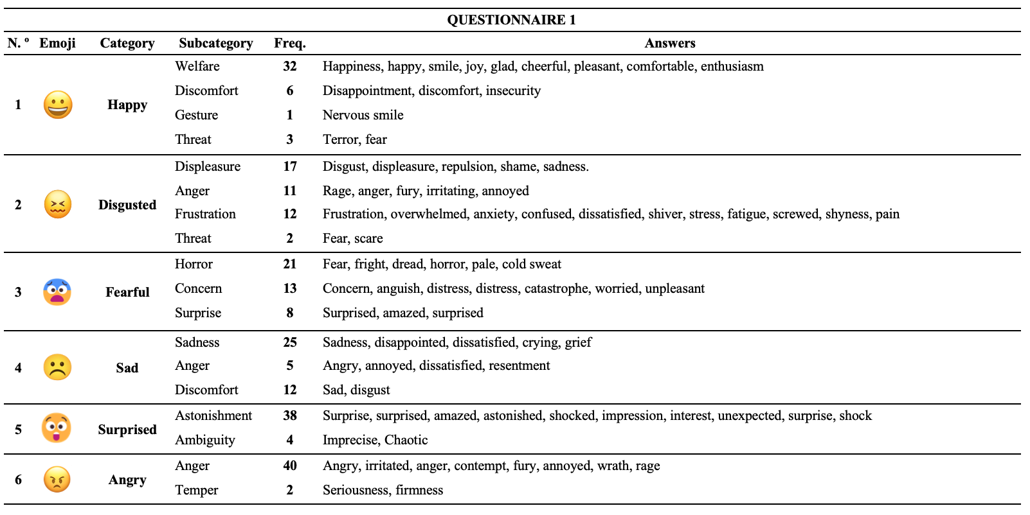
Fig. 1 Ad hoc category system for questionnaire No. 1
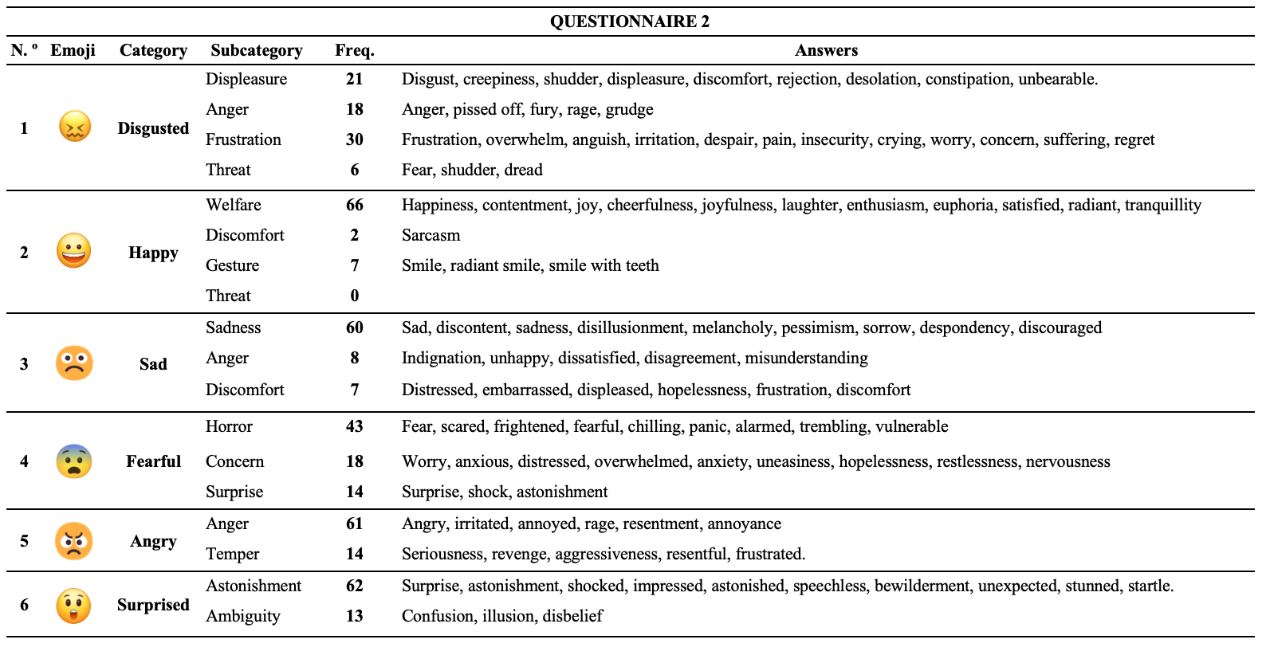
Fig. 2 Ad hoc category system for questionnaire No. 2
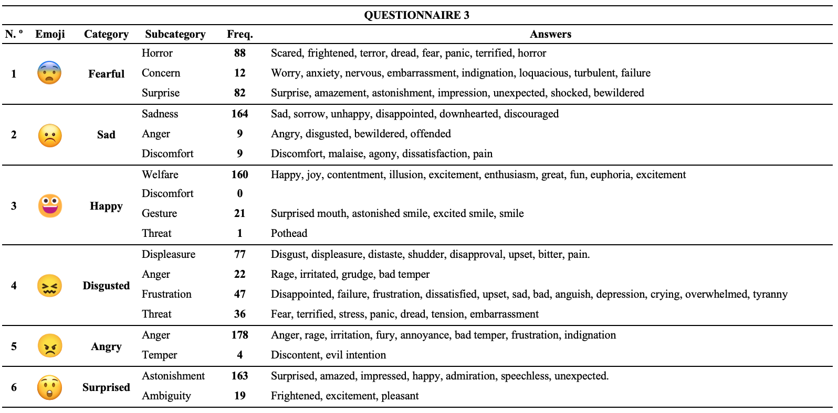
Fig. 3 Ad hoc category system for questionnaire No. 3
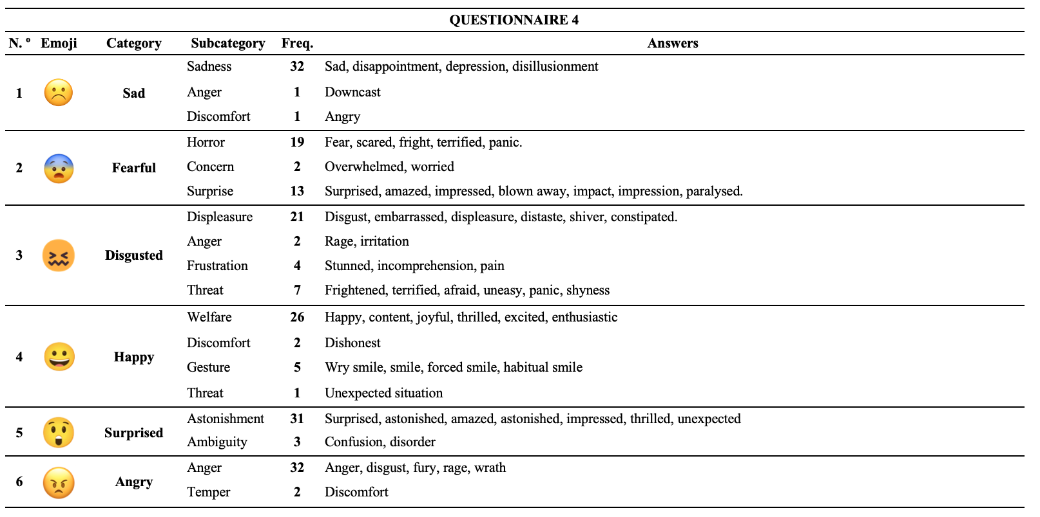
Fig. 4 Ad hoc category system for questionnaire No. 4

