Comparing Predictive, Simulation-Based and Hybrid Assessments in Undergraduate Process Engineering
Tahereh Jafary^{1, *}, Lee Pheiffer ², Halima Al Maqbali¹, Anteneh Mesfin Yeneneh¹, Abdelghani Benayoune ³
Email Addresses in order: tahereh@imco.edu.om, lpheiffer@qaa.ac.mu, Hsaid4174@gmail.com, anteneh@imco.edu.om, abdelghani.benayoune@udst.edu.qa

¹Process Engineering Department, International Maritime College Oman (IMCO), National University of Science and Technology, Suhar, Oman
²Quality Assurance Authority Mauritius, Mauritius
³ Applied Research, Innovation and Economic Development Directorate, University of Doha for Science and Technology, Doha, Qatar
Corresponding author: Tahereh Jafary (tahereh@imco.edu.om)

Supplementary data

a.  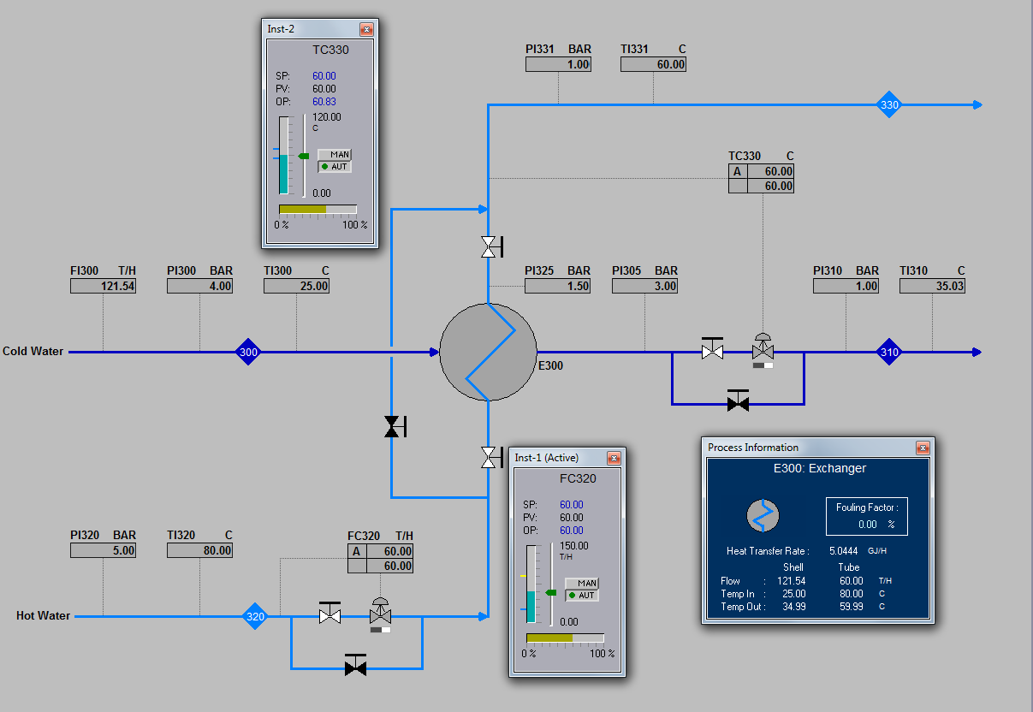 | b.  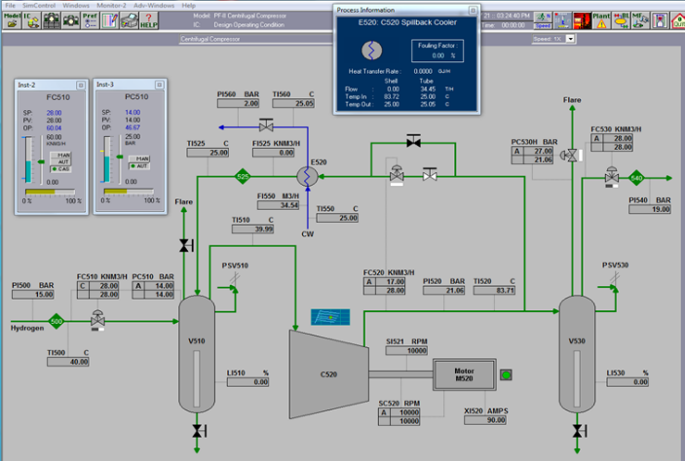
c.  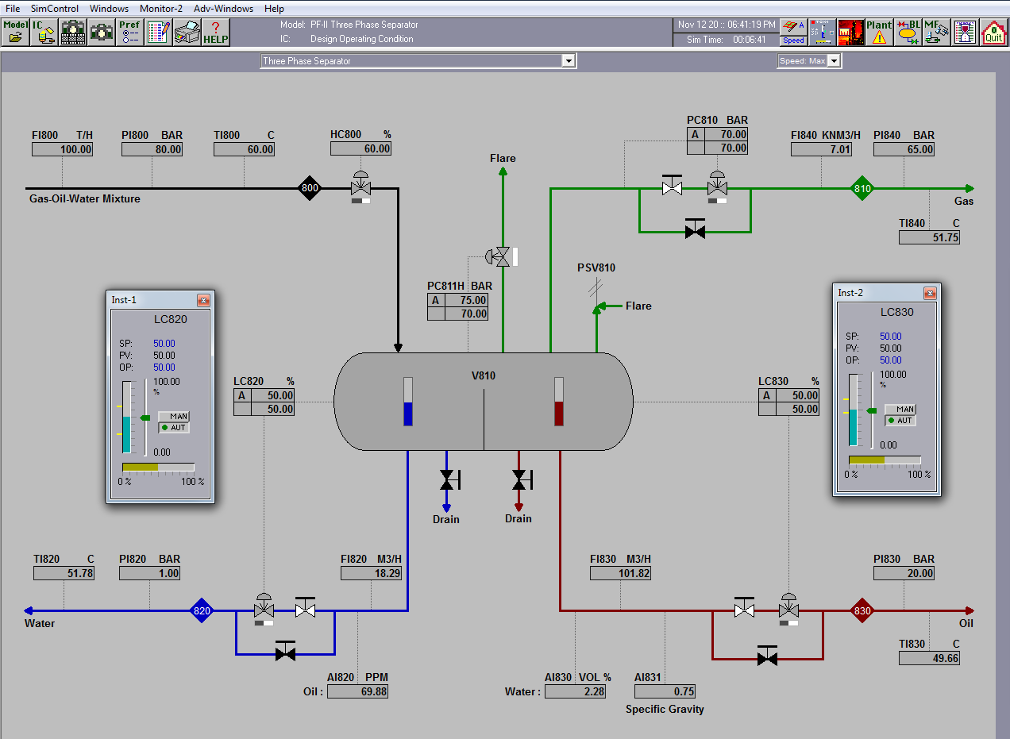 | d.  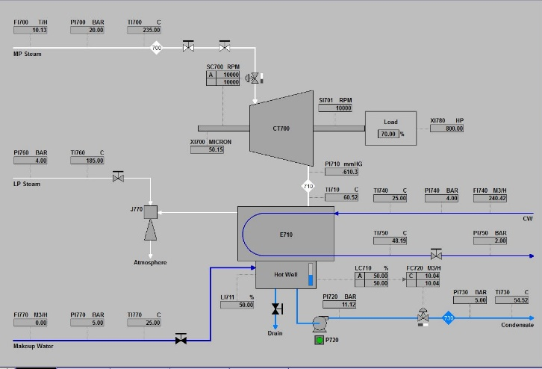
e.
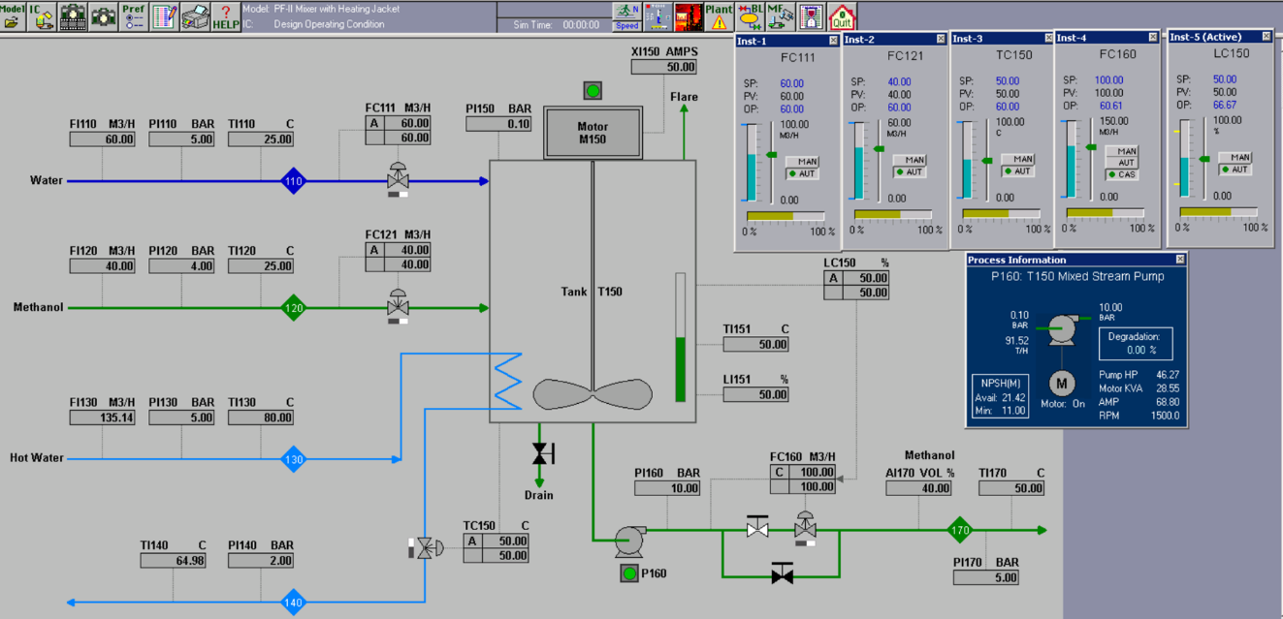
f.
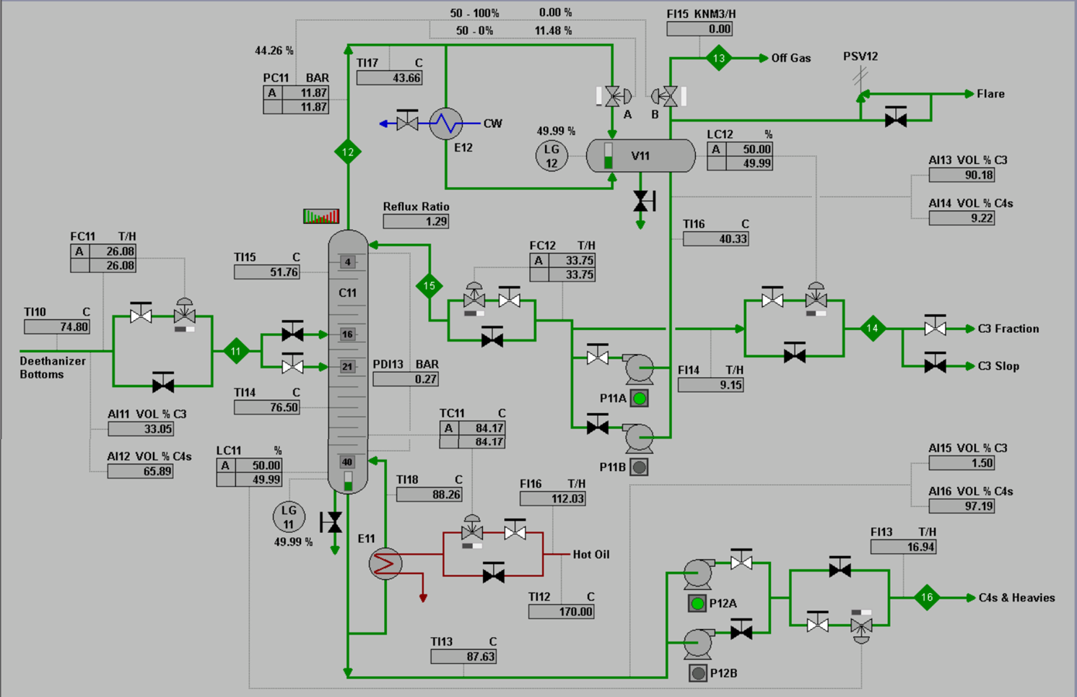

Figure S1. Snapshots of some of the models employed in various 'what-if' scenarios presented to students during the course of this research (GSE Systems, 2014); a. heat exchanger, b. compressors, c. three-phase separator, d. steam turbines, e. mixer, and f. depropanizer models.

Survey Questionnaire
1. What is your academic year?
2. How many courses have you used Envision simulation software in?
3. On average, how many hours have you spent using Envision simulation software weekly?
4. How motivated were you to use Envision simulation software at the beginning?
- Very unmotivated
- Somewhat unmotivated
- Neither motivated nor unmotivated
- Somewhat motivated
- Very motivated
5. Please indicate the extent to which you agree or disagree with each of the following statements regarding your experience during the simulation training session.
Use the following scale:
Strongly Disagree – Disagree – Neutral – Agree – Strongly Agree
- I was able to adapt to the simulation environment over time.
- I could clearly visualize engineering processes through the simulation.
- I was able to analyze and evaluate problems related to the simulation content.
- I was able to connect theoretical knowledge with simulation activities, which improved my understanding.
- I successfully analyzed trend graphs and computed data relevant to industrial processes.
- I communicated effectively, recognized responsibilities, and made sound judgments in engineering scenarios.
- Compared to theoretical classes of the same duration, I gained more process engineering knowledge during the simulation sessions.

6. Please indicate the extent to which you agree or disagree with the following statements based on your experience after completing the simulation training session.
Use the following scale:
Strongly Disagree – Disagree – Neutral – Agree – Strongly Agree
- The training enhanced my skills in critical thinking, problem-solving, and decision-making.
- I now feel motivated to explore various industrial processes and consider a future career in the industrial sector.
- I prefer simulation-based courses compared to traditional theoretical classes.

7. For each of the following outcomes, choose the mode that best helped you achieve it:
- Simulation-based Learning
- Theory based learning
- Hybrid mode
- To identify, formulate, and solve complex engineering problems
- To apply engineering concepts to produce solutions
- To recognize professional responsibilities in engineering situations
- To develop and conduct appropriate experimentation and interpret data
- To acquire and apply new knowledge using appropriate learning strategies
8. Please write any additional comments or suggestions.

