APPENDICES
Appendix A. Survey Questions and Answer Options
The full list of the survey questions and answer options used in the study is provided below. All items were scored on a five-point scale. Items Q12 and Q20 were reverse-coded prior to analysis so that, for every scored item, a higher score reflects safer or more security-conscious behavior. Q1 was not included in the analysis, as it is an open-ended, non-Likert item.
Q1. What is your average daily internet usage time? (Please specify the number)
Q2. Do you know what two-factor authentication is?
1. I definitely haven't heard of it.
2. I've heard of it, but I don't know what it is.
3. I've heard of it to a moderate extent and I partially know what it means.
4. I've heard of it and I generally know what it is.
5. I've definitely heard of it and I know exactly what it is.
Q3. Have you heard of "phishing", a type of cyberattack that attempts to steal your personal information through fraudulent emails or messages, or do you know what it is?
1. I definitely haven't heard of it.
2. I've heard of it, but I don't know what it is.
3. I've heard of it to a moderate extent and I partially know what it means.
4. I've heard of it and I generally know what it is.
5. I've definitely heard of it and I know exactly what it is.
Q4. A VPN (Virtual Private Network) is a technology that increases your privacy and security while browsing the internet. Have you heard of a VPN or do you know what it is?
1. I definitely haven't heard of it.
2. I've heard of it, but I don't know what it is.
3. I've heard of it to a moderate extent and I partially know what it means.
4. I've heard of it and I generally know what it is.
5. I've definitely heard of it and I know exactly what it is.
Q5. Do you know why a strong password is important?
1. I definitely haven't heard of it.
2. I've heard of it, but I don't know what it is.
3. I've heard of it to a moderate extent and I partially know what it means.
4. I've heard of it and I generally know what it is.
5. I've definitely heard of it and I know exactly what it is.
Q6. Have you heard of the term "social engineering" and do you know what it is?
1. I definitely haven't heard of it.
2. I've heard of it, but I don't know what it is.
3. I've heard of it to a moderate extent and I partially know what it means.
4. I've heard of it and I generally know what it is.
5. I've definitely heard of it and I know exactly what it is.
Q7. Do you know what a firewall does?
1. I definitely haven't heard of it.
2. I've heard of it, but I don't know what it is.
3. I've heard of it to a moderate extent and I partially know what it means.
4. I've heard of it and I generally know what it is.
5. I've definitely heard of it and I know exactly what it is.
Q8. Do you know what antivirus software is and what threats it can protect our devices from?
1. I definitely haven't heard of it.
2. I've heard of it, but I don't know what it is.
3. I've heard of it to a moderate extent and I partially know what it means.
4. I've heard of it and I generally know what it is.
5. I've definitely heard of it and I know exactly what it is.
Q9. Do you know what malware is?
1. I definitely haven't heard of it.
2. I've heard of it, but I don't know what it is.
3. I've heard of it to a moderate extent and I partially know what it means.
4. I've heard of it and I generally know what it is.
5. I've definitely heard of it and I know exactly what it is.
Q10. Do you know what consequences you might face if malware infects your device?
1. I definitely haven't heard of it.
2. I've heard of it, but I don't know what it is.
3. I've heard of it to a moderate extent and I partially know what it means.
4. I've heard of it and I generally know what it is.
5. I've definitely heard of it and I know exactly what it is.
Q11. What does it mean when you see "https://" and a lock icon in your internet browser's address bar and do you know what you should do to ensure security?
1. I definitely haven't heard of it.
2. I've heard of it, but I don't know what it is.
3. I've heard of it to a moderate extent and I partially know what it means.
4. I've heard of it and I generally know what it is.
5. I've definitely heard of it and I know exactly what it is.
Q12. How often do you use public Wi-Fi networks without passwords?
1. I never use it.
2. I use it rarely.
3. I use it with average frequency.
4. I use it frequently.
5. I use it very often.
Q13. Do you take security precautions when using public Wi-Fi networks without passwords?
1. Absolutely not, I don't take any precautions.
2. Rarely, sometimes I take some precautions.
3. Moderately, I usually take some basic precautions.
4. Yes, I mostly take safety precautions.
5. Absolutely yes, I always take safety precautions.
Q14. Do you carefully verify the sender's identity before opening an email attachment or link you receive?
1. Absolutely not, I open it without ever checking the sender's ID.
2. Rarely, sometimes I check the sender's ID.
3. Moderately, I usually check the sender's ID.
4. Yes, I mostly carefully check the sender's ID.
5. Absolutely yes, I always carefully check the sender's ID.
Q15. What type of lock screen do you use on your mobile devices (smartphones or tablets) for security?
1. I don't use any lock screen.
2. I use a simple pattern or PIN code.
3. I use biometric features such as fingerprint scanner or facial recognition.
4. I use a complex pattern, PIN code, or combination of biometric features.
5. I use dedicated apps or devices for security.
Q16. What authentication methods do you use when logging in on your computer?
1. I don't use any verification.
2. Just username and password.
3. Username and password, sometimes an SMS code as a second verification step.
4. Username and password, time-based verification codes or verification apps.
5. Username and password, biometric features such as fingerprint or facial recognition; I also use time-based verification codes or verification apps as a second verification step.
Q17. How do you secure your social media accounts?
1. I use the same password for all my accounts.
2. I use simple passwords for my accounts.
3. I use different passwords for each account.
4. I use strong and unique passwords for each account.
5. I use two-factor authentication (2FA) and strong and unique passwords for my accounts.
Q18. What methods do you use to keep your passwords safe?
1. I use the same password for different accounts.
2. I don't use strong passwords and I don't change my passwords regularly.
3. I use different and complex passwords, but I don't use a password manager.
4. I use different and complex passwords and I update my passwords regularly.
5. I use different and complex passwords, store my passwords using a manager and update them regularly.
Q19. Do you pay attention to the security of your card information when shopping online?
1. I definitely don't pay attention; I buy from the cheapest site.
2. I pay attention; if the site doesn't seem trustworthy, I buy without saving my card information.
3. I shop from trustworthy sites and save my card information.
4. I shop from trustworthy sites and don't save my card information.
5. I shop from trustworthy sites and create a virtual card to pay with.
Q20. Do you share personal information when playing games or live streaming?
1. I never share.
2. I rarely share.
3. I share occasionally.
4. I share frequently.
5. I always share.
Q21. How do you react when you encounter cyberbullying? (Cyberbullying is bullying or harassing behavior conducted over the internet or other digital communication tools.)
1. I ignore it and do nothing.
2. I retaliate against the bully.
3. I report the situation to my family, teacher, or a trusted adult.
4. I file a complaint on the social media platform or relevant application.
5. I report the situation to both my family, teacher, or a trusted adult and file a complaint on the social media platform or relevant application.
Q22. Do you follow the latest cybersecurity news and vulnerabilities to ensure your safety?
1. I definitely don't.
2. I rarely do.
3. I check occasionally.
4. I follow.
5. I follow frequently.

Appendix B. Test Sample Screens
The sample images of the fraudulent screen test that participants were asked to complete at the end of the survey are presented in Figures 2, 3, 4 and 5.
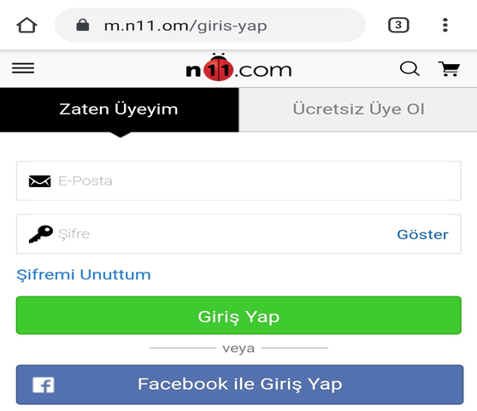
Figure 2. Sample Screen A

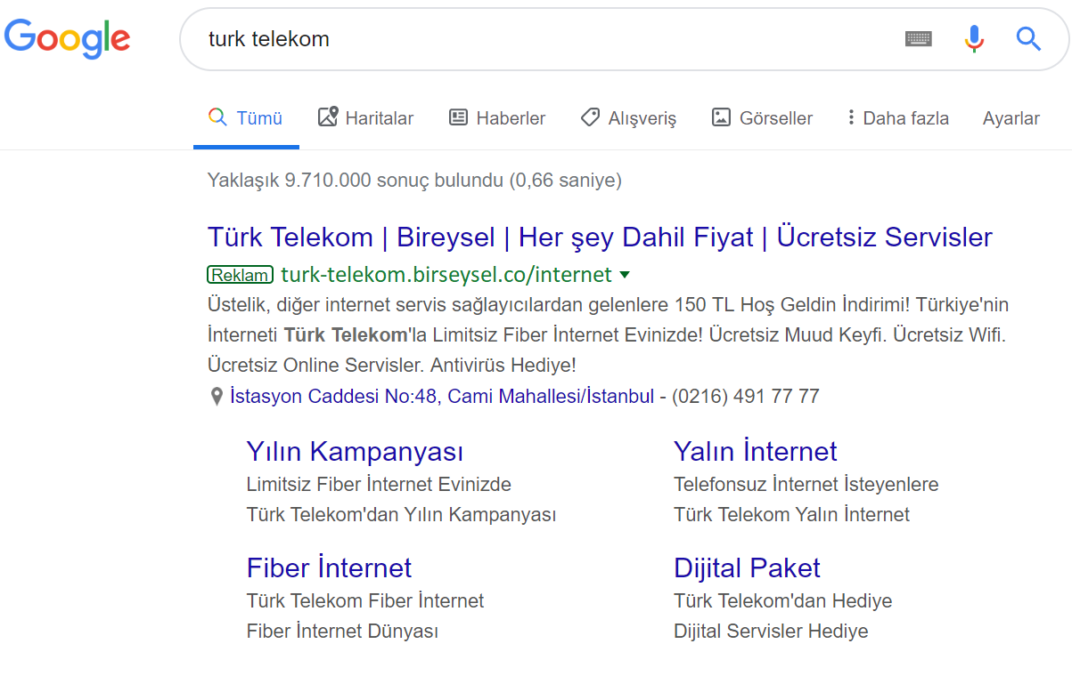
Figure 3. Sample Screen B

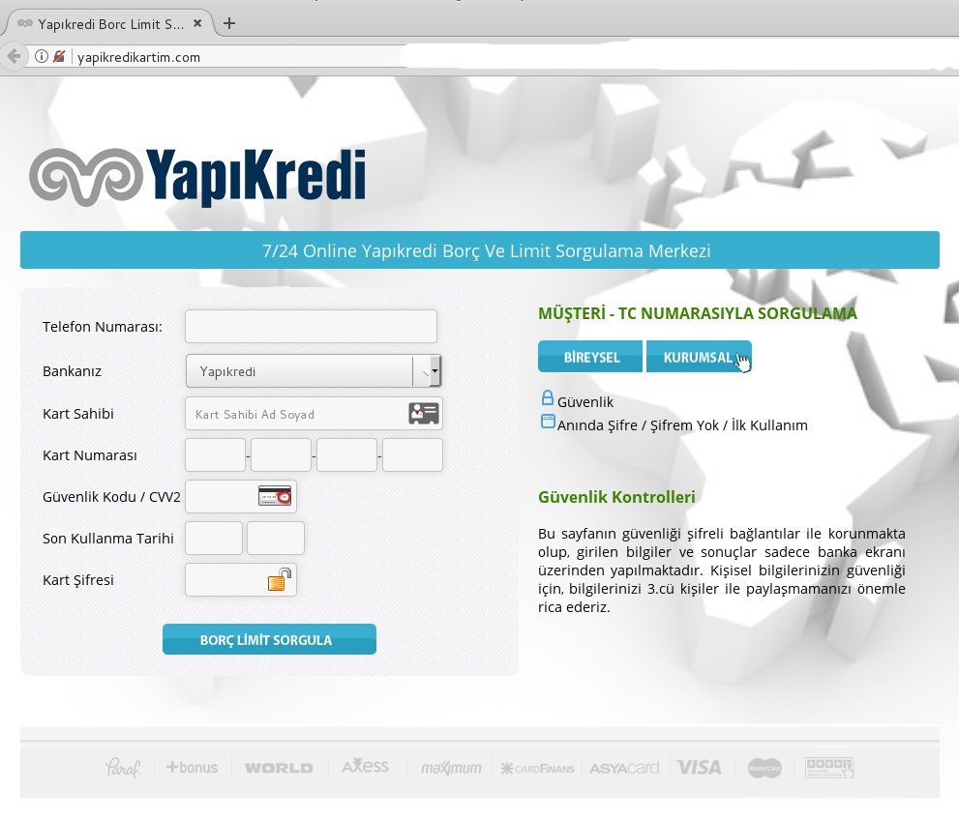
Figure 4. Sample Screen C

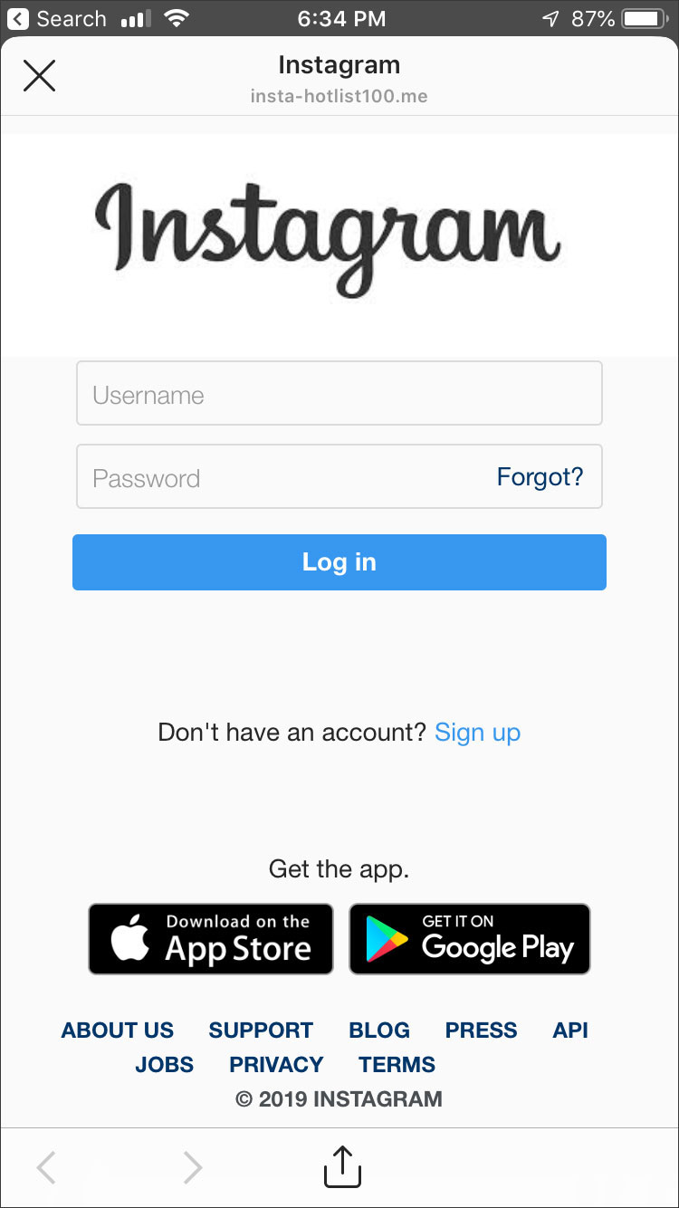
Figure 5. Sample Screen D

