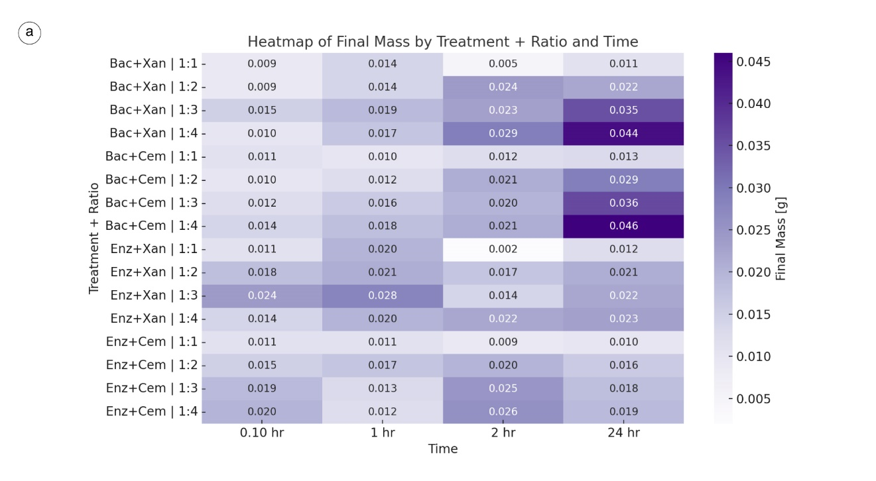SI 1 | Evolution of mineral accumulation across formulations and time.
Heatmap showing the final mass gain (g) after 10 min, 1 h, 2 h, and 24 h for bacterial and enzymatic formulations combined with xanthan (Xan) or cementation reagents (Cem) at different mixing ratios (1:1–1:4). The results indicate that bacterial formulations, particularly Bac + Cem 1:4 and Bac + Xan 1:4, achieved the highest mineral accumulation after 24 h (≈ 0.044–0.046 g), while enzymatic formulations produced more moderate but consistent precipitation. The gradient highlights the progressive increase in mineralization over time, with darker tones denoting higher mineral yield.

