Table S1: Univariate and multivariate logistic regression analysis to determine the effect of baseline characteristics on outcomes among patients with septic shock
Markers | Univariate |  | Multivariate
Markers | OR (95% CI) | P-value | OR (95% CI) | P-value
Mortality (yes vs. no)
Age | 0.996 (0.939-1.055) | 0.881 | 0.993 (0.901-1.094) | 0.881
Gender | 0.947 (0.412-2.178) | 0.889 | 0.794 (0.261-2.419) | 0.685
Comorbidity | 1.289 (0.414-4.017) | 0.662 | 0.247 (0.037-1.657) | 0.151
APACHE IV | 1.640 (1.339-2.008) | <0.001* | 1.282 (0.756-2.175) | 0.357
SOFA | 2.798 (1.812-4.321) | <0.001* | 1.933 (0.614-6.088) | 0.261
RRT (yes vs. no)
Age | 0.984 (0.926-1.046) | 0.611 | 0.977 (0.902-1.059) | 0.577
Gender | 0.639 (0.258-1.58) | 0.332 | 0.594 (0.234-1.509) | 0.273
Comorbidity | 1.155 (0.365-3.654) | 0.806 | 0.724 (0.157-3.346) | 0.679
APACHE IV | 1.092 (0.973-1.225) | 0.135 | 0.897 (0.572-1.405) | 0.634
SOFA | 1.216 (0.96-1.54) | 0.105 | 1.516 (0.601-3.822) | 0.378
ICU length of stay (≥13 days vs. <13 days)
Age | 0.991 (0.934-1.052) | 0.776 | 0.999 (0.925-1.079) | 0.986
Gender | 1.407 (0.603-3.281) | 0.431 | 1.471 (0.618-3.496) | 0.384
Comorbidity | 0.818 (0.262-2.554) | 0.731 | 1.449 (0.333-6.368) | 0.623
APACHE IV | 0.935 (0.84-1.041) | 0.221 | 1.094 (0.722-1.659) | 0.671
SOFA | 0.859 (0.691-1.07) | 0.176 | 0.709 (0.301-1.666) | 0.431
MV duration (≥10 days vs. <10 days)
Age | 0.991 (0.938-1.048) | 0.754 | 0.979 (0.907-1.057) | 0.592
Gender | 2.393 (1.319-6.823) | 0.058* | 2.334 (0.973-5.595) | 0.058
Comorbidity | 0.788 (0.277-2.241) | 0.655 | 0.418 (0.100-1.749) | 0.232
APACHE IV | 1.063 (0.962-1.175) | 0.231 | 0.995 (0.657-1.505) | 0.979
SOFA | 1.121 (0.914-1.375) | 0.273 | 1.046 (0.449-2.437) | 0.917
Vasopressors (1 vs. >1)
Age | 1.000 (0.941-1.062) | 0.995 | 1.018 (0.938-1.106) | 0.669
Gender | 2.471 (0.994-6.142) | 0.052 | 2.858 (1.075-7.599) | 0.035*
Comorbidity | 0.675 (0.201-2.269) | 0.525 | 2.567 (0.505-13.05) | 0.256
APACHE IV | 0.847 (0.751-0.956) | 0.007* | 0.844 (0.532-1.34) | 0.473
SOFA | 0.731 (0.572-0.932) | 0.012* | 0.971 (0.378-2.492) | 0.951
*P<0.05 considered as significant, Abbreviations: Odds ratio (OR), Acute Physiology and Chronic Health Evaluation (APACHE), Sequential Organ Failure Assessment (SOFA); Renal replacement therapy (RRT), Mechanical ventilator (MV).

Markers | Univariate |  | Multivariate
Markers | OR (95% CI) | P-value | OR (95% CI) | P-value
Mortality (Yes vs. No)
HR 0h | 1.014 (0.953-1.078) | 0.671 | 0.944 (0.756-1.179) | 0.611
HR 6h | 1.118 (1.041-1.202) | 0.002* | 1.366 (0.962-1.940) | 0.082
HR 24h | 1.101 (1.023-1.186) | 0.011* | 0.933 (0.695-1.254) | 0.647
MAP 0h | 0.755 (0.642-0.882) | <0.001* | 0.944 (0.551-1.618) | 0.835
MAP 6h | 0.743 (0.633-0.872) | <0.001* | 0.619 (0.329-1.176) | 0.143
MAP 24h | 1.165 (1.040-1.305) | 0.008* | 2.880 (1.020-8.132) | 0.046*
CVP 0h | 0.640 (0.481-0.851) | 0.002* | 1.726 (0.501-5.946) | 0.387
CVP 6h | 1.046 (0.842-1.299) | 0.685 | 0.959 (0.114-8.070) | 0.969
CVP 24h | 1.141 (0.860-1.513) | 0.360 | 3.071 (0.192-49.099) | 0.428
RRT (Yes vs. No)
HR 0h | 1.032 (0.966-1.103) | 0.349 | 1.025 (0.948-1.108) | 0.538
HR 6h | 1.053 (0.988-1.123) | 0.111 | 1.104 (1.007-1.212) | 0.036*
HR 24h | 1.038 (0.968-1.112) | 0.299 | 0.999 (0.921-1.084) | 0.988
MAP 0h | 1.034 (0.894-1.197) | 0.652 | 1.122 (0.921-1.367) | 0.253
MAP 6h | 0.975 (0.845-1.125) | 0.728 | 0.935 (0.757-1.156) | 0.536
MAP 24h | 0.999 (0.899-1.101) | 0.849 | 0.916 (0.795-1.055) | 0.221
CVP 0h | 1.078 (0.836-1.39) | 0.564 | 1.348 (0.861-2.110) | 0.192
CVP 6h | 1.055 (0.836-1.332) | 0.653 | 1.009 (0.714-1.424) | 0.961
CVP 24h | 0.996 (0.736-1.347) | 0.978 | 0.860 (0.579-1.277) | 0.454
Vasopressors (1 vs. >1)
HR 0h | 0.944 (0.884-1.009) | 0.088 | 0.959 (0.892-1.03) | 0.251
HR 6h | 0.941 (0.882-1.002) | 0.058 | 0.966 (0.895-1.041) | 0.363
HR 24h | 0.943 (0.879-1.01) | 0.095 | 0.963 (0.894-1.036) | 0.311
MAP 0h | 1.114 (0.969-1.282) | 0.131 | 1.061 (0.899-1.25) | 0.485
MAP 6h | 1.053 (0.916-1.21) | 0.467 | 0.983 (0.813-1.189) | 0.862
MAP 24h | 0.965 (0.875-1.065) | 0.481 | 1.017 (0.897-1.152) | 0.796
CVP 0h | 1.108 (0.862-1.424) | 0.422 | 1.025 (0.698-1.505) | 0.899
CVP 6h | 0.906 (0.72-1.139) | 0.397 | 0.834 (0.593-1.172) | 0.295
CVP 24h | 0.961 (0.72-1.283) | 0.789 | 1.061 (0.733-1.532) | 0.758
ICU length of stay (≥13 days vs. <13 days)
HR 0h | 0.99 (0.931-1.054) | 0.755 | 1.004 (0.926-1.088) | 0.931
HR 6h | 0.968 (0.912-1.027) | 0.283 | 0.93 (0.854-1.013) | 0.097
HR 24h | 1.051 (0.979-1.128) | 0.172 | 1.123 (1.027-1.229) | 0.011*
MAP 0h | 1.134 (0.988-1.303) | 0.074 | 1.271 (1.044-1.545) | 0.017*
MAP 6h | 0.939 (0.818-1.077) | 0.366 | 0.824 (0.656-1.036) | 0.097
MAP 24h | 0.968 (0.879-1.066) | 0.511 | 1.033 (0.900-1.185) | 0.647
CVP 0h | 0.89 (0.699-1.133) | 0.343 | 0.635 (0.392-1.031) | 0.066
CVP 6h | 0.974 (0.783-1.211) | 0.812 | 1.178 (0.824-1.684) | 0.371
CVP 24h | 0.869 (0.654-1.154) | 0.332 | 0.754 (0.504-1.129) | 0.171
MV duration (≥10 days vs. <10 days)
HR 0h | 1.037 (0.977-1.101) | 0.229 | 1.098 (1.004-1.201) | 0.040*
HR 6h | 1.024 (0.967-1.085) | 0.411 | 0.94 (0.856-1.033) | 0.198
HR 24h | 1.078 (1.006-1.156) | 0.034* | 1.22 (1.081-1.377) | 0.001*
MAP 0h | 0.873 (0.761-0.991) | 0.050* | 0.917 (0.748-1.123) | 0.400
MAP 6h | 0.821 (0.713-0.946) | 0.006* | 0.896 (0.708-1.133) | 0.359
MAP 24h | 0.998 (0.909-1.095) | 0.959 | 1.052 (0.88-1.257) | 0.579
CVP 0h | 0.762 (0.599-0.969) | 0.027* | 0.912 (0.571-1.456) | 0.699
CVP 6h | 0.843 (0.682-1.042) | 0.114 | 0.598 (0.382-0.936) | 0.024*
CVP 24h | 1.085 (0.826-1.426) | 0.557 | 1.404 (0.849-2.321) | 0.186
Table S2: Univariate and multivariate logistic regression analysis to determine the effect of macrocirculation markers on outcomes
A | B | C
D | E | F
G
Figure S1: ROC curves of fluid balance (A) at 6h, (B) at 24h, lactate (C) at baseline, (D) at 6h, (E) at 24h, and clearance lactate (F) at 6h, (G) at 24h to predict mortality
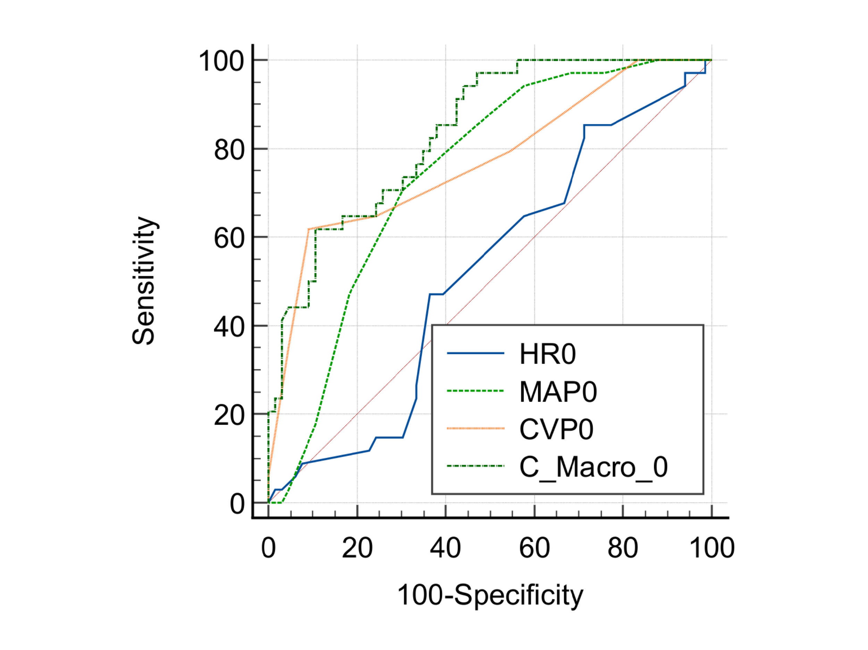
  HR0 vs. MAP0
  Difference between areas | 0.226
  Significance level | P = 0.0009
  HR0 vs. CVP0
  Difference between areas | 0.253
  Significance level | P = 0.0017
  HR0 vs. Combined marker at 0h
  Difference between areas | 0.320
  Significance level | P < 0.0001
  MAP0 vs. CVP0
  Difference between areas | 0.0276
  Significance level | P = 0.6906
  MAP0 vs. Combined marker at 0h
  Difference between areas | 0.0938
  Significance level | P = 0.0193
  CVP0 vs. Combined marker at 0h
  Difference between areas | 0.0662
  Significance level | P = 0.0449
Figure S2: Pairwise comparison of AUCs between macrocirculation markers and combine marker of macrocirculation to predict mortality at baseline

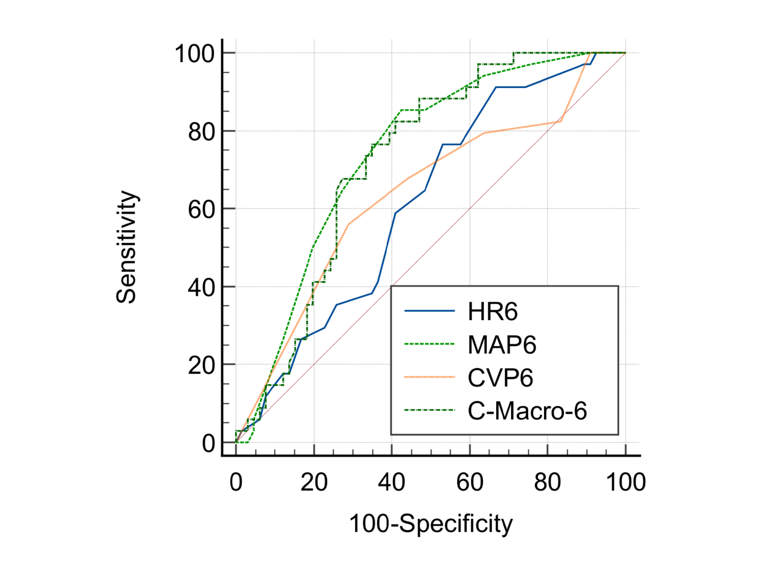
  HR6 vs. MAP6
  Difference between areas | 0.127
  Significance level | P = 0.1260
  HR6 vs. CVP6
  Difference between areas | 0.0227
  Significance level | P = 0.7679
  HR6 vs. Combined marker at 6h
  Difference between areas | 0.111
  Significance level | P = 0.0433
  MAP6 vs. CVP6
  Difference between areas | 0.104
  Significance level | P = 0.1738
  MAP6 vs. Combined marker at 6h
  Difference between areas | 0.0163
  Significance level | P = 0.7136
  CVP6 vs. Combined marker at 6h
  Difference between areas | 0.0878
  Significance level | P = 0.2967
Figure S3: Pairwise comparison of AUCs between macrocirculation markers and combine marker of macrocirculation to predict mortality at 6h

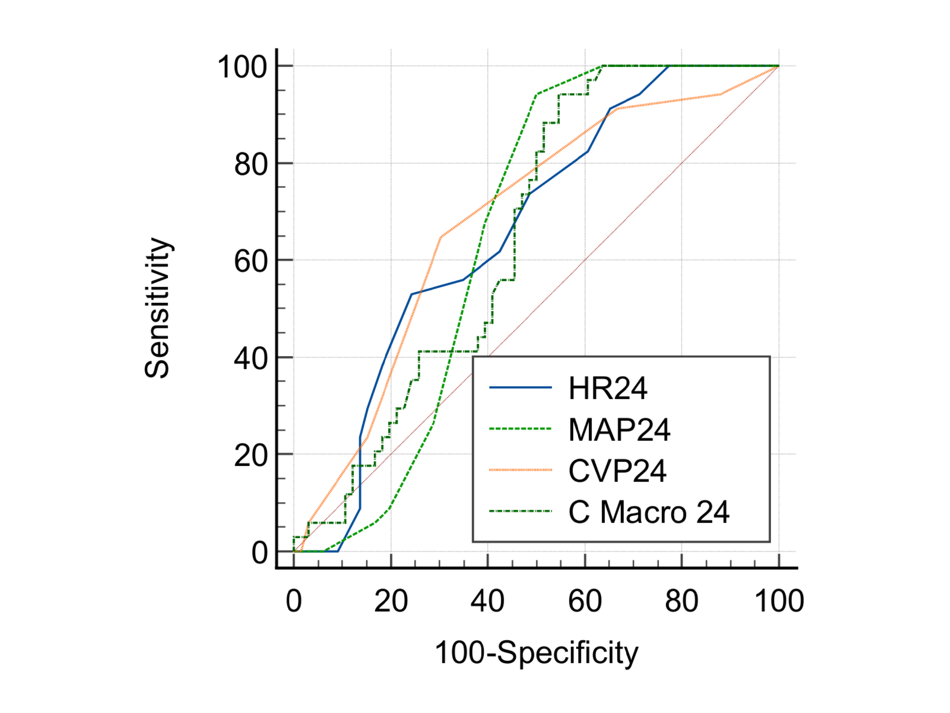
  HR24 vs. MAP24
  Difference between areas | 0.0102
  Significance level | P = 0.9003
  HR24 vs. CVP24
  Difference between areas | 0.0194
  Significance level | P = 0.7966
  HR24 vs. combined marker at 24h
  Difference between areas | 0.0109
  Significance level | P = 0.8257
  MAP24 vs. CVP24
  Difference between areas | 0.0296
  Significance level | P = 0.6966
  MAP24 vs. combined marker at 24h
  Difference between areas | 0.000668
  Significance level | P = 0.9904
  CVP24 vs. combined marker at 24h
  Difference between areas | 0.0303
  Significance level | P = 0.7339
Figure S4: Pairwise comparison of AUCs between microcirculation markers and combine marker of microcirculation to predict mortality at 24h

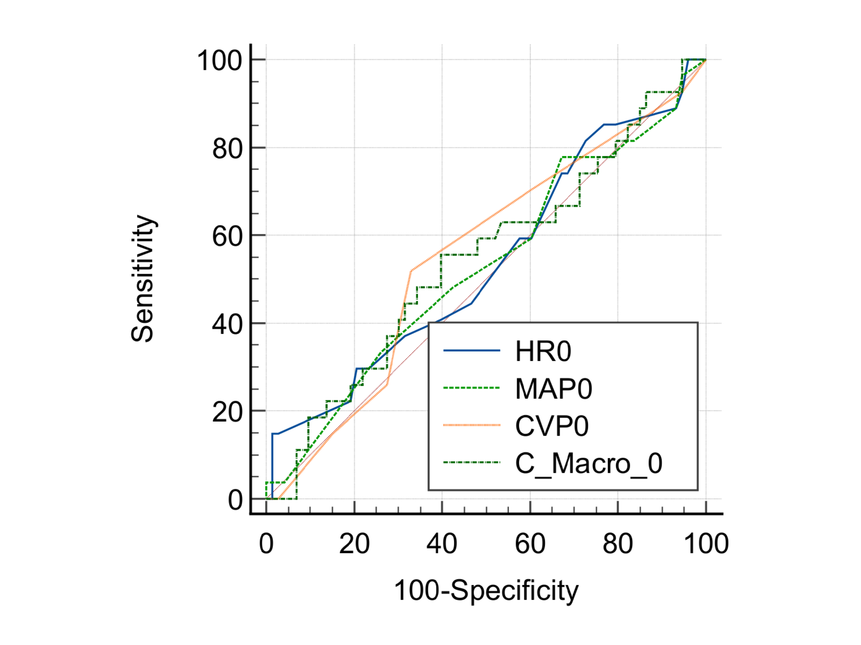
  HR0 vs. MAP0
  Difference between areas | 0.00812
  Significance level | P = 0.9327
  HR0 vs. CVP0
  Difference between areas | 0.0175
  Significance level | P = 0.8586
  HR0 vs. combined marker at 0h
  Difference between areas | 0.00710
  Significance level | P = 0.9425
  MAP0 vs. CVP0
  Difference between areas | 0.0256
  Significance level | P = 0.7533
  MAP0 vs. combined marker at 0h
  Difference between areas | 0.0152
  Significance level | P = 0.7044
  CVP0 vs. combined marker at 0h
  Difference between areas | 0.0104
  Significance level | P = 0.8418
Figure S5: Pairwise comparison of AUCs between macrocirculation markers and combine marker of macrocirculation to predict RRT at baseline

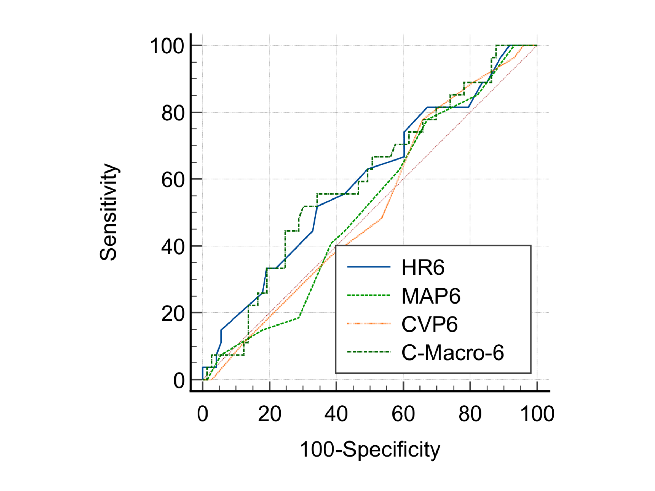
  HR6 vs. MAP6
  Difference between areas | 0.0758
  Significance level | P = 0.4329
  HR6 vs. CVP6
  Difference between areas | 0.0766
  Significance level | P = 0.4019
  HR6 vs. combined marker at 6h
  Difference between areas | 0.00152
  Significance level | P = 0.9794
  MAP6 vs. CVP6
  Difference between areas | 0.000761
  Significance level | P = 0.9935
  MAP6 vs. combined marker at 6h
  Difference between areas | 0.0774
  Significance level | P = 0.1566
  CVP6 vs. combined marker at 6h
  Difference between areas | 0.0781
  Significance level | P = 0.3450
Figure S6: Pairwise comparison of AUCs between macrocirculation markers and combine marker of macrocirculation to predict RRT at 6h

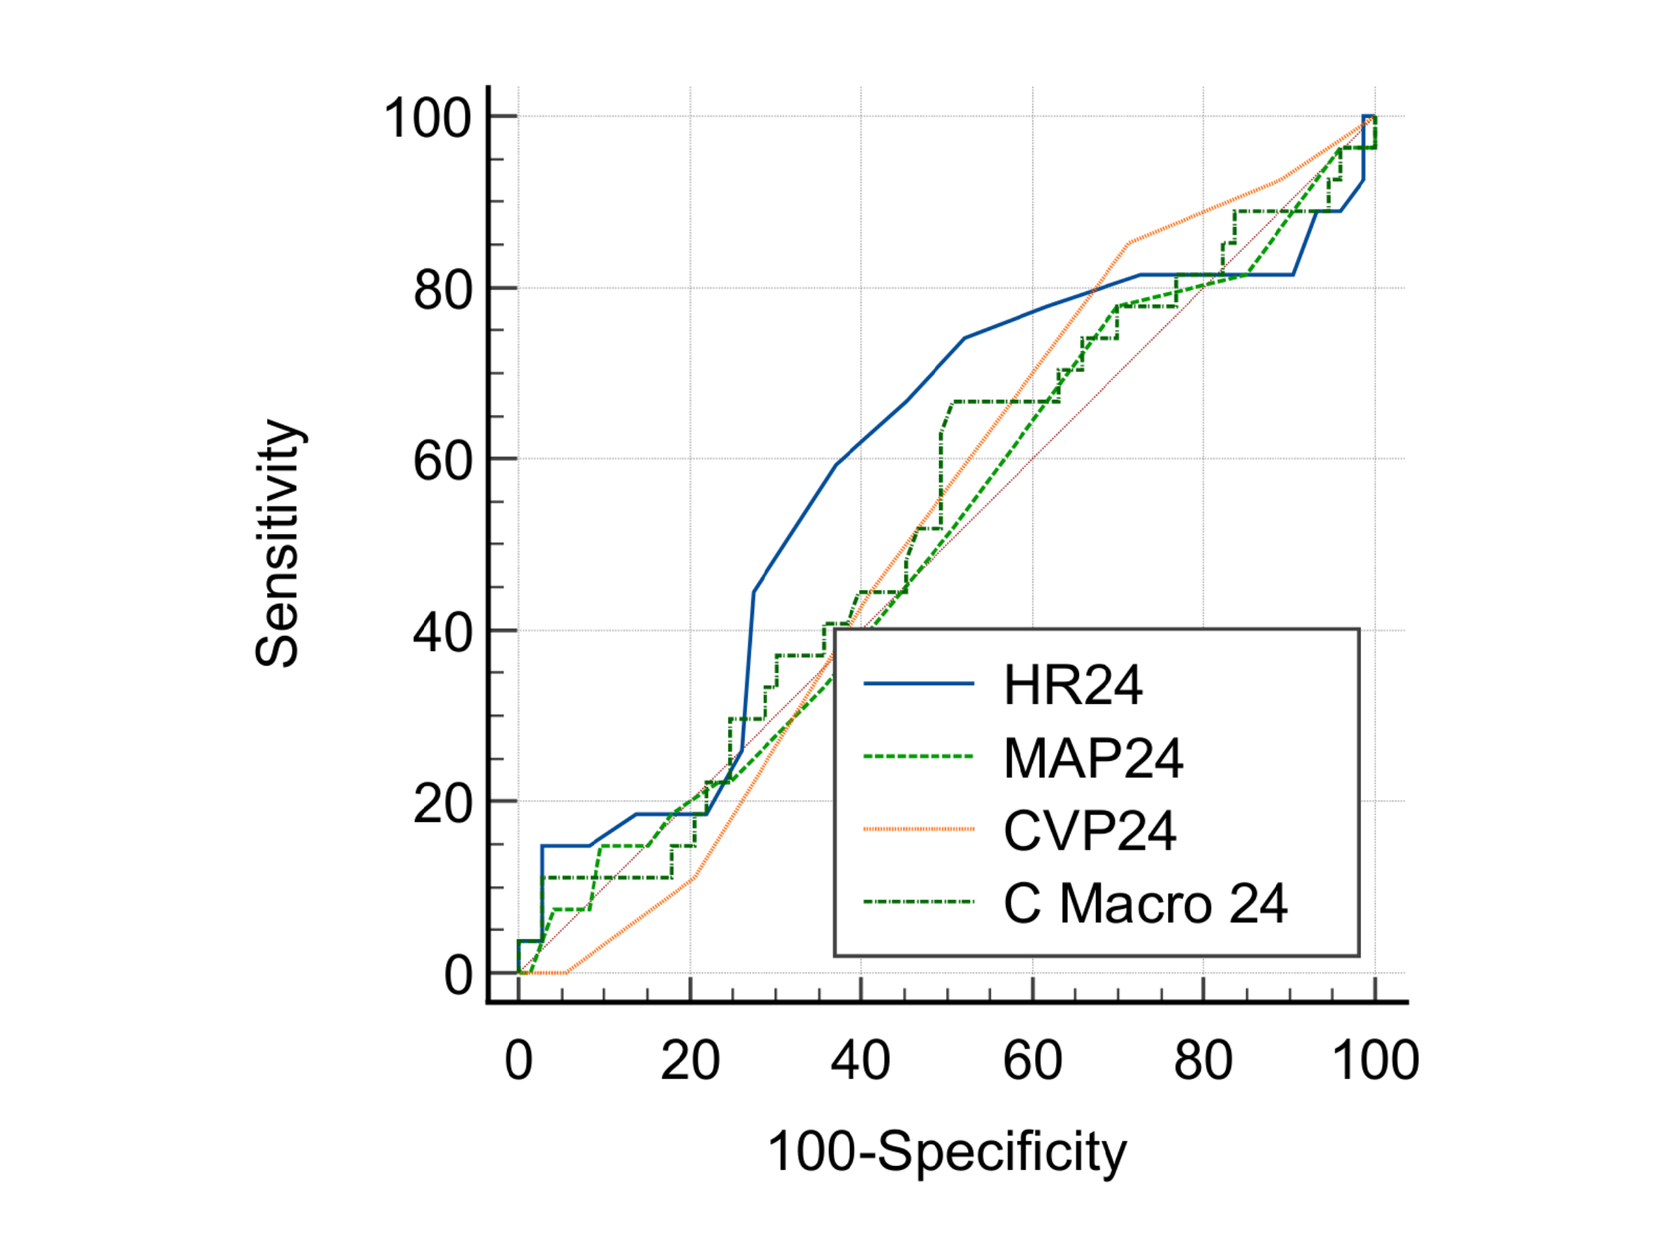
  HR24 vs. MAP24
  Difference between areas | 0.0802
  Significance level | P = 0.3805
  HR24 vs. CVP24
  Difference between areas | 0.0639
  Significance level | P = 0.5313
  HR24 vs. combined marker at 24h
  Difference between areas | 0.0586
  Significance level | P = 0.2991
  MAP24 vs. CVP24
  Difference between areas | 0.0162
  Significance level | P = 0.8560
  MAP24 vs. combined marker at 24h
  Difference between areas | 0.0216
  Significance level | P = 0.6976
  CVP24 vs. combined marker at 24h
  Difference between areas | 0.00533
  Significance level | P = 0.9501
Figure S7: Pairwise comparison of AUCs between macrocirculation markers and combine marker of macrocirculation to predict RRT at 24h

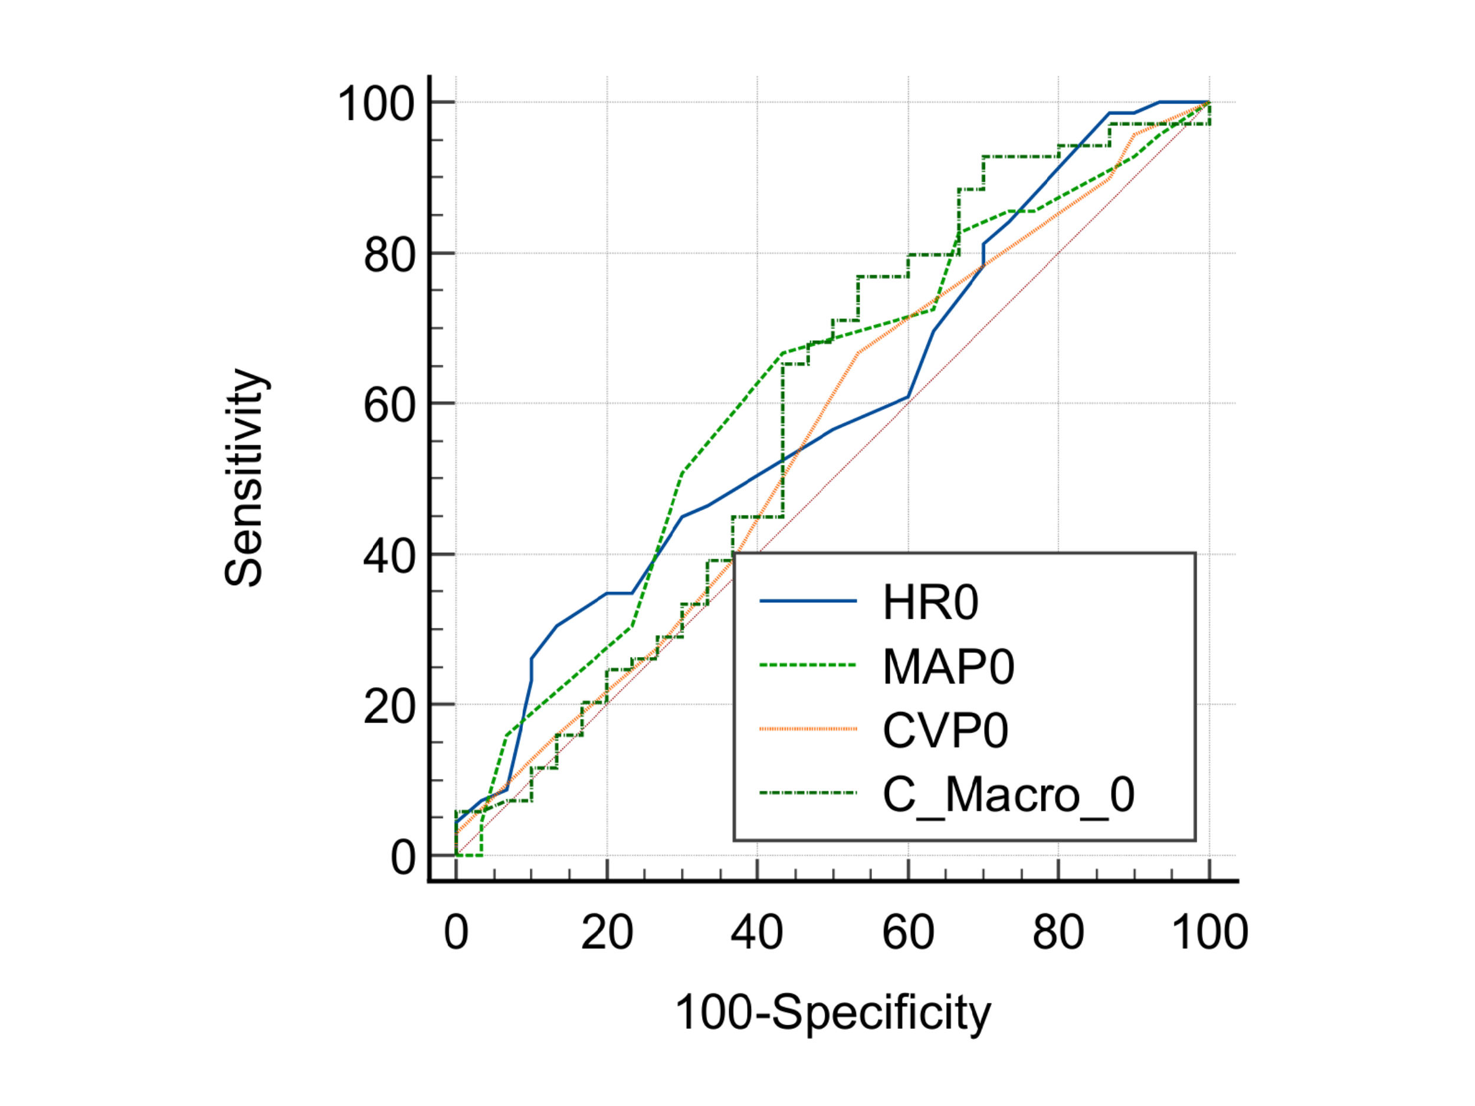
  HR0 vs. MAP0
  Difference between areas | 0.0205
  Significance level | P = 0.8128
  HR0 vs. CVP0
  Difference between areas | 0.0391
  Significance level | P = 0.6497
  HR0 vs. combined marker at 0h
  Difference between areas | 0.00169
  Significance level | P = 0.9850
  MAP0 vs. CVP0
  Difference between areas | 0.0597
  Significance level | P = 0.4049
  MAP0 vs. combined marker at 0h
  Difference between areas | 0.0222
  Significance level | P = 0.5634
  CVP0 vs. combined marker at 0h
  Difference between areas | 0.0374
  Significance level | P = 0.3994
Figure S8: Pairwise comparison of AUCs between macrocirculation markers and combine marker of macrocirculation to predict vasopressors at baseline

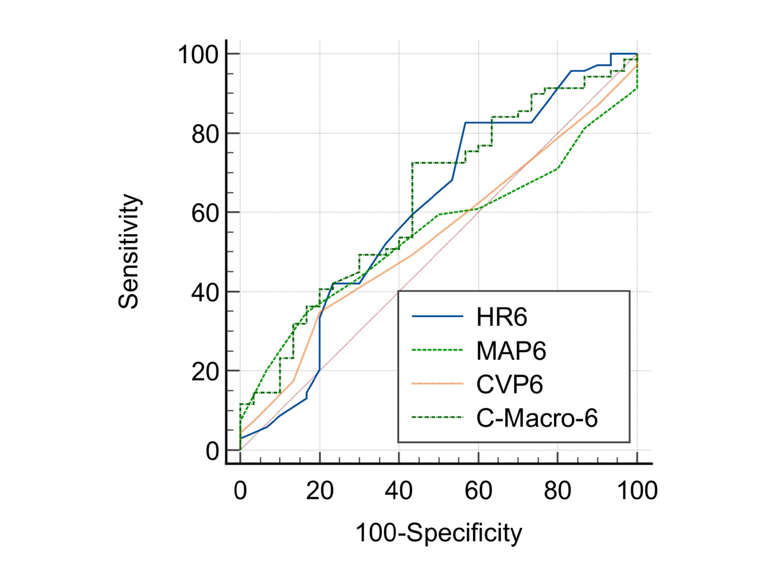
  HR6 vs. MAP6
  Difference between areas | 0.0568
  Significance level | P = 0.5331
  HR6 vs. CVP6
  Difference between areas | 0.0676
  Significance level | P = 0.4904
  HR6 vs. combined marker at 6h
  Difference between areas | 0.0285
  Significance level | P = 0.5745
  MAP6 vs. CVP6
  Difference between areas | 0.0109
  Significance level | P = 0.9049
  MAP6 vs. combined marker at 6h
  Difference between areas | 0.0853
  Significance level | P = 0.1215
  CVP6 vs. combined marker at 6h
  Difference between areas | 0.0961
  Significance level | P = 0.2713
Figure S9: Pairwise comparison of AUCs between macrocirculation markers and combine marker of macrocirculation to predict vasopressors at 6h

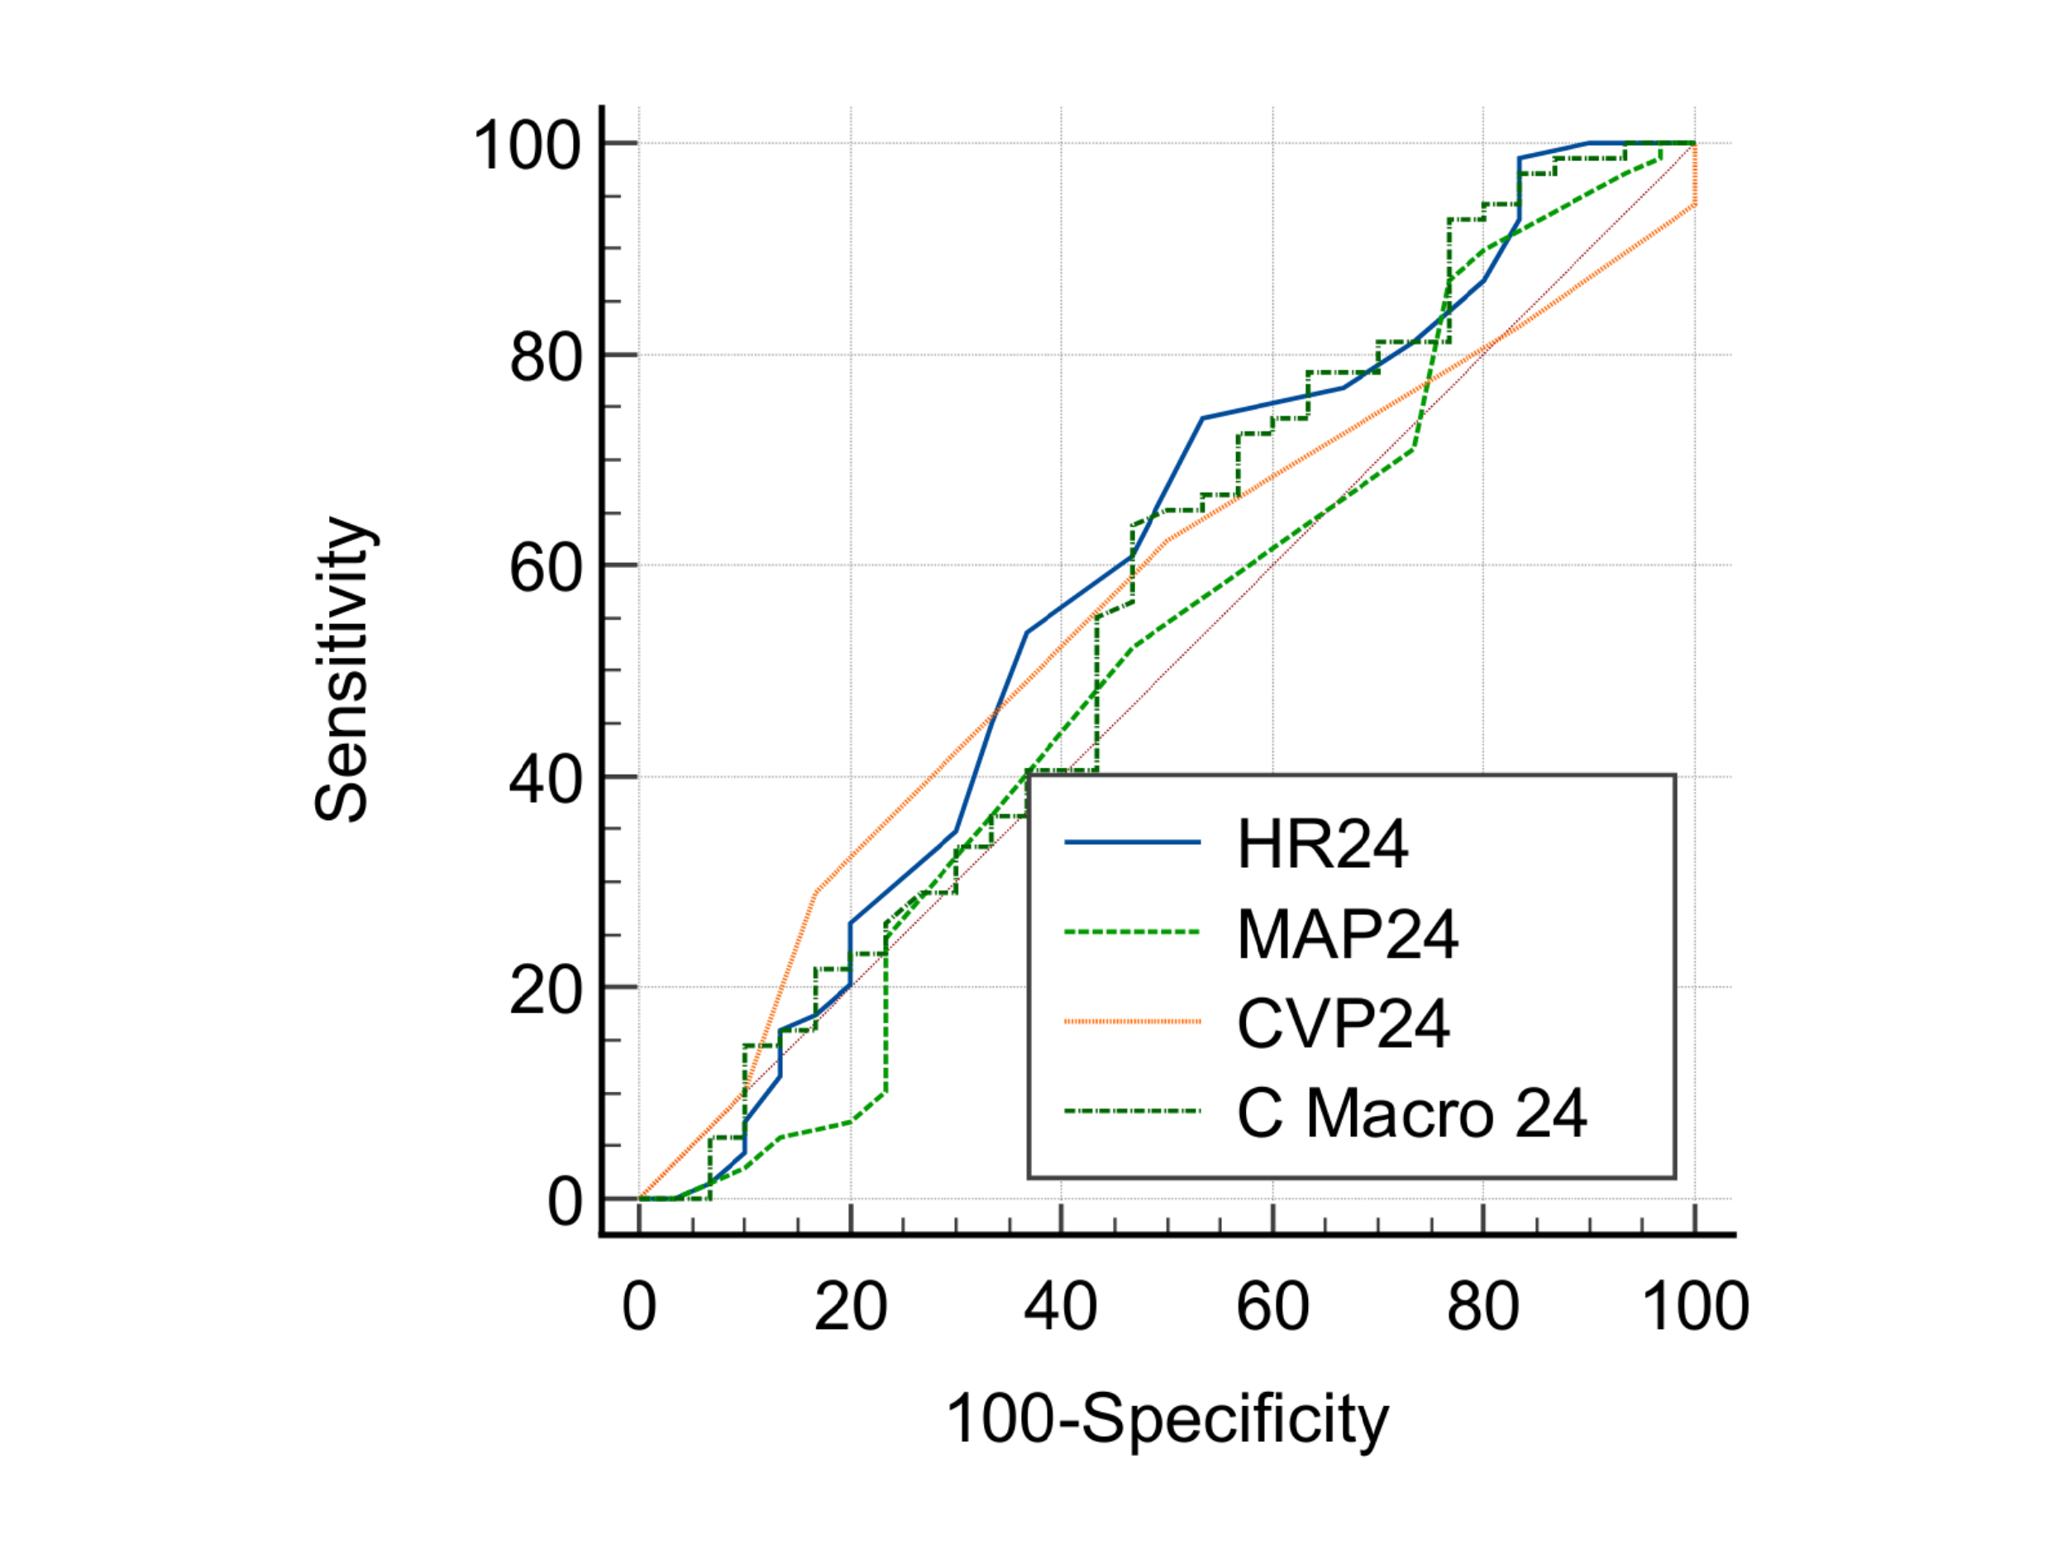
  HR24 vs. MAP24
  Difference between areas | 0.0742
  Significance level | P = 0.4489
  HR24 vs. CVP24
  Difference between areas | 0.0246
  Significance level | P = 0.7999
  HR24 vs. combined marker at 24h
  Difference between areas | 0.0215
  Significance level | P = 0.6901
  MAP24 vs. CVP24
  Difference between areas | 0.0495
  Significance level | P = 0.5580
  MAP24 vs. combined marker at 24h
  Difference between areas | 0.0527
  Significance level | P = 0.6596
  CVP24 vs. combined marker at 24h
  Difference between areas | 0.00314
  Significance level | P = 0.9700
Figure S10: Pairwise comparison of AUCs between macrocirculation markers and combine marker of macrocirculation to predict vasopressors at 24h

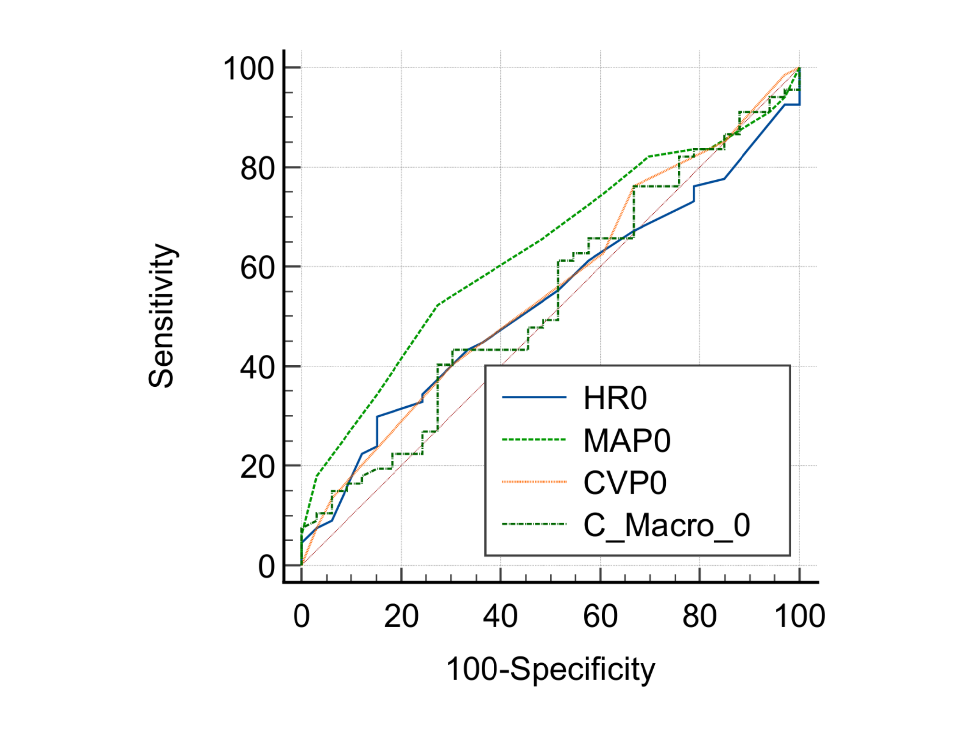
  HR0 vs. MAP0
  Difference between areas | 0.103
  Significance level | P = 0.1599
  HR0 vs. CVP0
  Difference between areas | 0.0253
  Significance level | P = 0.7665
  HR0 vs. combined marker at 0h
  Difference between areas | 0.00633
  Significance level | P = 0.9354
  MAP0 vs. CVP0
  Difference between areas | 0.0776
  Significance level | P = 0.4027
  MAP0 vs. combined marker at 0h
  Difference between areas | 0.0966
  Significance level | P = 0.0140
  CVP0 vs. combined marker at 0h
  Difference between areas | 0.0190
  Significance level | P = 0.8672
Figure S11: Pairwise comparison of AUCs between macrocirculation markers and combine marker of macrocirculation to predict ICU LOS at baseline

HR6 vs. MAP6
Difference between areas | 0.0226
Significance level | P = 0.7976
HR6 vs. CVP6
Difference between areas | 0.0726
Significance level | P = 0.3940
HR6 vs. combined marker at 6h
Difference between areas | 0.0728
Significance level | P = 0.2040
MAP6 vs. CVP6
Difference between areas | 0.0500
Significance level | P = 0.5839
MAP6 vs. combined marker at 6h
Difference between areas | 0.0502
Significance level | P = 0.6756
CVP6 vs. combined marker at 6h
Difference between areas | 0.000226
Significance level | P = 0.9981

Figure S12: Pairwise comparison of AUCs between macrocirculation markers and combine marker of macrocirculation to predict ICU LOS at 6h

HR24 vs. MAP24
Difference between areas | 0.0543
Significance level | P = 0.5081
HR24 vs. CVP24
Difference between areas | 0.0516
Significance level | P = 0.5120
HR24 vs. combined marker at 24h
Difference between areas | 0.0801
Significance level | P = 0.1662
MAP24 vs. CVP24
Difference between areas | 0.00271
Significance level | P = 0.9765
MAP24 vs. combined marker at 24h
Difference between areas | 0.0258
Significance level | P = 0.8132
CVP24 vs. combined marker at 24h
Difference between areas | 0.0285
Significance level | P = 0.7632

Figure S13: Pairwise comparison of AUCs between macrocirculation markers and combine marker of macrocirculation to predict ICU LOS at 24h
HR0 vs. MAP0
Difference between areas | 0.0171
Significance level | P = 0.8113
HR0 vs. CVP0
Difference between areas | 0.0424
Significance level | P = 0.6098
HR0 vs. combined marker at 0h
Difference between areas | 0.0420
Significance level | P = 0.5855
MAP0 vs. CVP0
Difference between areas | 0.0596
Significance level | P = 0.4095
MAP0 vs. combined marker at 0h
Difference between areas | 0.0591
Significance level | P = 0.1605
CVP0 vs. combined marker at 0h
Difference between areas | 0.000440
Significance level | P = 0.9908

Figure S14: Pairwise comparison of AUCs between macrocirculation markers and combine marker of macrocirculation to predict MV duration at baseline

HR6 vs. MAP6
Difference between areas | 0.138
Significance level | P = 0.0892
HR6 vs. CVP6
Difference between areas | 0.0699
Significance level | P = 0.4132
HR6 vs. combined marker at 6h
Difference between areas | 0.0791
Significance level | P = 0.4520
MAP6 vs. CVP6
Difference between areas | 0.0684
Significance level | P = 0.3721
MAP6 vs. combined marker at 6h
Difference between areas | 0.0591
Significance level | P = 0.1804
CVP6 vs. combined marker at 6h
Difference between areas | 0.00923
Significance level | P = 0.9168

Figure S15: Pairwise comparison of AUCs between macrocirculation markers and combine marker of macrocirculation to predict MV duration at 6h

HR24 vs. MAP24
Difference between areas | 0.148
Significance level | P = 0.0520
HR24 vs. CVP24
Difference between areas | 0.141
Significance level | P = 0.1042
HR24 vs. combined marker at 24h
Difference between areas | 0.0662
Significance level | P = 0.2435
MAP24 vs. combined marker at 24h
Difference between areas | 0.00703
Significance level | P = 0.9272
MAP24 vs. combined marker at 24h
Difference between areas | 0.0815
Significance level | P = 0.4390
CVP24 vs. combined marker at 24h
Difference between areas | 0.0745
Significance level | P = 0.3177

Figure S16: Pairwise comparison of AUCs between macrocirculation markers and combine marker of macrocirculation to predict MV duration at 24h

CRT0 vs. PPI0
Difference between areas | 0.142
Standard Error | 0.0471
z statistic | 3.024
Significance level | P = 0.0025
CRT0 vs. Combined marker at 0h
Difference between areas | 0.268
Standard Error | 0.0530
z statistic | 5.052
Significance level | P < 0.0001
PPI0 vs. Combined marker at 0h
Difference between areas | 0.125
Standard Error | 0.0368
z statistic | 3.407
Significance level | P = 0.0007

Figure S17: Pairwise comparison of AUCs between microcirculation markers and combine marker of microcirculation to predict mortality at baseline

CRT6 vs. PPI6
Difference between areas | 0.0370
Standard Error | 0.0319
z statistic | 1.161
Significance level | P = 0.2456
CRT6 vs. Combined marker at 6h
Difference between areas | 0.0412
Standard Error | 0.0375
z statistic | 1.099
Significance level | P = 0.2719
PPI6 vs. Combined marker at 6h
Difference between areas | 0.00423
Standard Error | 0.0313
z statistic | 0.135
Significance level | P = 0.8925

Figure S18: Pairwise comparison of AUCs between microcirculation markers and combine marker of microcirculation to predict mortality at 6h

CRT24 vs. PPI24
Difference between areas | 0.00334
Standard Error | 0.00827
z statistic | 0.404
Significance level | P = 0.6863
CRT24 vs. Combined marker at 24h
Difference between areas | 0.118
Standard Error | 0.0269
z statistic | 4.404
Significance level | P < 0.0001
PPI24 vs. Combined marker at 24h
Difference between areas | 0.122
Standard Error | 0.0260
z statistic | 4.680
Significance level | P < 0.0001

Figure 19: Pairwise comparison of AUCs between microcirculation markers and combine marker of microcirculation to predict mortality at 24h

CRT0 vs. PPI0
Difference between areas | 0.00583
Standard Error ª | 0.0540
z statistic | 0.108
Significance level | P = 0.9139
CRT0 vs. Combined marker at 0h
Difference between areas | 0.00710
Standard Error ª | 0.0708
z statistic | 0.100
Significance level | P = 0.9200
PPI0 vs. Combined marker at 0h
Difference between areas | 0.00127
Standard Error ª | 0.0530
z statistic | 0.0239
Significance level | P = 0.9809

Figure S20: Pairwise comparison of AUCs between microcirculation markers and combine marker of microcirculation to predict RRT at baseline

CRT6 vs. PPI6
Difference between areas | 0.0348
Standard Error ª | 0.0501
z statistic | 0.693
Significance level | P = 0.4881
CRT6 vs. Combined marker at 6h
Difference between areas | 0.00507
Standard Error ª | 0.0623
z statistic | 0.0814
Significance level | P = 0.9351
PPI6 vs. Combined marker at 6h
Difference between areas | 0.0297
Standard Error ª | 0.0445
z statistic | 0.666
Significance level | P = 0.5052

Figure S21: Pairwise comparison of AUCs between microcirculation markers and combine marker of microcirculation to predict RRT at 6h

CRT24 vs. PPI24
Difference between areas | 0.00203
Standard Error ª | 0.0406
z statistic | 0.0500
Significance level | P = 0.9601
CRT24 vs. Combined marker at 24h
Difference between areas | 0.0137
Standard Error ª | 0.0467
z statistic | 0.294
Significance level | P = 0.7691
PPI24 vs. Combined marker at 24h
Difference between areas | 0.0157
Standard Error ª | 0.0301
z statistic | 0.523
Significance level | P = 0.6008

Figure S22: Pairwise comparison of AUCs between microcirculation markers and combine marker of microcirculation to predict RRT at 24h

CRT0 vs. PPI0
Difference between areas | 0.0164
Standard Error ª | 0.0483
z statistic | 0.340
Significance level | P = 0.7337
CRT0 vs. Combined marker at 0h
Difference between areas | 0.110
Standard Error ª | 0.0632
z statistic | 1.742
Significance level | P = 0.0814
PPI0 vs. Combined marker at 0h
Difference between areas | 0.0937
Standard Error ª | 0.0544
z statistic | 1.723
Significance level | P = 0.0848

Figure S23: Pairwise comparison of AUCs between microcirculation markers and combine marker of microcirculation to predict vasopressor at baseline

CRT6 vs. PPI6
Difference between areas | 0.0524
Standard Error ª | 0.0465
z statistic | 1.128
Significance level | P = 0.2595
CRT6 vs. Combined marker at 6h
Difference between areas | 0.0514
Standard Error ª | 0.0678
z statistic | 0.759
Significance level | P = 0.4481
PPI6 vs. Combined marker at 6h
Difference between areas | 0.104
Standard Error ª | 0.0515
z statistic | 2.016
Significance level | P = 0.0438

Figure S24: Pairwise comparison of AUCs between microcirculation markers and combine marker of microcirculation to predict vasopressor at 6h

CRT24 vs. PPI24
Difference between areas | 0.00966
Standard Error ª | 0.0472
z statistic | 0.205
Significance level | P = 0.8379
CRT24 vs. Combined marker at 24h
Difference between areas | 0.0162
Standard Error ª | 0.0526
z statistic | 0.308
Significance level | P = 0.7584
PPI24 vs. Combined marker at 24h
Difference between areas | 0.0258
Standard Error ª | 0.0297
z statistic | 0.872
Significance level | P = 0.3834

Figure S25: Pairwise comparison of AUCs between microcirculation markers and combine marker of microcirculation to predict vasopressor at 24h

CRT0 vs. PPI0
Difference between areas | 0.00701
Standard Error ª | 0.0506
z statistic | 0.139
Significance level | P = 0.8897
CRT0 vs. Combined marker at 0h
Difference between areas | 0.0224
Standard Error ª | 0.0639
z statistic | 0.350
Significance level | P = 0.7261
PPI0 vs. Combined marker at 0h
Difference between areas | 0.0294
Standard Error ª | 0.0545
z statistic | 0.539
Significance level | P = 0.5897

Figure S26: Pairwise comparison of AUCs between microcirculation markers and combine marker of microcirculation to predict ICU LOS at baseline
CRT6 vs. PPI6
Difference between areas | 0.0339
Standard Error ª | 0.0478
z statistic | 0.710
Significance level | P = 0.4775
CRT6 vs. Combined marker at 6h
Difference between areas | 0.00588
Standard Error ª | 0.116
z statistic | 0.0509
Significance level | P = 0.9594
PPI6 vs. Combined marker at 6h
Difference between areas | 0.0280
Standard Error ª | 0.122
z statistic | 0.230
Significance level | P = 0.8181

Figure S27: Pairwise comparison of AUCs between microcirculation markers and combine marker of microcirculation to predict ICU LOS at 6h

CRT24 vs. PPI24
Difference between areas | 0.0360
Standard Error ª | 0.0379
z statistic | 0.949
Significance level | P = 0.3425
CRT24 vs. Combined marker at 24h
Difference between areas | 0.00543
Standard Error ª | 0.118
z statistic | 0.0461
Significance level | P = 0.9632
PPI24 vs. Combined marker at 24h
Difference between areas | 0.0414
Standard Error ª | 0.122
z statistic | 0.339
Significance level | P = 0.7343

Figure S28: Pairwise comparison of AUCs between microcirculation markers and combine marker of microcirculation to predict ICU LOS at 24h
CRT0 vs. PPI0
Difference between areas | 0.100
Standard Error ª | 0.0513
z statistic | 1.960
Significance level | P = 0.0500
CRT0 vs. Combined marker at 0h
Difference between areas | 0.0697
Standard Error ª | 0.0627
z statistic | 1.111
Significance level | P = 0.2667
PPI0 vs. Combined marker at 0h
Difference between areas | 0.0308
Standard Error ª | 0.0499
z statistic | 0.617
Significance level | P = 0.5372

Figure S29: Pairwise comparison of AUCs between microcirculation markers and combine marker of microcirculation to predict MV duration at baseline

CRT6 vs. PPI6
Difference between areas | 0.0796
Standard Error | 0.0464
z statistic | 1.716
Significance level | P = 0.0862
CRT6 vs. Combined marker at 6h
Difference between areas | 0.0325
Standard Error | 0.0489
z statistic | 0.665
Significance level | P = 0.5059
PPI6 vs. Combined marker at 6h
Difference between areas | 0.0470
Standard Error | 0.0416
z statistic | 1.129
Significance level | P = 0.2587

Figure S30: Pairwise comparison of AUCs between microcirculation markers and combine marker of microcirculation to predict MV duration at 6h
CRT24 vs. PPI24
Difference between areas | 0.0284
Standard Error ª | 0.0393
z statistic | 0.722
Significance level | P = 0.4702
CRT24 vs. Combined marker at 24h
Difference between areas | 0.0492
Standard Error ª | 0.0451
z statistic | 1.091
Significance level | P = 0.2751
PPI24 vs. Combined marker at 24h
Difference between areas | 0.0776
Standard Error ª | 0.0305
z statistic | 2.546
Significance level | P = 0.0109

Figure S31: Pairwise comparison of AUCs between microcirculation markers and combine marker of microcirculation to predict MV duration at 24h

