Title: Investigation on the Mechanical properties of Honey Comb Sandwich panels with brazed bonding structure

Novelty: 1. Forming Process of Core Strip:
2. Manufacturing Process of Brazing:
Forming Process of Core Strip:
A small strip was inserted onto the bottom die and moved step by step along the die teeth. If the strip was placed directly onto the die without this gradual movement, it would break into small pieces. Only one tooth could be formed with each stroke. If there was even a slight deviation while inserting the strip, the core shape would become angular, resulting in inconsistent cell sizes. To minimize these issues, a separate fixture was developed to guide the strip in a straight line during the process. This step was critical to successfully producing a single core strip from the press.
Manufacturing Process of Brazing:
During brazing, precise arrangement of the core strips is essential, requiring the use of jigs and fixtures. Proper clamping pressure must be maintained when fixing the cores. One face of a core strip is brazed to another core strip or to the face sheet. Manual brazing is a time-consuming process and is not ideal for large-scale production. For manufacturing multiple panels efficiently, automation of the brazing process is necessary. Otherwise, no other effective method exists for mass production through brazing.
Note: Pictures and graphs are available

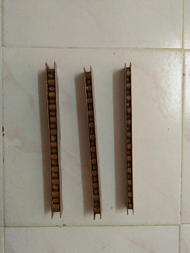
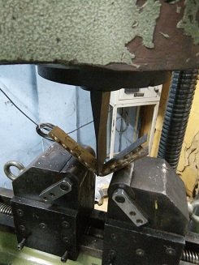
MANUFACTURED PANELS AND TESTING PICTURES

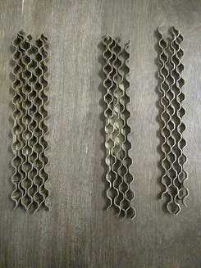
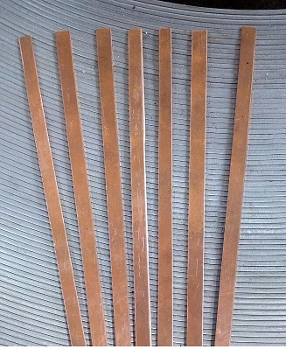
Sample panels 3- Point Bending

Copper strips Brass strips

Copper plates Dies
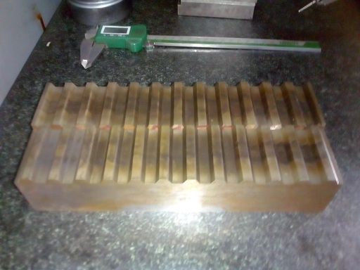


Sample panels Press tools

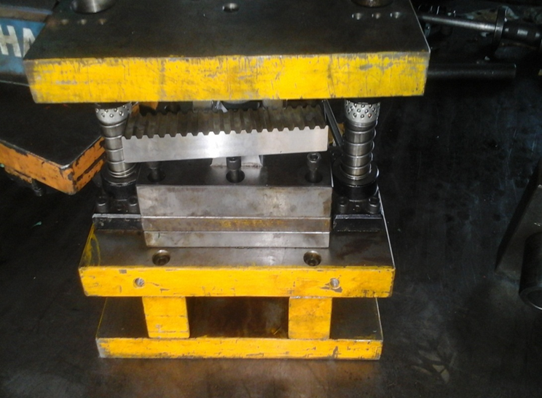


Various core formation

Press – Die loaded

Modelled core

Mesh product
