Supporting Information for

Tungsten–humic substances complexation

Zelin Xu ^{a,b}, Xin Liu ª, Jincheng Peng ª, Chenchen Qu ^{c}, Yifan Chen ^{b}, Ming Zhang ^{c}, Ding Liang ^{c}, Ming Lei ª, Boqing Tie ª, Huihui Du ^{a,}*
ª College of Resources and Environment, Hunan Agricultural University, 410127 Changsha, China
^{b} College of Environmental Science and Engineering, Tongji University, 200092 Shanghai, China
^{c} College of Resources of Environment, Huazhong Agricultural University, 430070 Wuhan, China

*Corresponding Author:
Huihui Du (Dr.): E-mail: duhuihui@hunau.edu.cn

Prepared for submission to Carbon Research

Direct Electrochemical Reduction (DER) of HA and FA
A three-electrode system consisted of a glassy carbon working electrode (GCWE), an Ag/AgCl reference electrode and a platinum wire counter electrode (Fig. S4). In the cathode electrolysis cell, the solution contained HA or FA dissolving in a buffered solution (0.1 M KCl and 0.1 M K₂HPO₄). The pH was fixed at 7 using 0.1 M phosphate during the reaction process. The anode electrolysis cell contained 0.1 M KCl electrolyte solutions. The counter electrode was connected to the anode chamber, and the separation from the cathode chamber was to reduce the reoxidation of reduced HA and FA. The CHI660E instrument was used to measure the change of current (I) with time (T). DER was carried out at an initial E_{h} = 0.59V. The determination time was 14000s and the interval was 0.1s. All electrochemical measurements were conducted in a confined space (Aeschbacher et al., 2010).

References
Aeschbacher, M., Sander, M., and Schwarzenbach, R.P. (2010). Novel electrochemical approach to assess the redox properties of humic substances. Environmental Science & Technology 44, 87-93.

Figure S1. Potentiometric titration curves for humic acid (0.6 g/L) and fulvic acid (1 g/L) solution. Lines are the 2-sites non-electrostatic model fits.

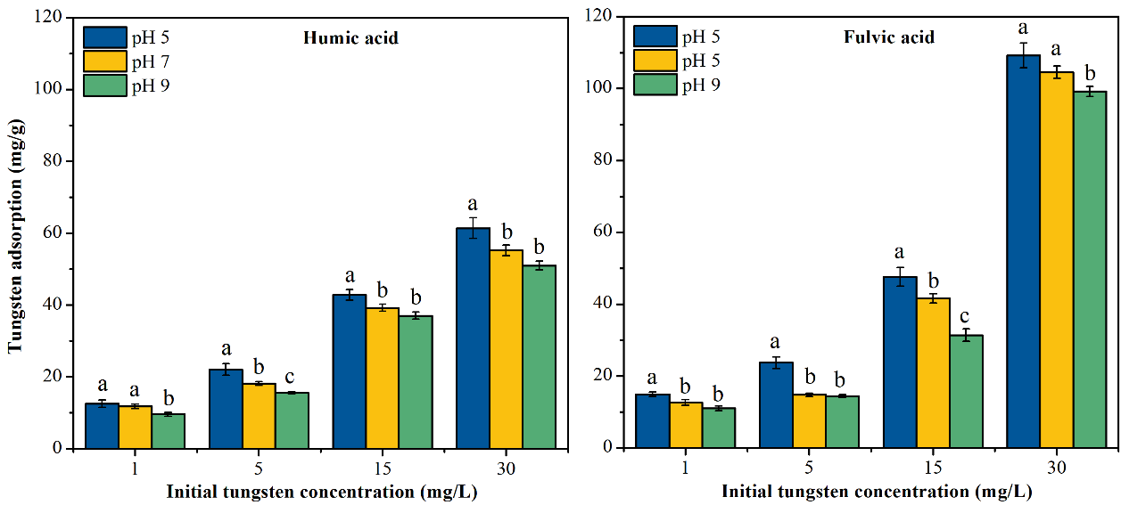
Figure S2. Complexed W(VI) amounts per mass (mg/g) on humic acid (HA) and fulvic acid (HA) (50 mg/L) at different pHs (~5, 7, 9) and initial W concentrations (1, 5, 15, 30 mg/L). Errorbars denote ± standard deviation (n=3). Lowercase letters repre-sent significant difference using one-way ANOVA (p < 0.05).

Figure S3. Raw heat flow (μW) versus time (s), for W(VI) titration into HA and FA at pH ~7.0.

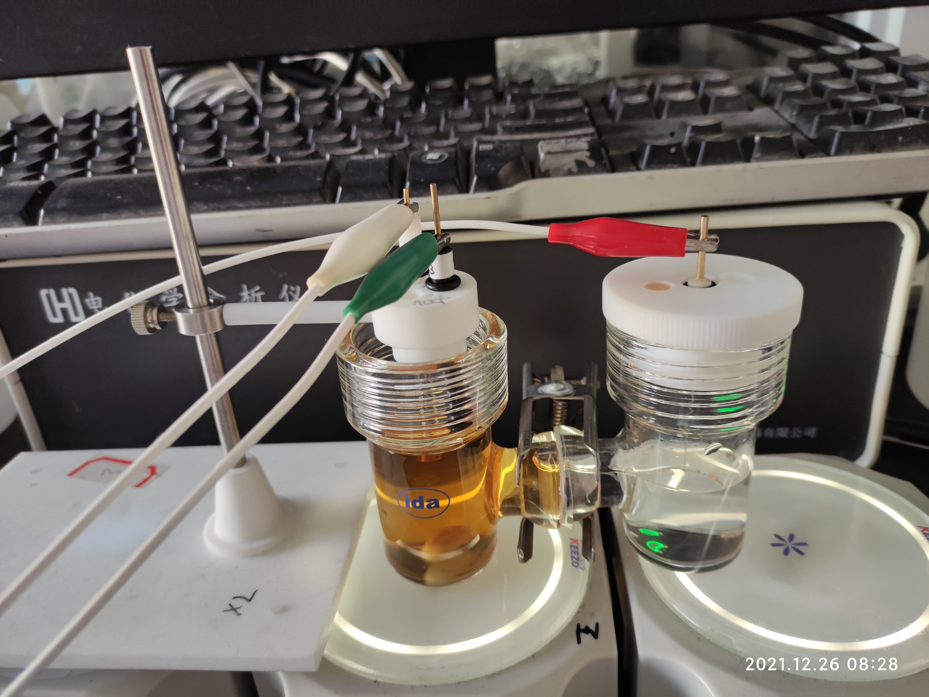
Working electrode
Counter electrode
Reference electrode
Cathode electrolysis cell

Anode electrolysis cell
Figure S4. A three-electrode system to measure the reducibility of HA and FA.

Figure S5. Reductive current during DER of HA and FA at Eh = –0.59 V for 14000s.

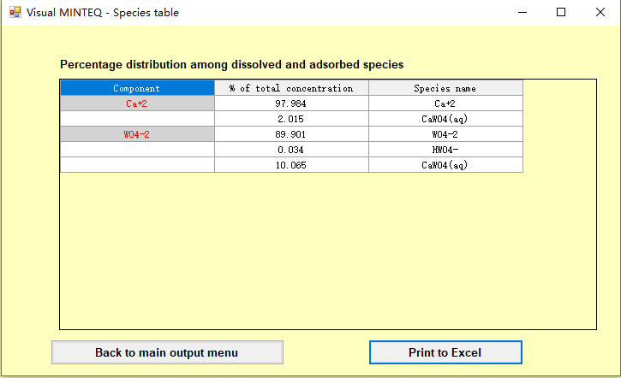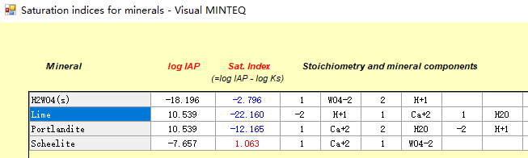
Figure S6. Solution speciation analysis by Visual Minteq. Experimental conditions: W:Ca molar ratio of 1:5; pH 7.

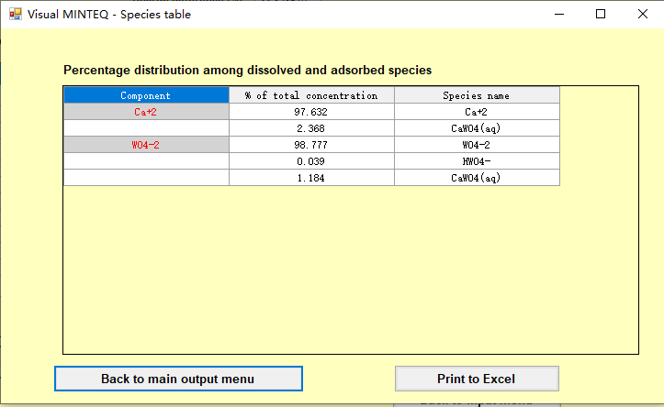
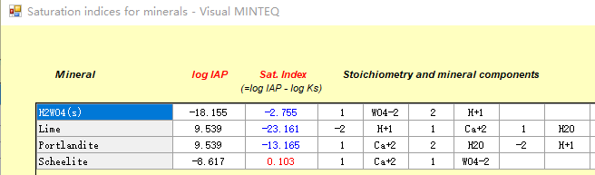
Figure S7. Solution speciation analysis by Visual Minteq. Experimental conditions: W:Ca molar ratio of 2:1; pH 7.

Table S1. Percentage distribution of different W(VI) species at ~15 mg/L and pH 5.0 calcualted by Visual Minteq.
Species | H₂W₁₂O₄₂⁻¹⁰ | HW₇O₂₄⁻⁵ | W₇O₂₄⁻⁶
Percentage (%) | 2.53 | 88.23 | 9.23

