Supplementary material

Recycling waste nickel-laden biochar to pseudo-capacitive material by hydrothermal treatment: roles of nickel-carbon interaction

Deping Liª, Jing Ma^{b}, Huacheng Xu^{c}, Xiaoyun Xuª, Hao Qiuª, Xinde Cao^{a, d}, Ling Zhao^{a, d,} *

ª School of Environmental Science and Engineering, Shanghai Jiao Tong University, Shanghai 200240, China
^{b} School of Environmental and Chemical Engineering, Shanghai University, Shanghai 200444,
China
^{c} State Key Laboratory of Lake Science and Environment, Nanjing Institute of Geography and Limnology, Chinese Academy of Sciences, Nanjing 210008, China
^{d} China-UK Low Carbon College, Shanghai Jiao Tong University, Shanghai 201306, China

*Corresponding authors. Tel: +86-21-54743926. E-mail: wszhaoling@sjtu.edu.cn (Ling Zhao)

Contents

Table S1 Basic properties of the biochar
Table S2 XPS results for the C 1s binding and its relative components distribution
Table S3 XPS results for the O 1s binding and its relative components distribution
Table S4 XPS results for the N 1s binding and its relative components distribution
Fig. S1 The CV curves (a) and electric discharge curves (b) of the control PS6 and PS6-H180 were measured with the scanning rate of 5 mV s⁻¹ and current density of 0.5 A g⁻¹
Fig. S2 The intensity for main peaks of Ni(OH)₂ from XRD spectrum at different hydrothermal temperature with two nickel contents (a: 100 mg g⁻¹, b: 500 mg g⁻¹)
Fig. S3 FTIR spectra for PS6, PS6-H180 and pseudo-capacitive materials with nickel content of 100 mg g⁻¹ (a) and 500 mg g⁻¹ (b)
Fig. S4 XPS spectrums of PS6, PS6-H180 and the pseudo-capacitive materials with nickel loaded
Fig. S5 High-resolution spectrum for C 1s, O 1s and N 1s of PS6, PS6-Ni1-H90 and PS6-Ni5-H90 from XPS results and its relative components distribution
Fig. S6 High-resolution spectrum for Ni 2p of the samples with nickel loaded from XPS results.
Fig. S7 The detail SEM image of PS6-H180 (a, b, c), PS6-Ni5-H90 (d, e, f) and PS6-Ni5-H180 (g, h, i)

Table S1 Basic properties of the biochar
Carbon  material | pH | Ash (%) | Elemental compositions (%) |  |  |  |  |  |  |  | S_{BET}-N₂  (m²·g⁻¹) | V_{micro}  (cm³·g⁻¹) | L_{micro}  (nm)
PS6 | 10.8 | 7.8 | C | H | N | O | Cl | K | Ca | Si | 143 | 0.131 | 1.54
PS6 | 10.8 | 7.8 | 81.2 | 2.6 | 1.3 | 7.5 | 0.5 | 1.8 | 1.4 | 0.1 | 143 | 0.131 | 1.54
Note: S_{BET}-N₂, external surface area; V_{micro}, micropore volume; L_{micro}, mean equivalent micropore width.

Table S2 XPS results for the C 1s binding and its relative components distribution
Sample \  Position (eV) \  C 1s Components (%) | C-C /C=C | C-O-C | C-O | C=N | C=O | O-C=O/ π-π*
PS6 | 284.8 | 285.6 | 286.6 | / | / | 289.7
PS6-H180 | 284.8 | 285.7 | 286.8 | / | 288.0 | /
PS6-Ni1-H90 | 284.8 | 285.5 | 286.7 | / | / | 289.5
PS6-Ni1-H180 | 284.8 | 285.4 | 286.7 | / | / | 289.6
PS6-Ni5-H90 | 284.8 | 285.6 | / | 287.1 | / | 289.9
PS6-Ni5-H180 | 284.8 | / | / | 287.1 | / | 290.0
PS6 | 51.06 | 17.66 | 23.95 | / | / | 7.32
PS6-H180 | 31.45 | 40.26 | 5.88 | / | 22.41 | /
PS6-Ni1-H90 | 37.88 | 27.66 | 26.26 | / | / | 8.21
PS6-Ni1-H180 | 47.11 | 16.85 | 29.02 | / | / | 7.02
PS6-Ni5-H90 | 19.77 | 47.13 | / | 23.32 | / | 9.77
PS6-Ni5-H180 | 43.80 | / | / | 52.49 | / | 3.71
References | (Miao et al., 2018; Zhou et al., 2018) | (Schulz et al., 2018) | (Chen et al., 2016) | (Sun et al., 2016) | (Bharath et al., 2019) | (Zhou et al., 2018)
Note: All of the peaks were refined with 284.8 for C 1s, “/” represents that component haven’t detected.

Sample \  Position (eV) \  O 1s Components (%) | Metal-O-II | Metal-O-I/ Ni(OH)₂ | C=O | C-O | H₂O
PS6 | / | 531.1 | 532.3 | 533.6 | 534.9
PS6-H180 | / | 531.6 | 532.2 | 533.9 | 535.2
PS6-Ni1-H90 | / | 531.3 | 532.1 | 533.2 | 534.7
PS6-Ni1-H180 | / | 531.2 | 532.3 | 533.2 | 534.8
PS6-Ni5-H90 | 529.6 | 531.3 | 532.1 | 533.8
PS6-Ni5-H180 | 529.4 | 531.1 | 532.1 | 533.3
PS6 | / | 15.43 | 38.19 | 37.58 | 8.81
PS6-H180 | / | 12.24 | 65.58 | 14.02 | 8.16
PS6-Ni1-H90 | / | 14.38 | 35.18 | 43.37 | 7.07
PS6-Ni1-H180 | / | 11.17 | 21.03 | 59.94 | 7.87
PS6-Ni5-H90 | 7.47 | 58.75 | 29.41 | 4.37 | /
PS6-Ni5-H180 | 3.66 | 42.16 | 42.92 | 11.27 | /
References | (Liang et al., 2020) | (Ren et al., 2016) | (Bharath et al., 2019) | (Bharath et al., 2019) | (Chen et al., 2017)
Table S3 XPS results for the O 1s binding and its relative components distribution

Sample \  Position (eV)\  N 1s Components (%) | Pyridinic N | Pyrrolic N | Quaternary -N | Pyridine-N-Oxide | N-O | NO₃⁻
PS6 | 398.8 | 400.7 | / | / | 404.0 | 408.1
PS6-H180 | 398.6 | 400.6 | 401.4 | / | // | 407.6
PS6-Ni1-H90 | 398.7 | 400.7 | / | / | 403.8 | 407.5
PS6-Ni1-H180 | 398.8 | 400.7 | / | 402.8 |  | 407.5
PS6-Ni5-H90 | 398.8 | 400.7 | / | / | 404.1 | 407.5
PS6-Ni5-H180 | 398.6 | 400.8 | / | 403.2 | 405.3 | /
PS6 | 18.99 | 34.4 |  | / | 14.6 | 31.93
PS6-H180 | 4.13 | 81.28 | 12.88 | / | / | 1.71
PS6-Ni1-H90 | 15.42 | 44.81 | / | / | 16.56 | 23.20
PS6-Ni1-H180 | 17.85 | 40.01 | / | 28.99 | / | 13.14
PS6-Ni5-H90 | 7.3 | 45.86 | / | / | 15.04 | 31.81
PS6-Ni5-H180 | 10.78 | 61.89 | / | 5.92 | 21.41 | /
References | (Yu et al., 2016; Liu et al., 2019) | (Yu et al., 2016) | (Yu et al., 2016) | (Satish et al., 2015) | (Liu et al., 2019) | (Isaenko et al., 2019)
Table S4 XPS results for the N 1s binding and its relative components distribution

(b)
(a)
Fig. S1 The CV curves (a) and electric discharge curves (b) of the control PS6 and PS6-H180 were measured with the scanning rate of 5 mV s⁻¹ and current density of 0.5 A g⁻¹

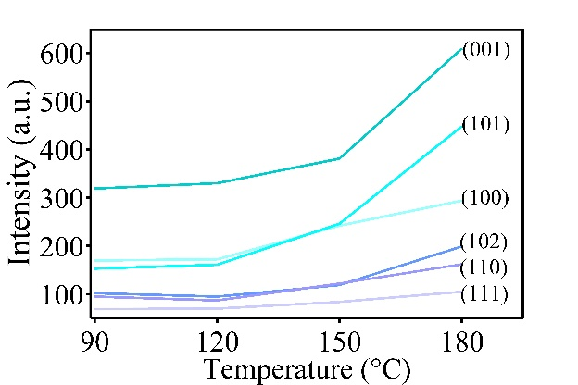
500 mg g⁻¹
100 mg g⁻¹
(b)
(a)
Fig. S2 The intensity for main peaks of Ni(OH)₂ from XRD spectrum at different hydrothermal temperature with two nickel contents (a: 100 mg g⁻¹, b: 500 mg g⁻¹)

(b)
(a)
Fig. S3 FTIR spectra for PS6, PS6-H180 and pseudo-capacitive materials with nickel content of 100 mg g⁻¹ (a) and 500 mg g⁻¹ (b)

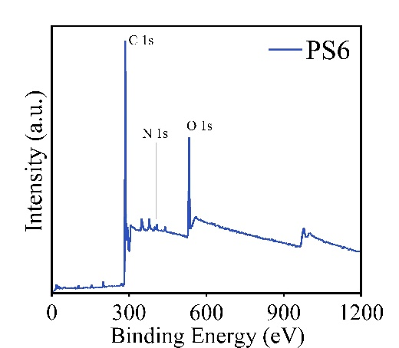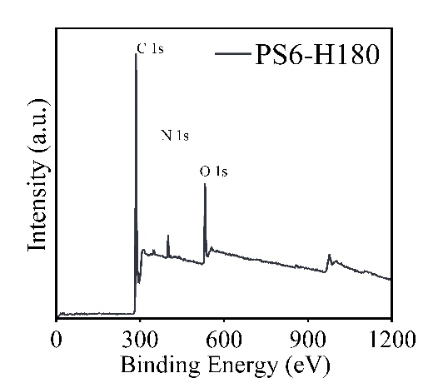
Ca 2p
K 2s
(a)
(b)
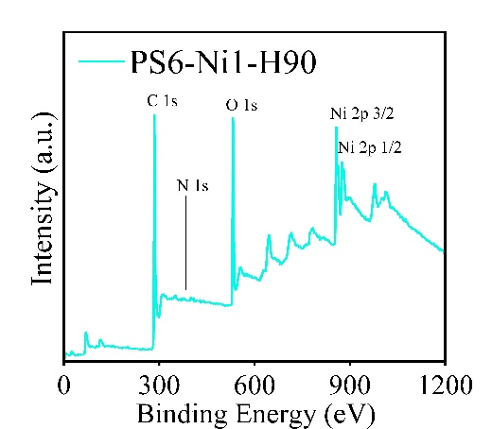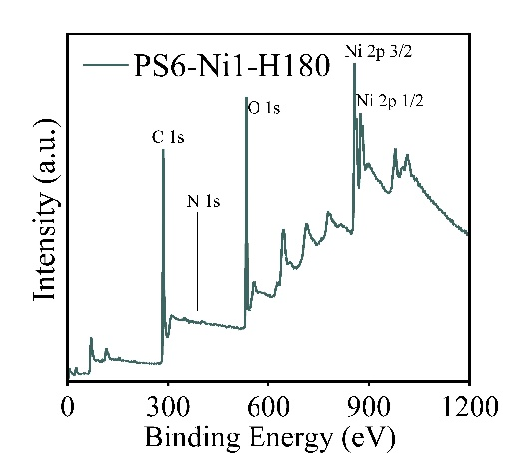
(c)
(d)
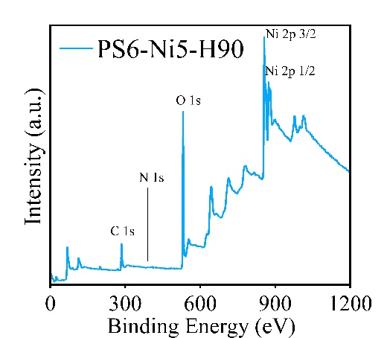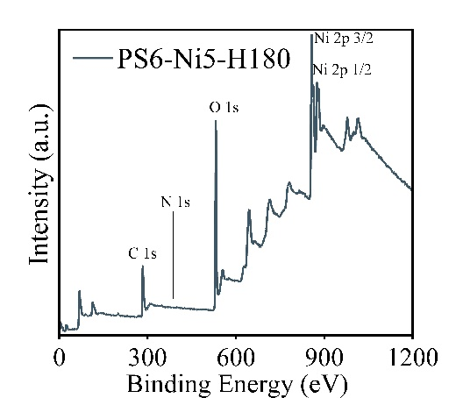
(e)
(f)
Fig. S4 XPS spectrums of PS6, PS6-H180 and the pseudo-capacitive materials with nickel loaded

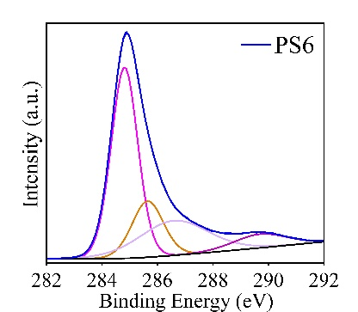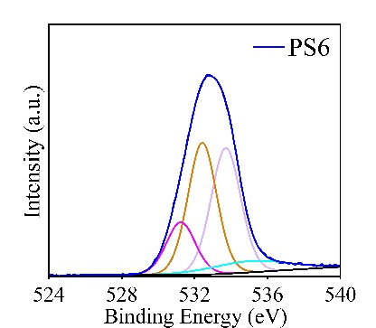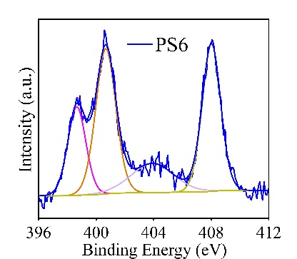
Pyridine-I
Pyridine-II
NO₃⁻
N-O
H₂O
C=O
C-O
Metal-O-I
C-O
C-O-C
C-C/C=C
O-C=O
(a)
(b)
(c)
(d)
(e)
(f)
(g)
(h)
(i)
C 1s
C 1s
C 1s
O 1s
O 1s
O 1s
N 1s
N 1s
N 1s
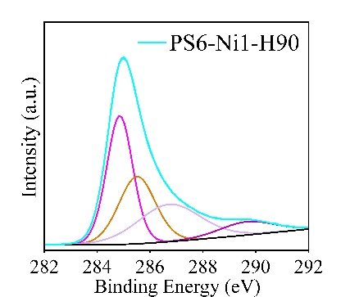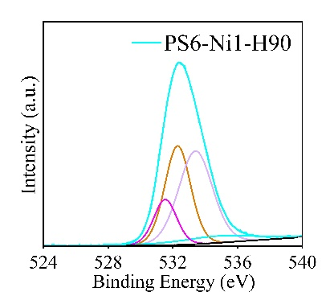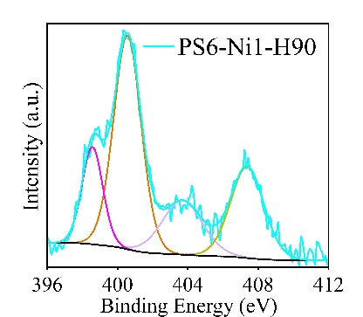
NO₃⁻
Pyridine-II
Pyridine-I
N-O
C=O
Metal-O-I/Ni(OH)₂
C-O
H₂O
O-C=O
C-O/C=N
C-O-C
C-C/C=C
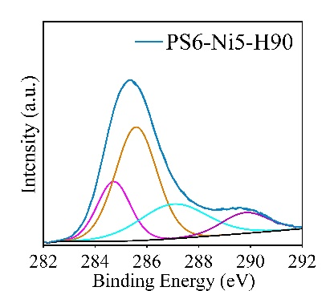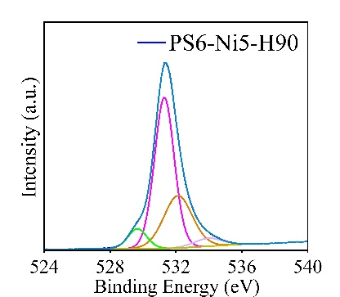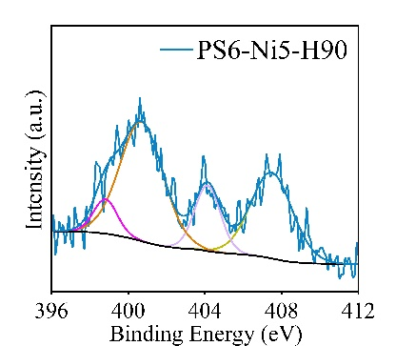
NO₃⁻
Pyridine-II
Pyridine-I
N-O
Metal-O-I/Ni(OH)₂
C=O
C-O
Metal-O-II
C=N
C-O-C
C-C/C=C
O-C=O
Fig. S5 High-resolution spectrum for C 1s, O 1s and N 1s of PS6, PS6-Ni1-H90 and PS6-Ni5-H90 from XPS results and its relative components distribution

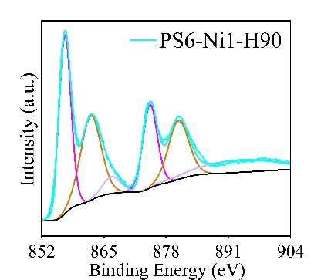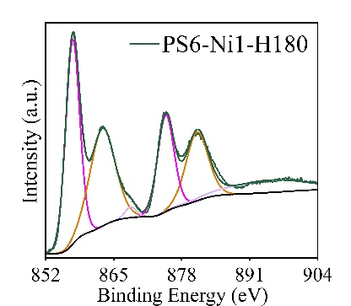
Ni 2p 3/2
Ni 2p 1/2
Ni 2p 3/2
Ni 2p 1/2
Ni 2p 1/2
Ni 2p 3/2
Ni 2p 1/2
Ni 2p 3/2
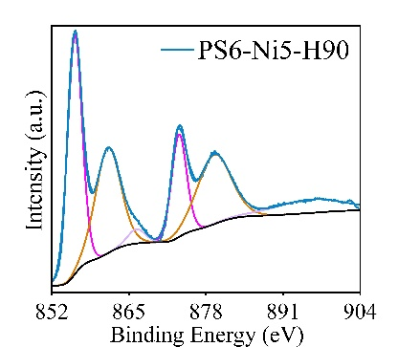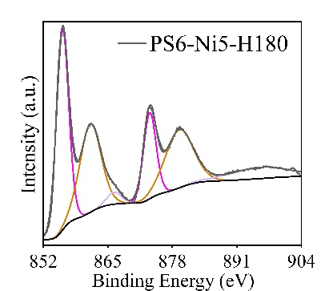
Ni 2p 1/2
Ni 2p 3/2
Ni 2p 1/2
Ni 2p 3/2
Ni 2p 1/2
Ni 2p 3/2
Ni 2p 1/2
Ni 2p 3/2
Fig. S6 High-resolution spectrum for Ni 2p of the samples with nickel loaded from XPS results.

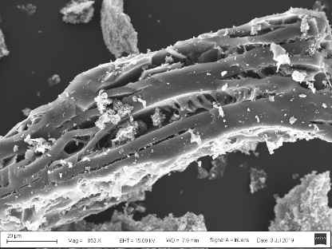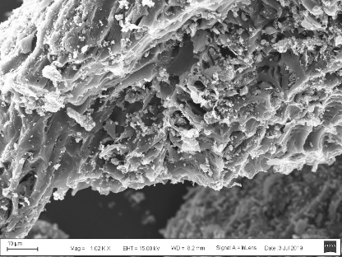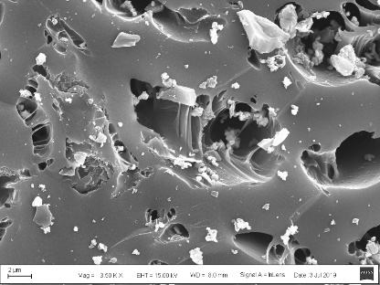
(a)
(b)
(c)
(i)
(h)
(g)
(f)
(e)
(d)
20um
10um
2um
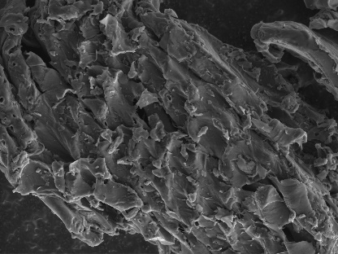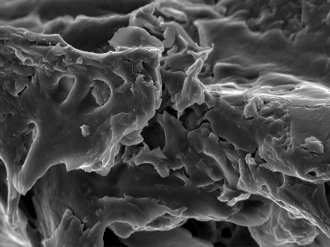
(l)
(k)
(j)
500nm
500nm
500nm
5um
5um
20um
10um
20um
20um
Fig. S7 The detail SEM image of PS6 (a, b, c), PS6-H180 (d, e, f), PS6-Ni5-H90 (g, h, i) and PS6-Ni5-H180 (j, k, l)

References
Bharath G, Rambabu K, Banat F, Hai A, Arangadi A F and Ponpandian N (2019) Enhanced electrochemical performances of peanut shell derived activated carbon and its Fe₃O₄ nanocomposites for capacitive deionization of Cr(VI) ions. Sci Total Environ 691: 713-726.
Chen F, Yang J, Bai T, Long B and Zhou X (2016) Facile synthesis of few-layer graphene from biomass waste and its application in lithium ion batteries. J Electroanal Chem 768: 18-26.
Chen J, Zhou X, Mei C, Xu J, Zhou S and Wong C-P (2017) Evaluating biomass-derived hierarchically porous carbon as the positive electrode material for hybrid Na-ion capacitors. J Power Sources 342: 48-55.
Isaenko L I, Korzhneva K E, Khyzhun O Y, Molokeev M S, Goloshumova A A and Tarasova A Y (2019) Structural and X-ray spectroscopy studies of Pb1-xBax(NO₃)₂ solid solutions. J Solid State Chem 277: 786-792.
Liang W, Wang S, Zhang Y, Gu J, Zhu K, Zhong J and Wang X (2020) β-Ni(OH)₂ nanosheets coating on 3D flower-like α-Ni(OH)₂ as high-performance electrodes for asymmetric supercapacitor and Ni/MH battery. J Alloy Comp 849: 156616.
Liu F, Wang Z, Zhang H, Jin L, Chu X, Gu B, Huang H and Yang W (2019) Nitrogen, oxygen and sulfur co-doped hierarchical porous carbons toward high-performance supercapacitors by direct pyrolysis of kraft lignin. Carbon 149: 105-116.
Miao M, Zuo S, Zhao Y, Wang Y, Xia H, Tan C and Gao H (2018) Selective oxidation rapidly decomposes biomass-based activated carbons into graphite-like crystallites. Carbon 140: 504-507.
Ren Z, Li J, Ren Y, Wang S, Qiu Y and Yu J (2016) Large-scale synthesis of hybrid metal oxides through metal redox mechanism for high-performance pseudocapacitors. Sci Rep 6: 20021.
Satish R, Vanchiappan A, Wong C L, Ng K W and Srinivasan M (2015) Macroporous carbon from human hair: A journey towards the fabrication of high energy Li-ion capacitors. Electrochim Acta 182: 474-481.
Schulz N, Hausbrand R, Dimesso L and Jaegermann W (2018) XPS-Surface Analysis of SEI Layers on Li-Ion Cathodes: Part I. Investigation of Initial Surface Chemistry. J Electrochem Soc 165: A819-A832.
Sun X, Jiang Z, Li C, Jiang Y, Sun X, Tian X, Luo L, Hao X and Jiang Z-J (2016) Facile synthesis of Co₃O₄ with different morphologies loaded on amine modified graphene and their application in supercapacitors. J Alloy Comp 685: 507-517.
Yu P, Zhang Z, Zheng L, Teng F, Hu L and Fang X (2016) A Novel Sustainable Flour Derived Hierarchical Nitrogen-Doped Porous Carbon/Polyaniline Electrode for Advanced Asymmetric Supercapacitors. Adv Energy Mater 6: 1601111.
Zhou J, Guo Y, Liang C, Yang J, Wang J and Nuli Y (2018) Confining small sulfur molecules in peanut shell-derived microporous graphitic carbon for advanced lithium sulfur battery. Electrochim Acta 273: 127-135.

