Supporting information (SI):

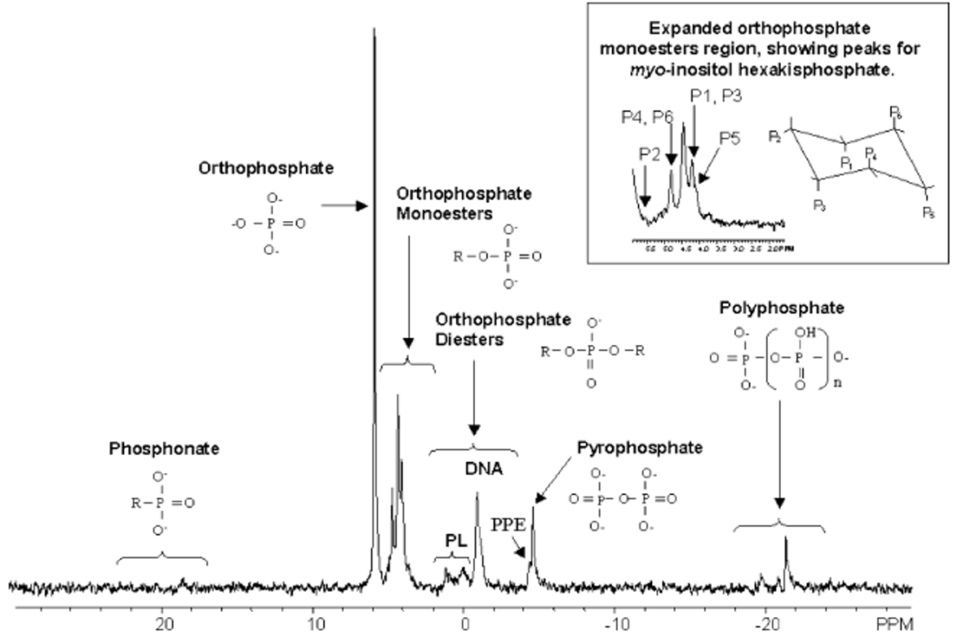
SI Fig.1 Typical 31P-NMR spectra of environmental samples (Cade-Menun et al., 2005, 2006)
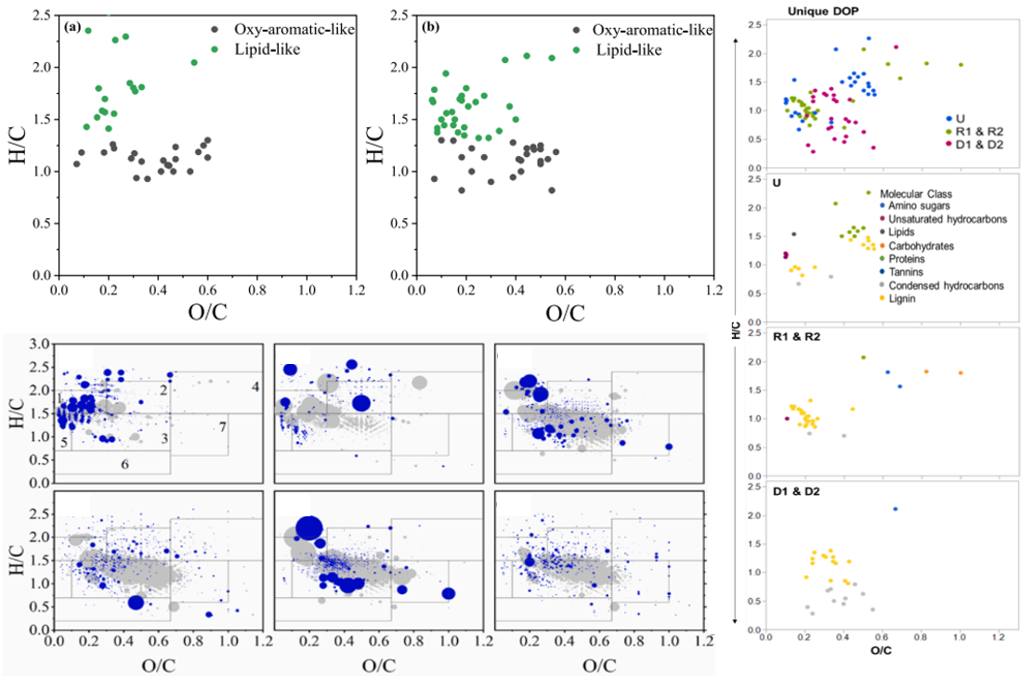
SI Fig.2 Influence of different factors on dissolved organic phosphorus and its distribution were studied by FT-ICR-MS technology (Gao et al., 2021; Li et al., 2022a; Yang et al., 2022)
SI. Table 1 Extraction methods of organic phosphorus from different environmental media
No. | Sample source | Sample types | Extraction condition | Pretreatment | Analytical technique | Reference
1 | Tai Lake,Chao Lake, China | Dissolved phosphorus and particulate phosphorus | 1 M NaOH+0.05 M EDTA at 25 ℃ for 16 h，extraction rate about 80% | 20L water samples, flocculation 4.0 g AlCl₃, at 8000g, 20 min, freeze-dried, centrifuged at 8000 g for 15 min. | Solution ³¹P-NMR (Bruker AV 600 MHz, Germany) | Feng et al., 2020
2 | Tai Lake, China | Algal (Microcystis, Chlorella, Spirulina), aquatic plant | 0.5 M NaOH+0.025 M EDTA, extraction ratio 1:60, 16 h. extraction rate 92.3%-96.2% | freeze-dried, grind and sift, centrifugation at 8000g for 30 min at 4℃ | Solution ³¹P NMR (BRUKER AV400M, Switzerland) | Feng et al., 2016
3 | Tai Lake, China | Foxtail algae, common reed and black algae | 0.5 M NaOH+0.025 M EDTA,  1 M NaOH + 0.1 M EDTA，extraction rate 90.3%-95.2% | APase enzyme activity 1.0 U/mL. Tris-HCl buffer (0.01 M, pH 9.0), 1 M NaN₃, 37 ℃, 18 h, 150 r/min. 2% SDS | Solution ³¹P NMR (Bruker AVANCE 400 MHz, Germany) | Feng et al., 2018
4 | Ten lakes and reservoirs, China | Water and algae | 1 M NaOH + 0.1 M EDTA (water), 16 h, 2000 rpm,20 min; 0.5 mol /L NaOH+25 mmol/L EDTA (algae)，25℃, 150 r/min, 16 h, centrifuge 10000 r/min, 30 min | 20 L water samples , through 1.20 micron GF/C filter membrane, 0.2g algae powder, filtered by 0.45 μm filter membrane | Solution ³¹P NMR (BRUKER AV600M, Switzerland) | Zhang et al., 2018
5 | Tai Lake Dianchi Lake, China | Sediments | 0.25 M NaOH + 0.05 M EDTA | NaOH-EDTA solution in a 1: 20 w/v rato, 16 h at 20 ℃. Centrifugation  at 10,000 rpm, 30 min | Solution ³¹P NMR (Bruker AV400) | Ding et al., 2010
6 | Pawnee, United States | Grassland soil | 1 M H₂SO₄+1 M NaOH/KOH/NH₄OH | 2 g air-dried soil，10 M H₂SO₄ for 3 h, 0.5 and 1.0 M each of NaOH, KOH and NH₄OH for 6 and 20 h.1.0 M H₂SO₄ and extracted with 0.5 M NaOH | Continuous classification | Bowman and Cole, 1978
7 | Yangtze River, Yungui Plateau, Qinghai-Tibet Plateau, Northeast China, Mongolia-Xinjiang Plateau, China | Sediment | 1 M H₂SO₄+0.5 M NaOH+1 M HCl+0.5 M NaHCO₃  extraction rate 84.71%-99.01% | 0.5 g, 50 ml 0.5 M NaHCO₃ at pH 8.5, 16 h. 1.0 M HCl for 3 h, followed by 0.5 M NaOH for 16 h. pH 0.2, NaOH extraction at 550 ℃ for 1 h, followed by dissolution in 1 M H₂SO₄ for 24 h. | Continuous classification | Huo et al., 2011
8 | Sønderby Lake, Denmark | Sediment | 1:1 mixture of 0.25 mol/L1 NaOH and 0.05 mol/L1 EDTA with a 1:3 (v/v) sediment to extractant ratio, 16 h  extraction rate 62% | ICP prior to 10 times pre-concentration of the extracts by rotary evaporation at 45 ℃. Five percent (v/v) of BD solution (0.11 M NaHCO₃+0.11 M Na₂S₂O₄)， | ³¹P NMR (Varian MercuryPlus, United States) | Reitzel et al., 2006
9 | Northern Sweden, Sweden | Forest humus soils | 0.25 M NaOH+0.05 M Na₂EDTA, 16 h, Centrifuged 30 min, 14000 g  extraction rate 94% | 1.5 g dry and milled soil, -80 ℃, 600 mg lyophilized material. | 1D ³¹P NMR (Bruker DRX 500, Germany) | Vestergren et al., 2012
10 | Lake Erken, Sweden | Sediment | 0.1 M NaOH, 1:3 (w/v) ratio, 16 h,25℃  extraction rate 65%-85% | Sequential fractionation | ESI-MS-MS, mass spectrometer (PE SCIEX API III+) | Brabandere et al., 2008
11 | Dianchi Lake and Tai Lake, China | Sediment | APase /PDEase/Phytase dissolves in 0.1 M Tris-HCl/0.1 M NaAc-HAc  extraction rate 93.9% | APase 1 U/mL，PDEase 0.02 U/mL, 4℃. Dialysis, phytase 0.06 U/mL, pH=7, 37 ℃ | Enzymatic hydrolysis | Zhu et al., 2013
12 | lowland tropical forest, Panama | Topsoils | 0.02 M citric acid+0.02 M maleic acid+0.02 M oxalic acid  extraction rate 91% | Deionized water, 180 oscillations/min,16 h | Enzymatic hydrolysis | Darch et al., 2016
13 | Coastal lagoons Thau and Méjean, France | Sediment | CaEDTA, Na₂EDTA, H₂SO₄, 2 M NaOH | 2 M NaOH, 90 ℃ for 30 minutes. Collected on a filter (Whatman, GF/F) | Enzymatic hydrolysis | Paing et al., 1999
14 | Pelham Bay Park in New York City, United States | Sediment | 0.4 M NaOH, 20 ℃ for 16 h, Centrifuged 30 min, 10,000g. extracted with NaOH mean 77.36 % | Vacuum rotary evaporator, 35 ℃. Spiked with 0.1 mL (1 mg P/ mL) of KH₂PO₄) as an internal standard | Solution ³¹P NMR (Bruker 300 UltraShield) | Pant et al., 2015
15 | Dovrefjell, Abisko and Joatka, Sweden and Norway | Topsoil | 0.25 M NaOH + 0.05 M EDTA,16 h,20 ℃, centrifuged 10,000 g, 30 min. Diluted extracts 100:1, Extraction recovered between 61 and 96%. | Freeze-dried | ³¹P NMR (Bruker AMX 600, Switzerland) | Turner et al., 2004
16 | Florida Everglades, United States | Benthic floc and underlying soil | 1 M NaOH + 1 M HCl+0.5 M NaHCO_{3,} 16h, 1:50 soil-to-solution, extracts ranged 12 and 74% | The acid extraction step removes inorganic phosphate and cations, centrifuged (7000 g, 30 min), filtered | Solution 31P NMR (Bruker Avance) | Turner et al., 2006
17 | Acacia mangium plantations at the Itatinga experimental station in Sao Paulo state, Brazil | Soil | 0.1 M NaOH, 0.1 M HCl, 0.1 M citric acid, 1 M NaOH, 0.1 M HCl in 0.03 M NH₄F | Sequential fractionation， 6 N HCl (1/300, v/v) to precipitate the humic acids required for glucose-6-phosphate. Enzyme assay (Sigma, Ref MAK014). | Ion chromatography | Waithaisong et al., 2015
18 | Haplustult, United States | Fine sandy clay loam | Sephadex powder+1.0 M Tris-HCl buffer, 110 °C for 16 h  The extraction rate is not less than 95% | 1g Sephadex G-25 (fine) gel powder, 1 mg myo-IP6. 20 °C. Centrifuged 5 min at low speed (<500 g). | ³¹P NMR（Bruker Advance DRX400, Germany | Turner et al., 2002

References:
Bowman RA, Cole CV (1978) An exploratory method for fractionation of organic phosphorus from grassland soils. Soil Science 125:95-101. https://doi.org/10.1097/00010694-197802000-00006
Brabandere HD, Danielsson R, Sjoberg PJR, Ahlgren J, Rydin E, Waldeback M (2008) Sediment extraction and clean-up for organic phosphorus analysis by
electrospray ionization tandem mass spectrometry. Talanta 74:1175-1183. https://doi.org/10.1016/j.talanta.2007.08.030
Cade-Menun BJ, Navaratnam JA, Walbridge MR (2006) Characterizing dissolved and particulate phosphorus in water with P-31 nuclear magnetic resonance spectroscopy. Environ Sci Technol 40:7874-7880. https://doi.org/10.1021/es061843e
Cade-Menun BJ (2005) Characterizing phosphorus in environmental and agricultural samples by 31P nuclear magnetic resonance spectroscopy. Talanta 66:359-371. https://doi.org 10.1016/j.talanta.2004.12.024
Darch T, Blackwell MSA, Chadwick D, Haygarth PM, Hawkins JMB, Turner BL (2016) Assessment of bioavailable organic phosphorus in tropical forest soils by organic acid extraction and phosphatase hydrolysis. Geoderma 284:93-102. https://doi.org/10.1016/j.geoderma.2016.08.018
Ding SM, Di X, Bin L, Fan CX, Zhang CS (2010) Improvement of (31)P NMR spectral resolution by 8-hydroxyquinoline precipitation of paramagnetic Fe and Mn in environmental samples. Environ Sci Technol 44:2555-2561. https://doi.org/10.1021/es903558g
Feng WY, Zhu YR, Wu FC, Meng W, Giesy JP, He ZQ, Song LR, Fan M (2016) Characterization of phosphorus forms in lake macrophytes and algae by solution 31P nuclear magnetic resonance spectroscopy. Environ Sci Pollut Res 23:7288-7297. https://doi.org/10.1007/s11356-015-5913-5
Feng WY, Yang F, Zhang C, Liu J, Song FH, Chen HY, Zhu YR, Liu SS, Giesy JP (2020) Composition characterization and biotransformation of dissolved, particulate and algae organic phosphorus in eutrophic lakes. Environ Pollut 265b:114838. https://doi.org/10.1016/j.envpol.2020.114838
Feng WY, Wu FC, He ZQ, Song FH, Zhu YR, Gisey JP, Wang Y, Qin N, Zhang C, Chen HY, Sun FH (2018) Simulated bioavailability of phosphorus from aquatic macrophytes and phytoplankton by aqueous suspension and incubation with alkaline phosphatase. Sci Total Environ 616:1431-1439. https://doi.org/10.1016/j.scitotenv.2017.10.172
Gao SX, Zhang X, Fan WY, Sheng GP (2021) Molecular insight into the variation of dissolved organic phosphorus in a wastewater treatment plant. Water Res. 203:117529. https://doi.org/10.1016/j.watres.2021.117529
Huo S, Zan F, Xi B, Li Q, Zhang J (2011) Phosphorus fractionation in different trophic sediments of lakes from different regions, China. J Environ Monit 13:1088. https://doi.org/10.1039/c0em00696c
Li XL, Guo ML, Wang Y, Liu GL, Fu QL (2022b) Molecular insight into the release of phosphate from dissolved organic phosphorus photo-mineralization in shallow lakes based on FT-ICR MS analysis. Water Res. 222:118859. https://doi.org/10.1016/j.watres.2022.118859
Paing J, Gomez E, Picot B (1999) Humic substances interactions with sedimentary phosphorus. Analusis 27:436-438. https://doi.org/10.1051/analusis:1999270436
Pant HK, Huang S (2015) Characterization of phosphorus in marshland sediments by (31) phosphorus nuclear magnetic resonance spectroscopy. Int J Environ Sci Technol (Tehran) 12:3427-3432. https://doi.org/10.1007/s13762-015-0787-0
Reitzel K, Ahlgren J, Gogoll A, Rydin E (2006) Effects of aluminum treatment on phosphorus, carbon, and nitrogen distribution in lake sediment: A 31P NMR study. Water Res 40:647-654. https://doi.org/10.1016/j.watres.2005.12.014
Turner BL, Baxter R, Mahieu N, Sjogersten S, Whitton BA (2004) Phosphorus compounds in subarctic Fennoscandian soils at the mountain birch, (Betula pubescens) - tundra ecotone. Soil Biol. Biochem 36:815-823. https://doi.org/10.1016/j.soilbio.2004.01.011
Turner BL, Newman S, Reddy KR (2006) Overestimation of organic phosphorus in wetland soils by alkaline extraction and molybdate colorimetry. Environ Sci Technol 40:3349-3354. https://doi.org/10.1021/es052442m
Turner BL, McKelvie ID (2002) A novel technique for the pre-concentration and extraction of inositol hexakisphosphate from soil extracts with determination by phosphorus-31 nuclear magnetic resonance. J Environ 31:466-470. https://doi.org/10.2134/jeq2002.0466
Vestergren J, Vincent AG, Jansson M, Persson P, Ilstedt U, GröBner G, Giesler R, Schleucher J (2012) High-Resolution Characterization of Organic Phosphorus in Soil Extracts Using 2D ¹H−³¹P NMR Correlation Spectroscopy. Environ Sci Technol 46:3950-3956. https://doi.org/10.1021/es204016h
Waithaisong K, Robin A, Martin A, Clairotte M, Villeneuve M, Plassard C (2015) Quantification of organic P and low-molecular-weight organic acids in ferralsol soil extracts by ion chromatography. Geoderma 257:94-101. https://doi.org/10.1016/j.geoderma.2014.12.024
Yang YY, Tfaily MM, Wilmoth JL, Toor GS (2022) Molecular characterization of dissolved organic nitrogen and phosphorus in agricultural runoff and surface waters. Water Res. 219:118533. https://doi.org/10.1016/j.watres.2022.118533
Zhang C, Feng WY, Chen HY, Zhu YR, Wu FC, Giesy JP, He ZQ, Wang H, Sun FH (2018) Characterization and sources of dissolved and particulate phosphorus in 10 freshwater lakes with different trophic statuses in China by solution 31P nuclear magnetic resonance spectroscopy. Ecol Res 34:106-118. https://doi.org/10.1111/1440-1703.1006
Zhu YR, Wu FC, He ZQ, Guo JY, Qu XX, Xie FZ, Giesy JP, Liao HQ, Guo Fei (2013) Characterization of Organic Phosphorus in Lake Sediments by Sequential Fractionation and Enzymatic Hydrolysis. Environ. Sci Technol 47:7679-7687. https://doi.org/10.1021/es305277g

