Size and composition of colloidal phosphorus across agricultural soils amended with biochar, manure and biogas slurry
Kamel Mohamed Eltohamy, Paul J. Milham, Mostafa Gouda, Daniel Menezes-Blackburn, Sangar Khan, Boyi Liu, Junwei Jin, Ye Ye*, Xinqiang Liang*
*Corresponding author: Xin-qiang Liang,
E-mail: liang410@zju.edu.cn; Tel: 86-571-88982809
Supplementary Material
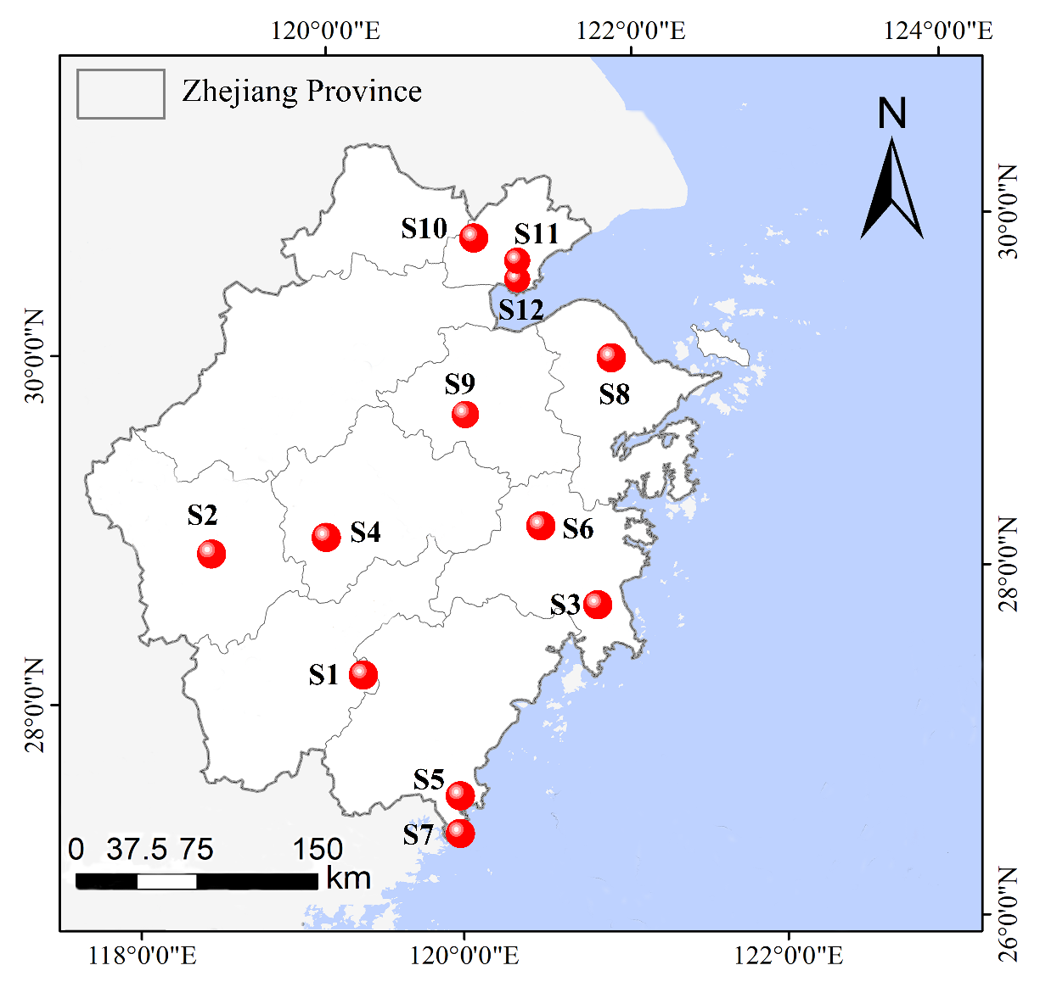
Fig. S1 Map detailing the sampling sites in Zhejiang province, China (Eltohamy et al. 2023).
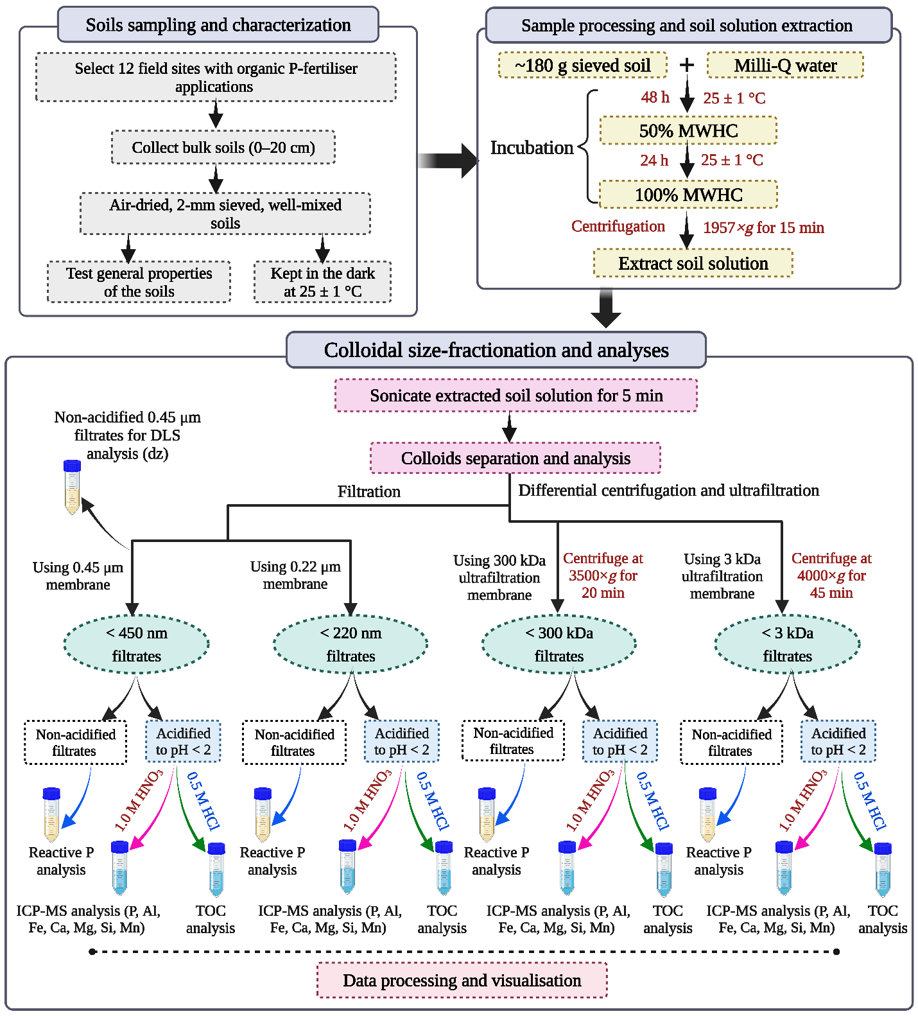
Fig. S2 The analytical flowchart shows the analytical workflow of the study.
Table S1. Background information on the selected sites.
Site | City | Location  (Latitude °, Longitude °) | Annual rainfall  (mm) | Land use
S1 | Liandu | 28.35521 N, 119.76349 E | 1474 | Rice-wheat rotation
S2 | Kecheng | 28.995007 N, 118.852710 E | 1187 | Vegetables
S3 | Luqiao | 28.508161N, 121.508641E | 1635 | Vegetables
S4 | Longquan | 27.978005 N, 119.06436 E | 896 | Rice-rape rotation
S5 | Lingxi | 27.223536 N, 120.426302 E | 1670 | Double cropping rice
S6 | Tiantai | 29.153014 N, 120.856479 E | 1374 | Vegetables
S7 | Mazhan | 27.275114 N, 120.485174 E | 1700 | Vegetables
S8 | Zhoushan | 30.038486N, 122.289812E | 1223 | Single rice
S9 | Zhuji | 29.742335 N, 120.407518 E | 1286 | Single rice
S10 | Tongxiang | 30.671709 N, 120.439522 E | 1633 | Rice-wheat rotation
S11 | Haining | 30.465654 N, 120.714636 E | 1489 | Rice-rape rotation
S12 | Haining | 30.4564486N, 120.746377E | 1657 | Orchard

Table S2. Detailed fertilisation schedule for each site over the previous two years prior to sampling (Eltohamy et al. 2023).
Siteª | City | Urea | Superphosphate | Compound fertiliser (15:15:15) | KCl | Ammonium bicarbonate | Organic fertiliser
 |  |  |  |  |  |  | Swine manure | Biogas slurry | Modified biocharª
Siteª | City | kg ha⁻¹ | kg ha⁻¹ | kg ha⁻¹ | kg ha⁻¹ | kg ha⁻¹ | kg ha⁻¹ |  | kg ha⁻¹
S1 | Liandu | 240 | 210 | − | 100.5 | 262.5 | 6000 | − | −
S2 | Kecheng | 350 | 595 | − | − | − | 8617 | − | 1500
S3 | Luqiao | 450 | 750 | − | 300 | − | 7500 | − | −
S4 | Longquan | 450 | 375 | − | 150 | 375 | − | 4500 | −
S5 | Lingxi | 105 | 52.5 | 315 | − | − | − | 3600 | −
S6 | Tiantai | 367.5 | 252 | − | 294 | − | 7200 | − | 1950
S7 | Mazhan | 345 | 495 | − | 150 | − | − | − | 1950
S8 | Zhoushan | 420 | − | 240 | − | − | − | − | 1725
S9 | Zhuji | 262.5 | 157.5 | 210 | 105 | 262.5 | − | − | 1725
S10 | Tongxiang | − | − | 525 | − | − | − | − | 1725
S11 | Haining | 502.5 | 720 | − | 289.5 | − | − | − | 3462
S12 | Haining | − | − | 300 | − | − | − | − | 1950

Table S3. Physical and chemical properties of modified biochar, sheep manure, and biogas slurry (Li et al. 2021).
Parameters | Modified biocharª | Sheep manure | Biogas slurry
Pyrolysis temperature (°C) | 600 | – | –
pH | 10.8 | 7.9 | 7.5
CEC (cmol kg⁻¹) | 46.2 | 421.6 | –
Total C (%) | 24.10 | 14.7 | 0.42
Total N (%) | 3.12 | 0.7 | 0.06
Total P (g kg⁻¹) | 6.8 | 2.4 | 0.25
Water extractable P (mg kg⁻¹) | 845 | 520 | –
Total oxygen (g kg⁻¹) | 2.82 | – | –
Total hydrogen (g kg⁻¹) | 0.34 | – | –
Ash content (%) | 4.5 | 23 | –
Surface area (m² g⁻¹) | 3.7 | 3.1 | –
Biochar was produced by rice straw at 600 °C for 2 h under oxygen-limited conditions, and the straw biochar was modified by anionic polyacrylamide (molecular weight 12 million) solution (50:1, w/w) at 100 °C for 1 h (Li et al. 2021).

Table S4. Mean concentrations of total dissolved phosphorus (TDP), organic carbon (TDOC), aluminium (TDAl), iron (TDFe), magnesium (TDMg), calcium (TDCa), silicon (TDSi), and manganese (TDMn) in soil solution (n = 3)
Soils | TDP  (μg L⁻¹) | TDOC  (mg L⁻¹) | TDAl  (mg L⁻¹) | TDFe  (mg L⁻¹) | TDMg (mg L⁻¹) | TDCa  (mg L⁻¹) | TDSi  (mg L⁻¹) | TDMn (mg L⁻¹)
S1 | 2238.0^{b} | 335.2ª | 28.5ª | 27.1ª | 27.2e | 52.0^{b} | 14.8^{b} | 6.8^{f}
S2 | 2826.3ª | 109.7de | 7.2^{c} | 7.0^{c} | 157.8ª | 109.8ª | 12.7^{bc} | 33.0ª
S3 | 1870.6^{c} | 136.5^{cd} | 3.5^{d} | 2.6^{d} | 82.9^{b} | 41.5^{c} | 9.5^{d} | 10.1e
S4 | 596.2^{d} | 75.3^{fg} | 9.8^{b} | 8.3^{c} | 21.3e | 23.4de | 5.9^{f} | 12.9^{d}
S5 | 400.7de | 152.4^{c} | 9.4^{b} | 9.9^{b} | 37.3^{d} | 20.1e | 6.5^{ef} | 11.3de
S6 | 427.9de | 144.2^{c} | 2.5^{d} | 0.7e | 3.3^{f} | 4.7^{g} | 20.4ª | 7.6^{f}
S7 | 459.0de | 75.6^{fg} | 1.8^{d} | 1.0e | 37.6^{d} | 27.3^{d} | 13.6^{bc} | 1.6^{g}
S8 | 352.6^{ef} | 222.6^{b} | 7.8^{bc} | 7.1^{c} | 68.9^{c} | 40.7^{c} | 9.4^{d} | 15.0^{c}
S9 | 274.4^{efg} | 67.6^{fg} | 2.8^{d} | 0.3e | 33.4de | 42.5^{c} | 8.3de | 1.4^{g}
S10 | 189.7^{fg} | 90.8^{ef} | 2.7^{d} | 0.8e | 8.9^{f} | 11.9^{f} | 5.3^{fg} | 17.1^{b}
S11 | 142.7^{g} | 34.7^{h} | 2.7^{d} | 0.1e | 41.1^{d} | 19.7e | 2.9^{g} | 6.1^{f}
S12 | 123.5^{g} | 52.7^{gh} | 3.1^{d} | 1.0e | 2.6^{f} | 2.2^{g} | 12.0^{c} | 0.5^{g}
Lowercase letters indicate significant differences in the independent variables among the soils at p < 0.05.

Table S5. Average concentration of truly soluble phosphorus (TSP), organic carbon (TSOC), aluminium (TSAl), iron (TSFe), magnesium (TSMg), calcium (TSCa), silicon (TSSi), and manganese (TSMn) in the soil solution (n = 3)
Soils | TSP  (μg L⁻¹) | TSOC  (mg L⁻¹) | TSAl  (mg L⁻¹) | TSFe  (mg L⁻¹) | TSMg  (mg L⁻¹) | TSCa  (mg L⁻¹) | TSSi  (mg L⁻¹) | TSMn  (mg L⁻¹)
S1 | 196.6^{c} | 101.8ª | 4.0ª | 3.2ª | 10.2^{d} | 45.0^{b} | 8.2^{d} | 3.5e
S2 | 1467.4ª | 23.2e | 0.8^{gh} | 0.0^{c} | 138.9ª | 99.4ª | 8.5^{cd} | 28.5ª
S3 | 817.0^{b} | 40.6^{cd} | 0.4^{i} | 0.1^{c} | 64.6^{b} | 37.1^{c} | 7.1de | 7.1^{d}
S4 | 118.2^{d} | 34.1de | 0.9^{fgh} | 0.2^{c} | 12.0^{d} | 20.9e | 4.4^{fg} | 11.2^{c}
S5 | 71.9de | 30.0de | 2.0^{c} | 2.8^{b} | 26.5^{c} | 18.6e | 5.4^{ef} | 10.1^{c}
S6 | 112.4^{d} | 46.6^{c} | 1.2^{ef} | 0.1^{c} | 1.2e | 4.0^{g} | 17.1ª | 6.2^{d}
S7 | 218.9^{c} | 29.5de | 0.9^{fgh} | 0.1^{c} | 29.7^{c} | 25.7^{d} | 13.1^{b} | 1.2^{f}
S8 | 119.4^{d} | 94.9ª | 2.5^{b} | 2.6^{b} | 60.1^{b} | 37.6^{c} | 7.7^{d} | 13.6^{b}
S9 | 46.7^{ef} | 36.7^{cd} | 0.7^{hi} | 0.1^{c} | 24.9^{c} | 38.7^{c} | 6.9de | 0.9^{f}
S10 | 47.7^{ef} | 58.7^{b} | 1.3de | 0.0^{c} | 4.0e | 10.9^{f} | 2.6^{gh} | 15.3^{b}
S11 | 15.9^{f} | 24.8e | 1.1^{efg} | 0.0^{c} | 28.5^{c} | 18.5e | 2.1^{h} | 5.3de
S12 | 19.9^{f} | 37.5^{cd} | 1.6^{d} | 0.3^{c} | 0.9e | 2.0^{g} | 10.3^{c} | 0.2^{f}
Lowercase letters indicate significant differences in the independent variables among the soils at p < 0.05.

Table S6. Average concentrations of colloidal organic carbon (OC_{coll}), aluminium (Al_{coll}), iron (Fe_{coll}), magnesium (Mg_{coll}), calcium (Ca_{coll}), silicon (Si_{coll}), and manganese (Mn_{coll}) in soil solution (n = 3)
Sites | OC_{coll}  (mg L⁻¹) | Al_{coll}  (mg L⁻¹) | Fe_{coll}  (mg L⁻¹) | Mg_{coll}  (mg L⁻¹) | Ca_{coll}  (mg L⁻¹) | Si_{coll}  (mg L⁻¹) | Mn_{coll}  (mg L⁻¹)
S1 | 234.0ª | 25.1ª | 24.5ª | 17.6ª | 7.6^{b} | 7.2ª | 3.9^{b}
S2 | 87.1^{c} | 7.0^{cd} | 7.6^{c} | 19.5ª | 11.0ª | 4.8^{b} | 5.1ª
S3 | 96.5^{c} | 3.7e | 3.1e | 18.8ª | 5.0^{c} | 3.0de | 3.6^{b}
S4 | 42.6^{d} | 9.5^{b} | 8.7^{b} | 9.9^{cd} | 3.1e | 2.1^{ef} | 2.3^{c}
S5 | 123.0^{b} | 8.0^{bc} | 7.7^{bc} | 11.4^{bc} | 2.1^{f} | 1.7^{fg} | 1.8de
S6 | 98.2^{c} | 1.9e | 1.2^{f} | 2.7^{f} | 1.3^{gh} | 3.9^{c} | 2.0^{cd}
S7 | 46.7^{d} | 1.6^{f} | 1.5^{f} | 8.5^{d} | 2.2^{ef} | 1.1^{g} | 1.0^{fg}
S8 | 128.3^{b} | 5.9^{d} | 5.1^{d} | 9.4^{cd} | 3.7de | 2.3e | 2.0^{cd}
S9 | 31.5^{def} | 2.7^{ef} | 0.8^{f} | 9.1^{cd} | 4.4^{cd} | 2.0^{ef} | 1.1^{fg}
S10 | 32.7de | 2.0^{ef} | 1.4^{f} | 5.5e | 1.6^{fgh} | 3.3^{d} | 2.4^{c}
S11 | 10.5^{f} | 2.2^{ef} | 0.7^{f} | 13.2^{b} | 1.8^{fg} | 1.4^{fg} | 1.4^{ef}
S12 | 15.8^{ef} | 2.1^{ef} | 1.3^{f} | 2.3^{f} | 0.7^{h} | 2.3e | 0.9^{g}
Lowercase letters indicate significant differences in the independent variables among the soils at p < 0.05.

Table S7. Pearson correlation coefficient (r) of the colloidal P (P_{coll}) forms and other colloidal compositions in soil solution at the three colloidal fractions
r |  | NC (1−20 nm) |  |  |  | FC (20−220 nm) |  |  |  | MC (220−450 nm) |  |  |  | Sum of fractions (1−450 nm)
r |  | P_{coll} | Pi_{coll} | Po_{coll} |  | P_{coll} | Pi_{coll} | Po_{coll} |  | P_{coll} | Pi_{coll} | Po_{coll} |  | P_{coll} | Pi_{coll} | Po_{coll}
OC_{coll} |  | 0.55** | 0.27 | 0.67** |  | 0.73** | 0.75** | 0.22 |  | 0.74** | 0.82** | 0.23 |  | 0.75** | 0.80** | 0.24
Al_{coll} |  | 0.32 | 0.31 | 0.30 |  | 0.84** | 0.90** | 0.16 |  | 0.82** | 0.73** | 0.49* |  | 0.81** | 0.89** | 0.23
Fe_{coll} |  | 0.27 | 0.22 | 0.29 |  | 0.86** | 0.90** | 0.22 |  | 0.83** | 0.74** | 0.49* |  | 0.83** | 0.88** | 0.28
Mg_{coll} |  | 0.27 | 0.25 | 0.27 |  | 0.79** | 0.64** | 0.60** |  | 0.54** | 0.32 | 0.55** |  | 0.76** | 0.56** | 0.67**
Ca_{coll} |  | 0.64** | 0.73** | 0.52** |  | 0.84** | 0.70** | 0.60** |  | 0.59** | 0.25 | 0.89** |  | 0.82** | 0.50** | 0.90**
Si_{coll} |  | 0.31 | 0.23 | 0.33 |  | 0.78** | 0.59** | 0.69** |  | 0.75** | 0.89** | 0.18 |  | 0.85** | 0.81** | 0.46*
Mn_{coll} |  | 0.25 | 0.25 | 0.23 |  | 0.78** | 0.59** | 0.68** |  | 0.86** | 0.44* | 0.87** |  | 0.84** | 0.56** | 0.84**
Note that values with * are significant (p ≤ 0.05) and with ** are highly significant (p ≤ 0.01) using the standard t-test

References
Eltohamy KM, Li J, Gouda M, et al (2023) Nano and fine colloids suspended in the soil solution regulate phosphorus desorption and lability in organic fertiliser-amended soils. Sci Total Environ 858:160195. https://doi.org/https://doi.org/10.1016/j.scitotenv.2022.160195
Li F, Zhang Q, Klumpp E, et al (2021) Organic Carbon Linkage with Soil Colloidal Phosphorus at Regional and Field Scales: Insights from Size Fractionation of Fine Particles. Environ Sci Technol 55:5815–5825. https://doi.org/10.1021/acs.est.0c07709

