Additional file 1: Table S1 Overall accuracy and Kappa index of supervised classification from 1985 to 2019. Table S2 The transformation of different marsh types and land reclamations between 1987 and 2021, where the total was the net change of land cover. Table S3 The soil C storage at the 0-100 cm soil depth and plant C storage per unit area, and their proportion to total C storage. Table S4 A brief comparison of S. alterniflora and mudflats, in the aspect of soil C stock, plant C stock, and CAR. Fig. S1 The flow chart of data analysis and remote sensing used to calculate the dynamics of C sequestration in Yancheng saltmarsh. Fig. S2 Factors in manipulating the C storage in Plant Soil in which (a) the indicators regulating plant biomass, (b) the indicators regulating C storage at the 0-20 cm soil depth, and (c) the indicators regulating C storage at the 20-50 cm soil depth. Fig. S3 The variation of total area in Yancheng saltmarsh along with time series. Fig. S4 The changes in coastlines under anthropogenic reclamation. Fig. S5 The proportion of different vegetation to the total area of Yancheng saltmarsh with time series. Fig. S6: The regulations of soil C storage, in which (a) the relationships between the total soil C storage in Yancheng saltmarsh and the total area of Yancheng saltmarsh, (b) the relationships between the total soil C storage in Yancheng saltmarsh and the area of S. alterniflora in Yancheng, and(c) the correlation of soil C accumulation rate and surface soil C stock. Fig. S7 The niches of different vegetations on the salt gradient and the consequences of S. alterniflora invasion on the saltmarsh vegetation successions.

Tables:
Table S1 Overall accuracy and Kappa index of supervised classification from 1985 to 2021
Year | Overall accuracy | Kappa index
1982 | 98% | 0.90
1987 | 92% | 0.87
1992 | 93% | 0.89
2002 | 88% | 0.82
2007 | 92% | 0.88
2012 | 87% | 0.83
2017 | 90% | 0.87
2021 | 91% | 0.85

Transformation | Area (km²) | Total (km²) | Proportion (%)
MF→SA | 245.5 | 287.5 | 85
SS→SA | 29.37 | 287.5 | 10
PA→SA | 12.62 | 287.5 | 4.0
PA→LD | 49.88 | 62.47 | 80
SS→PA | 100.7 | 368.7 | 27
SS→LD | 93.96 | 368.7 | 25
SS→MF | 144.7 | 368.7 | 39
Table S2 The transformation of different marsh types and land reclamations between 1987 and 2021, where the total was the net change of land cover. PA was P. australis, SA was S. alterniflora, SS was S. salsa, MF was mudflats, and LD was land reclamation
Table S3 The soil C storage at the 0-100 cm soil depth and plant C storage per unit area, and their proportion to total C storage. The P/T was the ratio of plant C storage to total C storage, and the S/T was the ratio of soil C storage to total C storage. PA was P. australis, SA was S. alterniflora, and SS was S. salsa
Vegetation | Soil C storage (Mg C ha⁻¹) | Plant C storage (Mg C ha⁻¹) | P/T (%) | S/T (%)
PA | 57.48±24.49 | 7.89±4.47 | 12 | 88
SA | 56.31±24.71 | 12.70±11.19 | 18 | 82
SS | 49.36±19.50 | 9.83±4.45 | 2 | 98

Table S4 A brief comparison of S. alterniflora and mudflats, in the aspect of soil C stock, plant C stock, and CAR
Type | Soil C stock (Mg C ha⁻¹) | Plant C stock (Mg C ha⁻¹) | CAR (g C m⁻² yr⁻¹)
S. alterniflora | 56.31±2.70 | 12.70±11.19 | 242.2±11.28
Mudflats | 24.71±5.24 | 0 | 36.58±2.86

Figures:
Fig. S1 The flow chart of data analysis and remote sensing used to calculate the dynamics of C sequestration in Yancheng saltmarsh
Fig. S2 Factors in manipulating the C storage in Plant Soil in which (a) the indicators regulating plant biomass, (b) the indicators regulating C storage at the 0-20 cm soil depth, and (c) the indicators regulating C storage at the 20-50 cm soil depth. The red lines showed positive paths and the green lines showed negative paths. Meanwhile, the solid line indicated that there was a significant relationship, while the dotted line indicated that there was no significant relationship
Fig. S3 The variation of total area in Yancheng saltmarsh along with time series

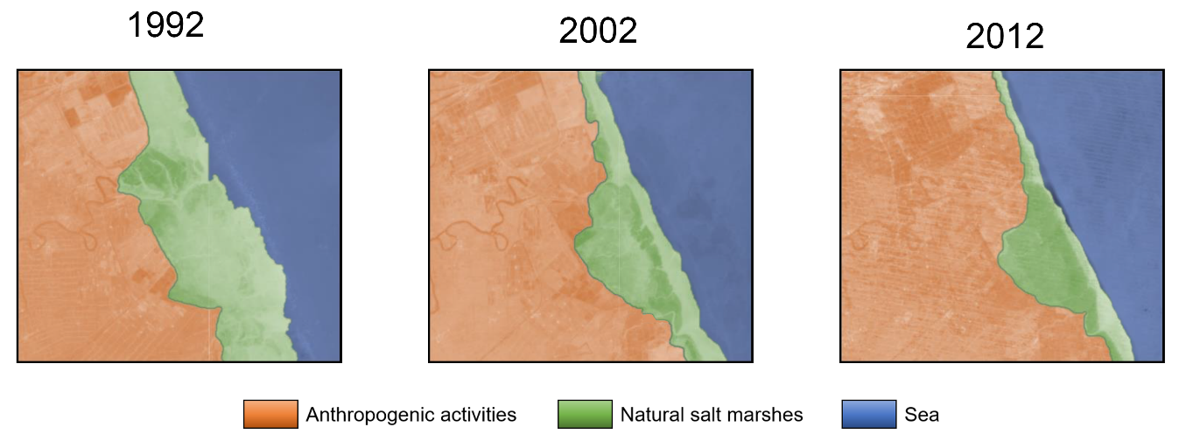
Fig. S4 The changes in coastlines under anthropogenic reclamation
Fig. S5 The proportion of different vegetation to the total area of Yancheng saltmarsh with time series. PA was P. australis, SA was S. alterniflora, and SS was S. salsa
Fig. S6: The regulations of soil C storage, in which (a) the relationships between the total soil C storage in Yancheng saltmarsh and the total area of Yancheng saltmarsh, (b) the relationships between the total soil C storage in Yancheng saltmarsh and the area of S. alterniflora in Yancheng, and (c) the correlation of soil C accumulation rate and surface soil C stock

Fig. S7 The niches of different vegetations on the salt gradient and the consequences of S. alterniflora invasion on the saltmarsh vegetation successions

