Supplementary Information

Production of reactive oxygen species and its role in mediating the abiotic transformation of organic carbon in sandy soil under vegetation restoration

Fuhao Liu^{a,b#}, Kecheng Zhu^{a,b#}, Zhiqiang Wang^{a,b}, Jinbo Liu^{a,b}, Zheng Ni ^{a,b}, Yuanyuan Ding^{a,b}, Chi Zhang^{a,b}, and Hanzhong Jia^{a,b}*

ªCollege of Natural Resources and Environment, Northwest A&F University, Yangling 712100, China
^{b}Key Laboratory of Low-carbon Green Agriculture in Northwestern China, Ministry of Agriculture and Rural Affairs, Yangling 712100, China

* Corresponding author
E-mails: jiahz@nwafu.edu.cn
#Fuhao Liu and Kecheng Zhu contributed equally to this work.

19 pages
5 Texts
2 Tables
11 Figures

Text S1 To isolate POC (53–2000 μm) and MOC (<53 μm) fractions, we used a classic size separation method following chemical dispersion (Lavallee et al. 2020). Specifically, 10 g of air-dried and sieved (<2 mm) soil was shaken in 50 mL of 0.5% sodium hexametaphosphate dispersing solution for 18 h. The dispersed soil solution was rinsed onto a 53 μm sieve and organic material passing through (<53 μm) was defined as MOC and organic material in the fraction remaining on the sieve (53–2000 μm) was defined as POC (Yu et al. 2022).

Text S2 K₂CrO₇ (99.8%), Benzoic acid (BA, 99%) and hydroethidine (HE, or dihydroethidium) of the highest purity were purchased from J&K Scientific Ltd, China. Hydroxylamine hydrochloride (98%), hydrochloric acid (GR), Methyl Cyanide (HPLC grade, 98%) and phosphoric acid (HPLC grade, 85%) were obtained from the National Medicines Corporation Ltd. (Beijing, China). All chemical reagents were used without further purification. Methanol (HPLC grade) was obtained from TEDIA Company (USA). All solutions were prepared using ultrapure water from a Synergy UV ultrapure water system with a Millipak-40 filter unit (Millipore Corporation Merck KGaA, Darmstadt, Ge).

Text S3 Soil pH was measured at a soil: water ratio of 1:2.5 (w/w) using a pH meter (METTLER TOLEDO). SOC, POC and MOC were determined by K₂CrO₇ digestion with external heating, the dissolved organic carbon (DOC) was tested by a total organic carbon analyzer (Shimadzu, TOC-L, Japan). Soil dissolved Fe(Ⅱ) was extracted by 0.5 M hydrochloric acid and then measured by the 1,10-o-phenanthroline analytical method at 510 nm using Evolution 201 UV–Visible spectrophotometer (Thermo Scientific, USA).

Text S4 For the detection of O₂^{•−} and •OH, 200 mg of soil was suspended into 100 mM DMPO in dimethyl sulfoxide (DMSO) or 1 mL 100 mM DMPO aqueous solution. Subsequently, the mixture was shaken for 1 min by a vortex oscillator, and the suspension was filtered through a 0.45 μm filter. Then, the filtrate was put in a capillary, placed in EPR tube, and analyzed using a Bruker EMXmicro-6/1/P/L spectrometer (Karlsruhe) EPR spectrometer. EPR instrument operating parameters were center field 3500 G; microwave frequency 9.8 GHz; microwave power 2.0 mW; modulation frequency 4.0 G; modulation amplitude 4.0 G; sweep width 200 G; receiver gain 3.54 × 104; time constant 41.0 ms; sweep time 15 s; 15 scans.

Text S5 The chemical probe of benzoic acid (BA) was utilized to measure the •OH concentration, which was transformed to p-hydroxybenzoic acid (p-HBA) after reacting with •OH. Specifically, 0.5 g of soil was blended with an excessive amount of BA probe (5 mM) and then rotated at 200 rpm in a reciprocating shaker under dark conditions. After that, the mixture was immediately filtered through a 0.22 μm organic membrane filter and 750 μL aliquots were collected into the brown bottle, and 50 μL methanol was added to terminate the reaction. Finally, the concentration of p-HBA was detected by an LC-15C HPLC (Ultimate3000) equipped with a UV detector and an Inter Sustain C18 column.
H₂O₂ concentration was determined by hydrogen peroxide assay kit purchased from Solarbio Life Sciences Co., Ltd (Beijing, China). Briefly, 0.5 g soil samples were mixed with 1 mL acetone. After that, the suspension was vortexed for 5 min and then centrifuged for 10 min at 8000 ×g. The obtained supernatants were collected and filtered using a syringe equipped with a 0.45 μm nylon water membrane. Finally, the filtrate was utilized for H₂O₂ analysis following the manufacturers’ protocol.
O₂^{•−} was analyzed by a modified hydroethidine (HE)-based assay. Specifically, O₂^{•−} was quantified by its unique scavenging reaction with HE in the presence of protons (from HCl). Their reaction generateda fluorescent substance known as 2-hydroxyethidium (2-OH-E⁺), which was measured at ex/em 505/580 nm with Microplate System (SpectraMax iD5, Molecular Devices, LLC. USA).
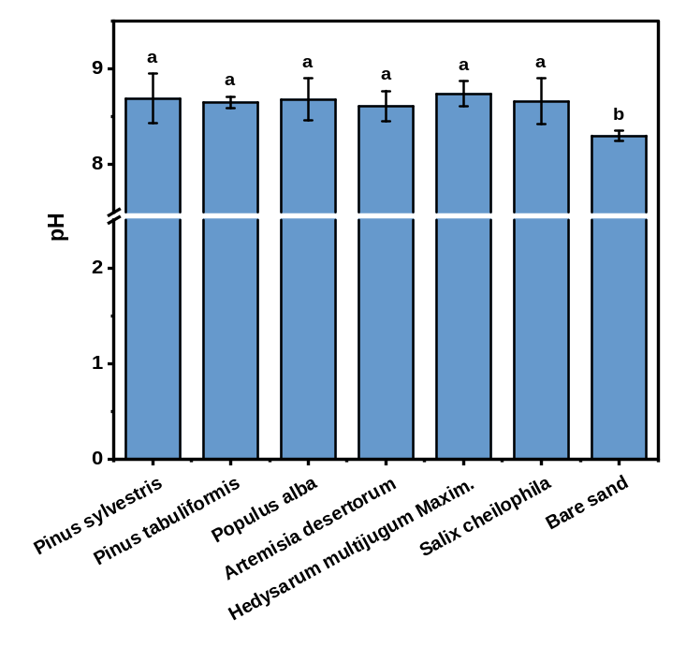Fig. S1 The pH values in different soil samples under vegetation restoration and bare sand. The bars indicate the standard error of the mean and different letters indicate significant differences (p < 0.05).
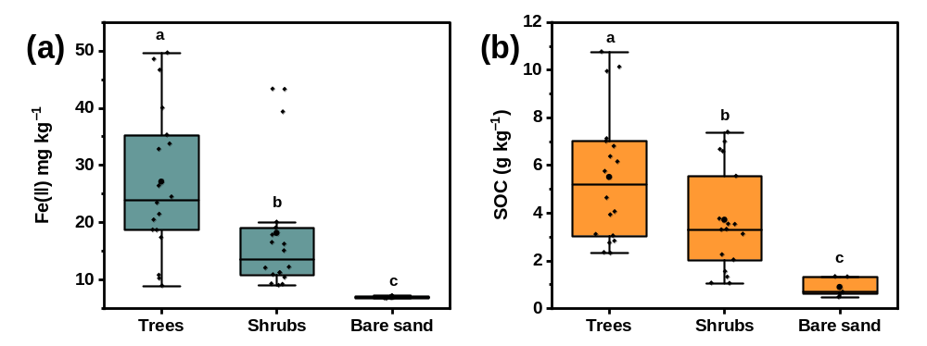Fig. S2 Difference of the concentration of Fe(Ⅱ) (a) and SOC (b) in soils covered by trees and shrubs, and bare sand (b). Letters indicate the presence of statistically significant (p < 0.05) differences samples.
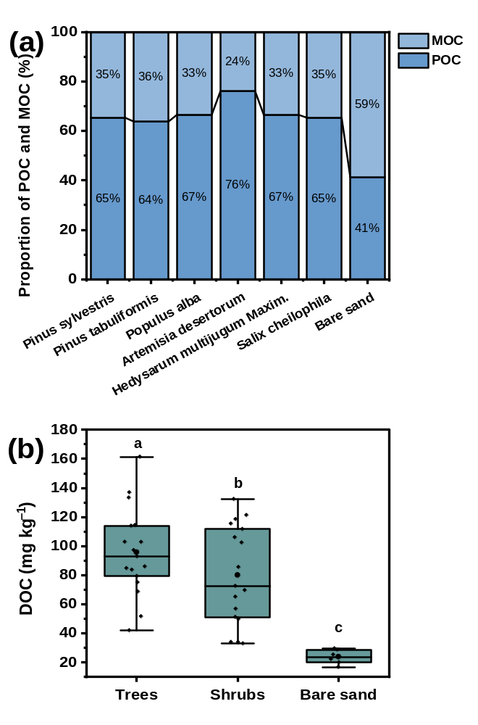Fig. S3 Proportion of POC and MOC in SOC (a). Difference of the concentration of DOC in soils covered by trees and shrubs, and bare sand (b). Letters indicate the presence of statistically significant (p < 0.05) differences samples.
Fig. S4 EPR spectra of O₂^{•−} (a) and •OH (b) in vegetated soils and bare sand captured by a mixture of DMSO or water with the spin-trapping agent of DMPO.

Fig. S5 The production concentration of •OH at different time intervals.

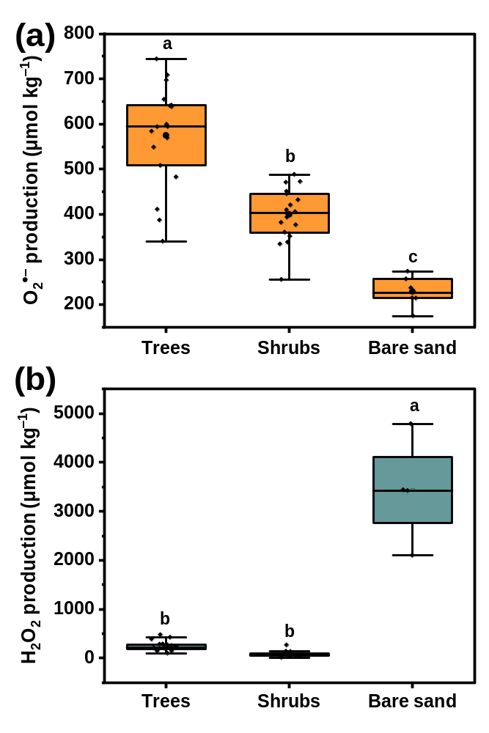Fig. S6 Difference of the concentration of O₂^{•−} (a) and H₂O₂ (b) in soils covered by trees and shrubs, and bare sand (b). Letters indicate the presence of statistically significant (p < 0.05) differences samples.
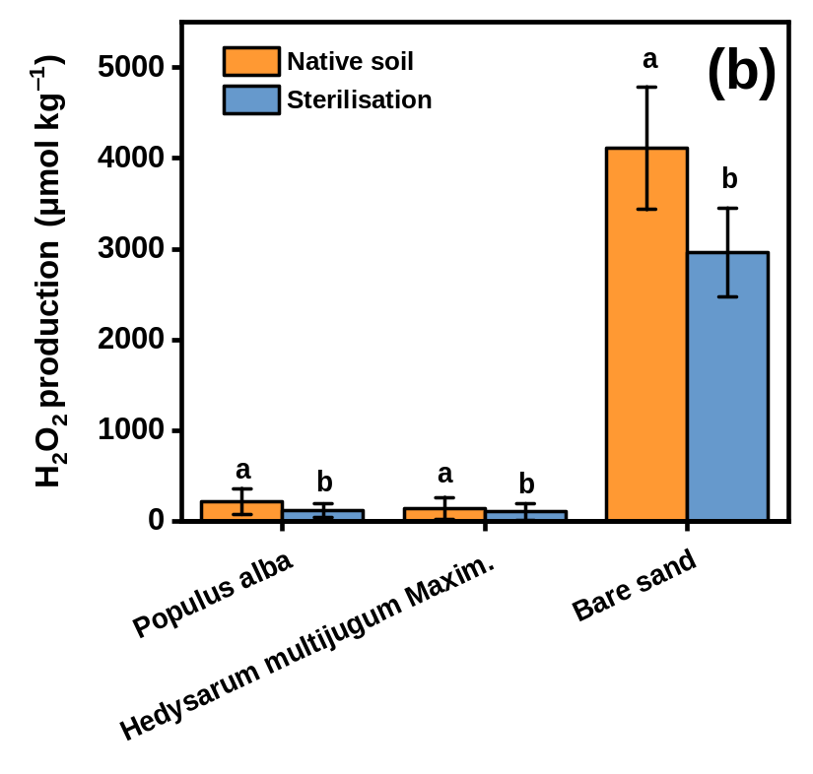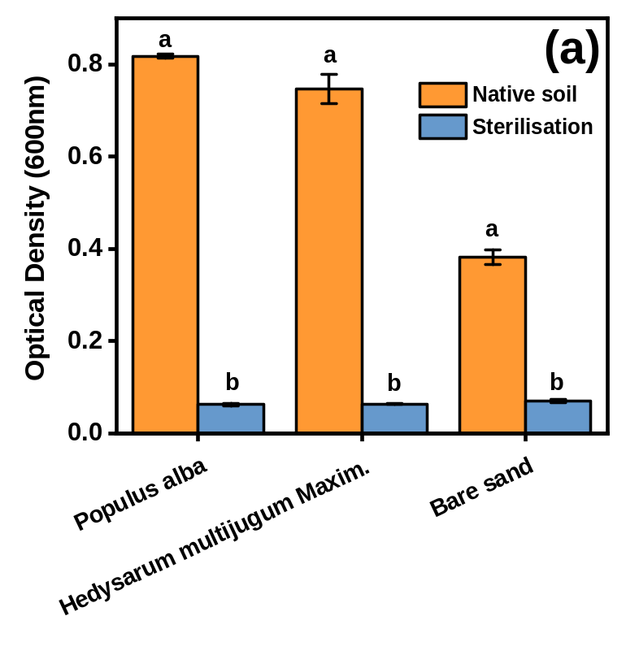Fig. S7 The effects of sterilisation on microbial communities activities (a) and H₂O₂ concentrations in soil samples (b).

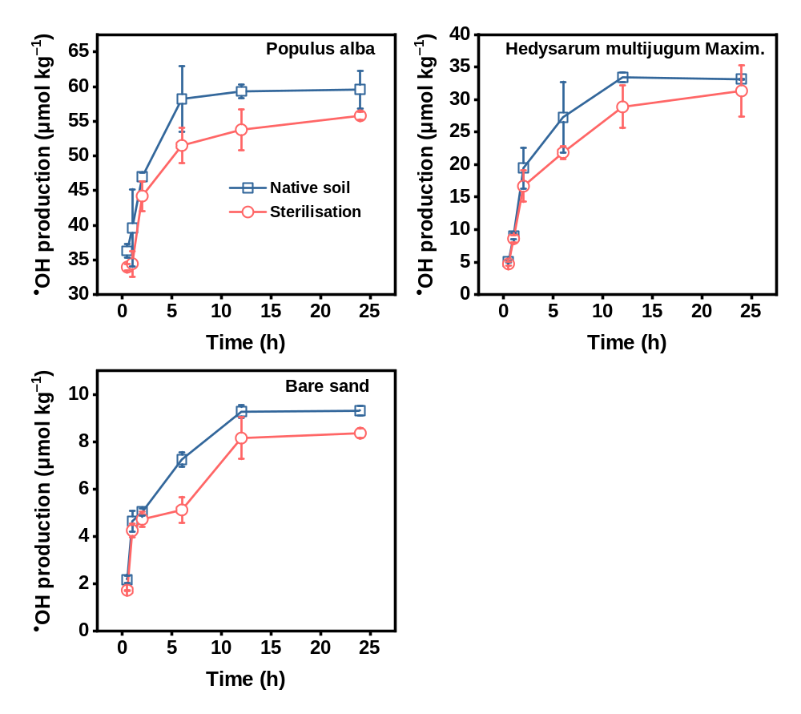Fig. S8 The effect of sterilisation on the accumulation of •OH in soil samples.
Fig. S9 The production of H₂O₂ during incubation in soil samples (a). The content change of β-D-glucosidase during incubation (b). The grey-shaded region represents the time period prior to sampling during the incubation experiment.

Fig. S10 Correlation heat maps between dominant bacterial phyla and ROS in different soils.
Fig. S11 Correlation analyses between the decrease in •OH accumulation (μmol kg⁻¹) and the production of CO₂ (μg C g⁻¹ soil d⁻¹) under the addition of 10%TBA in γ-irradiation sterilisation soils.

Table S1 Microbial diversity metrics (α-diversity) in soil samples were determined by 16S rDNA Illumina sequencing.
Treatments | OTUs numbers | Shannon | Simpson | Chao1 | Pielou-e
Pinus sylvestris | 2506±5 | 10.29±0.07 | 1.00±0.01 | 2284.39±7.99 | 0.91±0.01
Pinus tabuliformis | 2100±7 | 10.14±4.54 | 1.00±0.03 | 2100.03±13.25 | 0.89±0.01
Populus alba | 2420±52 | 10.23±0.11 | 1.00±0.03 | 2427.26±67.43 | 0.91±0.01
Artemisia desertorum | 3217±44 | 10.52±0.09 | 1.00±0.04 | 2237.52±32 | 0.94±0.01
Hedysarum multijugum Maxim. | 2280±37.5 | 10.28±0.06 | 1.00±0.01 | 2520.11±10.51 | 0.92±0.01
Salix cheilophila | 2243±42.5 | 10.31±0.03 | 1.00±0.02 | 2250.58±32.05 | 0.93±0.01
Bare Sand | 2008±7 | 9.80±0.09 | 1.00±0.03 | 2008.00±3.92 | 0.90±0.01

Table S2 Changes in soil properties of the samples (with n=3 replicates) after a 36-day incubation experiment.
 | 1d | 36d | 1d | 15d | 36d | 1d | 36d | 1d | 36d | 1d | 36d | 1d | 36d
Vegetation type | pH |  | Fe(Ⅱ) (mg kg⁻¹) |  |  | DOC (mg kg⁻¹) |  | POC (g kg⁻¹) |  | MOC g kg⁻¹) |  | SOC (g kg⁻¹)
Populusalba | 8.40±0.04a | 8.33±0.06a | 66.49±2.80ab | 55.05±5.66b | 79.50±9.30a | 143.15±8.84a | 103.03±5.38b | 8.45±0.08a | 7.42±0.27b | 3.61±0.12a | 3.65±0.03a | 12.08±0.35a | 11.39±0.52a
Hedysarum multijugum Maxim. | 8.59±0.11a | 8.66±0.09a | 48.92±0.98c | 43.74±1.03b | 61.47±3.19a | 136.52±2.18a | 89.38±6.42b | 3.38±0.13a | 2.48±0.12b | 1.97±0.08a | 1.91±0.04a | 5.27±0.03a | 4.97±0.06b
bare sand | 8.32±0.05a | 8.35±0.04a | 10.46±1.12a | 6.85±0.55b | 10.67±0.60a | 34.59±1.22a | 20.64±3.62b | 0.08±0.01a | 0.03±0.00a | 0.15±0.00a | 0.14±0.00a | 0.29±0.08a | 0.23±0.04a
Notes: Fe(Ⅱ), soil ferrous iron extracted by 0.5-M hydrochloric acid (HCl); DOC, dissolved organic carbon; POC, particulate organic carbon; MOC, mineral-associated organic carbon; SOC, soil organic carbon.
Reference:
Lavallee, JM., Soong, JL., Cotrufo, MF., 2020. Conceptualizing soil organic matter into particulate and mineral-associated forms to address global change in the 21st century. Global Change Biol. 26, 261-273. https://doi.org/10.1111/gcb.14859
Yu, W.J., Huang, W.J., Weintraub-Leff, S.R., Hall, S.J., 2022. Where and why do particulate organic matter (POM) and mineral-associated organic matter (MAOM) differ among diverse soils? Soil Biol. Biochem. 172, 108756. https://doi.org/10.1016/j.soilbio.2022.108756

