Supplementary Information

Heteroaggregation and sedimentation of natural goethite and artificial Fe₃O₄ nanoparticles with polystyrene nanoplastics in water

Aiming Wu ^{a,c†}, Chunyan Yang ^{a,b†}, Xiaoli Zhao ^{a*}, Junyu Wang ª, Weigang Liang ª, Xia Wang ª, Lingfeng Zhou ª, Miaomiao Teng ª, Guoqing Hou ª, Lin Niu ª, Zhi Tang ª, Fengchang Wu ª
a. State Key Laboratory of Environmental Criteria and Risk Assessment, Chinese Research Academy of Environmental Sciences, Beijing 100012, China;
b. State Environment Protection Key Laboratory of Regional Eco-Process and Function Assessment, Chinese Research Academy of Environmental Sciences, Beijing 100012, China;
c. Lijiang Ecology and Environment Bureau, Lijiang 674100, China

Number of Pages: 48
Number of Figures: 23
Number of Tables: 16

1. Experiments

1.1 EPS extraction methods
The Pseudomonas putida MnB1 (ATCC23483) cell suspension was obtained from the study by Zhang ^{[1]}. The suspension was incubated at 28°C with shaking at 150 rpm. After 18 h, when the bacterium had propagated to its stationary phase, the culture solution was used for EPS extraction. The EPS extraction method was based on a previous report ^{[2]} with slight modification. To remove excess medium, the culture solution was centrifuged at 8000 rpm for 5 min, and the residue was then resuspended in pure water and centrifuged at 18,000 rpm for 25 min at 4°C. The supernatant was collected as the raw bacterial EPS (EPS2). Chlorella pyrenoidosa was obtained from Shanghai Guangyu Biotechnology Co., Ltd. (Shanghai, China). The method of extracting EPS from Chlorella solution was based on previous methods ^{[3,4]} with slight modification. To remove the culture medium, the cell suspension (in logarithmic phase) was centrifuged at 4000 g for 5 min after being vibrated to achieve uniform cell distribution. The harvested cells were resuspended in 50% of the original volume and then centrifuged at 10,800 g for 20 min at 4 ℃. The collected supernatant was the raw algal EPS (EPS1). Both raw EPS solutions were filtered through 0.22 μm polyethersulfone membranes and purified with a dialysis membrane (3500 Da) for 24 h at 4°C at least five times. After dialysis, the EPS solutions were finally collected in brown bottles and frozen. Prior to the experiment, the total organic carbon (TOC) concentration of the EPS solutions was measured by a TOC analyzer (TOC-VCPN, Shimadzu, Japan) and the organic components were determined using an F-7000 excitation–emission matrix fluorescence spectroscope (Hitachi). Furthermore, after freeze-drying the EPS solutions, the organic components and functional groups of the EPS powders were determined by FTIR and XPS using an ESCALAB 250Xi (Thermo Scientific, Loughborough, UK).

1.2 Aggregation kinetics of heteroaggregates of goethite and Fe₃O₄ NPs with PS NPs
Goethite and Fe₃O₄ NPs were separately dispersed into PS NP solution for the heteroaggregation experiments. The mixed solution of goethite, Fe₃O₄ NPs, PS NPs, and electrolyte solution (CaCl₂) was pipetted into a DLS glass cuvette. The cuvette was then vortexed for 1 s and immediately placed in the DLS instrument ^{[5]}. The D_{h} measurements were conducted over a period ranging from 30 to 180 min. The initial aggregation rate constant (k_{a}) was proportional to the initial rate of increase in D_{h} with time (dD_{h}(t)/dt), which was calculated in the time period from aggregation initiation (t₀) to the time when D_{h} exceeded 1.50D_{h, 0,} according to Eq. (1) ^{[6,7]}:

(1)

where N₀ is the initial particle concentration. The value of dD_{h}(t)/dt was obtained through linear least squares regression analysis. This relationship has been widely used in studies of the aggregation kinetics of various NPs.
The particle attachment efficiency (α) (or inverse stability ratio, 1/W), ranging from 0 to 1, was used to quantify the aggregation kinetics of goethite and Fe₃O₄ NPs with PS NPs. The value of α was determined by normalizing the k_{a} value obtained under different solution conditions by the k_{fast} value obtained under favorable (fast) aggregation conditions, in which aggregation was independent of the electrolyte concentration, according to Eq. (2):

(2)
where k_{a} and k_{fast} represent the aggregation rate constants under reaction-limited aggregation (RLA) and diffusion-limited aggregation (DLA) regimes, respectively. The α values under RLA and DLA regimes were fitted by linear functions and their intersection yielded the CCC. CCC is the electrolyte concentration when α approaches 1 and is frequently used to measure the stability of NPs since it quantifies the minimum concentration of counter ions required to completely destabilize the particle suspension. In Eq. (2), N₀ can be neglected because the initial goethite and Fe₃O₄ NP concentrations were maintained constant across all samples.

1.3 Extended Derjaguin-Landau-Verwey-Overbeek (XDLVO) Theory

We proposed in our previous study ^{[8]} that osmotic repulsion (OSM), elastic-steric repulsion (ELAS), gravitational energy (V_{G}) ^{[9-12]}, and magnetic attraction (V_{M}) interaction energies should be concurrently integrated into the classic DLVO theory for quantitative analysis of the various interactions that affect the colloidal behavior of Fe₃O₄ NPs. However, the OSM and ELAS interaction energies that cause sorption and/or coating of HA onto NPs was found to be negligible compared to other interaction energies^{[8]}. Thus, V_{G} and V_{M} interaction energies were concurrently integrated into the classic DLVO theory for quantitative analysis of the various interactions affecting the colloidal behavior of heteroaggregates of goethite and Fe₃O₄ NPs with PS NPs or montmorillonite.
Goethite is assumed to be spherical. The ionic strength remained constant at 0.0378 mM (deionized water). The van der Waals (V_{LW}) and EDL (V_{EDL}) interaction energies can be calculated according to Eq. (3) and (6), respectively:
The van der Waals interaction energy (V_{VDW}) is given as follows:
Aggregation ^{[7]}:
$V_{LW}=\frac{-A}{6}[\frac{2a^{2}}{s\left(4a+s\right)}+\frac{2a^{2}}{{\left(2a+s\right)}^{2}}+Ins\frac{\left(4a+s\right)}{{\left(2a+s\right)}^{2}}]$ (3-1)
Sedimentation ^{[13]}:
$V_{LW}=\frac{-Aa}{12s}{\left[1+\frac{14s}{λ}\right]}^{-1}$ (3-2)
where a is the radius of the heteroaggregates; A is the Hamaker constant; s is the distance between NPs (or the separation distance between the NP and quartz surface); and λ is the characteristic wavelength of interaction, usually taken to be 100 nm^{[14]}.
The Hamaker constant between two different particles is calculated as follows:

$A_{132}=\left(\sqrt{A_{11}}-\sqrt{A_{33}}\right)\left(\sqrt{A_{22}}-\sqrt{A_{33}}\right)$ (4)
where A₁₁ and A₂₂ are the Hamaker constants of particles a and b in vacuum, respectively; and A₃₃ is the Hamaker constant of the dispersion medium (water/HA solution). The Hamaker constants of goethite ^{[13]}, Fe₃O₄ NPs ^{[15]}, PS NPs ^{[16]}, montmorillonite ^{[7]}, the quartz cell ^{[17]}, and water ^{[13]} are 5.0 × 10⁻²⁰, 2.1 × 10⁻¹⁹, 6.33 × 10⁻²⁰, 20 × 10⁻²⁰, 8.86 × 10⁻²⁰, and 3.7 × 10⁻²⁰ J, respectively.
In the presence of HA, the Hamaker constant (A_{X}) can be written as Eq. (5), according to the Lifshitz–van der Waals surface tension:

A_{X} = 24πl₀²γ_{x}^{VDW} (5)
where l₀ is the equilibrium separation distance between the surfaces of two interacting particles, which is usually taken as 1.58 ± 0.08 Å ^{[7]}; and γ_{x}^{VDW} is the van der Waals component of the surface free energy of the particle (x = p) or the water/HA solution (x = w), with γ_{HA}^{VDW} = 25.77 × 10⁻³ J/m² ^{[18]}.
To further investigate the effect of HA, A_{HA} = 4.85 × 10⁻²⁰ J in Eq. (5) was used to calculate the energy barrier ^{[13]}.
The A₁₃₂ values were calculated to be 9.77 × 10⁻²², 7.07 × 10⁻²⁰, 8.71 × 10⁻²², 7.41 × 10⁻²¹, 7.97 × 10⁻²¹, 6.78 × 10⁻²⁰, 1.85 × 10⁻²¹, and 1.58 × 10⁻²⁰ in water solutions with goethite, Fe₃O₄ NPs, goethite + HA, Fe₃O₄ NPs + HA, goethite + montmorillonite, Fe₃O₄ NPs + montmorillonite, goethite + PS NPs, and Fe₃O₄ NPs + PS NPs, respectively. In sedimentation processes, sorption and (or) coating of HA or EPS onto goethite or Fe₃O₄ NP heteroaggregates occurred when HA or EPS was present in their suspensions, particularly at high HA or EPS concentrations. Thus, the Hamaker constants for HA (4.85 × 10⁻²⁰ J) and EPS (7.78 × 10⁻²⁰ J) ^{[19]} were employed to represent the Hamaker constant for goethite or Fe₃O₄ NP heteroaggregates in the presence of HA or EPS. The combined Hamaker constants for the HA- and EPS-coated Fe₃O₄ NP (or goethite) heteroaggregate-water-quartz cell systems were 2.94 × 10⁻²¹ and 9.12 × 10⁻²¹ J ^{[13]}, respectively.
The EDL (V_{EDL}) interaction energy is given as follows:

Aggregation ^{[20]}: $V_{EDL}=4πε_{r}ε_{0}a{{}_{p}}^{2}\frac{a+s}{2a+s}ln(1+\frac{ae^{-κs}}{a+s})$ (6-1)
Sedimentation^{[13,17]}:
VEDL=0.5πε0εra2pcln1+exp⁡(-κs)1-exp⁡(-κs)+(p2+c2)ln1-exp⁡(-2κs) (6-2)

where ε_{r} is the relative dielectric constant of the liquid (78.5 C²N⁻¹m⁻²); ε₀ is the permittivity of the vacuum (8.854 × 10⁻¹² C²N⁻¹m⁻²); ζ_{p} and ζ_{c} are the potentials of NPs and quartz, respectively; and κ is the inverse Debye length (Eq. (7)).

(7)

where N_{A} is Avogadro’s constant (6.02 × 10²³ mol⁻¹), e is the electron charge (1.60 × 10⁻¹⁹ C), I is the ionic strength of the solution (mol/m³), k is the Boltzman constant (1.381 × 10⁻²³ m²·kg·s⁻²·K⁻¹), and T is absolute temperature (298 K).
The magnetic attraction (V_{M}) energy between equal-sized Fe₃O₄ NPs and their heteroaggregates is given as follows:

$V_{M}=-\frac{8πμ_{0}{Ms}^{2}a^{3}}{9{(\frac{s}{a}+2)}^{3}}$ (8)
where μ0 is the vacuum permeability (4π × 10⁻⁷ H/m). The saturation magnetization (Ms) values of Fe₃O₄ NPs and their heteroaggregates were 44.94 and 31.31 emu/g (Fig. S17), respectively, which equaled 3.33 × 10⁵ and 2.32 × 10⁵ A·m⁻¹ after conversion, respectively ^{[20]}.
μ0

Gravity is also a significant driving force of colloid deposition on quartz cells ^{[21]}. The gravitational energy is given by △mgh, where △m is the mass of NP minus the mass of the fluid it displaces, g is the acceleration due to gravity, and h is the height of the film ^{[9]}. The separation distance between the NP and quartz surface(s) is usually far less than the particle radius (a). Thus, the gravitational potential (V_{G}) of NP (an NP suspended over the quartz collector, as shown in Fig. S18) might be approximated as ^{[10-12]}:

$V_{G}=\frac{4πa^{3}(a+s)(ρ_{p}-ρ)}{3}$ (9)
where ρp and ρ are the densities of the NPs (4.95 g/cm³ for Fe₃O₄ NPs, 1.05 g/cm³ for PS NPs, 4.0 g/cm³ for goethite, and 1.60 g/cm³ for montmorillonite) and water (1.0 g/cm³), respectively. The average density of NP heteroaggregates was roughly estimated as follows：
ρpρ
$ρ_{p}=\frac{C_{1}+C_{2}}{\frac{C_{1}}{ρ_{1}}+\frac{C_{2}}{ρ_{2}}}$ (10)
where C1 and C2 are concentrations of two NPs in a heteroaggregate suspension; and ρ1 and ρ2 are the densities of two heteroaggregate NPs.
C1C2ρ1ρ2
The total XDLVO interaction energy (E_{TOT-XDLVO}) for NPs is given by
Goethite with PS NPs or montmorillonite: E_{TOT-XDLVO} = V_{LM} + V_{EDL} (11-1)
Fe₃O₄ NPs with PS NPs or montmorillonite: E_{TOT-XDLVO} = V_{LM} + V_{EDL} + V_{M} (11-2)
The total XDLVO interaction energy (E_{TOT-XDLVO}) for sedimentation of NPs is given by
Goethite and Fe₃O₄ NPs with PS NPs or montmorillonite: E_{TOT-XDLVO} = V_{LM} + V_{EDL} + V_{G} (11-3)

The application of XDLVO theory depends on many assumptions. However, goethite, HA, EPS, and heteroaggregate NPs were not spherical granules in this study. Therefore, the XDLVO calculations described above should be viewed as a first approximation of changes anticipated in the mean interaction energy in response to variations in NOM concentration and type ^{[13,17]}.

1.4 Molecular dynamics simulations
The optimized crystal structures of goethite (111) and Fe₃O₄ NPs (311) were obtained from our previous study ^{[8]}. The molecular structures of S- and N-PS NPs were based on the research results of Kim ^{[22]} and Verena ^{[23]}, respectively. Using the Chem3D tool in ChemDraw Professional 20 software to expand the PS molecular structure with 8 and 16 monomer units, the 3D structure of the polymer was then determined through MD simulations using NAMD software (Fig. S19). The gaff force field was adopted for the whole PS NP system, taking PS as the center, extending 0.1 nm outwards, and the topology was saved for the next step of the molecular docking simulation. Since goethite NPs (1000 × 200 nm) are larger than PS NPs (100 nm), while Fe₃O₄ NPs (10 nm) are smaller than PS NPs, the adsorption behavior of the best binding mode of 8 monomer units of PS (as "ligand") on the surface of larger goethite particles (as "acceptor") and smaller Fe₃O₄ NPs (as "ligand") on the surface of 16 monomer units of PS (as "acceptor") were respectively obtained by the molecular docking method. Then, the nanomaterials were surrounded in the lattice docking box to form a grid box (namely, the geometric center of the nanomaterials extended 1.2 nm outward) that wrapped all atoms for molecular docking using the Auto Grid program. Subsequently, all of the ions were placed in the box and randomly connected to the nanomaterials to generate a total of 100 adsorption bonding modes. Those with the lowest energies were selected as the optimal modes for subsequent MD simulations, and the structure of each bonding mode was optimized using NAMD software. Using the GROMACS force field (ffgmx) parameters, the force fields of atoms with different bond angles were set in the whole system. During the MD process, a 2000 kcal/mol position-limiting force was applied to all heavy atoms of the nanomaterials, with the optimization time of each system being at least 70 ns. After optimization, the average complex structure on the 70 ns trajectory was analyzed for structural changes before and after the mutation. All simulations were carried out with a time of step 2 fs at constant temperature (310 K) and pressure (1 bar). To explore the binding modes in the presence of Ca²⁺, the interaction between PS nanoplastics, goethite, and Fe₃O₄ NPs was also considered in the presence of 200 Ca²⁺ ions.

1.5 Heteroaggregation and sedimentation of natural goethite and artificial Fe₃O₄ NPs with montmorillonite and PS NPs
The morphology, ζ potential, and size of natural goethite, Fe₃O₄ NPs, and montmorillonite used in this study were the same as those reported in our previous study ^{[8]}. The D_{h} values of goethite, Fe₃O₄ NPs, and montmorillonite, as measured by TR-DLS, exhibited narrow distributions, with peaks at approximately 907.5, 1130.7, and 336.1 nm, respectively ^{[8]}. The ζ potential of montmorillonite was −24.6 ± 2.3 mV and only weakly altered upon pH change due to its permanent negative structural charges ^{[24]}.
The sedimentation experimental data in deionized water (Fig. S20a, b) revealed that the dispersion stability of goethite suspension increased with increasing concentrations of montmorillonite and S-PS NPs. However, the settleability of Fe₃O₄ NP suspension gradually increased with increasing S-PS NP concentration from 0 to 40 mg/L. With increasing montmorillonite concentration from 0 to 1 mg/L, the dispersion stability of Fe₃O₄ NP suspension gradually decreased but gradually increased with increasing montmorillonite concentration from 5 to 40 mg/L. The change in D_{h} value supported this result (Fig. S20c). In addition, with the addition of HA, montmorillonite, and S-PS NPs, the ζ potential of their heteroaggregates with goethite and Fe₃O₄ NPs gradually changed from positive to negative because a strong EDL repulsive force was generated between particles at the same time (Fig. S1), which was mainly due to the adsorption of montmorillonite and S-PS NPs on their surfaces (Fig. S2a–h). Notably, compared with goethite (4.0 g/cm³) ^{[25]} and Fe₃O₄ NPs (4.95 g/cm³) ^{[26]}, the mass densities (close to water) of montmorillonite (0.6–1.1 g/cm³) ^{[27]} and S-PS NPs (1.03–1.07 g/cm³) ^{[28]} were lower, indicating that the adsorption of montmorillonite or S-PS NPs on the surface of goethite or Fe₃O₄ NPs might promote particle suspension. Unexpectedly, the adsorption of negatively charged S-PS NPs on the positively charged Fe₃O₄ NP surface was beneficial to their heteroaggregation and sedimentation, which might have been due to the ζ potential and surface energy of Fe₃O₄ NPs being higher than those of bulk goethite, which is more conducive to surface charge neutralization and reducing the heteroaggregation energy barrier.
XDLVO theory was used to analyze the heteroaggregation and sedimentation behaviors of goethite and Fe₃O₄ NPs with montmorillonite or S-PS NPs. The analysis indicated that (Fig. S20d and S1, Table S1–S4): (1) The heteroaggregation and sedimentation Φ_{MAX}, mainly due to EDL repulsion (Fig. S1e, f) of goethite in S-PS NP suspension, rapidly increased with increasing S-PS NP concentration, eventually surpassing those in montmorillonite solution (Fig. S20d). This might imply that S-PS NPs could more effectively promote the heteroaggregation and suspension of goethite compared to the same concentration of montmorillonite (Fig. S20a, c). (2) Montmorillonite more effectively promoted heteroaggregation with Fe₃O₄ NPs than S-PS NPs only at low concentrations of montmorillonite and S-PS NP solutions (0–5 mg/L). However, the opposite trend was found at high concentrations of montmorillonite and S-PS NP solutions (20–40 mg/L). This was because Fe₃O₄ NPs had a larger D_{h} value (>2400 nm) at high concentrations of S-PS NPs than that at the same concentration of montmorillonite, resulting in a stronger magnetic attraction interaction between particles (Fig. S1e). More importantly, compared with the same concentrations of montmorillonite (especially <5 mg/L) and S-PS NPs (Fig. S20c and 2a–c), HA more effectively improved the dispersion and suspension of goethite (because HA adsorption on the particle surface provided strong EDL repulsion) and Fe₃O₄ NPs (because of their weak magnetic attraction in HA solution) in the heteroaggregation systems (Fig. S1e, f). (3) At 1 mg/L montmorillonite solution, the settlement curve of the Fe₃O₄ NP heteroaggregation system overlapped slightly with that of the goethite heteroaggregation system because charge neutralization occurred on the surface of Fe₃O₄ NPs and magnetic attraction promoted particle aggregation and then increased gravity interaction (Fig. S1e, f)). However, at high concentrations of montmorillonite solution (5–40 mg/L), the heteroaggregation system formed with Fe₃O₄ NPs and montmorillonite had poor settleability compared to that formed with goethite and montmorillonite because the stronger EDL repulsion (Fig. S1e) led to a lower D_{h} value (Fig. S20c) and gravity interaction (Fig. S1f). In contrast, at the same concentration of S-PS NP solution, the heteroaggregation system formed with Fe₃O₄ and S-PS NPs tended to more significantly aggregate and settle at high concentrations of S-PS NP solution (5–40 mg/L) compared to that formed with goethite and S-PS NPs due to strong magnetic attraction interaction between particles (Fig. S1e), resulting in a higher D_{h} value (Fig. S20c) and gravity interaction (Fig. S1f).

1.6 Aggregation and sedimentation of S- and N-PS NPs

The D_{h} (90-100 nm) and ζ potentials of N-PS NPs (28 mV) and S-PS NPs (-15.4 mV ~ -49.6 mV) was determined, which were same as other study ^{[6,29]}. The sedimentation curves (Fig. S8), ζ potential, and D_{h} (Fig. 4a) of 1 and 20 mg/L S- and N-PS NPs in seawater, river water, and lake water demonstrated that (1) Both ζ potential and D_{h} of S-PS NPs increased with their concentration. The increase in D_{h} value was mainly the result of increased probability of NPs colliding to form aggregates, which was proportional to NP concentration ^{[30,31]}, and negatively charged S-PS NPs being adsorbed onto the organic colloid with increasing NP concentration. While the ζ potential of N-PS NPs decreased with increasing NP concentration because more positively charged N-PS NPs were adsorbed on the organic colloid to neutralize the surface charge, this resulted in a decrease in aggregation Φ_{MAX} (Fig. S16, Table S11 and S12). This was mainly due to the reduction in EDL repulsion (Fig. S11c), and thus the D_{h} value increased with increasing NP concentration. (2) At 20 mg/L, S-PS NPs were more easily suspended in seawater, river water, and lake water than N-PS NPs, especially in lake water (Fig. S8), which was mainly due to their sedimentation Φ_{MAX} in lake water being lower than that in seawater and river water, resulting from a greater gravity effect (Fig. S11d, Tables S11–S12).

1.7 XRD, FTIR, SEM, and XPS analyses
The XRD spectra (Fig. S12) revealed that the peak intensities of goethite and Fe₃O₄ NP suspensions decreased after the addition of PS NPs, indicating that PS NPs may have been adsorbed onto the NP surface, resulting in reduced crystal surface content. The 3D fluorescence spectra of Chlorella EPS (EPS1) and P. putida EPS (EPS2) exhibited two fluorescence peaks (Fig. S13), with the excitation wavelength (Ex) of the first peak at approximately 225 nm and its emission wavelength (Em) at approximately 340 nm, while the Ex of the other peak was at 275–280 nm and the Em was at approximately 335 nm. They were emitted by protein-like substances containing tryptophan ^{[32]}. The FTIR spectra of EPS1 and EPS2 (Fig. S14) exhibited a peak at 3298 cm⁻¹ that was related to the N–H stretching vibration of amine ^{[33]}. In proteins, the C=O and C–N functional groups of amide I are represented by the peak band at 1653 cm⁻¹. The peak band at 1541 cm⁻¹ suggested the C–N stretching vibration and N–H deformation vibration of amide II. Also, the peak band at 1450 cm⁻¹ corresponded to the bending vibration of CH₃ and CH₂ groups in protein and might have also contributed to the amide III band, while that at approximately 1400 cm⁻¹ was attributed to the C–O bond stretching vibration of the carboxyl functional group, which overlapped with the spectral band of amide III ^{[34]}. Additionally, the peak band at 1253 cm⁻¹ corresponded to the C=O and C–N functional groups of amide I in protein, with that at 1241 cm⁻¹ attributed to the carboxyl functional group (C=O bond deformation vibration and OH stretching vibration) in combination with the peak band at 2931 cm⁻¹ attributed to CH₂, indicating the presence of uronic acid ^{[32]}. Although the peak band of EPS2 at 1083 cm⁻¹ indicated the existence of a phosphate diester bond, that of EPS1 at 1044 cm⁻¹ represented the stretching vibration of the C–O functional group ^{[35]}. In addition, the fingerprint peak of EPS1 below 1000 cm⁻¹ indicated the presence of the phosphate group of nucleic acids. The two EPS were complexes of proteins and polysaccharides as the main components, as shown by the 3D fluorescence and FTIR spectra ^{[3,32,36]}.
To determine the functional groups of EPS, high-resolution XPS spectra of C 1s, O 1s, N 1s, S 2p, and P 2p were utilized (Fig. S15). The C 1s peak (284.80 eV) was mainly attributed to C–(C, H) or the aromatic C=C bond in the side chain of polysaccharides or amino acids ^{[37]}. The peak at ~286.3 eV was mainly attributable to the products of the combination of a single carbon bond with oxygen or nitrogen (C–(O, N)), including ether, alcohol, amine, and amide ^{[38]}. The weak peak at approximately 287.8 eV indicated that the –C=O group was present in EPS1 ^{[39]}, while that at approximately 288.1 eV indicated that the presence of the O=C–OH group in the carboxyl or ester group of carboxylic acid and uronic acid ^{[40]}. The peaks of O 1s at 532.43, 531.32, and 531.05 eV were associated with the C–O ^{[41]} or O–H ^{[42]}, C–O–C ^{[43]}, and C=O ^{[44]} or C–O ^{[45]} functional groups in alcohol, respectively. The N 1s peaks at 401.47 and 399.84 eV corresponded to the amide group ^{[46]} and NH–C ^{[47]}, respectively. The high-resolution spectra of S 2p (Fig. S15e) revealed that the peak area of EPS1 was significantly larger than that of EPS2, indicating that EPS1 (0.94%) obviously contained more S elements than EPS2 (0.4%). EPS1 contained a C–S–C unit, which corresponded to S 2p_{3/2} and S 2p_{1/2} at 163.55 and 164.73 eV, respectively ^{[48]}. The two peaks of EPS2 at approximately 163.4 and 164.6 eV were attributed to S 2p_{3/2} and S 2p_{1/2} in the C=S/C–S band, respectively ^{[49]}. Also, the peaks at approximately 168.34 and 169.52 eV represented the characteristic peaks of sulfur oxides (such as sulphonates or sulfites) ^{[50]}. The high-resolution spectra of P 2p (Fig. S15f) demonstrated that the peak area of EPS1 was significantly smaller than that of EPS2, indicating that the P content of EPS1 (0.45%) was significantly lower than that of EPS2 (1.19%). The presence of the phosphate ^{[51]} or metaphosphate group ^{[52]} was indicated by peaks at 134.01 and 133.16 eV in EPS1, but those of EPS2 at approximately 134.2 and 133.3 eV could be attributed to the P–O [R] and P=OH/P–OH groups ^{[53,54]}, respectively.
Using high-resolution XPS spectra of C 1s, O 1s, N 1s, S 2p, and P 2p, the functional groups of goethite and Fe₃O₄ NPs in N-PS NP solution were determined (Fig. S21). In N-PS NPs, the C 1s peaks at approximately 286.22 and 288.58 eV were mainly attributed to the C–N bond ^{[55]} and carboxyl O–C=O ^{[56]} carbon peaks, respectively. The O 1s peaks at approximately 531.7 and 533.2 eV were mainly attributed to the C=O bond and COOH and OH oxygen peaks ^{[57]}. With the addition of goethite and Fe₃O₄ NPs to the N-PS NP solution, the O 1s peaks at approximately 530.0, 531.4, and 532.97 eV were mainly attributed to Fe–O or Fe–OH lattice oxygen ^{[58]}, nitrogen oxide ^{[59]}, and the C–O bond ^{[60]}, respectively. Also, after the addition of Fe₃O₄ NPs to the N-PS NP solution, the O 1s peak at 530.33 eV was mostly due to Fe–O lattice oxygen ^{[61]}, the O 1s peak at approximately 531.58 eV could be attributed to the Ca–O bond ^{[62,63]}, and the O 1s peak at approximately 533.08 eV could be due to the C–O–C group ^{[64]}. The presence of a primary amine group (NH₂₎ or protonated amino group (NH₃⁺) was indicated by the N 1s peak of N-PS NPs at approximately 401.7 eV ^{[65]}. When adding goethite and Fe₃O₄ NPs to the N-PS NP solution, the N 1s peak at 399.8–400.3 eV indicated the likely presence of the N–C(O) bond ^{[66,67]}, implying that the amino group had a polar interaction with the O atom on the NP surface. The N 1s peak at approximately 400.3 eV further confirmed the existence of positively charged amino groups ^{[68,69]}. In the C 1s spectrum, an oscillation signal indicated the presence of a PS aromatic ring when the binding energy > 291.0 eV, which was related to low energy π–π* electron transfer ^{[70]}.
High-resolution XPS spectra of C 1s, O 1s, N 1s, S 2p, and P 2p were also used to determine the functional groups of goethite and Fe₃O₄ NPs in S-PS NP solution (Fig. S22). The C 1s peaks at approximately 286.35 and 288.6–290.1 eV in S-PS NPs were mainly attributed to the C–O bond ^{[71]} and –COOH group ^{[72-74]}, respectively. The O 1s peaks at approximately 529.45, 531.71, and 532.1–532.25 eV in S-PS NPs were mainly attributed to surface O ^{[75]}, the sulfate group ^{[76]} and the O=S bond ^{[77,78]}, respectively. After Fe₃O₄ NPs and goethite were dispersed in N-PS NPs, the O 1s peak of surface O at 529.45 eV significantly decreased, indicating that the surface O atoms on S-PS NPs might combine with Ca²⁺ ions. In addition, the O 1s peak of 530.32–530.7 eV indicated the possible formation of the Fe–O–Ca bond ^{[8,79,80]}. The O 1s peaks between 533.16 and 533.4 eV were mainly due to the Fe–O bond ^{[81,82]}, adsorbed water molecules ^{[77]}, and the S–O bond ^{[82]}. The S 2p peak of S-PS NPs at approximately 170.2 and 171.4 eV indicated the presence of sulfonic acid groups ^{[83]}, and the S 2p peaks of Fe₃O₄ NPs and goethite at approximately 168.23 and 169.41 eV indicated the possible presence of sulfite (SO₃²⁻) groups on the goethite surface ^{[84,85]}. The presence of the Fe–SO₄ group indicated by the S 2p peak between 169.50 and 170.68 eV further confirmed that S-PS NPs might directly bind to Fe₃O₄ NPs ^{[86]}.

Using an element distribution diagram, SEM–EDS provided additional evidence for the formation of Ca²⁺ bridging between S-PS NPs and goethite or Fe₃O₄ NPs ^{[87,88]}. The aggregation images of S-PS NPs and goethite or Fe₃O₄ NPs in the absence of HA and EPS are shown in Fig. S23a, e. As expected, the iron element distribution map was consistent with the main position of Fe₃O₄ NPs in the SEM image. The surfaces of S-PS NPs, goethite, and Fe₃O₄ NPs might produce the oxygen corresponding to the iron position. However, the absence of HA and EPS had a greater impact than their presence on the related link between calcium, chlorine, and iron accumulation location (Fig. S23b–d and f–h), indicating that the aggregation process of S-PS NPs with goethite and Fe₃O₄ NPs might have different aggregation mechanisms in the absence and presence of HA and EPS. In the absence of HA and EPS, the distribution of oxygen and calcium (Fig. S23a, e) was consistent with the aggregation of goethite and Fe₃O₄ NPs, indicating that the aggregation of S-PS NPs and goethite or Fe₃O₄ NPs was caused by CaCl₂ through adsorption and electrostatic shielding. In addition, cationic bridging might form simultaneously between S-PS NPs and goethite or Fe₃O₄ NPs through ionic polarization ^{[8]}. XPS analysis confirmed that the chlorine corresponding to the position of the iron element (Fig. S23a, e) might be derived from the combination of Cl⁻ and Fe atoms on the surface of goethite and Fe₃O₄ NPs crystals. On the contrary, in the presence of HA and EPS, the distribution range of calcium was wider than that of iron. This confirmed that negatively charged HA and EPS might participate in bridging between S-PS NPs and goethite or Fe₃O₄ NPs at the same time ^{[89]}. Finally, regardless of the presence or absence of HA and EPS, the distribution of sulfur on the surface of S-PS NPs was relatively dispersed, which might indirectly confirm that S-PS NPs participated in the Ca²⁺ bridging process in both cases.

2. Tables

Table S1. The energy composition of maximum net energy (barrier) for hetero-aggregation of goethite in different concentration of montmorillonite and S-PS NPs
 | Maximum net energy (barrier) (KT) | Separation distance (nm) | Van der waals interaction energy (KT) | Electrical double layer interaction energy (KT)
0 mg/L PS NPs or montmorillonite | 1.9313 | 22.8404 | -0.9694 | 2.9007
1 mg/L PS NPs | 166.3102 | 4.2424 | -10.9777 | 177.2879
5 mg/L PS NPs | 351.4744 | 2.9588 | -15.8871 | 367.3616
20 mg/L PS NPs | 766.9430 | 2.0231 | -23.4045 | 790.3475
30 mg/L PS NPs | 804.1865 | 1.9767 | -23.9628 | 828.1494
40 mg/L PS NPs | 1145.9547 | 1.6614 | -28.5844 | 1174.5391
1 mg/L montmorillonite | 555.2247 | 4.5340 | -39.2828 | 594.5075
5 mg/L montmorillonite | 568.3497 | 4.4616 | -39.5233 | 607.8730
20 mg/L montmorillonite | 659.2406 | 4.1002 | -41.9025 | 701.1431
30 mg/L montmorillonite | 565.2548 | 4.0508 | -35.4033 | 600.6580
40 mg/L montmorillonite | 800.3541 | 4.0208 | -49.9076 | 850.2617

Table S2. The energy composition of maximum net energy (barrier) for hetero-aggregation of Fe₃O₄ NPs in different concentration of montmorillonite and S-PS NPs
 | Maximum net energy (barrier) (KT) | Separation distance (nm) | Van der waals interaction energy (KT) | Electrical double layer interaction energy (KT) | Magnetic interaction energy (KT)
0 mg/L PS NPs or montmorillonite | -534.2990 | 50 | -44.5564 | 45.2663 | -535.0089
1 mg/L PS NPs | -376.5014 | 50 | -8.8246 | 24.7397 | -392.4165
5 mg/L PS NPs | -586.8765 | 50 | -10.3804 | 25.7532 | -602.2493
20 mg/L PS NPs | -1181.6569 | 21.478 | -34.5115 | 154.8925 | -1302.0379
30 mg/L PS NPs | -971.5056 | 13.2641 | -56.4113 | 334.6660 | -1249.7603
40 mg/L PS NPs | -1131.2536 | 11.3607 | -71.1855 | 478.4365 | -1538.5046
1 mg/L montmorillonite | -1757.5985 | 50 | -65.9690 | 27.9705 | -1719.6001
5 mg/L montmorillonite | -1088.9662 | 33.5336 | -90.0076 | 219.0911 | -1218.0498
20 mg/L montmorillonite | 104.3807 | 16.2697 | -32.2913 | 145.5403 | -8.8683
30 mg/L montmorillonite | 79.4732 | 14.8538 | -20.0680 | 101.5603 | -2.0191
40 mg/L montmorillonite | 82.7020 | 14.8543 | -20.9877 | 105.9472 | -2.2575

Table S3. The energy composition of maximum net energy (barrier) for sedimentation of goethite in different concentration of montmorillonite and S-PS NPs
 | Maximum net energy (barrier) (KT) | Separation distance (nm) | Van der waals interaction energy (KT) | Electrical double layer interaction energy (KT) | Gravitational energy (KT)
0 mg/L PS NPs or montmorillonite | -83.7944 | 27.5724 | -2.6461 | 2.6843 | -83.8326
1 mg/L PS NPs | 96.9225 | 4.1994 | -11.0935 | 177.4025 | -69.3866
5 mg/L PS NPs | 308.6712 | 2.9498 | -15.9367 | 367.4110 | -42.8031
20 mg/L PS NPs | 380.3421 | 2.7807 | -16.9274 | 415.4572 | -18.1877
30 mg/L PS NPs | 633.8378 | 2.1970 | -21.5220 | 668.7706 | -13.4107
40 mg/L PS NPs | 1135.2091 | 1.6610 | -28.5914 | 1174.5461 | -10.7456
1 mg/L montmorillonite | 545.8911 | 4.5259 | -44.1815 | 665.1131 | -75.0405
5 mg/L montmorillonite | 585.1000 | 4.4576 | -44.8796 | 686.9968 | -57.0171
20 mg/L montmorillonite | 730.5923 | 4.1018 | -48.8941 | 814.7730 | -35.2865
30 mg/L montmorillonite | 751.7816 | 4.0615 | -49.3933 | 831.5080 | -30.3331
40 mg/L montmorillonite | 772.9107 | 4.0173 | -49.9524 | 850.3064 | -27.4434

Table S4. The energy composition of maximum net energy (barrier) for sedimentation of Fe₃O₄ NPs in different concentration of montmorillonite and S-PS NPs
 | Maximum net energy (barrier) (KT) | Separation distance (nm) | Van der waals interaction energy (KT) | Electrical double layer interaction energy (KT) | Gravitational energy (KT)
0 mg/L PS NPs or montmorillonite | -879.1049 | 50 | -53.9719 | -315.7346 | -509.3983
1 mg/L PS NPs | -524.7244 | 50 | -10.8594 | -238.0668 | -275.7982
5 mg/L PS NPs | -554.2255 | 50 | -12.5022 | -264.6654 | -277.0579
20 mg/L PS NPs | -20.8412 | 30.3058 | -26.4479 | 299.7941 | -294.1874
30 mg/L PS NPs | 307.2871 | 18.6503 | -42.3262 | 550.1809 | -200.5676
40 mg/L PS NPs | 480.8958 | 14.8663 | -56.8787 | 747.3366 | -209.5621
1 mg/L montmorillonite | -2507.2575 | 50 | -76.0230 | -342.5253 | -2088.7092
5 mg/L montmorillonite | -567.0406 | 27.2591 | -124.0297 | 479.9360 | -922.9469
20 mg/L montmorillonite | 166.3987 | 15.6952 | -42.1681 | 209.3555 | -0.7887
30 mg/L montmorillonite | 112.1237 | 14.7884 | -27.5469 | 139.7674 | -0.0969
40 mg/L montmorillonite | 116.7773 | 14.7447 | -28.6507 | 145.5279 | -0.0999

Table S5. The energy composition of maximum net energy (barrier) for hetero-aggregation of goethite and Fe₃O₄ NPs together with varying concentrations of S-PS NPs and N-PS NPs suspensions in prensence of 5 mg/L CaCl₂.
 | Maximum net energy (barrier) (KT) | Separation distance (nm) | Van der waals interaction energy (KT) | Electrical double layer interaction energy (KT) | Magnetic interaction energy (KT)
Goethite | 433.8182 | 0.2238 | -42.7400 | 476.5582 | 0.0000
1 mg/L S-PS NPs Goethite | 448.3681 | 0.4766 | -105.7911 | 554.1592 | 0
20 mg/L S-PS NPs Goethite | 146.6781 | 0.7701 | -65.2914 | 211.9696 | 0
1 mg/L N-PS NPs Goethite | 612.6742 | 0.3440 | -97.9209 | 710.5951 | 0
20 mg/L N-PS NPs Goethite | 732.0949 | 0.2534 | -82.7468 | 814.8417 | 0
Fe₃O₄ NPs | -12.7618 | 50.00 | -6.9612 | 5.1445E-07 | -5.8007
1 mg/L S-PS NPs Fe₃O₄ NPs | -35.4696 | 1.9262 | -164.9253 | 217.0696 | -87.6139
20 mg/L S-PS NPs Fe₃O₄ NPs | -1293.9497 | 50.00 | -13.7543 | 1.4894E-06 | -1280.1954
1 mg/L N-PS NPs Fe₃O₄ NPs | -137.9626 | 1.8703 | -231.8007 | 313.0170 | -219.1789
20 mg/L N-PS NPs Fe₃O₄ NPs | 229.1892 | 0.8723 | -121.7458 | 354.2681 | -3.3331

Table S6. The energy composition of maximum net energy (barrier) for hetero-aggregation of goethite and Fe₃O₄ NPs in different concentration of N-PS NPs
 | Maximum net energy (barrier) (KT) | Separation distance (nm) | Van der waals interaction energy (KT) | Electrical double layer interaction energy (KT) | Magnetic interaction energy (KT)
0 mg/L N-PS NPs + goethite | 1.9313 | 22.8404 | -0.9694 | 2.9007 | 0
1 mg/L N-PS NPs + goethite | 1.2270 | 33.1404 | -1.1604 | 2.3874 | 0
5 mg/L N-PS NPs + goethite | 37.9701 | 6.2057 | -3.7225 | 41.6926 | 0
20 mg/L N-PS NPs + goethite | 111.6880 | 3.1106 | -5.2865 | 116.9745 | 0
0 mg/L N-PS NPs + Fe₃O₄ NPs | -534.2990 | 50.0000 | -44.5564 | 45.2663 | -535.0089
1 mg/L N-PS NPs + Fe₃O₄ NPs | -628.6786 | 50.0000 | -10.5362 | 8.4051 | -626.5474
5 mg/L N-PS NPs + Fe₃O₄ NPs | 22.5633 | 12.2460 | -25.8084 | 154.8096 | -106.4379
20 mg/L N-PS NPs + Fe₃O₄ NPs | 45.4563 | 6.2819 | -4.3203 | 49.9029 | -0.1263

Table S7. The energy composition of maximum net energy (barrier) for sedimentation of goethite and Fe₃O₄ NPs in different concentration of N-PS NPs
 | Maximum net energy (barrier) (KT) | Separation distance (nm) | Van der waals interaction energy (KT) | Electrical double layer interaction energy (KT) | Gravitational energy (KT)
0 mg/L N-PS NPs + goethite | -181.4074 | 50.0000 | -0.5093 | -95.6349 | -85.2632
1 mg/L N-PS NPs + goethite | -156.0491 | 50.0000 | -0.9323 | -92.5539 | -62.5628
5 mg/L N-PS NPs + goethite | -126.5320 | 50.0000 | -0.5022 | -122.6694 | -3.3604
20 mg/L N-PS NPs + goethite | -151.3615 | 50.0000 | -0.3506 | -150.6617 | -0.3493
0 mg/L N-PS NPs + Fe₃O₄ NPs | -879.1049 | 50.0000 | -53.9719 | -315.7346 | -509.3983
1 mg/L N-PS NPs + Fe₃O₄ NPs | -711.0273 | 50.0000 | -12.6661 | -190.0049 | -508.3564
5 mg/L N-PS NPs + Fe₃O₄ NPs | -325.3217 | 50.0000 | -6.9665 | -291.1163 | -27.2389
20 mg/L N-PS NPs + Fe₃O₄ NPs | -50.5972 | 50.0000 | -0.7530 | -49.8422 | -0.0020

Table S8. The energy composition of maximum net energy (barrier) for hetero-aggregation of goethite and Fe₃O₄ NPs together with varying concentrations of S-PS NPs suspensions in prensence of 5 mg/L CaCl₂ and HA or EPS.
 | Maximum net energy (barrier) (KT) | Separation distance (nm) | Van der waals interaction energy (KT) | Electrical double layer interaction energy (KT) | Magnetic interaction energy (KT)
Goethite | 433.8182 | 0.2238 | -42.7400 | 476.5582 | 0
1 mg/L S-PS NPs + Goethite | 448.3681 | 0.4766 | -105.7911 | 554.1592 | 0
20 mg/L S-PS NPs + Goethite | 146.6781 | 0.7701 | -65.2914 | 211.9696 | 0
1 mg/L S-PS NPs + Goethite + 5 mg/L HA | 69.6465 | 0.5329 | -18.8071 | 88.4535 | 0
20 mg/L S-PS NPs + Goethite + 5 mg/L HA | 90.9156 | 0.4249 | -18.5720 | 109.4875 | 0
1 mg/L S-PS NPs + Goethite + 5 mg/L EPS1 | -1.5152 | 50 | -1.5152 | 0.0000 | 0
20 mg/L S-PS NPs + Goethite + 5 mg/L EPS1 | 6.4642 | 2.1323 | -30.9267 | 37.3910 | 0
1 mg/L S-PS NPs + Goethite + 5 mg/L EPS2 | -1.7515 | 50 | -1.7515 | 0.0000 | 0
20 mg/L S-PS NPs + Goethite + 5 mg/L EPS2 | 21.6148 | 1.8369 | -56.1146 | 77.7294 | 0
Fe₃O₄ NPs | -12.7618 | 50 | -6.9612 | 5.1445E-07 | -5.8007
1 mg/L S-PS NPs + Fe₃O₄ NPs | -35.4696 | 1.9262 | -164.9253 | 217.0696 | -87.6139
20 mg/L S-PS NPs + Fe₃O₄ NPs | -1293.9497 | 50.00 | -13.7543 | 1.4894E-06 | -1280.1954
1 mg/L S-PS NPs + Fe₃O₄ NPs + 5 mg/L HA | 19.5286 | 0.5478 | -5.5620 | 25.7502 | -0.6596
20 mg/L S-PS NPs + Fe₃O₄ NPs + 5 mg/L HA | 22.9099 | 0.4620 | -5.1757 | 28.4061 | -0.3205
1 mg/L S-PS NPs + Fe₃O₄ NPs + 5 mg/L EPS1 | -21.6055 | 50 | -1.2790 | 1.2953E-07 | -20.3265
20 mg/L S-PS NPs + Fe₃O₄ NPs + 5 mg/L EPS1 | 1.9990 | 2.1634 | -8.8913 | 11.1297 | -0.2394
1 mg/L S-PS NPs + Fe₃O₄ NPs 5 mg/L EPS2 | -1.6498 | 50 | -0.3629 | 4.2638E-08 | -1.2869
20 mg/L S-PS NPs + Fe₃O₄ NPs + 5 mg/L EPS2 | -4.1578 | 2.1798 | -33.1653 | 39.2331 | -10.2256

Table S9. The energy composition at maximum net energy (barrier) for hetero-aggregation of goethite and Fe₃O₄ NPs together with S-PS NPs in HA and EPS suspensions
 | Maximum net energy (barrier) (KT) | Separation distance (nm) | Van der waals interaction energy (KT) | Electrical double layer interaction energy (KT) | Magnetic interaction energy (KT)
Goethite | 2.0546 | 22.8791 | -1.0397 | 3.0944 | 0
20 mg/L S-PS NPs + Goethite | 204.6526 | 2.7623 | -8.5882 | 213.2408 | 0
5 mg/L HA +20 mg/L S-PS NPs + Goethite | 421.9517 | 1.1434 | -7.2411 | 429.1928 | 0
5 mg/L EPS1 +20 mg/L S-PS NPs + Goethite | 221.9091 | 4.428 | -15.5430 | 237.4521 | 0
5 mg/L EPS2 +20 mg/L S-PS NPs + Goethite | 180.4723 | 6.4984 | -18.7148 | 199.1871 | 0
Fe₃O₄ NPs | -534.299 | 50.0000 | -44.5564 | 45.2663 | -535.0089
20 mg/L S-PS NPs + Fe₃O₄ NPs | -1181.6569 | 21.4780 | -34.5115 | 154.8925 | -1302.0379
5 mg/L HA +20 mg/L S-PS NPs + Fe₃O₄ NPs | 36.3022 | 1.7009 | -0.9664 | 37.4012 | -0.1326
5 mg/L EPS1 +20 mg/L S-PS NPs + Fe₃O₄ NPs | 43.0073 | 4.6397 | -3.0368 | 46.1796 | -0.1356
5 mg/L EPS2 +20 mg/L S-PS NPs + Fe₃O₄ NPs | 30.8966 | 5.9536 | -2.7976 | 33.9265 | -0.2324

Table S10. The energy composition at maximum net energy (barrier) for sedimentation of goethite and Fe₃O₄ NPs together with S-PS NPs in HA and EPS suspensions
 | Maximum net energy (barrier) (KT) | Separation distance (nm) | Van der waals interaction energy (KT) | Electrical double layer interaction energy (KT) | Gravitational energy (KT)
Goethite | -214.1784 | 50 | -1.8313 | -102.0518 | 0
20 mg/L S-PS NPs + Goethite | 276.4252 | 6.2160 | -3.9868 | 281.6844 | 0
5 mg/L HA + 20 mg/L S-PS NPs + Goethite | 423.622 | 2.2461 | -14.2763 | 438.46 | 0
5 mg/L EPS1 + 20 mg/L S-PS NPs + Goethite | 276.6744 | 5.4761 | -17.0158 | 294.1234 | 0.0000
5 mg/L EPS2 + 20 mg/L S-PS NPs + Goethite | 268.1042 | 11.2839 | -14.0713 | 285.8367 | 0
Fe₃O₄ NPs | -846.507 | 50 | -21.3741 | -315.7346 | -535.0089
20 mg/L S-PS NPs + Fe₃O₄ NPs | -20.8412 | 30.3058 | -26.4479 | 299.7941 | -1295.2247
5 mg/L HA +20 mg/L S-PS NPs + Fe₃O₄ NPs | 47.8717 | 6.8861 | -1.0158 | 48.8889 | -0.1242
5 mg/L EPS1 +20 mg/L S-PS NPs + Fe₃O₄ NPs | 56.9734 | 6.6274 | -3.3421 | 60.3171 | -0.1323
5 mg/L EPS2 +20 mg/L S-PS NPs + Fe₃O₄ NPs | 46.1855 | 11.0654 | -2.399 | 48.5879 | -0.2207

Table S11. The energy composition of maximum net energy (barrier) for aggregation of N-PS NPs and S-PS NPs in sea, river and lake water
 | Maximum net energy (barrier) (KT) | Separation distance (nm) | Van der waals interaction energy (KT) | Electrical double layer interaction energy (KT)
Sea water +1 mg/L S-PS | -1.4002 | 50 | -1.4002 | 0
Sea water +20 mg/L S-PS | -2.4444 | 50 | -2.4444 | 0
River water +1 mg/L S-PS | 7.3683 | 2.6675 | -7.9065 | 15.2748
River water +20 mg/L S-PS | 17.3728 | 1.7266 | -8.3240 | 25.6968
Lake water +1 mg/L S-PS | 92.4973 | 2.1260 | -37.1367 | 129.6341
Lake water +20 mg/L S-PS | 196.2987 | 1.8855 | -67.0581 | 263.3568
Sea water +1 mg/L N-PS | -3.2642 | 50 | -3.2642 | 0
Sea water +20 mg/L N-PS | -8.8165 | 50 | -8.8165 | 0
River water +1 mg/L N-PS | 27.4111 | 2.1249 | -19.8055 | 47.2165
River water +20 mg/L N-PS | -15.1707 | 50 | -15.1715 | 0.0008
Lake water +1 mg/L N-PS | 153.3603 | 2.1251 | -62.3155 | 215.6758
Lake water +20 mg/L N-PS | 141.0568 | 4.4568 | -270.7330 | 411.7898
Deionized water +20 mg/L S-PS | 107.8803 | 7.1030 | -11.5326 | 119.4129
Deionized water +20 mg/L N-PS | 54.0632 | 10.1864 | -8.2798 | 62.3430

Table S12. The energy composition of maximum net energy (barrier) for sedimentation of N-PS NPs and S-PS NPs in sea, river and lake water
 | Maximum net energy (barrier) (KT) | Separation distance (nm) | Van der waals interaction energy (KT) | Electrical double layer interaction energy (KT) | Gravitational energy (KT)
Sea water +1 mg/L S-PS | -8.0249 | 50 | -7.8780 | 0.0000 | -0.1468
Sea water +20 mg/L S-PS | -13.1194 | 50 | -12.2741 | 0.0000 | -0.8453
River water +1 mg/L S-PS | 2.3468 | 4.4915 | -20.1812 | 22.5284 | -0.0004
River water +20 mg/L S-PS | 10.9586 | 3.1745 | -19.3670 | 30.3258 | -0.0001
Lake water +1 mg/L S-PS | 83.1295 | 3.7918 | -81.8487 | 165.0315 | -0.0533
Lake water +20 mg/L S-PS | 168.3832 | 3.4293 | -142.7584 | 311.4706 | -0.3290
Sea water +1 mg/L N-PS | -17.8194 | 50 | -15.6217 | 0.0000 | -2.1977
Sea water +20 mg/L N-PS | -109.2570 | 50 | -37.5247 | 0.0000 | -71.7323
River water +1 mg/L N-PS | 16.2798 | 3.7044 | -45.8042 | 62.0887 | -0.0048
River water +20 mg/L N-PS | -596.1531 | 50 | -62.0735 | 0.0039 | -534.0835
Lake water +1 mg/L N-PS | 138.0595 | 3.7830 | -135.7470 | 274.2049 | -0.3984
Lake water +20 mg/L N-PS | -2436.3180 | 6.8575 | -669.8129 | 775.3226 | -2541.8278

Table S13. The energy composition of maximum net energy (barrier) for hetero-aggregation of goethite and Fe₃O₄ NPs together with N-PS NPs or S-PS NPs in sea, river and lake water
 | Maximum net energy (barrier) (KT) | Separation distance (nm) | Van der waals interaction energy (KT) | Electrical double layer interaction energy (KT) | Magnetic interaction energy (KT)
Sea water + 1 mg/L S-PS NPs goethite | -1.6536 | 50.0000 | -1.6536 | 0.0000 | 0.0000
Sea water + 1 mg/L S-PS NPs Fe₃O₄ NPs | -1080.5292 | 50.0000 | -12.8595 | 0.0000 | -1067.6697
Sea water + 20 mg/L S-PS NPs goethite | -1.5080 | 50.0000 | -1.5080 | 0.0000 | 0.0000
Sea water + 20 mg/L S-PS NPs Fe₃O₄ NPs | -573.0091 | 50.0000 | -10.1191 | 0.0000 | -562.8900
Sea water + 1 mg/L N-PS NPs goethite | -2.7446 | 50.0000 | -2.7446 | 0.0000 | 0.0000
Sea water + 1 mg/L N-PS NPs Fe₃O₄ NPs | -10886.5359 | 50.0000 | -29.8069 | 0.0000 | -10856.7290
Sea water + 20 mg/L N-PS NPs goethite | -1.8869 | 50.0000 | -1.8869 | 0.0000 | 0.0000
Sea water + 20 mg/L N-PS NPs Fe₃O₄ NPs | -1007.6636 | 50.0000 | -12.5276 | 0.0000 | -995.1360
River water + 1 mg/L S-PS NPs goethite | 212.2690 | 1.1035 | -58.4385 | 270.7075 | 0
River water + 1 mg/L S-PS NPs Fe₃O₄ NPs | -598.3247 | 50 | -10.2874 | 5.46E-04 | -588.0378
River water + 20 mg/L S-PS NPs goethite | 228.9936 | 0.8345 | -43.8711 | 272.8647 | 0
River water + 20 mg/L S-PS NPs Fe₃O₄ NPs | -591.6395 | 50 | -10.2434 | 0.0008 | -581.3969
River water + 1 mg/L N-PS NPs goethite | 390.4475 | 0.9894 | -93.2924 | 483.7399 | 0
River water + 1 mg/L N-PS NPs Fe₃O₄ NPs | -3735.7883 | 50 | -20.3027 | 0.0005 | -3715.4861
River water + 20 mg/L N-PS NPs goethite | -2.7427 | 50 | -2.7428 | 0.0001 | 0
River water + 20 mg/L N-PS NPs Fe₃O₄ NPs | -3344.1277 | 50 | -19.5022 | 0.0001 | -3324.6255
Lake water + 1 mg/L S-PS NPs goethite | 294.7687 | 0.9737 | -43.5004 | 338.2691 | 0
Lake water + 1 mg/L S-PS NPs Fe₃O₄ NPs | -2058.9501 | 3.3330 | -289.1345 | 617.7230 | -2387.5386
Lake water + 20 mg/L S-PS NPs goethite | 314.3452 | 0.9425 | -44.6466 | 358.9917 | 0
Lake water + 20 mg/L S-PS NPs Fe₃O₄ NPs | -3373.2797 | 3.3433 | -335.6841 | 715.4350 | -3753.0306
Lake water + 1 mg/L N-PS NPs goethite | 502.6267 | 1.0091 | -77.6617 | 580.2883 | 0
Lake water + 1 mg/L N-PS NPs Fe₃O₄ NPs | -25617.8467 | 4.3101 | -497.7216 | 825.4280 | -25945.55301
Lake water + 20 mg/L N-PS NPs goethite | 45.5642 | 3.5977 | -48.8384 | 94.4026 | 0
Lake water + 20 mg/L N-PS NPs Fe₃O₄ NPs | -20384.6326 | 50.0000 | -37.2148 | 0.1695 | -20347.5873

Table S14. The energy composition of maximum net energy (barrier) for sedimentation of goethite and Fe₃O₄ NPs together with N-PS NPs or S-PS NPs in sea, river and lake water
 | Maximum net energy (barrier) (KT) | Separation distance (nm) | Van der waals interaction energy (KT) | Electrical double layer interaction energy (KT) | Gravitational energy (KT)
Sea water + 1 mg/L S-PS NPs goethite | -1082.8762 | 0.8145 | -187.4136 | 192.5163 | -1087.9788
Sea water + 1 mg/L S-PS NPs Fe₃O₄ NPs | -1016.6372 | 18.2435 | -7.7231 | 3.8794E-11 | -1008.9141
Sea water + 20 mg/L S-PS NPs goethite | -185.0859 | 0.7620 | -184.5329 | 205.0111 | -205.5641
Sea water + 20 mg/L S-PS NPs Fe₃O₄ NPs | -103.2270 | 47.1299 | -2.4210 | 0.0000 | -100.8060
Sea water + 1 mg/L N-PS NPs goethite | -6800.2716 | 0.7106 | -340.5117 | 408.0491 | -6867.8091
Sea water + 1 mg/L N-PS NPs Fe₃O₄ NPs | -21637.6619 | 8.4662 | -35.8531 | 0.0012 | -21601.8100
Sea water + 20 mg/L N-PS NPs goethite | -454.8340 | 0.8209 | -209.3576 | 213.2264 | -458.7029
Sea water + 20 mg/L N-PS NPs Fe₃O₄ NPs | -215.5160 | 39.0633 | -3.5242 | 0.0000 | -211.9919
River water + 1 mg/L S-PS NPs goethite | 140.3334 | 1.5661 | -65.9725 | 434.7791 | -228.4732
River water + 1 mg/L S-PS NPs Fe₃O₄ NPs | -292.8604 | 2.8634 | -40.4261 | 204.3625 | -456.7968
River water + 20 mg/L S-PS NPs goethite | 326.0003 | 1.0745 | -54.7245 | 387.0157 | -6.2910
River water + 20 mg/L S-PS NPs Fe₃O₄ NPs | 135.1597 | 2.3042 | -50.0495 | 287.9968 | -102.7876
River water + 1 mg/L N-PS NPs goethite | -314.1089 | 1.3504 | -109.1902 | 742.4829 | -947.4016
River water + 1 mg/L N-PS NPs Fe₃O₄ NPs | -5066.0861 | 3.9679 | -53.6204 | 198.9487 | -5211.4144
River water + 20 mg/L N-PS NPs goethite | -1790.4043 | 7.4644 | -32.3963 | 42.7248 | -1800.7329
River water + 20 mg/L N-PS NPs Fe₃O₄ NPs | -1042.5212 | 29.0081 | -7.0696 | -0.2115 | -1035.2401
Lake water + 1 mg/L S-PS NPs goethite | 375.2387 | 1.3156 | -51.7146 | 469.9228 | -42.9696
Lake water + 1 mg/L S-PS NPs Fe₃O₄ NPs | 1744.8335 | 1.3726 | -132.9021 | 1202.6106 | -2814.5419
Lake water + 20 mg/L S-PS NPs goethite | 425.9852 | 1.2533 | -53.9168 | 490.8741 | -10.9721
Lake water + 20 mg/L S-PS NPs Fe₃O₄ NPs | 66.3079 | 1.3784 | -153.8670 | 1395.0591 | -1174.8842
Lake water + 1 mg/L N-PS NPs goethite | 234.5936 | 1.3861 | -90.4105 | 819.3746 | -494.3705
Lake water + 1 mg/L N-PS NPs Fe₃O₄ NPs | -65945.3391 | 1.8092 | -223.2862 | 1951.5231 | -67673.5760
Lake water + 20 mg/L N-PS NPs goethite | -3153.2413 | 6.0702 | -46.4446 | 218.2872 | -3325.0839
Lake water + 20 mg/L N-PS NPs Fe₃O₄ NPs | -13875.4061 | 2.6605 | -150.6137 | 1245.3581 | -14970.1506

Table S15. CCC(CaCl₂) values of goethite and Fe₃O₄ NPs together with varying concentrations of S-PS NPs and N-PS NPs.
 | 1 mg/L S-PS NPs | 20 mg/L S-PS NPs | 1 mg/L N-PS NPs | 20 mg/L N-PS NPs
Goethite | 50 mM | 75 mM | 15 mM | 260 mM
Fe₃O₄ NPs | 4.5 mM | 4.0 mM | 17.5 mM | 135 mM

Table S16 CCC (CaCl₂) values of goethite and Fe₃O₄ NPs together with varying concentrations of S-PS NPs in the absence or presence of HA, EPS1, and EPS2.
 | Deionized water | 5 mg/L HA | 5 mg/L EPS1 | 5 mg/L EPS2
1 mg/L S-PS NPs + Goethite | 50 mM | 12.5 mM | 50 mM | 30 mM
20 mg/L S-PS NPs + Goethite | 75 mM | 10 mM | 197 mM | 60 mM
1 mg/L S-PS NPs + Fe₃O₄ NPs | 4.5 mM | 6 mM | 20 mM | 5 mM
20 mg/L S-PS NPs + Fe₃O₄ NPs | 4.0 mM | 6 mM | 19.5 mM | 30 mM

3. Figures
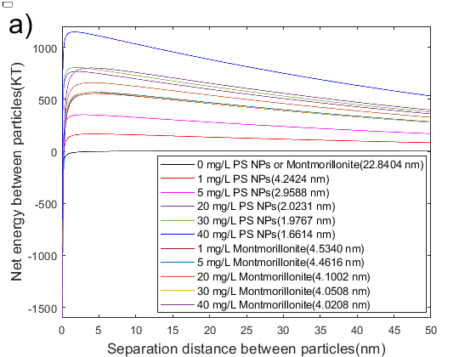 | 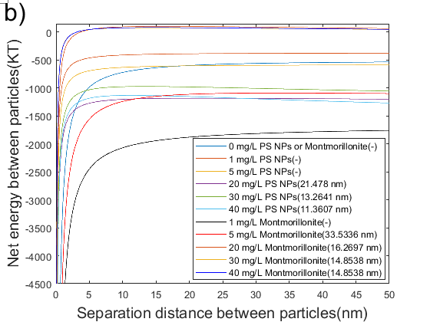
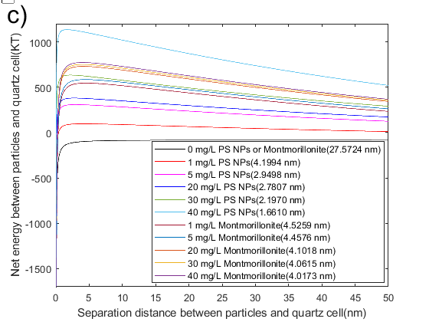 | 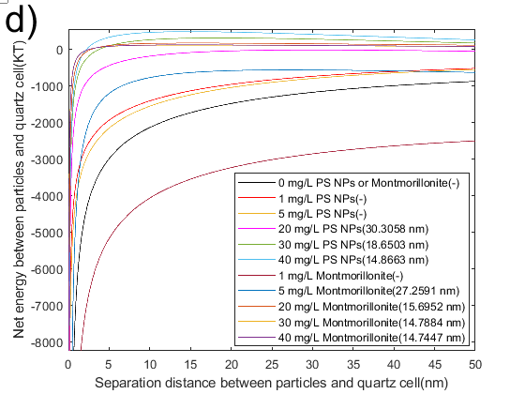
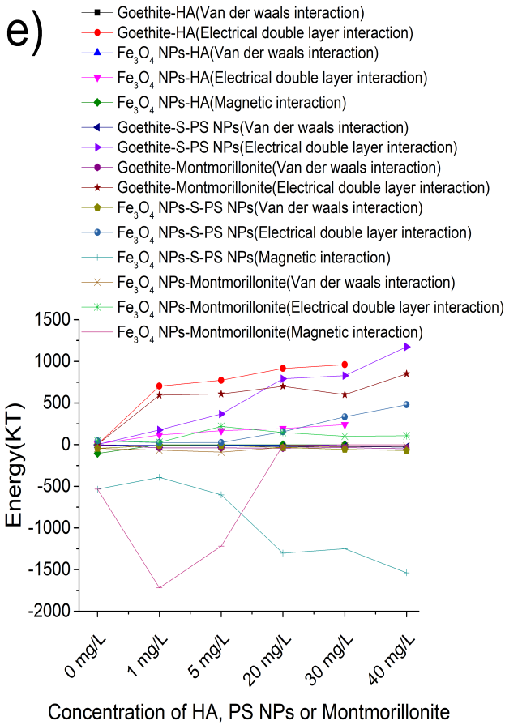 | 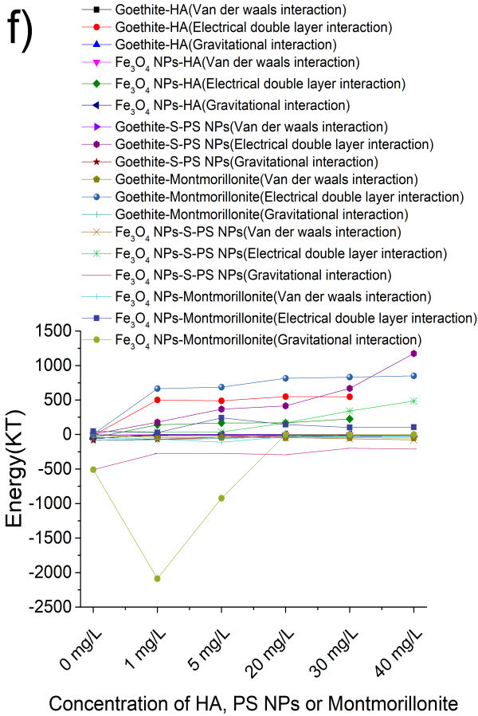

Fig. S1. XDLVO interaction energy profiles for hetero-aggregation of goethite (a) and Fe₃O₄ NPs (b) in varying concentration of montmorillonite and PS NPs. XDLVO interaction energy profiles for sedimentation of goethite (c) and Fe₃O₄ NPs (d) in varying concentration of montmorillonite and PS NPs. The energy composition at maximum net energy (barrier) for hetero-aggregation (f) and sedimentation (e) of goethite and Fe₃O₄ NPs in varying concentration of montmorillonite and PS NPs
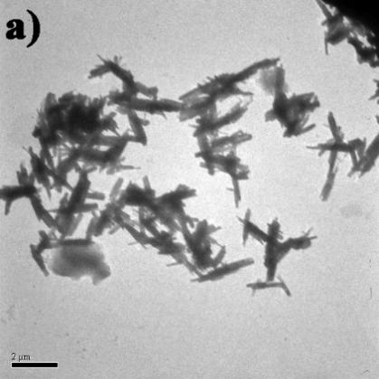 | 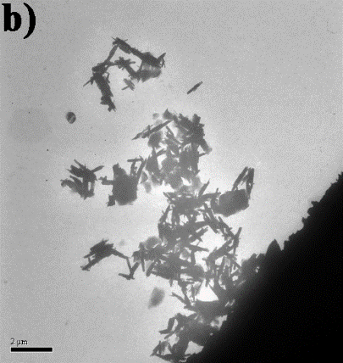 | 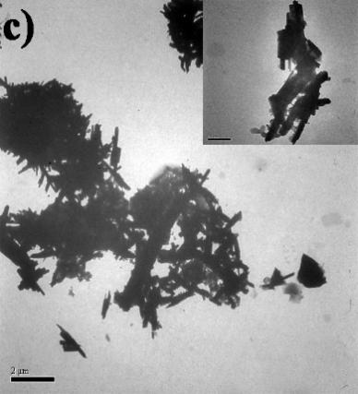
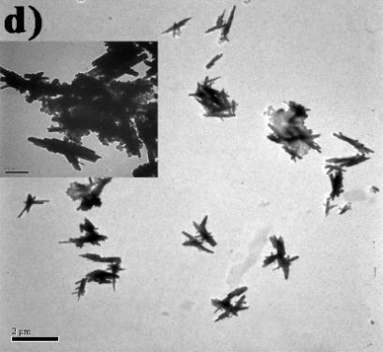 | 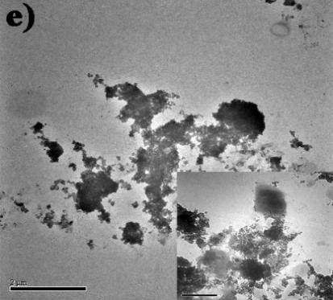 | 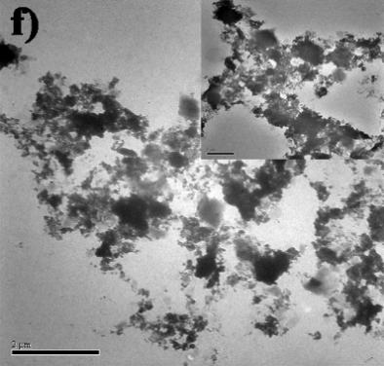
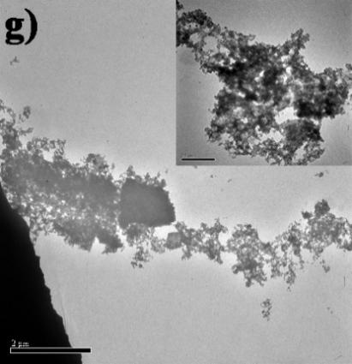 | 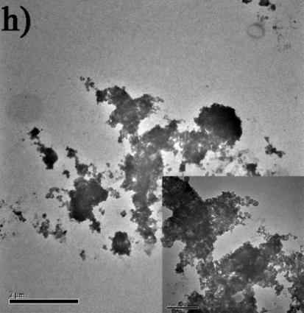

Fig. S2. Goethite in 1 mg/L (a) and 20 mg/L (b) montmorillonite suspensions. Goethite in 1 mg/L (c) and 20 mg/L (d) S-PS NPs suspensions. Fe₃O₄ NPs in 1 mg/L (e) and 20 mg/L (f) montmorillonite suspensions. Fe₃O₄ NPs in 1 mg/L (g) and 20 mg/L (h) S-PS NPs suspensions
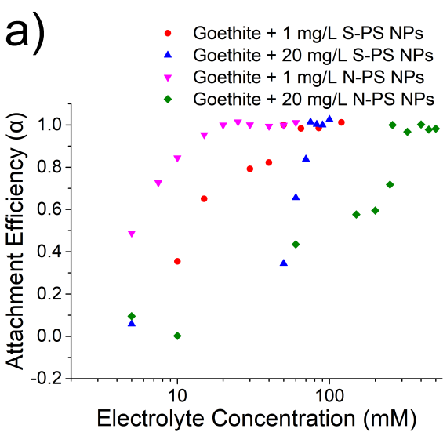 | 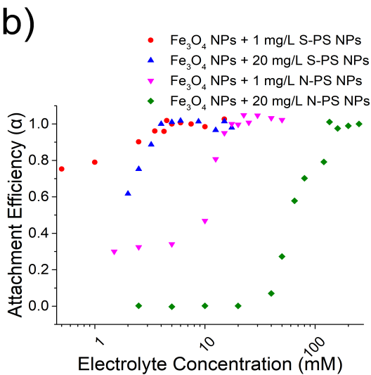
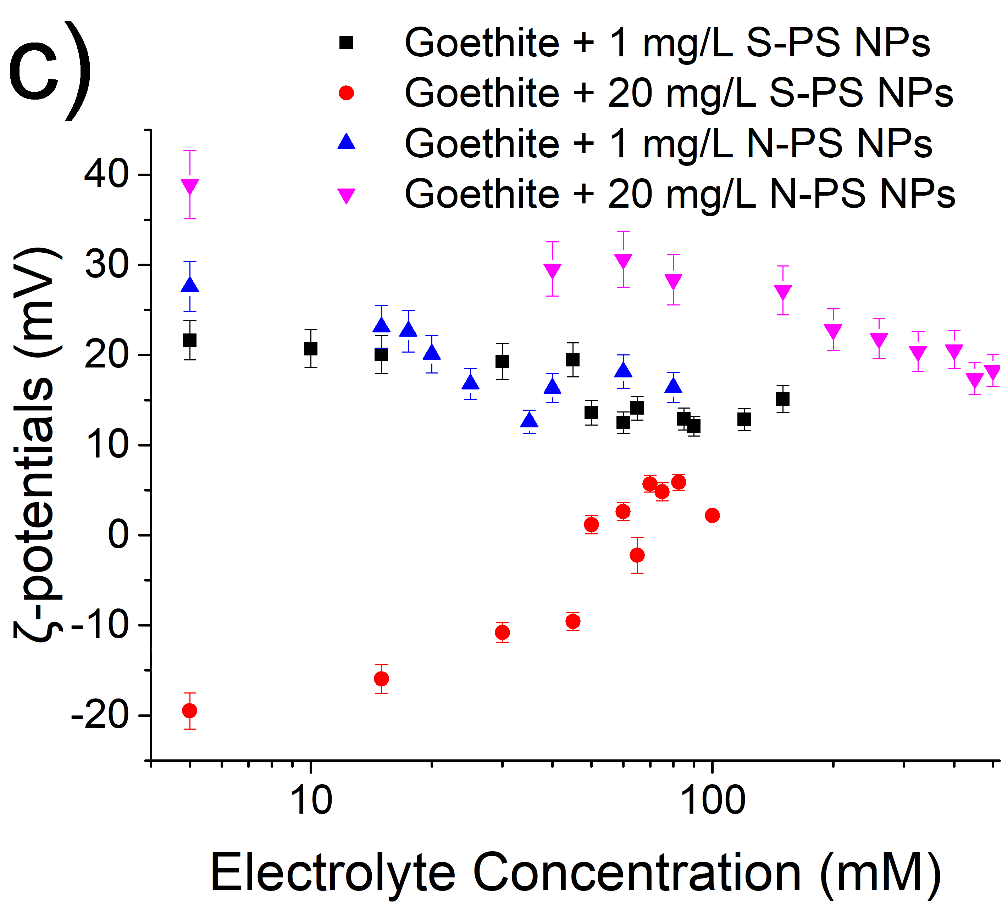 | 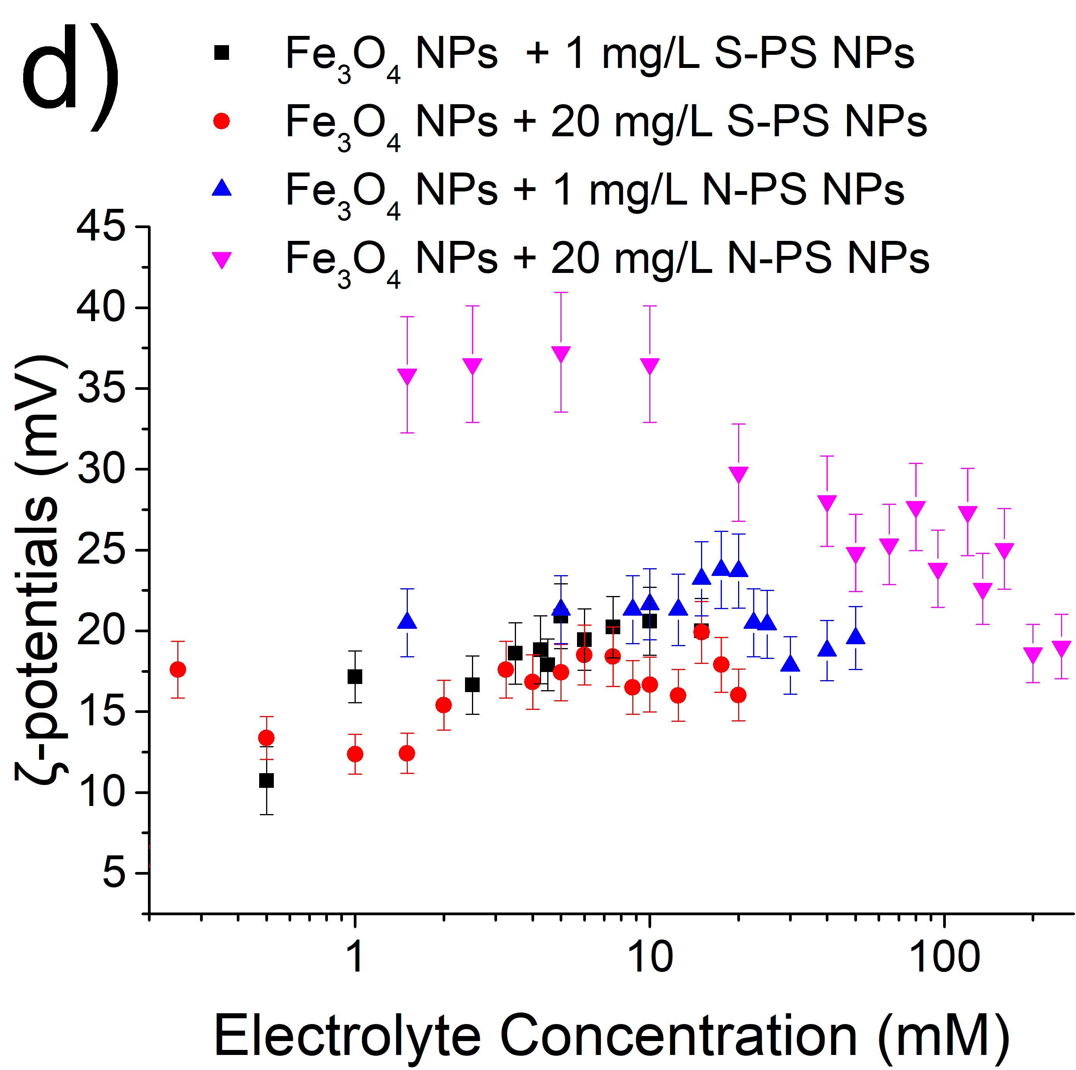
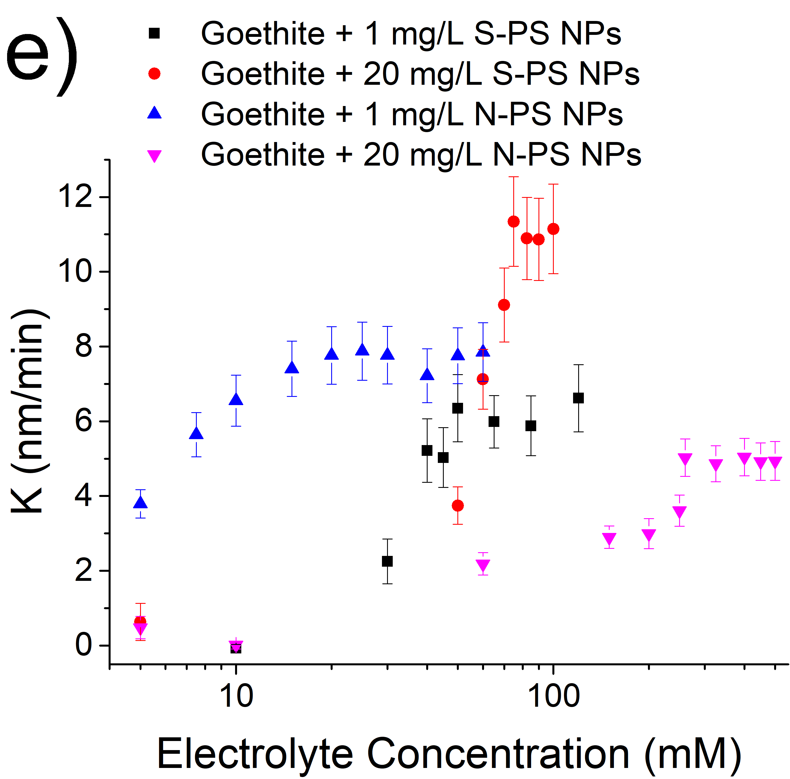 | 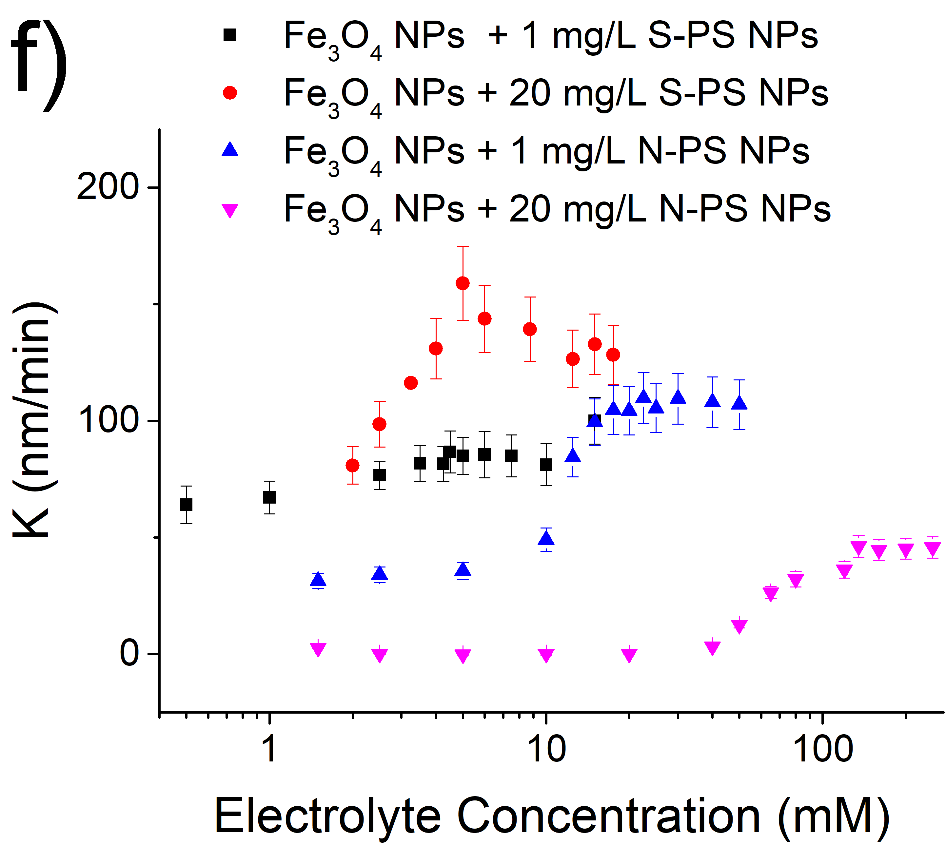
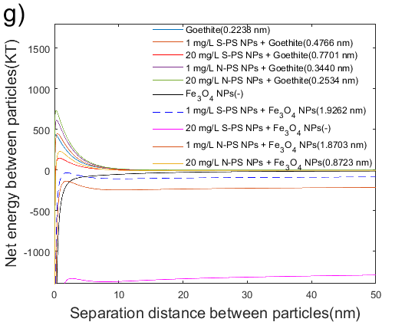 | 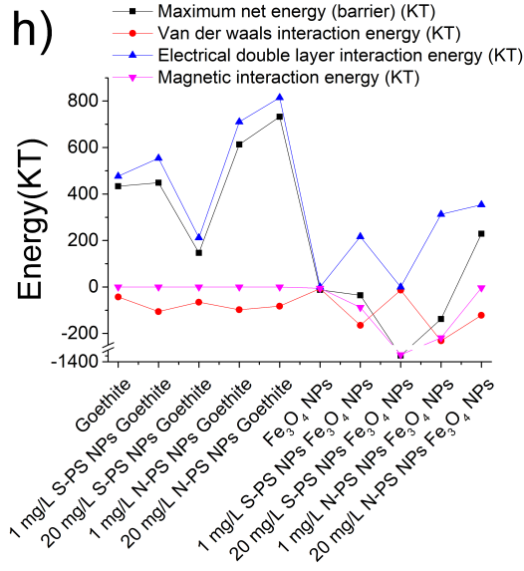

Fig. S3 The α of hetero-aggregation of (a) goethite and (b) Fe₃O₄ NPs together with varying concentrations of S-PS NPs and N-PS NPs as a function of CaCl₂ concentrations. The ζ-potentials of hetero-aggregation of (c) goethite and (d) Fe₃O₄ NPs together with varying concentrations of S-PS NPs and N-PS NPs as a function of CaCl₂ concentrations. The aggregation rate of hetero-aggregation of (e) goethite and (f) Fe₃O₄ NPs together with varying concentrations of S-PS NPs and N-PS NPs as a function of CaCl₂ concentrations. (g) XDLVO interaction energy profiles and (h) the energy composition of maximum net energy (barrier) for hetero-aggregation of goethite and Fe₃O₄ NPs together with varying concentrations of S-PS NPs and N-PS NPs suspensions in prensence of 5 mg/L CaCl₂
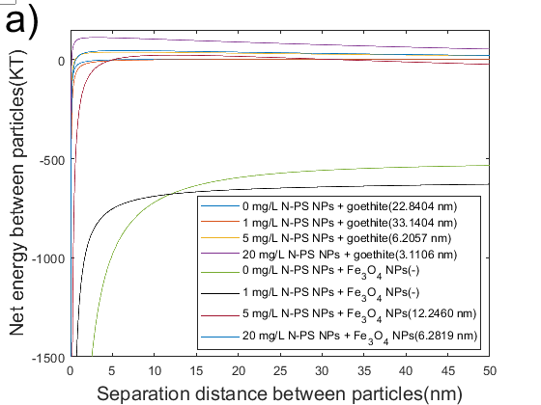 | 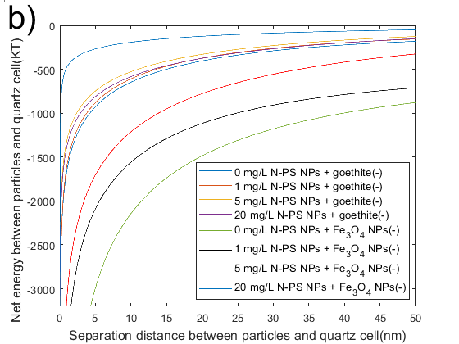
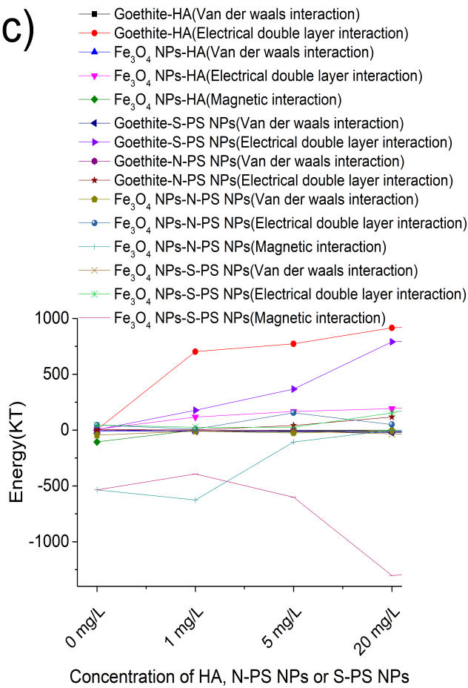 | 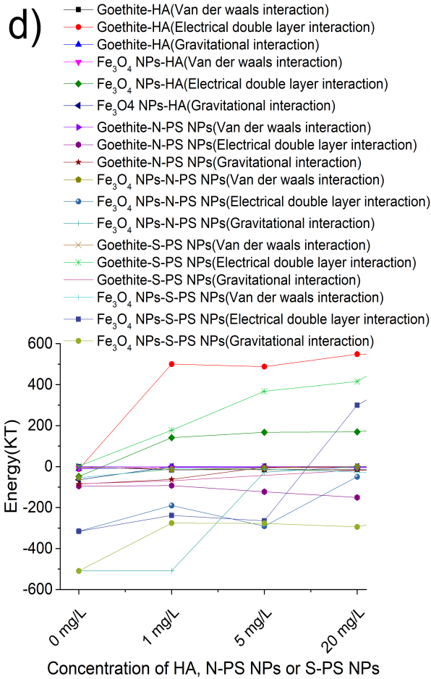

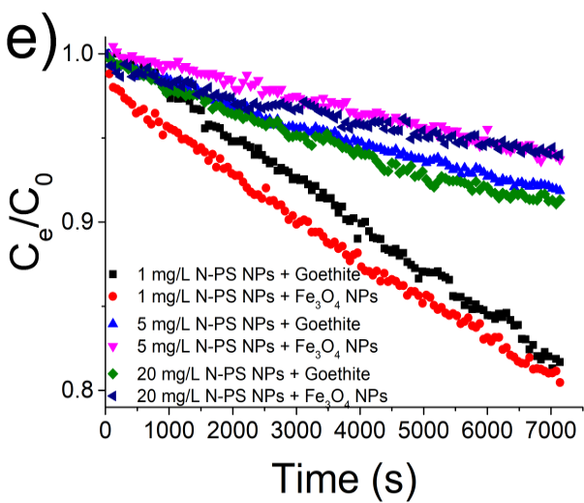

Fig. S4 XDLVO interaction energy profiles for hetero-aggregation (a) and sedimentation (b) of goethite and Fe₃O₄ NPs in varying concentration of N-PS NPs. The energy composition at maximum net energy (barrier) for hetero-aggregation (c) and sedimentation (d) of goethite and Fe₃O₄ NPs in varying concentration of HA, S-PS NPs and N-PS NPs. (e) Settling data showing optical density (C_{e}/C₀) of 20 mg/L goethite and Fe₃O₄ NPs dispersion in varying concentrations of N-PS NPs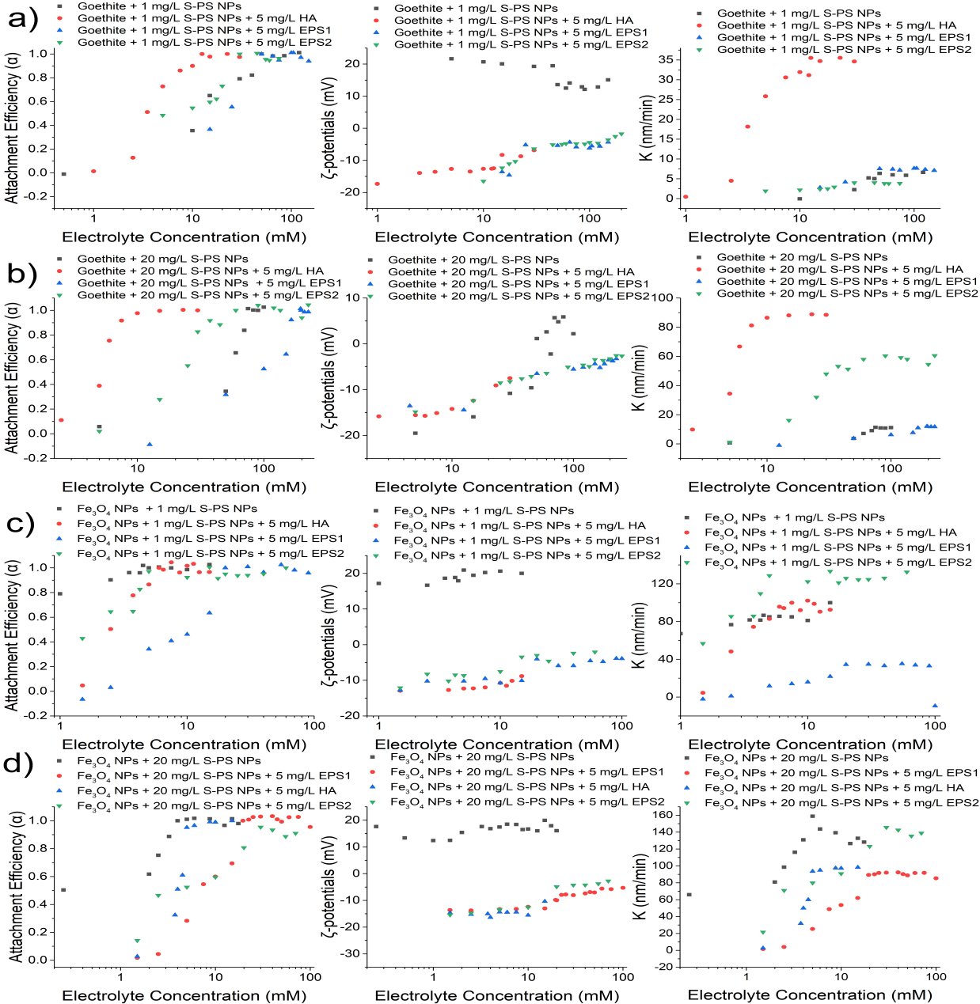

Fig. S5 The α, ζ-potentials and aggregation rate of hetero-aggregation of goethite together with (a) 1 mg/L S-PS NPs and (b) 20 mg/L S-PS NPs in HA and EPS suspensions as a function of CaCl₂ concentrations. The α, ζ-potentials and aggregation rate of hetero-aggregation of Fe₃O₄ NPs together with (c) 1 mg/L S-PS NPs and (d) 20 mg/L S-PS NPs in HA and EPS suspensions as a function of CaCl₂ concentrations
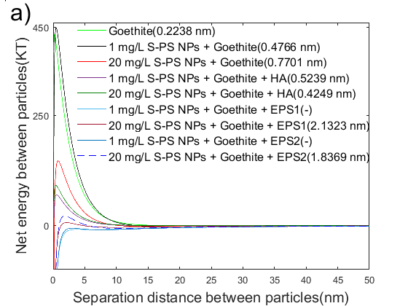 | 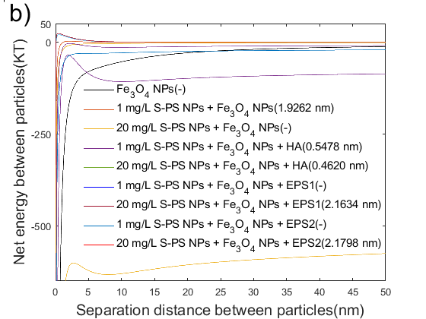

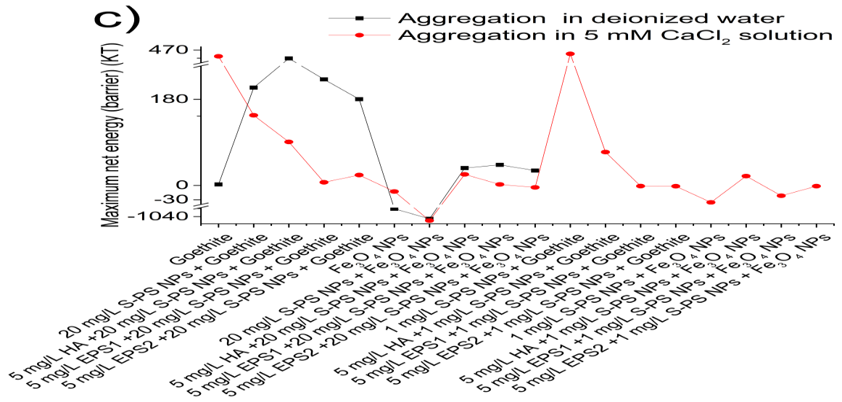

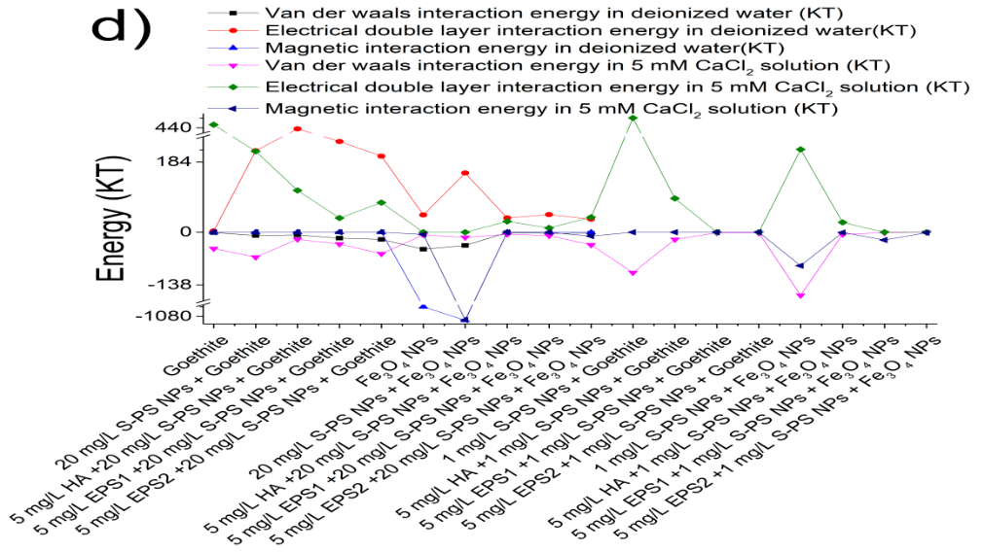

Fig. S6 XDLVO interaction energy profiles for hetero-aggregation of (a) goethite and (b) Fe₃O₄ NPs together with varying concentrations of S-PS NPs suspensions in prensence of 5 mg/L CaCl₂ and HA or EPS. (c) The maximum net energy (barrier) and (d) energy composition for hetero-aggregation of goethite and Fe₃O₄ NPs together with varying concentrations of S-PS NPs suspensions in prensence of 5 mg/L CaCl₂ and HA or EPS
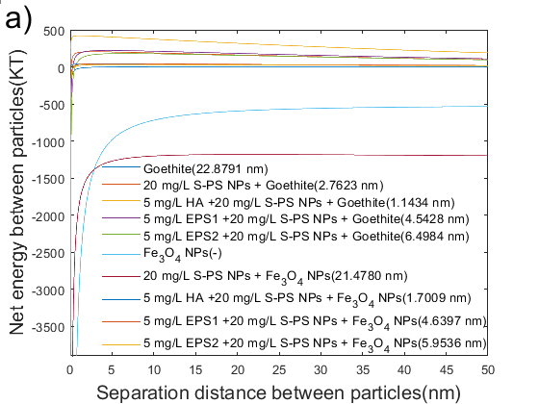 | 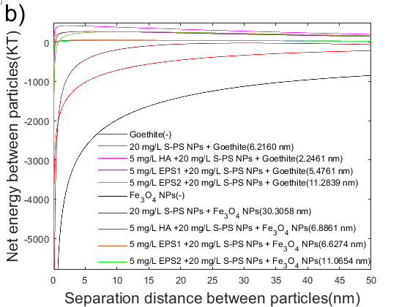
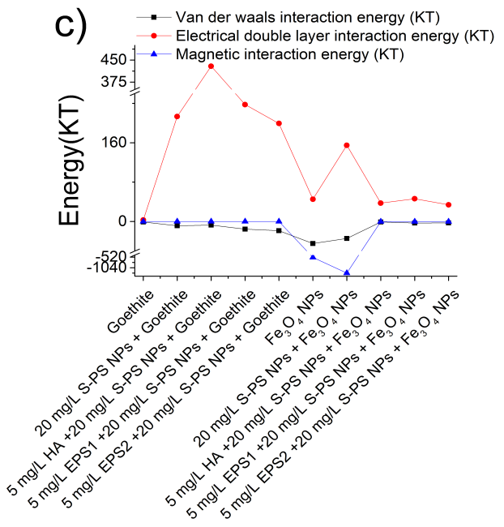 | 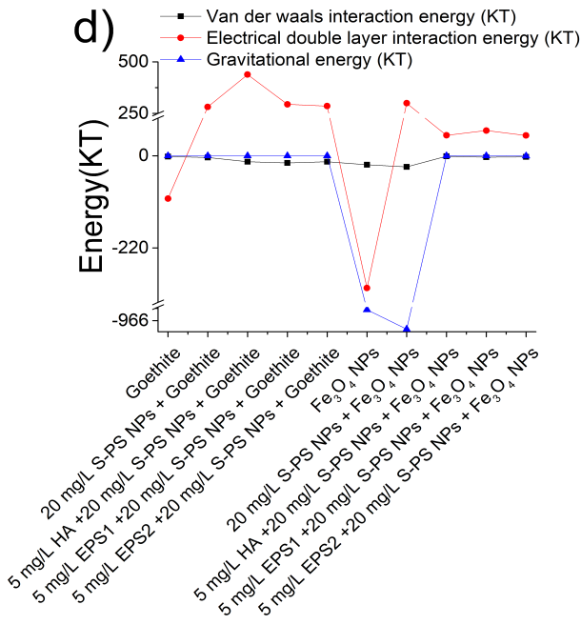

Fig. S7 XDLVO interaction energy profiles for hetero-aggregation (a) and sedimentation (b) of goethite and Fe₃O₄ NPs together with S-PS NPs in HA and EPS suspensions. The energy composition at maximum net energy (barrier) for hetero-aggregation (c) and sedimentation (d) of goethite and Fe₃O₄ NPs together with S-PS NPs in HA and EPS suspensions
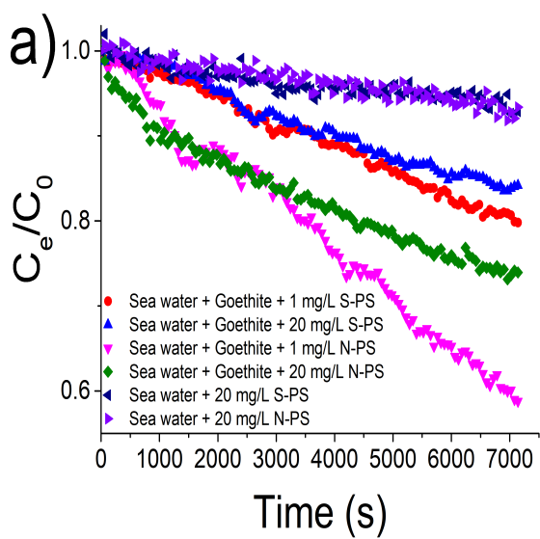 | 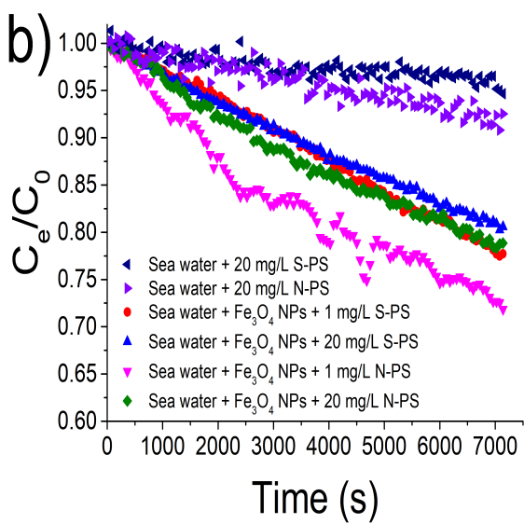
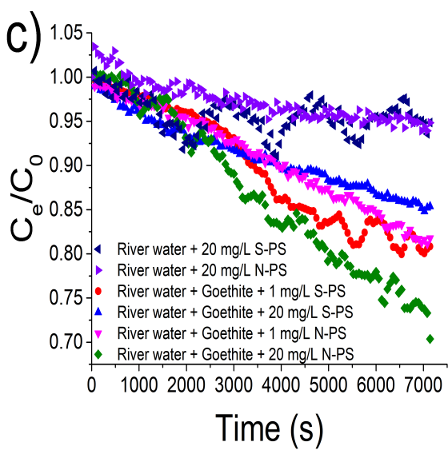 | 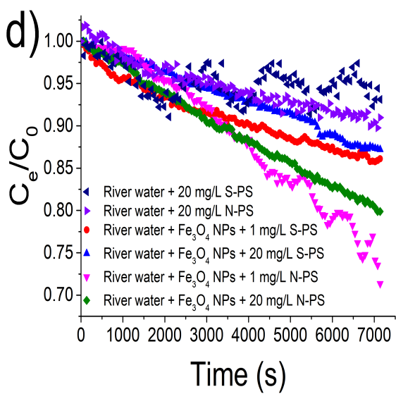
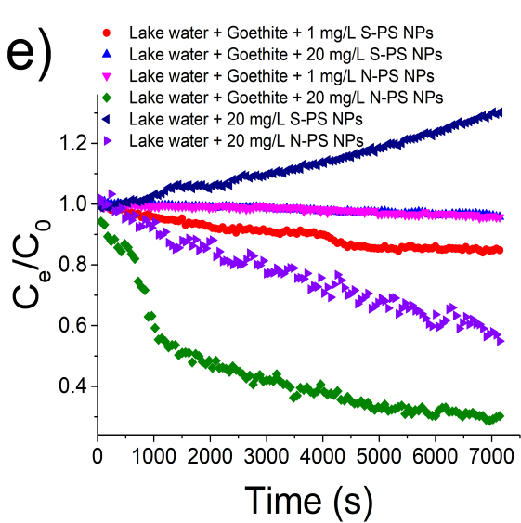 | 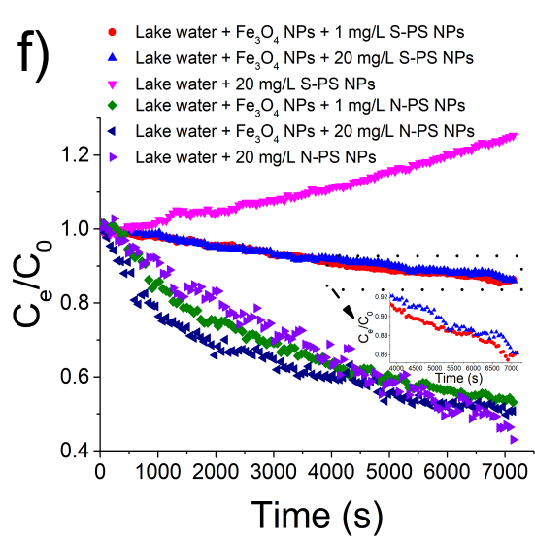
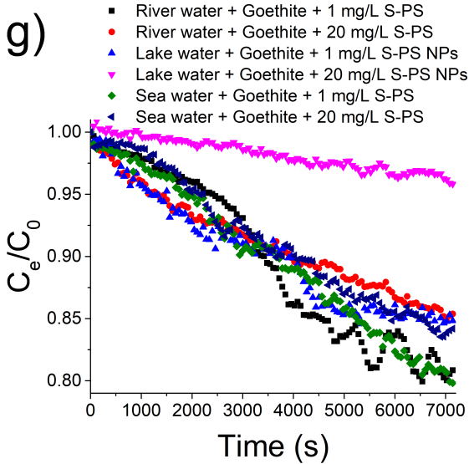 | 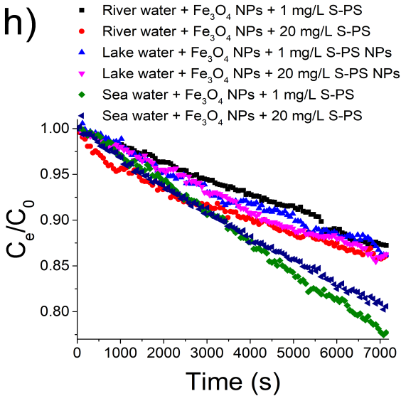
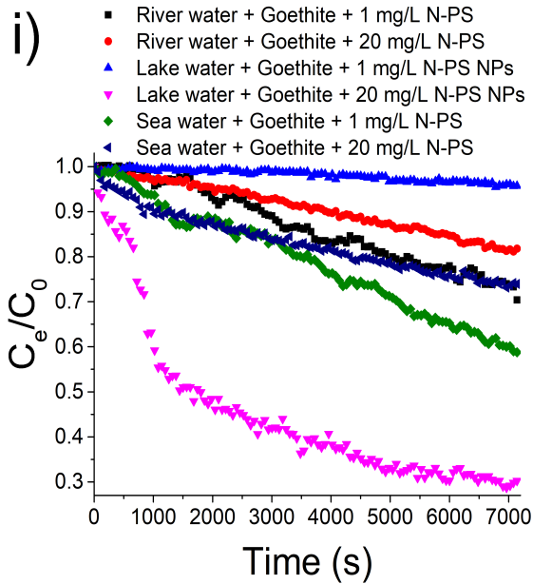 | 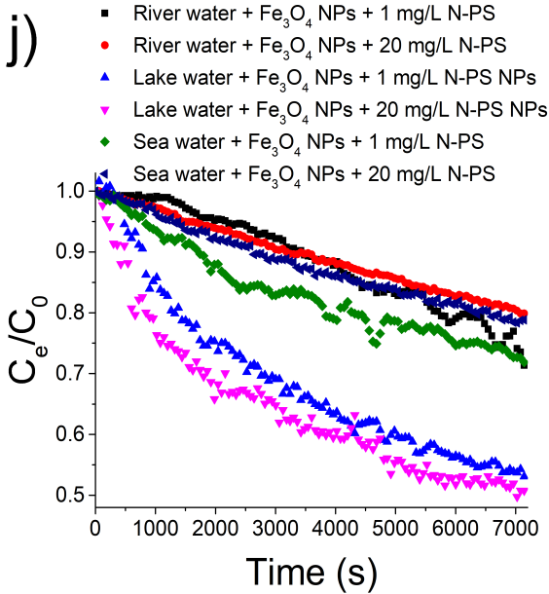

Fig. S8 Settling data showing optical density (C_{e}/C₀) of 20 mg/L (a) goethite and (b) Fe₃O₄ NPs together with N-PS NPs or S-PS NPs in sea water. Settling data showing optical density (C_{e}/C₀) of 20 mg/L (c) goethite and (d) Fe₃O₄ NPs together with N-PS NPs or S-PS NPs in river water. Settling data showing optical density (C_{e}/C₀) of 20 mg/L (e) goethite and (f) Fe₃O₄ NPs together with N-PS NPs or S-PS NPs in lake water. Settling data showing optical density (C_{e}/C₀) of 20 mg/L (g) goethite together with S-PS NPs, (h) Fe₃O₄ NPs together with S-PS NPs, (i) goethite together with N-PS NPs and (j) Fe₃O₄ NPs together with N-PS NPs in sea, river and lake water
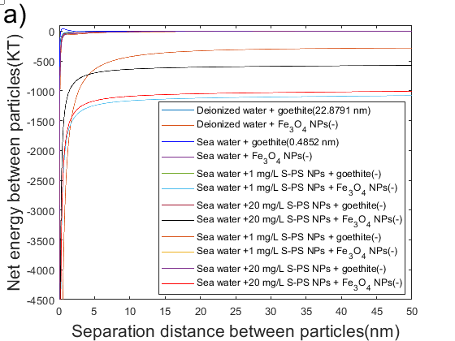 | 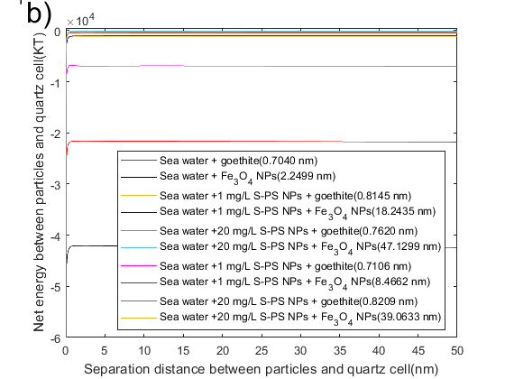
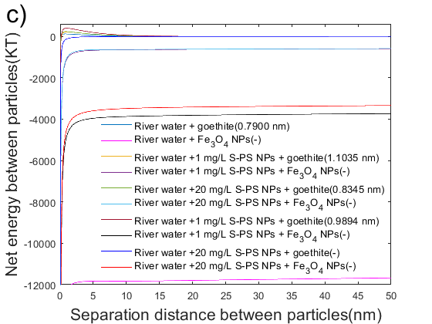 | 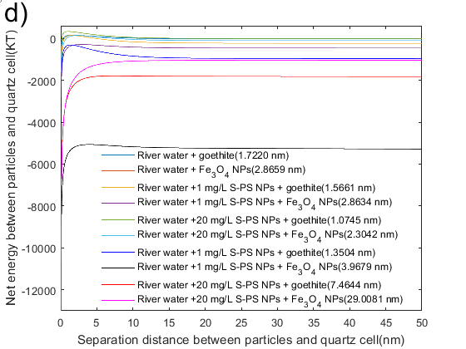
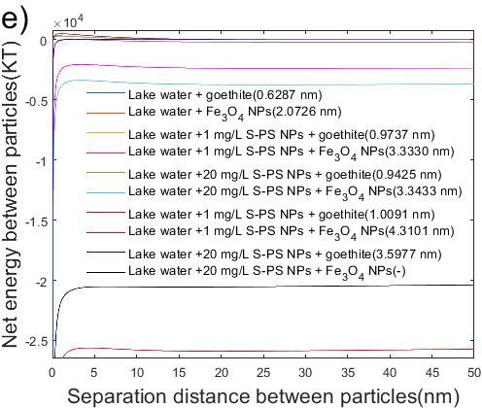 | 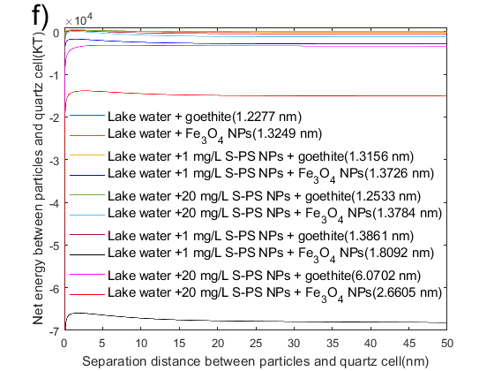
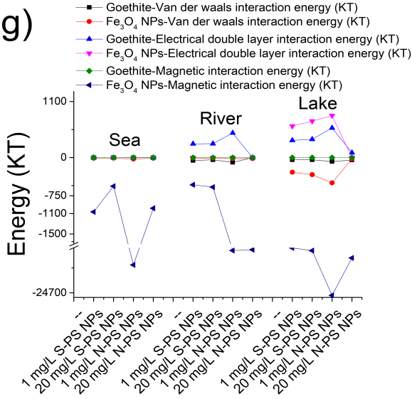 | 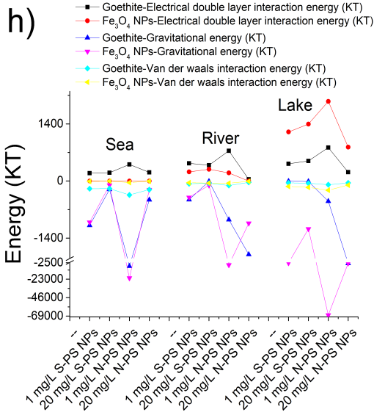

Fig. S9 XDLVO interaction energy profiles for hetero-aggregation (a) and sedimentation (b) of goethite and Fe₃O₄ NPs together with N-PS NPs or S-PS NPs in sea water. XDLVO interaction energy profiles for hetero-aggregation (c) and sedimentation (d) of goethite and Fe₃O₄ NPs together with N-PS NPs or S-PS NPs in river water. XDLVO interaction energy profiles for hetero-aggregation (e) and sedimentation (f) of goethite and Fe₃O₄ NPs together with N-PS NPs or S-PS NPs in lake water. The energy composition at maximum net energy (barrier) for hetero-aggregation (g) and sedimentation (h) of goethite and Fe₃O₄ NPs together with N-PS NPs or S-PS NPs in sea, river and lake water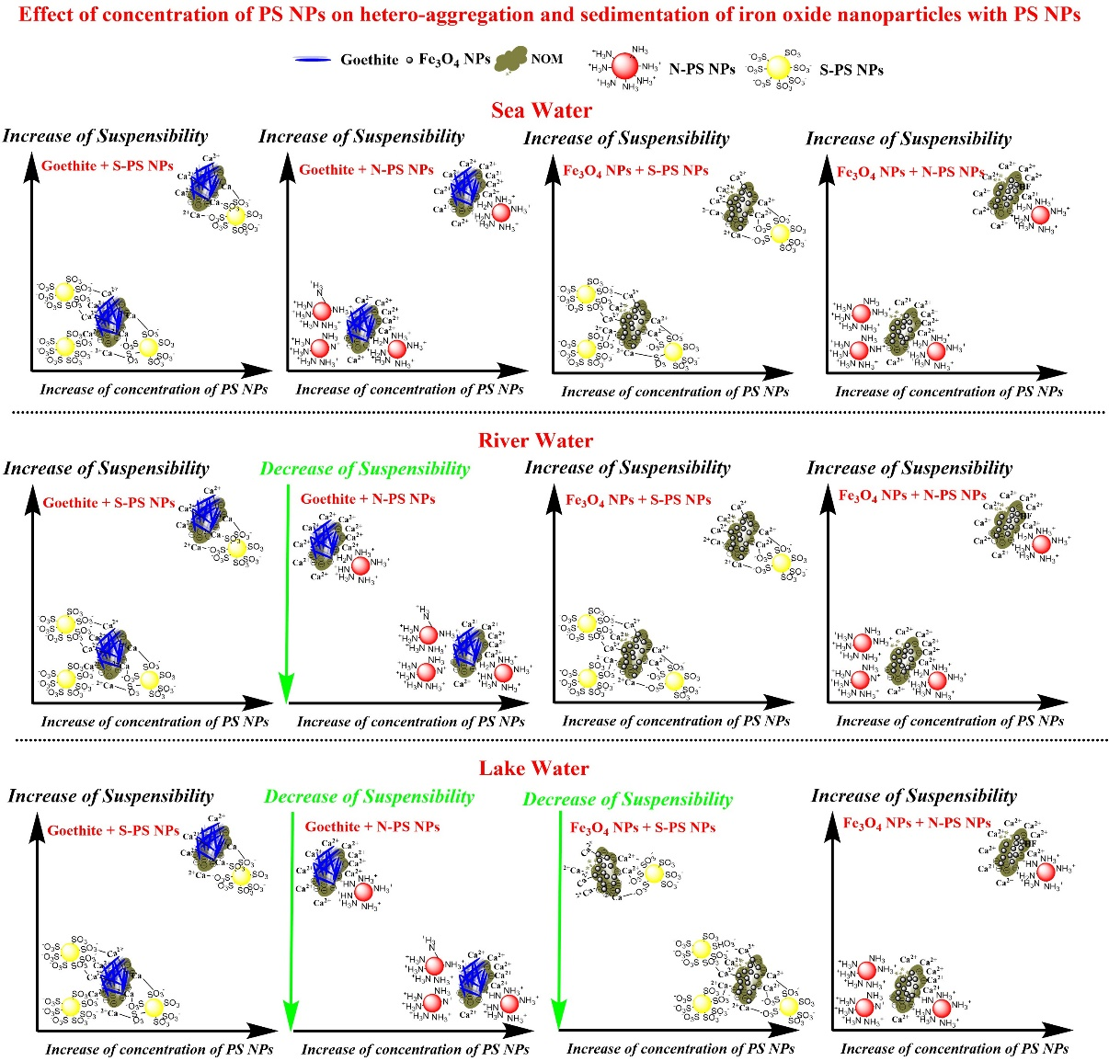图

Fig. S10 Effect of concentration of PS NPs on hetero-aggergation and sedimentation of goethite and Fe₃O₄ NPs with PS NPs in sea, river and lake waters
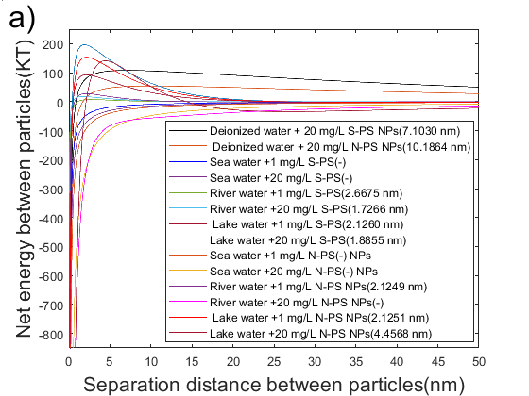 | 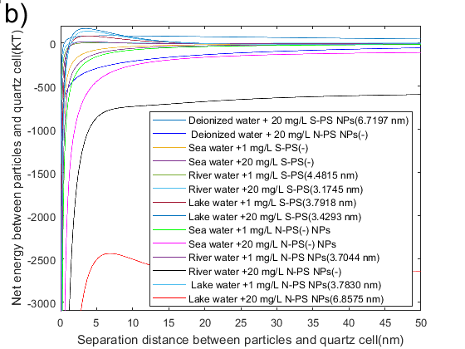
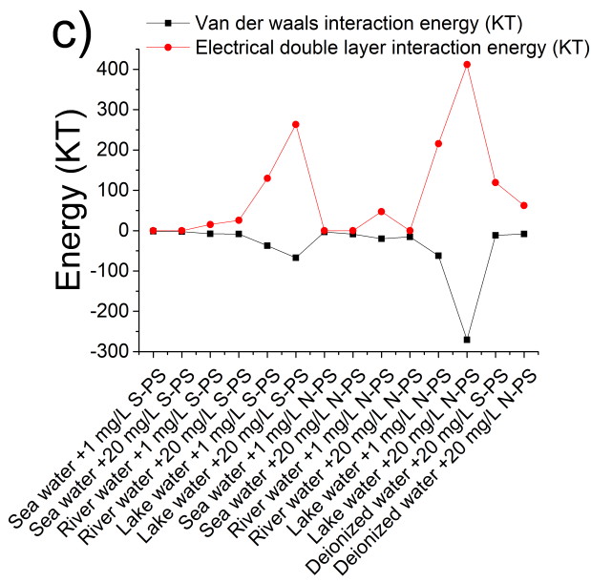 | 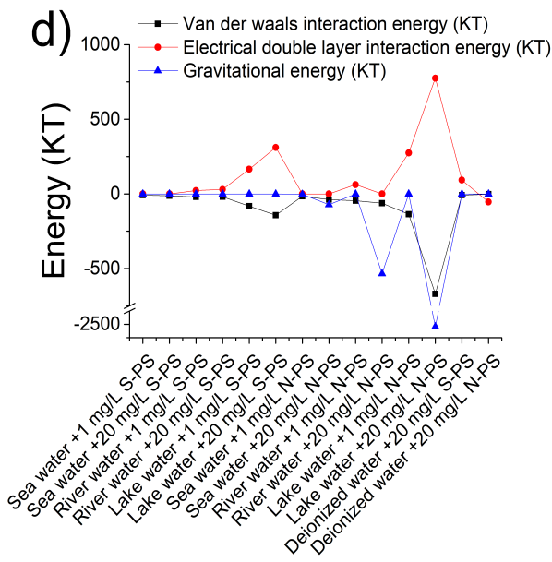

Fig. S11 XDLVO interaction energy profiles for hetero-aggregation (a) and sedimentation (b) of N-PS NPs and S-PS NPs in sea, river and water. The energy composition at maximum net energy (barrier) for aggregation (c) and sedimentation (d) of N-PS NPs and S-PS NPs in sea, river and lake water

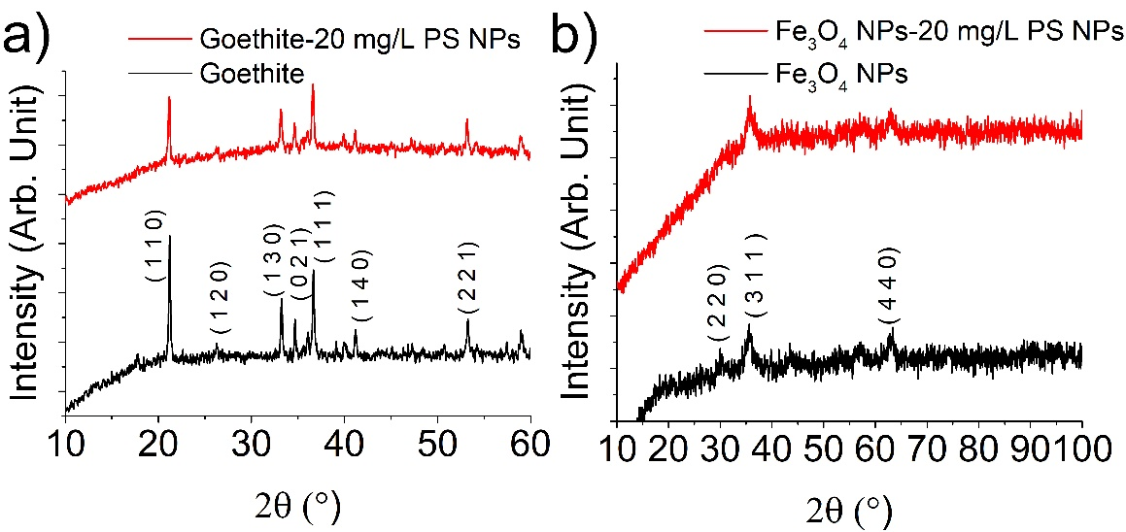

Fig. S12 XRD patterns of (a) goethite and (b) Fe₃O₄ NPs with PS NPs
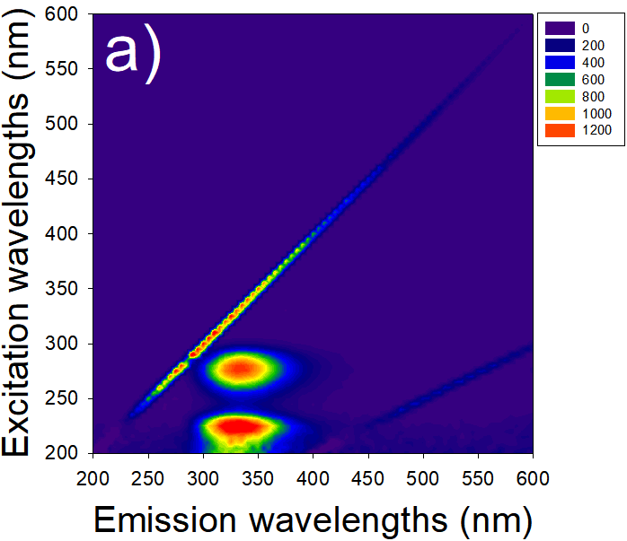 | 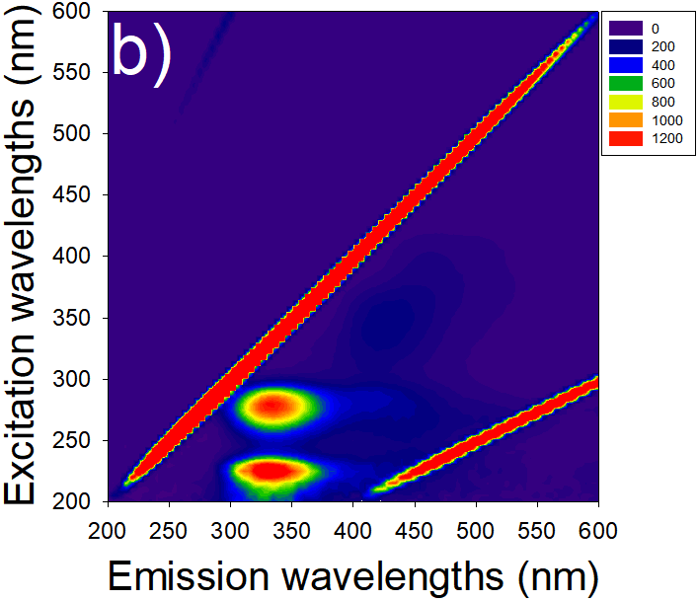

Fig. S13 EEM fluorescene spectra of Chlorella pyrenoidosa EPS(EPS1) and Pseudomonas putida strain MnB1 EPS (EPS2), the concentration of EPS1 and EPS2 were 10 mg/L TOC
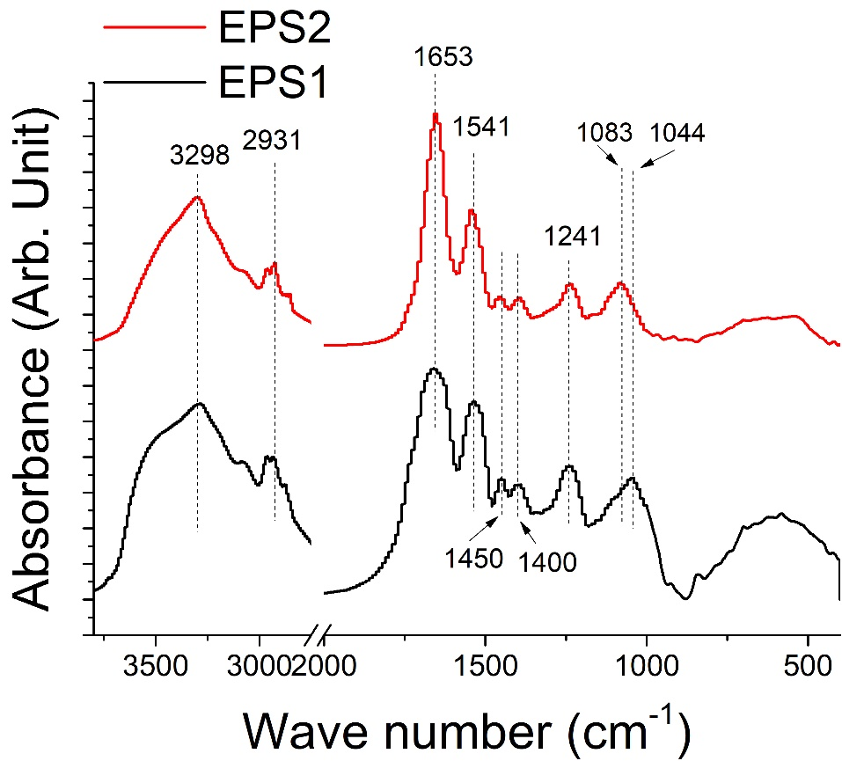

Fig. S14 FTIR spectrums of Chlorella vulgaris EPS(EPS1) and Pseudomonas putida strain MnB1 EPS (EPS2)
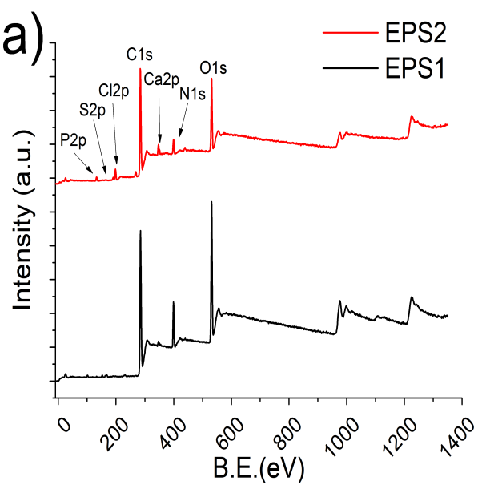 | 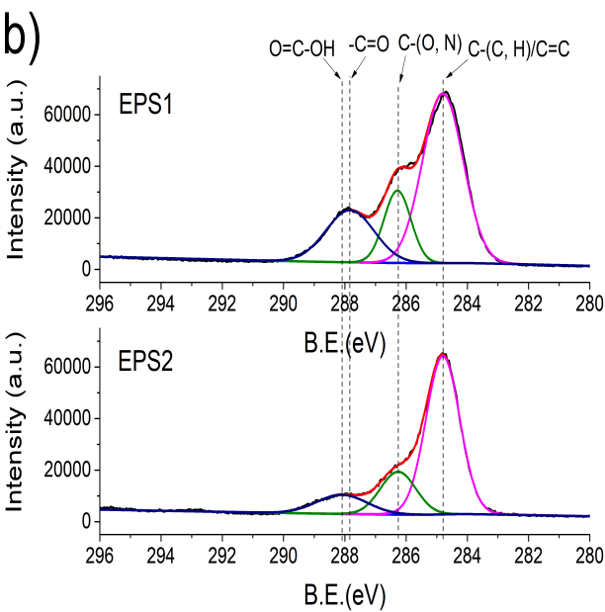
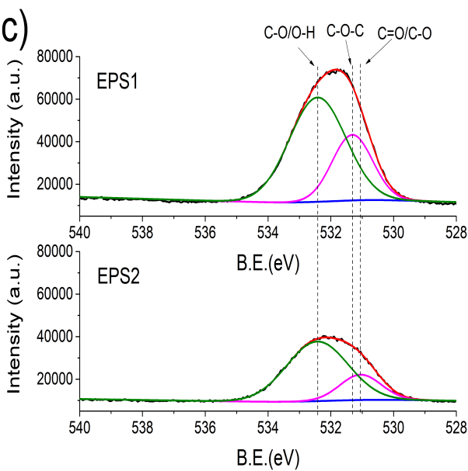 | 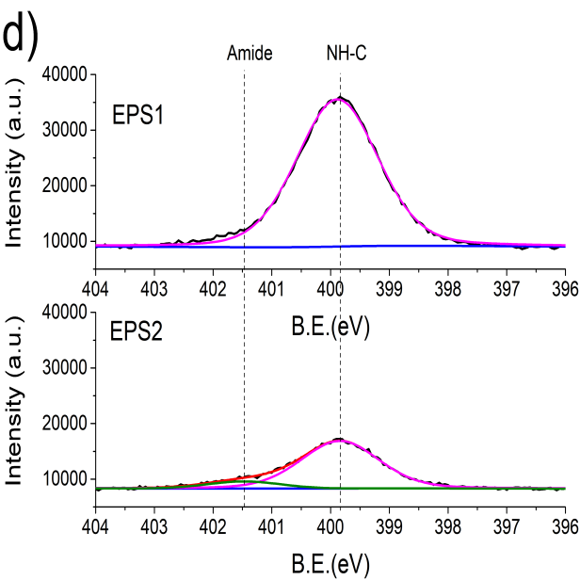
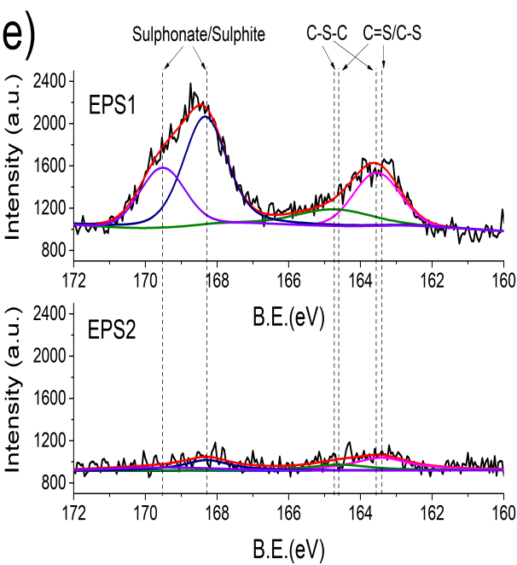 | 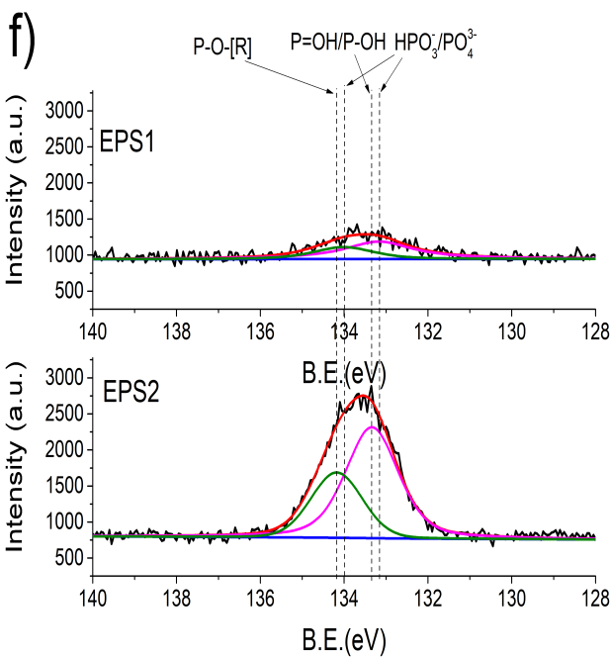

Fig. S15 (a) XPS survey scans of Chlorella vulgaris EPS(EPS1) and Pseudomonas putida strain MnB1 EPS (EPS2); High-resolution (b) C 1s, (c) O 1s, (d) N 1s, (e) S 2p and (f) P 2p of Chlorella vulgaris EPS(EPS1) and Pseudomonas putida strain MnB1 EPS (EPS2)
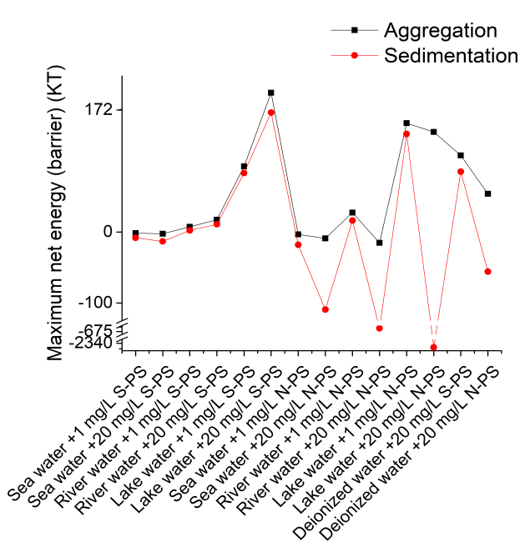

Fig. S16 The maximum net energy (barrier) for sedimentation and hetero-aggregation of N-PS NPs or S-PS NPs in sea, river, and lake waters
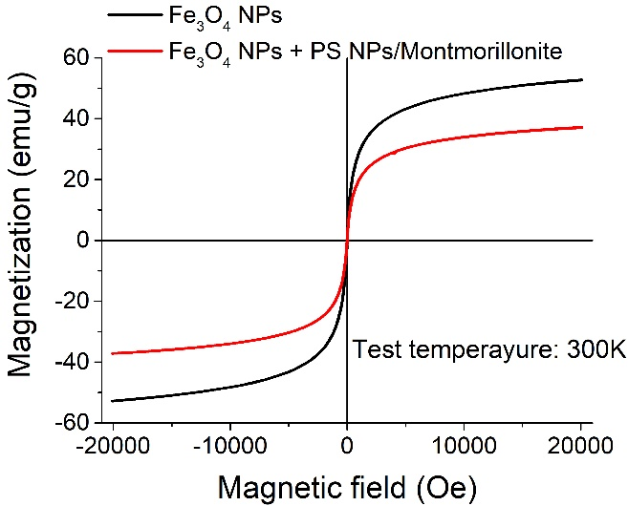

Fig. S17 The magnetic moments of Fe₃O₄ NP and its dispersal in PS NP suspension

Nanoparticle

a

s
Collector

Fig. S18 A nanoparticle suspended on the quartz collector

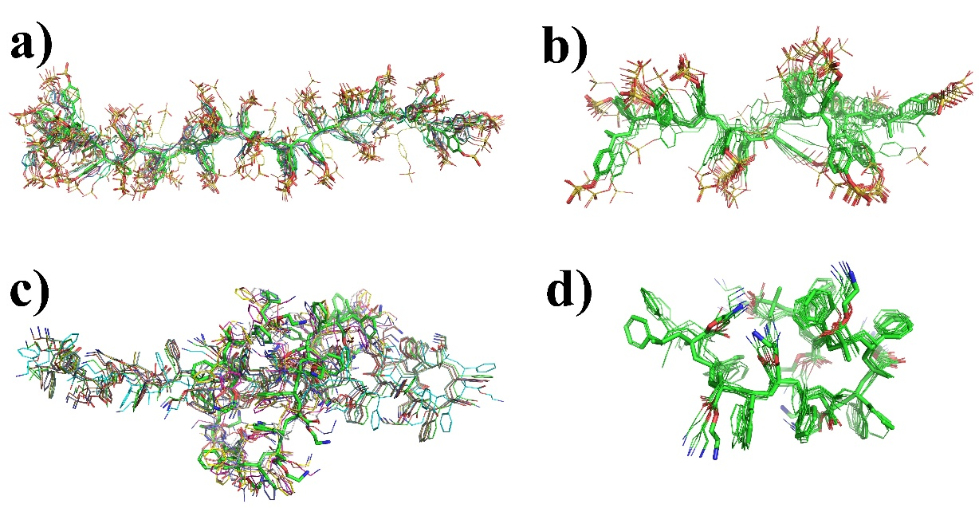

Fig. S19 Three-dimensional structures of PS molecular polymers. a) 16 S-PS NPs units, b) 8 S-PS NPs units, c) 16 N-PS NPs units, and d) 8 N-PS NPs units. Brown, red, white, yellow, and blue balls represent Fe, O, H, S, and N atoms, respectively
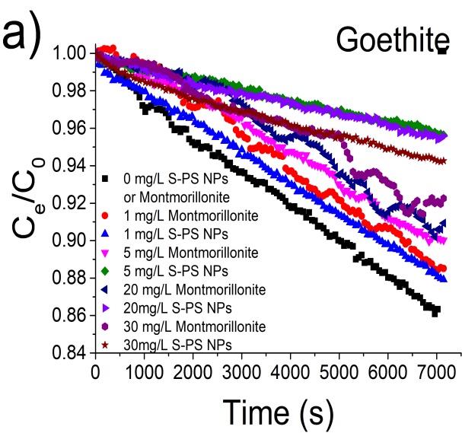 | 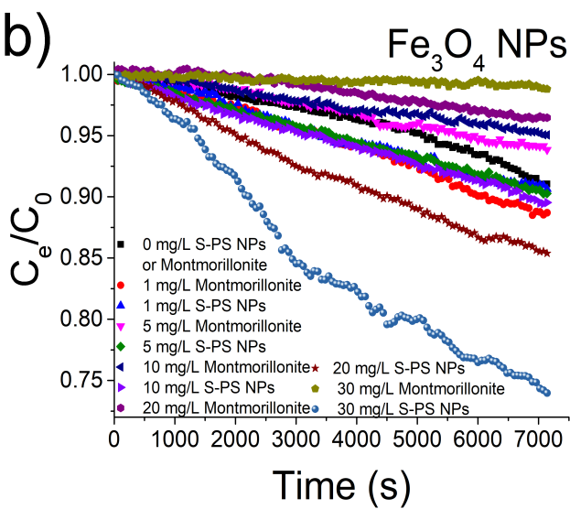
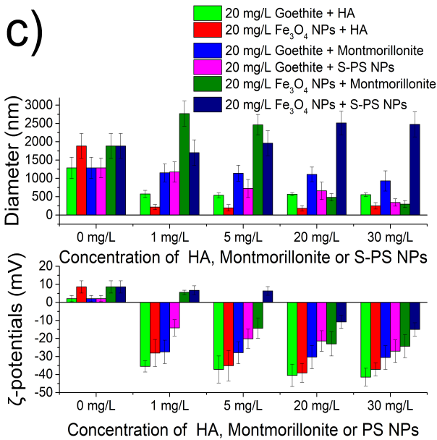 | 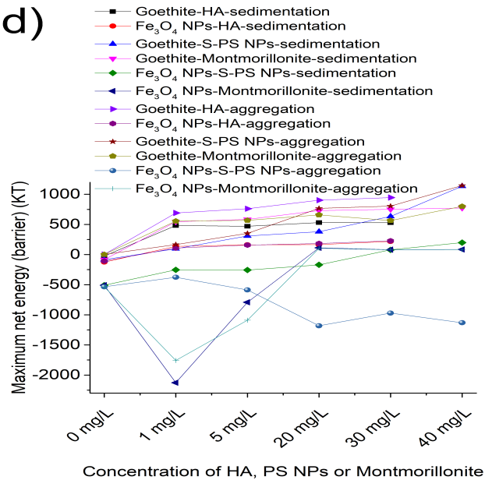

Fig. S20 Settling data showing the optical density (C_{e}/C₀) of 20 mg/L (a) goethite and (b) Fe₃O₄ NP dispersions in varying concentrations of montmorillonite and PS NPs. (c) D_{h} and ζ potentials, and (d) the maximum net energy (barrier) (Φ_{MAX}) of goethite and Fe₃O₄ NPs in varying concentrations of HA, montmorillonite, and PS NPs. Settling data showing the optical density (C_{e}/C₀) of 20 mg/L goethite and Fe₃O₄ NP dispersions in varying concentrations of (e) montmorillonite and (f) PS NPs
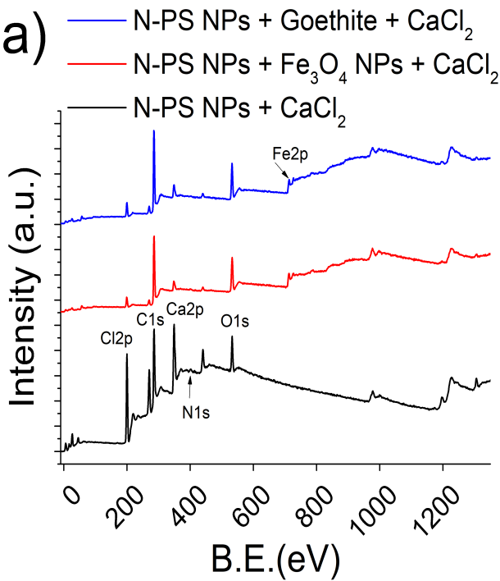 | 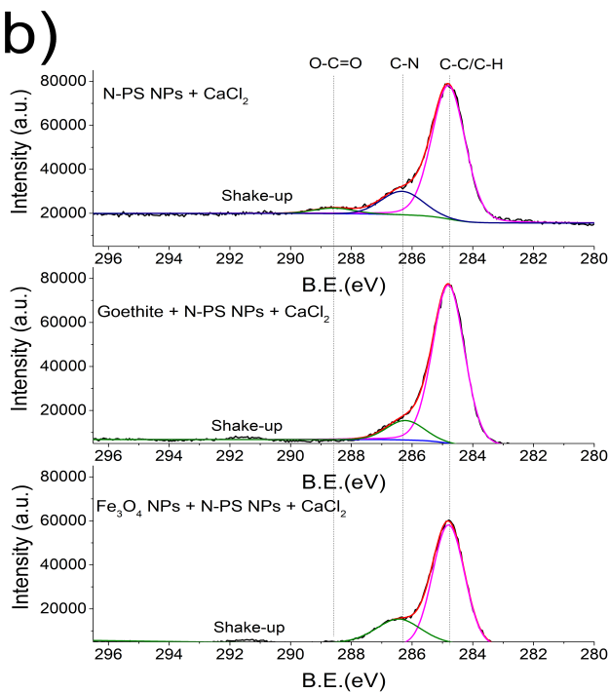
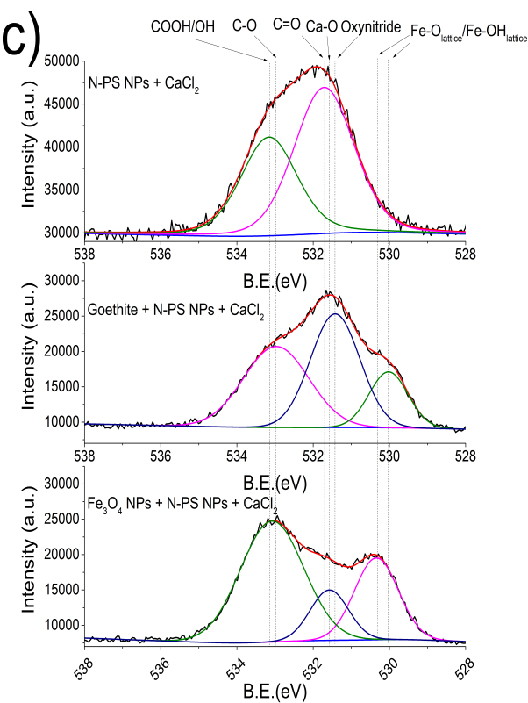 | 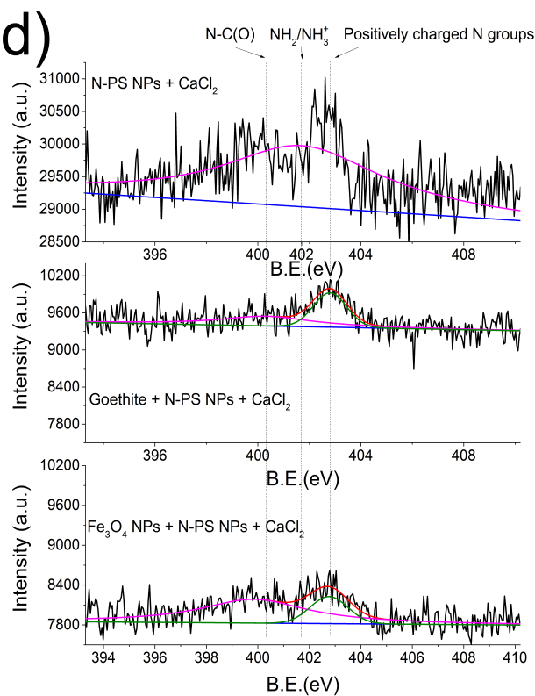

Fig. S21 (a) XPS survey scans of Fe₃O₄ NPs and goethite in N-PS NP suspensions; high-resolution (b) C 1s, (c) O 1s, and (d) N 1s of Fe₃O₄ NPs and goethite in N-PS NP suspension
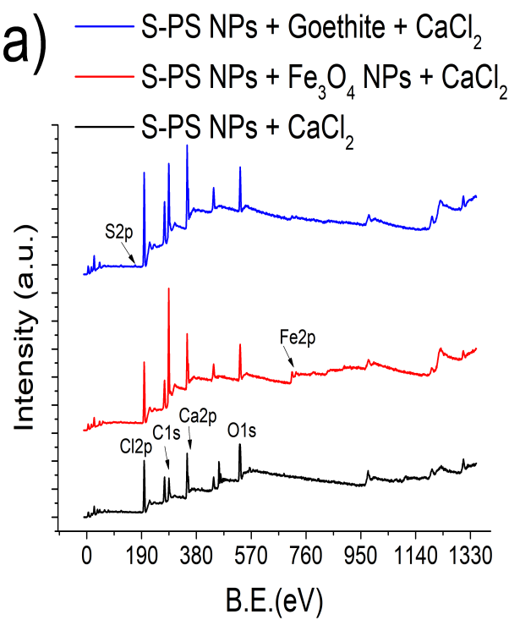 | 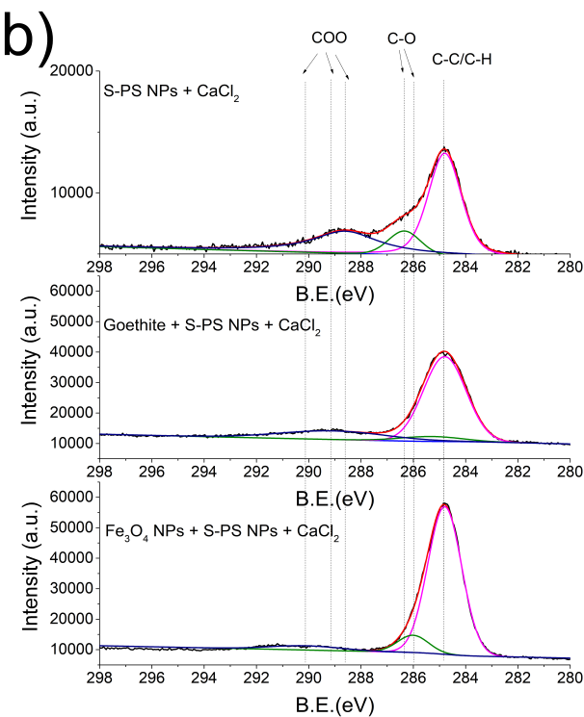
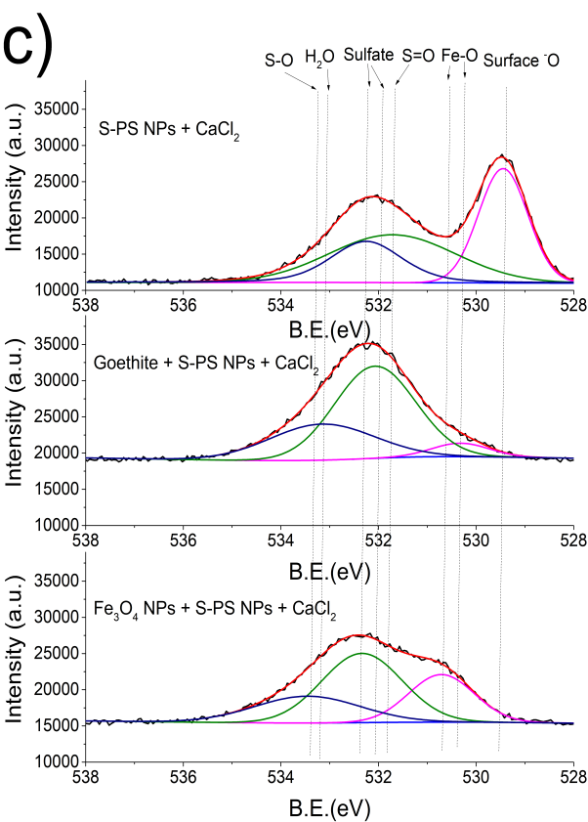 | 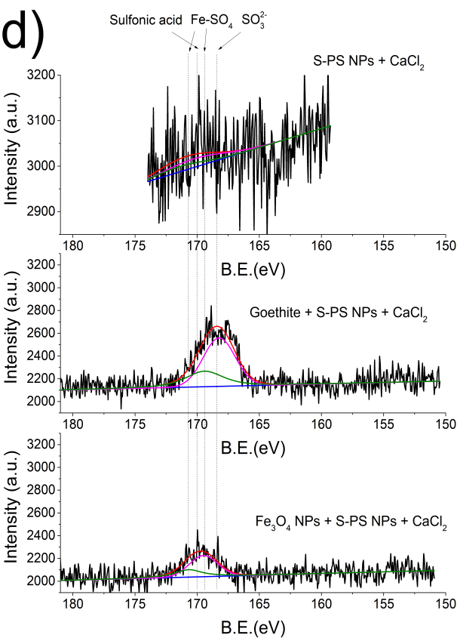

Fig. S22 (a) XPS survey scans of Fe₃O₄ NPs and goethite in S-PS NP suspensions; high-resolution (b) C 1s, (c) O 1s, and (d) N 1s of Fe₃O₄ NPs and goethite in S-PS NP suspensions
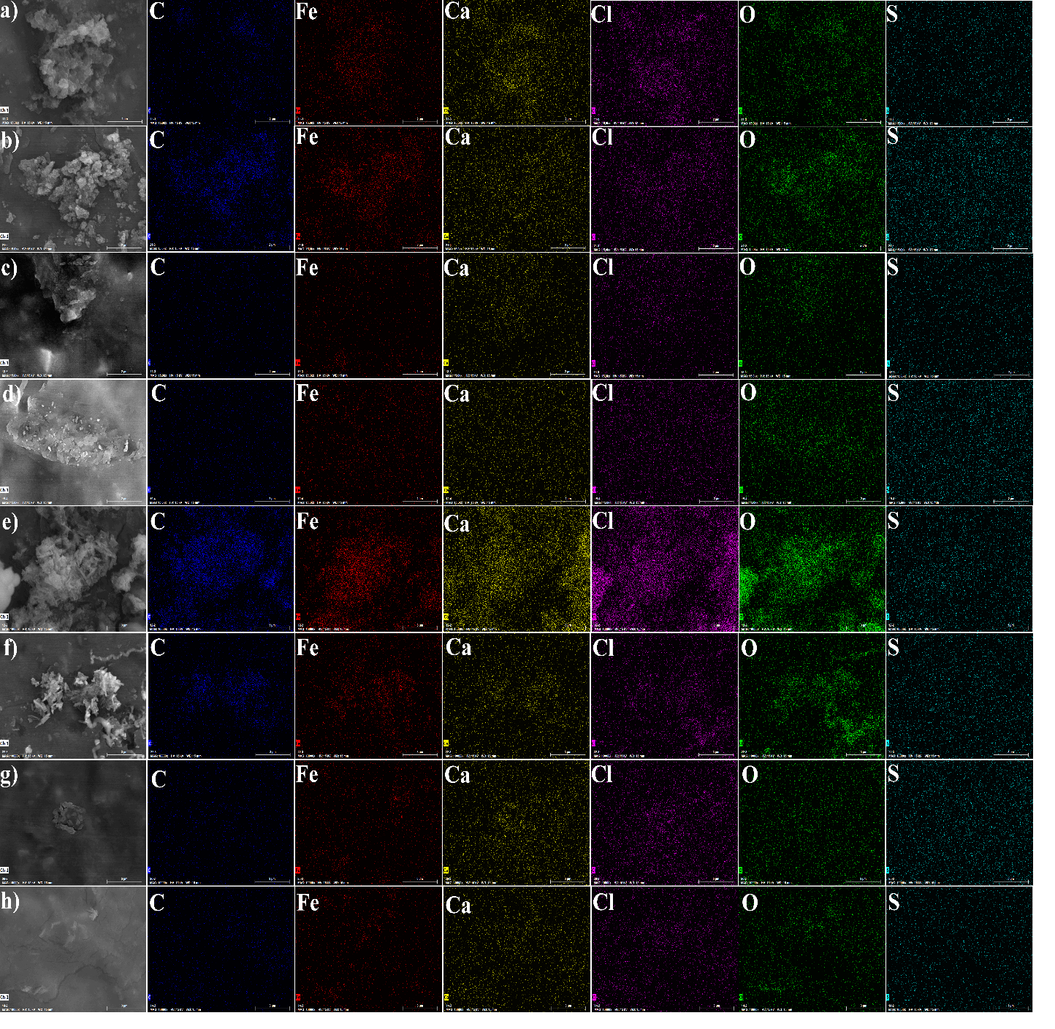

Fig. S23 (a) SEM–EDS images of Fe₃O₄ NPs and S-PS NPs in a 20 mM CaCl₂ solution. SEM–EDS images of Fe₃O₄ and S-PS NPs in 20 mM CaCl₂ solution in the presence of (b) 5 mg/L HA, (c) 5 mg/L EPS1, and (d) 5 mg/L EPS2. (e) SEM–EDS images of goethite and S-PS NPs in 20 mM CaCl₂ solution. SEM–EDS images of goethite and S-PS NPs in 20 mM CaCl₂ solution in the presence of (f) 5 mg/L HA, (g) 5 mg/L EPS1, and (h) 5 mg/L EPS2

Reference:
[1] Zhang L., Yang Y., Wu S., et al. Insights into the synergistic removal mechanisms of thallium(I) by biogenic manganese oxides in a wide pH range. Science of The Total Environment [J]. 2022, 831: 154865.
[2] Zhang D., Lee D., Pan X. Desorption of Hg(II) and Sb(V) on extracellular polymeric substances: Effects of pH, EDTA, Ca(II) and temperature shocks. Bioresource Technology [J]. 2013, 128: 711-715.
[3] Mao Y., Li H., Huangfu X., et al. Nanoplastics display strong stability in aqueous environments: Insights from aggregation behaviour and theoretical calculations. Environmental Pollution [J]. 2020, 258: 113760.
[4] Zhang Y., Li X., Du J., et al. Effects of chlorella extracellular polymeric substances on the aggregation and stability of TiO₂ nanoparticles as electrolytes. Desalination and Water Treatment [J]. 2021, 209: 334-341.
[5] Chowdhury I., Mansukhani N. D., Guiney L. M., et al. Aggregation and stability of reduced graphene oxide: Complex roles of divalent cations, pH, and natural organic matter. Environ. Sci. Technol. [J]. 2015, 49(18): 10886-10893.
[6] Wang J., Zhao X., Wu A., et al. Aggregation and stability of sulfate-modified polystyrene nanoplastics in synthetic and natural waters. Environmental Pollution [J]. 2021, 268: 114240.
[7] Wang J., Zhao X., Wu F., et al. Impact of montmorillonite clay on the homo- and heteroaggregation of titanium dioxide nanoparticles (nTiO₂) in synthetic and natural waters. Science of The Total Environment [J]. 2021, 784: 147019.
[8] Wu A., Zhao X., Yang C., et al. A comparative study on aggregation and sedimentation of natural goethite and artificial Fe₃O₄ nanoparticles in synthetic and natural waters based on extended Derjaguin–Landau–Verwey–Overbeek (XDLVO) theory and molecular dynamics simulations. Journal of Hazardous Materials [J]. 2022: 128876.
[9] Kim B. J., Chiu J. J., Yi G. R., et al. Nanoparticle-induced phase transitions in diblock-copolymer films. Advanced Materials [J]. 2005, 17(21): 2618-2622.
[10] Chen G., Hong Y., Walker S. L. Colloidal and bacterial deposition: Role of gravity. Langmuir [J]. 2010, 26(1): 314-319.
[11] Prieve D. C., Ruckenstein E. Effect of london forces upon the rate of deposition of brownian particles. AIChE Journal [J]. 1974, 20(6): 1178-1187.
[12] Birdi K. S. Handbook of surface and colloid chemistry (fourth edition) [M]. CRC Press: Boca Raton, 2015.
[13] Wang D. J., Jin Y., Jaisi D. P. Effect of size-selective retention on the cotransport of hydroxyapatite and goethite nanoparticles in saturated porous media. Environ. Sci. Technol. [J]. 2015, 49(14): 8461-8470.
[14] Chen Y., Ma J., Wu X., et al. Sedimentation and transport of different soil colloids: Effects of goethite and humic acid. Water [J]. 2020, 12(4): 980.
[15] Llamas-Bueno M., López-Valdivieso A., Corona-Arroyo M. A. On the mechanisms of silica (SiO₂) recovery in magnetite ore low-magnetic-drum concentration. Mining, Metallurgy & Exploration [J]. 2019, 36(1): 131-138.
[16] Liu Y., Hu Y., Yang C., et al. Aggregation kinetics of uv irradiated nanoplastics in aquatic environments. Water Research [J]. 2019, 163: 114870.
[17] Qian X., Ma J., Weng L., et al. Influence of agricultural organic inputs and their aging on the transport of ferrihydrite nanoparticles: From enhancement to inhibition. Science of The Total Environment [J]. 2020, 719: 137440.
[18] Wang H., Dong Y., Zhu M., et al. Heteroaggregation of engineered nanoparticles and kaolin clays in aqueous environments. Water Research [J]. 2015, 80: 130-138.
[19] Tong M., Zhu P., Jiang X., et al. Influence of natural organic matter on the deposition kinetics of extracellular polymeric substances (EPS) on silica. Colloids and Surfaces B: Biointerfaces [J]. 2011, 87(1): 151-158.
[20] Wang H., Han X., Chen Y., et al. Effects of F⁻, Cl⁻, Br⁻, NO³⁻, and SO₄²⁻ on the colloidal stability of Fe₃O₄ nanoparticles in the aqueous phase. Science of The Total Environment [J]. 2021, 757: 143962.
[21] Chrysikopoulos C. V., Syngouna V. I. Effect of gravity on colloid transport through water-saturated columns packed with glass beads: Modeling and experiments. Environ. Sci. Technol. [J]. 2014, 48(12): 6805-6813.
[22] Kim S., Pyo H. B., Ko S. H., et al. Fabrication of anionic sulfate-functionalized nanoparticles as an immunosensor by protein immobilization. Langmuir [J]. 2010, 26(10): 7355-7364.
[23] Holzapfel V., Musyanovych A., Landfester K., et al. Preparation of fluorescent carboxyl and amino functionalized polystyrene particles by miniemulsion polymerization as markers for cells. Macromolecular Chemistry and Physics [J]. 2005, 206(24): 2440-2449.
[24] Wang H., Zhao X., Han X., et al. Effects of monovalent and divalent metal cations on the aggregation and suspension of Fe₃O₄ magnetic nanoparticles in aqueous solution. Science of The Total Environment [J]. 2017, 586: 817-826.
[25] Juang R., Wu W. Adsorption of sulfate and copper(II) on goethite in relation to the changes of zeta potentials. Journal of Colloid and Interface Science [J]. 2002, 249(1): 22-29.
[26] Mohammed H. G., Albarody T. M. B., Mustapha M., et al. Investigate the effect of process parameters of magnetic inductively assisted spark plasma sintering (SPS) of iron oxide (Fe₃O₄) on microstructure behaviour – part I. Materials Today: Proceedings [J]. 2021, 42: 2106-2112.
[27] Kozaki T., Fujishima A., Sato S., et al. Self-diffusion of sodium ions in compacted sodium montmorillonite. Nuclear Technology [J]. 1998, 121(1): 63-69.
[28] Li X., He E., Xia B., et al. Protein corona-induced aggregation of differently sized nanoplastics: Impacts of protein type and concentration. Environmental Science: Nano [J]. 2021, 8(6): 1560-1570.
[29] Shin E. H., Li Y., Kumar U., et al. Membrane potential mediates the cellular binding of nanoparticles. Nanoscale [J]. 2013, 5(13): 5879-5886.
[30] Metreveli G., Philippe A., Schaumann G. E. Disaggregation of silver nanoparticle homoaggregates in a river water matrix. Science of The Total Environment [J]. 2015, 535: 35-44.
[31] Peijnenburg W. J. G. M., Baalousha M., Chen J., et al. A review of the properties and processes determining the fate of engineered nanomaterials in the aquatic environment. Critical Reviews in Environmental Science and Technology [J]. 2015, 45(19): 2084-2134.
[32] Wang H., Zhang D., Song W., et al. Effect of exopolymers on oxidative dissolution of natural rhodochrosite by pseudomonas putida strain MnB1: An electrochemical study. Applied Geochemistry [J]. 2015, 59: 95-103.
[33] Yuan F., Song C., Sun X., et al. Adsorption of Cd(ii) from aqueous solution by biogenic selenium nanoparticles. RSC Advances [J]. 2016, 6(18): 15201-15209.
[34] Sun X., Wang S., Zhang X., et al. Spectroscopic study of Zn²⁺ and Co²⁺ binding to extracellular polymeric substances (EPS) from aerobic granules. Journal of Colloid and Interface Science [J]. 2009, 335(1): 11-17.
[35] Sajna K. V., Sukumaran R. K., Gottumukkala L. D., et al. Studies on structural and physical characteristics of a novel exopolysaccharide from pseudozyma sp. NII 08165. International Journal of Biological Macromolecules [J]. 2013, 59: 84-89.
[36] Wang H., Pan X. Role of extracellular polymeric substances (EPS) from pseudomonas putida strain MnB1 in dissolution of natural rhodochrosite. Biogeosciences Discuss. [J]. 2014, 2014: 7273-7290.
[37] Yang Y., Zheng S., Li R., et al. New insights into the facilitated dissolution and sulfidation of silver nanoparticles under simulated sunlight irradiation in aquatic environments by extracellular polymeric substances. Environmental Science: Nano [J]. 2021, 8(3): 748-757.
[38] Paulo C., Kenney J. P. L., Persson P., et al. Effects of phosphorus in growth media on biomineralization and cell surface properties of marine cyanobacteria synechococcus. Geosciences [J]. 2018, 8(12): 471.
[39] Dobrowolski R., Szcześ A., Czemierska M., et al. Studies of cadmium(II), lead(II), nickel(II), cobalt(II) and chromium(VI) sorption on extracellular polymeric substances produced by rhodococcus opacus and rhodococcus rhodochrous. Bioresource Technology [J]. 2017, 225: 113-120.
[40] Ma B., Li S., Wang S., et al. Effect of Fe₃O₄ nanoparticles on composition and spectroscopic characteristics of extracellular polymeric substances from activated sludge. Process Biochemistry [J]. 2018, 75: 212-220.
[41] Zhang C., Tan X., Yang X. Understanding interaction of engineered nanomaterials and dissolved organic matters in river sediments. Research Square [J]. 2022: 1-20.
[42] Nigam A., Rawat P., Kala S. Synthesis of Fe:Ag nanocomposites and their anti-bacterial activities. Journal of Physics: Conference Series [J]. 2021, 2070(1): 012155.
[43] Sun J., Wang Q., Yang J., et al. 2,4-dinitrobenzenesulfonate-functionalized carbon dots as a turn-on fluorescent probe for imaging of biothiols in living cells. Microchimica Acta [J]. 2019, 186(7): 402.
[44] Hu J., Zhang R., Chen H., et al. The study on calcium polyphosphate/poly-amino acid composite for supportive bone substitute materials in vitro. New Journal of Chemistry [J]. 2021, 45(18): 8072-8082.
[45] Cazzola M., Ferraris S., Boschetto F., et al. Green tea polyphenols coupled with a bioactive titanium alloy surface: In vitro characterization of osteoinductive behavior through a kusa a1 cell study. International Journal of Molecular Sciences [J]. 2018, 19(8): 2255.
[46] Dombrowski K. E., Wright S. E., Birkbeck J. C., et al. X-ray photoelectron spectroscopy of amino acids, polypeptides and simple carbohydrates. Methods in protein structure analysis [M], Atassi, M. Z.; Appella, E., Eds. Springer US: Boston, MA, 1995: 251-260.
[47] Huang B., Chen Y., Tong F., et al. Modification of hydrophilic property of polypropylene fiber film with water-soluble chitosan for improvement of blood compatibility. Advanced Science Letters [J]. 2012, 7(1): 16-20.
[48] Liu Y., Gong X., Gao Y., et al. Carbon-based dots co-doped with nitrogen and sulfur for Cr(vi) sensing and bioimaging. RSC Advances [J]. 2016, 6(34): 28477-28483.
[49] Huang Y., Yang J., Hu L., et al. Mycelial pellet-derived heteroatom-doped carbon nanosheets with a three-dimensional hierarchical porous structure for efficient capacitive deionization. Environmental Science: Nano [J]. 2019, 6(5): 1430-1442.
[50] Lalwani N. N. Arsonium and phosphonium-functionalized gold nanoparticles for mitochondria [D]. Sheffield: Sheffield Hallam University, 2017.
[51] Healy K. E., Ducheyne P. Hydration and preferential molecular adsorption on titanium in vitro. Biomaterials [J]. 1992, 13(8): 553-561.
[52] Mahmudunnabi R. G., Umer M., Seo K. D., et al. Exosomal micrornas array sensor with a bioconjugate composed of p53 protein and hydrazine for the specific lung cancer detection. Biosensors and Bioelectronics [J]. 2022, 207: 114149.
[53] Wei L., Hong T., Hu Z., et al. Modeling surface acid-base properties of struvite crystals synthesized in aqueous solution. Colloids and Surfaces A: Physicochemical and Engineering Aspects [J]. 2018, 553: 237-243.
[54] Hufton J., Harding J. H., Romero-González M. E. The role of extracellular DNA in uranium precipitation and biomineralisation. Physical Chemistry Chemical Physics [J]. 2016, 18(42): 29101-29112.
[55] Gengenbach T. R., Major G. H., Linford M. R., et al. Practical guides for x-ray photoelectron spectroscopy (XPS): Interpreting the carbon 1s spectrum. Journal of Vacuum Science & Technology A [J]. 2021, 39(1): 013204.
[56] Shakeri A., Jarad N. A., Terryberry J., et al. Antibody micropatterned lubricant-infused biosensors enable sub-picogram immunofluorescence detection of interleukin 6 in human whole plasma. Small [J]. 2020, 16(45): 2003844.
[57] Pérez-Fernández C., Ruiz-Bermejo M., Gálvez-Martínez S., et al. An XPS study of hcn-derived films on pyrite surfaces: A prebiotic chemistry standpoint towards the development of protective coatings. RSC Advances [J]. 2021, 11(33): 20109-20117.
[58] Pervez M. N., Fu D., Wang X., et al. A bifunctional α-FeOOH@GCA nanocomposite for enhanced adsorption of arsenic and photo fenton-like catalytic conversion of As(iii). Environmental Technology & Innovation [J]. 2021, 22: 101437.
[59] Wiesing M., De los Arcos T., Grundmeier G. Uhv afm based colloidal probe studies of adhesive properties of valn hard coatings. Applied Surface Science [J]. 2018, 428: 767-774.
[60] Ran X., Qu Q., Li L., et al. One-step synthesis of novel photoluminescent nitrogen-rich carbon nanodots from allylamine for highly sensitive and selective fluorescence detection of trinitrophenol and fluorescent ink. ACS Sustainable Chemistry & Engineering [J]. 2018, 6(9): 11716-11723.
[61] Zhang X., Li F., Fan R., et al. F, P double-doped Fe₃O₄ with abundant defect sites for efficient hydrogen evolution at high current density. Journal of Materials Chemistry A [J]. 2021, 9(28): 15836-15845.
[62] Zhai H., Liu F., Huang Y., et al. Preparation of peanut shell-like calcium carbonate from biowaste chicken eggshell and its application for aqueous victoria blue b removal. Microporous and Mesoporous Materials [J]. 2022, 329: 111549.
[63] Zheng H., Zhang S., Yang C., et al. Simultaneous removal of Ni(II) and Cr(VI) from aqueous solution by froth flotation using PNIPAM-CS intelligent nano-hydrogels as collector. Journal of Molecular Liquids [J]. 2021, 342: 117551.
[64] Huang H., Zhong B., Zu X., et al. Fabrication of ordered nanopattern by using abc triblock copolymer with salt in toluene. Nanoscale Research Letters [J]. 2017, 12(1): 491.
[65] Paris J. B., Seyer D., Jouenne T., et al. Elaboration of antibacterial plastic surfaces by a combination of antiadhesive and biocidal coatings of natural products. Colloids and Surfaces B: Biointerfaces [J]. 2017, 156: 186-193.
[66] Beranek R., Kisch H. Tuning the optical and photoelectrochemical properties of surface-modified TiO₂. Photochemical & Photobiological Sciences [J]. 2008, 7(1): 40-48.
[67] Inagaki N., Narushima K., Hashimoto H., et al. Implantation of amino functionality into amorphous carbon sheet surfaces by NH₃ plasma. Carbon [J]. 2007, 45(4): 797-804.
[68] Premathilaka S., Hyland M., Chen X., et al. A study of the effects of surface chemistry on the initial deposition mechanisms of dairy fouling. Food and Bioproducts Processing [J]. 2006, 84(4): 265-273.
[69] Jousseaume V., Morsli M., Bonnet A., et al. X-ray photoelectron spectroscopy of conducting polyaniline and polyaniline–polystyrene blends. Journal of Applied Polymer Science [J]. 1998, 67(7): 1209-1214.
[70] Musyanovych A., Adler H. J. P. Grafting of amino functional monomer onto initiator-modified polystyrene particles. Langmuir [J]. 2005, 21(6): 2209-2217.
[71] Pang Y. Applications of graphene in improving mechanical and energy conversion materials[D]. Indiana: University of Notre Dame, 2020.
[72] Wang D., An J., Luo Q., et al. A convenient approach to synthesize stable silver nanoparticles and silver/polystyrene nanocomposite particles. Journal of Applied Polymer Science [J]. 2008, 110(5): 3038-3046.
[73] Yan Y., Kuila T., Kim N. H., et al. Effects of reduction and polystyrene sulfate functionalization on the capacitive behaviour of thermally exfoliated graphene. Journal of Materials Chemistry A [J]. 2013, 1(19): 5892-5901.
[74] Czwartos J., Budner B., Bartnik A., et al. Effect of photoionized plasma and euv induced surface modification on physico-chemical properties and cytocompatibility of PLLA. eXPRESS Polymer Letters [J]. 2020, 14(11): 1063-1077.
[75] Shaheen K., Shah Z., Marwat R., et al. Synthesis of silver and aluminum doped magnetic nanoparticles: New fascinating materials with multipurpose applications. Chemical Physics Letters [J]. 2020, 742: 137167.
[76] Cellier C. M., Vromman V., Ruaux V., et al. Sulfation mechanism and catalytic behavior of manganese oxide in the oxidation of methanethiol. The Journal of Physical Chemistry B [J]. 2004, 108(28): 9989-10001.
[77] Suyantara G. P. W., Hirajima T., Miki H., et al. Effect of Na₂SO₃ on the floatability of chalcopyrite and enargite. Minerals Engineering [J]. 2021, 173: 107222.
[78] Zhao Y., Mai Z., Shen P., et al. Nanofiber based organic solvent anion exchange membranes for selective separation of monovalent anions. ACS Applied Materials & Interfaces [J]. 2020, 12(6): 7539-7547.
[79] Kundu S., Naskar M. K. Al–Mg–Ca-layered double oxides for efficient removal of As(V) from water: The role of amides. Journal of Chemical & Engineering Data [J]. 2019, 64(4): 1594-1604.
[80] Lu H., Smirniotis P. G. Calcium oxide doped sorbents for CO₂ uptake in the presence of SO₂ at high temperatures. Industrial & Engineering Chemistry Research [J]. 2009, 48(11): 5454-5459.
[81] García A., González R., Hernández Battez A., et al. Ionic liquids as a neat lubricant applied to steel–steel contacts. Tribology International [J]. 2014, 72: 42-50.
[82] Jincheng R., Qiu X., Hu Z., et al. Selective flotation of pyrite from arsenopyrite by low temperature oxygen plasma pre-treatment. Minerals [J]. 2018, 8(12).
[83] Goh S. H., Lee S. Y., Dai J., et al. X-ray photoelectron spectroscopic studies of ionic interactions between sulfonated polystyrene and poly(styrene-co-4-vinylpyridine). Polymer [J]. 1996, 37(23): 5305-5308.
[84] Liu W., Xu D., Li X. Self-assembly synthesis of mulberry-like Fe/n/s-doped highly porous carbon materials: Efficient and stable catalysts for oxygen reduction reaction. ChemNanoMat [J]. 2019, 5(2): 201-207.
[85] Li Q., Li R., Ma X., et al. Comparative removal of As(V) and Sb(V) from aqueous solution by sulfide-modified α-FeOOH. Environmental Pollution [J]. 2020, 267: 115658.
[86] Tresintsi S., Simeonidis K., Pliatsikas N., et al. The role of SO₄²⁻ surface distribution in arsenic removal by iron oxy-hydroxides. Journal of Solid State Chemistry [J]. 2014, 213: 145-151.
[87] Li X., He E., Zhang M., et al. Interactions of CeO₂ nanoparticles with natural colloids and electrolytes impact their aggregation kinetics and colloidal stability. Journal of Hazardous Materials [J]. 2020, 386: 121973.
[88] Liu X., Wazne M., Chou T., et al. Influence of Ca²⁺ and suwannee river humic acid on aggregation of silicon nanoparticles in aqueous media. Water Research [J]. 2011, 45(1): 105-112.
[89] Hou J., Ci H., Wang P., et al. Nanoparticle tracking analysis versus dynamic light scattering: Case study on the effect of Ca²⁺ and alginate on the aggregation of cerium oxide nanoparticles. Journal of Hazardous Materials [J]. 2018, 360: 319-328.

