Supplementary Materials

for

Study of Methylene Blue Dye removal using biochar derived from leaf and stem of Lantana camara L.

Deepa Kundu¹, Prabhakar Sharma^{2,3*}, Sayan Bhattacharya¹, Kaushik Gupta⁴, Shubhalakshmi Sengupta⁵, Jianying Shang⁶
¹School of Ecology and Environment Studies, Nalanda University, Rajgir, Nalanda, Bihar, India
²Department of Agricultural Engineering and Technology, School of Engineering and Technology, Nagaland University, Dimapur, Nagaland, India
³Lok Prerna, Deoghar, Jharkhand, India
⁴Belur High School (H.S), Howrah, West Bengal, India
⁵Department of Chemistry, School of Applied Science and Humanities, Vignan's Foundation for Science Technology and Research (VFSTR) deemed to be university, Vadlamudi 522213, Guntur, Andhra Pradesh

⁶Department of Soil and Water Sciences, China Agricultural University, Beijing, PR China

*Corresponding author’s email. prabhakar.sharma@gmail.com
Ph: 0091-9341330340
ORCID: 0000-0003-0894-0809
1. Adsorption quantification
The amount of MB removed and MB adsorbed were obtained using following equations (Bulut et al., 2006):
MB removal (%) = $\left({\text{C}}_{\text{0}}\text{-}{\text{C}}_{\text{e}}\right)\text{×}\frac{\text{1}}{{\text{C}}_{\text{0}}}\text{ ×100}$ (S1)
Amount of MB adsorbed (${\text{q}}_{\text{e}}$) = $\left({\text{C}}_{\text{0}}\text{-}{\text{C}}_{\text{e}}\right)\text{×}\frac{\text{1}}{\text{M}}\text{ ×V}$ (S2)

where C₀ and C_{e} are the respective initial and equilibrium concentrations of MB, M is the mass of the biochar, V is the volume of the solution, and ${\text{q}}_{\text{e}}$ is the absorbed amount of MB. Each sorption experiment was performed twice to acquire reproductive results. The final absorption values are the average of two sets.

2. Adsorption kinetics
The adsorption kinetics of methylene blue onto biochar synthesized from Lantana camara L. was investigated using two kinetics models, namely the Lagergren “pseudo-first-order” and “pseudo-second-order” model, which is one of the most widely used rate determining equation for the adsorption of solute from a liquid solution (Gautam et al., 2015). The “pseudo-first-order” kinetics model (Eq. S3) can be demonstrated as follows (Bulut et al., 2006):
$\text{log }\left({\text{q}}_{\text{e}}\text{-}{\text{q}}_{\text{t}}\right)\text{=} \text{log}{{\text{q}}_{\text{e}}}\text{-} {\text{k}}_{\text{1}}\frac{\text{t}}{\text{2.303}}$ (S3)
where ${\text{q}}_{\text{e}}$ and ${\text{q}}_{\text{t}}$ are the amount of MB adsorbed at equilibrium and at time t, respectively, and k₁ is the equilibrium rate constant of “pseudo-first-order” sorption. The slope and intercept of the plot $\text{log}\left({\text{q}}_{\text{e}}\text{-}{\text{q}}_{\text{t}}\right)$ versus t was used to determine the value of first-order rate constant. The “pseudo-second-order” model (Eq. S4) is expressed as follows (Ho and Mckay 1999):
$\frac{{\text{dq}}_{\text{t}}}{\text{dt}}\text{=} {\text{k}}_{\text{2}}{\left({\text{q}}_{\text{e}}\text{-}{\text{q}}_{\text{t}}\right)}^{\text{2}}$ (S4)
After rearranging and integrating Eq. S4 for the boundary conditions t = 0 to t and q = 0 to ${\text{q}}_{\text{t}}$, it gives:
$\frac{\text{t}}{{\text{q}}_{\text{t}}}\text{= }\frac{\text{1}}{{{\text{k}}_{\text{2}}{\text{q}}_{\text{e}}}^{\text{2}}}\text{+ }\frac{\text{t}}{{\text{q}}_{\text{e}}}$ (S5)
where ${\text{k}}_{\text{2}}$ is the equilibrium rate constant of the “pseudo-second-order” adsorption. The slope of plot ${\text{t}}/{{\text{q}}_{\text{t}}}$ versus t was used to determine the value of equilibrium rate constant for the “pseudo-second-order” reaction. The applicability of the “pseudo-first-order” and “pseudo-second-order” model was tested for the adsorption of MB onto ${\text{BC}}_{\text{L}}600$ and ${\text{BC}}_{\text{S}}600$ and the best-fit was selected based on the values of R² (linear regression correlation coefficient). The corresponding R² values of different dye concentrations were obtained by fitting the data in the “pseudo-first-order” and “pseudo-second-order” model.

3. Adsorption isotherms
The adsorption capacity of the biochar in effectively removing MB from the aqueous solution can be elucidated by fitting the equilibrium experimental data into the Langmuir and Freundlich isotherm eq. The Langmuir isotherm model proposes that the uptake emerges on a homogeneous surface by monolayer sorption. The model presumes that each site on the surface of adsorbent can enclose at most one molecule of the adsorbate restricting the transmigration of adsorbate molecules in the plane surface. It also assumes uniform distribution of adsorption energies onto the surface of the adsorbent. On the other hand, the Freundlich isotherm model suggests a monolayer sorption with heterogeneous energy distribution of the active sites, supported by interaction of the adsorbate molecules with the adjacent sites on the absorbent surface.
The linearized Langmuir isotherm model (Langmuir 1918) can be expressed as follows (Eq. S6):
$\frac{{\text{C}}_{\text{e}}}{{\text{q}}_{\text{e}}}\text{=} \frac{\text{1}}{{\text{q}}_{\text{0}}{\text{K}}_{\text{L}}}\text{+} \frac{{\text{C}}_{\text{e}}}{{\text{q}}_{\text{0}}}$ (S6)
where ${\text{C}}_{\text{e}}$ and ${\text{q}}_{\text{e}}$ are the equilibrium concentrations of MB and amount of adsorbed MB onto the surface of biochar, respectively. The maximum adsorption capacity of the biochar is reflected by ${\text{q}}_{\text{0}}$ and the Langmuir isotherm coefficient is given by ${\text{K}}_{\text{L}}$, which is related to sorption energy. The slope and intercept values obtained from the plot of ${{\text{C}}_{\text{e}}}/{{\text{q}}_{\text{e}}}$ versus ${\text{C}}_{\text{e}}$ can be used to determine the values of ${\text{q}}_{\text{0}}$ and $1/{{\text{q}}_{\text{0}}{\text{K}}_{\text{L}}}$, respectively (Chen 2015). The essential characteristics of the Langmuir isotherm is expressed in terms of R_{L} (dimensionless separation factor), which can be given by Eq. (S7):
${\text{R}}_{\text{L}}\text{=} \frac{\text{1}}{{\text{K}}_{\text{L}}{\text{C}}_{\text{0}}}$ (S7)
In which, ${\text{C}}_{\text{0}}$ and ${\text{K}}_{\text{L}}$ are defined in previous equations. The value of ${\text{R}}_{\text{L}}$ can be used to understand the nature of the adsorption process (Bulut et al., 2006).
The logarithmic form of Freundlich isotherm model (Freundlich 1906) can be expressed as follows (Eq. S8):
$\text{log} {\text{q}}_{\text{e}}{\text{=} \text{log}{{\text{K}}_{\text{F}}}\text{-} \frac{\text{1}}{\text{n}} \text{log}{{\text{C}}_{\text{e}}}}$ (S8)
where ${\text{K}}_{\text{F}}$ and n are the Freundlich adsorption capacity and adsorption intensity respectively. The slope and intercept values obtained by plotting $\text{log} {\text{q}}_{\text{e}}$ versus $\text{log}{{\text{C}}_{\text{e}}}$were used to determine the values of n and ${\text{K}}_{\text{F}}$. The values of n generally lie in the range of 1 to 10, representing a good adsorption (Magdy and Daifullah 1998).

4. Thermodynamic of the adsorption process
Thermodynamic studies were performed to elucidate the mechanism involved in the adsorption of MB onto BC_{L}600 and BC_{S}600. Different thermodynamic parameters such as $\text{∆}{\text{G}}^{\text{0}}$ (Gibbs free energy change), $\text{∆}{\text{H}}^{\text{0}}$ (enthalpy change), and $\text{∆}{\text{S}}^{\text{0}}$ (entropy change) were evaluated to predict the nature of the reaction. $\text{∆}{\text{G}}^{\text{0}}$ and ${\text{K}}_{\text{L}}$ from Langmuir equation can be as follows (Bulut et al., 2006):
$\text{∆}{\text{G}}^{\text{0}}\text{= -RT} \text{ln}{{\text{K}}_{\text{L}}}$ (S9)
where R is the “universal gas constant” and T is the absolute temperature. $\text{∆}{\text{H}}^{\text{0}}$ and $\text{∆}{\text{S}}^{\text{0}}$ are estimated using the following Van’t Hoff eq correlated with ${\text{K}}_{\text{L}}$ given by Eq S10: $\text{ln}{{\text{K}}_{\text{L}}\text{=} \frac{\text{∆}{\text{S}}^{\text{0}}}{\text{R}}}\text{-}\frac{\text{∆}{\text{H}}^{\text{0}}}{\text{RT}}$ (S10)
A plot of $\text{ln}{{\text{K}}_{\text{L}}}$ versus $1/{\text{T}}$ was used to estimate the thermodynamic parameters for adsorption of dye by ${\text{BC}}_{\text{L}}600$ and ${\text{BC}}_{\text{S}}600$. The values of $\text{∆}{\text{H}}^{\text{0}}$ and $\text{∆}{\text{S}}^{\text{0}}$ can be determined from the slope and intercept of the plot (Bulut et al., 2006).
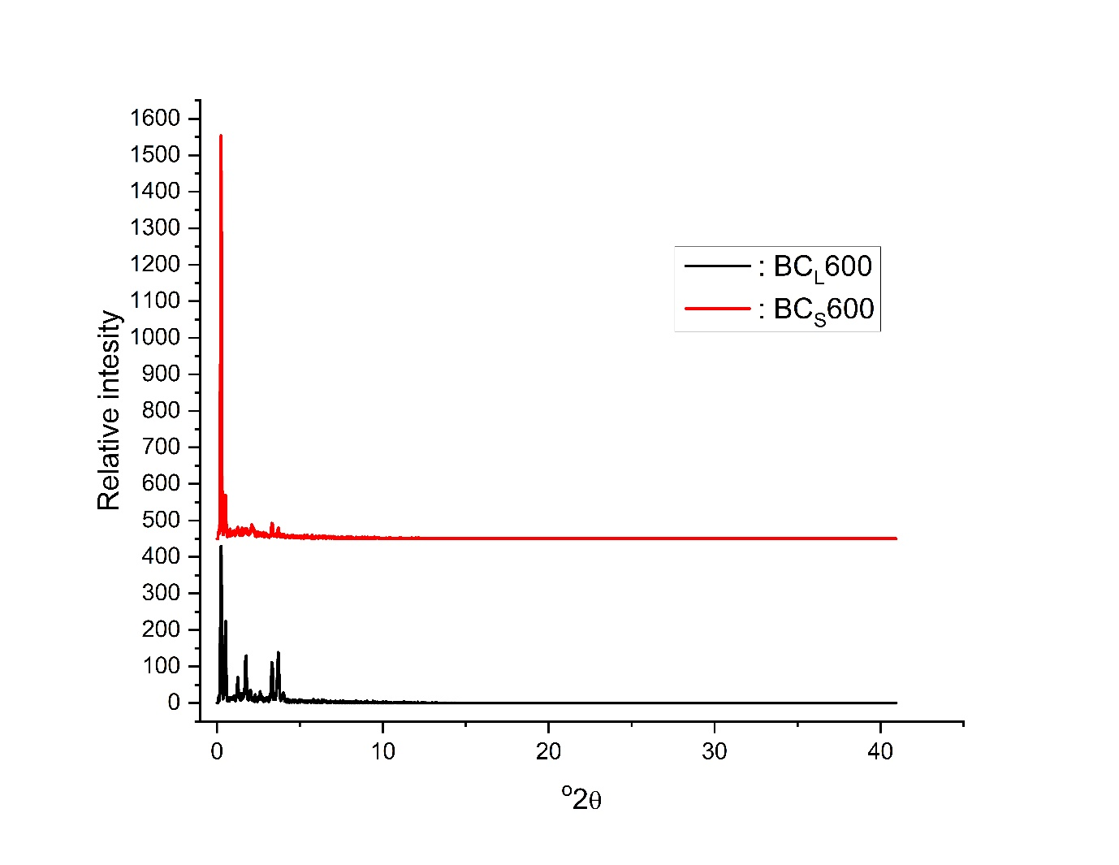Fig. S1: XRD pattern of BC_{L}600 and BC_{S}600.

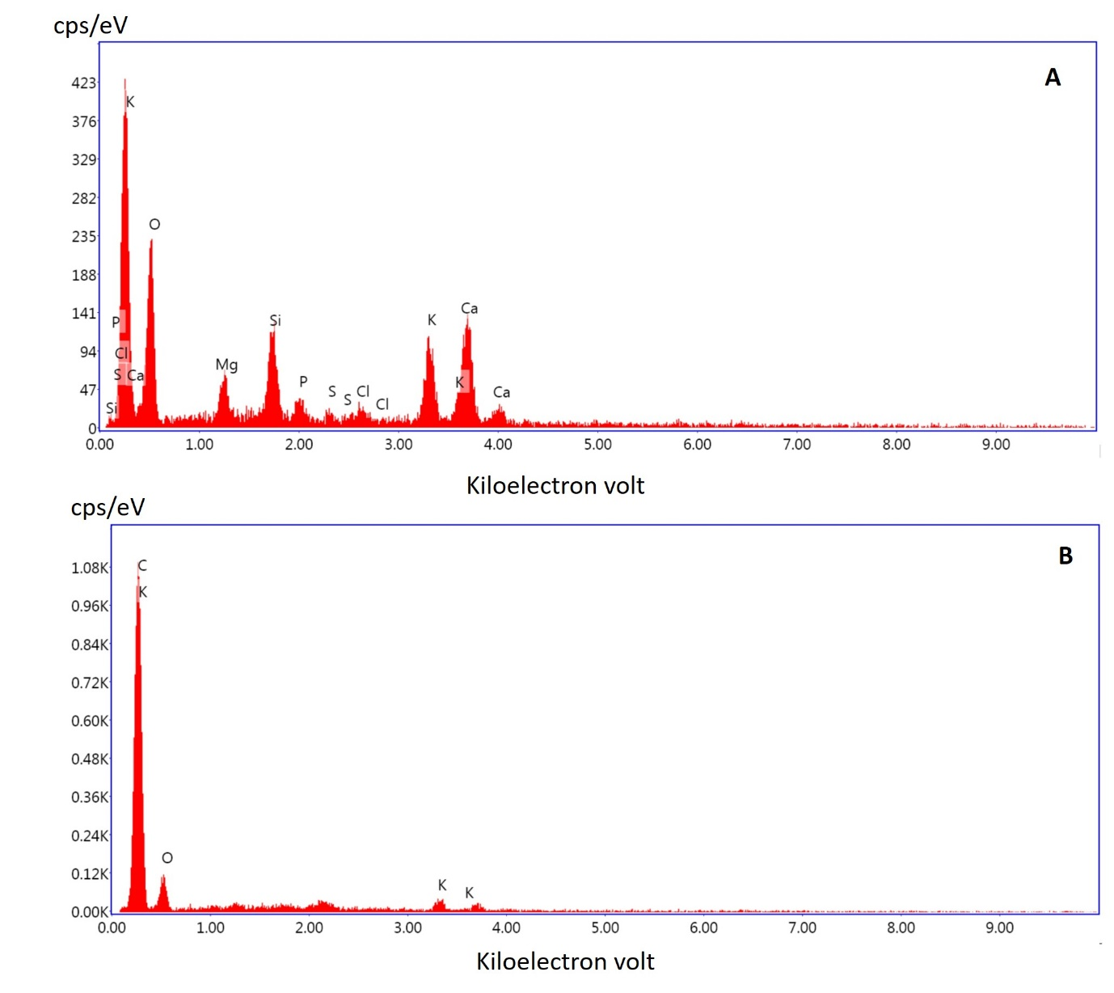
Fig. S2: EDAX analysis of (A) BC_{L}600 (B) BC_{S}600.
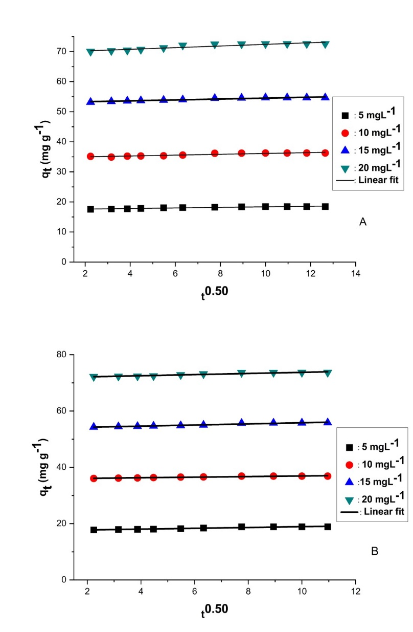
Fig. S3: Intraparticle diffusion analysis of adsorption of MB dye with (A) ${\text{BC}}_{\text{L}}600$and (B) ${\text{BC}}_{\text{S}}600$(Temperature = 303 K, pH = 8) at different concentration.

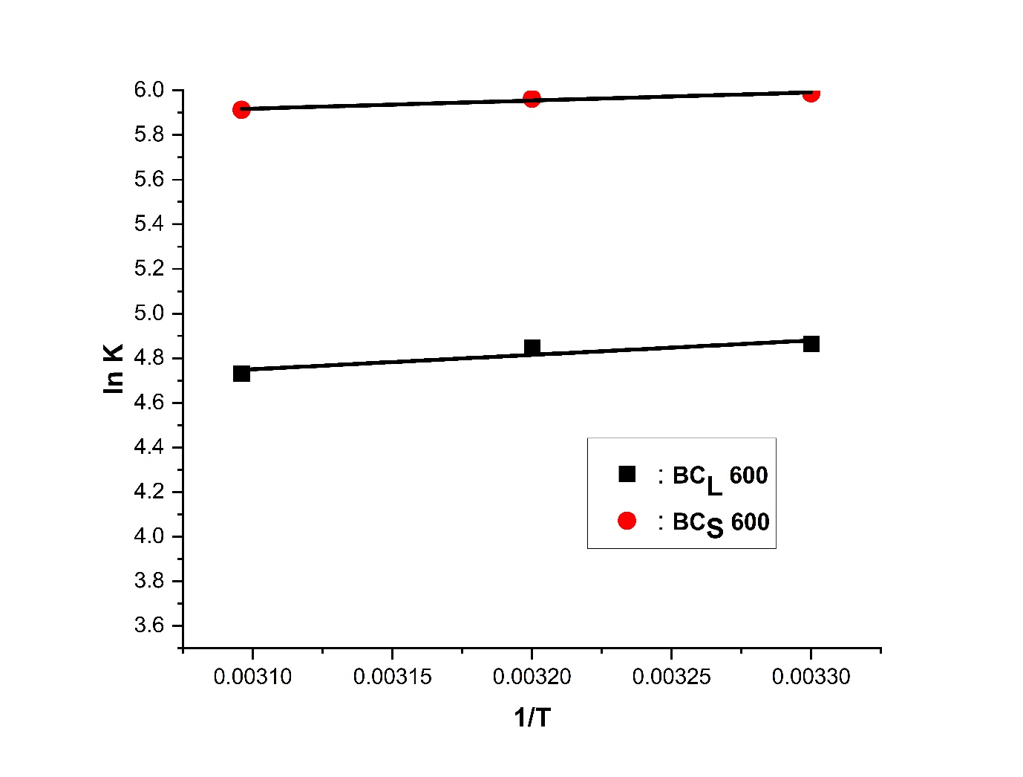
Fig. S4: Van’t Hoff plot for adsorption of MB dye onto (a)${ \text{BC}}_{\text{L}}600$and (b) ${\text{BC}}_{\text{S}}600$.

References
Bulut, Y., Aydin, H. (2006). A kinetics and thermodynamics study of methylene blue adsorption on wheat shells. Desalination, 194, 259–267.
Chen, X. (2015). Modeling of experimental adsorption isotherm data, Information, 6, 14–22.
Freundlich, H.M.F. (1906). Over the adsorption in solution. The Journal of Physical Chemistry, 57, 385–471.
Gautam, R.K., Gautam, P.K., Banerjee, S., Rawat, V., Soni, S., Sharma, S.K., Chattopadhyaya, M.C. (2015). Removal of Tartrazine by activated carbon biosorbents of Lantana camara: Kinetic, equilibrium modeling and spectroscopic analysis. Journal of Environmental Chemical Engineering, 3, 79-88.
Ho, Y.S., Mckay, G. (1999). Pseudo-second order model for sorption processes, Process Biochemistry, 34, 451–465.
Langmuir, I. (1918). The adsorption of gases on plane surfaces of glass, mica and platinum. Journal of American Chemical Society, 40, 1361–1403.
Magdy, Y.H., Daifullah, A.A.M. (1998). Adsorption of a basic dye from aqueous solutions onto sugar- industry-mud in two modes of operations. Waste Management, 18, 219-226.

