Supporting Information

Text S1
The sensor was equipped with two 410-420 nm LED arrays acting as excitation light sources. Images of the fluorescent light emitted by the planar optode sensor were captured by a digital camera (resolution 4272 × 2848 pixels) equipped with a macro lens (Fortune Technology, China) and a 460 nm long pass emission filter (Nmot, China). The planar optode sensor films for soil pH and DO concentration measurement were placed on the detachable plate of the rhizobox corresponding to the positions of the root tips of the two rice plants. The DO level was presented as percent air saturation.

Text S2
The DGT film was placed next to the planar optode sensor on the detachable plate of rhizobox. The cleanliness of the interface and the uniformity of the soil during the deployment process of DGT and planar optode sensor were ensured by using a filter membrane (0.45 μm) attached to the detachable plate of the rhizobox, which protected the roots and soil from interference when the detachable plate was removed later. The labile P was measured by computer-imaging densitometry in combination with a coloration technique according to Ding et al. (2013). The surfaces of the Zr-oxide were scanned using a flat-bed scanner (Canon 5600F, Japan) at a pixel size of 42 × 42 μm². The intensity of the collected grayscale images was analyzed using ImageJ 1.46. The 2D imaging of labile P in soils was presented as the time-averaged flux (F_{DGT}, pg cm⁻² s⁻¹). Temporal variations in the measured parameters represent 14 and 28 days after seedling transplanting, and spatial variation represents the vertical gradient in the rhizosphere. As the fluorescent materials used in planar optode sensor could not determine pH and DO at the same rice rhizosphere location simultaneously, two Zr-oxide DGT films were arranged correspondingly to determine labile P.

Text S3
A high-resolution DGT (HR-ZCA DGT) was used for simultaneous 2D imaging, the DGT units were carefully retrieved using plastic tweezers after 24 hours of deployment of spectrometry. The center position of the root tip on DGT gel (1.4 × 1.6 cm²) was selected to observe the correlation between P and S and metallic cations. The DGT units were then placed on the hybrid layer of gel blotting paper and polyvinylidene fluoride membrane, and then dried with a gel vacuum dryer at 50 °C for 3 hours (Ren et al., 2021). The accumulation of trace elements on the DGT gels was measured by LA-ICP-MS. To improve the accuracy of the analysis, ¹³C as the main element of the combined gel matrix was used as an internal normalization standard (Williams et al., 2014). The 2D imaging of fluxes of labile elements in soils was presented as the time-averaged flux (F_{DGT}, pg cm⁻² s⁻¹). The adjustment of operating parameters in the LA-ICP-MS system, quantitative analysis, and flux calculation of multiple elements were processed according to Ren et al. (2021). Similar to Zr-oxide DGT films, two HR-ZCA DGT films are placed corresponding to the positions of pH and DO, respectively.

Text S4
To analyze P fractions in the rhizosphere zone, soil was separated from roots by gentle shaking, the soil was then processed sequentially in deionized water with one resin strip (Sinopharm Chemical Reagent Co., Ltd), 0.5 M NaHCO₃ (pH 8.5), 0.1 M NaOH, 1 M HCl, and H₂SO₄ with H₂O₂ digested at 360 °C. The extraction process was reciprocated for 16 h and then centrifuged and filtered through a filter membrane (0.45 μm). Soil P concentrations were measured following an ascorbic acid molybdenum blue method (Murphy and Riley, 1962) using an ultraviolet spectrometer (UV 2500, Shimadzu, Japan). Resin-P and NaHCO₃-Pi were represented as available P pool. NaHCO₃-Po and NaOH-Po were accounted for organic P. NaOH-Pi was considered as secondary mineral P that is bound with Fe/Al. HCl-P is considered as primary mineral P which is bound with calcium. Residual P represented occluded P pool.

Fig. S1
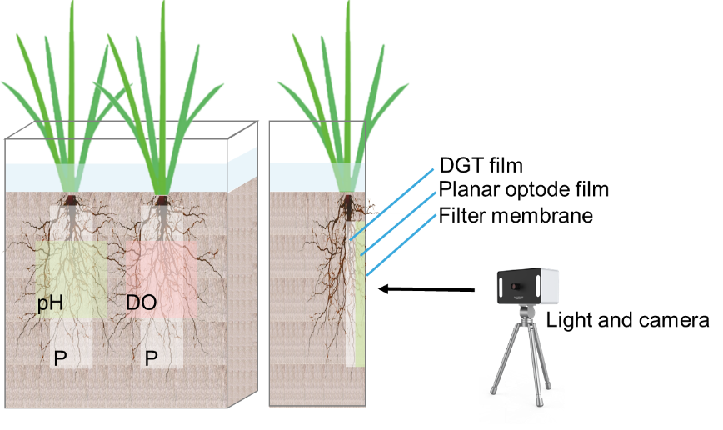
Fig. S1 The scheme of experimental design

Fig. S2
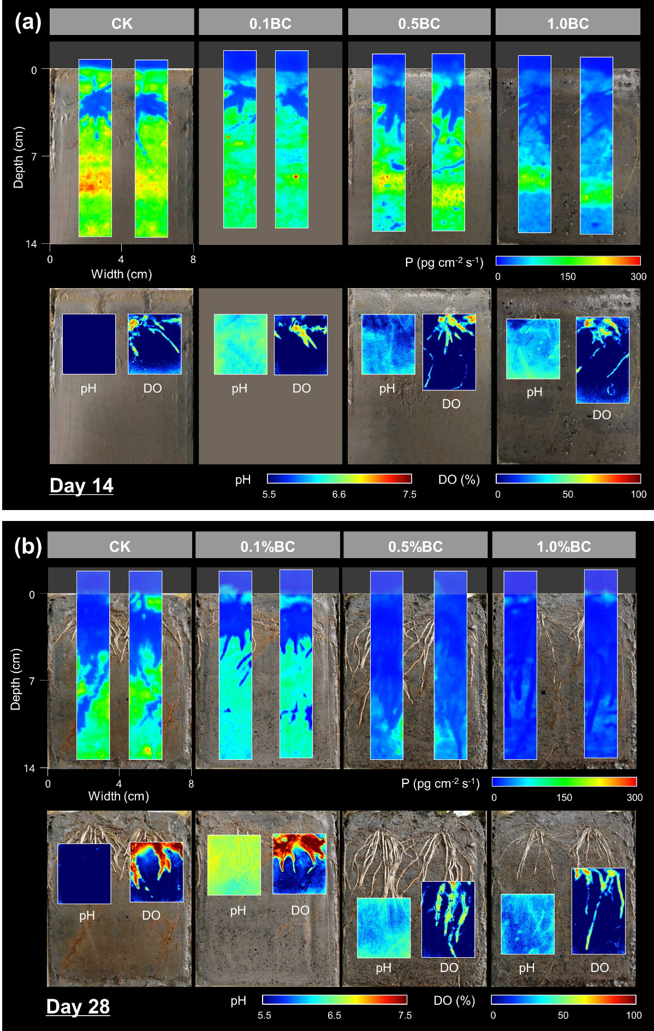
Fig. S2 Temporal and spatial variations of labile P flux, dissolved oxygen (DO) and pH by Zr-oxide DGT and planer optode in rice rhizosphere on the (a) 14th and (b) 28th day of cultivation. Two colored columns in each of the treatments in the top half of the figure were labile P flux, and the left and right one in each of the treatments in the bottom half of the figure were pH and DO, respectively. CK, 0.1BC, 0.5BC and 1.0BC refer to biochar application rates of 0%, 0.1%, 0.5% and 1% of soil weight, which are equivalent to 0, 4.5, 22.5 and 45.0 Mg ha⁻¹ yr⁻¹, respectively

Fig. S3
Fig. S3 The average flux of soil labile P on the rice rhizosphere (Figure S1) on the 28th day of cultivation. CK, 0.1BC, 0.5BC and 1.0BC refer to biochar application rates of 0%, 0.1%, 0.5% and 1% of soil weight, which are equivalent to 0, 4.5, 22.5 and 45.0 Mg ha⁻¹ yr⁻¹, respectively. The error bars were presented the standard error of the average flux of the two DGT labile P in each treatments on the 28th day of cultivation. Different letters indicate significant differences between means at p < 0.05.

Fig. S4
Fig. S4 The concentration of soil P fractions of the original soil and in the rice rhizosphere on the 30th day of cultivation. CK, 0.1BC, 0.5BC and 1.0BC refer to biochar application rates of 0%, 0.1%, 0.5% and 1% of soil weight, which are equivalent to 0, 4.5, 22.5 and 45.0 Mg ha⁻¹ yr⁻¹, respectively. The error bars were presented the standard error. Different letters indicate significant differences between means at p < 0.05 during the same cultivation time.

Fig. S5
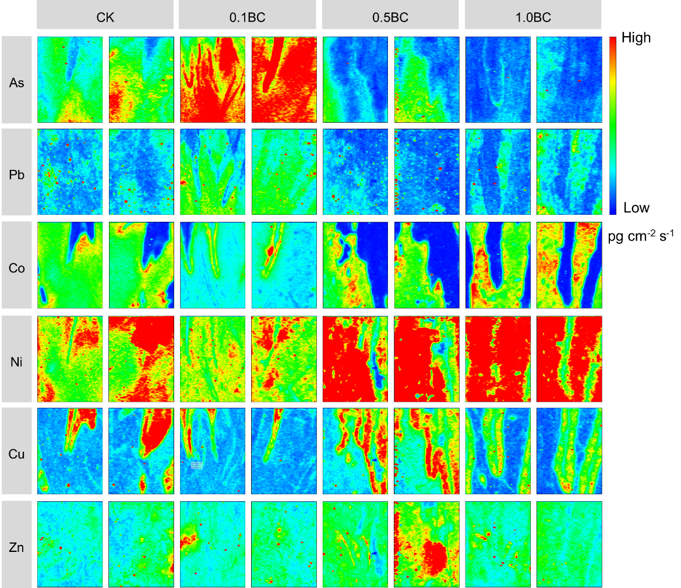
Fig. S5 2D distributions of various fluxes of labile elements in rice rhizosphere (1.4 × 1.6 cm²) on the 30th day of cultivation. The left and right one in each of the treatments represented the flux of labile elements at the same rhizosphere position as DO or pH. The flux increased with the color scale shown from blue to red. The scales in the figure represent the following range from 0 to 1 for As, from 0 to 0.5 for Pb, from 0 to 75 for Co, and from 0 to 5 for Ni, Cu and Zn. CK, 0.1BC, 0.5BC and 1.0BC refer to biochar application rates of 0%, 0.1%, 0.5% and 1% of soil weight, which are equivalent to 0, 4.5, 22.5 and 45.0 Mg ha⁻¹ yr⁻¹, respectively

CK 0.1BC 0.5BC 1.0BC
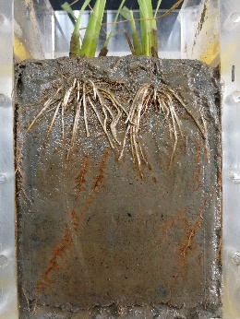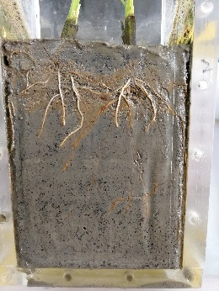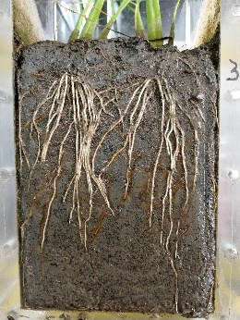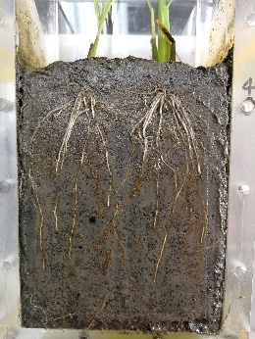
Fig. S6 The rice root distribution after incubation.
Table S1: The longest root length and total root length in each treatment after incubation.
Treatments | Longest root length (cm) | Total root length (cm)
CK | 18.25 | 777.4
0.1BC | 14.24 | 605.7
0.5BC | 20.56 | 1246
1.0BC | 19.75 | 948.5

