Supplementary material
Effects of straw returning on photochemical process and
imidacloprid degradation in paddy water through a field experiment

Mabo Li^{a, b}, Yu Zeng^{a, b}, Qinglong Fu^{c, *}, Mingyang Zhang^{a, b}, Ning Chenª, Yujun Wang^{a, b}, Dongmei Zhou^{d}, Guodong Fang^{a, b, *}

ª State Key Laboratory of Soil and Sustainable Agriculture, Institute of Soil Science, Chinese Academy of Sciences, Nanjing 210008, P.R. China
^{b} University of Chinese Academy of Sciences, Beijing 100049, P.R. China
^{c} School of Environmental Studies, China University of Geosciences, Wuhan 430074, P.R. China
^{d} State Key Laboratory of Pollution Control and Resource Reuse, School of the Environment, Nanjing University, Nanjing 210023, P.R. China
*Corresponding author. Tel.: +86 25 86881327; fax: +86 25 86881000.
E-mail address: gdfang@issas.ac.cn (G.D. Fang); fuqinglong@cug.edu.cn (Q.L. Fu)

Text S1. Chemicals
2,4,6-trimethylphenol (TMP, 98%), p-phthalic acid (TPA, 98%) and 2-hydroxyterephthalic acid (hTPA, 99%) were purchased from Aladdin Industrial Co. (Shanghai, China). Furfuryl alcohol (FFA, 98.5%), hydrochloric acid (HCl, 35%), disodium hydrogen phosphate dodecahydrate (99%), and sodium dihydrogen phosphate dihydrate (99%) were obtained from Nanjing Chemical Reagents Co., Ltd. (Nanjing, Jiangsu, China). HPLC-grade methanol and acetonitrile were provided by Merck (Darmstadt, Germany). A Synergy UV ultrapure water system equipped with a Millipak-40 filter unit (Millipore Corporation Merck KGaA, Darmstadt, Germany) provided ultrapure water for all the experiments.
The rice straw was purchased from Muyangqingchuanmu horticulture Co., Ltd. (Muyang, Jiangsu, China). Chemical fertilizer was purchased from Shandong Sanfang Chemical Co., LTD (Linyi, Shandong, China). Chemical components of rice straw and chemical fertilizer were shown in Table.S2.

Text S2. Characterization of dissolved organic matter
The spectral indexes including aromaticity index (SUVA₂₅₄), E₂:E₃ (related to the DOM molecular size), CDOM/DOM ratio (Chromophoric Dissolved Organic Matters content), humification index (HIX) and biological index (BIX) were determined with UV-vis and EEM spectra. EEM–PARAFAC model was applied to analyze fluorescence spectra of paddy waters with DOMFLuor toolbox in MATLAB R2018b.

Text S3. Solid phase extraction procedure of DOM
All samples were desalted by solid phase extraction (SPE) procedure using Agilent Bond Elut-PPL cartridges (1.0g per 6 mL). All samples were first passed through a 0.22 µm membrane to remove impurities, and acidized with hydrochloric acid (1M) (pH 2.0) to improve the quantity and intensity of aromatic compounds with high oxygen content (Han et al. 2022). Meanwhile, all SPE cartridges were activated by flushing 12 mL of methanol (LC-MS grade) and hydrochloric acid (0.01M), respectively. The samples were slowly passed through SPE cartridges at a flow rate of ～5 mLmin⁻¹ for enrichment of target compounds. Finally, SPE cartridges were washed with hydrochloric acid (0.01M) to remove the residual salts, and the dried with a stream of N₂, and DOM was collected by 10 mL methanol eluent (LC-MS grade).

Text S4. FT-ICR MS analysis of DOM
The Bruker SolariX FT-ICR-MS equipped with electrospray ionization (ESI) ion source (negative ion mode) combined with 15.0 T superconducting magnet was used to analyze the DOM molecular composition. The mass range was set to m/z = 100–1600 Da. Sodium formate (10 mM) was used for calibration of FTICR-MS. The syringe pump injected the samples into ESI ion source at 120 μL/h. For ensuring a mass accuracy (< 1.0 ppm), FT-ICR MS spectra of samples were internally recalibrated with known NOM molecules.
The following rules were applied when assigning molecular formulas: C=1−50 atoms, H/C = 0.3−2.25, 0 < O/C < 1.2, N ≤ 5 atoms, S ≤ 3 atoms, P ≤ 1 atoms, the relative error was less than 1.0 ppm. Based on the assigned formulae of each DOM molecule, the intensity-weighted average (wa) parameters such as double-bond equivalence (DBE_{wa}), molecular weight (MW_{wa}), H/C_{wa}, O/C_{wa} were calculated on the basis of the following equations (Fu, Fujii, and Kwon 2020, Fu, Fujii, and Riedel 2020):
${H/C}_{W}=\sum{({H/C}_{i}*M_{i})}$ (1)
${O/C}_{W}=\sum{({O/C}_{i}*M_{i})}$ (2)
$DBE=(2C+N+P-H+2)/2$ (3)
${DBE}_{W}=\sum{({DBE}_{i}*M_{i})}$ (4)
${AI}_{mod}=\frac{1+C-0.5O-S-O.5(N+P+H)}{C-0.5O-N-S}$ (5)
${AI}_{modw}=\sum{({AI}_{modi}*M_{i})}$ (6)
$NOSC=4-\left[\left(4C+H-3N-2O-2S\right)/C\right]$ (7)
${NOSC}_{w}=\sum{\left({NOSC}_{i}*M_{i}\right)}$ (8)
$M_{i}=I_{I}/\sum{I_{i}}$ (9)
where C, H, O, N, S, and P are the stoichiometric numbers of carbon, hydrogen, oxygen, nitrogen, and sulfur atoms per formula, respectively. The subscript w denotes magnitude-weighted values, and relative magnitudes (M_{i}) were calculated by dividing the signal peak magnitude (I_{i}) by the summed total magnitude.
In general, the typical biogeochemical compounds were considered to have their characteristic H/C or O/C ratios and correspond to specific locations on the van Krevelen diagram (Wu, Fujii, and Fu 2023): saturated compounds (H/C = 1.50 – 2.20, O/C = 0 – 0.52); aminosugars (H/C = 1.50 – 2.20, O/C = 0.52 – 0.71); carbohydrates (H/C = 1.50 – 2.40, O/C = 0.71 – 1.20); Unsaturated hydrocarbons (H/C = 0.70 – 1.50, O/C = 0 – 0.10); lignins (H/C = 0.70 – 1.50, O/C = 0.10 – 0.67); tannins (H/C = 0.50 – 1.50, O/C = 0.67 – 1.20); and condensed aromatics structures (H/C = 0.20 – 0.70, O/C = 0 – 0.67).

Text S5. Quantum yields and steady-state concentrations of RIs
Steady-state concentrations of RIs were determined by probe compounds. ${[RI]}_{ss}$ is steady-concentration of RI. $r_{RI}^{f}$ is formation rate of RI. $k_{RI}^{d}$ is the first-order rate constant for deactivation of RI. PC is probe compound, and $k_{RI,PC}^{q}$ is the second-order rate constants for the reaction of the RI with PC. The pseudo-first-order transformation rate constant of FFA、TMP and 2hTPA can be determined by linear fitting. Meanwhile, the yields of products for the reaction of 2hTPA are about 35%. Owing to the natural quenchers negligible contribution to the quenching of ³DOM*、¹O₂ and •OH, we can get the ${[RI]}_{ss}$ using the following equations (Zhang, Yan, and Song 2014, Rosario-Ortiz and Canonica 2016, Zhou, Lian, et al. 2017):
${[RI]}_{ss}=\frac{r_{RI}^{f}}{k_{RI}^{d}+k_{RI,PC}^{q}}$ (10)
$-\frac{d\left[TMP\right]}{dt}=k_{TMP,3DOM*}[{}_{}^{3}{DOM^{*}}]_{ss}[TMP]$ (11)
$-\frac{d\left[FFA\right]}{dt}=k_{FFA,1O2}[{}_{}^{1}{O_{2}}]_{ss}[FFA]$ (12)
$\frac{d\left[2hTPA\right]}{dt}={0.35k}_{TPA,·OH}[{}_{}^{•}{OH}]_{ss}[TPA]$ (13)
where $k_{TMP,3DOM*}=8.1×{10}^{8}{ M}^{-1}s^{-1}$ ; $k_{FFA,1O2}=8.3×{10}^{7}{ M}^{-1}s^{-1}$; $k_{·OH,TPA}=3.3×{10}^{9} M^{-1}s^{-1}$ (Latch et al. 2003, Mark et al. 1998, Erickson et al. 2018).
The formation rates ($R_{i}^{f}$) of ¹O₂ and ·OH were obtained by the fllowing equations:
$R_{1O2}^{f}={(k}_{w}+k_{FFA,1O2}[FFA])[{}_{}^{1}{O_{2}}]_{ss}$ (14)
$R_{·OH}^{f}=k_{TPA,·OH}[{}_{}^{•}{OH}]_{ss}$ (15)
where k_{w} is the reaction rate constant of natural quenching by water (2.4 ⅹ 10⁵ s⁻¹).
We calculated the quantum yileds Φ_{i} by the formation rates of RIs (¹O₂ and •OH) and the rates of light absorption Ra. While the quantum yileds of ³DOM* (f_{TMP}) were obtained by eq.17. Ra (Berg et al. 2019, Zhou et al. 2019) can be calculated by eq.18 .

$Φ_{i}=R_{i}/R_{a}$ (16)
$f_{TMP}=k_{TMP}/R_{a}$ (17)
$Ra=\sum_{λ}{\frac{E_{p,λ}^{0}(1-10^{-A_{λ}})Δλ}{l}}$ (18)
where $E_{p,λ}^{0}$ stands for the spectral photon irradiance of the xenon lamp (einstein cm^{–2} s^{–1} nm^{–1}), Δλ for the absorbance of the solution, and l for the optical path length.
We measured Ra using p‑Nitroacetophenone/Pyridine (PNA-pyr) actinometers. Details of experimental process referenced the following references (Kuhn, Braslavsky, and Schmidt 2004, Zhou, Yan, et al. 2017, Laszakovits et al. 2016).

Text S6. Calculation of total light screening coefficient
Light screening coefficient (S_{λ}) and total light screening coefficient were calculated by the following equations(Janssen, Erickson, and McNeill 2014):
$S_{λ}=\frac{1-(10^{-(α_{λ}+ε_{λ}[IMD]l)})}{2.303(α_{λ}+ε_{λ}[IMD])l}$ (19)
$\sum{S_{λ}=\frac{\sum{I_{λ}s_{λ}}ε_{λ}}{\sum{I_{λ}ε_{λ}}}}$ (20)
where α_{λ} is unit absorbance of DOM (cm-1), ε_{λ} is molar absorption coefficient of IMD (cm⁻¹Lmol⁻¹), [IMD] is concentration of IMD (mol/L), l is light path (cm). Based on the ΣS_{λ}, indirect photolysis rate constant caused by DOM was predicted by the following equation:
$k_{obs,IMD}=k_{DOM}-k_{UW}\sum{S_{λ}}$ (21)
where k_{DOM} and k_{UW} (h⁻¹) are the photolysis rate constants of IMD in the presence or absence of DOM and up water, respectively.

Text S7. Detection of reactive intermediates and IMD
FFA, TMP and 2hTPA concentrations were measured using HPLC. The detection condition of 2hTPA was that IR detection wavelength: 225 nm; mobile phase: 7% acetonitrile, 30% methanol and 70% formic acid (1g/kg); flow rate: 1 mL/min. FFA and TMP concentrations were measured using UV detection with 270 nm wavelength. Mobile phase of FFA was 30% methanol and 70% ultrapure water, which flow rate was 1 mL/min. Mobile phase of TMP was 70% acetonitrile and 30% phosphate buffer (pH = 5), which flow rate was 1 mL/min. The detection condition of TMD was that IR detection wavelength: 225 nm; mobile phase: 80% acetonitrile, 20% ultrapure water; flow rate: 1 mL/min.

Text S8. Structural equation model
According to DOM properties and RIs concentration determined in our experiments, a structural equation model (SEM) was constructed to quantify the multivariate causal network in which strawing returning dosage and cultivation time were involved (Figure 3). First, SEM contained four composite variables that represent the collections of variables in terms of DOC concentration and property. We chose a set of indexes of DOC concentration and property that influencing on RIs formation by Pearson correlations (Figure S8). DOC, E₂:E₃, BIX, HIX, FI and CDOM/DOM were chosen for the model. Then SEM was developed with the fully conceptual model using χ² tests with maximum likelihood estimation. The model assumption that the sample covariance matrix is not different from the assumed model's expected covariance matrix, should not be true (P>0.05).

Text S9. Instrumental settings of LC-MS/MS
The column temperature was maintained at 40 °C, the injection volume was 10 μL. The mobile phase was composed of 2 mM ammonium acetate (phase A) and acetonitrile (phase B) with the flow rate of 0.25 ml/min. Total run time was about 27 min. The full scanning analysis of mass spectrometry was acquired in the range of m/z 50-800 Da in the positive ion mode of electrospray ionization (ESI). Instrumental settings were as following: 5500 V ionspray voltage; 550°C temperature; 55 psi gas 1; 55 psi gas 2; 35 psi curtain gas (pure nitrogen); 60 V declustering potential; 15V collision energy.

Table S1. Chemical properties of paddy soil samples
 | pH | Organic matter content (g/kg) | Electrical conductivity (mS/m) | Fe  (mg/kg) | Mn  (mg/kg) | Cation exchange capacity  (cmol/kg)
CK (100% CF) | 5.3 | 29.3 | 3.9 | 29970 | 257 | 13.2
25%RS+75%CF | 5.4 | 30.9 | 4.4 | 25620 | 236 | 12.9
75%RS+25%CF | 5.5 | 35.5 | 4.8 | 26620 | 246 | 13.2
CF: chemical fertilizer; RS: rice straw.

Table S2. Chemical components of rice straw and chemical fertilizer
 | C (%) | N (%)
Rice straw | 35.64±0.9 | 0.93±0.1
Chemical fertilizer | None | 25

Table S3. The amount of rice straw and nitrogen fertilizer for each treatment
Treatment | Rice straw (kg) | Nitrogen fertilizer (kg)
CK | 0 | 0.24
25%RS | 1.6 | 0.18
75%RS | 4.8 | 0.06

Table S4. Steady-state concentrations and quantum yield coefficients of RIs in paddy water samples (ex-situ trapping experiments)
Time | Treatment | [·OH]_{ss}  (ⅹ10¹⁷ mol/L) | [³DOM*]_{ss}  (ⅹ10⁻¹³ mol/L) | [¹O₂]_{ss}  (ⅹ10⁻¹³ mol/L) | Φ_{·OH}  (ⅹ10⁻⁵) | f_{TMP} | Φ_{1O2}  (ⅹ10⁻²)
10 | CK | 1.71±0.01 | 0.82±0.04 | 1.53±0.05 | 1.38±0.10 | 33.48±5.11 | 1.47±0.10
10 | 25%RS | 2.83±0.02 | 1.16±0.26 | 2.27±0.03 | 1.69±0.15 | 24.15±3.35 | 1.81±0.03
10 | 75%RS | 2.27±0.12 | 1.06±0.02 | 2.13±0.00 | 1.04±0.22 | 24.48±3.70 | 1.61±0.02
20 | CK | 0.89±0.09 | 0.54±0.14 | 0.82±0.07 | 1.10±0.01 | 32.51±1.23 | 1.34±0.01
20 | 25%RS | 1.42±0.19 | 0.58±0.02 | 1.47±0.16 | 1.54±0.07 | 37.46±2.55 | 2.09±0.19
20 | 75%RS | 1.02±0.09 | 0.75±0.08 | 1.64±0.16 | 1.13±0.00 | 26.08±0.80 | 1.89±0.15
30 | CK | 1.07±0.01 | 0.37±0.02 | 0.97±0.11 | 0.67±0.00 | 9.59±1.27 | 0.73±0.05
30 | 25%RS | 0.68±0.05 | 0.81±0.08 | 2.30±0.01 | 0.41±0.16 | 16.60±1.07 | 1.60±0.15
30 | 75%RS | 0.98±0.01 | 0.77±0.02 | 1.74±0.36 | 0.41±0.03 | 15.51±1.50 | 1.03±0.14
50 | CK | 0.85±0.00 | 0.34±0.03 | 0.77±0.10 | 1.19±0.11 | 19.48±0.17 | 0.97±0.26
50 | 25%RS | 1.19±0.01 | 0.56±0.04 | 1.50±0.26 | 1.54±0.08 | 24.12±6.59 | 1.78±0.13
50 | 75%RS | 1.07±0.05 | 0.77±0.06 | 1.91±0.15 | 1.22±0.07 | 34.28±6.04 | 3.11±0.14
70 | CK | 0.38±0.02 | 0.21±0.05 | 0.21±0.01 | 1.37±0.13 | 30.24±3.58 | 5.80±0.33
70 | 25%RS | 1.33±0.03 | 0.37±0.03 | 0.76±0.04 | 3.63±0.28 | 43.37±2.58 | 2.90±0.07
70 | 75%RS | 1.24±0.01 | 0.24±0.06 | 0.22±0.05 | 6.37±0.24 | 70.81±8.21 | 1.98±0.08

Table S5. Bulk DOM properties of paddy water samples
Time | Treament | SUVA₅₂₄  (L/mg/m) | E₂:E₃ | CDOM/DOM  (L/mg/m) | HIX | FI | BIX
10 | CK | 6.06±0.52 | 4.39±0.18 | 0.81±0.07 | 0.81±0.02 | 2.26±0.04 | 0.76±0.00
10 | 25%RS | 5.52±0.35 | 2.96±0.03 | 1.99±0.03 | 0.80±0.02 | 2.27±0.05 | 0.80±0.01
10 | 75%RS | 5.28±0.06 | 3.60±0.23 | 1.68±0.08 | 0.78±0.01 | 2.40±0.08 | 0.80±0.00
20 | CK | 4.72±0.29 | 5.47±0.17 | 1.04±0.03 | 0.85±0.01 | 2.31±0.02 | 0.79±0.01
20 | 25%RS | 6.18±0.86 | 4.39±0.12 | 1.95±0.33 | 0.87±0.01 | 2.32±0.04 | 0.76±0.01
20 | 75%RS | 12.40±1.04 | 4.69±0.31 | 2.58±0.18 | 0.85±0.00 | 2.31±0.03 | 0.76±0.07
30 | CK | 5.55±0.45 | 3.34±0.10 | 0.80±0.07 | 0.84±0.01 | 2.31±0.07 | 0.81±0.02
30 | 25%RS | 2.98±0.62 | 2.71±0.03 | 1.87±0.06 | 0.84±0.01 | 2.18±0.08 | 0.83±0.00
30 | 75%RS | 3.69±0.03 | 2.69±0.09 | 2.03±0.05 | 0.82±0.02 | 2.33±0.03 | 0.77±0.01
50 | CK | 3.73±0.55 | 4.80±0.51 | 0.70±0.07 | 0.84±0.02 | 2.24±0.07 | 0.74±0.01
50 | 25%RS | 2.16±0.45 | 4.24±0.39 | 0.67±0.07 | 0.73±.03 | 2.36±0.09 | 0.77±0.00
50 | 75%RS | 2.99±0.46 | 4.61±0.01 | 0.81±0.08 | 0.86±0.00 | 2.24±0.07 | 0.78±0.00
70 | CK | 2.05±0.13 | 4.59±0.20 | 0.44±0.01 | 0.72±0.01 | 2.19±0.01 | 0.79±0.01
70 | 25%RS | 4.07±0.77 | 3.04±0.08 | 1.01±0.04 | 0.73±0.03 | 2.27±0.28 | 0.760.05
70 | 75%RS | 2.74±0.40 | 4.43±0.14 | 0.54±0.03 | 0.81±0.01 | 2.07±0.06 | 0.790.00

Time | Treament | F_{max}(C1) | F_{max}(C2) | F_{max}(C3) | F_{max}(C4)
 | CK | 0.32±0.03 | 0.27±0.04 | 0.28±0.04 | 0.096±0.00
10 | 25%RS | 0.32±0.03 | 0.25±0.01 | 0.08±0.03 | 0.090±0.01
 | 75%RS | 0.38±0.05 | 0.31±0.03 | 0.36±0.05 | 0.096±0.00
 | CK | 0.29±0.07 | 0.20±0.05 | 0.24±0.06 | 0.071±0.00
20 | 25%RS | 0.32±0.03 | 0.21±0.02 | 0.25±0.03 | 0.066±0.01
 | 75%RS | 0.35±0.05 | 0.23±0.05 | 0.26±0.06 | 0.062±0.00
 | CK | 0.32±0.02 | 0.21±0.00 | 0.26±0.01 | 0.077±0.00
30 | 25%RS | 0.36±0.04 | 0.26±0.04 | 0.32±0.06 | 0.100±0.00
 | 75%RS | 0.46±0.01 | 0.30±0.04 | 0.36±0.04 | 0.115±0.01
 | CK | 0.24±0.01 | 0.18±0.00 | 0.20±0.01 | 0.057±0.00
50 | 25%RS | 0.26±0.01 | 0.20±0.01 | 0.23±0.02 | 0.061±0.01
 | 75%RS | 0.29±0.02 | 0.30±0.01 | 0.25±0.02 | 0.063±0.00
 | CK | 0.04±0.00 | 0.03±0.00 | 0.04±0.00 | 0.015±0.00
70 | 25%RS | 0.03±0.02 | 0.03±0.02 | 0.03±0.02 | 0.018±0.00
 | 75%RS | 0.05±0.01 | 0.04±0.01 | 0.05±0.01 | 0.015±0.00
Table S6. F_{max} values of four fluorescent components

Table S7. Chemical properties of paddy water samples
Time | Treatment | [NO²⁻] (mg/L) | [NO³⁻] (mg/L) | pH
10 | CK | 0.010 | 0.043 | 6.757
10 | 25%RS | 0.009 | 0.022 | 6.727
10 | 75%RS | 0.010 | 0.028 | 6.760
20 | CK | 0.031 | 0.014 | 6.747
20 | 25%RS | 0.010 | 0.072 | 6.847
20 | 75%RS | 0.009 | 0.046 | 6.863
30 | CK | 0.013 | 0.016 | 6.310
30 | 25%RS | 0.005 | 0.012 | 6.617
30 | 75%RS | 0.006 | 0.061 | 6.480
50 | CK | 0.014 | 0.086 | 6.063
50 | 25%RS | 0.010 | 0.732 | 5.833
50 | 75%RS | 0.014 | 0.123 | 5.740
70 | CK | 0.001 | 0.020 | 5.853
70 | 25%RS | 0.003 | <0.015 | 5.687
70 | 75%RS | 0.006 | 0.019 | 5.497

Table S8. Predicted toxicity of IMD and its products based on ECOSAR
Compound | Imidacloprid  (m/z=256) | P1  (m/z=271) | P2  (m/z=241) | P3  (m/z=212) | P4  (m/z=226) | P5  (m/z=209) | P6  (m/z=141)
Fish | 417.00 | 4810.00 | 10.80 | 9.98 | 7180.00 | 8.63 | 652.00
Daphnid | 121.00 | 938.00 | 0.30 | 0.26 | 3460.00 | 0.26 | 343.00
Green Algae | 73.40 | 623.00 | 149.00 | 147.00 | 1310.00 | 190.00 | 186.00
Toxicity classification according to the Globally Harmonized System of Classification and Labelling of Chemicals: Very toxic, LC50/EC50≤1; Toxic, 1<LC50/EC50≤10;
Harmful, 10<LC50/EC50≤100; Not harmful, LC50/EC50 >100.
LC50, half lethal concentration of fish and daphnid; EC50, half effective concentration of green algae.

Table S9. DOM intensity-weighted average (wa) parameters of elemental ratios (H/C, O/C, S/C and P/C), modified aromaticity index (AI_{mod}) and double bond equivalents (DBE) on the 10th day after fertilization.
Treatment | H/C_{W} | O/C_{W} | S/C_{W}  (ⅹ 10⁻³) | P/C_{W}  (ⅹ 10⁻⁴) | AI_{mod} | DBE_{W}
CK-10d | 1.28 | 0.50 | 1.91 | 1.97 | 0.23 | 7.77
25%RS-10d | 1.27 | 0.49 | 2.71 | 5.40 | 0.23 | 7.86
75%RS-10d | 1.30 | 0.47 | 2.73 | 8.63 | 0.22 | 7.50

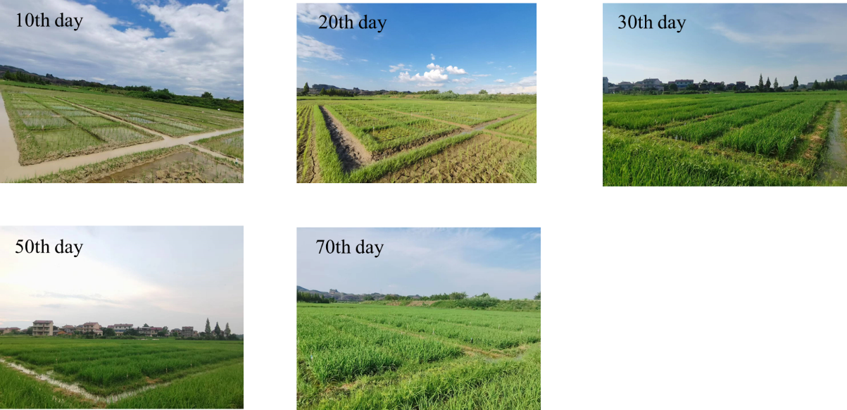

Figure S1. The outdoor field experiment of paddy cultivation with different treatment, located in Guixi, Yingtan, Jiangxi, China (177°10′51.75″ N, 28°14′39.52″ E).

Figure S2. Photochemically generated cumulative concentration of hTPA and photodegradation
of FFA and TMP in paddy water samples. 0.5mM TPA used as probe for •OH; 50 µM FFA used
as probe for ¹O₂; 50 µM TMP used as probe for ³DOM*

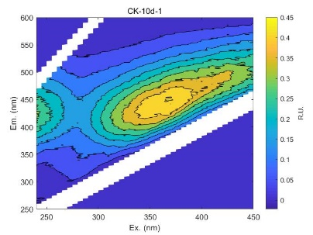 | 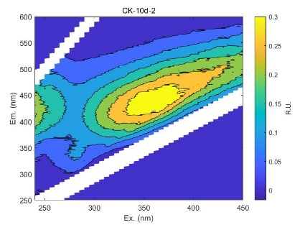 | 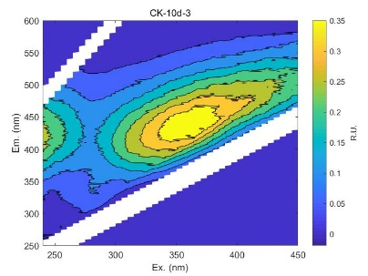
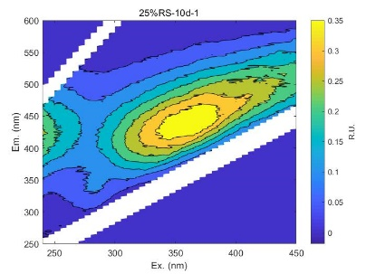 | 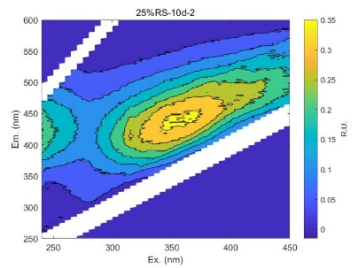 | 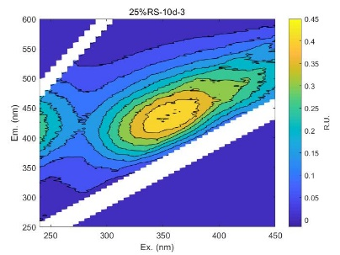
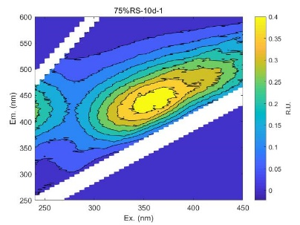 | 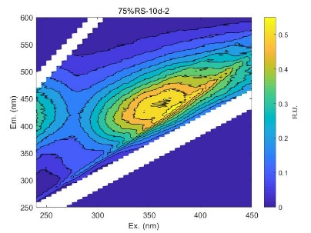 | 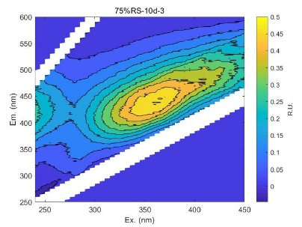
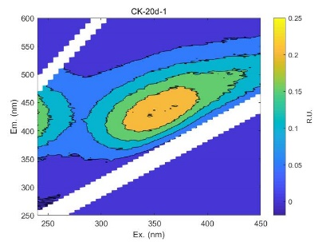 | 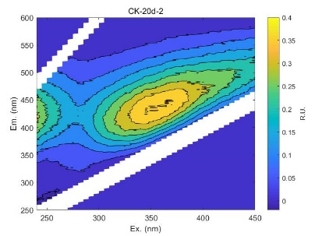 | 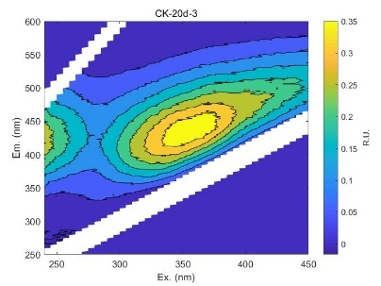
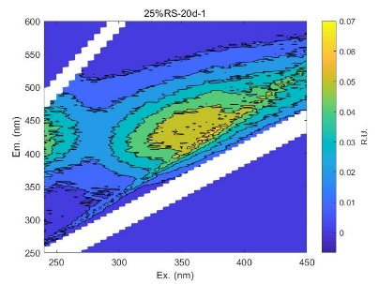 | 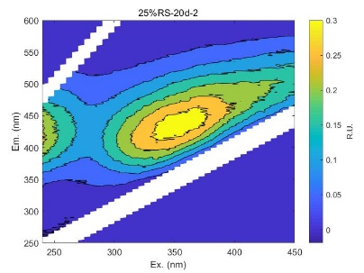 | 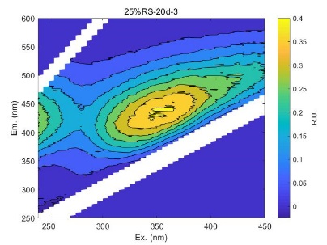
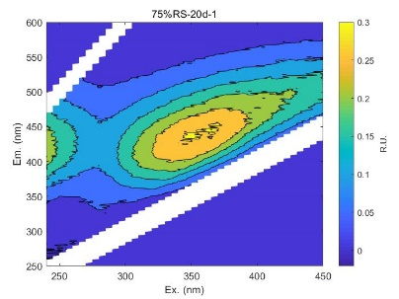 | 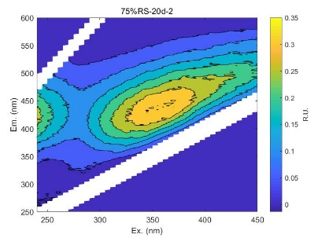 | 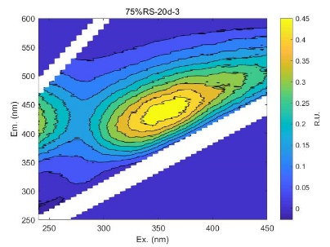
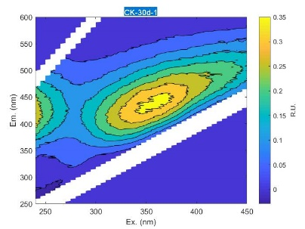 | 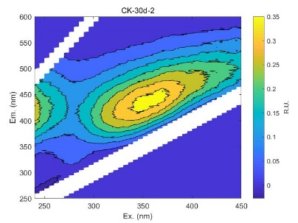 | 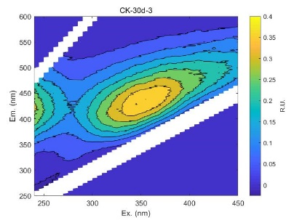
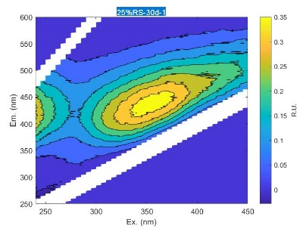 | 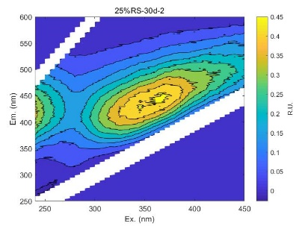 | 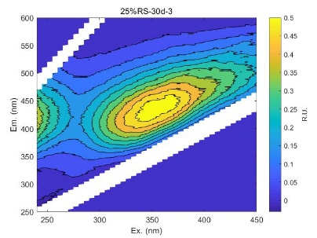
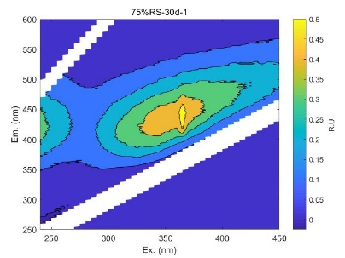 | 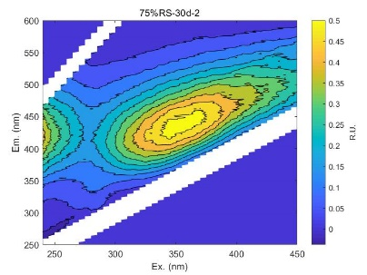 | 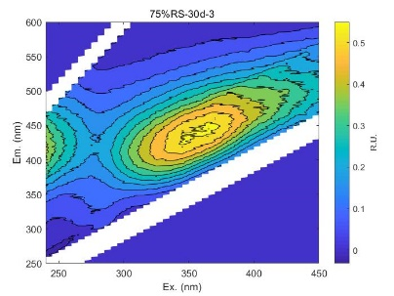
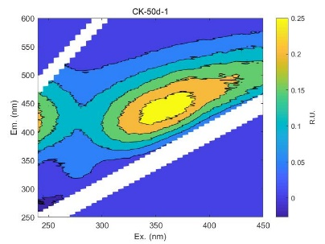 | 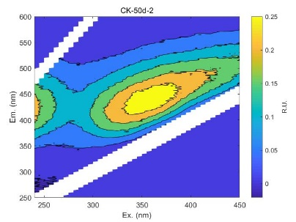 | 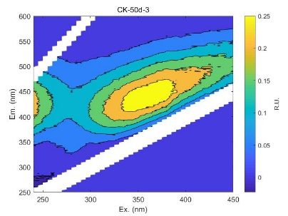
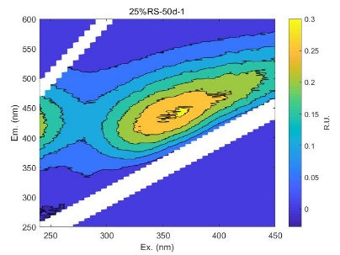 | 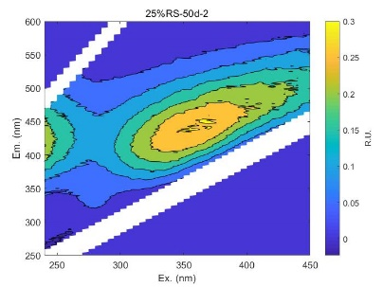 | 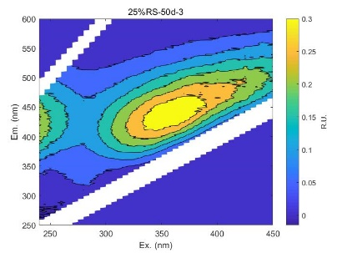
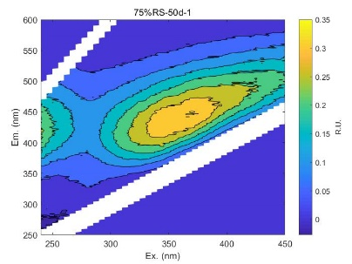 | 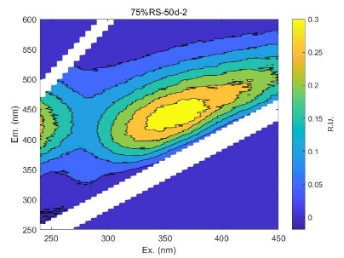 | 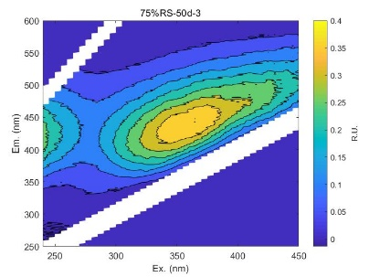
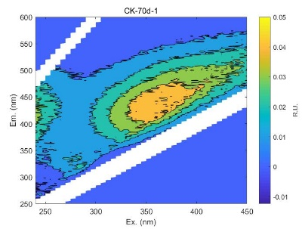 | 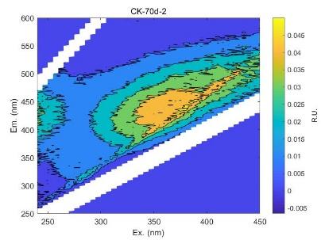 | 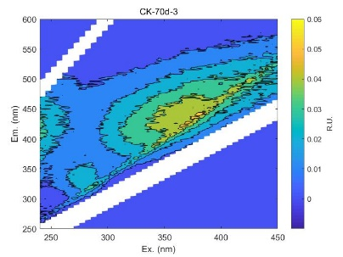
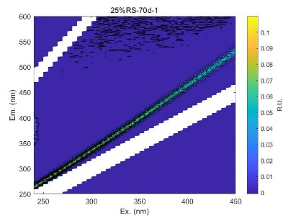 | 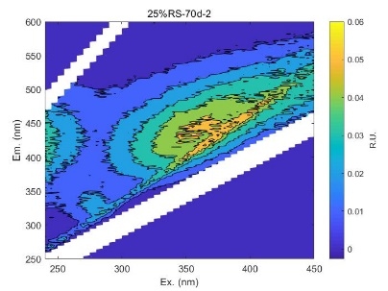 | 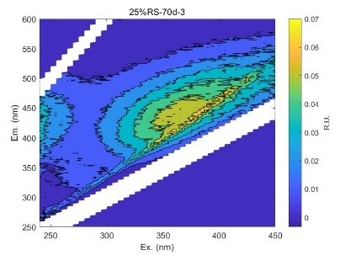
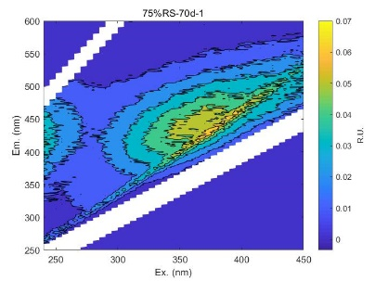 | 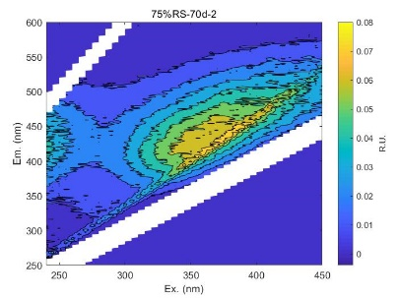 | 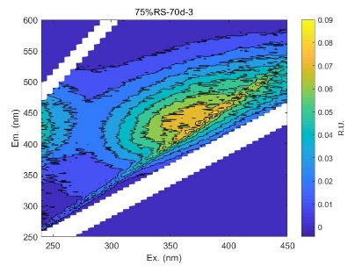

Figure S3. EEM spectra of paddy water samples. (F-7000spectrofluorometer at 1 and 5 nm intervals for 250–600 nm and 200–450 nm excitation wavelengths; Fluorescence intensities normalized to Raman units using the Raman scatter peak of water)

Figure S4. Bulk DOM properties index (a: HIX; b: BIX; c: FI; d: SUVA₂₅₄; f: CDOM/DOM; g: E₂:E₃ ratio) and concentration of DOM (e: [DOC]) of paddy water.

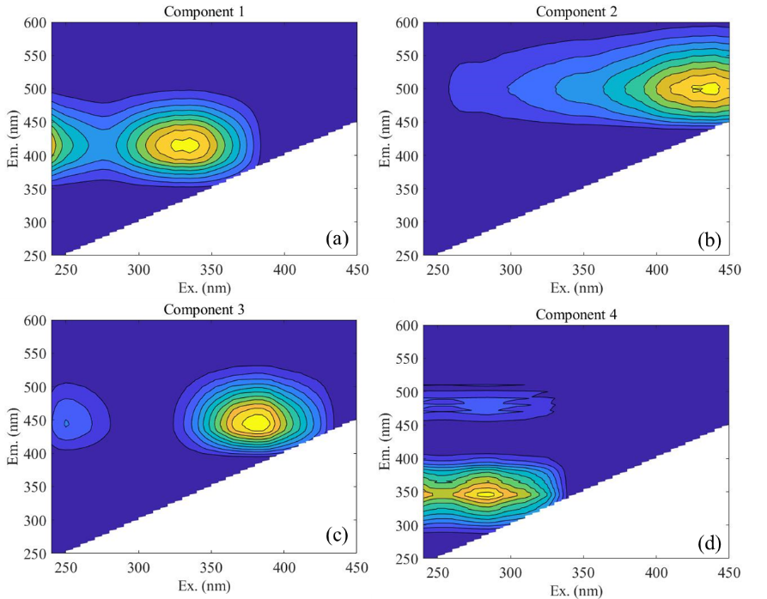

Figure S5. Four fluorescent components (a:C1; b:C2; c:C3; d:C4) and their F_{max} values (e-h) by PAPAFAC model.

Figure S6. Van Krevelen diagrams of DOM formulas in paddy water samples (warm and cold colors indicate high and low intensities, respectively). (a) CK-10d; (b) 25% RS-10d; (c) 75% RS-10d

Figure S7. Spearman correlation analysis of DOM intensity-weighted values and DOM photochemical indexes (n=9).

Figure S8. Pearson correlation analysis of bulk DOM properties and DOM photochemical indexes (n=45).

Figure S9. Pseudo-first order fitting for (a-b) IMD degradation in different paddy water samples
under irradiation on 10th and 30th days; (c) IMD degradation in sample 25%RS–10d subjected to different treatments [CH₃OH 100 mM; FFA 5 mM; TMP 5 mM]. Reaction conditions: IMD 10 μM, 25℃, 500W Xe lamp.

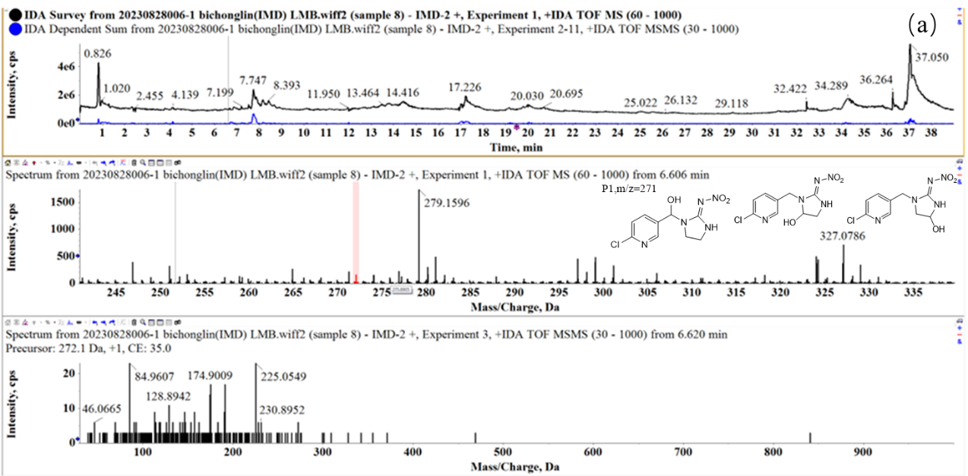
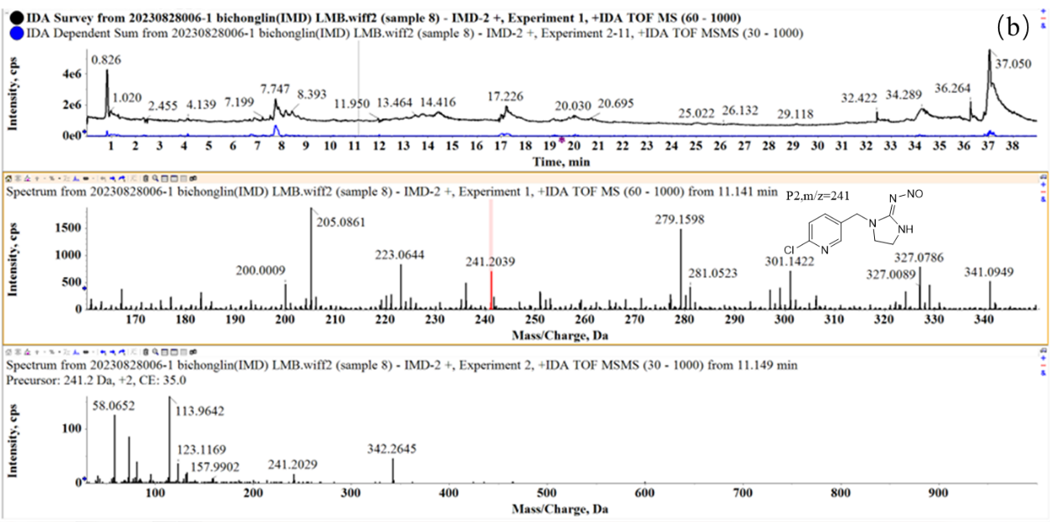
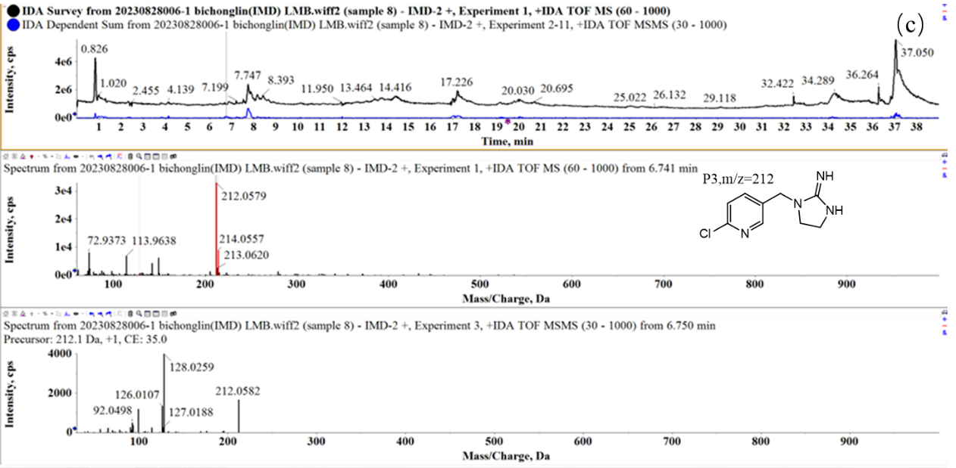
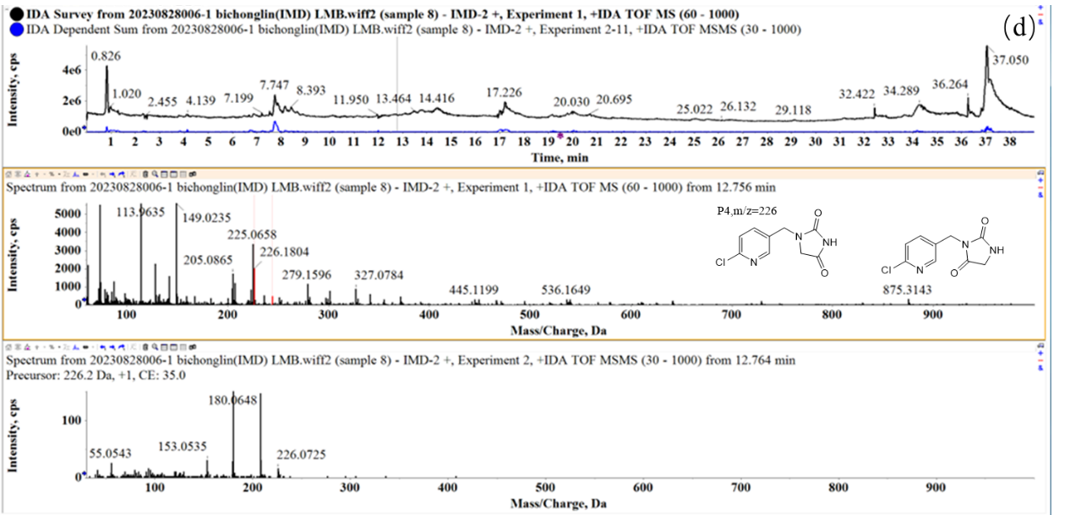
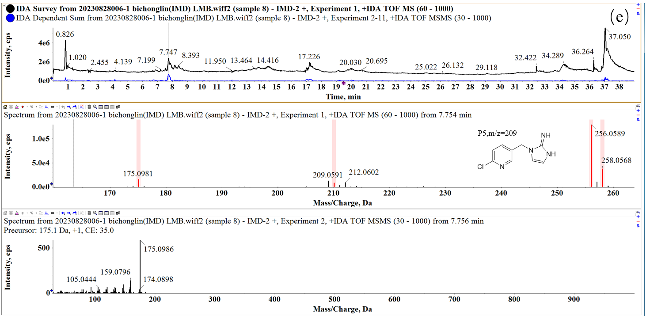
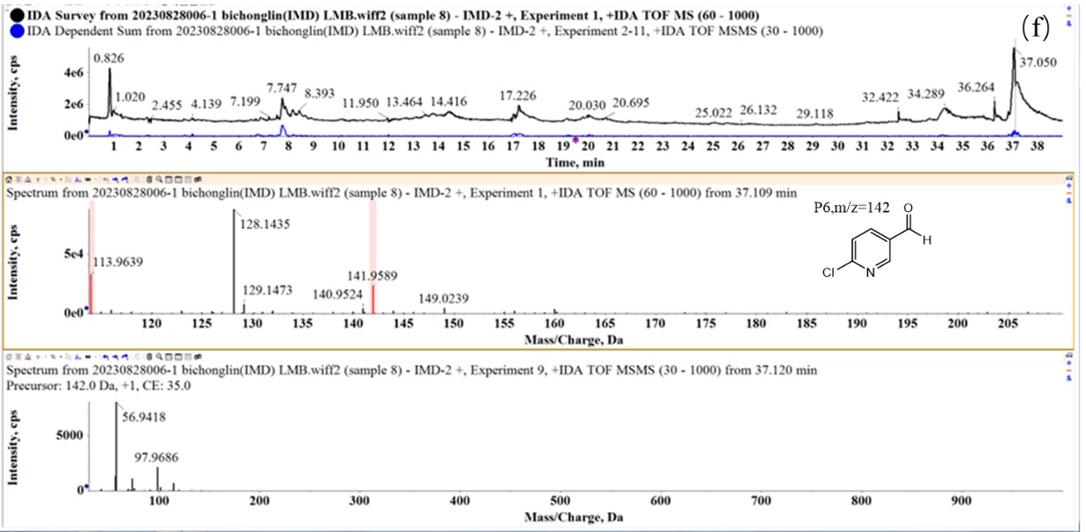

Figure S10. Degradation products of IMD (a-f), including total ion flow, MS and MS/MS, detected by LC–TOF–MS/MS (Positive ion mode).

References

Berg, S. M., Q. T. Whiting, J. A. Herrli, R. Winkels, K. H. Wammer, and C. K. Remucal. 2019. "The Role of Dissolved Organic Matter Composition in Determining Photochemical Reactivity at the Molecular Level." Environ. Sci. Technol. 53 (20):11725-11734. doi: 10.1021/acs.est.9b03007.
Erickson, P. R., K. J. Moor, J. J. Werner, D. E. Latch, W. A. Arnold, and K. McNeill. 2018. "Singlet Oxygen Phosphorescence as a Probe for Triplet-State Dissolved Organic Matter Reactivity." Environ Sci Technol 52 (16):9170-9178. doi: 10.1021/acs.est.8b02379.
Fu, Q. L., M. Fujii, and E. Kwon. 2020. "Development and Application of a High-Precision Algorithm for Nontarget Identification of Organohalogens Based on Ultrahigh-Resolution Mass Spectrometry." Anal Chem 92 (20):13989-13996. doi: 10.1021/acs.analchem.0c02899.
Fu, Q. L., M. Fujii, and T. Riedel. 2020. "Development and comparison of formula assignment algorithms for ultrahigh-resolution mass spectra of natural organic matter." Anal Chim Acta 1125:247-257. doi: 10.1016/j.aca.2020.05.048.
Han, Huixia, Yujie Feng, Jing Chen, Qiaorong Xie, Shuang Chen, Ming Sheng, Shujun Zhong, Wan Wei, Sihui Su, and Pingqing Fu. 2022. "Acidification impacts on the molecular composition of dissolved organic matter revealed by FT-ICR MS." Science of The Total Environment 805:150284. doi: https://doi.org/10.1016/j.scitotenv.2021.150284.
Janssen, Elisabeth M. L., Paul R. Erickson, and Kristopher McNeill. 2014. "Dual Roles of Dissolved Organic Matter as Sensitizer and Quencher in the Photooxidation of Tryptophan." Environmental Science & Technology 48 (9):4916-4924. doi: 10.1021/es500535a.
Kuhn, H. J., S. E. Braslavsky, and R. Schmidt. 2004. "Chemical actinometry." Pure and Applied Chemistry 76 (12):2105-2146. doi: 10.1351/pac200476122105.
Laszakovits, Juliana R., Stephanie M. Berg, Brady G. Anderson, Jessie E. O’Brien, Kristine H. Wammer, and Charles M. Sharpless. 2016. "p-Nitroanisole/Pyridine and p-Nitroacetophenone/Pyridine Actinometers Revisited: Quantum Yield in Comparison to Ferrioxalate." Environmental Science & Technology Letters 4 (1):11-14. doi: 10.1021/acs.estlett.6b00422.
Latch, Douglas E., Brian L. Stender, Jennifer L. Packer, William A. Arnold, and Kristopher McNeill. 2003. "Photochemical Fate of Pharmaceuticals in the Environment: Cimetidine and Ranitidine." Environmental Science & Technology 37 (15):3342-3350. doi: 10.1021/es0340782.
Mark, Gertraud, Armin Tauber, Rüdiger Laupert, Heinz-Peter Schuchmann, Dorothea Schulz, Andreas Mues, and Clemens von Sonntag. 1998. "OH-radical formation by ultrasound in aqueous solution – Part II: Terephthalate and Fricke dosimetry and the influence of various conditions on the sonolytic yield." Ultrasonics Sonochemistry 5 (2):41-52. doi: https://doi.org/10.1016/S1350-4177(98)00012-1.
Rosario-Ortiz, F. L., and S. Canonica. 2016. "Probe Compounds to Assess the Photochemical Activity of Dissolved Organic Matter." Environ. Sci. Technol. 50 (23):12532-12547. doi: 10.1021/acs.est.6b02776.
Wu, Shixi, Manabu Fujii, and Qinglong Fu. 2023. "Molecular characterization of coastal seawater dissolved organic matter by ultrahigh-resolution mass spectrometry: a photochemical study of the Tokyo Bay, Japan." Carbon Research 2 (1):46. doi: 10.1007/s44246-023-00083-z.
Zhang, D., S. Yan, and W. Song. 2014. "Photochemically induced formation of reactive oxygen species (ROS) from effluent organic matter." Environ. Sci. Technol. 48 (21):12645-53. doi: 10.1021/es5028663.
Zhou, H., L. Lian, S. Yan, and W. Song. 2017. "Insights into the photo-induced formation of reactive intermediates from effluent organic matter: The role of chemical constituents." Water Res. 112:120-128. doi: 10.1016/j.watres.2017.01.048.
Zhou, H., S. Yan, L. Lian, and W. Song. 2019. "Triplet-State Photochemistry of Dissolved Organic Matter: Triplet-State Energy Distribution and Surface Electric Charge Conditions." Environ Sci Technol 53 (5):2482-2490. doi: 10.1021/acs.est.8b06574.
Zhou, H., S. Yan, J. Ma, L. Lian, and W. Song. 2017. "Development of Novel Chemical Probes for Examining Triplet Natural Organic Matter under Solar Illumination." Environ Sci Technol 51 (19):11066-11074. doi: 10.1021/acs.est.7b02828.

