Supporting information

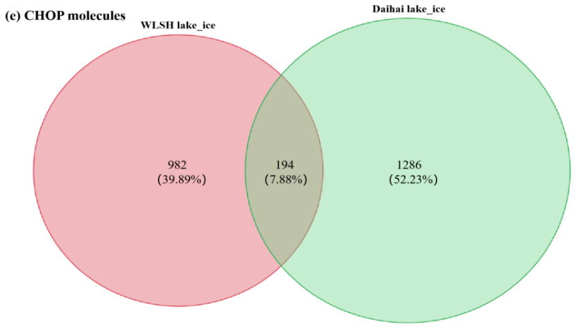
Figure S1 Venn diagram of CHOP molecules in the Daihai Lake and the Wuliangsuhai Lake ice samples
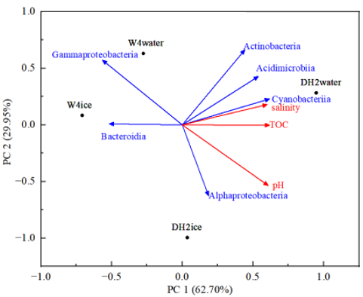
Figure S2 Redundancy analysis of all kinds of molecules between microbial species and environmental factors.
Indicators | Unit | Wuliangsuhai Lake_water | Daihai Lake_water | Wuliangsuhai Lake_ice | Daihai Lake_ice
pH |  | 8.85±0.90 | 9.42±0.19 | 8.94±1.03 | 9.43±0.24
ORP | mV | 184.73±45.37 | 105.17±68.63 | 158.81±32.39 | 181.98±36.32
DO | mg/L | 30.28±17.29 | 8.20±4.19 | 7.49±2.78 | 5.27±3.78
TDS | mg/L | 1395.19±853.81 | 7157.65±7202.35 | 76.52±243.48 | 2313.67±1551.33
temperature | ℃ | 0.14±0.22 | -0.94±0.10 | 0.56±0.73 | 0.13±0.50
salt | ‰ | 2.17±1.03 | 16.08±0.34 | 0.07±0.34 | 2.47±1.20
depth of water | m | 1.76±0.19 | 3.63±1.27
ice thickness | cm |  |  | 38.71±11.29 | 28.57±4.43
TOC | mg/L | 10.04±3.99 | 65.68±32.38 | 4.01±7.82 | 20.83±8.89
TC | mg/L | 133.41±19.39 | 402.80±128.00 | 8.57±8.55 | 76.06±30.44
Table S1. Basic parameters of the ice and water samples from the Wuliangsuhai Lake and the Daihai Lake

Table S2. DOM molecular species and characteristics
Molecular name | Molecular formula | Molecular characteristics
Lauryl sulfuric acid | C₁₂H₂₅O₄S | A nutritional supplement, mainly from the input of exogenous organic matter; the organic matter molecules in the same group are CH₂ as the unit change, and the species is less abundant in ice and water.
Tetraallylbenzene sulfonic acid | C₁₈H₂₉O₃S | Easily combined with sodium ions to form a water treatment adsorbent.
Monoethyl 2-adamantyl succinate | C₁₆H₂₁O₄ | The esterification of hydroxy-containing organic matter and succinic acid.
Gallic acid | C₁₅H₂₂O₅ | Often used as an antioxidant.
Phenyl-1-mercaptan-β-D-galactoside | C₁₂H₁₆O₅S | A carbohydrate metabolic intermediate, related to the microorganisms living on carbohydrate metabolism in the lake.
Stearic acid | C₁₈H₃₅O₂ | Commonly found in fatty substances in nature.
Melilotine | C₁₅H₁₈O₈ | Mainly formed by the condensation of sugars secreted by Melilotus officinalis with other organic matter.

