Supplement material
Table S1 Activity data and emission factor for land carbon balance assessment of Guangdong province used in this study
Boundary | Activity data | Emission factor | Duration | Source
Forest ecosystem carbon sink | Forest standing live timber volume | Wood density: 0.474 Mg m⁻³  Biomass conversion factor (BEF_{tot}): 1.915  carbon conversion factor (F_{c}): 0.5 | 2015-2021 | Provincial Greenhouse Gas Inventory Compilation Guide (Trial), Guangdong Statistical Yearbook
Energy activities emission | Terminal energy consumption | Raw coal: 1.981 t CO₂ t⁻¹  Oil products: 3.018 t CO₂ t⁻¹  Other energy: 2.773 t CO₂ t⁻¹ standard coal  Electricity: 6.69 t CO₂ per ten thousand kilowatt-hours | 2016-2021 | As above
Industrial processes emission | Production of industrial products: cement and steel are mainly considered | Cement: 0.538 t CO₂ t⁻¹ cement  Steel: 0.213 t CO₂ t⁻¹ steel | 2016-2021 | As above and  (Li et al. 2016)
Agricultural activities emission | CH4 from paddy field: Rice type, sowing area | Early rice: 241.0 kg CH₄ ha⁻¹  Late rice: 273.2 kg CH₄ ha⁻¹ | 2016-2021 | Provincial Greenhouse Gas Inventory Compilation Guide (Trial), Guangdong Statistical Yearbook
Agricultural activities emission | N₂O emission from cropland: nitrogen fertilizer amount, animal type and number | N₂O from nitrogen fertilizer: 0.0178 kg N₂O-N kg⁻¹ N input  N₂O from atmospheric nitrogen deposition: 0.001 kg N₂O-N kg⁻¹ N  N₂O from leaching and runoff: 0.0075 kg N₂O-N kg⁻¹ N | 2016-2021 | As above
Agricultural activities emission | CH₄ emission from animal intestinal fermentation: animal type and number | Buffalo: 70.5 kg CH₄ head⁻¹ year⁻¹  Cow: 88.1 kg CH₄ head⁻¹ year⁻¹  Goat: 8.9 kg CH₄ head⁻¹ year⁻¹  Pig: 1 kg CH₄ head⁻¹ year⁻¹ | 2016-2021 | As above
Agricultural activities emission | CH₄ and N₂O from animal excrement management: animal type and number | Buffalo: 8.24 kg CH₄ head⁻¹ year⁻¹, 0.86 kg N₂O head⁻¹ year⁻¹  Cow: 8.45 kg CH₄ head⁻¹ year⁻¹, 1.71 kg N₂O head⁻¹ year⁻¹  Goat: 0.31 kg CH₄ head⁻¹ year⁻¹, 0.106 kg N₂O head⁻¹ year⁻¹  Pig: 5.85 kg CH₄ head⁻¹ year⁻¹, 0.157 kg N₂O head⁻¹ year⁻¹  Poultry: 0.02 kg CH₄ head⁻¹ year⁻¹, 0.007 kg N₂O head⁻¹ year⁻¹ | 2016-2021 | As above
Waste management emission | Solid waste amount,  chemical oxygen demand (COD) and nitrogen content in wastewater | Solid waste: 0.27 t CO₂ t⁻¹ solid waste  Wastewater: 0.126 kg CH₄ kg⁻¹ COD, 0.005 kg N₂O-N kg⁻¹ N | 2016-2021 | As above

Table S2 Parameters and hypothesized values in the life cycle analysis of biochar
Parameters | Value |  |  | Source
Feedstock for biochar production | Agricultural residues | Forestry residues | Bioenergy crops | This study
The emission factor of feedstock cultivation and collection (kg CO₂e t⁻¹ dry biomass) | 68 | 151.8 | 151.8 | (Robert et al. 2010; Gvein et al. 2023)
Biochar yield (%) | 31.5 | 37.6 | 33.825 | (Jiang et al. 2013; Deng et al. 2024)
Bio-oil (%) | 38 | 35.2 | 36.6 | (Jiang et al. 2013)
Bio-gas (%) | 30.5 | 27.2 | 28.85 | (Jiang et al. 2013)
Biochar carbon content (%) | 64 | 76.4 | 63.095 | (Jiang et al. 2013)
Biochar stable carbon (%) | 63.6 | 72.1 | 74.95 | (Jiang et al. 2013)
Transport vehicle | Diesel truck |  |  | (Roberts et al. 2010)
Transport loss of feedstock | 0.01 |  |  | (Hammond et al. 2011)
Transport loss of biochar | 0.03 |  |  | (Hammond et al. 2011)
Heat value of diesel (MJ kg⁻¹) | 42 |  |  | (Liu et al. 2014)
Conversion Factors (kg CO₂ (dm. km)⁻¹), diesel | 0.272 |  |  | (Defra 2008)
Biogas heat value (MJ kg⁻¹) | 6 |  |  | (Laird et al. 2009)
Emission factors of coal tar (t CO₂e t⁻¹) | 1.62 |  |  | (Yang et al. 2021)
Power conversion factor (%) | 35 |  |  | (Gaunt and Lehmann 2008)
CO₂e emissions from coal-fired power generation (kg kWh⁻¹) | 1.1 |  |  | (Gaunt and Lehmann 2008)
CO₂e emissions from biochar apply (kg t⁻¹ biochar) | 45.32 |  |  | (West and Marland 2002)
Biochar application rate (t ha⁻¹) | 20 |  |  | This study
Distance (km) | — |  |  | Calculated in this study
Conversion of C to CO₂ | 3.6 |  |  | -
100-year GWP of N₂O | 273 |  |  | (IPCC 2022)
Nfer/Pfer/Kfer (kg ha⁻¹) | Global Database |  |  | (Mueller et al. 2012)
N content of straw biochar (g kg⁻¹) | 1.54 |  |  | (Ippolito et al. 2020)
P content of straw biochar (g kg⁻¹) | 8 |  |  | (Ippolito et al. 2020)
K content of straw biochar (g kg⁻¹) | 40.9 |  |  | (Ippolito et al. 2020)
Nfer_decre | 0.1 |  |  | (Hammond et al. 2011)
Pfer_decre | 0.05 |  |  | (Hammond et al. 2011)
Kfer_decre | 0.05 |  |  | (Hammond et al. 2011)
Nfer_co₂e (kg kg⁻¹) | 3 |  |  | (Roberts et al. 2010)
Pfer_co₂e (kg kg⁻¹) | 0.7 |  |  | (Roberts et al. 2010)
Kfer_co₂e (kg kg⁻¹) | 1 |  |  | (Roberts et al. 2010)
N₂O remission rate from Nfer (%) | 1.325 |  |  | (Roberts et al. 2010)
Inhibition rate of N₂O (%) | 25 |  |  | (Hammond et al. 2011)
SOC change with biochar | Assumed to be biochar stable carbon content |  |  | (Roberts et al. 2010)

Table S3 The biomass resource of Guangdong province
Biomass types |  | Types | Biomass  (Tg biomass) | Rate
Agricultural residues |  | Rice | 9.21 | 0.75
Agricultural residues |  | Maize | 0.65 | 0.05
Agricultural residues |  | Other grain | 0.01 | 0.00
Agricultural residues |  | Canola | 0.03 | 0.00
Agricultural residues |  | Peanuts | 1.35 | 0.11
Agricultural residues |  | Soybeans | 0.07 | 0.01
Agricultural residues |  | Potatoes | 0.98 | 0.08
Agricultural residues |  | Sum | 12.29 | 1.00
Forestry residues | Wood exploitation and process | Merchant | 1.44 | 0.07
Forestry residues | Wood exploitation and process | Fire | 4.86 | 0.25
Forestry residues | Wood exploitation and process | Log | 0.29 | 0.02
Forestry residues | Bamboo exploitation and process | Bamboo | 3.36 | 0.18
Forestry residues | Forest logging | Fuel | 0.11 | 0.01
Forestry residues | Forest logging | Timber | 1.98 | 0.10
Forestry residues | Forest logging | Protect | 0.19 | 0.01
Forestry residues | Forest logging | Economic | 6.30 | 0.33
Forestry residues | Forest logging | Special purpose | 0.04 | 0.00
Forestry residues | Forest logging | Shrub | 0.17 | 0.01
Forestry residues | Forest logging | Sparse | 0.45 | 0.02
Forestry residues |  | Sum | 19.19 | 1.00
Bioenergy crops cultivated on marginal land I |  | Miscanthus | 19.14 | 0.25
Bioenergy crops cultivated on marginal land I |  | Eucalypt | 21.29 | 0.28
Bioenergy crops cultivated on marginal land I |  | Poplar | 12.31 | 0.16
Bioenergy crops cultivated on marginal land I |  | Switchgrass | 12.00 | 0.16
Bioenergy crops cultivated on marginal land I |  | Willow | 12.48 | 0.16
Bioenergy crops cultivated on marginal land II |  | Miscanthus | 29.13 | 0.25
Bioenergy crops cultivated on marginal land II |  | Eucalypt | 31.96 | 0.27
Bioenergy crops cultivated on marginal land II |  | Poplar | 18.68 | 0.16
Bioenergy crops cultivated on marginal land II |  | Switchgrass | 18.18 | 0.16
Bioenergy crops cultivated on marginal land II |  | Willow | 18.88 | 0.16

Table S4 Key parameters for uncertainty analyses
Parameters | Range | Mean | Standard deviation | References
Biochar yield (%) | 23.2 - 34.8 | 29 | 3.53 | Deng et al. (2024)
Biochar carbon (%) | 53 - 79 | 66 | 8.03 | Deng et al. (2024)
Biochar stable carbon (%) | 60.3 - 89.6 | 67.8 | 10.54 | Estimated from Jiang et al. (2013)
Biogas yield (%) | 13 - 41.7 | 27.6 | 9.42 | Estimated from Jiang et al. (2023)
Biochar application rate (t ha⁻¹) | 0.9 - 120 | 20 | 24 | Estimated from Han et al. (2021)

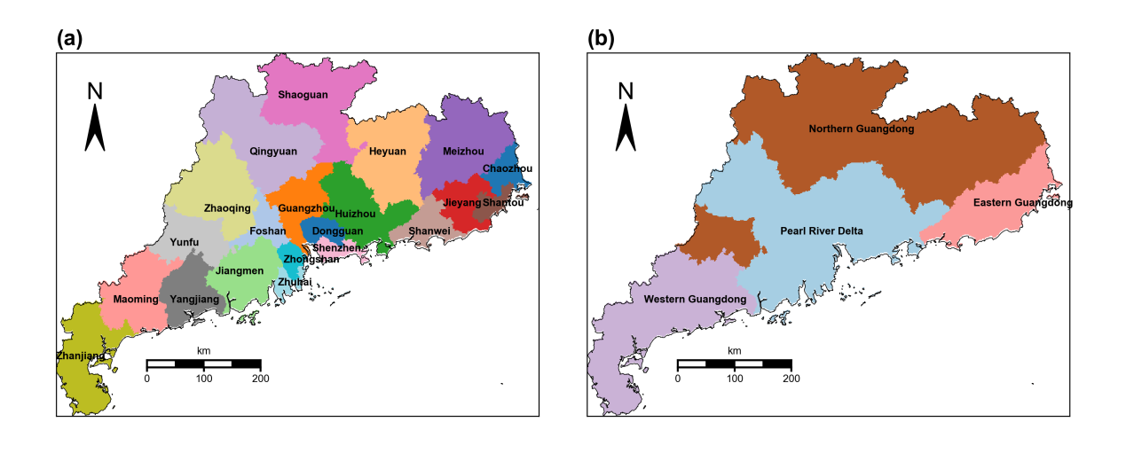
Fig. S1 Administrative division (a) and regional division (b) of Guangdong province

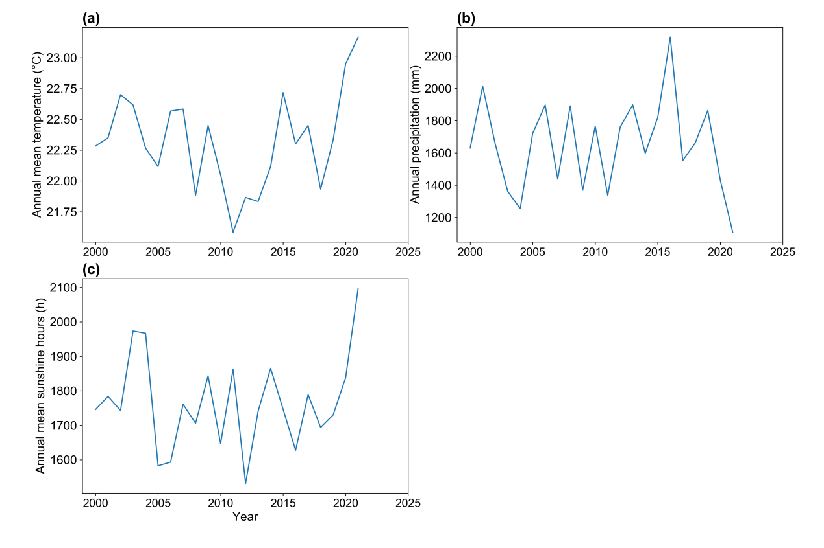
Fig. S2 Annual mean temperature (a), annual precipitation (b), and annual mean sunshine hours (c) of Guangdong province from 2000 to 2021

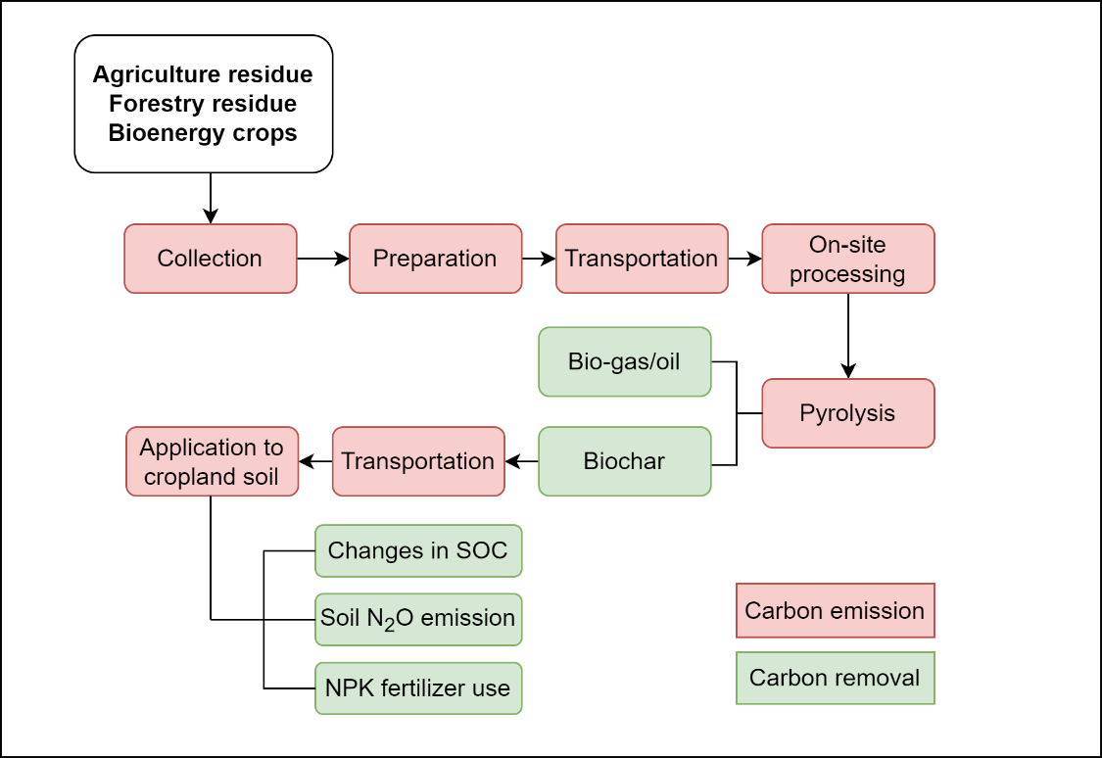
Fig. S3 Framework for life cycle analysis of biochar in this study

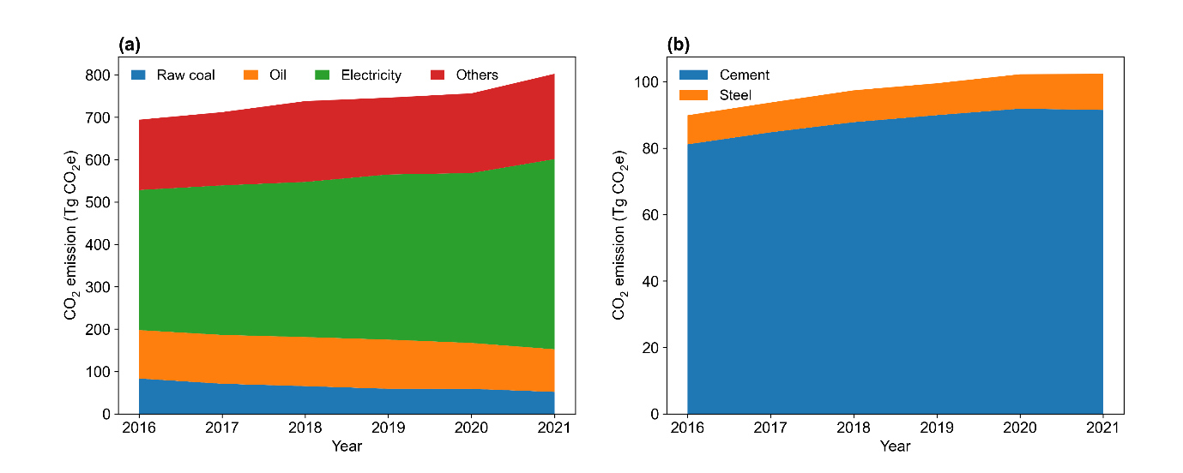
Fig. S4 Carbon emission from energy consumption (a) and industrial processes of cement and steel production (b) in Guangdong province from 2016 to 2021

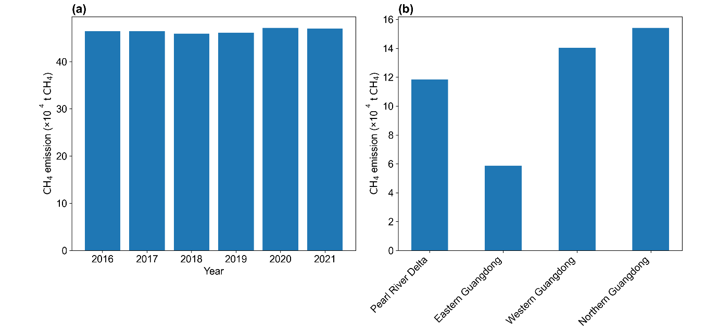
Fig. S5 The CH₄ emissions from rice paddies of Guangdong province from 2016 to 2021 (a) and in four regions for 2021 (b)

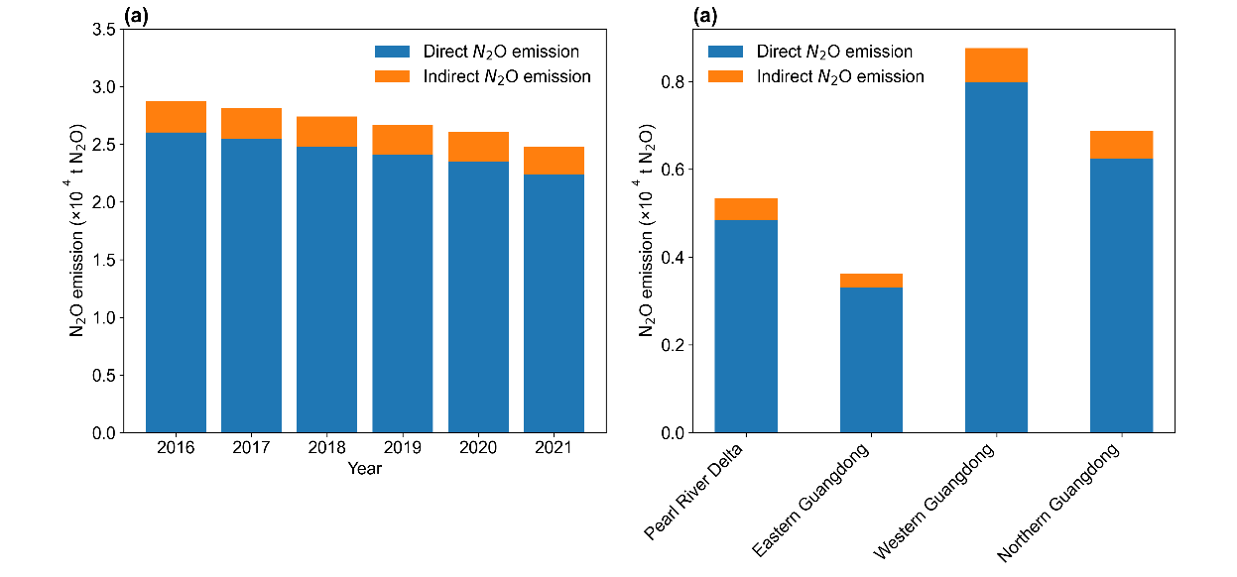
Fig. S6 Direct and indirect N₂O emission from cropland in Guangdong province from 2016 to 2021 (a) and in four regions for 2021(b)

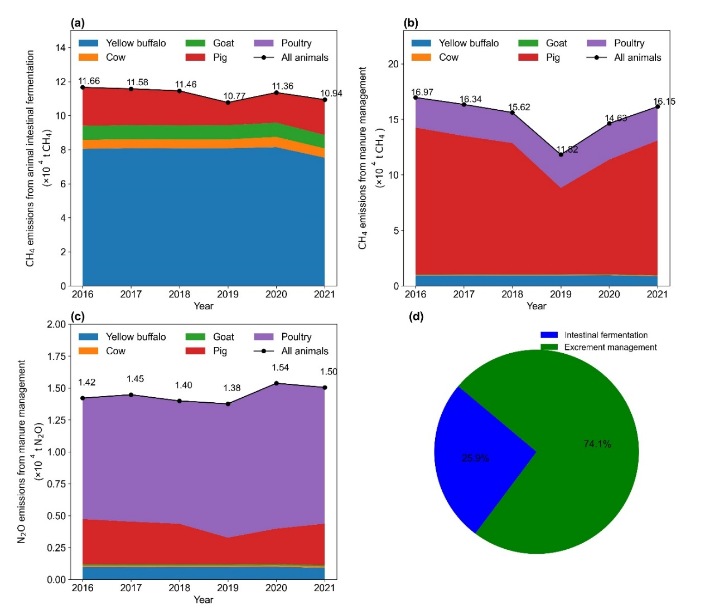
Fig. S7 The CH₄ emission from animal intestinal fermentation (a), CH₄ (b), and N₂O emission (c) from animal excrement management of Guangdong province from 2016 to 2021. (d) is the proportion of CO₂ emissions from animal intestinal fermentation and excrement management

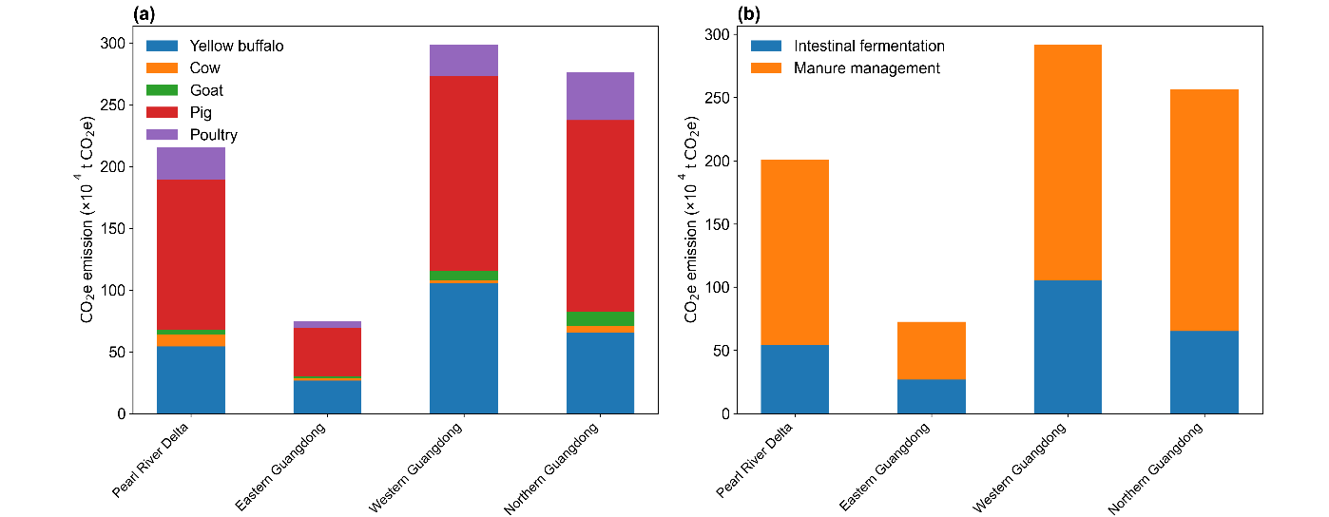
Fig. S8 The CO₂ emission from livestock activities grouped by animal type (a) and intestinal fermentation/ excrement management (b) in four regions of Guangdong province for 2021

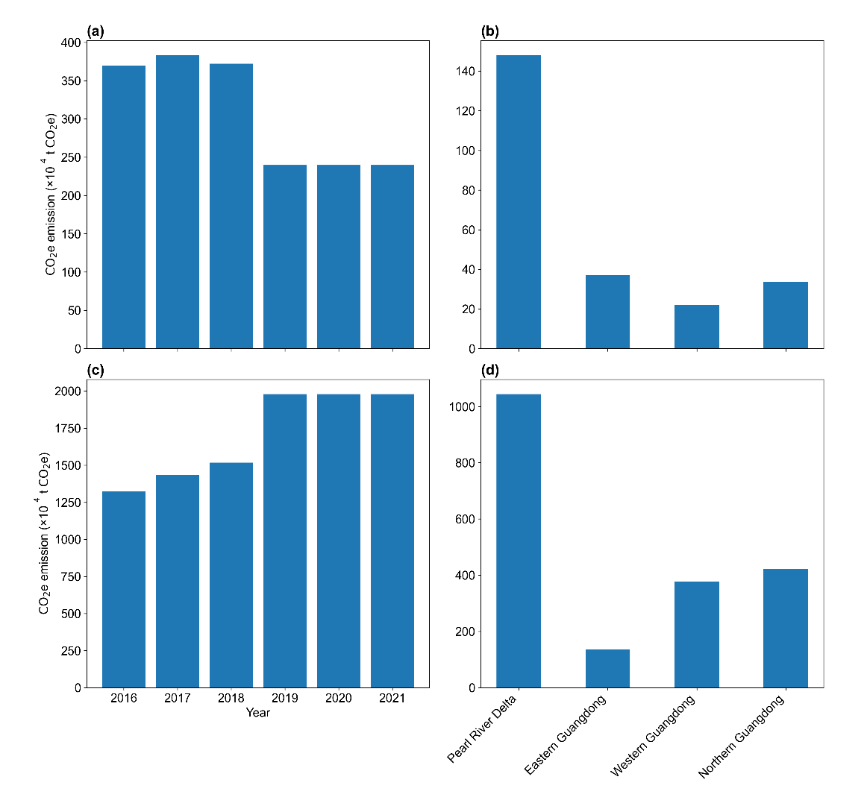
Fig. S9 The CO₂ emission from wastewater (a, b) and solid waste (c, d) in Guangdong province from 2016 to 2021 (a, c) and in four regions (b, d) for 2021

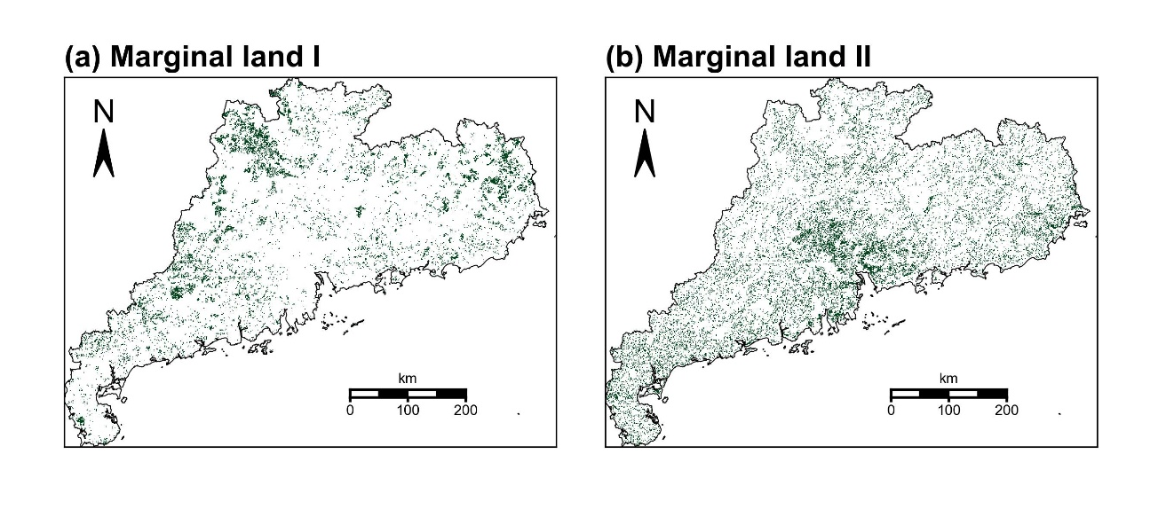
Fig. S10 Distribution of marginal land I (a) and marginal land II (i.e., abandoned cropland) (b) in Guangdong province

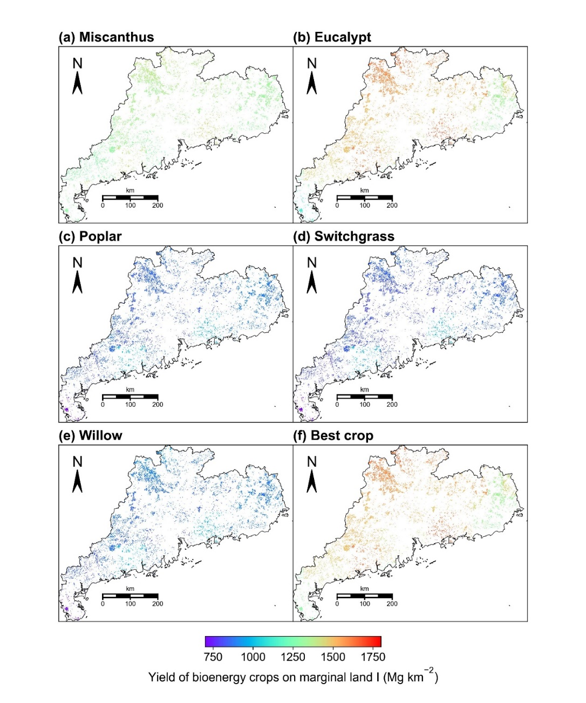

Fig. S11 Yield of five bioenergy crops of (a) Miscanthus, (b) Eucalypt, (c) Poplar, (d) Switchgrass, (e) Willow and (f) the best crop type with maximum yield in each grid cell on marginal land I of Guangdong province

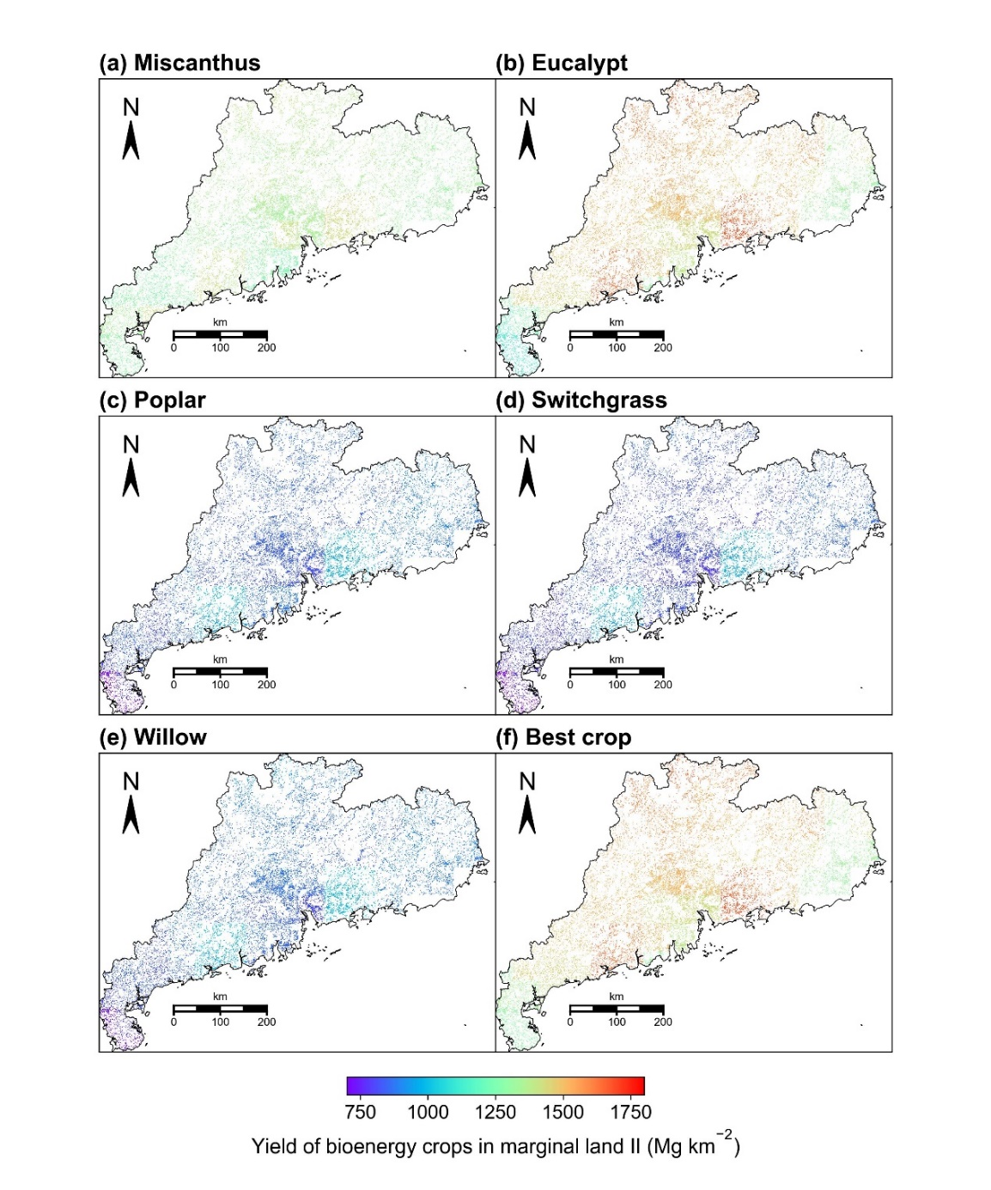
Fig. S12 Yield of five bioenergy crops of (a) Miscanthus, (b) Eucalypt, (c) Poplar, (d) Switchgrass, (e) Willow and (f) best crop type with maximum yield in each grid cell on marginal land II (i.e., abandoned cropland) of Guangdong province

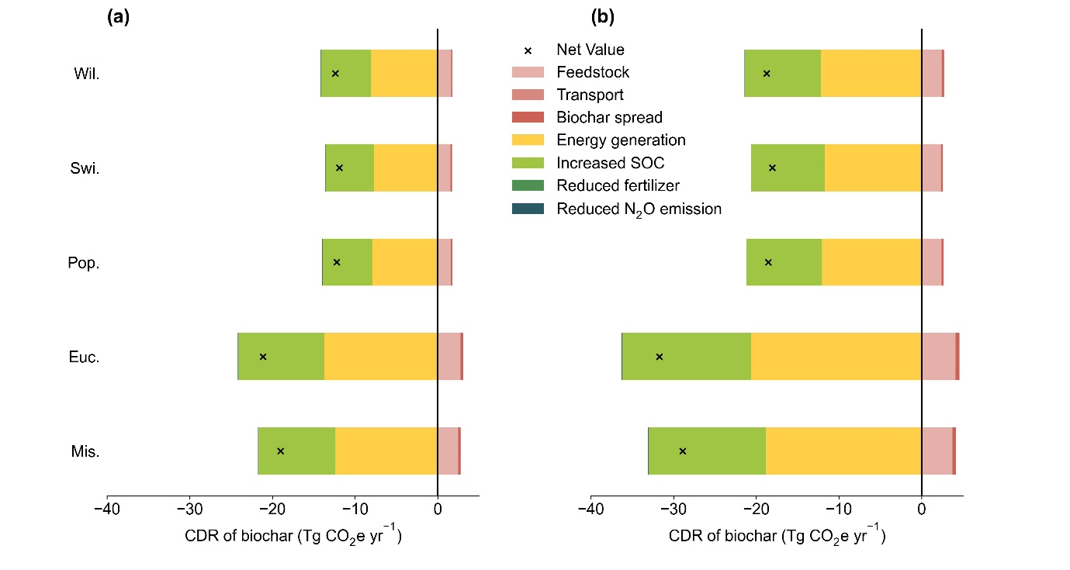
Fig. S13 The CO₂ emission and removal of biochar derived from five bioenergy crops (i.e., Miscanthus, Eucalypt, Poplar, Switchgrass and Willow) in Guangdong province

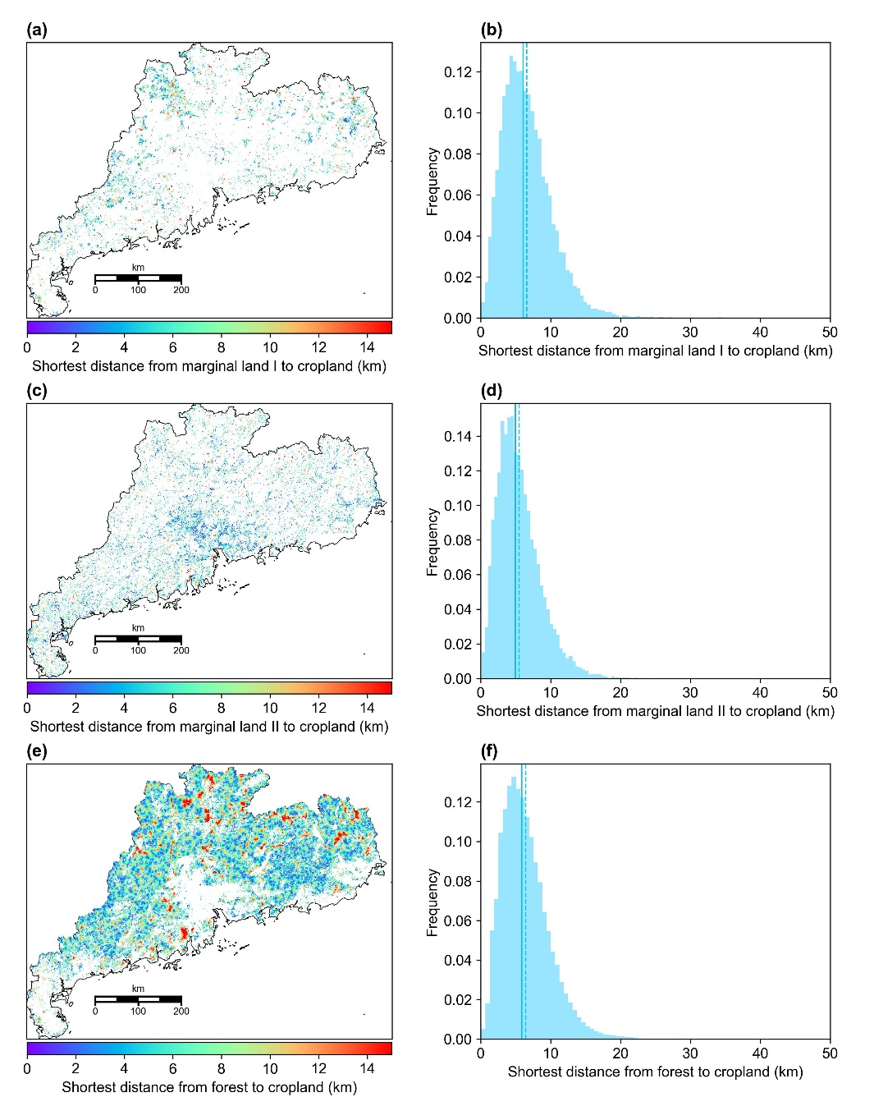
Fig. S14 The shortest distance from cropland to marginal land I (a), marginal land II (c) and forestry land (e). The corresponding frequency distribution of the shortest distance is shown in (b), (d) and (f), respectively. The mean and median values are represented by dashed and solid lines, respectively

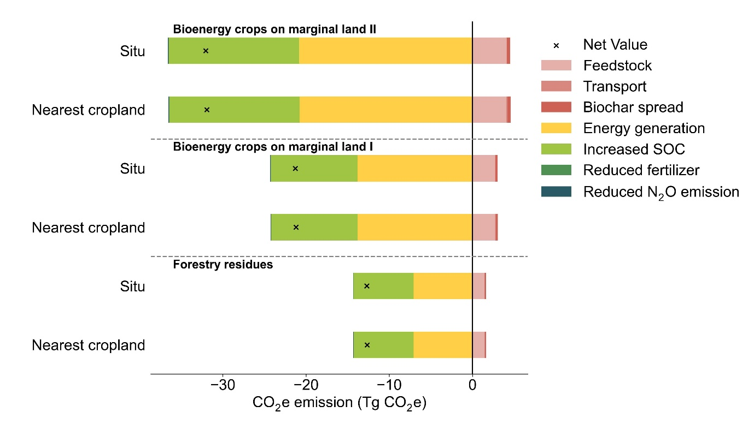
Fig. S15 Total CDR potential of biochar derived from forestry residues and best bioenergy crops on marginal land I and II (i.e., abandoned cropland). Two scenarios of applying biochar to the nearest cropland and in situ were compared

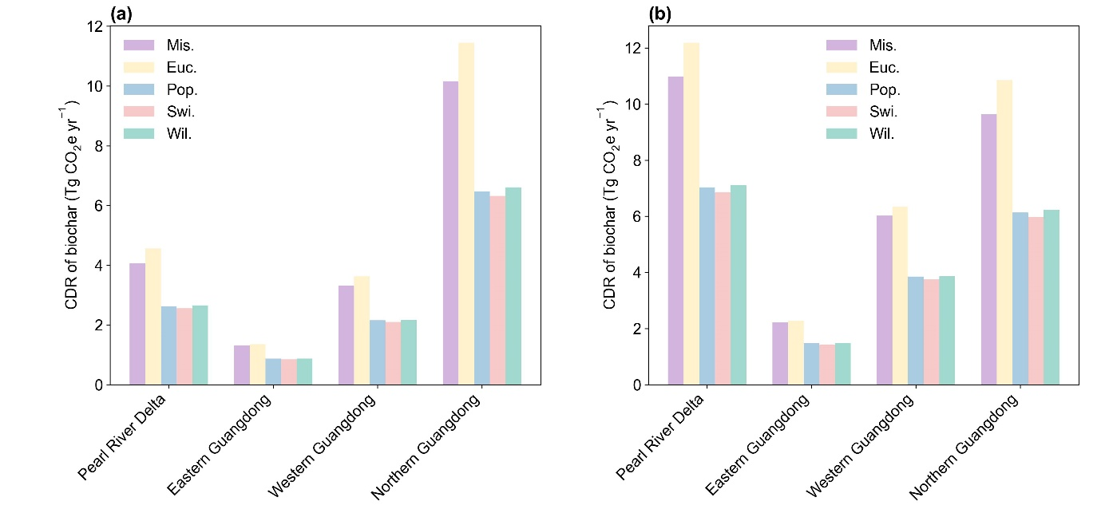
Fig. S16 CDR of biochar derived from five bioenergy crops planted on marginal land I (a) and marginal land II (i.e., abandoned cropland) (b) in four regions of Guangdong province

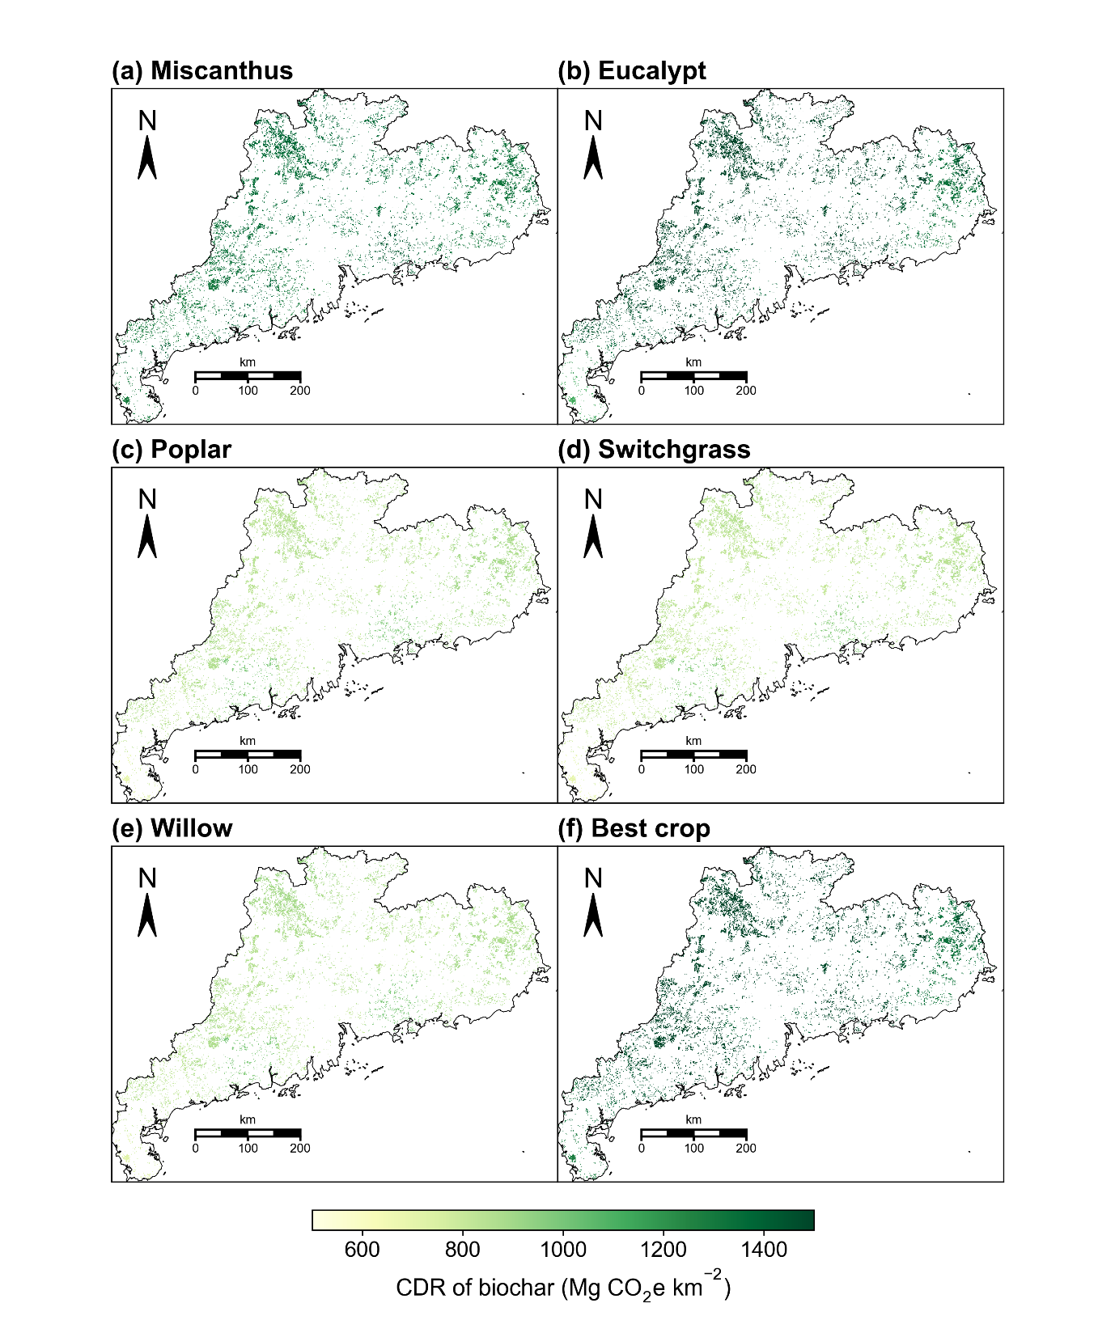
Fig. S17 Spatial distribution of CDR of biochar derived from (a) Miscanthus, (b) Eucalypt, (c) Poplar, (d) Switchgrass, (e) Willow and (f) the best crop (best crop type with maximum yield in each grid cell) planted on the marginal land I of Guangdong province

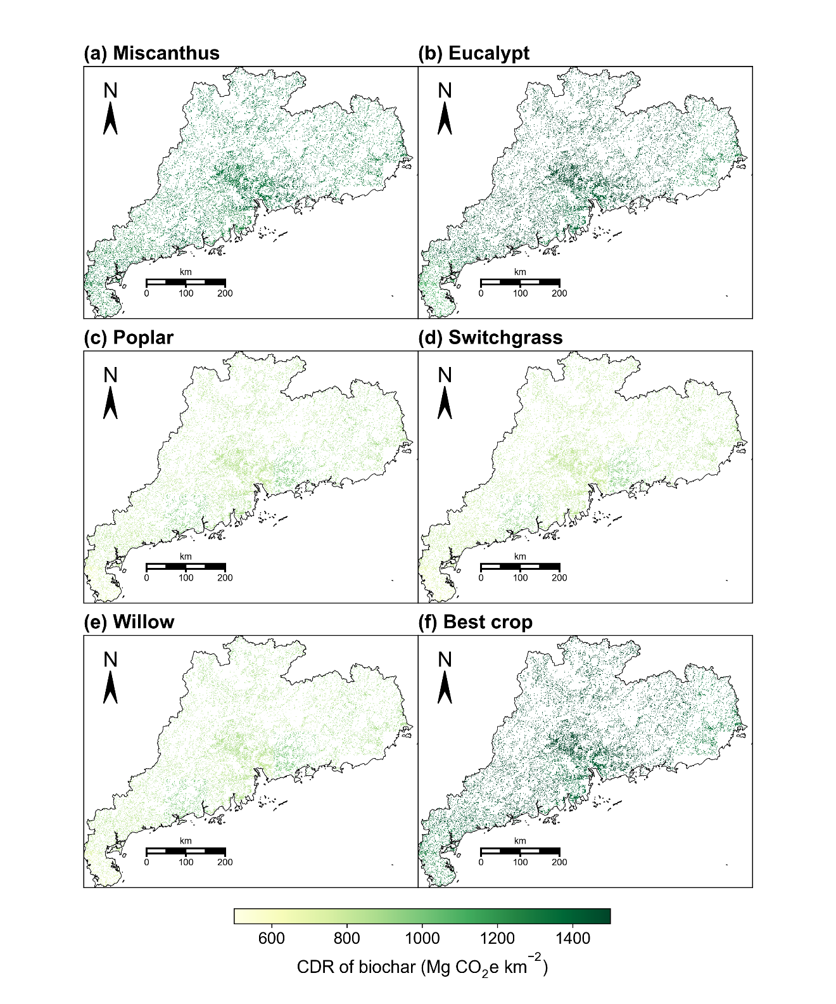
Fig. S18 Spatial distribution of CDR of biochar derived from (a) Miscanthus, (b) Eucalypt, (c) Poplar, (d) Switchgrass, (e) Willow and (f) the best crop (best crop type with maximum yield in each grid cell) planted on the marginal land II (i.e., abandoned cropland) of Guangdong province

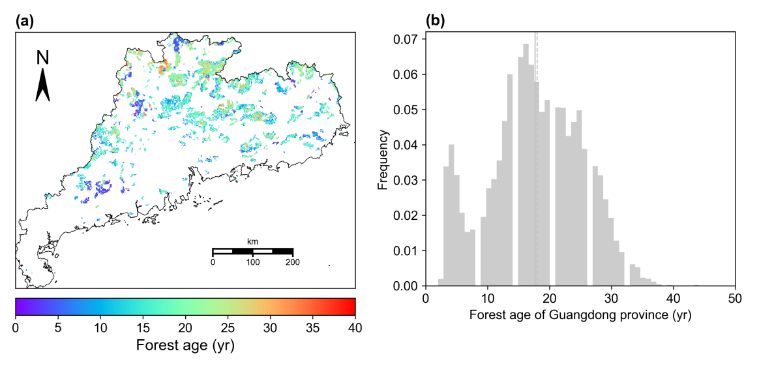
Fig. S19 The spatial map (a) and frequency distribution (b) of forest age in Guangdong province. The grey line and dashed line are the mean and median of the forest age, respectively

References
Defra 2008. Guidelines to Defra's GHG Conversion Factors. http://www.aef.org.uk/downloads/ghg-cf-guidelines-annexes2008.pdf . Accessed 23 April 2024
Deng X, Teng F, Chen M, Du Z, Wang B, Li R, Wang P (2024) Exploring negative emission potential of biochar to achieve carbon neutrality goal in China. Nat Commun 15: 1085. https://doi.org/10.1038/s41467-024-45314-y
Gaunt JL, Lehmann J (2008) Energy balance and emissions associated with biochar sequestration and pyrolysis bioenergy production. Environ Sci Technol 42: 4152-4158
Gvein MH, Hu X, Næss JS, Watanabe MDB, Cavalett O, Malbranque M, Kindermann G, Cherubini F (2023) Potential of land-based climate change mitigation strategies on abandoned cropland. Commun Earth Environ 4: 39. https://doi.org/10.1038/s43247-023-00696-7
Hammond J, Shackley S, Sohi S, Brownsort P (2011) Prospective life cycle carbon abatement for pyrolysis biochar systems in the UK. Energy Policy 39: 2646-2655. https://doi.org/10.1016/j.enpol.2011.02.033
Han M, Zhao Q, Li W, Ciais P, Wang YP, Goll DS, Zhu L, Zhao Z, Wang J, Wei Y, Wu F (2021) Global soil organic carbon changes and economic revenues with biochar application. Glob Change Biol Bioenergy 14: 364-377. https://doi.org/10.1111/gcbb.12915
IPCC (2022) Climate Change 2022: Mitigation of Climate Change. Contribution of Working Group III to the Sixth Assessment Report of the Intergovernmental Panel on Climate Change. https://www.ipcc.ch/report/sixth-assessment-report-working-group-3/. Accessed 23 April 2024
Ippolito JA, Cui L, Kammann C, Wrage-Mönnig N, Estavillo JM, Fuertes-Mendizabal T, Cayuela ML, Sigua G, Novak J, Spokas K (2020) Feedstock choice, pyrolysis temperature and type influence biochar characteristics: a comprehensive meta-data analysis review. Biochar 2: 421-438
Jiang Z-X, Zheng H, Li F-M, Wang Z-Y (2013) Preliminary assessment of the potential of biochar technology in mitigating the greenhouse effect in China. Environ Sci 34: 2486-2492
Laird DA, Brown RC, Amonette JE, Lehmann J (2009) Review of the pyrolysis platform for coproducing bio-oil and biochar. Biofuel Bioprod Biorefin 3: 547-562. https://doi.org/10.1002/bbb.169
Li X, Xie H, Kou W, Wang W, Zhang N (2016) Discussion and case study on the CO₂ emission calculation methods in iron and steel industry. J Saf Environ 16: 320-324
Liu X, Li Z, Zhang Y, Feng R, Mahmood IB (2014) Characterization of human manure-derived biochar and energy-balance analysis of slow pyrolysis process. Waste Manage 34: 1619-1626
Mueller ND, Gerber JS, Johnston M, Ray DK, Ramankutty N, Foley JA (2012) Closing yield gaps through nutrient and water management. Nature 490: 254-257
Roberts KG, Gloy BA, Joseph S, Scott NR, Lehmann J (2010) Life Cycle Assessment of Biochar Systems: Estimating the Energetic, Economic, and Climate Change Potential. Environ Sci Technol 44: 827-833. https://doi.org/10.1021/es902266r
West TO, Marland G (2002) A synthesis of carbon sequestration, carbon emissions, and net carbon flux in agriculture: comparing tillage practices in the United States. Agric Ecosyst Environ 91: 217-232
Yang Q, Zhou H, Bartocci P, Fantozzi F, Masek O, Agblevor FA, Wei Z, Yang H, Chen H, Lu X, Chen G, Zheng C, Nielsen CP, McElroy MB (2021) Prospective contributions of biomass pyrolysis to China's 2050 carbon reduction and renewable energy goals. Nat Commun 12: 1698. https://doi.org/10.1038/s41467-021-21868-z

