Drivers of soil organic carbon recovery under forest restoration: a global meta-analysis

Shan Xuª, Nico Eisenhauer^{b,c}, Zhenzhong Zengª, Xiaohan Moª, Yan Dingª, Derrick Y.F. Lai^{d}, Junjian Wang^{a*}
ªGuangdong Provincial Key Laboratory of Soil and Groundwater Pollution Control, School of Environmental Science and Engineering, Southern University of Science and Technology, Shenzhen 518055, China
^{b}German Centre for Integrative Biodiversity Research (iDiv) Halle-Jena-Leipzig, Puschstrasse 4, 04103 Leipzig, Germany
^{c}Institute of Biology, Leipzig University, Puschstrasse 4, 04103 Leipzig, Germany
^{d}Department of Geography and Resource Management, The Chinese University of Hong Kong, Shatin, New Territories, Hong Kong, China
*Corresponding author:Junjian Wang, E-mail: wangjj@sustech.edu.cn; Phone: 0755-88018093)

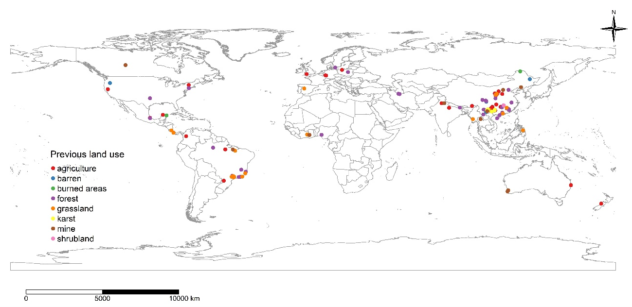
Figure S1 Map of site distributions of forest restoration effects on surface soil organic carbon (SOC) recovery in sites with different previous land use, including agriculture, barren, burned areas, forest, grassland, karst, mine and shrubland.

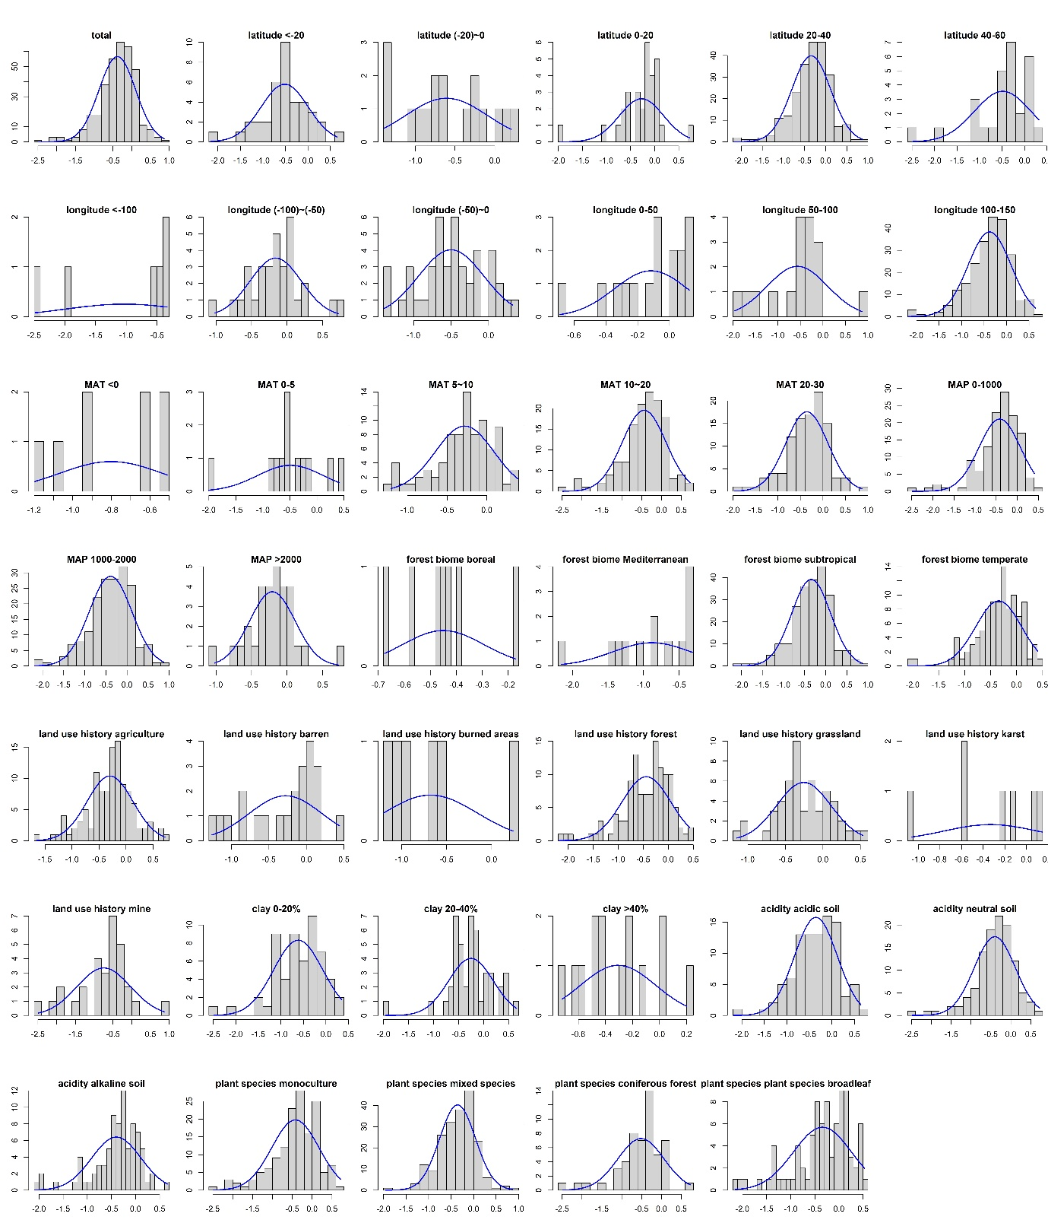
Figure S2 Normal distribution (frequency) of the natural log of response ratios (lnRRs) of all variables in Figure 3.

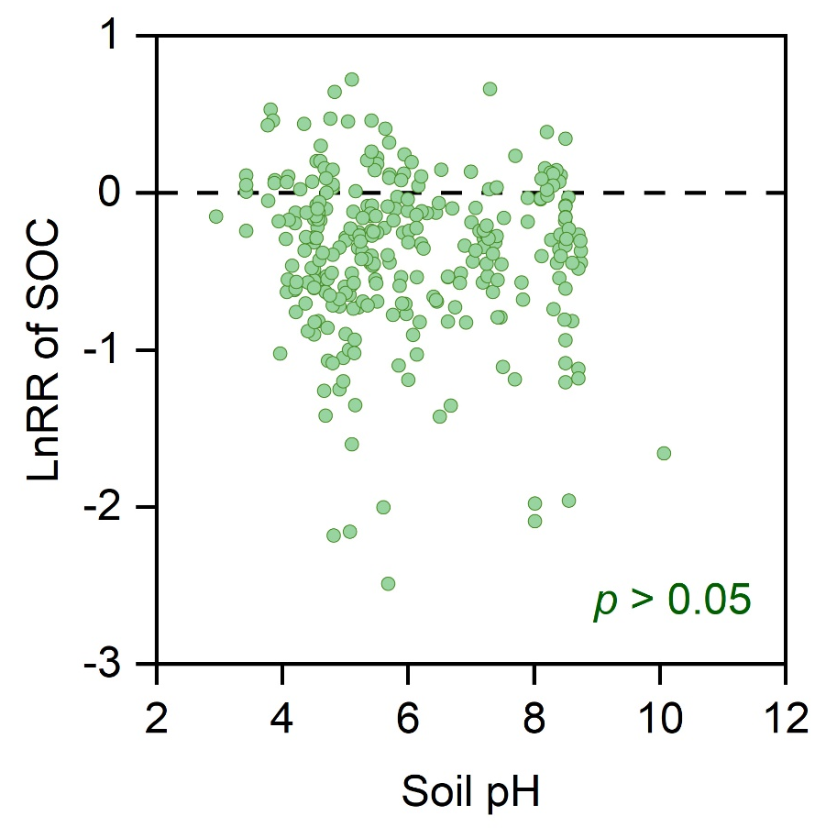
Figure S3 Relationships of soil pH with the changes in surface soil carbon (C) concentrations. r² values and non-linear regression lines are shown for signiﬁcant relationships at p<0.05.
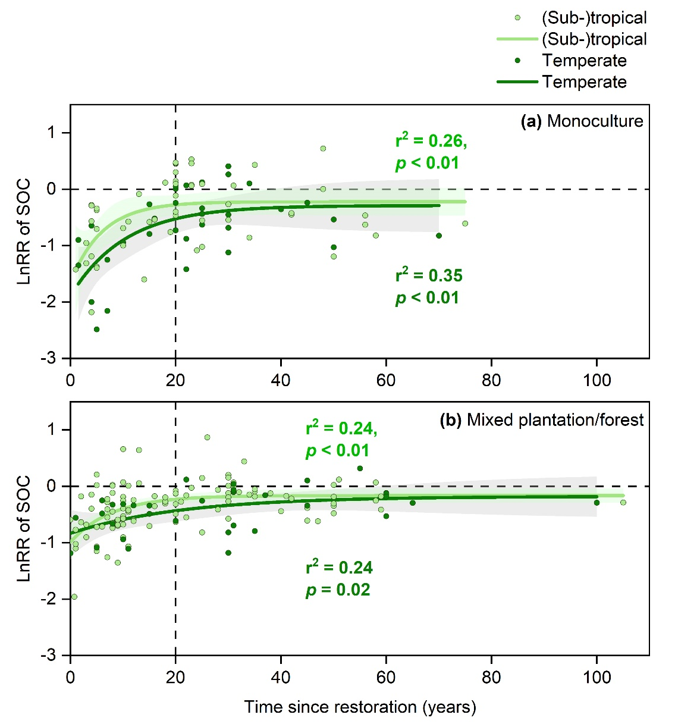
Figure S4 Relationships of time since restoration (years) with the changes in surface soil carbon concentrations in (a) (sub-)tropical and non-(sub-)tropical monoculture restoration and (b) (sub-)tropical and non-(sub-)tropical mixed species restoration. r² values and non-linear regression lines are shown for signiﬁcant relationships at p<0.05.

