Supporting Information
Effect of low-carbon coal gangue on the stability and dissolved or-ganic matter characteristics of co-pyrolysis biochar: insights on py-rolysis temperatures and minerals
Table S1 The basic properties and oxide composition of coal gangue.
Sample | C(%) | H(%) | N(%) | S(%) | SiO₂(%) | Al₂O₃(%) | Fe₂O₃(%)
Coal gangue | 2.60 | 0.948 | 1.69 | 0.076 | 65.80 | 23.16 | 1.97

Table S2 Calculation formula for EEM fluorescence spectral parameters.
Parameter | Formula
Fluorescence index (FI) | $$FI=\frac{F_{λ_{em}=450nm}}{F_{λ_{em}=500nm}}{, λ}_{ex}=370nm$$
Biological index (BIX) | $$BIX=\frac{F_{λ_{em}=380nm}}{F_{λ_{em}=430nm}}{, λ}_{ex}=310nm$$
Humification index (HIX) | $$HIX=\frac{∑F_{λ_{em}=435-480nm}}{∑F_{λ_{em}=300-345nm}}{, λ}_{ex}=255nm$$

Table S3 R₅₀ values of straw biochar and coal gangue-straw co-pyrolysis biochar.
Biochar | R300 | R450 | R600 | W300 | W450 | W600 | C300 | C450 | C600
R₅₀ | 0.50 | 0.52 | 0.57 | 0.50 | 0.52 | 0.57 | 0.50 | 0.52 | 0.55
Co-pyrolysis biochar | CR300 | CR450 | CR600 | CW300 | CW450 | CW600 | CC300 | CC450 | CC600
R₅₀ | 0.47 | 0.52 | 0.58 | 0.45 | 0.50 | 0.56 | 0.47 | 0.53 | 0.60

Table S4 Basic properties of corn straw biochar and coal gangue-corn straw co-pyrolysis biochar.
Sample | C300 | C450 | C600 | CC300 | CC450 | CC600
C(%) | 51.81 | 54.60 | 51.22 | 43.59 | 41.26 | 41.34
H(%) | 2.89 | 1.64 | 0.75 | 2.33 | 1.30 | 0.65
O(%) | 12.98 | 2.98 | 2.31 | 13.17 | 5.18 | 2.59
Ash(%) | 28.88 | 37.48 | 42.03 | 38.17 | 48.69 | 51.85
H:C | 0.67 | 0.36 | 0.18 | 0.64 | 0.38 | 0.19
O:C | 0.19 | 0.04 | 0.03 | 0.23 | 0.09 | 0.05

Table S5 R₅₀ values of corn straw biochar and minerals-corn straw co-pyrolysis biochar.
Sample | C600 | FeC600 | AlC600 | SiC600
R₅₀ | 0.55 | 0.57 | 0.58 | 0.56

Table S6 UV-vis and EEM spectra parameters of DOM derived from minerals-corn straw co-pyrolysis biochar.
 | Sample |  | SUVA₂₅₄  (L mg⁻¹ m⁻¹) |  | SUVA₂₆₀  (L mg⁻¹ m⁻¹) | FI | BIX |  | HIX
FeC600 |  | 5.49±0.68 |  | 4.23±0.59 |  | 1.49±0.02 |  | 0.30±0.01 |  | 9.04±0.50
AlC600 |  | 9.35±0.98 |  | 7.26±0.80 |  | 1.47±0.02 |  | 0.53±0.01 |  | 11.09±0.26
SiC600 |  | 9.71±0.37 |  | 7.78±0.55 |  | 1.42±0.01 |  | 0.60±0.00 |  | 9.99±0.29

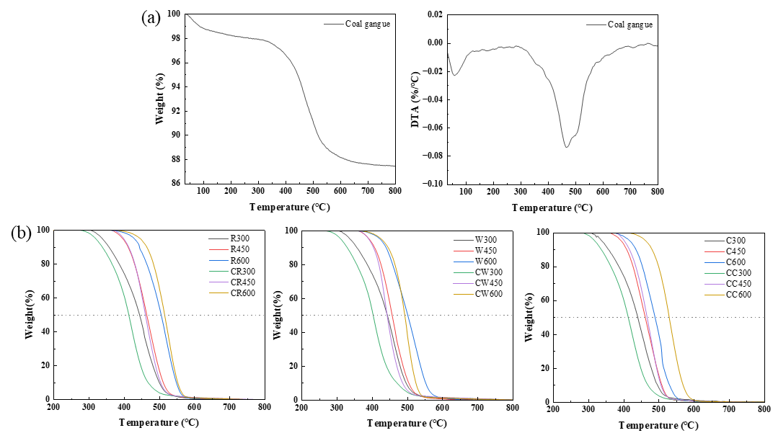
Fig. S1 (a) TGA and DTA curves of coal gangue and corrected TGA curves of biochar and co-pyrolysis biochar.

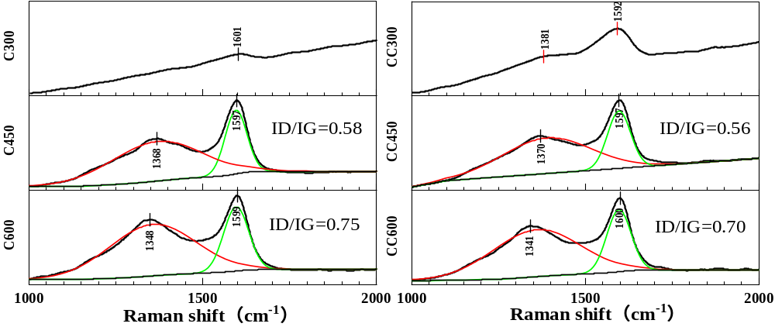
Fig. S2 The Raman spectra of corn straw biochar and coal gangue-corn straw co-pyrolysis biochar.

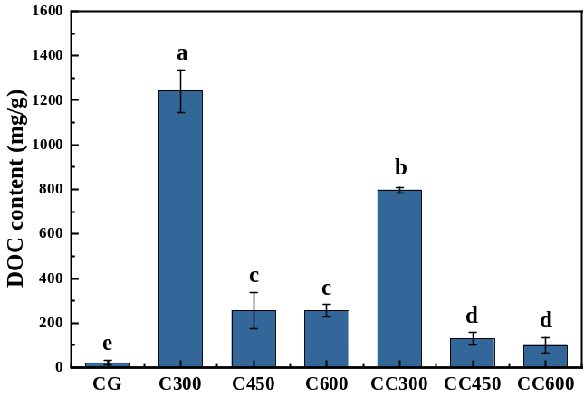
Fig. S3 The DOC content in corn straw biochar and coal gangue-corn straw co-pyrolysis biochar.

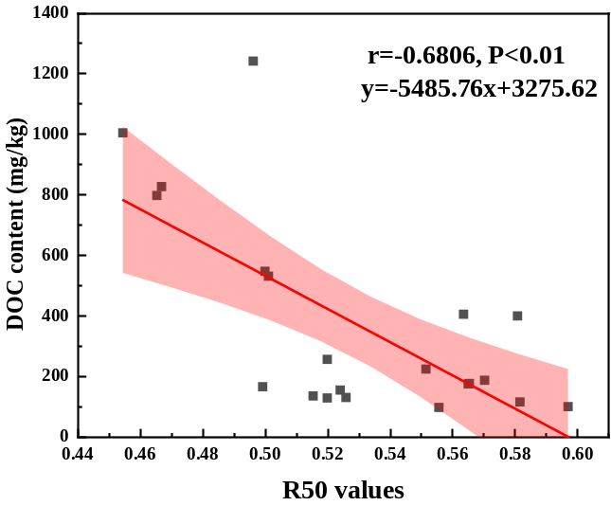
Fig. S4 Linear regression analysis of DOC content and R50 values.

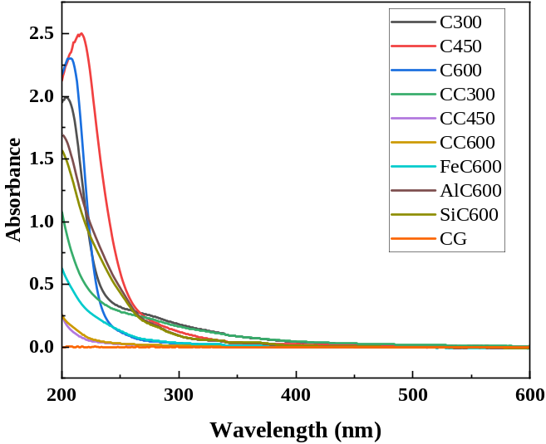
Fig. S5 UV-vis patterns of coal gangue and biochar samples.

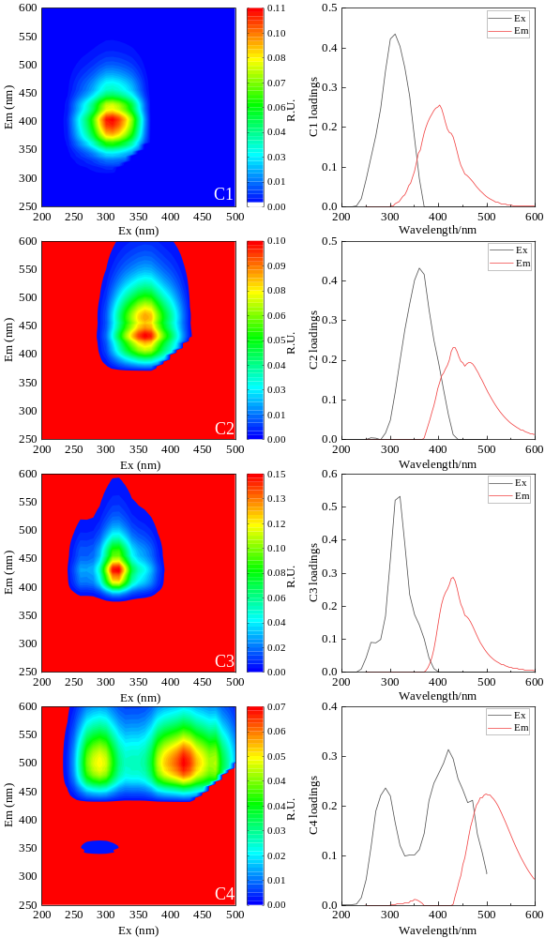
Fig. S6 Four components and loadings map of DOM.
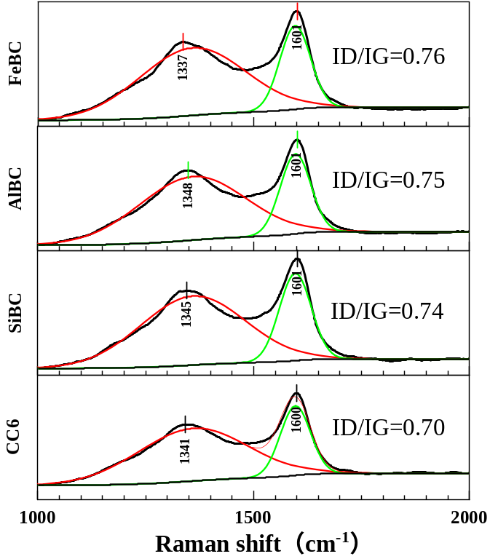
Fig. S7 Raman spectra of corn straw biochar and minerals-corn straw co-pyrolysis biochar.

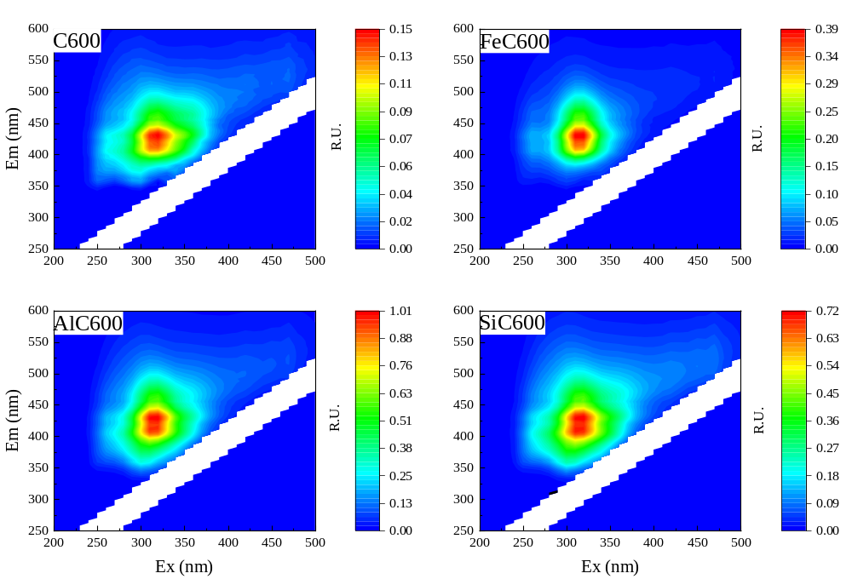Fig. S8 The fluorescence excitation-emission matrix (EEM) spectra of DOM derived from corn straw biochar and minerals-corn straw co-pyrolysis biochar.

