Supplementary information

Methods

Method S1 Selecting and calculating classification features
First, the surface reflectance from the original spectral bands, calculated via the GEE platform, was used as a foundational spectral feature. To enhance the ability to differentiate water bodies and various plant communities, the Modified Normalized Difference Water Index (MNDWI) and six additional vegetation indices—NDVI, BSI, MSAVI, LSWI, EVI, and NDBI—were incorporated. These indices effectively reflect vegetation growth and were added as supplementary classification features. Second, recognizing that the growth and physical characteristics of vegetation vary cyclically—such as during different stages of growth, maturity, and decline—additional red-edge spectral indices (MCARI, PSSRI, NDI45, NDre1, and NDre2) were selected to capture these variations. A detailed description of these spectral features is provided in Table S5. Third, to further refine the image analysis, two feature transformation methods were used: Principal Component Analysis (PCA) and Tassel Cap Transformation (TCT). PCA was employed to extract the first three principal components, which best explain image variability, while TCT was used to derive the Brightness, Greenness, and Wetness components, representing key feature variables in the imagery. Fourth, texture features were extracted using the Gray-Level Co-occurrence Matrix. To minimize redundancy from the high number of texture features, the grey levels in the original surface reflectance image were compressed. Nine key texture features were selected: angular second moment, contrast, correlation, variance, inverse moment, sum mean, sum variance, entropy, and second entropy. Fifth, topographic features—slope and elevation—were incorporated from the NASA DEM30m digital elevation dataset, adding two additional bands to the imagery for enhanced feature extraction. Finally, recognizing that radar data can capture structural features of plant communities, this study incorporated radar data into the classification process to evaluate the benefits of multi-source remote sensing data for wetland vegetation classification.

Method S2 Random Forest Classification Model Hyperparameter Tuning
After preparing the comprehensive feature set, we employed the Random Forest classification model for wetland vegetation classification. To ensure optimal model performance and address potential issues of underfitting or overfitting, we conducted a thorough hyperparameter tuning process. Specifically, we utilized Grid Search in combination with 5-fold cross-validation to optimize key hyperparameters of the Random Forest model: Number of Trees (n_estimators): Tested values were 100, 200, 300, 400, 500, 600, 700, 800, 900, and 1000. Number of Features to Consider at Each Split (max_features): Options included None, sqrt, and log2.
These hyperparameter adjustments were carried out during the model training process to ensure robustness and prevent overfitting. The cross-validation results indicated that when max_features was set to sqrt or log2, the model achieved higher accuracy, with cross-validation scores reaching approximately 0.80. In contrast, setting max_features to None resulted in a significant decrease in model performance. When comparing sqrt and log2, although the difference in scores was not substantial, sqrt consistently maintained a high score of approximately 0.80 across different values of n_estimators. The log2 scores showed slight fluctuations and tended to be around 0.79. Additionally, choosing max_features = 'sqrt' helped prevent overfitting while ensuring that the model training time did not significantly increase. From the validation curves, it was evident that the cross-validation accuracy peaked and stabilized when the number of trees (n_estimators) was set between 400 and 500. Increasing the number of trees beyond this range (e.g., 700 or 1000) did not result in significant improvements in model performance but incurred higher computational costs. Conversely, when the number of trees was too low (e.g., 100 or 200), the model's performance slightly decreased compared to the optimal configuration. Therefore, we selected n_estimators = 500, which provided a good balance between model performance and computational efficiency.
Ultimately, we selected max_features = 'sqrt' and n_estimators = 500 based on a combination of cross-validation performance, computational efficiency, and robustness. This configuration allowed the model to achieve good generalization performance on test data while being computationally efficient. The hyperparameter tuning process ensured that the model complexity was appropriate for the variability present in the data, effectively balancing the risk of overfitting and underfitting.

Method S3 Correction of carbon density based on temperature and precipitation
This study examines the impact of temperature and precipitation on carbon storage in vegetation. Temperature influences the activity of photosynthesis-related enzymes, and a moderate increase in temperature can enhance carbon storage in plants. Precipitation, on the other hand, affects carbon storage by altering the hydrological processes within the ecosystem. To improve the accuracy of our carbon storage simulations, we adjusted carbon density based on these two climate factors—air temperature and precipitation. It was observed that the correlation between air temperature and soil carbon density is significantly weaker than that between precipitation and soil carbon density. Therefore, in this study, we focused only on the effect of precipitation on soil carbon density. The relationship between annual precipitation (MAP) and soil carbon density (C_{SP}) was explored using Equation S1. Regarding biomass carbon density, both temperature and precipitation were found to have a significant correlation with it (C_{BP}, C_{BT}). Consequently, Equations S2 and S3 were used to examine the relationships between annual average precipitation (MAP), temperature (MAT), and biomass carbon density:

$C_{SP}=3.3968×MAP+3.996.1$ (R²=0.11) | (S1)
$C_{BP}=6.798×e^{0.0054×MAP}$ (R²=0.70) | (S2)
$C_{BT}=28×MAT+398$ (R² =0.47, P<0.01) | (S3)

Method S4 Valuation of carbon sinks
In estimating the value of carbon sinks, various methods are available, though China's carbon tax policy is still in development (Jianfeng et al. 2023). International experiences provide valuable insights for China as it develops a carbon pricing mechanism (Feng et al. 2024). However, no standardized global tax rate exists, and rates vary by country. Chinese researchers often use Sweden's tax rate of 150 USD per ton as a benchmark for estimating the value of ecosystem carbon sequestration, converting this to 1,080 RMB per ton using the current exchange rate of 7.2 RMB/USD (Rachid et al. 2024).
The afforestation cost method views forests as a means of sequestering CO₂, equating the cost of afforestation with the economic value of CO₂ absorption. According to China's Ministry of Forestry, the average afforestation cost in 1990 was RMB 260.9, which, when adjusted using the discount rate formula, equals RMB 739.31 today. Some scholars argue that the tax rates in Western countries are too high compared to China, making it difficult to accurately reflect the willingness to pay using the afforestation cost method alone. Therefore, an average of the carbon tax and afforestation cost methods is often used to estimate carbon sequestration value, resulting in a figure closer to actual conditions (Evro et al. 2024). This study adopts this approach, estimating the value at 849.66 RMB/t.
The market value method, which is the most direct and widely used, was also applied in this study. The current carbon market price of 99.0 RMB per ton was used as a benchmark, providing a basis for future green GDP accounting and carbon trading (Guo et al. 2023).
Combining domestic and international research on carbon sink valuation, our study employed the silvicultural cost method, carbon tax method, market value method, and the average of the carbon tax and silvicultural cost methods to estimate the value of carbon sinks in the wetland ecosystems of Weishan County. The calculation follows the specifications outlined in the "Specification for Forest Ecosystem Service Function Assessment" (GB/T 38582-2020), using the common formula provided below:
$$Y_{i}=C_{i}×P_{i}$$ | (S4)
Where Y_{i} denotes the value of carbon sinks under the estimation method of type i (10⁴RMB); C_{i} denotes the amount of carbon storage of type i (Mt); P_{i} denotes the unit price of carbon sinks/carbon tax under the estimation method of type i, in RMB/t.

Tables
Table S1 Information on Sentinel-2 band specifications and their primary applications
Band | Sentinel-2A |  | Sentinel-2B |  | Spatial resolution  （m）
Band | Center wavelength (nm) | Band width (nm) | Center wavelength (nm) | Band width (nm) | Spatial resolution  （m）
Band 1–Coastal aerosol | 442.7 | 21 | 442.2 | 21 | 60
Band 2–Blue | 492.4 | 66 | 492.1 | 66 | 10
Band 3–Green | 559.8 | 36 | 559 | 36 | 10
Band 4 – Red | 664.6 | 31 | 664.9 | 31 | 10
Band 5 – Vegetation red edge | 704.1 | 15 | 703.8 | 16 | 20
Band 6 – Vegetation red edge | 740.5 | 15 | 739.1 | 15 | 20
Band 7 – Vegetation red edge | 782.8 | 20 | 779.7 | 20 | 20
Band 8 – NIR | 832.8 | 106 | 832.9 | 106 | 10
Band 8A – Narrow NIR | 864.7 | 21 | 864 | 22 | 20
Band 9 – Water vapour | 945.1 | 20 | 943.2 | 21 | 60
Band 10 – SWIR – Cirrus | 1373.5 | 31 | 1376.9 | 30 | 60
Band 11 – SWIR | 1613.7 | 91 | 1610.4 | 94 | 20
Band 12 – SWIR | 2202.4 | 175 | 2185.7 | 185 | 20

Table S2 Carbon density of aboveground biomass (kg/m²) collected from bibliometrics
Type of land use | Carbon density | Authors | Study time | Study area
Agricultural land | 0.57±0.13 | Li et al | 2003 | China
Forest | 4.24±0.50 | Xie et al | 2004 | China
Water body | 0±0.00 | Li et al | 2003 | China
Artificial land | 0.25±0.05 | Chen et al | 2002 | China
Unused land | 0.13±0.03 | Chen et al | 2002 | China
Reed land | 2.35±0.75 | Yu et al | 2011 | Shandong province

Table S3 Carbon density of belowground biomass (kg/m²) collected from bibliometrics
Type of land use | Carbon density | Researchers | Study time | Study area
Agricultural land | 2.2±0.50 | Yu and Yu i | 2001 | China
Forest | 8.63±1.20 | Zhang et al | 2018 | Shandong province
Water body | 1.6±0.40 | Dai et al | 2017 | Shandong province
Artificial land | 0±0.00 | Dai et al | 2017 | Shandong province
Unused land | 0±0.00 | Dai et al | 2017 | Shandong province
Reed land | 0.9±0.30 | Du et al | 2022 | The Huanghe Delta

Table S4 Soil carbon density (kg/m²) collected from bibliometrics
Type of land use | Carbon density | Researchers | Study time | Study area
Agricultural land | 8.39±1.25 | Li et al | 2003 | China
Forest | 10.84±1.50 | Li et al | 2003 | China
Water body | 1.4±0.30 | Li et al | 2003 | China
Artificial land | 7.8±1.20 | Zhu et al | 2012 | China
Unused land | 3.14±0.75 | Xie et al | 2004 | China
Reed land | 8.74±1.10 | Zhao et al | 2020 | Shandong province
Mudflat land | 1.5±0.40 | Zhao et al | 2020 | Shandong province

Table S5 Spectral characterization
Index abbreviations | Index full names | Calculation formula
NDVI | Normalized Difference Vegetation Index | (B8-B4)/(B8+B4)
MNDWI | Modified Normalized Difference Water Index | (B3-B11)/(B3+B11)
BSI | Bare Soil Index | ((B4+B11)-(B8+B2))/((B4+B11)+(B8+B2))
MSAVI | Modified Soil Adjusted Vegetation Index | 2×B8+1- √ (2×B8+1)²-8×(B8-B4)]/2
LSWI | Land Surface Water Index | (B8-B11)/(B8+B11)
EVI | Enhanced Vegetation Index | 2.5×(B8-B4)/(B8+6.0×B4-7.5×B2+1)
NDBI | Normalized Difference Built-up Index | (B11-B8)/(B11+B8)
MCARI | Modified Chlorophyll Absorption Ratio Index | [(B5-B4)-0.2×(B5-B3)]×(B5-B4)
PSSRI | Pigment Specific Simple Ratio Index | B7/B4
NDI45 | Normalized Difference Index | (B5-B4)/(B5+B4)
NDrel | Normalized Difference red-edgel | (B6-B5)/(B6+B5)
NDre2 | Normalized Difference red-edge2 | (B7-B5)/(B7+B5)

Table S6 Single-source vs. multi-source
Experiment Number | Feature Type | Number of Variables
1-1 | Spectral features + Transformation features + Texture features + Terrain features | 39
1-2 | Spectral features + Transformation features + Texture features + Terrain features + Sentinel-1 polarization bands + Sentinel-1 texture features | 50

Figures
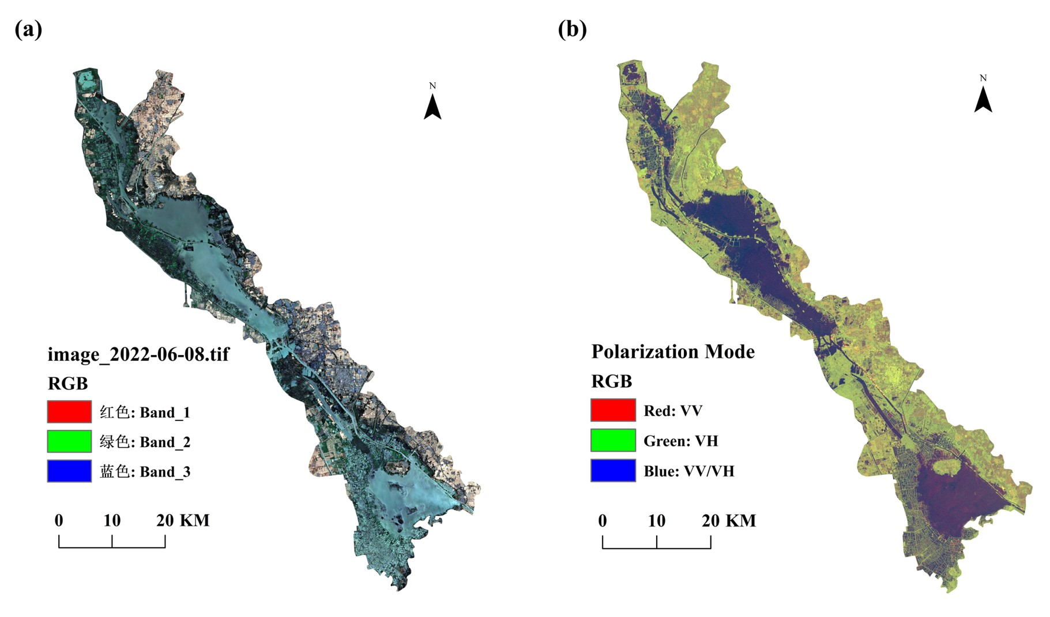
Fig. S1 True Color Composite Sentinel Images Covering the Study Area in 2022. (a) The red-green-blue bands were used to visualize the study area. (b) Horizontal polarization, vertical polarization, and the divisor of both were used as red-green-blue bands to visualize the study area.
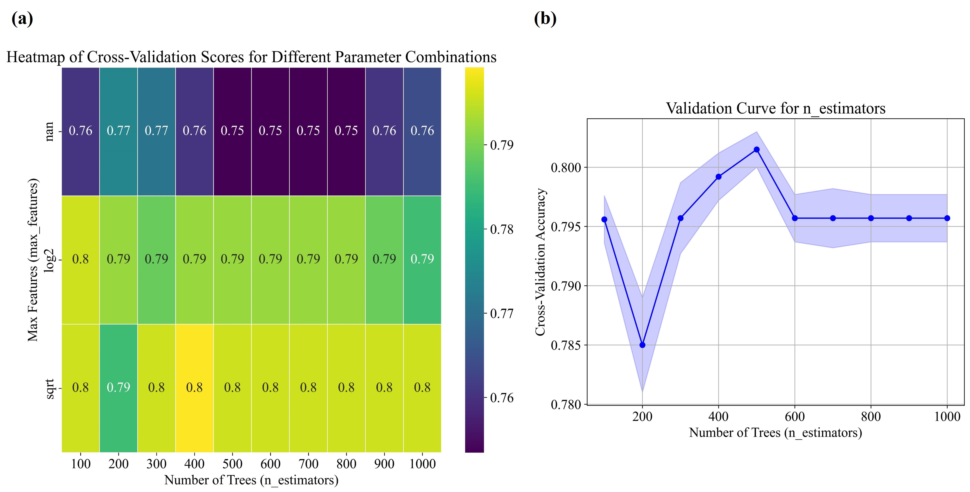
Fig. S2 Cross-validation analysis of Random Forest hyperparameters based on grid search. (a) Heatmap of cross-validation scores for different parameter combinations of Random Forest. The x-axis represents the number of trees (n_estimators), and the y-axis represents the selection of the maximum features (max_features). The color indicates the cross-validation score, where brighter colors correspond to higher scores. (b) Validation curve for 'n_estimators' parameter, showing the cross-validation accuracy as a function of the number of trees. The shaded region represents the variability (standard deviation) across cross-validation folds, and the points indicate the mean accuracy for each setting of 'n_estimators'.

References
Chen, L., Liu, G., and Li, H. (2002). Estimating Net Primary Productivity of Terrestrial Vegetation in China Using Remote Sensing (in Chinese). Journal of Remote Sensing, 6(2), 129-136.
Dai, J., Xugui., P., Dong, J., Wang, Z., and Yu, C. (2017). Soil Organic Carbon Pool and Temporal Variation Characteristics in Shandong Province (in Chinese). Geoscience, 31(2), 386-393.
Du, S., Bai, J., Jia J., Guan, Y., Zhang, G.,…… andGai, L. (2022). Changes of soil organic carbon storage in Phragmites australis wetlands along a salinity gradient in the Yellow River Delta (in Chinese). Acta Scientiae Circumstantiae, 42(1): 80-87. https://doi.org/10.13671/j.hjkxxb.2021.0520
Li, K., Wang, S., and Cao, M. (2003). Carbon storage of vegetation and soil in China (in Chinese). Science in China (Series D), 1(1), 72-80.
Xie, X., Sun, B., Zhou, H., and Li, Z. (2004). Soil carbon stocks and their influencing factors under native vegetations in China (in Chinese). Acta Pedologica Sinica, 41(5), 687-699.
Yu, W., and Yu, Y. (2001). Advances in the rescarch of underground biomass (in Chinese). Chinese Journal of Applied Ecology, 12(6), 927-932. https://doi.org/10. 13287/j. 1001-9332. 2001. 0220
Yu, Q., Zang, Z., Lv, Ji., and Sun, J. (2020). Spatial and temporal variation of vegetation carbon storage in Nansihu lake wetland from 1987 to 2008 (in Chinese). Ecology and Environmental Sciences, 21(9): 1527-1532. https://doi.org/10.16258/j.cnki.1674-5906.2012.09.006
Zhao, D. (2020). The Change of Land Use Types and Its Influence on Soil Organic Carbon Storage in Nansi Lake (in Chinese). Shandong University, https://doi.org/10.27272/d.cnki.gshdu.2020.001560.
Zhang, C., Ju, W., Wang, D., Wang, X., and Wang, X. (2018). Biomass carbon stocks and economic value dynamics of forests in Shandong Province from 2004 to 2013 (in Chinese). Acta Ecologica Sinica, 38(5), 1739-1749. https://doi.org/10.5846/stxb201703280535
Zhu, C., Zhao, S., and Zhou, D. (2012). Organic carbon storage in urban built-up areas of China in 1997-2006 (in Chinese). Chinese Journal of Applied Ecology, 23(5), 1195-1202. https://doi.org/10.13287/j.1001-9332.2012.0165

