Supplemental Information
Facile sulfonation of lignite for Cadmium removal: performance, mechanism, and recovery as photocatalysts
Jing Hu ª, Bing Han ^{a, b}, Clayton Butterly ª, Wei Zhang ^{a, c, d}, Ji-Zheng He ª, Deli Chen ^{a,} *
ª School of Agriculture, Food and Ecosystem Sciences, Faculty of Science, The University of Melbourne, Parkville, VIC 3010, Australia
^{b} School of Engineering, Deakin University, Geelong, Victoria, Australia
^{c} School of Environmental Science and Engineering, Yancheng Institute of Technology, Yancheng 224051, China
^{d} Jiangsu Engineering Research Center of Biomass Waste Pyrolytic Carbonization & Application, Yancheng 224051, China

Number of pages (including the cover page): 5
Number of figures: 3
Number of tables: 1

* Corresponding author: Deli Chen. E-mail address: delichen@unimelb.edu.au

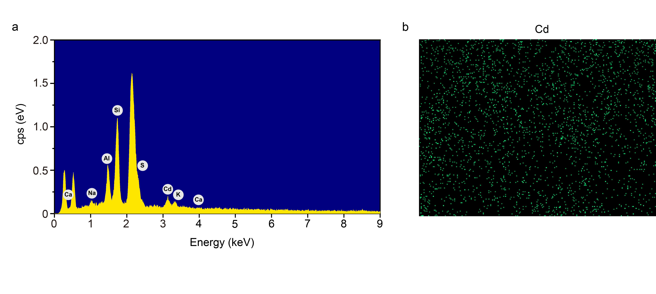
Fig. S1 SEM-EDS mapping for SL after Cd adsorption showing the successful adsorption of Cd on its surface. (a) EDS element distributions for SL after Cd adsorption and (b) Cd mapping for SL after Cd adsorption.

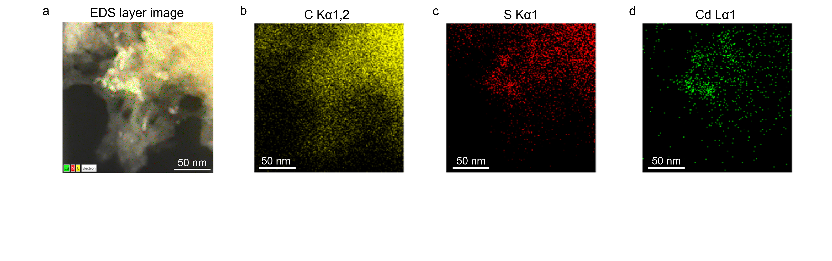
Fig. S2 TEM-EDS mapping for SL (a) shows the distribution of C (b), S (c), and Cd (d) elements.

Fig. S3 MB degradation under light exposure without photocatalysts.

Table S1 Exchange ion concentration in blank solution and the supernatant after Cd adsorption.
Solution | Al (mg/L) | Ca (mg/L)
Blank solution | 0.62 | 0.04
Cd solution | 3.12 | 0.83

