Vassoler et al. Supplementary material

Table S1 Coordinates of sampling sites.
Site | Latitude | Longitude
COQUEIRAL | 19°56'32.20"S | 40° 8'7.01"W
COSTA BELA | 20° 6'13.68"S | 40°10'16.91"W
ENSEADA | 20° 1'51.91"S | 40° 9'28.24"W
FALÉSIAS | 20° 4'43.36"S | 40°10'23.09"W
GRAMUTÉ | 19°58'25.58"S | 40° 8'12.08"W
JURONG | 19°53'36.05"S | 40° 5'14.71"W
MAR AZUL | 19°55'2.31"S | 40° 5'47.40"W

Table S2 Biomass (wet and dry weight in grams) of each macroalgae genus in each sample collected on sites at SW Atlantic. W = wet weight; D = dry weight.
Site | Caulerpa |  | Halimeda |  | Anadyomene |  | Ulva |  | Sargassum |  | Dictyopteris |  | Lobophora |  | Zonaria |  | Spatoglossum |  | Padina |  | Dichotomaria |  | Bryothamnion |  | Vidalia |  | Plocamium |  | Amphiroa |  | Glacilaria
Site | D | W | D | W | D | W | D | W | D | W | D | W | D | W | D | W | D | W | D | W | D | W | D | W | D | W | D | W | D | W | D | W
COQUEIRAL | 0 | 0 | 0 | 0 | 0 | 0 | 0 | 0 | 29.4 | 183.9 | 0 | 0 | 0 | 0 | 31 | 141.3 | 0 | 0 | 0 | 0 | 51.5 | 11.1 | 0 | 0 | 0 | 0 | 0.2 | 1.6 | 0 | 0 | 0 | 0
COQUEIRAL | 0 | 0 | 2.7 | 23.6 | 0 | 0 | 0 | 0 | 48 | 302.5 | 0.5 | 3.2 | 0 | 0 | 1.8 | 7 | 0 | 0 | 0 | 0 | 13 | 0 | 2.3 | 0 | 2.9 | 18.1 | 0.1 | 0.8 | 0 | 0 | 0 | 0
COQUEIRAL | 0 | 0 | 0 | 0 | 0.3 | 1.3 | 0 | 0 | 27.3 | 168 | 0 | 0 | 0.6 | 2.4 | 0 | 0 | 0 | 0 | 0 | 0 | 113.4 | 22.1 | 0 | 0 | 0 | 0 | 1.4 | 10.3 | 1.7 | 12.5 | 0 | 0
COSTA BELA | 0 | 0 | 0.4 | 5.8 | 1.5 | 7.3 | 0 | 0 | 15.2 | 106.1 | 0 | 0 | 1.2 | 4.2 | 0 | 0 | 0 | 0 | 0 | 0 | 23.5 | 5.3 | 0 | 0 | 0 | 0 | 0 | 0 | 0 | 0 | 0 | 0
COSTA BELA | 6.2 | 81.8 | 0 | 0 | 2.5 | 14.8 | 0 | 0 | 0 | 0 | 1.2 | 9.2 | 1.9 | 6.5 | 0 | 0 | 0 | 0 | 0 | 0 | 8.8 | 2 | 0 | 0 | 0 | 0 | 0 | 0 | 0 | 0 | 0 | 0
COSTA BELA | 8.9 | 113.8 | 0 | 0 | 0 | 0 | 0 | 0 | 22.2 | 142.4 | 2.8 | 14.8 | 0 | 0 | 0 | 0 | 0 | 0 | 0 | 0 | 0 | 0 | 0 | 0 | 0 | 0 | 0 | 0 | 0 | 0 | 0 | 0
ENSEADA | 0 | 0 | 0 | 0 | 0 | 0 | 0 | 0 | 51.1 | 308 | 0 | 0 | 1.1 | 4.5 | 1.8 | 6.6 | 0 | 0 | 0 | 0 | 69.9 | 16.8 | 0 | 0 | 0 | 0 | 0 | 0 | 0 | 0 | 0 | 0
ENSEADA | 0 | 0 | 0 | 0 | 0 | 0 | 1.8 | 13.7 | 36.8 | 234.9 | 0 | 0 | 0 | 0 | 0 | 0 | 0 | 0 | 0 | 0 | 0 | 0 | 0 | 0 | 2.2 | 8.8 | 0.6 | 5.6 | 0 | 0 | 0 | 0
ENSEADA | 0.4 | 5.2 | 3.1 | 25.7 | 0 | 0 | 0 | 0 | 34.7 | 237.7 | 1.2 | 8.4 | 0 | 0 | 0 | 0 | 0 | 0 | 0 | 0 | 6.1 | 1.6 | 0 | 0 | 1.5 | 7 | 0 | 0 | 0 | 0 | 0 | 0
FALÉSIAS | 0.2 | 1.8 | 4.8 | 37.9 | 0.5 | 2.1 | 1 | 6.1 | 18.7 | 97.8 | 0 | 0 | 1 | 3.3 | 0 | 0 | 0 | 0 | 0 | 0 | 49.8 | 11 | 2.7 | 15 | 0.5 | 2.4 | 0 | 0 | 0 | 0 | 0 | 0
FALÉSIAS | 3 | 27.3 | 2.3 | 19.1 | 4.4 | 21.2 | 0 | 0 | 15 | 102.3 | 1.7 | 10.2 | 1.2 | 4.2 | 0 | 0 | 0 | 0 | 0 | 0 | 5 | 1.1 | 0 | 0 | 0 | 0 | 0 | 0 | 0 | 0 | 0 | 0
FALÉSIAS | 0 | 0 | 4.5 | 34.6 | 2 | 6.8 | 0 | 0 | 41.2 | 249.9 | 9.3 | 38.9 | 0 | 0 | 6.2 | 17.4 | 0 | 0 | 0 | 0 | 0 | 0 | 0 | 0 | 8.9 | 41.5 | 1.1 | 8 | 0 | 0 | 0.6 | 4.3
GRAMUTÉ | 0 | 0.3 | 0 | 0 | 0.3 | 1.6 | 0 | 0 | 11.4 | 82.8 | 2.2 | 15.8 | 25.8 | 101.1 | 0 | 0 | 0 | 0 | 0.3 | 1.7 | 0 | 0 | 0.3 | 2.2 | 0 | 0 | 0.2 | 1.2 | 0 | 0 | 0 | 0
GRAMUTÉ | 0 | 0 | 0 | 0 | 0.7 | 3.6 | 0 | 0 | 77.7 | 453.3 | 7.3 | 48 | 7 | 21.8 | 1.7 | 5.4 | 0 | 0 | 0 | 0 | 0 | 0 | 0.4 | 2 | 0 | 0 | 0.1 | 0.8 | 0 | 0 | 0 | 0
GRAMUTÉ | 0 | 0 | 0 | 0 | 0 | 0 | 0 | 0 | 23.4 | 140.4 | 5.6 | 33 | 10.8 | 35.7 | 0 | 0 | 1.6 | 12.4 | 0 | 0 | 0 | 0 | 10.8 | 55.3 | 0 | 0 | 0 | 0 | 0 | 0 | 0 | 0
JURONG | 0 | 0 | 0 | 0 | 0 | 0 | 2.2 | 13.8 | 0 | 0 | 0 | 0 | 0 | 0 | 0 | 0 | 0 | 0 | 0 | 0 | 130.9 | 31.4 | 0 | 0 | 0 | 0 | 0 | 0 | 0 | 0 | 0 | 0
JURONG | 0 | 0 | 0 | 0 | 0 | 0 | 1.4 | 8.3 | 0 | 0 | 0 | 0 | 0 | 0 | 0 | 0 | 0 | 0 | 0.4 | 1.8 | 0 | 0 | 0 | 0 | 0 | 0 | 0 | 0 | 0 | 0 | 0 | 0
JURONG | 0 | 0 | 0 | 0 | 0 | 0 | 0 | 0 | 15.1 | 105.4 | 0 | 0 | 0 | 0 | 0 | 0 | 0 | 0 | 0 | 0 | 0 | 0 | 0 | 0 | 0 | 0 | 0.3 | 2 | 0 | 0 | 0 | 0
MAR AZUL | 0 | 0 | 0 | 0 | 0 | 0 | 0 | 0 | 4.1 | 24.2 | 2.1 | 13.6 | 0 | 0 | 0 | 0 | 0 | 0 | 0 | 0 | 72.2 | 18.2 | 0 | 0 | 2.6 | 15.1 | 0 | 0 | 0 | 0 | 0 | 0
MAR AZUL | 0 | 0 | 0.4 | 4.2 | 0 | 0 | 0 | 0 | 26.1 | 171 | 6.4 | 39 | 1.9 | 6.8 | 0 | 0 | 0 | 0 | 0 | 0 | 0 | 0 | 15.5 | 102.4 | 3.9 | 24.7 | 0 | 0 | 0 | 0 | 0 | 0
MAR AZUL | 0 | 0 | 0 | 0 | 0 | 0 | 0 | 0 | 12 | 70.3 | 9.1 | 74.7 | 0.9 | 2.9 | 0 | 0 | 0 | 0 | 0 | 0 | 0 | 0 | 15.5 | 86.7 | 1.7 | 11.7 | 0 | 0 | 0 | 0 | 0 | 0

Table S3 Total ecosystem carbon stock (TECS) belowground in areas with (PMA) and without macroalgae coverage (AMA) per sample
Site | PMA/AMA | % C | Dry Weight (g) | Bulk density (g.cm-³) | g C.cm-³ | Mg C.ha-¹
COQUEIRAL | PMA | 6.46 | 188.37 | 1.66 | 0.11 | 1.07
COQUEIRAL | PMA | 9.13 | 160.60 | 1.41 | 0.13 | 1.29
COQUEIRAL | PMA | 8.72 | 153.58 | 1.35 | 0.12 | 1.18
COQUEIRAL | AMA | 7.34 | 143.96 | 1.27 | 0.09 | 0.93
COQUEIRAL | AMA | 9.43 | 154.61 | 1.36 | 0.13 | 1.28
COQUEIRAL | AMA | 9.17 | 124.74 | 1.10 | 0.10 | 1.01
COSTA BELA | PMA | 3.67 | 166.70 | 1.47 | 0.05 | 0.54
COSTA BELA | PMA | 8.62 | 159.38 | 1.40 | 0.12 | 1.21
COSTA BELA | PMA | 9.6 | 155.09 | 1.36 | 0.13 | 1.31
COSTA BELA | AMA | 4.39 | 134.68 | 1.18 | 0.05 | 0.52
COSTA BELA | AMA | 9.36 | 153.77 | 1.35 | 0.13 | 1.27
COSTA BELA | AMA | 8.13 | 152.32 | 1.34 | 0.11 | 1.09
ENSEADA | PMA | 6.23 | 163.99 | 1.44 | 0.09 | 0.90
ENSEADA | PMA | 8.7 | 184.25 | 1.62 | 0.14 | 1.41
ENSEADA | PMA | 8.29 | 163.42 | 1.44 | 0.12 | 1.19
ENSEADA | AMA | 9.11 | 187.49 | 1.65 | 0.15 | 1.50
ENSEADA | AMA | 8.85 | 185.59 | 1.63 | 0.14 | 1.45
ENSEADA | AMA | 7.05 | 167.61 | 1.47 | 0.10 | 1.04
FALÉSIAS | PMA | 7.15 | 151.61 | 1.33 | 0.10 | 0.95
FALÉSIAS | PMA | 7.71 | 186.23 | 1.64 | 0.13 | 1.26
FALÉSIAS | PMA | 7.88 | 138.59 | 1.22 | 0.10 | 0.96
FALÉSIAS | AMA | 7.97 | 184.27 | 1.62 | 0.13 | 1.29
FALÉSIAS | AMA | 8.94 | 171.58 | 1.51 | 0.13 | 1.35
FALÉSIAS | AMA | 8.66 | 139.46 | 1.23 | 0.11 | 1.06
GRAMUTÉ | PMA | 6.57 | 156.94 | 1.38 | 0.09 | 0.91
GRAMUTÉ | PMA | 7.6 | 165.96 | 1.46 | 0.11 | 1.11
GRAMUTÉ | PMA | 9.94 | 169.19 | 1.49 | 0.15 | 1.48
GRAMUTÉ | AMA | 9.73 | 99.24 | 0.87 | 0.08 | 0.85
GRAMUTÉ | AMA | 7.71 | 141.53 | 1.25 | 0.10 | 0.96
GRAMUTÉ | AMA | 10.2 | 175.01 | 1.54 | 0.16 | 1.57
JURONG | PMA | 10.3 | 149.06 | 1.31 | 0.14 | 1.35
JURONG | PMA | 10.7 | 170.10 | 1.50 | 0.16 | 1.60
JURONG | PMA | 10.9 | 94.11 | 0.83 | 0.09 | 0.90
JURONG | AMA | 10.3 | 86.48 | 0.76 | 0.08 | 0.78
JURONG | AMA | 9.52 | 130.88 | 1.15 | 0.11 | 1.10
JURONG | AMA | 8.74 | 176.73 | 1.55 | 0.14 | 1.36
MAR AZUL | PMA | 6.51 | 177.67 | 1.56 | 0.10 | 1.02
MAR AZUL | PMA | 7.93 | 161.96 | 1.42 | 0.11 | 1.13
MAR AZUL | PMA | 7.28 | 159.06 | 1.40 | 0.10 | 1.02
MAR AZUL | AMA | 9.31 | 130.95 | 1.15 | 0.11 | 1.07
MAR AZUL | AMA | 9.3 | 137.54 | 1.21 | 0.11 | 1.13
MAR AZUL | AMA | 7.44 | 169.37 | 1.49 | 0.11 | 1.11

Table S4 Permutational analysis of variance results from biomass and composition of macroalgae beds among sampled beaches and class (Chlorophyceae, Phaeophyceae, and Rhodophyceae). Significative results are considered when p < 0.05 and are presented in bold. Df = degrees of freedom; SS = sum of squares; MS = mean of squares.
Source | df | SS | MS | Pseudo-F | p-value
Beach | 6 | 5.38 | 0.897 | 2.998 | 0.014
Macroalgae | 2 | 31.603 | 15.802 | 52.811 | 0.001
Beach X macroalgae | 12 | 12.447 | 1.037 | 3.467 | 0.004
Residual | 42 | 12.567 | 0.299
Total | 62 | 62
Table S5 Permutational analysis of variance results from sediment carbon stocks among sampled beaches and areas with and without macroalgae coverage. Significative results are considered when p < 0.05. Df = degrees of freedom; SS = sum of squares; MS = mean of squares.
Source | df | SS | MS | Pseudo-F | p-value
Beach | 6 | 4.029 | 0.672 | 0.553 | 0.738
Macroalgae coverage | 1 | 2.572e-3 | 2.572e-3 | 2.119e-3 | 0.958
Beach x macroalgae coverage | 6 | 2.984 | 0.497 | 0.410 | 0.872
Residual | 28 | 33.985 | 1.214
Total | 41 | 41

Table S6 Permutational analysis of variance results from total environmental carbon stocks among sampled beaches. Significative results are considered when p < 0.05. Df = degrees of freedom; SS = sum of squares; MS = mean of squares.
Source | df | SS | MS | Pseudo-F | p-value
Beach | 6 | 6.737 | 1.122 | 1.147 | 0.33
Residual | 35 | 34.263 | 0.978
Total | 41 | 41

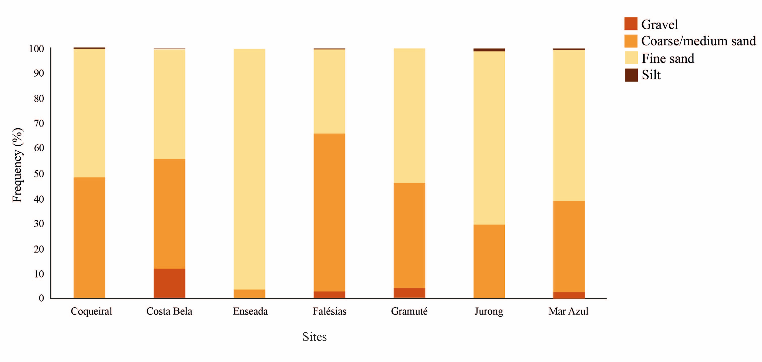
Fig. S1 Granulometry in each sampled site at the SW Atlantic.

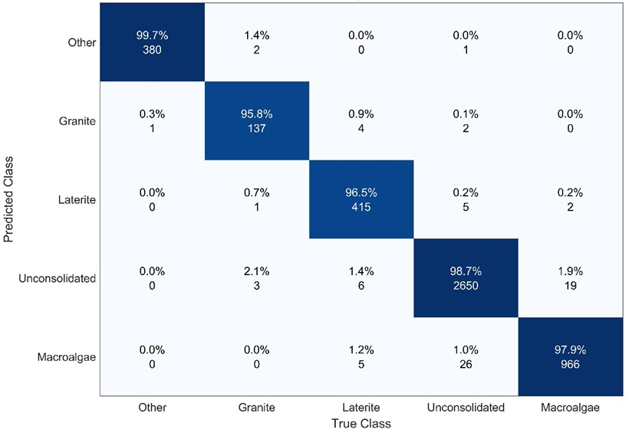
Fig. S2 Confusion matrix of the five classified categories obtained from the testing set

