Direct air capture-assisted sustainable fuel solution in maritime sector: a carbon footprint perspective
Shuangjun Li ^{a,1}, Zhenyu Du ^{b,1}, Junyao Wang ^{c,1}, Hao Wang ^{b}, Xiangkun Elvis Cao ^{d}, Runkai Chen ^{c}, Yujia Pang ^{e}, Shuai Deng ^{e,*}, Ondřej Mašek ^{f}, Xiangzhou Yuan ^{g,**}, Ki Bong Lee ^{a,***}

- Department of Chemical and Biological Engineering, Korea University, 145 Anam-ro, Seongbuk-gu, Seoul 02841, Republic of Korea
- The Laboratory of Heat and Mass Transport at Micro-Nano Scale, College of Engineering, Peking University, Beijing 100871, China
- School of Materials and Energy, Guangdong University of Technology, Guangdong 510006, China
- Department of Chemical Engineering, Massachusetts Institute of Technology, Cambridge 02139, USA
- State Key Laboratory of Engines, Tianjin University, Tianjin 300350, China
- UK Biochar Research Centre (UKBRC), School of GeoSciences, University of Edinburgh, King's Buildings, Edinburgh EH9 3JN, UK
- Ministry of Education of Key Laboratory of Energy Thermal Conversion and Control, School of Energy and Environment, Southeast University, Nanjing 210096, China

- These authors contributed equally as the first authors.

*Corresponding author
Email: sdeng@tju.edu.cn (S. Deng)
**Corresponding author
Email: yuanxz@seu.edu.cn (X. Yuan)
***Corresponding author
Email: kibonglee@korea.ac.kr (K.B. Lee)

Table S1 CO₂ emissions and carbon removal efficiency of specific DAC technologies
Technology | Energy consumption | Electricity supply | Heat source | Emissions  (kg CO₂ eq. /kg) | Carbon removal efficiency (%) | Ref
HS-DAC ª | 211-473 kWh/t | Coal-based | Ambient heat | 0.30 | 70 | (van der Giesen et al., 2017)
HT-DAC ^{b} | 193 kWh/t | - | Natural gas | 0.90 | 10 | (de Jonge et al., 2019)
HT-DAC | - | Fossil-based | - | 0.14 | 86 | (Liu et al., 2020)
HT-DAC | - | Nearly carbon-free | - | 0.04 | 96 | (Liu et al., 2020)
LT-DAC ^{c} | - | Wind power | Heat pump | 0.049 | 95 | (Deutz and Bardow, 2021)
LT-DAC | >0.15 g CO₂ eq. /kWh | Grid | Waste heat | 0.0337-0.52 | 48-97 | (Terlouw et al., 2021)
LT-DAC | >0.15 g CO₂ eq. /kWh | Grid | Heat pump | 0.0466-0.914 | 8.6-95 | (Terlouw et al., 2021)
LT-DAC | >0.15 g CO₂ eq. /kWh | PV | Fresnel solar-thermal heat collector | 0.087-0.162 | 84-91 | (Terlouw et al., 2021)
LT-DAC | >0.15 g CO₂ eq. /kWh | PV | Heat pump with PV installation | 0.111-0.206 | 79-89 | (Terlouw et al., 2021)
LT-DAC | >0.15 g CO₂ eq. /kWh | PV | Heat pump with waste heat | 0.0774-0.150 | 85-92 | (Terlouw et al., 2021)
HT-DAC | 345 kWh/t  4.47 GJ/t | - | Natural gas | 0.588 | 41 | (Madhu et al., 2021)
HT-DAC | 70 g CO₂ eq./kWh | Renewable electricity | Heat pump | 0.26 | 73 | (Madhu et al., 2021)
LT-DAC | 180 kWh/t,  2.6 GJ/t | - | Natural gas | 0.303 | 70 | (Madhu et al., 2021)
LT-DAC | - | Renewable electricity | Heat pump | 0.15 | 86 | (Madhu et al., 2021)
HT-DAC and LT-DAC | - | Grid | - | 0.06-0.64 | 36-94 | (Qiu et al., 2022)
HT-DAC and LT-DAC | - | Grid (its combined share of nuclear and renewable generation increases from 35 to 61%) | (Natural gas or Biomethanol) and (biomethane or heat pump) | -0.12-0.28 | 72 to over 100% ^{d} | (Qiu et al., 2022)
HT-DAC and LT-DAC | - | Grid (higher renewable energy penetration(81%)) | (Natural gas or Biomethanol) and (biomethane or heat pump) | -0.25-0.09 | 91 to over 100% ^{d} | (Qiu et al., 2022)
ª HS-DAC denotes the humidity-swing-based direct air capture.
^{b} HT-DAC denotes the high-temperature aqueous solutions-based on direct air capture.
^{c} LT-DAC denotes the low-temperature solid sorbents-based direct air capture.
^{d} The carbon removal efficiency is over 100% because extra negative CO₂ emissions are contributed by biomethane used as the heat source

Table S2 Key information on the fundamental technical characteristics and life cycle assessment in typical e-methanol production research.
Catalyst | Reaction condition |  | Feedstock (kg/kg methanol) |  | Emission range ª | System design ^{b} | GWP (kg CO₂ eq./kg methanol) | Ref.
Catalyst | Temperature (ºC) | Pressure (bar) | CO₂ | H₂
Cu-ZnO-Al₂O₃ | 200-300 | 50-100 | 2.046 | 0.282 | Region A | Base design | -0.390 | (Bargiacchi et al., 2019)
- | 250 | 80-100 | 1.370 | 0.190 | Region A | Base design | -1.390 | (Eggemann et al., 2020)
Cu-ZnO- Al₂O₃ | 250 | 90 | 1.440 | 0.200 | Region A | Base design | -0.689 | (Abbas et al., 2022)
 |  |  |  |  |  | Thermal integration | -1.167 | (Abbas et al., 2022)
 |  |  |  |  |  | Renewable energy integration | -1.583 | (Abbas et al., 2022)
Cu-ZnO- Al₂O₃ | 210 | 78 | 1.392 | 0.443 | Region A | Base design | -1.078 | (Yusuf and Almomani, 2023)
 |  |  |  |  |  | Thermal integration | -1.385 | (Yusuf and Almomani, 2023)
Cu-ZnO- Al₂O₃ | 210 | 76 | 1.460 | 0.199 | Region A | Base design | -1.234 | (Pérez-Fortes et al., 2016)
Cu-ZnO- Al₂O₃ | 280 | 47 | 1.840 | - | Region B | Base design | 1.870 | (Kim et al., 2011)
 |  |  |  |  |  | Renewable energy integration | -1.710 | (Kim et al., 2011)
- | - | - | - | 0.276 | Region B | Renewable energy integration | 0.476 ^{c} | (Eleonora Bargiacchi, 2020)
 |  |  |  |  |  |  | 0.0928 ^{d} | (Eleonora Bargiacchi, 2020)

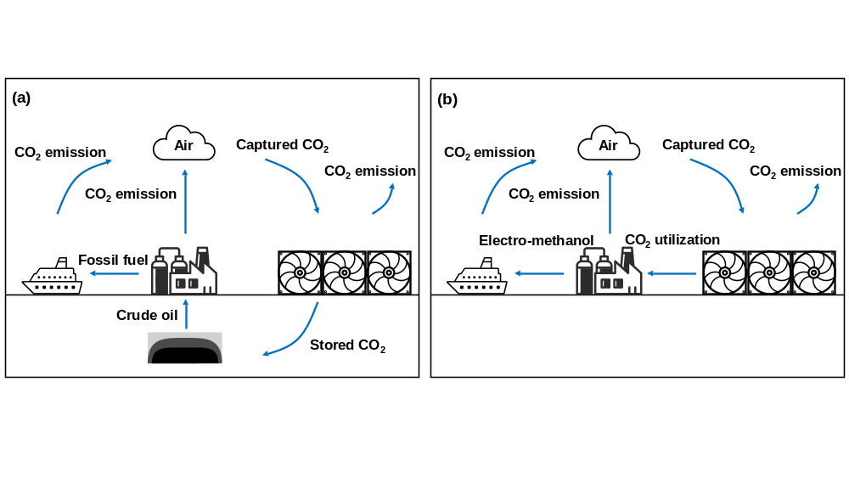
Fig. S1 Illustration of technology application scenarios and their climate change impact: (A) In the maritime sector, fossil fuels currently serve as the primary energy source, contributing significantly to climate change. Employing DAC technology, coupled with permanent geological storage of CO₂, emerges as the sole viable solution to mitigate the climate impact stemming from emissions in this sector. (B) Through DAC technology, captured CO₂ is repurposed as a feedstock for the production of e-methanol. This innovative approach establishes a closed carbon cycle, particularly beneficial when e-methanol is utilized within the maritime domain.

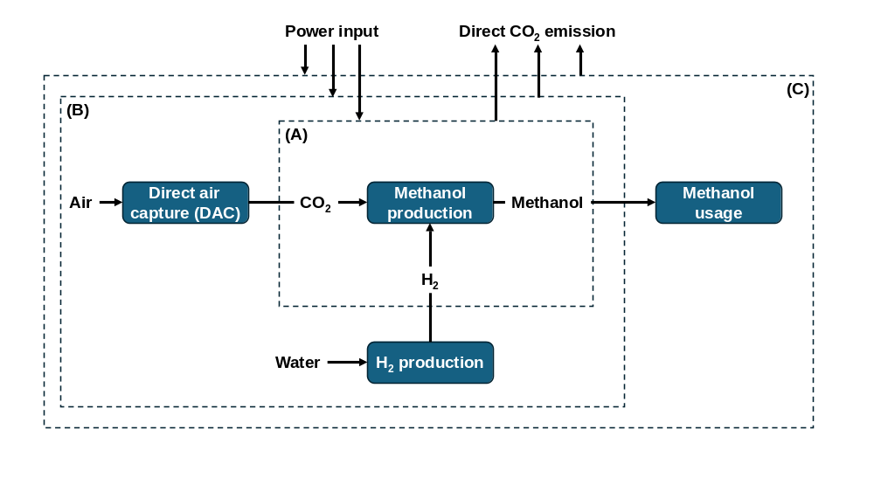
Fig. S2 Simplified illustration of the e-methanol life cycle with the dotted lines indicating the commonly used system boundary in the life cycle assessment (LCA). In Region A, the specific e-methanol production process is studied, while the CO₂ and H₂ are supplied as the feedstock only (i.e., gate-to-gate). In Region B, the production process of CO₂ and H₂ are also considered, allowing for the well-to-tank emission evaluation (i.e., cradle-to-gate). In Region C, the emission from burning e-methanol is added, and a comprehensive well-to-wake emission assessment can be obtained (i.e., cradle-to-grave).

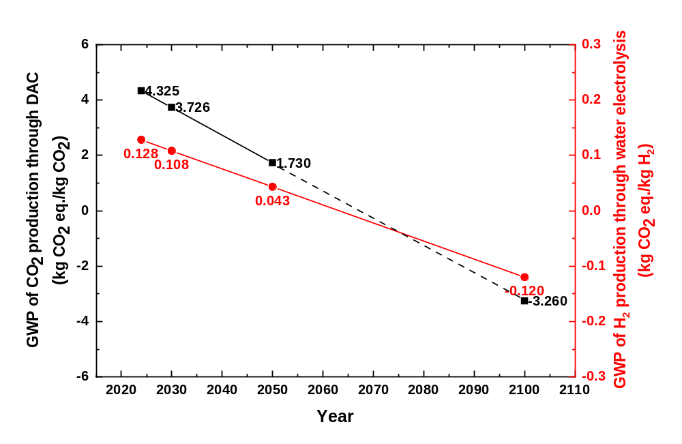
Fig. S3 GWP predictions for production of CO₂ and H₂ in the near-term and long-term according to literature report (Kolahchian Tabrizi et al., 2023; Qiu et al., 2022). The dashed line indicates predictions made solely based on trends, lacking support from data.

IRNEA shipping energy scenarios
International Renewable Energy Agency (IREA) analysed four energy scenarios, based on the Organisation for Economic Co-operation and Development’s (OECD’s) long-term projections presented in the Fourth IMO GHG Study 2020 (IMO, 2021).
Base energy scenario: Socio-economic and technological progress heavily rely on the utilization of fossil fuels. Projected energy demand and supply in the maritime sector align with historical patterns. High-fuel oil (HFO), very low-sulphur fuel oil (VLSFO), and marine gas oil (MGO) persist as the primary fuel sources by 2050, with limited adoption of energy efficiency measures.
Planned energy scenario: The primary reference case indicates moderate decarbonization within the maritime sector. Actions entail a 'dash-for-gas' dynamic, with HFO, VLSFO, and MGO being supplanted by liquefied natural gas (LNG) as the sector's defining fuel. Adoption of energy efficiency measures is somewhat nebulous.
Transforming energy scenario: As decarbonization ambitions escalate, LNG emerges as the primary fuel, displacing HFO, VLSFO, and MGO. Energy demand within the maritime sector has become more diversified, with renewable fuels such as advanced biofuels and powerfuels being extensively utilized. Additionally, energy efficiency measures are wholeheartedly embraced.
IRNEA 1.5 ºC scenario: In the years leading up to 2050, the maritime sector undertakes a profound journey towards decarbonization. The future of maritime transportation is defined by the widespread utilization of renewable fuels and the adoption of energy efficiency measures. With substantial improvements in energy intensity levels, the prominence of green H₂-based fuels surpasses that of fossil fuels.

WEO-2021 scenarios
The World Energy Outlook-2021 (WEO-2021) offers a comprehensive assessment of the progress countries have made in their transitions toward clean energy, as well as the distance they still need to cover (IEA, 2021).
Stated policies scenario: It presents a conservative benchmark for the future, as it doesn't assume that governments will achieve all announced goals. Instead, it offers a detailed, sector-by-sector analysis of the actual progress toward these and other energy-related objectives, considering not only existing policies and measures but also those still in development.
Announced pledges scenario: This marks the inaugural appearance of this scenario in the WEO. It encompasses all climate commitments made by governments worldwide, including Nationally Determined Contributions (NDCs) as well as longer-term net zero targets, assuming their full and timely realization. The global trends depicted in this scenario reflect the collective ambition of the world to address climate change, as of mid-2021.
Sustainable development scenario: It serves as a conduit to the objectives outlined in the Paris Agreement. It hinges on a significant increase in clean energy policies and investments, aligning the energy system with key Sustainable Development Goals (SDGs). Within this framework, all existing net-zero commitments are met completely, with substantial endeavors directed towards immediate emissions reductions. Advanced economies achieve net-zero emissions by 2050, China by approximately 2060, and all other nations by no later than 2070.
Net zero emissions by 2050 scenario: This normative scenario outlines a focused yet attainable trajectory for the global energy sector to reach net-zero CO₂ emissions by 2050, with advanced economies leading the charge. It aligns with key energy-related United Nations Sustainable Development Goals (SDGs), particularly universal energy access by 2030 and significant enhancements in air quality. Importantly, this scenario doesn't rely on emissions reductions from sectors outside of energy to meet its objectives but assumes commensurate reductions in non-energy emissions. It is in line with limiting the global temperature increase to 1.5 ºC without surpassing it (with a 50% probability).
Calculating the CO₂ emission reduction contribution of e-methanol substituting natural gas-derived methanol
The CO₂ emission reduction achieved by substituting 1 kg of e-methanol for 1 kg of methanol produced from coal can be calculated based on the estimated well-to-wake emissions of e-methanol at the studied time points. Taking into account the energy supply of methanol, the corresponding amount of methanol usage can be determined for each time point (2030 and 2050). The total CO₂ emission reduction can then be obtained accordingly.

Equation: Total CO₂ emissions reduction (C_{total})
C_{e-MeOH} | Well-to-wake emission of 1 kg e-methanol | 1.351 kg CO₂ eq. (2030)
C_{e-MeOH} | Well-to-wake emission of 1 kg e-methanol | 0.726 kg CO₂ eq. (2050)
C_{coal-MeOH} | Well-to-wake emission of 1 kg coal-derived methanol | 3.909 kg CO₂ eq.(Xing et al., 2021)
E | Energy provision from renewable carbon fuels | 1.65 EJ (2030)
E | Energy provision from renewable carbon fuels | 9.13 EJ (2050)
e_{MeOH} | Calorific value of methanol combustion | 20.712 MJ/kg

Calculating the CO₂ emission in e-methanol scenario
As described in the panned energy scenario, LNG was treated as the maritime sector's defining fuel. Considering the partial energy supply provided by e-methanol at key time points (2030 and 2050), the CO₂ emission reduction achieved by substituting LNG can be calculated.

Equation: Total CO₂ emissions reduction (C_{total})
C_{e-MeOH} | Well-to-wake emission of 1 kg e-methanol | 1.351 kg CO₂ eq. (2030)
C_{e-MeOH} | Well-to-wake emission of 1 kg e-methanol | 0.726 kg CO₂ eq. (2050)
C_{LNG} | Well-to-wake emission of 1 kg LNG | 4.7 kg CO₂ eq.(Nikita Pavlenko, 2020)
E | Energy provision from renewable carbon fuels | 1.65 EJ (2030)
E | Energy provision from renewable carbon fuels | 9.13 EJ (2050)
e_{MeOH} | Calorific value of methanol combustion | 20.712 MJ/kg
e_{LNG} | Calorific value of LNG combustion | 50 MJ/kg
Definition of Carbon Removal Efficiency
To quantify the carbon removal performance of direct air capture from life cycle perspective, the carbon removal efficiency (%) was defined as follows:

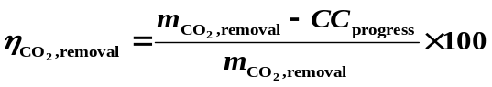

Where $η_{{CO}_{2}, removal}$ represents the carbon removal efficiency; $m_{{CO}_{2}, captured}$ is the amount of CO₂ captured in kilograms and ${CC}_{progress }$is the life cycle climate change impact due to the operation of DAC plant and the carbon transportation and storage process. A $η_{{CO}_{2}, removal}>0$ indicates that more greenhouse gas (GHG) is finally removed from the atmosphere than emitted, while $η_{{CO}_{2}, removal}<0$ indicates that more GHG is emitted than captured. An ideal DAC process achieves a $η_{{CO}_{2}, removal}$ of 100%. When DAC is coupled with biomass utilization, such as using biomethane, a burden-free CO₂ fuel, as a heat source, the $η_{{CO}_{2}, removal}$ could exceed 100% when the CO₂ released during the heat generation is captured.

Reference
Abbas, A., Qadeer, K., Al-Hinai, A., Tarar, M.H., Qyyum, M.A., Al-Muhtaseb, A.a.H., Abri, R.A., Lee, M., Dickson, R., 2022. Process development and policy implications for large scale deployment of solar-driven electrolysis-based renewable methanol production. Green Chemistry 24(19), 7630-7643. https://doi.org/10.1039/d2gc01993k.
Bargiacchi, E., Antonelli, M., Desideri, U., 2019. A comparative assessment of Power-to-Fuel production pathways. Energy 183, 1253-1265. https://doi.org/10.1016/j.energy.2019.06.149.
de Jonge, M.M.J., Daemen, J., Loriaux, J.M., Steinmann, Z.J.N., Huijbregts, M.A.J., 2019. Life cycle carbon efficiency of Direct Air Capture systems with strong hydroxide sorbents. International Journal of Greenhouse Gas Control 80, 25-31. https://doi.org/10.1016/j.ijggc.2018.11.011.
Deutz, S., Bardow, A., 2021. Life-cycle assessment of an industrial direct air capture process based on temperature–vacuum swing adsorption. Nature Energy 6(2), 203-213. https://doi.org/10.1038/s41560-020-00771-9.
Eggemann, L., Escobar, N., Peters, R., Burauel, P., Stolten, D., 2020. Life cycle assessment of a small-scale methanol production system: A Power-to-Fuel strategy for biogas plants. Journal of Cleaner Production 271, 122476. https://doi.org/10.1016/j.jclepro.2020.122476.
Eleonora Bargiacchi, N.T., Jutta Geldermann, Umberto Desideri, Marco Antonelli, 2020. Life Cycle Assessment of synthetic fuel production from renewable hydrogen: process contribution and impact assessment considering different 2030 energy mixes. The 33rd international conference on efficiency, cost, optimization, simulation and environmental impact of energy systems.
IEA, 2021. World Energy Outlook 2021.
IMO, 2021. Fourth IMO Greenhouse Gas Study 2020
Kim, J., Henao, C.A., Johnson, T.A., Dedrick, D.E., Miller, J.E., Stechel, E.B., Maravelias, C.T., 2011. Methanol production from CO2 using solar-thermal energy: process development and techno-economic analysis. Energy & Environmental Science 4(9), 3122. https://doi.org/10.1039/c1ee01311d.
Kolahchian Tabrizi, M., Famiglietti, J., Bonalumi, D., Campanari, S., 2023. The Carbon Footprint of Hydrogen Produced with State-of-the-Art Photovoltaic Electricity Using Life-Cycle Assessment Methodology. Energies 16(13), 5190. https://doi.org/10.3390/en16135190.
Liu, C.M., Sandhu, N.K., McCoy, S.T., Bergerson, J.A., 2020. A life cycle assessment of greenhouse gas emissions from direct air capture and Fischer–Tropsch fuel production. Sustainable Energy & Fuels 4(6), 3129-3142. https://doi.org/10.1039/c9se00479c.
Madhu, K., Pauliuk, S., Dhathri, S., Creutzig, F., 2021. Understanding environmental trade-offs and resource demand of direct air capture technologies through comparative life-cycle assessment. Nature Energy 6(11), 1035-1044. https://doi.org/10.1038/s41560-021-00922-6.
Nikita Pavlenko, B.C., Yuanrong Zhou, Nigel Clark, Dan Rutherford, 2020. The climate implications of using LNG as a marine fuel. International council on clean transportation 02.
Pérez-Fortes, M., Schöneberger, J.C., Boulamanti, A., Tzimas, E., 2016. Methanol synthesis using captured CO2 as raw material: Techno-economic and environmental assessment. Applied Energy 161, 718-732. https://doi.org/10.1016/j.apenergy.2015.07.067.
Qiu, Y., Lamers, P., Daioglou, V., McQueen, N., de Boer, H.S., Harmsen, M., Wilcox, J., Bardow, A., Suh, S., 2022. Environmental trade-offs of direct air capture technologies in climate change mitigation toward 2100. Nat Commun 13(1), 3635. https://doi.org/10.1038/s41467-022-31146-1.
Terlouw, T., Bauer, C., Rosa, L., Mazzotti, M., 2021. Life cycle assessment of carbon dioxide removal technologies: a critical review. Energy & Environmental Science 14(4), 1701-1721. https://doi.org/10.1039/d0ee03757e.
van der Giesen, C., Meinrenken, C.J., Kleijn, R., Sprecher, B., Lackner, K.S., Kramer, G.J., 2017. A Life Cycle Assessment Case Study of Coal-Fired Electricity Generation with Humidity Swing Direct Air Capture of CO2 versus MEA-Based Postcombustion Capture. Environ Sci Technol 51(2), 1024-1034. https://doi.org/10.1021/acs.est.6b05028.
Xing, H., Stuart, C., Spence, S., Chen, H., 2021. Alternative fuel options for low carbon maritime transportation: Pathways to 2050. Journal of Cleaner Production 297, 126651. https://doi.org/10.1016/j.jclepro.2021.126651.
Yusuf, N., Almomani, F., 2023. Highly effective hydrogenation of CO2 to methanol over Cu/ZnO/Al2O3 catalyst: A process economy & environmental aspects. Fuel 332, 126027. https://doi.org/10.1016/j.fuel.2022.126027.

