Support Information
Building a knowledge-based machine learning loop framework to optimize biochar for anaerobic digestion performance
Yi Zhang^{b,#}, Yu Fu^{a,#}, Zhonghao Renª, Yeqing Li^{a,d*},Yijing Fengª，Zheng Hao Leong^{b}，Junting Pan^{c*}
ª State Key Laboratory of Heavy Oil Processing, Beijing Key Laboratory of Biogas Upgrading Utilization, College of New Energy and Materials, China University of Petroleum Beijing (CUPB), Beijing, P.R. China, 102249.
^{b} State Key Joint Laboratory of Environment Simulation and Pollution Control (SKLESPC), School of Environment, Tsinghua University, Beijing 100084, China.
^{c} Institute of Agricultural Resources and Regional Planning, Chinese Academy of Agricultural Sciences, Beijing, 100081, P.R. China.
^{d} Shandong Institute of Petroleum and Chemical Technology, Carbon Neutrality Research Institute, Dongying 257061, China.

*Corresponding authors:
E-mail address:liyeqingcup@126.com (Y.Li); panjunting@caas.cn (J. Pan).
# Yi Zhang and Yu Fu contributed equally to this work and should be considered co-first authors.
The supporting information (a total of 16 pages) contains:
Texts S1-S4
Tables S1-S3
Figures S1-S7
Text S1 Detailed description of GBR
The Gradient Boosting Regression (GBR) algorithm is a machine learning technique designed for regression tasks and belongs to the ensemble learning category under the Gradient Boosting framework. GBR builds a strong predictive model by sequentially combining multiple weak predictive models, typically decision trees. During the training process, each weak model is added in a stepwise manner, with each model focusing on correcting the residual errors from the previous one, thus gradually reducing the overall prediction error. A new decision tree model is then fitted to these residuals, with the aim of bringing the combined prediction of the current and new models closer to the true target values. The current model is subsequently updated by adding the predictions from the new model, resulting in a more powerful predictive model. This process is iterated multiple times, with gradient descent being used to optimize the loss function incrementally, leading to improved predictive accuracy. Despite being an ensemble model, GBR retains a certain level of interpretability in its decision paths, making it a valuable approach for addressing the black-box nature of many machine learning models.
Text S2 Introduction to the SHAP algorithm
SHAP (SHapley Additive exPlanations) is a method used to explain feature importance in machine learning model predictions. It highlights the specific influence of each feature on the prediction outcome, including the direction of the effect—whether positive or negative. The core concept is based on the Shapley Value theory from cooperative game theory, which aims to fairly distribute the gains among participants in a cooperative game. In SHAP, this theory is applied to evaluate feature importance in machine learning models. SHAP values assign a contribution score to each feature for every instance, reflecting how much that feature contributed to the prediction result for that particular case. One of the key advantages of the SHAP method is its interpretability and fairness, offering both global and local explanations for each feature. This allows researchers to better understand the decision-making process of complex models. Moreover, SHAP has been widely applied to tree-based models, where it aids in feature selection, model performance optimization, and provides deeper insights into model predictions.
Text S3 Detailed experimental details and device description of AD
Prior to conducting the experiment, anaerobic sludge must undergo an acclimatization process. Two grams of glucose are added to a 5000 mL screw-cap blue bottle containing 4000 mL of anaerobic sludge. Nitrogen gas is introduced to create an anaerobic environment, and after sealing the bottle, it is placed in a 37°C constant temperature incubator for acclimatization until biogas production ceases.
Text S4 Experimental Testing Methods
TS and VS
Total solids (TS) represent the total amount of solid material remaining in a sample after moisture has been removed. The measurement procedure generally involves the following steps:
Ensure the crucibles are thoroughly cleaned, then place them in a preheated oven at 105°C for 2 hours. Afterward, transfer the crucibles to a muffle furnace, where they are heated at 600°C for 1 hour. Allow the crucibles to cool naturally to 100°C. Using heat-resistant gloves, remove the crucibles and let them cool to room temperature before weighing them. Record the weight as a grams.
Take an appropriate amount of acclimated anaerobic sludge (50 to 100 mL), place it in the crucible, and weigh it. Record the weight as b grams. Then, place the crucible containing the sludge in an oven at 105°C and dry it for 12 hours. After drying, weigh the crucible again and record the weight as c grams.
Next, place the crucible in a muffle furnace at 600°C for 4 hours. Once cooled, weigh it again and record the weight as d grams.
To ensure the accuracy of the results, the above steps are repeated in three parallel experiments to reduce measurement errors. The calculation methods for total solids (TS) and volatile solids (VS) in the sample are as follows:
TS=(c-a)/(b-a)×100% （1）
Ash=(d-a)/(b-a)×100% （2）
VS=TS-Ash （3）
Volatile Fatty Acids (VFAs)
Volatile fatty acids (VFAs) are key indicators in the anaerobic digestion process, and their concentrations can be measured using gas chromatography (GC). Before the measurement, samples must undergo the following pretreatment steps: First, the biogas slurry sample is centrifuged using a low-temperature high-speed centrifuge (set at 10,000 r/min and 10°C) for 10 minutes. After centrifugation, the sample is diluted with ethanol according to the actual VFA concentration, typically at a dilution ratio of 5 to 10 times. The sample is then filtered through a 0.45-micron organic filter to remove any solid particles or other impurities that might interfere with chromatographic analysis. The filtered sample is now ready for GC analysis.
Elemental Content
The elemental content of biochar is quantified using a fully automated elemental analyzer. The ash content is calculated by subtracting the sum of the C, H, O, and N contents from 100%.
Ammonia Nitrogen (NH₄⁺-N)
To measure the ammonia nitrogen content, approximately 2 mL of the sample is placed in a centrifuge tube and centrifuged at 10,000 rpm for 10 minutes at 10°C. The supernatant is then diluted with distilled water to a ratio of approximately 1:1000. Finally, Nessler's reagent is added, and the ammonia nitrogen content is determined using a UV spectrophotometer at a specific wavelength.
Biogas Production and Component Analysis
Anaerobic digestion experiments are conducted in screw-cap blue bottles, with biogas generated during the experiment being collected in gas collection bags. The gas phase components of the biogas are analyzed using intermittent gas sampling with a syringe, with a sample volume of 0.5 mL, taken at 24-hour intervals. The samples are injected into a gas chromatograph for analysis. Biogas production is measured using a wet gas meter, and the measured volume is included in the cumulative biogas production calculation.
Biochar pH and Conductivity Testing
A 0.05 g biochar sample is dissolved in 5 mL of deionized water to form a 10 g/L biochar suspension. After stirring and letting it settle for 3 minutes, the pH of the supernatant is measured using a pH meter. The same 10 g/L biochar suspension is shaken and allowed to settle for 3 minutes, after which the conductivity of the supernatant is measured using a conductivity meter.
Biochar Specific Surface Area and Pore Structure Parameters
The specific surface area and pore structure parameters of different biochar materials are measured using an automatic gas adsorption analyzer.
Biochar Functional Group Analysis
Fourier Transform Infrared Spectroscopy (FT-IR) is used for the qualitative analysis of biochar functional groups, with a scanning wavelength range of 400 to 4000 cm⁻¹.

Text S5: Statistical Analysis of Data
In this study, we conducted a detailed statistical analysis of the input features from both experimental and literature data. The literature data presents a broader range of features, including wider variations in PT, HT, and EC, reflecting the diversity of experimental conditions. Particularly, variables such as H, O, and N exhibit higher variability in the literature data, which may pose greater challenges for the model when handling features with significant fluctuations. However, this also allows the machine learning (ML) model to achieve more comprehensive learning. Due to the diverse sources and complex materials of the literature data, we added experimental data for continuous training. The experimental data, which covers more consistent testing conditions, has narrower feature ranges, thus helping to reduce data fluctuations, especially for key variables such as HR, SSA, and BCA. This concentrated dataset provides a more stable foundation for training the machine learning model.
In the experimental data, the physicochemical properties of biochar, such as SSA, EC, and pH, exhibit high stability. For instance, the mean specific surface area is 117.39 m²/g with a standard deviation of 166.91 m²/g, showing considerable variation in biochar across the experimental groups. In contrast, the mean specific surface area in the literature data is higher at 133.56 m²/g, with a standard deviation of 131.99 m²/g, indicating significant differences in the physicochemical properties of biochar in the literature.Regarding methane production performance, the mean CMP in the experimental data is 318 ± 16.63 mL/g VS, a 39.6% increase compared to the control group. In the literature data, despite variations in biochar methane production under different experimental conditions, the Rmax is 66.51 mL/g·day, with a standard deviation of 104.61 mL/g·day. In comparison, the maximum methane production rate in the experimental data is more stable, indicating more consistent experimental conditions.
Through the comparison of these variables’ ranges, means, and standard deviations, the study shows that the smaller fluctuations in the experimental data contribute to the stability of the model, while the broader range of the literature data provides greater generalization capability. This enhances the model's prediction accuracy, especially when optimizing biochar preparation and AD processes, allowing the model to better capture the impact of diverse experimental conditions on the results.
Table S1 Biochar preparation conditions.
serial number | Preparation temperature (℃) | heating rate (℃/min) | Keeping time (h)
A1(400-5-1) | 400 | 5 | 1
A2(400-5-2) | 400 | 5 | 2
A3(400-5-4) | 400 | 5 | 4
A4(400-10-1) | 400 | 10 | 1
A5(400-10-2) | 400 | 10 | 2
A6(400-10-4) | 400 | 10 | 4
B1(550-5-1) | 550 | 5 | 1
B2(550-5-2) | 550 | 5 | 2
B3(550-5-4) | 550 | 5 | 4
B4(550-10-1) | 550 | 10 | 1
B5(550-10-2) | 550 | 10 | 2
B6(550-10-4) | 550 | 10 | 4
C1(700-5-1) | 700 | 5 | 1
C2(700-5-2) | 700 | 5 | 2
C3(700-5-4) | 700 | 5 | 4
C4(700-10-1) | 700 | 10 | 1
C5(700-10-2) | 700 | 10 | 2
C6(700-10-4) | 700 | 10 | 4
T650 | 650 | 15 | 3

Table S3 Specific surface area and pore structure parameters of T650 and C6 biochar.
Sample | Specific surface area (m²/g) | Pore capacity (cm³/g) | Average pore size (nm)
T650 | 450.21 | 0.2083 | 1.85
C6 | 435.271 | 0.1982 | 1.82

Table S4 Statistical analysis table of experiment data.
Feature | Class | count | mean | std | min | max
HR | Input | 53.00 | 7.55 | 2.523475e+00 | 5.00 | 10.00
PT | Input | 53.00 | 552.83 | 1.230287e+02 | 400.00 | 700.00
HT | Input | 53.00 | 2.36 | 1.257200e+00 | 1.00 | 4.00
SSA | Input | 53.00 | 117.39 | 1.669132e+02 | 3.26 | 435.27
PS | Input | 53.00 | 0.35 | 1.681271e-16 | 0.35 | 0.35
C | Input | 53.00 | 70.65 | 2.985167e+00 | 64.31 | 74.36
H | Input | 53.00 | 2.18 | 1.183609e+00 | 0.81 | 4.97
O | Input | 53.00 | 9.81 | 1.865562e+00 | 7.21 | 14.91
N | Input | 53.00 | 0.71 | 1.609133e-01 | 0.50 | 0.99
ASH | Input | 53.00 | 16.65 | 3.047831e+00 | 11.74 | 23.93
pHBC | Input | 53.00 | 10.42 | 1.971788e-01 | 10.10 | 10.83
EC | Input | 53.00 | 112.28 | 2.811717e+01 | 78.00 | 162.67
BCA | Input | 53.00 | 10.00 | 0.000000e+00 | 10.00 | 10.00
SM | Input | 53.00 | 1.00 | 0.000000e+00 | 1.00 | 1.00
T | Input | 53.00 | 37.00 | 0.000000e+00 | 37.00 | 37.00
TS | Input | 53.00 | 100.00 | 0.000000e+00 | 100.00 | 100.00
VS | Input | 53.00 | 100.00 | 0.000000e+00 | 100.00 | 100.00
pHAD | Input | 53.00 | 7.90 | 1.404830e-01 | 7.65 | 8.21
DT | Input | 53.00 | 10.00 | 0.000000e+00 | 10.00 | 10.00
MY | Output | 53.00 | 288.56 | 2.787498e+01 | 216.21 | 335.34
Rmax | Output | 53.00 | 57.61 | 6.810279e+00 | 40.04 | 73.61

Table S5 Statistical analysis table of literature data.
Feature | Class | count | mean | std | min | max
HR | Input | 228.00 | 10.70 | 5.08 | 4.00 | 20.00
PT | Input | 228.00 | 541.69 | 128.25 | 180.00 | 900.00
HT | Input | 228.00 | 1.62 | 0.94 | 0.02 | 4.00
SSA | Input | 228.00 | 133.56 | 131.99 | 0.59 | 774.48
PS | Input | 228.00 | 2.70 | 10.04 | 0.01 | 62.50
C | Input | 228.00 | 57.30 | 19.84 | 11.70 | 89.10
H | Input | 228.00 | 2.72 | 1.67 | 0.24 | 12.80
O | Input | 228.00 | 22.69 | 10.75 | 1.27 | 58.49
N | Input | 228.00 | 0.99 | 0.77 | 0.00 | 4.50
ASH | Input | 228.00 | 21.76 | 18.88 | 0.15 | 85.05
pHBC | Input | 228.00 | 8.38 | 1.75 | 1.59 | 12.10
EC | Input | 228.00 | 18.75 | 48.33 | 0.00 | 509.82
BCA | Input | 228.00 | 11.68 | 9.42 | 0.04 | 50.00
SM | Input | 228.00 | 15.13 | 17.99 | 0.00 | 81.08
T | Input | 228.00 | 36.62 | 5.77 | 20.00 | 55.00
TS | Input | 228.00 | 25.70 | 27.92 | 0.16 | 100.00
VS | Input | 228.00 | 79.43 | 18.06 | 20.67 | 100.00
pHAD | Input | 228.00 | 7.29 | 0.67 | 6.00 | 9.80
DT | Input | 228.00 | 31.75 | 22.67 | 2.00 | 100.00
MY | Output | 228.00 | 278.93 | 176.07 | 26.06 | 924.24
Rmax | Output | 228.00 | 66.51 | 104.61 | 1.34 | 517.26

Fig. S1 Box plot of normal distribution of data characterizing biochar preparation: (a) HR, (b) PT, (c) HT

Fig. S2 Comparison of ammonia nitrogen concentration before and after reaction of biochar-added anaerobic digestion system.

Fig. S3 Elemental Composition of Different Biochar Samples.

Fig. S4 Chemical properties of biochar. pH (a) (b), conductivity (c) (d).

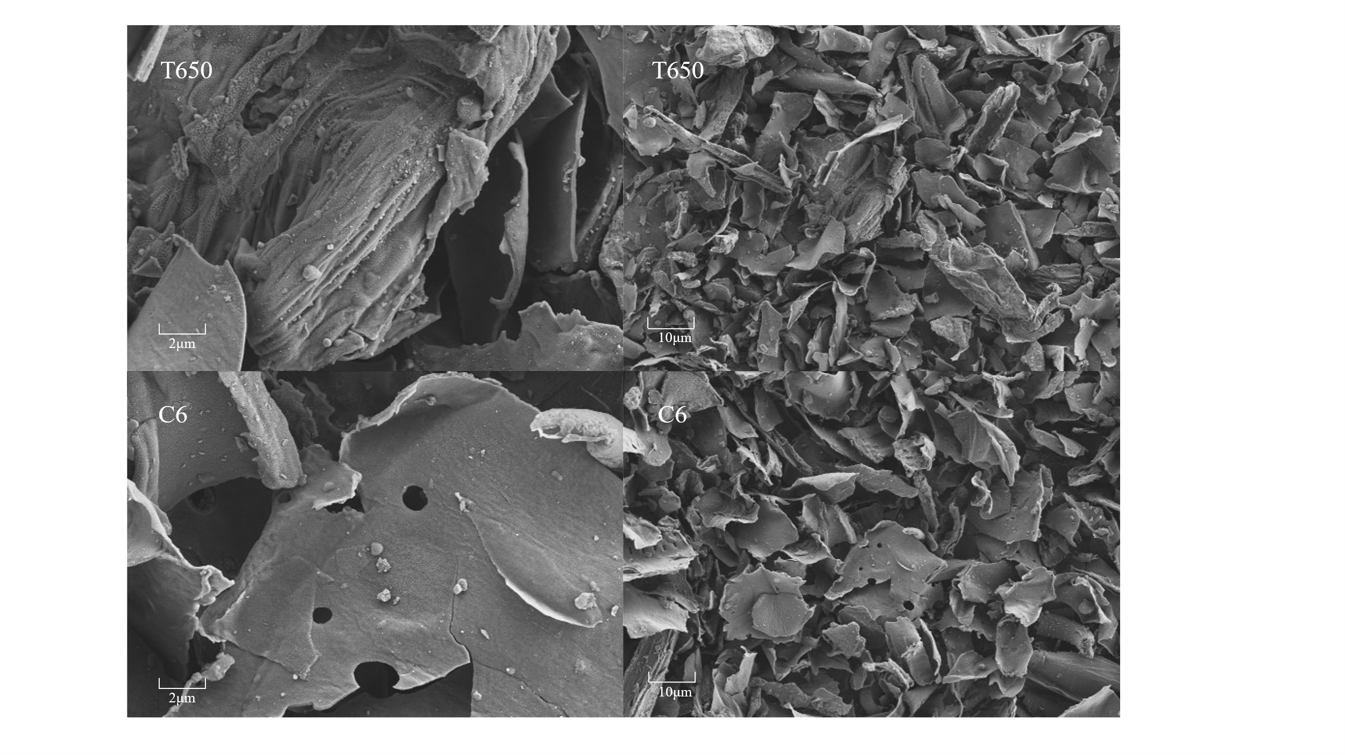
Fig. S5 Surface morphology of T650 and C6 biochars.

Fig. S6 (a) pH and (b) conductivity of T650 and C6 biochars.

Fig. S7 FTIR of biochar.

