Supplementary Information for
Single-step thermal treatment of SWCNTs for enhanced CO₂ adsorption capacity
Amit Kumar Pal ª, Dmitry V. Krasnikov ª *, Liubov A. Varlamova ^{b}, Konstantin K. Zamansky ª, Kseniya A. Litvintseva ª, Sergei V. Porokhin ª, Nikita E. Gordeev ª, Anastasia E. Goldt ª, Eugene E. Nazarov ª, Stanislav S. Fedotov ª, Pavel B. Sorokin ^{b}, and Albert G. Nasibulin ª *
ª Skolkovo Institute of Science and Technology, Moscow, Russia.
^{b} National University of Science and Technology MISIS, Moscow, Russia.
*E-mail: a.nasibulin@skol.tech, d.krasnikov@skol.tech

Figure S1 Schematic flow chart of SWCNT sample preparation. Pristine SWCNTs were first thermally treated and labelled as ‘heat-treated SWCNT’ at 400 °C for 4 h in air to obtain heat-treated SWCNTs, followed by reflux in HCl/H₂O (3:2 v/v) at 100 °C for 12 h to obtain purified SWCNTs.

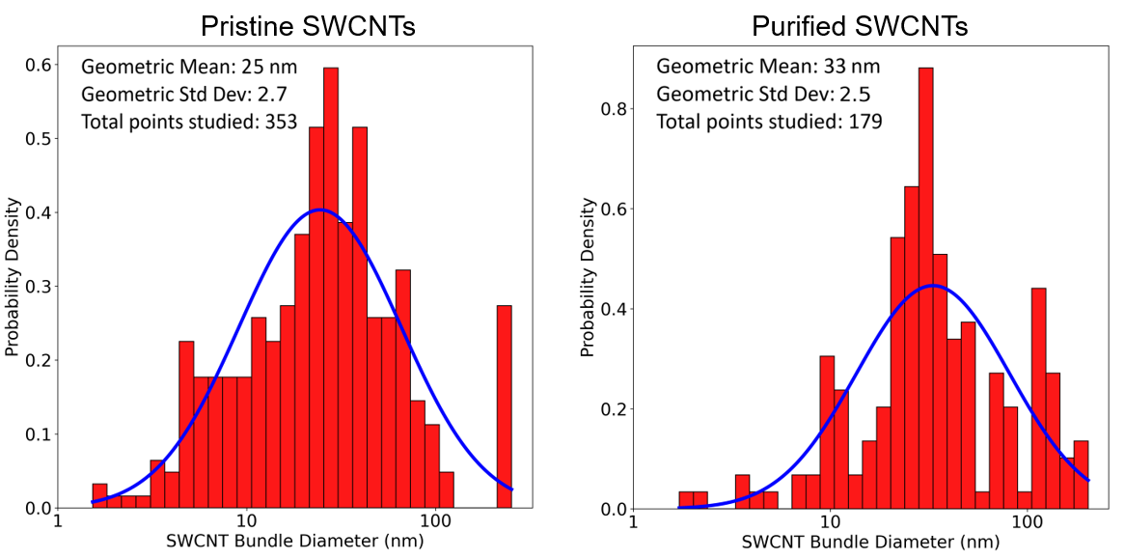
Figure S2 Log-scale distribution of bundle diameters of pristine and purified SWCNTs

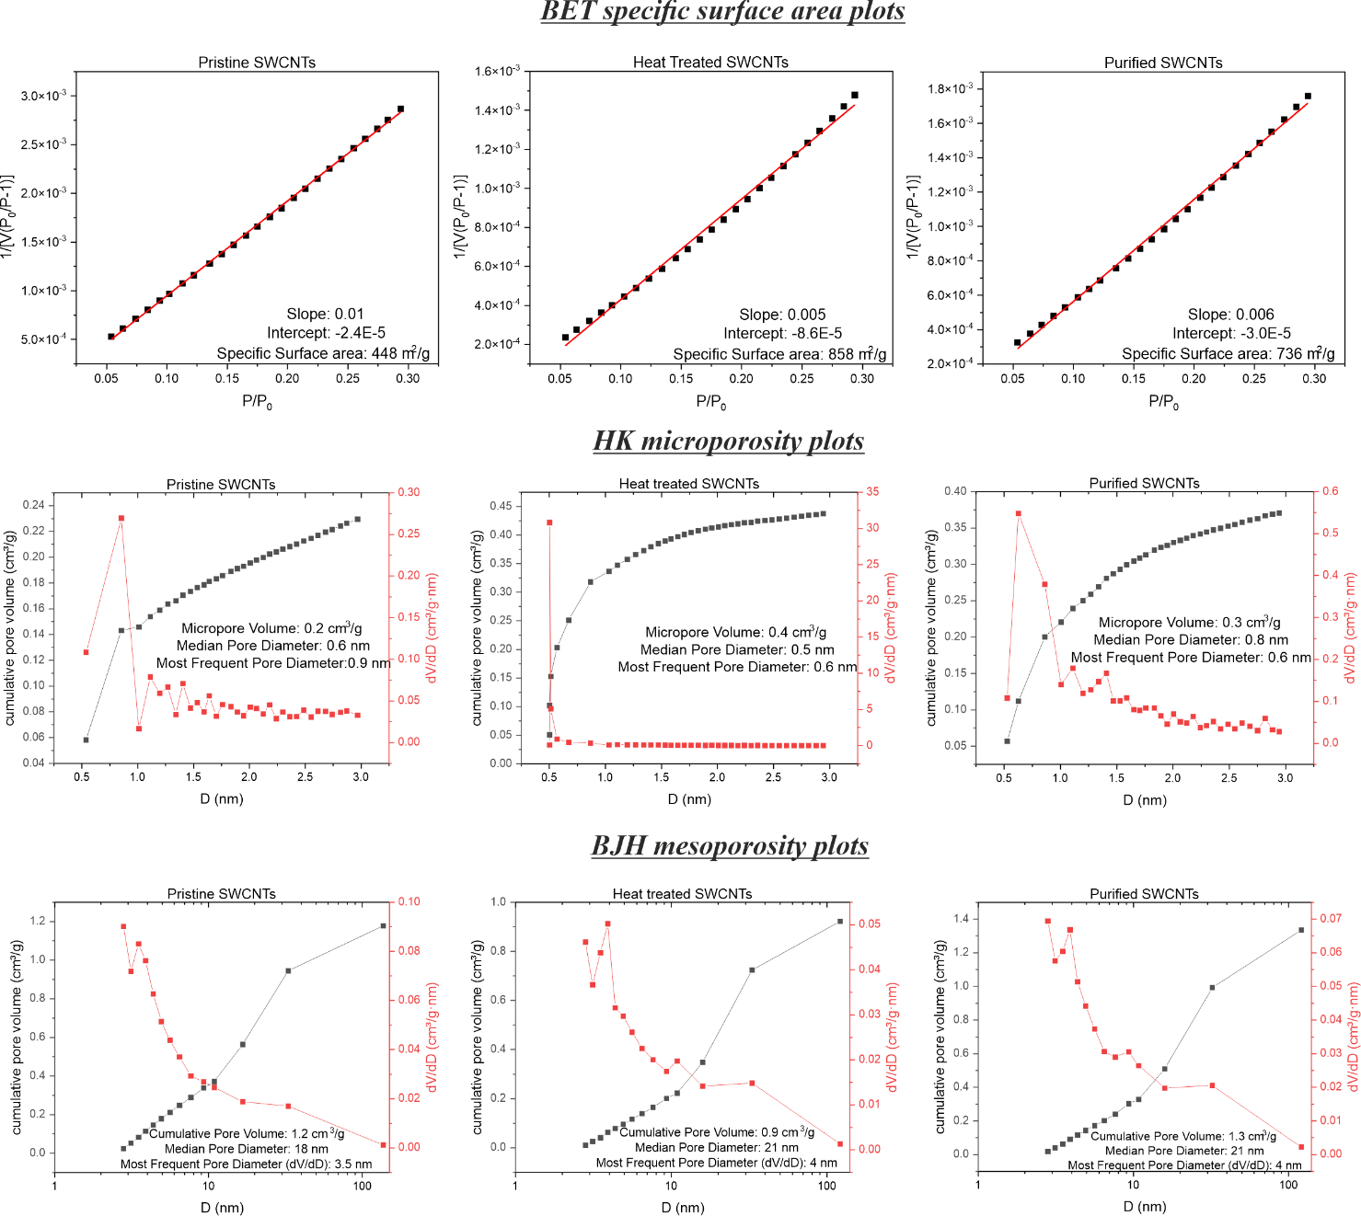
Figure S3 Surface area and pore structure analysis of pristine, heat-treated, and purified SWCNTs using BET, HK, and BJH methods. The top row shows linearized BET plots used to calculate the specific surface area (SSA) based on nitrogen adsorption in the relative pressure range P/P₀ = 0.05–0.30. The x-axis represents the relative pressure (P/P₀), which indicates the degree of surface saturation during adsorption, while the y-axis corresponds to the BET function [1/V((P/P₀) − 1)], where V is the volume of gas adsorbed, P is the equilibrium pressure, and P₀ is the saturation pressure. black points represent the experimental data, and red lines indicate the linear fit used to derive SSA. The calculated SSA values were 448 m²/g for pristine, 858 m²/g for heat-treated, and 736 m²/g for purified SWCNTs, confirming significant enhancement in surface area after thermal treatment. The middle row presents Horvath–Kawazoe (HK) plots for micropore size distribution, with pore diameter (D, in nm) on the x-axis. The left y-axis (black line) shows cumulative pore volume (cm³/g), and the right y-axis (red line) shows differential pore volume (dV/dD, cm³/g·nm). Heat treatment increased the micropore volume from 0.2 to 0.4 cm³/g and slightly reduced the median pore diameter from 0.6 to 0.5 nm. The bottom row shows Barrett–Joyner–Halenda (BJH) plots based on the nitrogen desorption branch, where the x-axis is pore diameter (nm, log scale), the left y-axis (black line) represents cumulative pore volume (cm³/g), and the right y-axis (red line) shows dV/dD (cm³/g·nm). The purified sample exhibits the highest mesopore volume (1.3 cm³/g), followed by pristine (1.2 cm³/g) and heat-treated (0.9 cm³/g) SWCNTs. These results indicate that heat treatment is most effective in enhancing microporosity and total SSA, while purification primarily improves mesoporosity but introduces bundling, which may reduce inner channel accessibility.
Figure S4 BET plot of the water treated SWCNTs.

Table S1 Textural properties and CO₂ adsorption capacities of various carbon materials at SATP (25 °C, 1 bar). The table lists specific surface area (SSA), total pore volume (V total), micropore volume (V micro), CO₂ uptake capacity, mean pore size, material type, and references. * NAN = Not available, and our CO₂ adsorption at 30°C, 1 bar
Material | SSA, m²/g | V _{total,} cm³/g | V _{micro,} cm³/g | CO₂ capacity, mmol/g (SATP) | Mean Pore size (nm) | Comments | Ref.
Porous carbon nanosheets | 610 | 0.31 | 0.26 | 2.88 | NAN | PCN-71 | (Hao et al. 2013)
Non-porous carbon | 37 | 0.04 | 0.03 | 0.39 | NAN | NC | (Mehra and Paul 2022)
Reduced graphene | 732 | 3.56 | 0.32 | 1.56 | 3.9 | RG | (Mehra and Paul 2022)
Immense microporous carbon | 3030 | 1.49 | 1.25 | 2.89 | 0.57 | IMC | (Mehra and Paul 2022)
Biordered ultramicroporous graphitic carbon | 2472 | 1.07 | 1.15 | 4.29 | 0.57 | BUGG | (Mehra and Paul 2022)
Microporous mesoporous carbon | 3090 | 2.30 | 0.97 | 2.82 | 1.32 | MMC | (Mehra and Paul 2022)
Carbon aerogels | 679 | 0.37 | 0.32 | 5.72 | 2.18 | MMT-CA-1 | (Alhwaige et al. 2016)
Mesoporous carbon | 605 | 0.83 | 0.13 | 1.38 | 1.48 | STC-P-500 | (De Souza et al. 2013)
Activated mesoporous carbon | 1743 | 0.84 | 0.64 | 4.37 | 1.26 | STC-P-500-A | (De Souza et al. 2013)
Carbon spheres | 661 | 0.30 | 0.21 | 2.51 | 0.5 | CS-6 | (Wickramaratne and Jaroniec 2013)
Activated carbon spheres | 2284 | 0.89 | 0.43 | 4.55 | 1.2 | CS-6-CD-4 | (Wickramaratne and Jaroniec 2013)
Hollow carbon nanospheres | 777 | 0.63 | 0.24 | 1.81 | NAN | HCN | (Chen et al. 2016)
Pristine SWCNT | 448 | 1.2 | 0.2 | 2.7 | 0.6 |  | This work
Heat Treated SWCNTs | 858 | 0.9 | 0.4 | 5.0 | 0.5 |  | This work
Purified SWCNTs | 736 | 1.3 | 0.3 | 4.5 | 0.6 |  | This work

References:
Alhwaige AA, Ishida H, Qutubuddin S. Carbon Aerogels with Excellent CO2 Adsorption Capacity Synthesized from Clay-Reinforced Biobased Chitosan-Polybenzoxazine Nanocomposites. ACS Sustain Chem Eng. American Chemical Society; 2016 Mar 7;4(3):1286–95.
Chen A, Li S, Yu Y, Liu L, Li Y, Wang Y, et al. Self-catalyzed strategy to form hollow carbon nanospheres for CO2 capture. Mater Lett. Elsevier B.V.; 2016 Dec 15;185:63–6.
Hao GP, Jin ZY, Sun Q, Zhang XQ, Zhang JT, Lu AH. Porous carbon nanosheets with precisely tunable thickness and selective CO2 adsorption properties. Energy Environ Sci. 2013 Dec;6(12):3740–7.
Mehra P, Paul A. Decoding Carbon-Based Materials’ Properties for High CO2Capture and Selectivity. ACS Omega. American Chemical Society; 2022 Sep 27;7(38):34538–46.
De Souza LKC, Wickramaratne NP, Ello AS, Costa MJF, Da Costa CEF, Jaroniec M. Enhancement of CO2 adsorption on phenolic resin-based mesoporous carbons by KOH activation. Carbon N Y. 2013 Dec;65:334–40.
Wickramaratne NP, Jaroniec M. Activated carbon spheres for CO2 adsorption. ACS Appl Mater Interfaces. 2013 Mar 13;5(5):1849–55.

