Supporting information

Towards High-Voltage Supercapacitors with Suppressed Self-Discharge via a Weakly Solvating Electrolyte
Shichao Zhang,^{†a} Shenglin Liu,^{†b} Suyang Si,ª Keqi Zeng,ª Chenxin Cai,ª Yawen Tang,ª Feng Gong,^{*b} Hualin Ye^{*a}
ª Jiangsu Key Laboratory of New Power Batteries, Jiangsu Collaborative Innovation Center of Biomedical Functional Materials, School of Chemistry and Materials Science, Nanjing Normal University, Nanjing 210023, China.
^{b} Key Laboratory of Energy Thermal Conversion and Control of Ministry of Education, School of Energy and Environment, Southeast University, Nanjing, 211189, Jiangsu, China.
† These authors contributed equally to this work.

- Supporting Experimental Section

Material characterizations
The surface morphology of the carbon materials was examined using a scanning electron microscope (SEM, ZEISS Gemini 300). The porous structure and specific surface area were analyzed by nitrogen adsorption-desorption isotherms at 77 K using a surface area and porosimetry analyzer (Micromeritics, ASAP2460). The specific surface area was calculated using the Brunauer-Emmett-Teller (BET) method, and the pore size distribution was determined using the non-local density functional theory (NLDFT) model. The crystallographic structure was characterized by X-ray diffraction (XRD, Rigaku D/max 2500/PC) with Cu Kα radiation. The degree of disorder and graphitization was assessed using a Raman spectrometer (XploRA PLUS) with a 532 nm laser source. The surface elemental composition and chemical states were analyzed by X-ray photoelectron spectroscopy (XPS, Thermo Scientific K-Alpha). The wettability of the electrode materials was evaluated by measuring the contact angle of an electrolyte droplet on a pressed pellet of the carbon powder (Dataphysics OCA 20).

Kinetic Analysis of Self-Discharge Behavior
To quantitatively investigate the self-discharge mechanism of supercapacitor, open-circuit voltage (OCV) decay curves were analyzed by kinetic fitting. Based on the classical model developed by B.E. Conway et al., Faradaic-driven self-discharge can be divided into two representative processes: Activation-Controlled Faradaic Reaction (ACFR) and Diffusion-Controlled Faradaic Reaction (DCFR).
Activation-Controlled Faradaic Reaction (ACFR): Arises from slow, continuous parasitic reactions at the electrode–electrolyte interface (e.g., solvent oxidation). The reaction rate is determined by an activation energy barrier, and the corresponding OCV decay exhibits a linear dependence on the logarithm of time, ln(t).
Diffusion-Controlled Faradaic Reaction (DCFR): Governed by the diffusion of mobile redox-active species (e.g., dissolved shuttle molecules) from the bulk electrolyte to the electrode surface. In this case, the OCV decay is linearly proportional to the square root of time, $\sqrt{t}$.
By considering ACFR and DCFR along with Ohmic leakage through internal resistance, the overall OCV decay over time (U_{t}) can be fitted using the following comprehensive equation:
U_{t} =U₀ exp(-$\frac{t}{RC}$) - m$\sqrt{t}$ - a - bln(t+$\frac{CK}{i_{0}}$)
where the parameters are defined as follows: U_{t} is the cell voltage during the self-discharge process. U₀ is the initial voltage of the cell. t is the time. R is the equivalent internal resistance of the cell; the first term, U₀ exp(-$\frac{t}{RC}$), describes the voltage decay due to Ohmic leakage. C is the capacitance of the cell. m is a coefficient related to ion diffusion; the second term, - m$\sqrt{t}$ , describes the voltage decay caused by the DCFR process. b is a constant associated with the activation-controlled reaction; the third term, - a - bln(t+$\frac{CK}{i_{0}}$), describes the voltage decay caused by the ACFR process. a is a constant associated with ACFR. i₀ is the exchange current. K is an integration constant.
By applying a non-linear fit of this equation to the experimentally measured OCV decay curves, the contribution of each process to the total self-discharge can be deconvoluted. The magnitudes of the fitted coefficients m and b allow for a quantitative evaluation of the severity of the DCFR and ACFR processes, respectively, thereby providing deep insight into the dominant self-discharge factors within different electrolyte systems.

- Supporting Tables
Table S1. Comparison of surface area and pore structure parameters between HPC and commercial
YP-50F.
Material | Specific Surface Area (S_{BET,} m² g⁻¹) | Total Pore Volume (V_{t,} cm² g⁻¹) | Micropore Volume (V_{micro,} cm³ g⁻¹) |  | Mesopore Volume (V_{micro,} cm³ g⁻¹) | Main pore size (nm)
YP-50F | 1580 | 0.75 | 0.61 | 0.58 |  | 0.59
HPC_{insu} | 1991 | 0.76 | 1.79 | 0.68 |  | 0.62
HPC | 2844 | 1.32 | 1.79 | 0.83 |  | 0.8
HPC_{exce} | 1784 | 1.75 | 1.75 | 0.81 |  | 1-8

- Supporting Figures
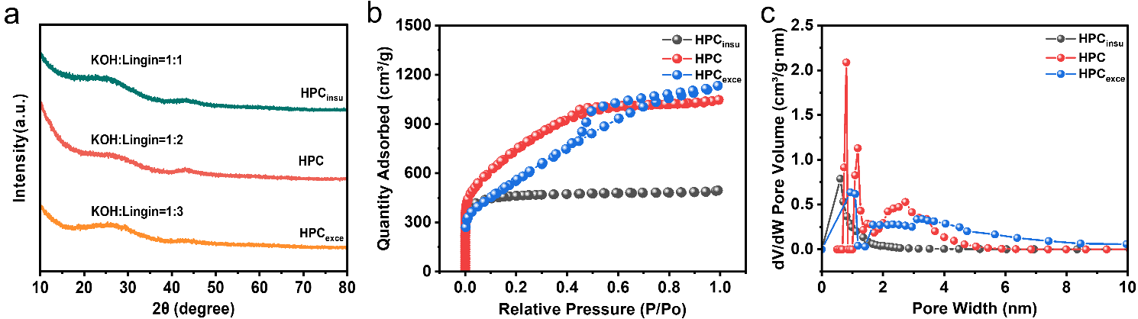
Figure S1. Physicochemical characterizations of HPC prepared with different KOH-to-lignin mass ratios. (a) X-ray diffraction patterns; (b) Nitrogen adsorption–desorption isotherms, and (c) corresponding pore size distributions.

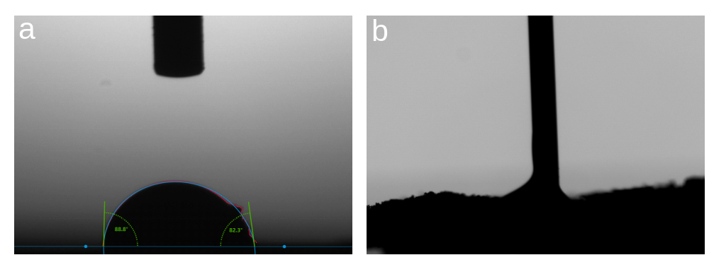
Figure S2. Contact angle measurements of an electrolyte droplet on the surface of pressed pellets of (a) YP-50F and (b) HPC electrodes. The significantly smaller contact angle for HPC electrodes reflects its superior electrolyte wettability, contributing from the abundant surface oxygen functional groups.

Figure S3. SEM images of commercial YP-50F at different magnifications.

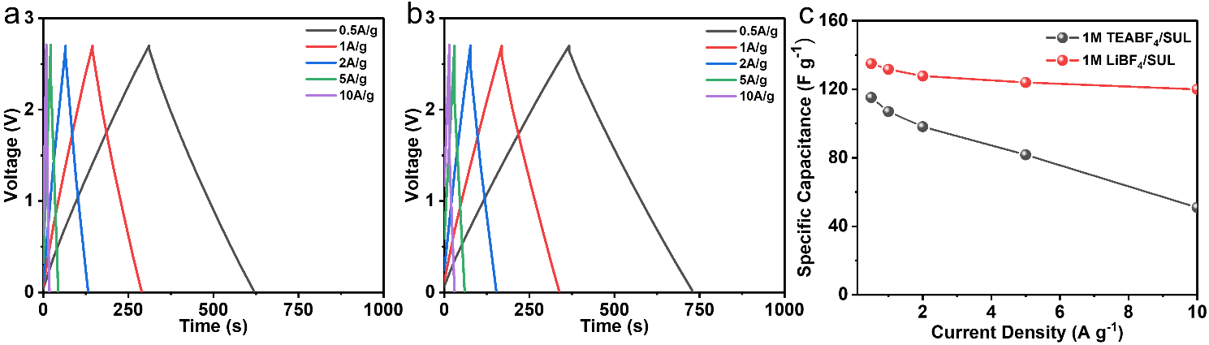
Figure S4. GCD curves of HPC electrodes at various current densities in (a) 1 M TEABF₄/SUL and (b) 1 M LiBF₄/SUL electrolytes. (c) Comparison of the specific capacitances of the two electrolyte systems as a function of current density.
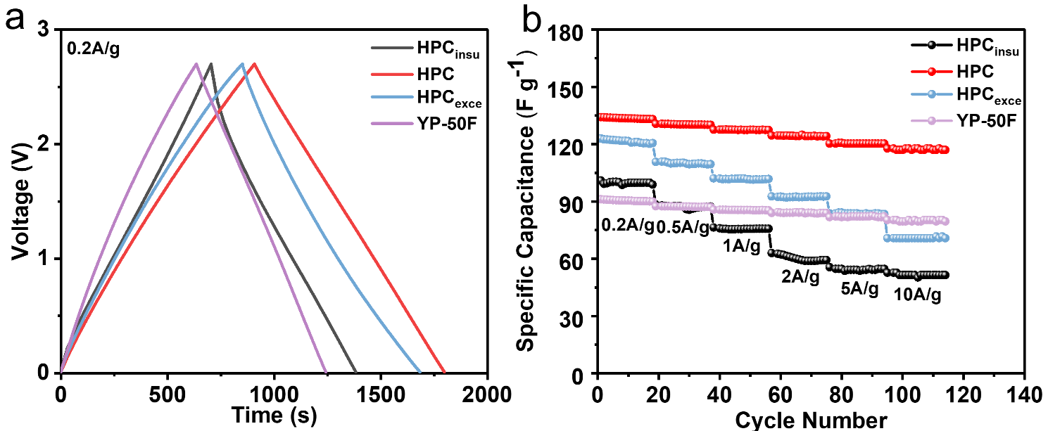
Figure S5. Electrochemical performance of HPC and YP-50F electrodes in 1 M LiBF₄/SUL. (a) GCD curves and (b) rate performance of different HPC electrodes and YP-50F electrodes in the 1 M LiBF₄/SUL electrolyte within the voltage window of 0–2.7 V.

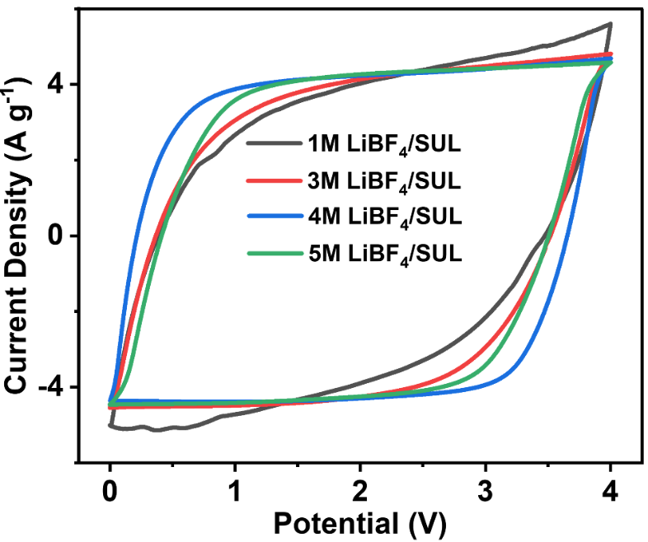
Figure S6. CV curves of HPC electrodes in LiBF₄/SUL electrolytes with varying LiBF₄ concentrations.

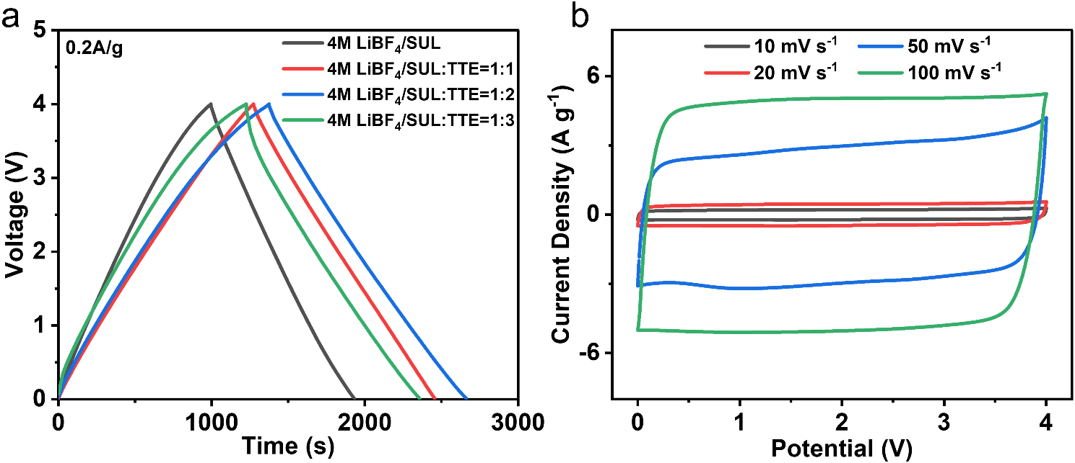
Figure S7. (a) GCD curves of HPC electrodes in 4 M LiBF₄/SUL electrolytes with different volume ratios of TTE added. (b) CV profiles of HPC electrodes at different scan rates in 4 M LiBF₄/SUL:TTE=1:2 electrolyte.

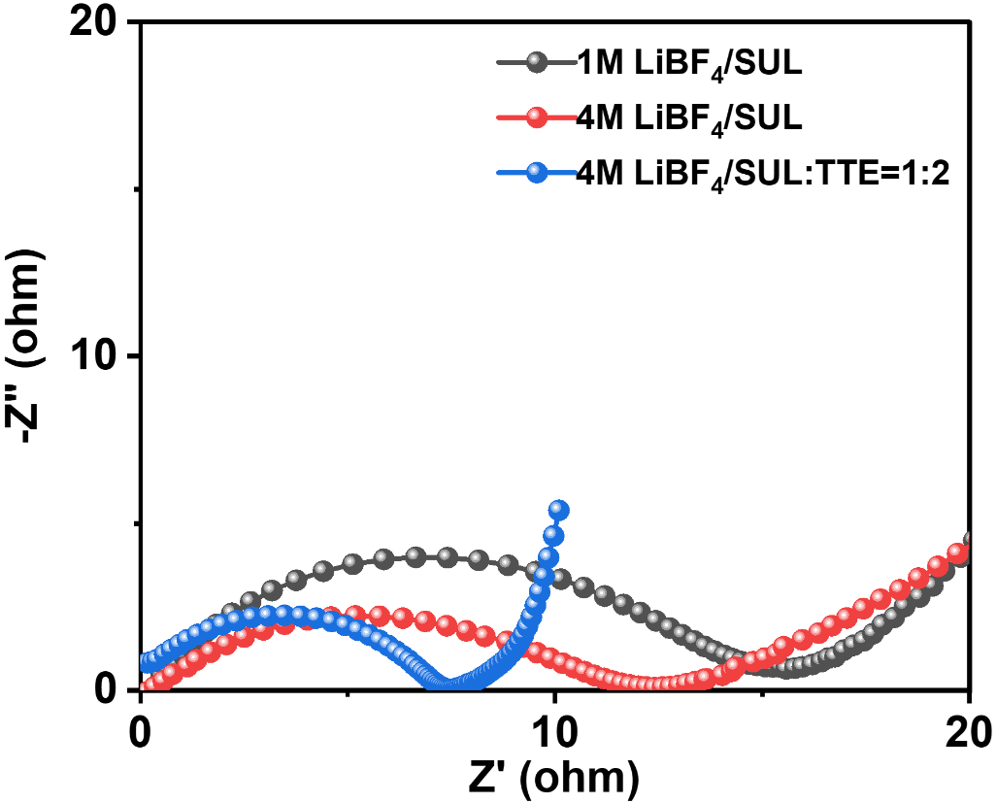
Figure S8. Nyquist Plots of HPC electrodes recorded at the OCV state in different electrolyte systems.

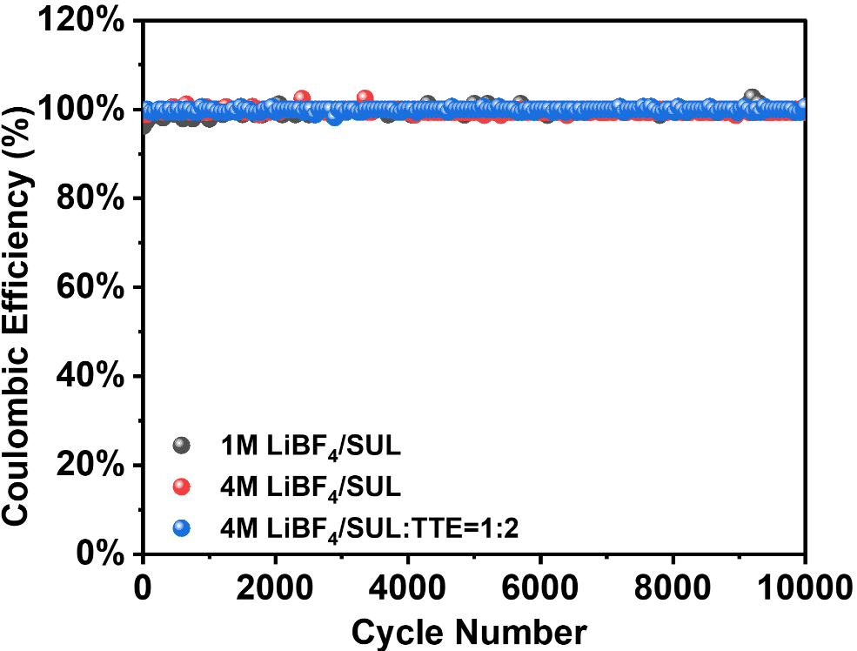
Figure S9. Comparison of Coulombic efficiencies of HPC electrodes in electrolytes with different SUL/TTE volumetric ratios.

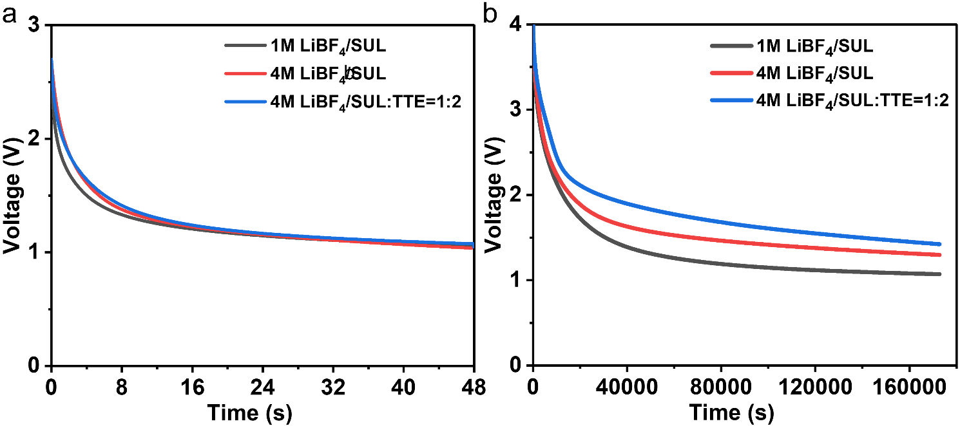Figure S10. Leakage voltage of HPC electrodes at (a) 2.7 V and (b) 4.0 V in different electrolyte systems.

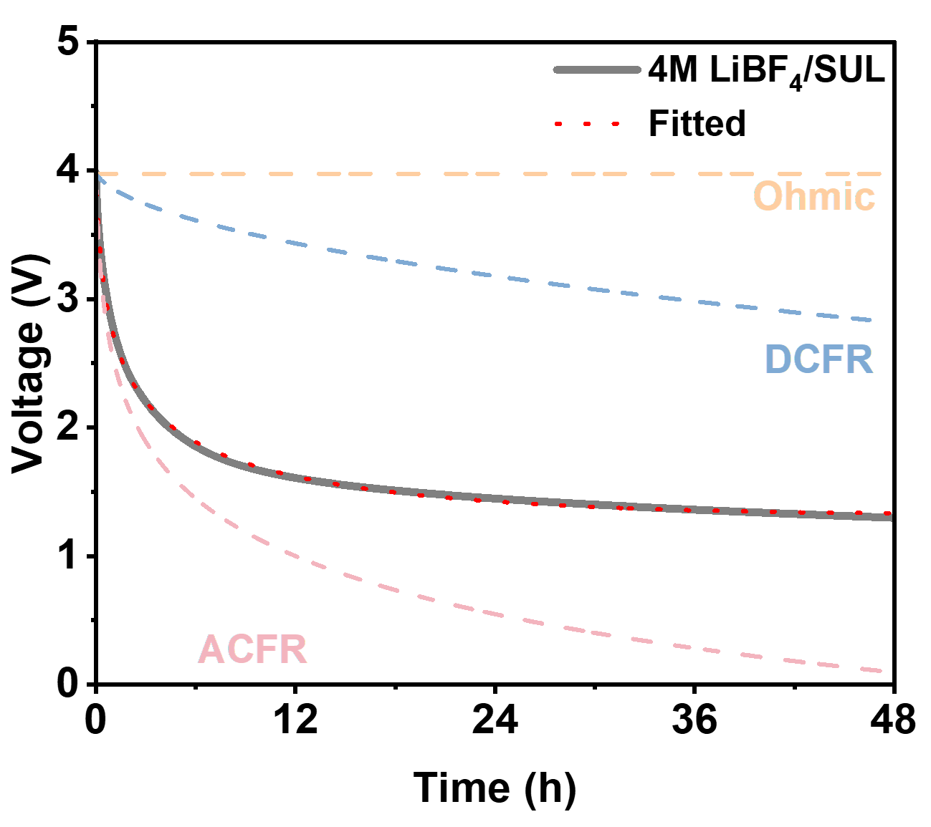
Figure S11. Curve fitting of the OCV profiles for HPC electrodes at HCE (4M LiBF₄/SUL) electrolyte systems.

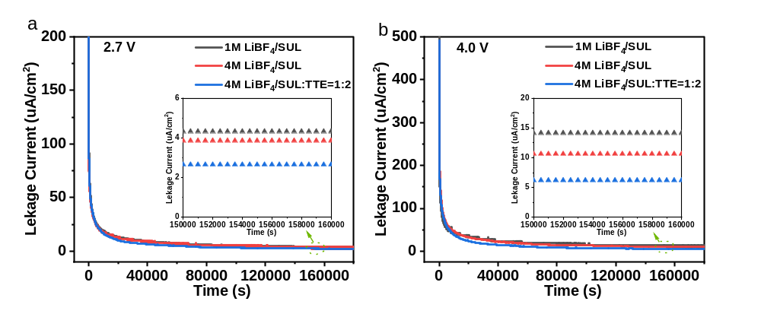
Figure S12. Leakage current of HPC electrodes at (a) 2.7 V and (b) 4.0 V in different electrolyte systems.
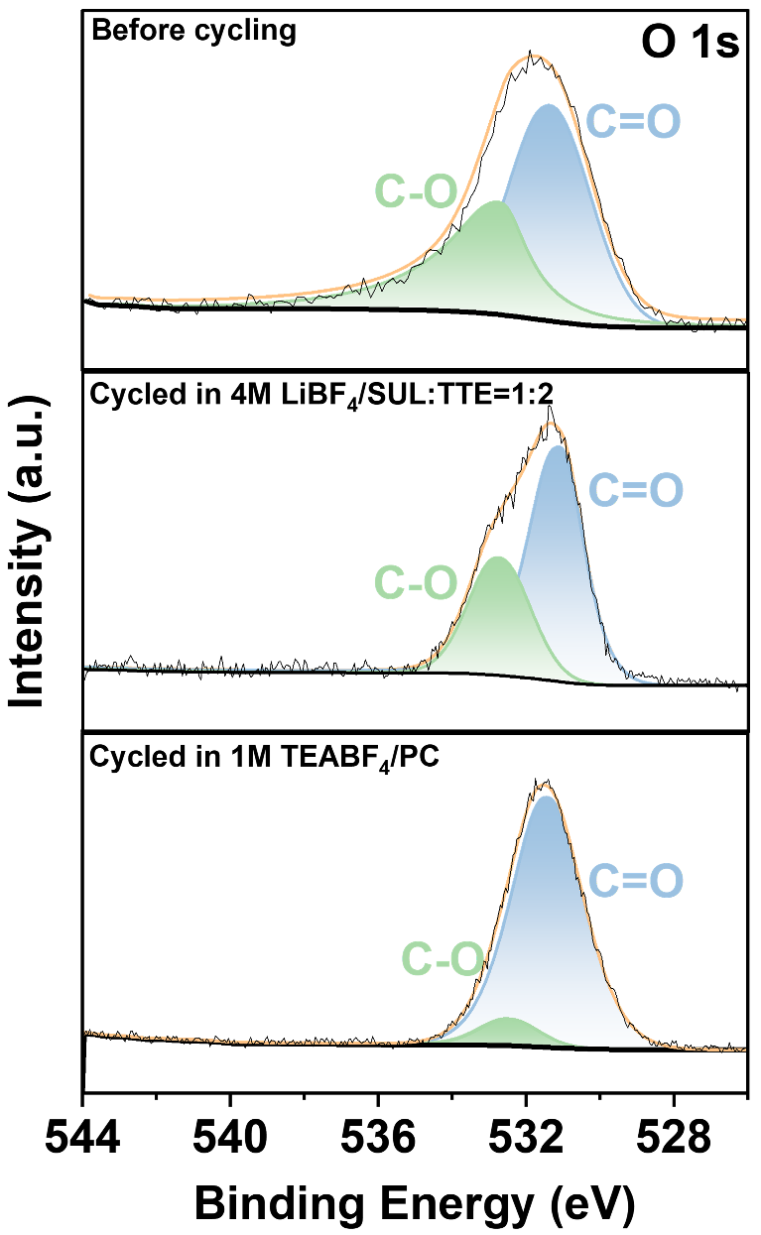
Figure S13. Comparison of O 1s XPS spectra of HPC electrodes cycled in 1 M TEABF₄/PC and 4 M LiBF₄/SUL:TTE (1:2) electrolytes after 10000 cycles at a voltage window of 0–4 V.

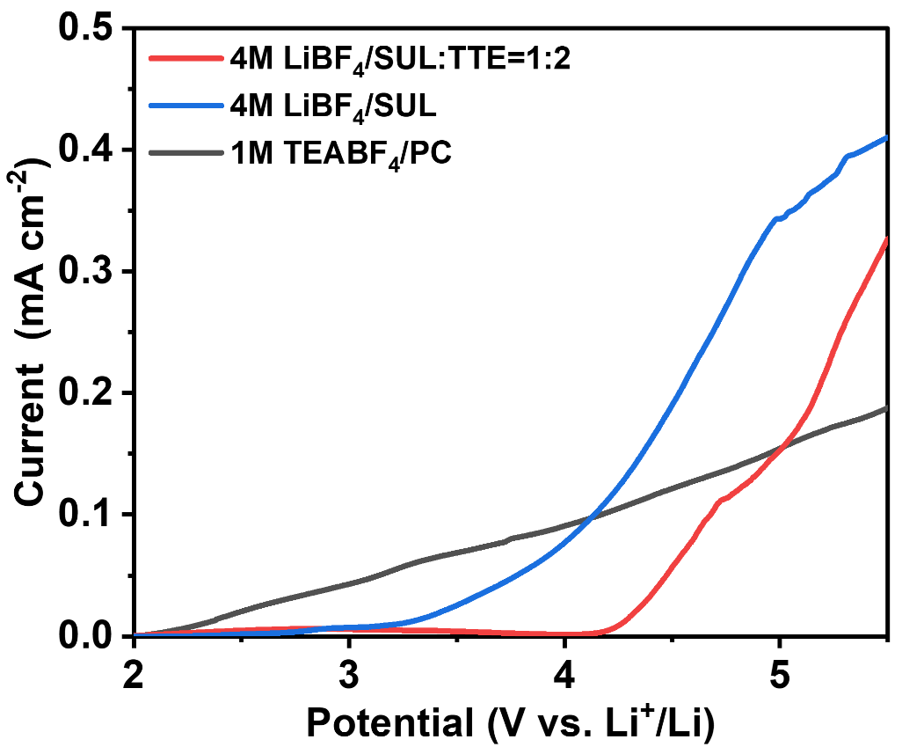
Figure S14. LSV curve of HPC in different electrolyte systems with lithium anode as the reference and counter electrodes.

