Supplementary Information
for

Mechanisms of Labile Phosphorus Accumulation in Paddy Soils under TPU Microplastics versus Chicken-manure Hydrochar Addition: Roles of Dissolved Organic Matter and Bacterial Communities
Xudong Zhong,^{†,‡,l} Yanfang Feng,^{‡,l} Rixing Zhu,† Yang Song,‖ Yuanyuan Feng,# Huifang Xie,†,* Bingyu Wang,†,*, Gerrard Eddy Jai Poinern,§
† Jiangsu Key Laboratory of Chemical Pollution Control and Resources Reuse, School of Environmental and Biological Engineering, Nanjing University of Science and Technology, Nanjing 210094, China
‡ Key Laboratory of Agro-Environment in Downstream of Yangtze Plain, Ministry of Agriculture and Rural Affairs, Institute of Agricultural Resources and Environment, Jiangsu Academy of Agricultural Sciences, Nanjing 210014, China
‖ State Key Laboratory of Soil & Sustainable Agriculture, Institute of Soil Science, Chinese Academy of Sciences, Nanjing 210008, China
# Co-Innovation Center for Sustainable Forestry in Southern China, College of Forestry and Grassland, Nanjing Forestry University, Nanjing 210037, China
§ Murdoch Applied Innovation Nanotechnology Research Group, College of Science, Health, Engineering and Education, Murdoch University, Perth, WA, 6150, Australia
* Corresponding author: bingyuwang@njust.edu.cn; huifangxie@njust.edu.cn
¹ These authors contributed equally to this study.

Text S1
The method for extracting DOM derived from soil samples was as follows: 1 g of the source material was mixed with deionized water at a soil/water ratio of 1:10 (w/v). and shaken for 24 h at a constant temperature of 25 ℃. After that, the supernatants were separated by centrifugation (4000 rpm for 20 min) and passed through a 0.45 μm cellulose acetate membrane.

Text S2
After 40 days of incubation, the integrated fluorescence intensities of DOM characteristics showed marked divergence between the MP and HC treatments (Fig. 1e–h). In the MPs-amended soil, the increasing integrated areas across all DOM regions—most notably in the protein-like region—suggest that MPs acted as a continuous source of labile carbon. This pattern can be attributed to the combined effects of the gradual leaching of MP-derived components and enhanced microbial activity during incubation. In the early stage, the release of DOM from the relatively stable MPs was slow (Hofmann et al. 2023), resulting in significantly lower fluorescence intensities in MPs-treated soil compared to HC. As incubation progressed, specific microorganisms utilized the leached DOM as substrates. However, studies indicate that the consumption rate of these compounds is substantially lower than the rate of DOC accumulation (Guo et al. 2023). Concurrently, increased microbial activity likely led to the secretion of substantial amounts of extracellular proteins, which may explain the pronounced rise of DOM components in MPs-treated soil, particularly those associated with protein-like substances, in the soil extracts (Shiu et al. 2020).
﻿In contrast, the declining DOM fluorescence intensity in the HC treatment highlights its capacity for rapid release of bioavailable carbon. Shortly after incorporation, a substantial fraction of DOM in HC was quickly released into the soil, where it was readily utilized by microorganisms (Azeem et al. 2023). The resulting enrichment of bioavailable carbon stimulated microbial proliferation, which in turn accelerated the uptake and consumption of DOM, ultimately leading to a rapid decrease in extractable DOM from the soil.
﻿

Text S3

The four fluorescent components (C1–C4) identified in 36 samples across all treatments were listed. These components were analyzed by referencing existing literature in the OpenFluor database and compared with fluorescent components reported in previous studies (Table S2). The tucker convergence coefficients of the matched components exceeded 0.95. The EEMs spectral characteristics of C1 were characterized by peaks at 340 nm excitation with 430 nm emission wavelengths, which is described as a terrestrial-derived humic matter (Hong et al. 2021), commonly found in wastewater and characterized by low aromaticity and molecular weight (Wang et al. 2022). In EEMs spectra of C2, there were two excitation maxima (285 nm and 365 nm) at a 495 nm emission wavelength, similar to a soil fulvic-like component (Meilleur et al. 2023), which originates from terrestrial higher plants and is directly associated with microbial reduction reactions (Zhou et al. 2019). C3 was characterized by peaks at 320 nm excitation with 390 nm emission, additionally represents a humic-like component (Chen et al. 2018). The C4 component had excitation maxima at 265/315 nm and emission maximum at 420 nm, similar to a humic-like substance linked to UV photodegradation (Søndergaard et al. 2003), previously identified as a photochemical product of terrestrial organic matter (DeFrancesco and Guéguen 2021).

Table S1 The basic properties of two carbon-rich materials
Samples | C (%) | H (%) | O (%) | N (%) | P (g/kg)
 |  |  |  |  | TP | H₂O-P | NaHCO₃-P | NaOH-P | HCl-P | Residual-P
HC | 47.95 | 4.99 | 10.02 | 4.15 | 15.13 | 0.14 | 0.04 | 0.04 | 14.48 | 0.43
MPs | 58.96 | 7.88 | 28.97 | 3.18 | ND | ND | ND | ND | ND | ND
Note: ND, not detected.

Table S2 Fluorescence characteristics of the four components identified by PARAFAC model and literature comparisons based on the OpenFluor database.
Component | Ex/Em (nm/nm) | Determination
C1 | 340/430 | terrestrial-derived humic (Hong et al. 2021; Wang et al. 2022)
C2 | 285(365)/495 | soil fulvic-like component, associated with microbial reduction reactions (Meilleur et al. 2023; Zhou et al. 2019)
C3 | 320/390 | microbially- derived humic-like (Chen et al. 2018)
C4 | 265(315)/420 | photochemical product of terrestrial organic matter (Søndergaard et al. 2003; DeFrancesco and Guéguen 2021)

Table S3 Detrended correspondence analysis (DCA) analysis of bacterial community.
 | DCA1 | DCA2 | DCA3 | DCA4
Gradient length | 2.928169 | 2.76551 | 2.787608 | 2.607476
Note: Based on the results of detrended correspondence analysis (DCA), the maximum gradient length of bacterial species data was less than 3, indicating a linear response. Therefore, redundancy analysis (RDA) was selected over canonical correspondence analysis (CCA).

Table S4 Variance inflation factor (VIF) screening.
Environmental factors | VIF
pH | 2.34
SOC | 1.72
TK | 2.31
AN | 2.05
AK | 2.90
LP | 4.77
MLP | 2.13
DOC | 5.35
SUVA₂₅₄ | 4.42
HIX | 5.12
C1 | 7.99
C2 | 7.70
C3 | 9.14
Note: The analysis is used to detect multicollinearity in the model, remove environmental variables with VIF values greater than 10, and improve the stability and interpretability of the model.

Table S5 Checking the importance of sorting models and obtaining the contribution of each variable to the RDA model
Parameters | RDA1 | RDA2 | r² | Pr (>r)
pH | 0.55103 | -0.83448 | 0.1184 | 0.12
SOC | -0.00459 | 0.99999 | 0.1694 | 0.04*
TK | 0.57262 | 0.81982 | 0.2595 | 0.02*
AN | 0.43166 | 0.90204 | 0.3343 | 0.004**
AK | -0.21355 | 0.97693 | 0.4518 | 0.001***
LP | 0.9355 | 0.35332 | 0.5748 | 0.001***
MLP | -0.03019 | -0.99954 | 0.0083 | 0.878
DOC | 0.71748 | 0.69658 | 0.6232 | 0.001***
SUVA₂₅₄ | -0.27109 | 0.96255 | 0.3584 | 0.001***
HIX | 0.41846 | 0.90823 | 0.558 | 0.001***
C1 | -0.41288 | 0.91079 | 0.5836 | 0.001***
C2 | 0.16411 | 0.98644 | 0.5043 | 0.002**
C3 | -0.47719 | 0.8788 | 0.8363 | 0.001***

Fig. S1 Fourier transform infrared spectroscopy of (a) MPs and (b) HC.

Fig. S2 Physicochemical properties of paddy soil from three treatments during incubation. (a) pH, (b) TC, (c) SOC, (d) TN, (e) TK, (f) TP, (g) AN and (h) AK. TC was total carbon. SOC and DOC meant soil organic carbon and dissolved organic carbon. TK and TP were total potassium and phosphorus. AK and AP were available potassium and phosphorus. Colored letters indicate statistically significant differences between treatments of the same day at the p = 0.05 level.
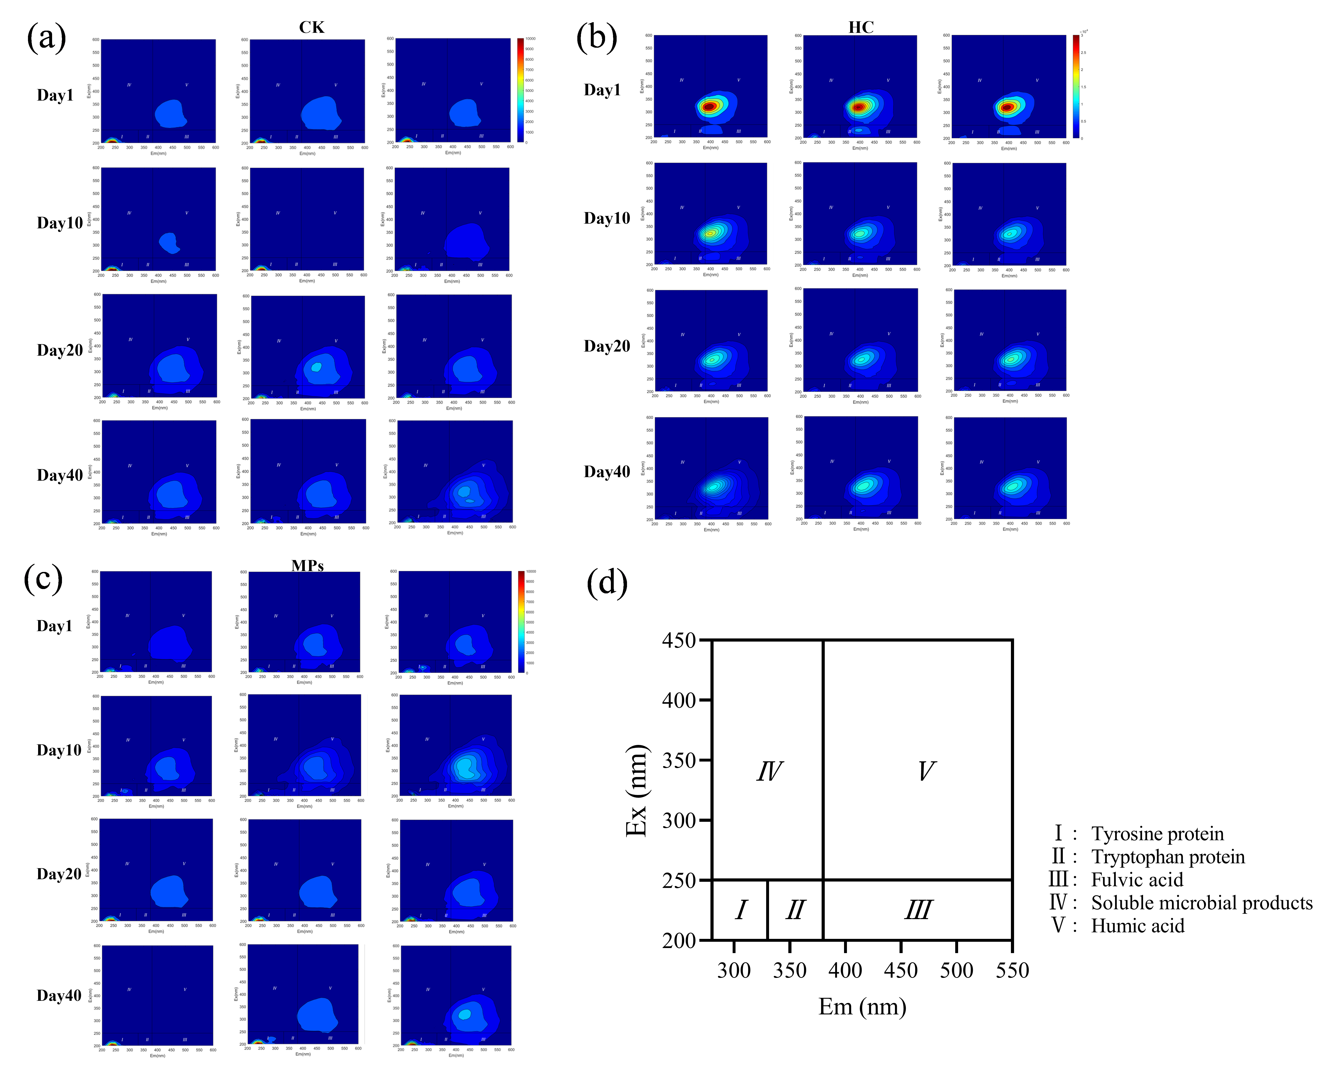
Fig. S3 3D-EEM of paddy soil from three treatments during incubation. (a) CK, (b) HC, (c) MPs. Em means the emission wavelength, and Ex means the excitation wavelength. (d): Relative positions of five components based on fluorescence spectroscopy.
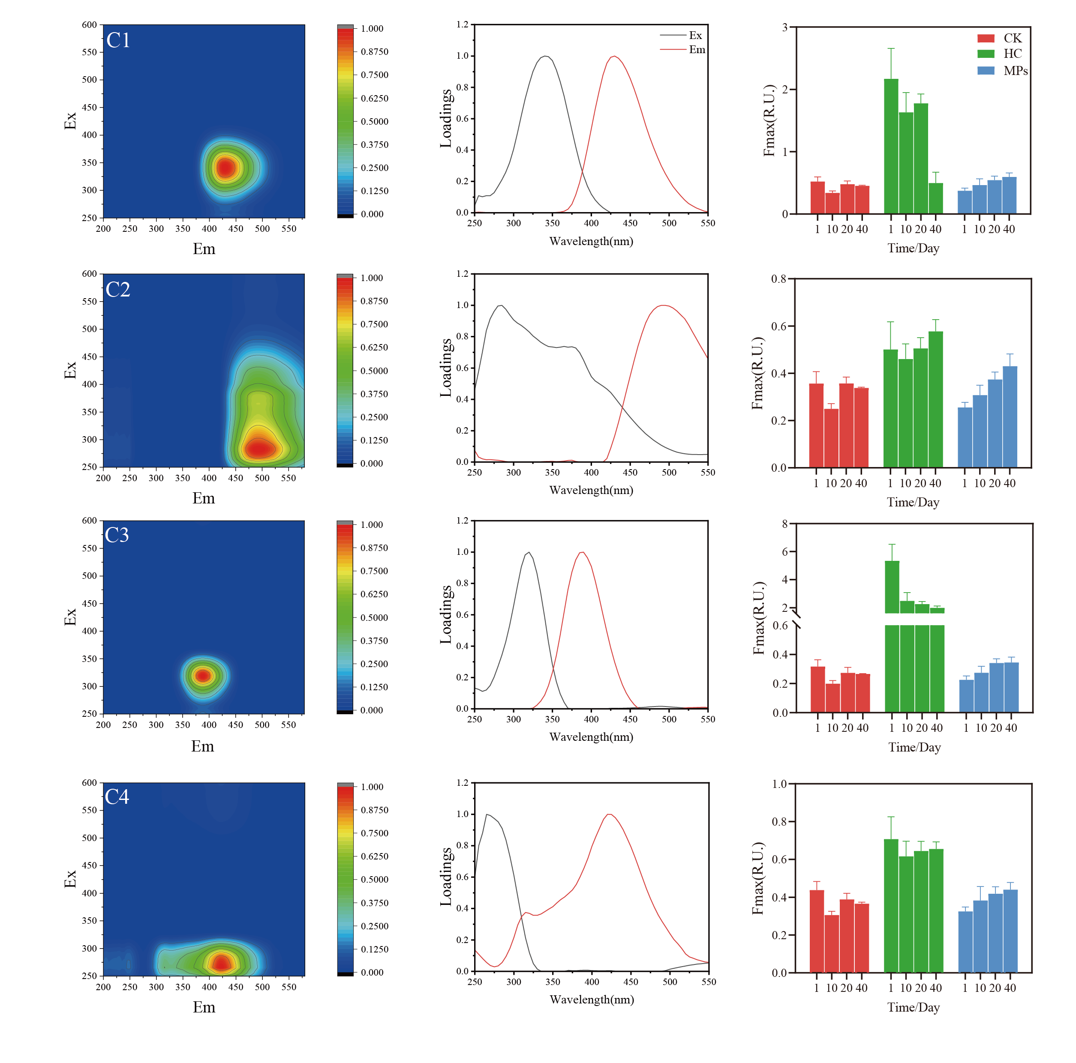
Fig. S4 Fluorescence characteristics of the four components identified by PARAFAC model.

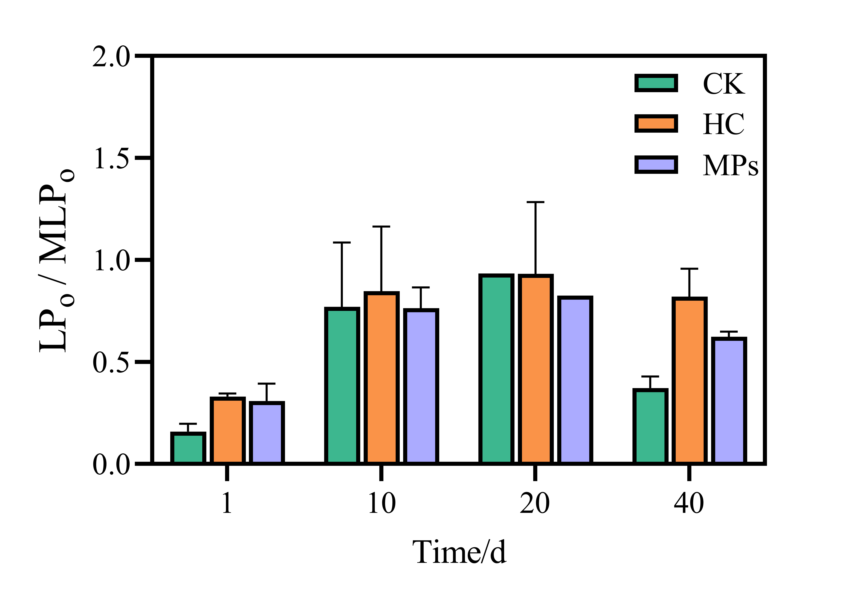

Fig. S5 Changes in ratios of relatively labile fractions (LP_{o}) relative to more slowly cycling fractions (MLP_{o}).

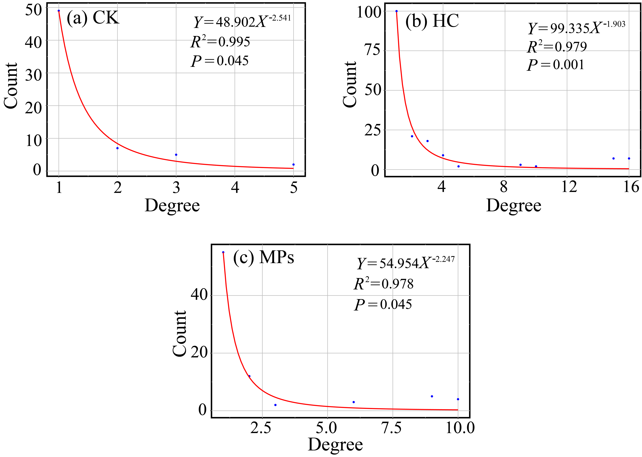
Fig. S6 Validation of network topology by power-law distribution analysis. The degree distributions of the microbial co-occurrence networks in the (a) CK, (b) HC, and (c) MPs treatments all significantly fit a power-law model (p < 0.05), confirming their scale-free and non-random properties.

References
Azeem M, Sun T-R, Jeyasundar PGSA, Han R-X, Li H, Abdelrahman H, Shaheen SM, Zhu Y-G, Li G (2023) Biochar-derived dissolved organic matter (BDOM) and its influence on soil microbial community composition, function, and activity: A review. Critical Reviews in Environmental Science and Technology 53: 1912-1934. https://doi.org/10.1080/10643389.2023.2190333
Chen B, Huang W, Ma S, Feng M, Liu C, Gu X, Chen K (2018) Characterization of chromophoric dissolved organic matter in the littoral zones of eutrophic lakes Taihu and Hongze during the algal bloom season. Water 10: 861. https://doi.org/10.3390/w10070861
DeFrancesco C, Guéguen C (2021) Long-term trends in dissolved organic matter composition and its relation to sea ice in the Canada Basin, Arctic Ocean (2007–2017). Journal of Geophysical Research: Oceans 126: e2020JC016578. https://doi.org/10.1029/2020JC016578
Guo Z, Li P, Yang X, Wang Z, Wu Y, Li G, Liu G, Ritsema CJ, Geissen V, Xue S (2023) Effects of microplastics on the transport of soil dissolved organic matter in the Loess Plateau of China. Environmental Science & Technology 57: 20138-20147. https://doi.org/10.1021/acs.est.3c04023
Hofmann T et al. (2023) Plastics can be used more sustainably in agriculture. Communications Earth & Environment 4: 332. https://doi.org/10.1038/s43247-023-00982-4
Hong H, Wu S, Wang Q, Dai M, Qian L, Zhu H, Li J, Zhang J, Liu J, Li J, Lu H, Yan C (2021) Fluorescent dissolved organic matter facilitates the phytoavailability of copper in the coastal wetlands influenced by artificial topography. Science of The Total Environment 790: 147855. https://doi.org/10.1016/j.scitotenv.2021.147855
Meilleur C, Kamula M, Kuzyk ZA, Guéguen C (2023) Insights into surface circulation and mixing in James Bay and Hudson Bay from dissolved organic matter optical properties. Journal of Marine Systems 238: 103841. https://doi.org/10.1016/j.jmarsys.2022.103841
Shiu R-F, Vazquez CI, Chiang C-Y, Chiu M-H, Chen C-S, Ni C-W, Gong G-C, Quigg A, Santschi PH, Chin W-C (2020) Nano- and microplastics trigger secretion of protein-rich extracellular polymeric substances from phytoplankton. Science of The Total Environment 748: 141469. https://doi.org/10.1016/j.scitotenv.2020.141469
Søndergaard M, Stedmon CA, Borch NH (2003) Fate of terrigenous dissolved organic matter (DOM) in estuaries: Aggregation and bioavailability. Ophelia 57: 161-176. https://doi.org/10.1080/00785236.2003.10409512
Wang S, Wasswa J, Feldman AC, Kabenge I, Kiggundu N, Zeng T (2022) Suspect screening to support source identification and risk assessment of organic micropollutants in the aquatic environment of a Sub-Saharan African urban center. Water Research 220: 118706. https://doi.org/10.1016/j.watres.2022.118706
Zhou Y, Martin P, Müller M (2019) Composition and cycling of dissolved organic matter from tropical peatlands of coastal Sarawak, Borneo, revealed by fluorescence spectroscopy and parallel factor analysis. Biogeosciences 16: 2733-2749. https://doi.org/10.5194/bg-16-2733-2019

