Supplementary Materials and Methods for
Adsorption and Incubation Show Iron (oxyhydr)oxides Control the Persistence of Bacterial Extracellular Polymeric Substances in Soils

Chenchen Qu¹, Jiaxin Zhao¹, Shanshan Yang², Mohammad Bahadori³, Chengrong Chen³, Xueqi Song¹, Ming Zhang¹, Yichao Wu¹, Peng Cai^{1, *}, Wenli Chen¹, Qiaoyun Huang^{1, *}
¹National Key Laboratory of Agricultural Microbiology, Huazhong Agricultural University, Wuhan 430070, China
²Institute for Environment and Safety, Wuhan Academy of Agricultural Sciences, Wuhan 430000, China
³ School of Environment and Sciences, Griffith University, Brisbane, Qld 4111, Australia
*Corresponding author. E-mail: cp@mail.hzau.edu.cn, qyhuang@mail.hzau.edu.cn

NEXAFS data analysis
A semiquantitative analysis of NEXAFS spectra was carried out by peak deconvolution using the software Athena. The spectra were normalized and deconvoluted using arctangent function for the ionization step at 291.4 eV with amplitude and full-width at half maximum (FWHM) fixed to 1.0 and 0.5 eV, respectively ¹. The FWHM of the Gaussian peaks were set at 0.4 eV and five Gaussian functions at 285.4 (aromatic-C), 287.0 (phenolic-C), 287.8 (aliphatic-C), 288.7 (carboxylic-C) and 289.7 (O-alkyl-C) were resolved ^{2,3}. Moreover, one Gaussian peak at 290.5 eV was simulated with FWHM of <1 eV representing broad additional σ transitions of saturated single covalent bonds and direct inner-shell ionization. Since the fine structure in the C NEXAFS region above 290 eV transitions tends to be very broad and overlap, only main π transitions below 290 eV were used for subsequent quantification and interpretation of the C (1s) NEXAFS results in the present investigation ^{1,4}.
The collected N-XANES spectra have been normalized to the total amount of nitrogen (measured by the edge step between the pre-edge region (390-395 eV) and the post-edge region (407-420 eV) using the Athena software package. The N-XANES spectra showed features at 400.7 eV (aromatic N in rings), 401.8 eV (amide), 403.2 eV (pyrrolic), 404.2 eV (N-bonded aromatic) and 405.8 eV (alkyl-N and inorganic N) ⁵. The center position, the amplitude and the width of the arctangent function are fixed to 404, 1.0 and 0.4 eV, respectively. Each Gaussian function had a fixed energy position and a constant width of 0.4 to 1 eV.
The collected S-XANES spectra have been normalized to the total amount of sulfur (measured by the edge step between the pre-edge region (2450-2462 eV) and the post-edge region (2491-2520 eV)) using the Athena software package. For each S species, two arctangent functions were selected representing the species specific edge step, were fitted in the energy range 2466-2487 eV ⁶. The center position, the amplitude and the width of these arctangent functions are fixed to 2475.7 eV, 1 and 0.66 eV; 2482.5 eV, 0.12 and 0.66 eV, respectively. Five Gaussian (white-line) functions were taken into account for the K-edge S-XANES. The white line position and electronic oxidation state (OS) are: 2473.5 eV (OS=0.5), 2474.40 eV (OS=1), 2476.40 eV (OS=2), 2479.00 eV (OS=4), 2481.00 eV (OS=5). The full width at half maximum of each Gaussian component for low-valent S (< 2) is constrained at 0.6 eV, while that of Gaussian components for higher valent S are constrained at 1.4 eV. The areas of the different Gaussian peaks were calculated and corrected for their OS-dependent absorption cross section by a generic curve ⁶.
NMR data analysis
The ¹³C CPMAS NMR spectra were divided into eight major chemical shift regions: carbonyl C (210-180 ppm), carboxyl C (180-160), O-aromatic C (160-145), aromatic C (145-110 ppm), O₂-alkyl C (110-90 ppm), O-alkyl C (90-60 ppm), N-alkyl/methoxy C (60-45 ppm) and alkyl C (45-0 ppm), with additional region (230-210 ppm) for the measurement of spinning side band intensity. The relative intensities for each region were determined by integration using the NMR software processing package MestReNova 12.0 (Mestrelab Research S.L.). Two indices of organic material stability were calculated: (i) aliphaticity index, the ratio of alkyl C/(methoxyl C + O-alkyl C + di-O-alkyl C); and (ii) recalcitrance index, the ratio of (alkyl C + aromatic C + phenolic C)/(methoxyl C + O-alkyl C + di-O-alkyl C + carbonyl C).

Table S1 The initial native soil physicochemical properties
Items | Mollisol | Alfisol | Ultisol
sand (%) | 14.04 | 20.72 | 41.42
silt (%) | 58.70 | 71.14 | 39.75
clay (%) | 27.26 | 8.14 | 18.83
Texture | Silt clay loam | Silt loam | Loam
SOM (g kg⁻¹) | 56.7 ± 0.1 | 26.6 ± 0.3 | 11.1 ± 0.7
MBC (mg kg⁻¹) | 477.4 ± 170.6 | 363.9 ± 87.8 | 48.5 ± 12.9
NH₄-N+NO₃-N (mg kg⁻¹) | 30.21 | 21.28 | 22.6
Available P (mg kg⁻¹) | 19.26 | 6.79 | 3.61
CEC (cmol kg⁻¹) | 34.99 ± 0.07 | 8.74 ± 0.03 | 6.80 ± 0.16
pH (H₂O) | 5.79±0.00 | 7.43±0.02 | 5.97±0.01
DCB-extractable Fe (g kg⁻¹) | 10.55±0.02 | 10.63±0.05 | 18.40±0.0
Amorphous Fe (g kg⁻¹) | 5.06±0.03 | 0.99±0.01 | 4.31±0.1
DCB-extractable Al (g kg⁻¹) | 2.36±0.2 | 0.84±0.1 | 5.03±0.2
Amorphous Al (g kg⁻¹) | 1.24±0.1 | 0.48±0.0 | 1.34±0.0
Kaolinite | 38% | 14% | 82%
Vermiculite | 26% | 0% | 0%
Illite | 36% | 34% | 12%
Chlorite | 0% | 42% | 0%
Montmorillonite | 0% | 10% | 0%
1.4 nm transition | 0% | 0% | 6%

Table S2 Deconvolution results for C, S NEXAFS and ¹³C-NMR of Mollisol, Alfisol and Ultisol before and after incubation with EPS.
 | Carboxylic/Aliphatic | Reduced sulfur (%) | alkyl | methoxyl | O-alkyl | di-O-alkyl | aryl | O-  aryl | carboxyl | Alkyl/O-alkyl | Recalcitrance index
Bs.-EPS | 2.41 | 37.6
Mollisol | 2.77 | 12.7 | 12.8 | 8.3 | 26.5 | 9.93 | 20.5 | 5.82 | 16.2 | 0.29 | 0.76
Mollisol_EPS | 2.85 | 13.6
Mollisol_EPS_incubation | 3.71 | 19.8 | 13.2 | 8.0 | 25.6 | 9.65 | 19.2 | 5.87 | 18.4 | 0.30 | 0.75
Alfisol | 2.59 | 13.8 | 14.5 | 10.5 | 23.7 | 8.89 | 21.3 | 5.42 | 15.7 | 0.34 | 0.84
Alfisol_EPS | 3.12 | 15.6
Alfisol_EPS_incubation | 3.38 | 18.8 | 16.2 | 10.3 | 23.6 | 8.73 | 20.2 | 5.21 | 15.6 | 0.38 | 0.87
Ultisol | 3.16 | 12.5 | 13.2 | 10.4 | 19.8 | 9.82 | 20.4 | 6.31 | 20.1 | 0.33 | 0.84
Ultisol_EPS | 3.46 | 15.6
Ultisol_EPS_incubation | 3.9 | 17.8 | 14.8 | 9.8 | 19.5 | 9.15 | 20.3 | 6.31 | 20.1 | 0.38 | 0.93

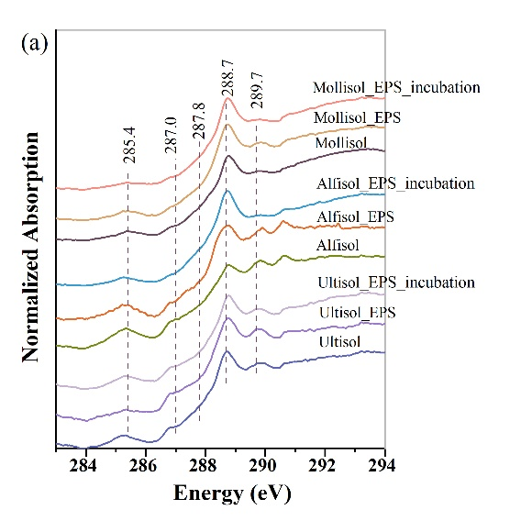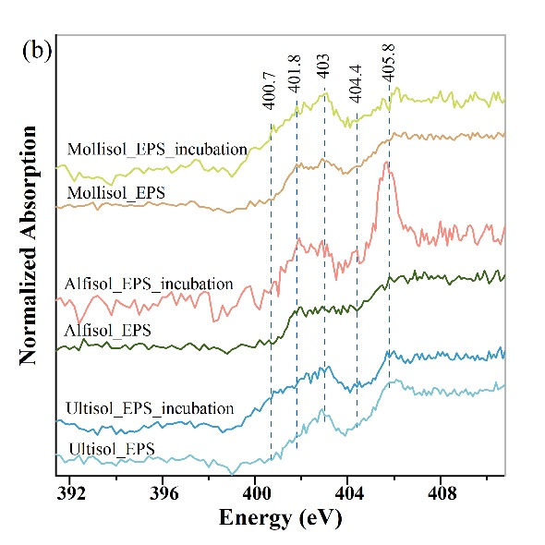
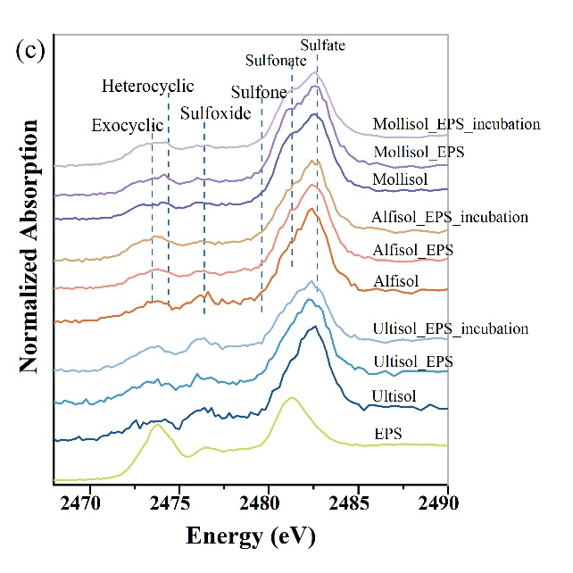
Figure S1. Carbon (a), nitrogen (b), and sulfur (c) K-edge NEXAFS spectra of untreated, EPS adsorbed and EPS incubated soils.

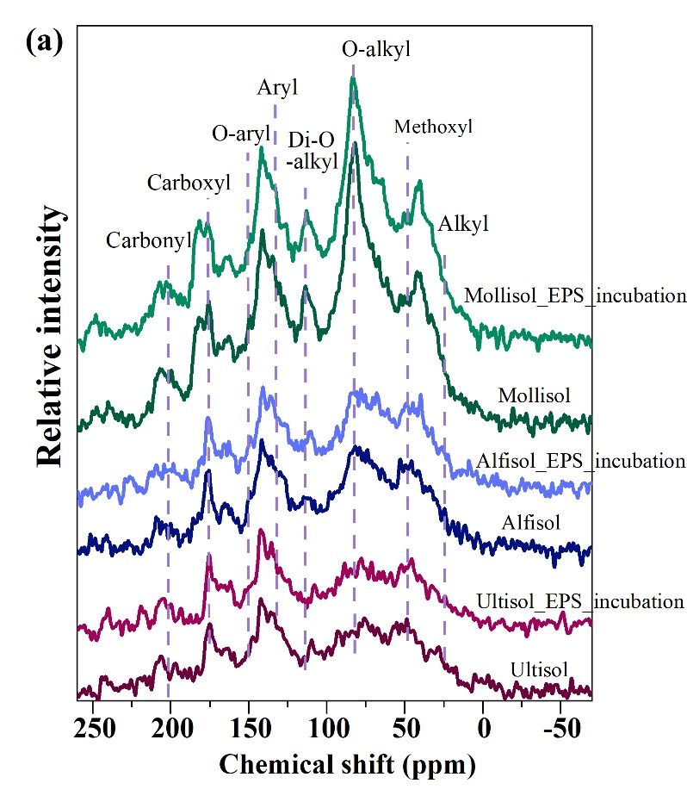
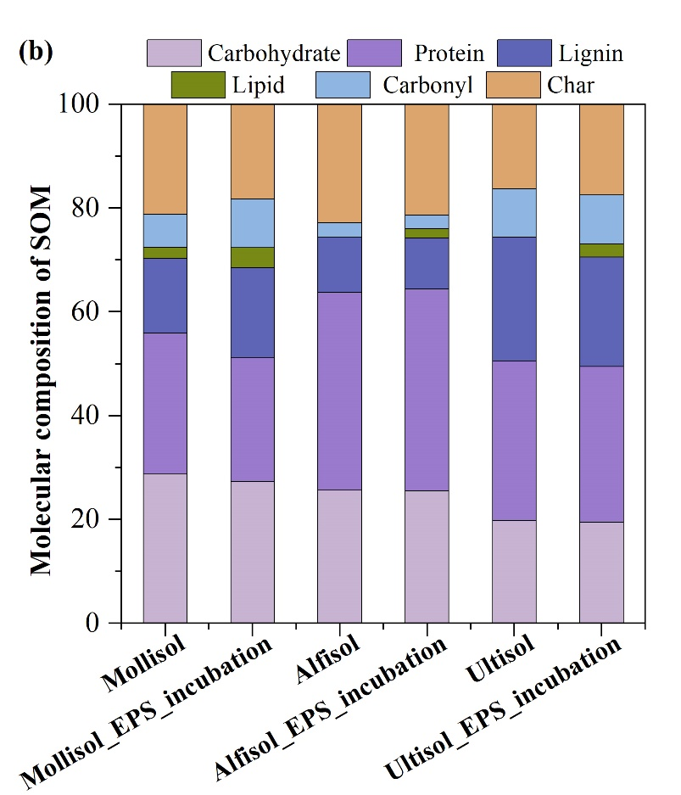
Figure S2. Carbon speciation of unamended soils and incubated with EPS as assessed by CPMAS ¹³C NMR spectroscopy (a), and organic molecular composition calculated using mixing model (b).
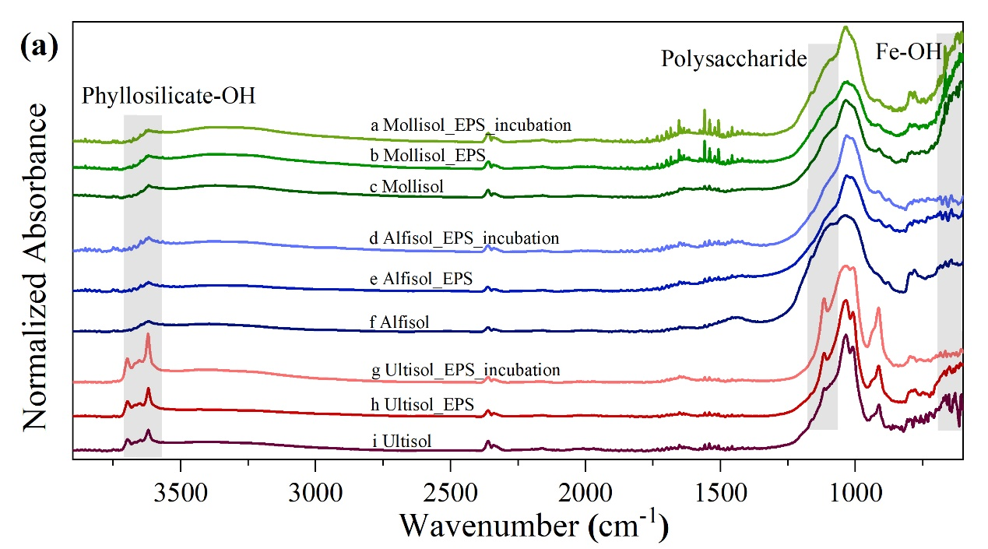
Figure S3. Averaged μ-FTIR spectra for soils without EPS, after adsorption and incubation with EPS. Phyllosilicates O-H groups are at 3550-3740 cm⁻¹, aliphatic-C are at 2800-3000 cm⁻¹, proteins are at 1645-1660 cm⁻¹, carboxyl groups are at 1710-1725 cm⁻¹, polysaccharides are at 1050-1170 cm⁻¹, and Fe-OH groups are at 600-700 cm⁻¹.

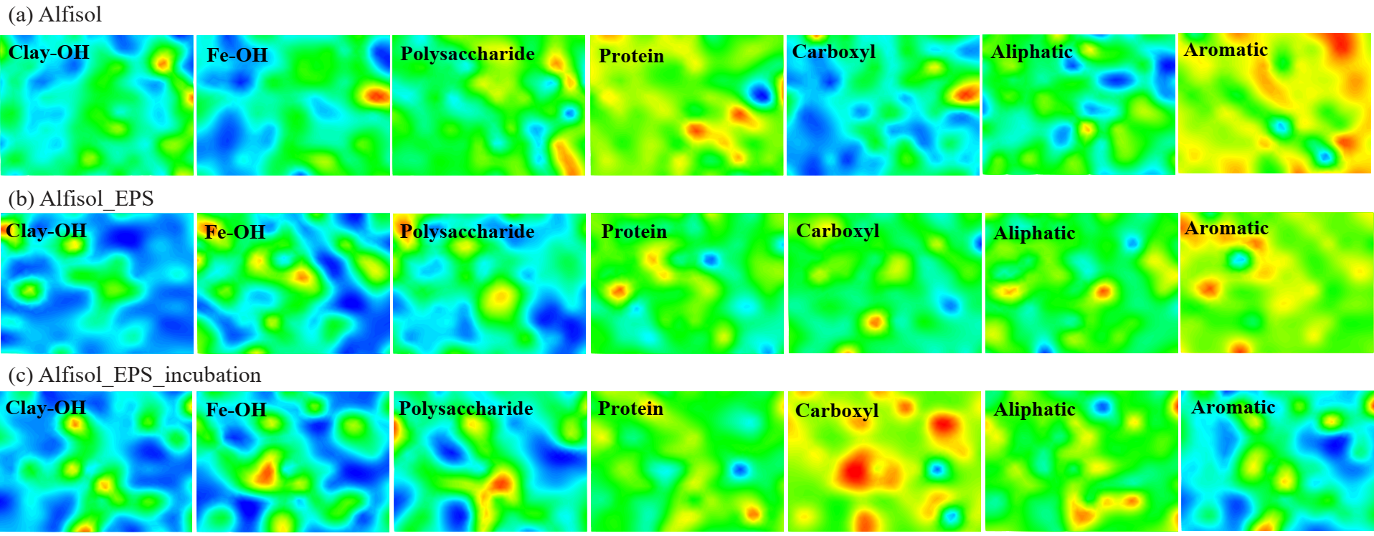
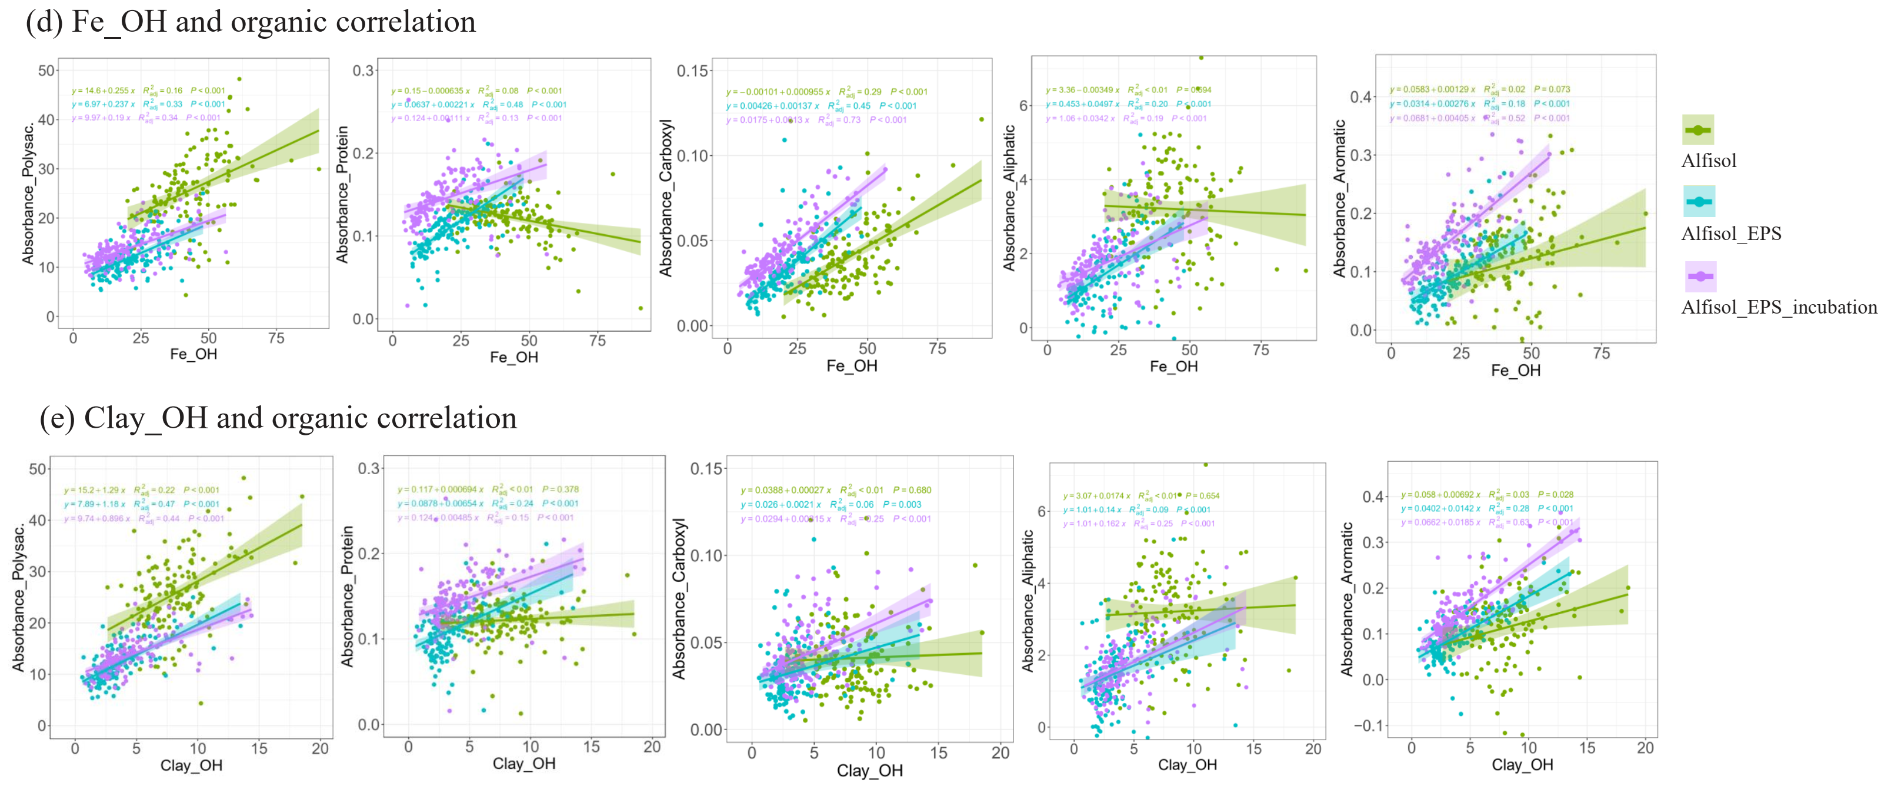
Figure S4. Quantitation distribution and correlation between mineral and biopolymers measured by μ-FTIR. Respectively spectral maps showing non-incubated initial Alfisol (a, Alfisol, n = 140), after adsorption of EPS (b, Alfisol_EPS, n = 140), and incubation with EPS (c, Alfisol_EPS_incubation, n = 140). The color from red-yellow to green-blue corresponds to the relative FTIR absorbance from high to low. Linear regression analysis between iron oxide (d, Fe_OH), phyllosilicates (e, Clay_OH) and C functional groups. The FTIR absorbance between 3500 and 3740 cm⁻¹ for O-H groups of phyllosilicates, between 2800 and 3000 cm⁻¹ for aliphatic C, between 1710 and 1725 cm⁻¹ for carboxyl group, between 1645 and 1660 cm⁻¹ for protein, between 1600 and 1630 cm⁻¹ for aromatic, between 1050 and 1170 cm⁻¹ for polysaccharide and between 600 and 700 cm⁻¹ for Fe-OH. R² indicates the goodness of fit and P-value indicates statistical significance for the linear correlation analysis.

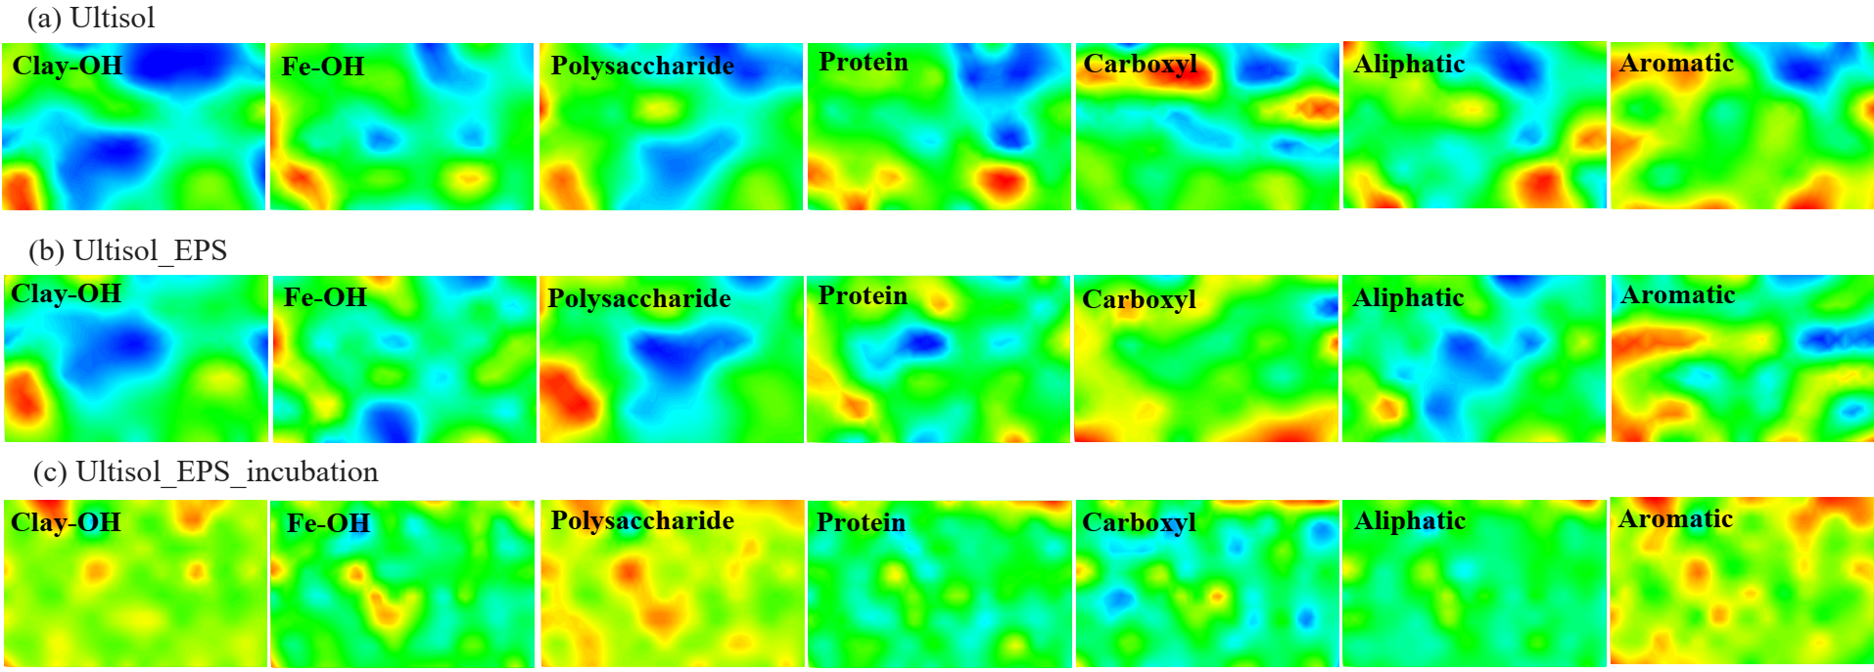
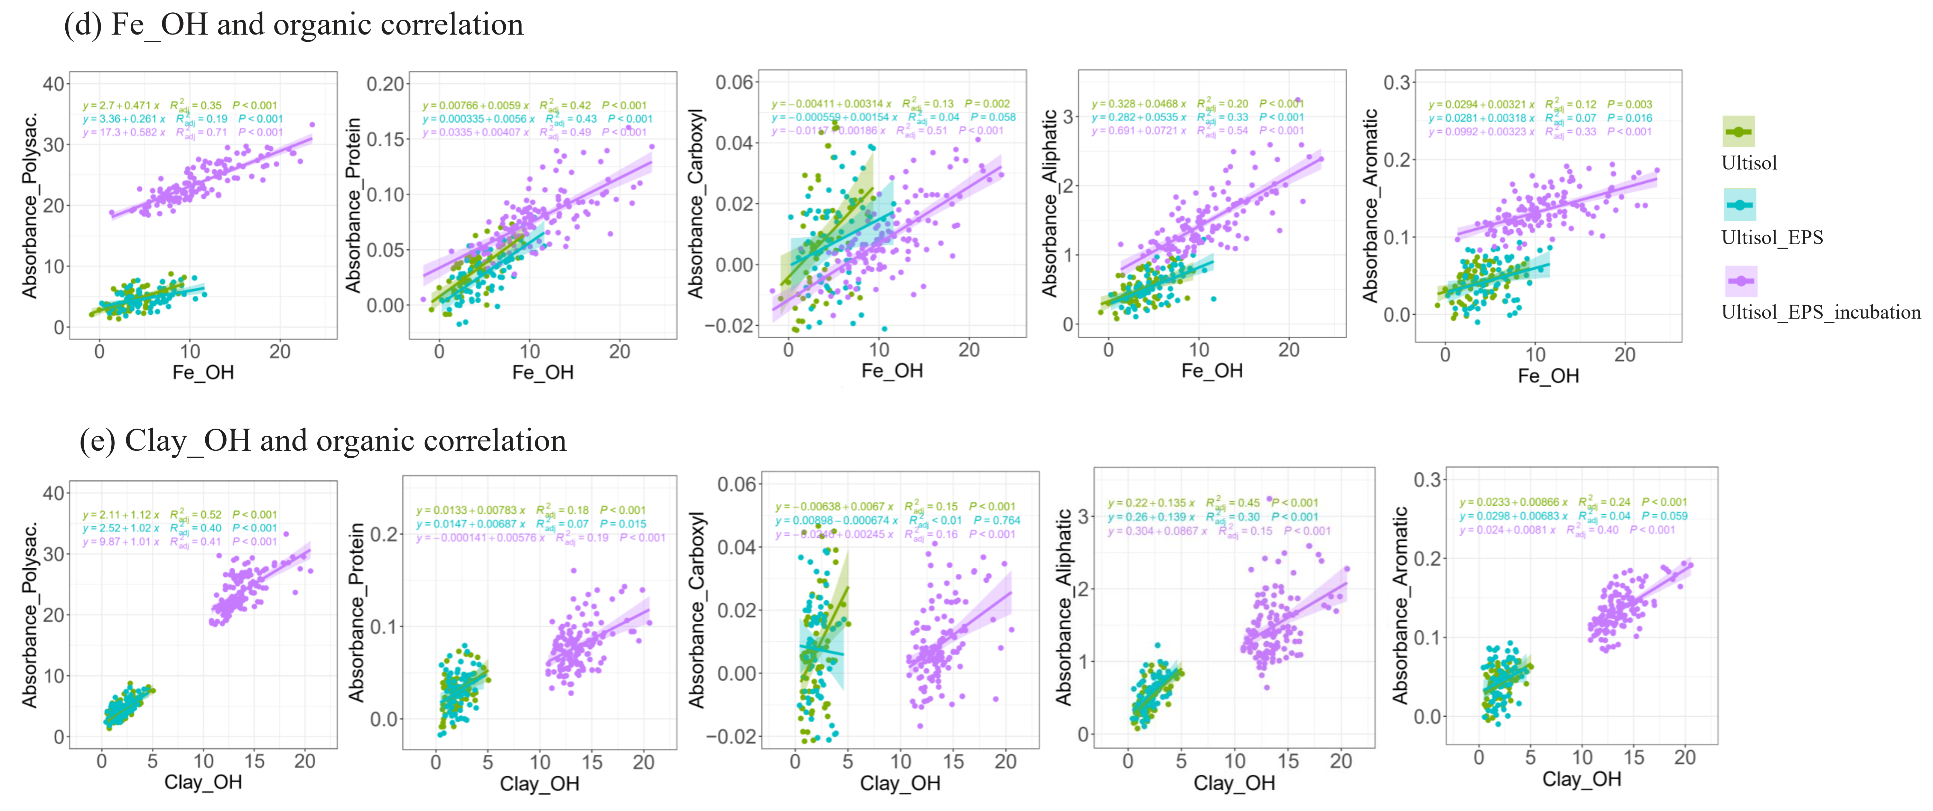
Figure S5. Quantitation distribution and correlation between mineral and biopolymers measured by μ-FTIR. Respectively spectral maps showing non-incubated initial Ultisol (a, Ultisol, n = 66), after adsorption of EPS (b, Ultisol_EPS, n = 66), and incubation with EPS (c, Ultisol_EPS_incubation, n = 128). The color from red-yellow to green-blue corresponds to the relative FTIR absorbance from high to low. Linear regression analysis between iron oxide (d, Fe_OH), phyllosilicates (e, Clay_OH) and C functional groups. See Figure S4 for details on the FTIR spectral analysis method.

References:
1 Solomon, D., Lehmann, J., Kinyangi, J., Liang, B. & Schäfer, T. Carbon K-Edge NEXAFS and FTIR-ATR Spectroscopic Investigation of Organic Carbon Speciation in Soils. 69, 107-119, doi:https://doi.org/10.2136/sssaj2005.0107dup (2005).
2 Prietzel, J. et al. Comparison of soil organic carbon speciation using C NEXAFS and CPMAS (13)C NMR spectroscopy. Sci Total Environ 628-629, 906-918, doi:10.1016/j.scitotenv.2018.02.121 (2018).
3 Kleber, M. et al. Old and stable soil organic matter is not necessarily chemically recalcitrant: implications for modeling concepts and temperature sensitivity. Global Change Biology 17, 1097-1107, doi:10.1111/j.1365-2486.2010.02278.x (2011).
4 Schumacher, M., Christl, I., Scheinost, A. C., Jacobsen, C. & Kretzschmar, R. Chemical Heterogeneity of Organic Soil Colloids Investigated by Scanning Transmission X-ray Microscopy and C-1s NEXAFS Microspectroscopy. Environmental Science & Technology 39, 9094-9100, doi:10.1021/es050099f (2005).
5 Gillespie, A. W. et al. XANES and Pyrolysis-FIMS Evidence of Organic Matter Composition in a Hummocky Landscape. Soil Science Society of America Journal 75, 1741-1755, doi:10.2136/sssaj2010.0279 (2011).
6 Manceau, A. & Nagy, K. L. Quantitative analysis of sulfur functional groups in natural organic matter by XANES spectroscopy. Geochimica et Cosmochimica Acta 99, 206-223, doi:https://doi.org/10.1016/j.gca.2012.09.033 (2012).

