Supporting Information

New Magnetic Carbon Beads Doped with Graphene and Cobalt to Efficiently Degrade Sulfamethoxazole: Superoxide Radical Acceleration Strategy

Jingang Wang¹, Zhenlei Hu^{1,3}, Zhipeng Zheng², Cuiping Wang², Hongwen Sun², Yawei Du¹, Xuejiao Tang^{2*}

¹ School of Chemical Engineering, Hebei University of Technology, Tianjin 300130, P.R. China
² Key Laboratory of Pollution Processes and Environmental Criteria, Ministry of Education, Tianjin 300350, PR China; Tianjin Key Laboratory of Environmental Remediation and Pollution Control, Tianjin 300350, PR China; Tianjin Engineering Center of Environmental Diagnosis and Contamination Remediation, Tianjin 300350, PR China; College of Environmental Science and Engineering, Nankai University, Tianjin 300350, PR China
³ Oil & Gas Technology Research Institute of Huabei Oilfield Company, Renqiu 062552, P.R. China

CONTENTS
Text S1 Chemical reagent information 4
Text S2 Material preparation methods 5
Text S3 Specific test methods 8
Text S4 Means of expression 9
Text S5 Theoretical calculation method 10
Text S6 Appearance of different materials 12
Text S7 Effect of calcination at different temperatures on catalytic properties 13
Text S8. Calculation of Radical Steady-State Concentration in CoNC@cPAN/rGO-800/PMS System 14
Text S9 Continuous filled bed tower reactor design 16
Fig. S1. Appearance and morphology images 17
Fig. S2. Particle size distribution of CoNC@cPAN/rGO-800 17
Fig. S3. The N₂ adsorption-desorption isotherm of cPAN (a), cPAN/rGO (b), CoNC@cPAN (c), CoNC@cPAN/rGO-800 (d); Pore size distribution curve of cPAN (e), cPAN/rGO (f), CoNC@cPAN (g), CoNC@cPAN/rGO-800 (h). 18
Fig. S4. Catalytic activity of CoNC@cPAN/rGO-800 at different temperatures of calcination 18
Fig. S5. Variation of pH during the degradation of SMX in the CoNC@cPAN/rGO-800/PMS system 18
Fig. S6. Degradation of SMX with PMS 19
Fig. S7. Effect of SOD on the concentration of reactive species. 19
Fig. S8. Degradation of SMX by CoNC@PAN/rGO-800 in different gas atmospheres 19
Fig. S9. Model for the O_{v}-Co₃O₄ (110) surface. 20
Fig. S10. Ov -Co₃O₄ (110) surface adsorbed O₂. 20
Fig. S11. (a) The concentration changing of O₂^{·-} in the NBT probe experiment; (b) Segment fitting results of O₂^{·-} generation process. 20
Fig. S12. The EPR spectra of O₂⁻ (CoNC@cPAN activated PMS). 21
Fig. S13. The effect of chelation of Co³⁺ by sodium pyrophosphate on the degradation efficiency of SMX. 21
Fig. S14. The O 1s (a) and Co 2p (b) XPS spectra of CoNC@cPAN/rGO-800 after 8 cyclic degradation experiments. 21
Fig. S15. Magnetization hysteresis loop of CoNC@cPAN and CoNC@cPAN/rGO-800. 22
Fig. S16. Recovery of CoNC@cPAN/rGO-800 from solution by using a magnet. 22
Fig. S17. The catalytic activity of CoNC in activating PMS for SMX degradation (0.1 g/L catalyst, 10 mg/L SMX, 0.1 g/L PMS, pH=7); (b) The metal leaching amount of CoNC@cPAN/rGO-800 at different pH values. 22
Fig. S18. (a) The degradation rate of SMX in column reactor under different cycles (10 mg/L SMX; 0.1 g/L PMS); (b) Degradation performance of the column reactor at different flow rates; (c) Breakthrough curves at different PMS concentrations. 23
Table S1. The relative ratio of different elements by XPS fitting. 24
Table S2. Water quality testing results from different sources 26
Table S3. Comparison of catalytic SMX degradation performance of CoNC@cPAN/rGO-800 with related literatures. 27

Text S1 Chemical reagent information

Potassium peroxymonosulfate (PMS, 2KHSO₅·KHSO₄·K₂SO₄, 4.7% active oxygen) was obtained from Tianjin Jiangtian Chemical Technology Co., Ltd. Graphene oxide for commercial applications (GO, monolayer, 98%) was obtained from ‌Shanghai Yuanye Bio-Technology Co., Ltd. Co(NO₃)₂·6H₂O, 2-methylimidazole (2-MeIm), triethylamine (TEA, 99%), polyacrylonitrile (PAN), methanol (MeOH, 99.9%), tert-butyl alcohol (TBA, 99.9%), p-benzoquinone (p-BQ), furfuryl alcohol (FFA, 98.1%), sodium hydroxide (NaOH), hydrochloric acid (HCl), 5,5-dimethyl-1-pyrrolidine-N-oxide (DMPO), 2,2,6,6-tetramethyl-4-piperidinol (TEMP) were all purchased from Shanghai Macklin Biochemical Co., Ltd. Na₂CO₃ (99.9%), Na₂SO₄ (99.95%), NaCl (99.99%), NaNO₃ (99.8%), Na₂HPO₄ (99.5%), N, N-Dimethylformamide (DMF) were purchased from Meryer (Shanghai) Biochemical Technology Co., Ltd.

Text S2 Material preparation methods
ZIF-67 was synthesized with the triethylamine-assisted method according to previous reports. Co(NO₃)₂·6H₂O of 1.96 g was dissolved in 15 ml of purified water following by sonication to ensure homogeneous dispersion and solution A was obtained. 2-methylimidazole of 2.21 g was dissolved in 15 ml of purified water, then 3 mL of triethylamine was added, followed by sonication to obtain solution B. Solution A was slowly added dropwise to solution B at room temperature with magnetic stirring for 3 h. After reaction, the precipitate was collected by centrifugation, washed with purified water repeatedly, and the washing–centrifugation cycle was repeated four times. The precipitate was then dried at 60 ℃ for 24 h to obtain the purple powder, namely ZIF-67.
GO was prepared according to a modified Hummers method ^{[1]}. Briefly, 1 g of graphite flakes and 1 g of NaNO₃ were placed in a 250 mL beaker, followed by the addition of 46 mL of concentrated H₂SO₄. The mixture was magnetically stirred for 30 min in an ice bath at a controlled temperature of 5 °C. Then, 6 g of KMnO₄ was added portionwise at a slow rate to avoid excessive temperature rise, with the reaction temperature maintained below 5 °C at all times, and the stirring was continued for another 2 h after the complete addition. Subsequently, the reaction system was heated up to 35 °C and stirred for 2 h at this temperature. After that, 46 mL of deionized water was slowly added dropwise into the beaker, and the system temperature was further elevated to 98 °C. After constant-temperature reaction at 98 °C for 15 min, the external heating source was removed. Next, 100 mL of deionized water and 20 mL of 30% H₂O₂ solution were added successively to the reaction mixture. The resulting mixture was subjected to centrifugation, and the precipitate obtained was washed repeatedly with deionized water.
Then 6 ml of DMF solution containing 0.6 g PAN and 0.05 g GO and 6 ml of DMF solution containing 0.6 g ZIF-67 powder were both stirred in a water bath at 60 °C for 1 h, which were recorded as solution C and solution D, respectively. During the preparation of the composite, the mass ratio of ZIF-67 to PAN was controlled at 1:1 (the mass ratio of ZIF-67: PAN: GO was 12:12:1). Then a purple viscous liquid was obtained by slowly adding solution D to solution C, followed by continuously stirring the mix solution at 60 °C for 3 hours in a water bath. The liquid was then subjected to sonication in order to ensure the absence of any air bubbles in it. Subsequently, the purple viscous liquid was added dropwise with a 32 G gauge needle syringe to pure water under magnetic stirring, which was solidified to be beads following collection with filter. Beads were washed three times with purified water and left to dry completely at room temperature, then assigned as ZIF-67@PAN/GO.
Then, ZIF-67@PAN/GO beads were subjected to calcination in a tube furnace under nitrogen atmosphere at various temperatures (600 °C, 700 °C, 800 °C, 900 °C) for 240 min with a heating rate of 5 ℃/min followed by natural cooling. The obtained black carbon beads were then washed with ethanol and pure water alternately for three times and subsequently dried, thus obtaining CoNC@cPAN/rGO-600, CoNC@cPAN/rGO-700, CoNC@cPAN/rGO-800 and CoNC@cPAN/rGO-900, respectively.

Text S3 Specific test methods
The experiment was conducted in a beaker system containing 100 ml of SMX solution (10 mg/L) and a defined quantity of catalyst. The beaker was placed in a water bath shaker set at a temperature of 25 °C to reach the adsorption equilibrium. Then a specific volume of a PMS solution at a known concentration was added to start the degradation. Sampling was conducted at 0, 1, 3, 5, 7, 10, 15, 20, 25, and 30 minutes with 0.5 ml of the reaction solution taken and filtered through a PTFE membrane. This solution was then mixed with 0.5 ml of methanol, which quenched any excess free radicals present and prevented further degradation in the system. The concentration of SMX was then determined by high performance liquid chromatography (HPLC). Furthermore, the impacts of PMS concentration, catalyst dosage, various inorganic anions, humic acid (HA) and different quenchers on the degradation of SMX were also examined. The proposed kinetic rate constant (k_{obs}) for SMX removal was also calculated and analyzed based on the proposed primary kinetic equation (Eqs. S(1)).
$-ln({[SMX]}_{t}/{[SMX]}_{0})=k_{obs}×t$ (S1)
where [SMX]_{t} is the concentration of SMX at reaction time (t) and [SMX]₀ is the initial concentration of SMX.

Text S4 Means of expression
Characterization of the surface morphology of the material is done by a scanning electron microscope (ZEISS GeminiSEM 300) with 3.0 kV scanning voltage. Crystal morphology was tested by X-ray diffraction (XRD, Rigaku Ulitma IV) at condition of λ=0.154 nm, 40 kV, 40 mA, and the scan rate is 10°/min. The degree of graphitization of the material and the Co₃O₄ crystals were tested using Raman spectroscopy (HORIBA XploRA PLUS) at an excitation wavelength of 533 nm. The functional groups on the catalysts were tested by Fourier transform infrared spectroscopy (FTIR, THERMO Nicolet iS50). The composition and chemical states of elements are analyzed by X-ray photoelectron spectroscopy (XPS) using a Thermo Scientific K-Alpha instrument equipped with an Al Kα X-ray source. The Brunauer-Emmett-Teller (BET) surface area was measured via N₂ adsorption-desorption isotherms using the BELSORP MAX instrument. ROS detected by electron paramagnetic resonance (EPR) equipment. EIS, i-t, and LSV curves were recorded by Chenhua Electrochemical Workstation 760e electrochemical station using a typical three-electrode mode in 0.2 M Na₂SO₄ aqueous solution.

Text S5 Theoretical calculation method
First-principles calculations were carried out with using the Vienna ab initio simulation package (VASP) [2, 3]. The projector-augmented wave (PAW) method was used in conjunction with the Perdew-Burke-Ernzerhof (PBE) functional for exchange-correlation, applying the generalized gradient approximation (GGA). The geometry optimization was deemed as convergence when the force change fell below 0.02 eV/Å (EDIFFG) and the energy change was less than 10⁻⁵ eV (EDIFF). A plane-wave basis set with a cutoff energy of 520 eV was employed. Cutting the (110) surface of Co₃O₄ and V_{O}-Co₃O₄ while constructing a 15 Å vacuum layer in the z-axis direction. For cobalt metal oxides, the strong on-site coulomb interactions of localized electrons are treated by the DFT+U approach for Co, where the value of Ueff is 3.5 eV. The adsorption energies for the adsorption of PMS on Co₃O₄ and V_{O}-Co₃O₄ are calculated by the equation: E_{ads} = E_{PMS+slab} - E_{PMS} -E_{slab}, where E _{PMS+slab} is the overall energy, E_{slab} is the adsorbed substrate energy, E_{PMS} is the PMS energy.
Geometry optimization and active site analysis of SMX molecules were performed using Gaussian 16 quantum chemistry software and visualized using Gauss View 6.0. Geometry optimization and frequency calculations were performed using the M06-2x general function and the 6-31G (d,p) basis set, while single site energy calculations were performed. The highest occupied molecular orbital (HOMO), lowest unoccupied molecular orbital (LUMO) and natural population analysis (NPA) charge distributions of SMX were obtained using the Multiwfn software package (version 3.8). The isosurface maps of HOMO, LUMO were visualized and optimized using molecular dynamics (VMD) software. Reaction sites for electrophilic, nucleophilic and radical attacks are predicted by the Fukui function. For the definition of Fukui see Eqs.S2.
$f\left(r\right)={{\left(\frac{∂^{2}E}{∂N. ∂v\left(r\right)}\right)=\left[\frac{∂μ}{∂v(r)}\right]}_{N}=\left[\frac{∂ρ\left(r\right)}{∂N}\right]}_{V\left(r\right)}$ (S2)
To describe the electron density at a point (r) in space, where “N” denotes the number of electrons in the system and “v” represents the external potential in the partial derivative, the condensed version of the Fukui function employs the atomic population number to represent the distribution of electron density around an atom. The compressed Fukui function can be calculated as:
Nucleophilic attack: $f_{k}^{+}=q_{N}^{k}-q_{N+1}^{k}$ (S3)
Electrophilic attack: $f_{k}^{-}=q_{N-1}^{k}-q_{N}^{k}$ (S4)
Radical attack: $f_{k}^{0}={(q}_{N-1}^{k}-q_{N+1}^{k})/2$ (S5)
where q^{k} is the atomic charge of the atom k in the corresponding state, and the Fukui index value of the reactive site is usually larger than in other regions. Thus, the free radical-related reactions and SMX degradation pathways can be verified by calculating the Fukui index of SMX molecules.

Text S6 Appearance of different materials
From Fig. S1a, it can be seen that the pure BPAN beads show pure white color and after mixing with GO, the PAN/GO's show light white color (Fig. S1b). Meanwhile, the bead sizes of these two types did not change much and the diameter size was within 2.11±0.20 mm. Whereas for ZIF-67@PAN (Fig. S1c), after the addition of ZIF-67, the beads were completely changed to purple color while the diameter of the beads was slightly decreased, i.e. 1.85±0.17 mm, and then there was no significant change after the addition of GO (Fig. S1d). After calcination, all four materials showed a charcoal black color, with the diameter of cPAN and cPAN/rGO significantly reduced to 0.66±0.11 mm (Fig. S1e, f), whereas the diameter of CoNC@cPAN and CoNC@cPAN/rGO-800 (Fig. S1g, h) was relatively unchanged, i.e. 1.32±0.36 mm.

Text S7 Effect of calcination at different temperatures on catalytic properties
Fig. S4 shows the catalytic performance of CoNC@cPAN/rGO after calcination at 600 ℃, 700 ℃, 800 ℃ and 900 ℃, respectively. It can be seen that the degradation of SMX under PMS activation by CoNC@cPAN/rGO-600 and CoNC@cPAN/rGO-700 is worse than that by CoNC@cPAN/rGO-800 and CoNC@cPAN/rGO-900. This is due to the fact that the degree of graphitization of carbon beads calcinated at temperature of 800 °C was highest with appropriate defects, and the number of pores in the skeletal structure was sufficient and the cobalt metal can be mostly monomerized. Although the activation effect of CoNC@cPAN/rGO-900 is comparable to that of CoNC@cPAN/rGO-800, calcination at 800 °C is a suitable condition from the point of view of energy saving.

Text S8. Calculation of Radical Steady-State Concentration in CoNC@cPAN/rGO-800/PMS System
The key reactive oxygen species (ROS) to be quantified in this system include hydroxyl radicals (·OH), sulfate radicals (SO₄·⁻), superoxide radicals (O₂·⁻), and singlet oxygen (¹O₂); for the specific quantification of each species, the selected probes and corresponding reaction rate constants are as follows: nitrobenzene (NB) as the specific probe for ·OH, with a second-order reaction rate constant of 3.9×10⁹ M⁻¹s⁻¹ with ·OH; atrazine (ATZ) as the probe for SO₄·⁻, with a second-order reaction rate constant of 2.6×10⁹ M⁻¹s⁻¹ with ·OH and 2.6×10⁹ M⁻¹s⁻¹ with SO₄·⁻; furfuryl alcohol (FFA) as the probe for ¹O₂, with a second-order reaction rate constant of 1.2×10⁸ M⁻¹s⁻¹ with ¹O₂ ^{[4]}.
The degradation of NB, ATZ, p-BQ, and FFA follows pseudo-first-order kinetic characteristics, and the pseudo-first-order rate constant (kobs) is calculated using the formula:
$\ln\left(\frac{C_{t}}{C_{0}}\right)=-k_{obs}×t$ (S6)
The reaction between radicals and probes follows second-order kinetics; among them, the degradation rate of NB is determined only by its reaction with ·OH, expressed as:
$-\frac{d[NB]}{dt}$=$k_{·OH+NB}\left[NB\right][·OH]$ (S7)
ATZ reacts with both ·OH and SO₄·⁻, and its degradation rate is:
$-\frac{d\left[ATZ\right]}{dt}=k_{·OH+ATZ}\left[ATZ\right]\left[·OH\right]+k_{{so}_{4}^{·-}+ATZ}[ATZ][{SO}_{4}^{·-}]$ (S8)
The degradation rate of FFA is dominated only by its reaction with ¹O₂, expressed as:
$-\frac{d\left[FFA\right]}{dt}=k_{1o_{2}^{}+FFA}[FFA][1O_{2}^{}]$ (S9)
And then the steady-state concentration of ·OH is derived as:
${[OH]}_{SS}=\frac{k_{obs,NB}}{k_{·OH+NB}}$ (S10)
Substituting [⋅OH]_{ss​} obtained from the NB probe into the above formula, the ssteady-state concentration of SO₄·⁻ can be calculated as:
${[SO}_{4}^{·-}]ss=\frac{k_{obs,ATZ}-k_{·OH+ATZ}×\frac{k_{obs,NB}}{k_{·OH+NB}}}{k_{{SO}_{4}^{·-}+ATZ}}$ (S11)
the steady-state concentration of ¹O₂ is calculated by the formula:
${[{}_{}^{1}{O_{2}^{}}]}_{SS}=\frac{k_{obs,FFA}}{k_{{{}_{}^{1}O}_{2}^{}+FFA}}$ (S12)
Nitroblue tetrazolium (NBT) was employed as a specific probe for superoxide radical (O₂^{•−}) detection ^{[5]}, where the yellow NBT is reduced by O₂^{•−} to form a blue formazan product. Specifically, 50 μM NBT, 0.1 g/L of CoNC@cPAN/rGO-800 catalyst, and 0.1 g/L of PMS were mixed into 20 mL of aqueous solution. At preset-time points, 500 µL of the reaction mixture was sampled, immediately quenched with an excess of Na₂S₂O₃ solution. The characteristic absorption peak of formazan was measured at 259 nm using a UV-visible spectrophotometer. Based on the 1:4 stoichiometric ratio between NBT and O₂^{•−}, the concentration of O₂^{•−} in the reaction system was quantitatively determined.

Text S9 Continuous filled bed tower reactor design
Considering the practical applications, we designed a continuous packed bed column reactor. A quartz tube with an inner diameter of 1 cm was selected as the packing vessel, and this small inner diameter vessel ensures that the packing length can be maximized with a relatively small amount of packing filling, thus increasing the contact time between the reaction liquid and the catalyst. Filled columns are placed parallel to the table to avoid the influence of gravity on the actual liquid flow rate. The filler weight is 0.3 g, the volume is 7.85 cm³, and the overall filler length in the tube is 10 cm. Both ends of the packing are fixed with added quartz wool. Add quartz sand evenly to the inside of the column and weigh it to calculate the pore volume inside the column. The density of quartz sand is 1.45 g/cm³, calculate the pore volume to be 2.11 cm³. The liquid flow rate was controlled at 1 mL/min. Based on the pore volume, the residence time of the reaction solution in the packed bed was calculated to be 126.6 s. Under this flow condition, the pressure drop across the packed bed was measured to be approximately 3.0 kPa.

Fig. S1. Appearance and morphology images of (a) BPAN; (b) PAN/GO; (c) ZIF-67@PAN; (d) ZIF-67@PAN/GO; (e) cPAN; (f) cPAN/rGO; (g) CoNC@cPAN and (h) CoNC@cPAN/rGO-800.

Fig. S2. Particle size distribution of CoNC@cPAN/rGO-800

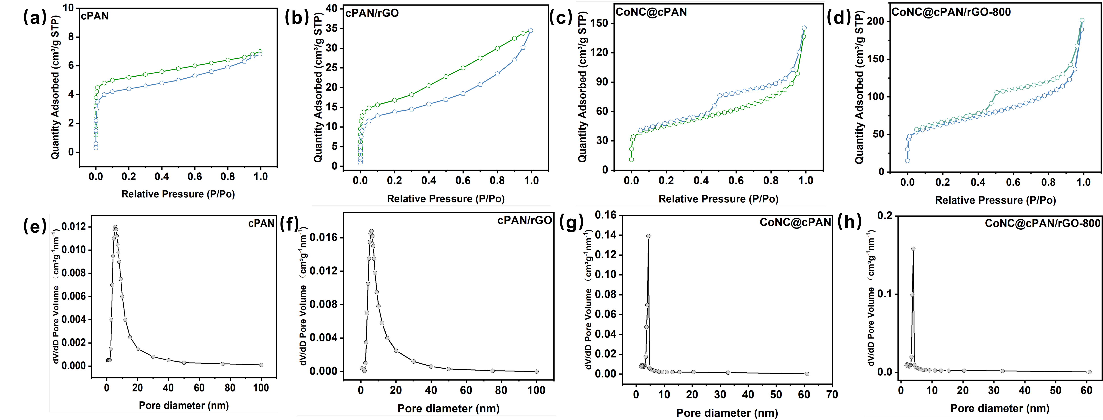

Fig. S3. The N₂ adsorption-desorption isotherm of cPAN (a), cPAN/rGO (b), CoNC@cPAN (c), CoNC@cPAN/rGO-800 (d); Pore size distribution curve of cPAN (e), cPAN/rGO (f), CoNC@cPAN (g), CoNC@cPAN/rGO-800 (h).

Fig. S4. Catalytic activity of CoNC@cPAN/rGO-800 at different temperatures of calcination
  - g/L catalyst, 10 mg/L SMX, 0.1 g/L PMS, pH=7).

Fig. S5. Variation of pH during the degradation of SMX in the CoNC@cPAN/rGO-800/PMS system

Fig. S6. Degradation of SMX with PMS (10 mg/L SMX, 0.1 g/L PMS, pH=7).
s
Fig. S7. Effect of SOD on the concentration of reactive species.

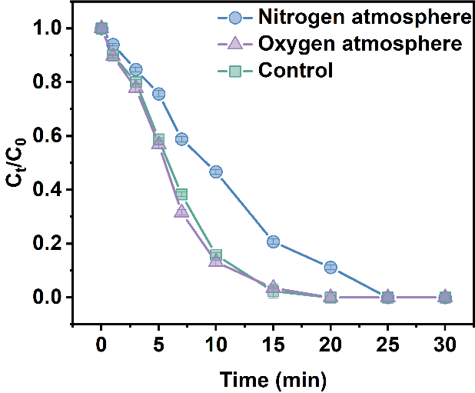

Fig. S8. Degradation of SMX by CoNC@PAN/rGO-800 in different gas atmospheres
(0.1 g/L catalyst, 10 mg/L SMX, 0.1 g/L PMS, pH=7).
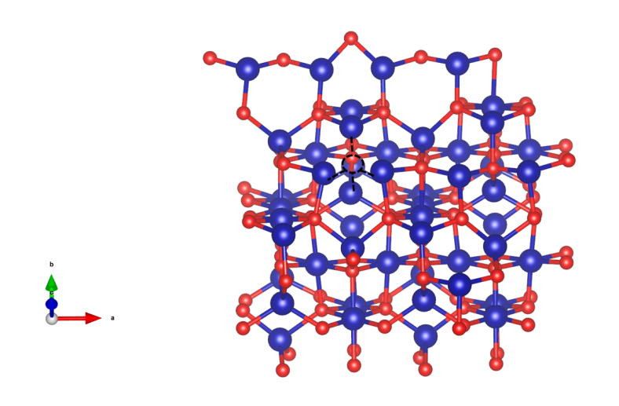

Fig. S9. Model for the O_{v}-Co₃O₄ (110) surface.
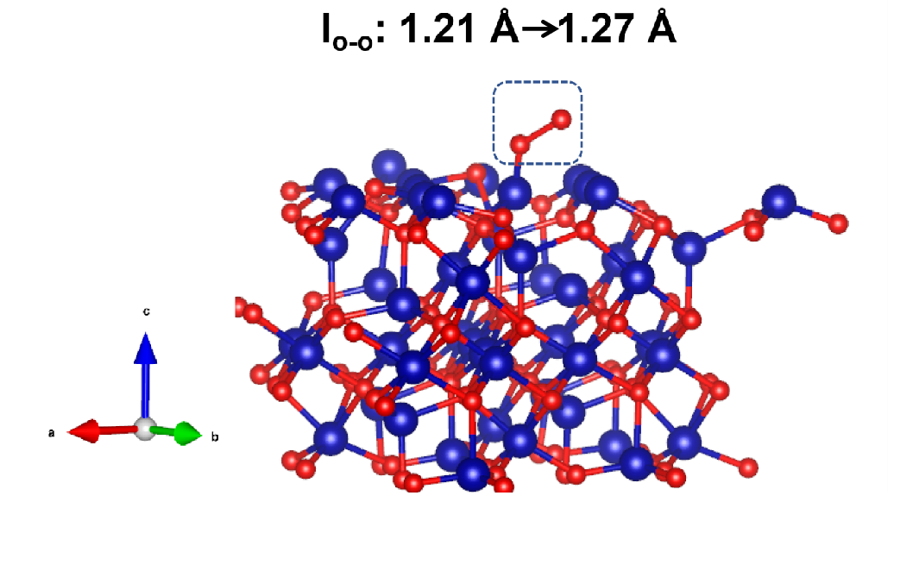

Fig. S10. Ov -Co₃O₄ (110) surface adsorbed O₂.
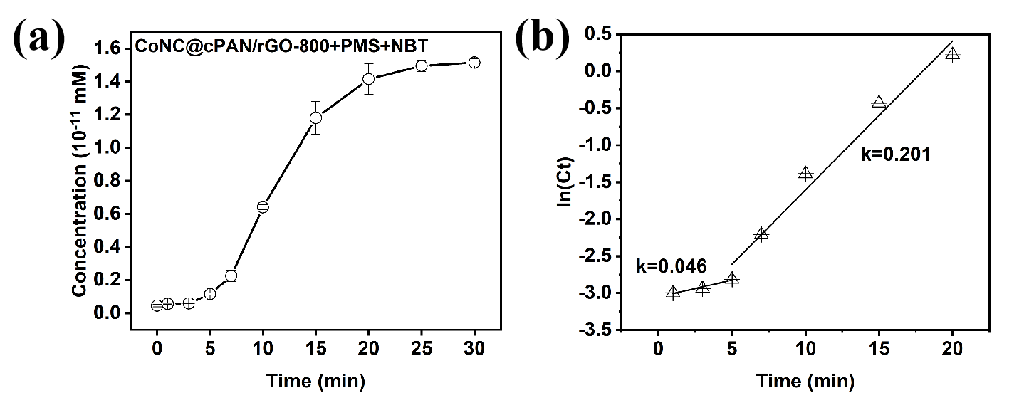

Fig. S11. (a) The concentration changing of O₂^{·-} in the NBT probe experiment; (b) Segment fitting results of O₂^{·-} generation process.

Fig. S12. The EPR spectra of O₂⁻ (CoNC@cPAN activated PMS).

Fig. S13. The effect of chelation of Co³⁺ by sodium pyrophosphate on the degradation efficiency of SMX.
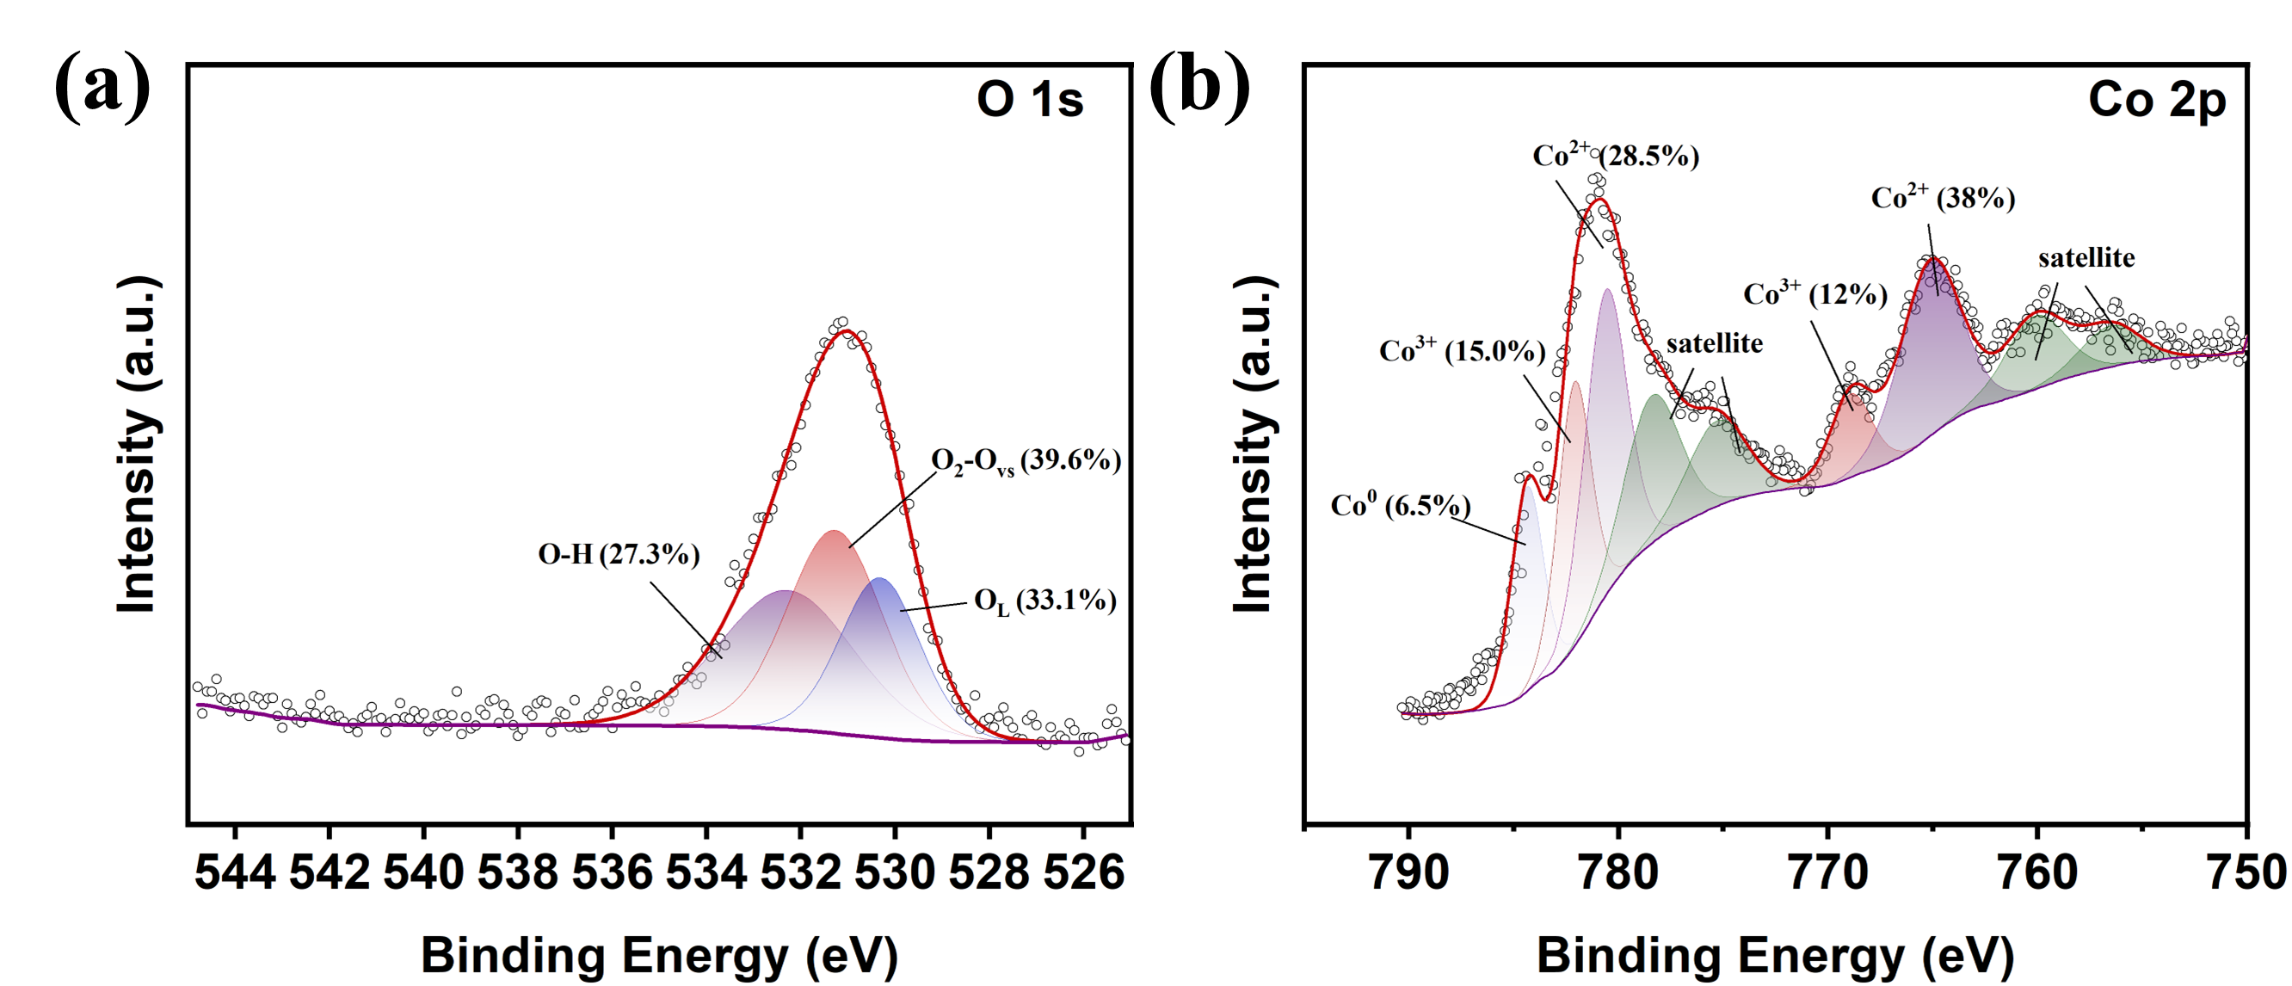

Fig. S14. The O 1s (a) and Co 2p (b) XPS spectra of CoNC@cPAN/rGO-800 after 8 cyclic degradation experiments.

Fig. S15. Magnetization hysteresis loop of CoNC@cPAN and CoNC@cPAN/rGO-800.

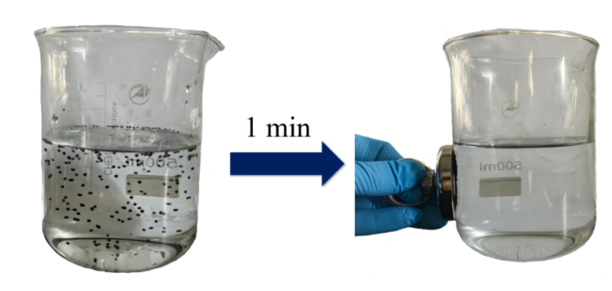

Fig. S16. Recovery of CoNC@cPAN/rGO-800 from solution by using a magnet.

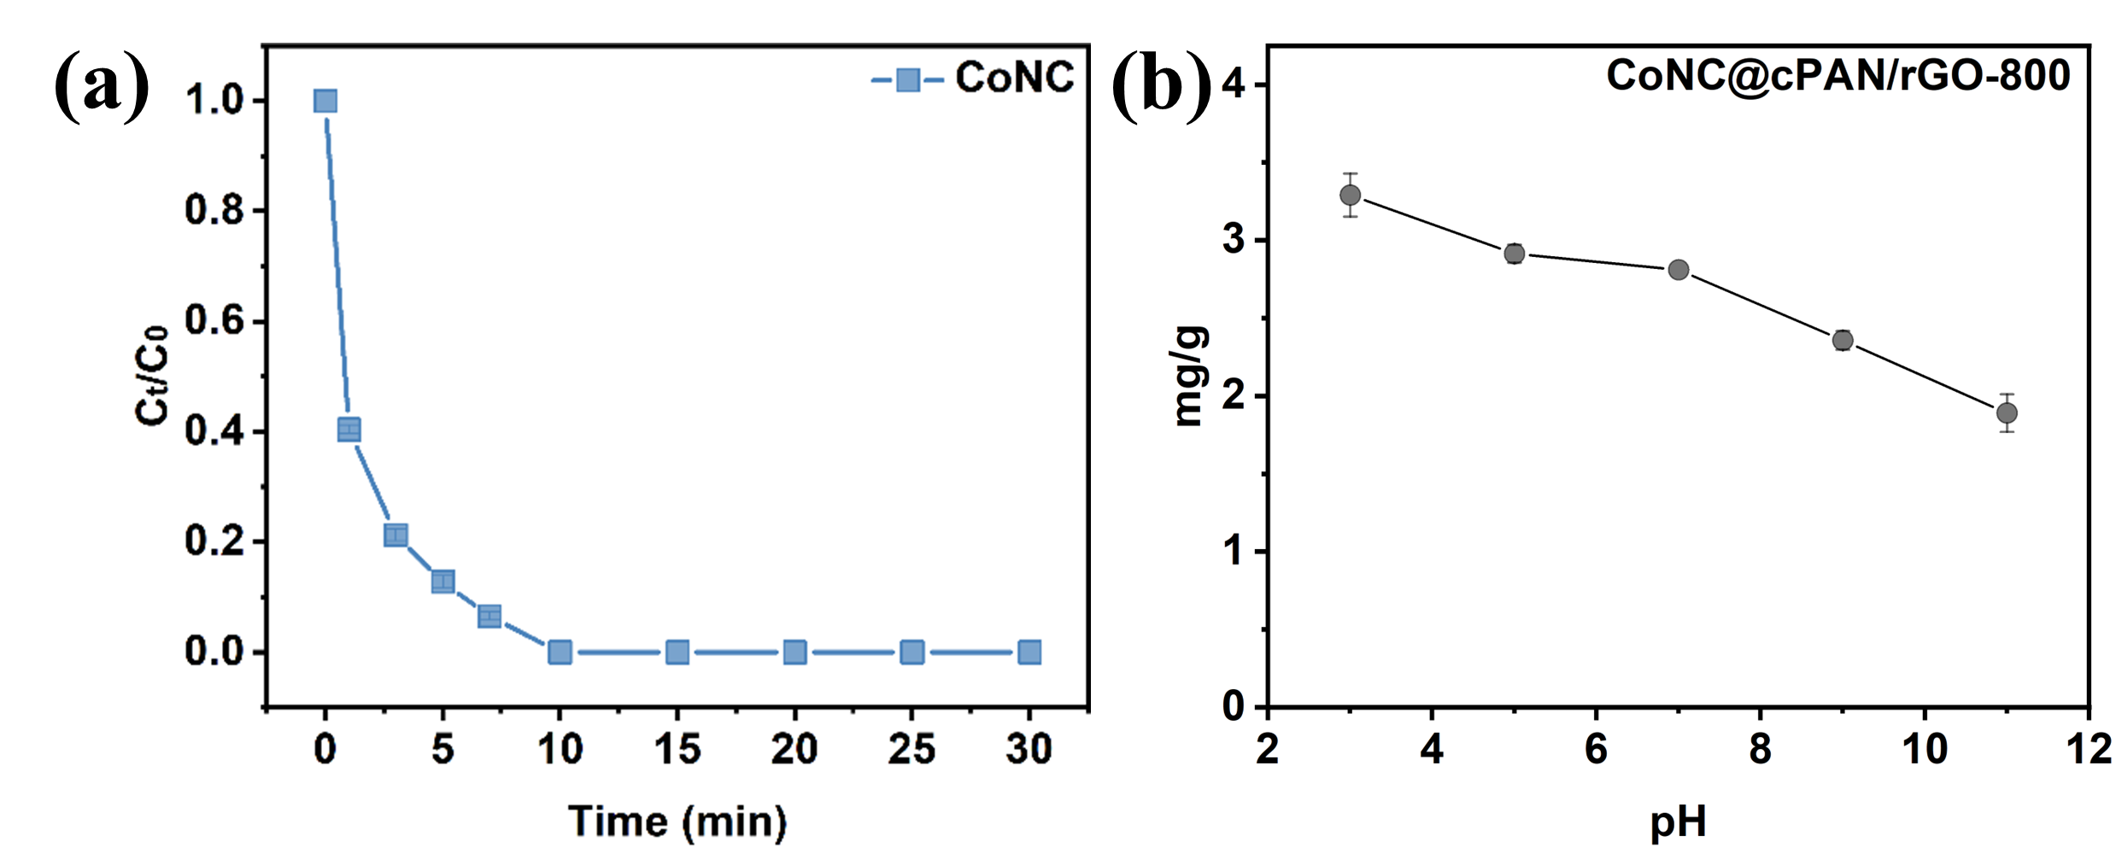

Fig. S17. The catalytic activity of CoNC in activating PMS for SMX degradation (0.1 g/L catalyst, 10 mg/L SMX, 0.1 g/L PMS, pH=7); (b) The metal leaching amount of CoNC@cPAN/rGO-800 at different pH values.

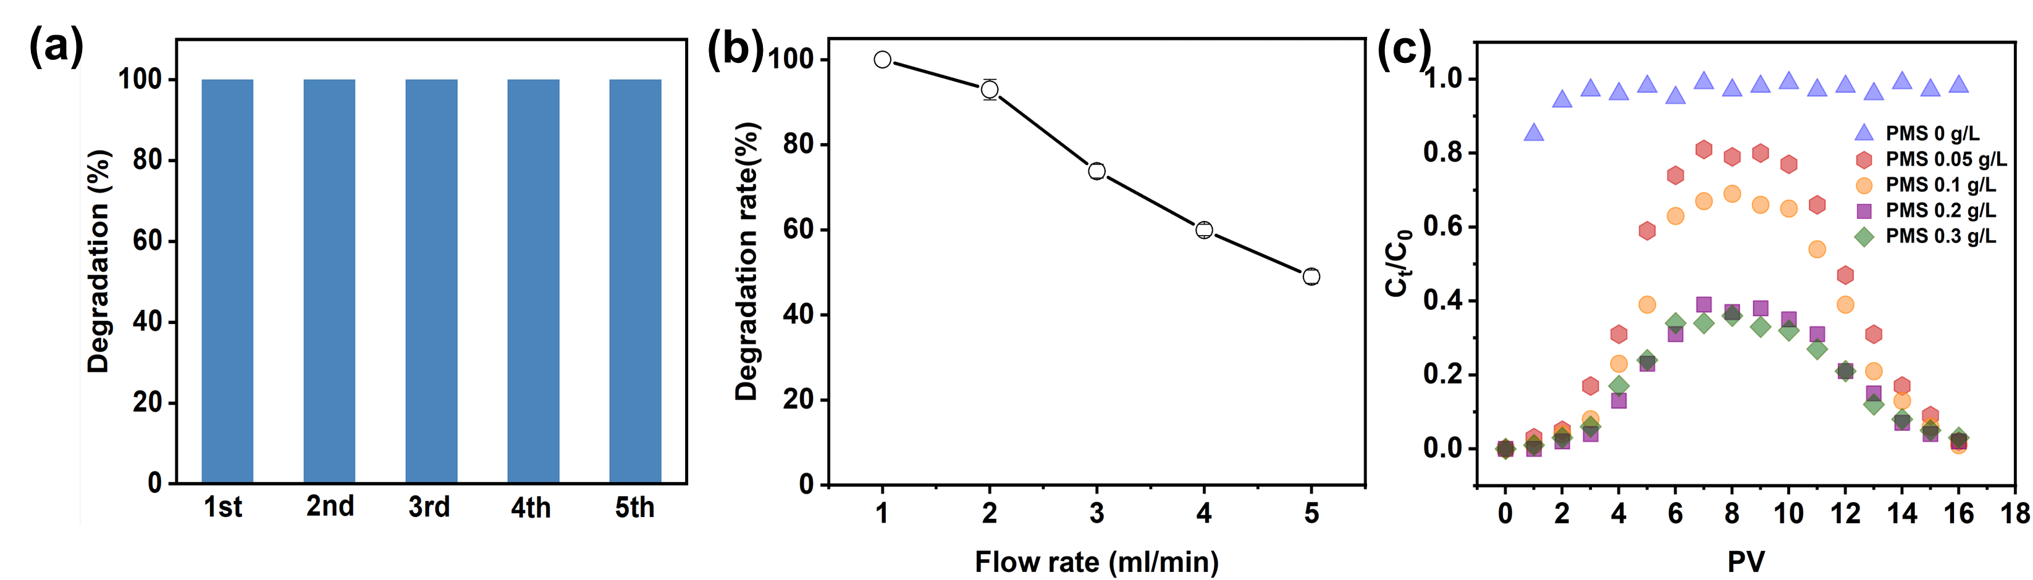 Fig. S18. (a) The degradation rate of SMX in column reactor under different cycles (10 mg/L SMX; 0.1 g/L PMS); (b) Degradation performance of the column reactor at different flow rates; (c) Breakthrough curves at different PMS concentrations.

Table S1. The relative ratio of different elements by XPS fitting.
Element |  | cPAN |  | cPAN/rGO |  | CoNC@cPAN |  | CoNC@cPAN/rGO-800
 |  | B.E. (eV) | ratio | B.E. (eV) | ratio | B.E. (eV) | ratio | B.E. (eV) | ratio
C | C-C | 284.8 | 57.98 | 284.8 | 44.96 | 284.8 | 46.66 | 284.8 | 60.1
C | C-O | 285.9 | 30.26 | 285.6 | 39.53 | 285.58 | 35.38 | 286.3 | 26.9
C | C=O | 288.0 | 8.79 | 288.18 | 11.35 | 288.57 | 8.64 | 289.12 | 9.00
C | π*←π shake-up | 290.7 | 2.94 | 291.49 | 4.17 | 291.41 | 6.32 | 291.77 | 4.00
N | Pyridinic N | 398.13 | 24.83 | 398.22 | 23.27 | 398.27 | 18.13 | 398.17 | 14.9
N | Pyrrole N | 399.3 | 28.32 | 399.01 | 24.20 | 399.58 | 26.80 | 398.96 | 12.8
N | Graphitic N | 400.72 | 39.47 | 400.77 | 44.62 | 401.26 | 48.23 | 400.95 | 64.7
N | Oxygen N | 403.82 | 6.80 | 404.53 | 7.91 | 405.02 | 6.84 | 404.97 | 7.6
O | —— | 532.23  (O _{ads} H₂O) | 77.25 | 532.29  (O _{ads} H₂O) | 81.13 | 532.88  (O-H) | 49.99 | 532.32  (O-H) | 43.57
O | —— | 534.23  (O _{ads} O₂) | 22.75 | 534.53  (O _{ads} O₂) | 18.87 | 533.81  （O_{v}） | 30.35 | 533.75  （O_{v}） | 45.83
O | O _{lattice} | —— | —— | —— | —— | 531.50 | 19.66 | 530.8 | 10.6
Co | Co⁰ | —— | —— | —— | —— | 778.54 | 15.23 | 778.28 | 16.56
Co | Co³⁺ | —— | —— | —— | —— | 779.52 | 32.71 | 779.17 | 30.40
Co | Co³⁺ | —— | —— | —— | —— | 793.70 | 14.81 | 793.58 | 15.00
Co | Co²⁺ | —— | —— | —— | —— | 781.65 | 26.96 | 781.22 | 15.82
Co | Co²⁺ | —— | —— | —— | —— | 797.05 | 10.62 | 796.83 | 22.22

Table S2. Water quality testing results from different sources
Samples | pH | BOD₅  (mg/L) | COD  (mg/L) | Cl⁻  (mg/L) | SO₄²⁻  (mg/L) | HCO₃⁻  (mg/L) | NO₃⁻  (min) | HPO₄²⁻  (mg/L) | DOC  （mg/L） | Turbidity  (NTU)
River | 8.2 | 0.8 | 5.1 | 19.3 | 5.0 | 4.6 | 1.9 | 0.03 | 2.1 | 1.9
Campus Lake | 8.8 | 1.3 | 4.3 | 15.6 | 7 | 2.7 | 0.7 | 0.01 | 1.9 | 3.8

Table S3. Comparison of catalytic SMX degradation performance of CoNC@cPAN/rGO-800 with related literatures.
Samples | Morphological | SMX  (mg/L) | Catalyst dose  (g/L) | pH | PMS dose  (g/L) | Time  (min) | Removal rate  (%) | Ref.
CoNC@cPAN/rGO-800 | Bead | 10 | 0.1 | 5.0 | 0.1 | 20 | 100% | This work
Co/Mn@LDH | Powder | 3 | 0.1 | 8.63 | 0.05 | 30 | Nearly 100% | [6]{Su, 2023 #88}
Fe⁰@Fe₃O₄-MC | Powder | 9.4 | 0.1 | 3.4 | 0.34 | 120 | 100% | [7]
Co₉S₈@S-N-RG | Powder | 1 | 0.2 | 3.4 | 0.09 | 20 | 100% | [8]
BOSBC | Powder | 5 | 0.1 | 3 | 0.011 | 60 | 98.6% | [9]
Co/MSCBs | Bead | 40 | 0.2 | 7 | 0.035 | 120 | 59.1% | [10]

Reference
[1] W.S. Hummers, Jr., R.E. Offeman, Preparation of Graphitic Oxide, Journal of the American Chemical Society, 80 (1958) 1339-1339.
[2] G. Kresse, J. Furthmüller, Efficiency of ab-initio total energy calculations for metals and semiconductors using a plane-wave basis set, Computational Materials Science, 6 (1996) 15-50.
[3] G. Kresse, J. Furthmüller, Efficient iterative schemes forab initiototal-energy calculations using a plane-wave basis set, Institut f&uuml;r Theoretische Physik, Technische Universit&auml;t Wien, Wiedner Hauptstraβe 8-10/136, A-1040 Wien, Austria Institut f&uuml;r Festk&ouml;rpertheorie und Theoretische Optik, Friedrich-Schiller-Universit&auml;t Jena, Max-, 54 (1996) 11169-11186.
[4] Y. Yang, J. Jiang, X. Lu, J. Ma, Y. Liu, Production of Sulfate Radical and Hydroxyl Radical by Reaction of Ozone with Peroxymonosulfate: A Novel Advanced Oxidation Process, Environmental Science & Technology, 49 (2015) 7330-7339.
[5] J. Hu, X. Xu, Y. Ji, H. Zhu, Y. Zhou, M. Zhu, Y. Huang, Role of Mn(III) intermediates in the degradation of carbamazepine via peroxymonosulfate activation by manganese single-atom catalysts: Radical and non-radical synergistic effects, Applied Catalysis B: Environment and Energy, 373 (2025) 125337.
[6] C. Su, N. Zhang, X. Zhu, Z. Sun, X. Hu, pH adjustable MgAl@LDH-coated MOFs-derived Co_{2.25}Mn_{0.75}O₄ for SMX degradation in PMS activated system, Chemosphere, 339 (2023) 139672.
[7] S. Wang, J. Wang, Synergistic effect of PMS activation by Fe⁰@Fe₃O₄ anchored on N, S, O co-doped carbon composite for degradation of sulfamethoxazole, Chemical Engineering Journal, 427 (2022) 131960.
[8] S. Wang, J. Hu, J. Wang, Degradation of sulfamethoxazole using PMS activated by cobalt sulfides encapsulated in nitrogen and sulfur co-doped graphene, Science of The Total Environment, 827 (2022) 154379.
[9] X. Chen, J. Zhu, Y. Ma, C. Zeng, R. Mu, Z. Deng, Z. Zhang, Facile synthesis of ball-milling and oxalic acid co-modified sludge biochar to efficiently activate peroxymonosulfate for sulfamethoxazole degradation: ¹O₂ and surface-bound radicals, Journal of Hazardous Materials, 465 (2024) 133026.
[10] J. Zheng, H. Sun, K. Li, Z. Wu, Catalytic micro-structured ceramic beads and efficacy evaluation through SMX degradation in PMS-activated systems, Separation and Purification Technology, 354 (2025) 129060.

