Supplementary Information
Microbial inorganic carbon fixation characteristics in the largest saline lake of China during the ice-covered period

Yixuan Han^{a,b*}, Fangzhong Shi^{a,b}, Xin Liu^{a,b}, Zhigang Wang^{a,b}, Rui Wang^{a,b}, Xiaoyan Li^{a,b*}

ª State Key Laboratory of Earth Surface Processes and Hazards Risk Governance (ESPHR), Faculty of Geographical Science, Beijing Normal University
^{b} School of Natural Resources, Faculty of Geographical Science, Beijing Normal University, Beijing, 100875, China

* To whom the correspondence should be addressed:
202331051068@mail.bnu.edu.cn (Yixuan Han), xyli@bnu.edu.cn (Xiaoyan Li). State Key Laboratory of Earth Surface Processes and Hazards Risk Governance (ESPHR), Faculty of Geographical Science, Beijing Normal University, 19 Xinjiekouwai Street, Beijing, 100875, China.

This Supplementary Material includes:
Figures S1 to S4
Materials and Method: Microbial diversity analysis.
Figures S1 - S4.
Reference

Materials and Method:
Microbial diversity analysis
PCR amplification was conducted targeting the V9 hypervariable region of eukaryotic 18S rRNA genes and the V3-V4 hypervariable regions of bacterial 16S rRNA genes. The detailed amplification parameters were as follows: an initial pre-denaturation step at 95°C for 2 min, followed by 25 cycles of denaturation at 95°C for 30 s, annealing at 55°C for 30 s, and extension at 72°C for 30 s, and concluding with a final extension step at 72°C for 5 min. The primers employed were: 18SV9F (5'-barcode-CCCTGCCNTTTGTACACAC-3'), 18SV9R (5'-CCTTCNGCAGGTTCACCTAC-3'), CYA359F (5'-barcode-GGGGAATYTTCCGCAATGGG-3'), and CYA781R (5'-barcode-GACTACWGGGGTATCTAATCCCWTT-3'), where barcode is an eight-base sequence unique to each sample. PCR reactions were performed in triplicate 20 μL mixture containing 4 μL of 5 × FastPfu Buffer, 2 μL of 2.5 mM dNTPs, 0.8 μL of each primer (5 μM), 0.4 μL of FastPfu Polymerase, and 10 ng of template DNA. Amplicons were extracted from 2% agarose gels and purified using the AxyPrep DNA Gel Extraction Kit (Axygen Biosciences, Union City, CA, U.S.) according to the manufacturer’s instructions.
Processing of sequencing data
Raw fastq files were first demultiplexed using Trimmomatic (Bolger et al., 2014) (http://www.usadellab.org/cms/uploads/supplementary/Trimmomatic) and in-house perl scripts according to the barcode sequences information for each sample with the following criteria: (i) the 300 bp reads were truncated at any site receiving an average quality score <20 over a 10 bp sliding window, discarding the truncated reads that were shorter than 50 bp, (ii) exact barcode matching, 2 nucleotide mismatch in primer matching, reads containing ambiguous characters were removed, (iii) only sequences that overlap longer than 10 bp were assembled according to their overlap sequence. Reads which could not be assembled were discarded.
Passed sequences were dereplicated and subjected to the DADA2 algorithm (QIIME 2 recommended) to identify indel-mutations and substitutions (Callahan et al., 2016). The trimming and filtering were performed on paired reads with a maximum of two expected errors per read (maxEE = 2). After merging paired reads and chimera filtering, the phylogenet-ic affiliation of each 16S and 18S gene sequence (herein called ASVs) were analyzed by uclust algorithm (Edgar, 2010) (16S: https://github.com/topics/uclust) (18S: http://www.drive5.com/usearch/manual/uclust_algo.html) against the Silva (SSU138.2) database (default) using confidence threshold of 80%(Quast et al., 2013).
After ASVs generation, the analysis of the 16S rDNA data were operated by CFViSA plantform (http://www.cloud.biomicroclass.com/en/CFViSA), which contained microbiome analysis pipeline and nearly 80 analysis tools spanning simple sequence processing, visualization, and statistics available for the amplicon sequencing data. ASVs belonging to phytoplankton were binned separately using an in-house R script,and then the taxonomic names at phylum level were rematched(Kim and Chun, 2014; Sun et al., 2023). Finally, the phytoplankton ASV abundance tables were normalized using a standard number of reads according to the sample with the least number of reads.

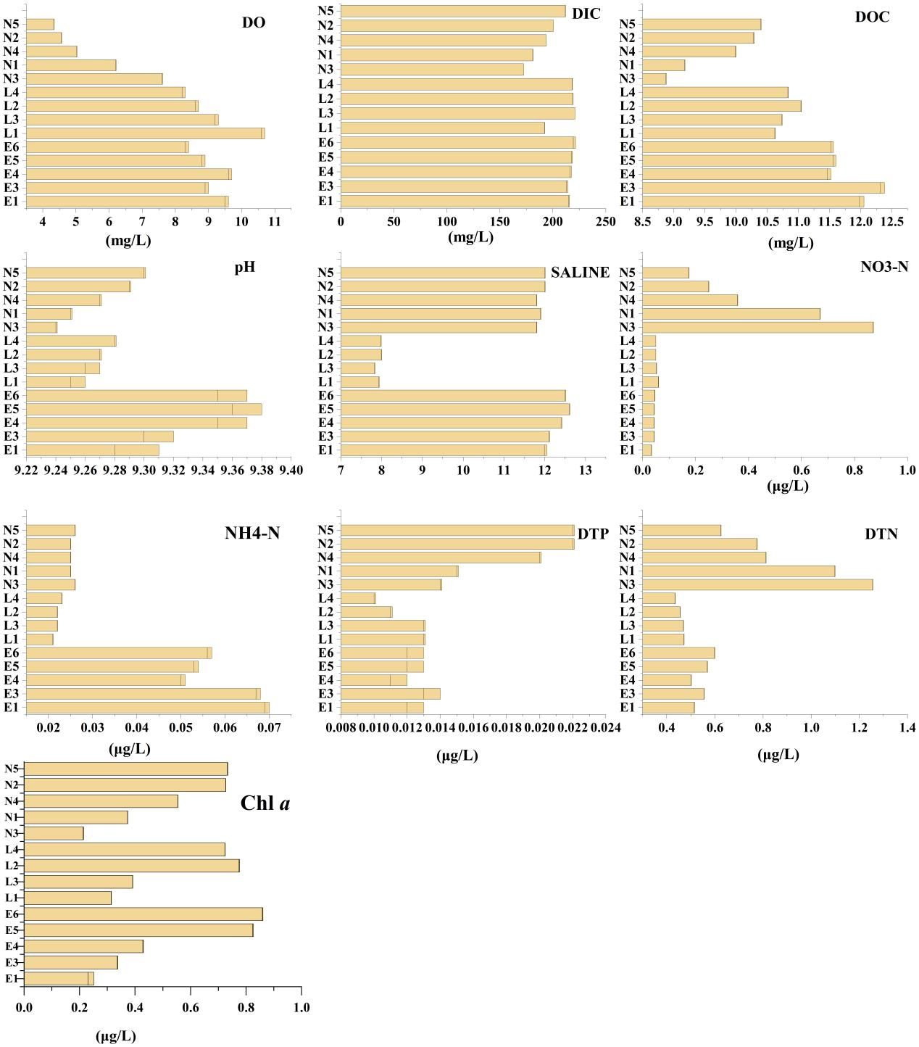

Fig. S1. The physicochemical parameters of the studied lake water samples in this study.
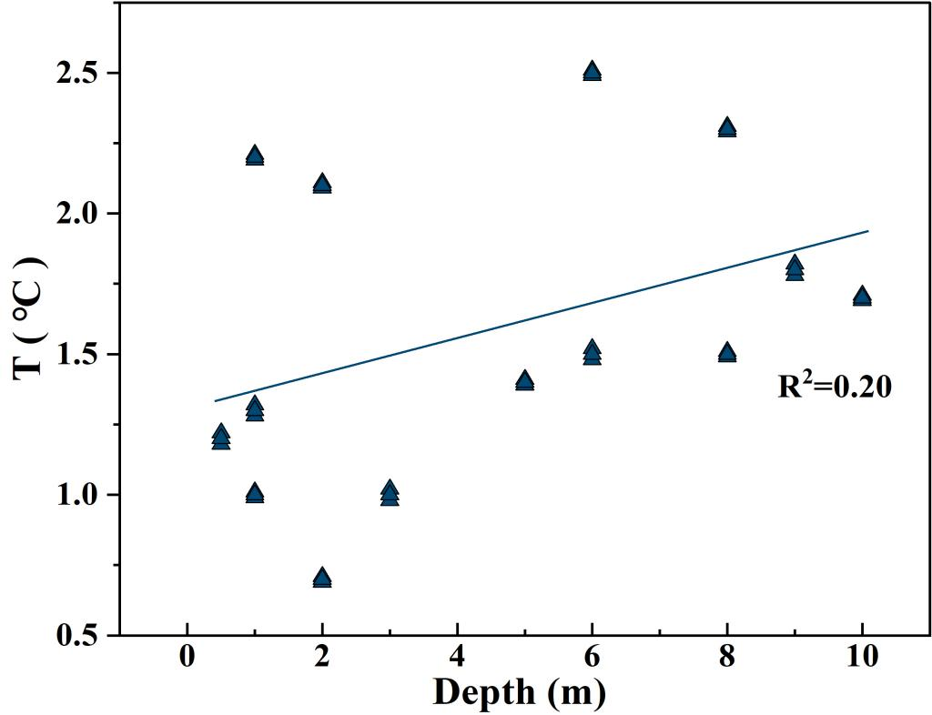
Fig. S2. Linear regression analysis showing correlations between the Temperature and depth in the studied saline lake water samples.

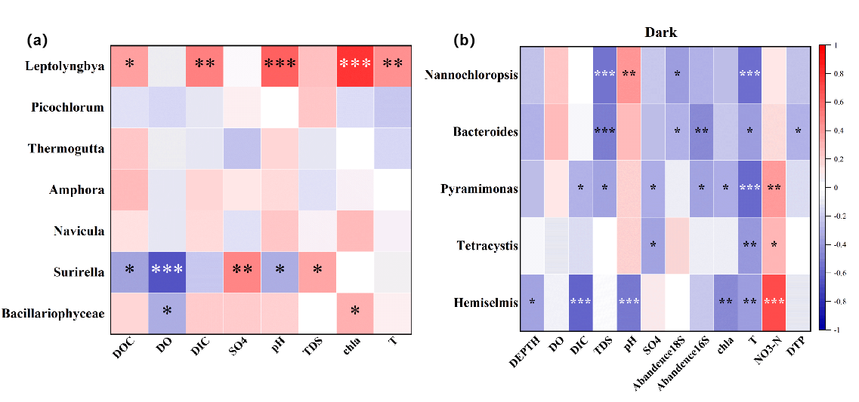
Fig. S3. Spearman correlation analysis between genera related to carbon fixation rate of light and dark microorganisms and environmental factors.

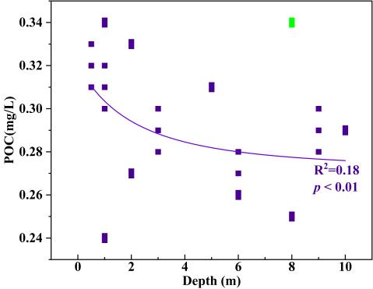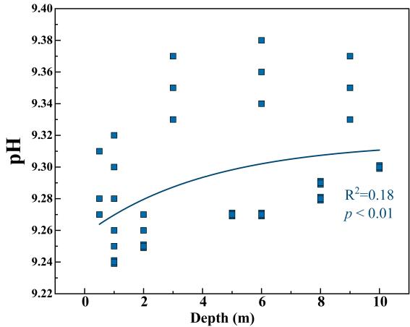
(b)
(a)

Fig. S4. Nonlinear regression analysis shows the correlation between POC concentration (a), pH(b) and depth in the studied salt lake water samples.
Reference
Bolger, A., Lohse, M., Usadel, B., 2014. Trimmomatic: a flexible trimmer for Illumina sequence data. BIOINFORMATICS 30, 2114–2120. https://doi.org/10.1093/bioinformatics/btu170
Callahan, B., McMurdie, P., Rosen, M., Han, A., Johnson, A., Holmes, S., 2016. DADA2: High-resolution sample inference from Illumina amplicon data. NATURE METHODS 13, 581. https://doi.org/10.1038/NMETH.3869
Edgar, R., 2010. Search and clustering orders of magnitude faster than BLAST. BIOINFORMATICS 26, 2460–2461. https://doi.org/10.1093/bioinformatics/btq461
Kim, M., Chun, J., 2014. 16S rRNA Gene-Based Identification of Bacteria and Archaea using the EzTaxon Server, in: Goodfellow, M., Sutcliffe, I., Chun, J. (Eds.), NEW APPROACHES TO PROKARYOTIC SYSTEMATICS. pp. 61–74. https://doi.org/10.1016/bs.mim.2014.08.001
Quast, C., Pruesse, E., Yilmaz, P., Gerken, J., Schweer, T., Yarza, P., Peplies, J., Glöckner, F., 2013. The SILVA ribosomal RNA gene database project: improved data processing and web-based tools. NUCLEIC ACIDS RESEARCH 41, D590–D596. https://doi.org/10.1093/nar/gks1219
Sun, Y., Li, H., Wang, X., Jin, Y., Nagai, S., Lin, S., 2023. Phytoplankton and Microzooplankton Community Structure and Assembly Mechanisms in Northwestern Pacific Ocean Estuaries with Environmental Heterogeneity and Geographic Segregation. MICROBIOLOGY SPECTRUM 11. https://doi.org/10.1128/spectrum.04926-22

