Table 5 : Analysis of variance (Anova) of the cost of caesarean section according to type of health facility
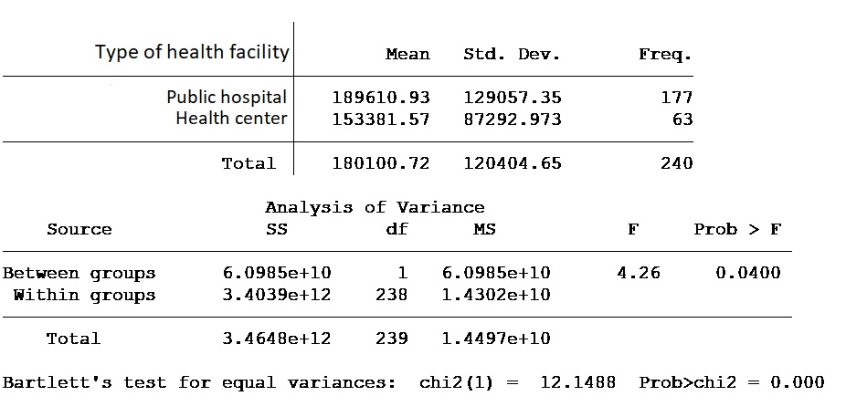
Table 6 : Analysis of variance (Anova) of the cost of caesarean section according to the woman's department of residence
