Experimental study on corrosion inhibition of mild steel using Mukia maderaspatana leaves extract as green inhibitor

KV Radha ^{1*}, Deepanshu Patel ¹, Varshith Vijayan Nithya ¹, Dharmaraj Saravanan ¹.

¹ Department of Chemical Engineering, Alagappa College of Technology, Anna University, Guindy, Chennai, Tamil Nadu 600025.

Number of pages 3 and List of Figures as:

Fig.S1. Corrosion rate measurements in absence of inhibitor.
Fig.S2. Corrosion rate measurements in presence of 2% (v/v) inhibitor.
Fig.S3. Corrosion rate measurements in presence of 4% (v/v) inhibitor.
Fig.S4. Corrosion rate measurements in presence of 6% (v/v) inhibitor.
Fig.S5. Corrosion rate measurements in presence of 8% (v/v) inhibitor.

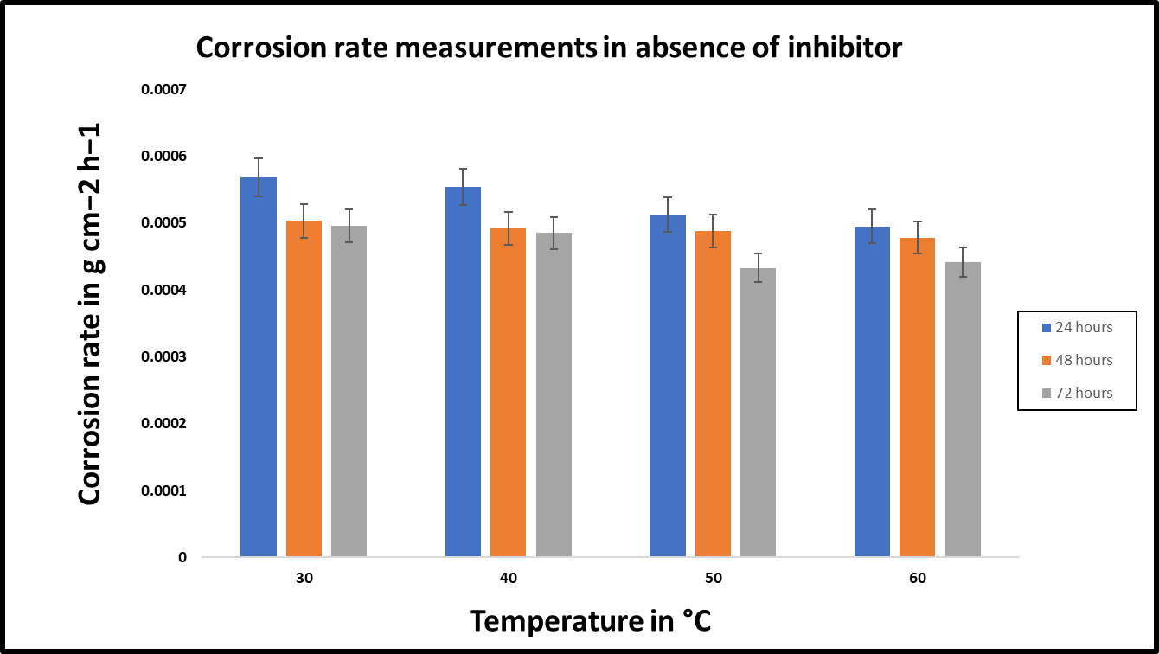

Fig.S1. Corrosion rate measurements in absence of inhibitor.

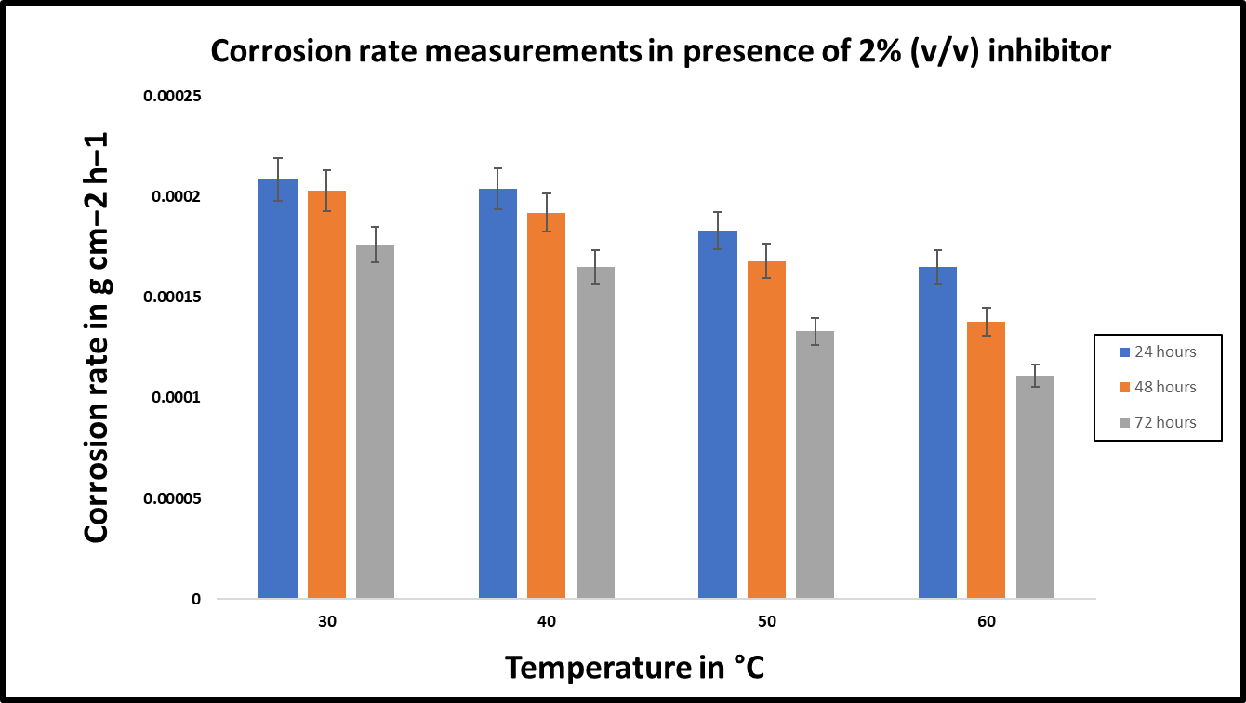
Fig.S2. Corrosion rate measurements in presence of 2% (v/v) inhibitor.

Fig.S3. Corrosion rate measurements in presence of 4% (v/v) inhibitor.

Fig.S4. Corrosion rate measurements in presence of 6% (v/v) inhibitor

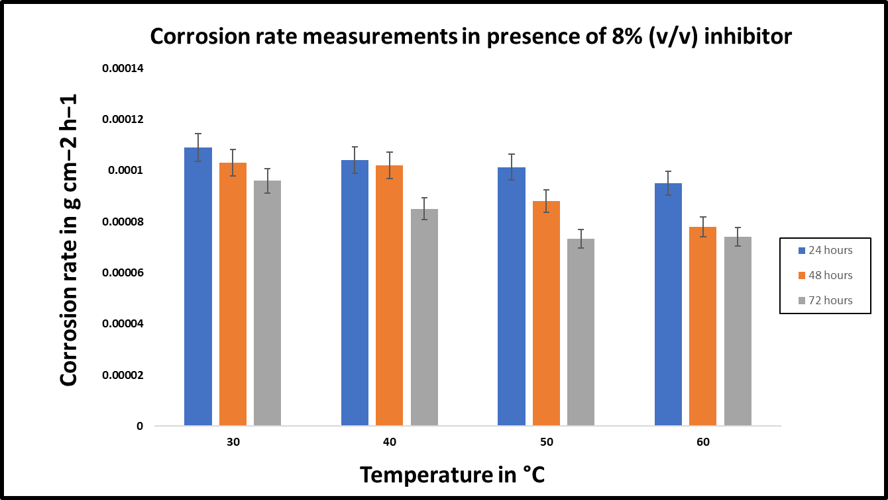
Fig.S5. Corrosion rate measurements in presence of 8% (v/v) inhibitor.

