Supplementary Figures and Tables legend

Supplementary Table 1. Inclusion and Exclusion criteria

Supplementary Figure 1. Lung Ultrasound Scoring tool

Supplementary Figure 2. The clinical edema scoring tool

Supplementary Table 2. Summarised lung ultrasound score and clinical edema score at each time point
Supplementary Table 3. Summarised changes in lung ultrasound score, body weight, clinical edema scores, and fluid balance at each time interval
Supplementary Figure 4. Distribution of Lung Ultrasound Scores at Baseline, 24 hours and 48 hours
Supplementary Figure 5. Distribution of the change in Lung Ultrasound Scores between baseline and 24 hours and 24 and 48 hours.
Supplementary Figure 6. Comparison of the lung ultrasound score for each lung zone at baseline, 24 and 48 hours
Supplementary Figure 7. Lung Ultrasound Score for each lung zone within each lung at all time points
Supplementary Table 4. Mean lung ultrasound scores for each lung zone over the study period (n = 302 lung zones)
Supplementary Table 5. Linear mixed effects regression analysis for the association between a clinical oedema score and lung ultrasound score
Supplementary Table 6. Mixed linear effects regression analysis for the association between changes in body weight, fluid balance and lung ultrasound score.
Supplementary Table 7. Change in the clinical edema score, body weight and fluid balance when there was no change in lung ultrasound score (n = 15 time intervals)

Supplementary Table 1. Inclusion and Exclusion criteria

Inclusion criteria

Mechanically ventilated at enrolment or expected to be intubated upon elective PICU admission
Enrolled within 72 hours of PICU admission or return from theatre
Expected to be mechanically ventilated until the day after tomorrow
Expected to have arterial or venous access for 48 hours after enrolment
Can be safely and accurately weighed
Exclusion criteria

Unable to be weighed safely
Children expected to stay in PICU less than 48 hours
Cerebral venous obstruction/proximal upper limb, upper leg venous obstruction or thrombosis
Ocular/facial injury/Surgery
Prone positioning in the 6 hours prior to enrolment
Known protein losing states – e.g., Nephrotic syndrome, protein losing enteropathy, lymphangiectasia
Prior enrolment in the same study
COVID-19 positive or clinical suspicion of COVID-19

Supplementary Figure 1. Lung Ultrasound Scoring tool

Lung Ultrasound Score | Definition
0 | Presence of A lines only
1 | Presence of 1 or 2 well-spaced B-lines
2 | Presence of ≥3 well-spaced B-lines or coalescent B lines
3 | Presence of consolidation limited to the subpleural space or any pleural effusion

Supplementary Figure 2. The clinical edema scoring tool

Case Report Form - Clinician Assessment | Med 1/med 2/ nurse
Date/Time
Patient
UR
Oedema Score
Eyelid
none | 0
mild | 1
mod | 2
severe | 3
Upper Limb
none | 0
mild | 1
mod | 2
severe | 3
Hands
none | 0
mild | 1
mod | 2
severe | 3
Torso
none | 0
mild | 1
mod | 2
severe | 3
Lower Limb
none | 0
mild | 1
mod | 2
severe | 3
Feet
none | 0
mild | 1
mod | 2
severe | 3
total score out of 18

Circumferences: Upper Arm ______ __ Leg _______
Eyelid
0 None – preserved eyelid creases/normal eyelids
1 Mild – loss of normal eyelid creases can easily open eye complete iris visible
2 Moderate – some restricted eye opening, moderate retraction to visualise whole iris
3 Severe – very restricted eye opening, unable to visualise complete iris
Limbs
0 None – no oedema
1 Mild – loss of normal skin creases
2 Moderate – fullness of tissues, some pitting
3 Severe – significant pitting

Supplementary Table 2. Summarized lung ultrasound score and clinical edema score at each time point

Time | Lung Ultrasound Score | Clinical Edema Score
Baseline | n = 53  mean (sd) = 8.7 (3.7)  median (IQR) = 9 (6 – 11) | n = 53  mean (sd) = 5.0 (3.7)  median (IQR) = 4 (2 – 8)
24 hours | n = 52  mean (sd) = 9.2 (4.2)  median (IQR) = 10 (6 – 11) | n = 53  mean (sd) = 5.5 (4.1)  median (IQR) = 4 (2 – 9)
48 hours | n = 46  mean (sd) = 9.1 (3.4)  median (IQR) = 9 (6 – 11) | n = 53  mean (sd) = 3.8 (4.0)  median (IQR) = 2 (0 – 7)

Supplementary Table 3. Summarized changes in lung ultrasound score, body weight, clinical edema scores, and fluid balance at each time interval

Time | Lung Ultrasound Score (change) | Body weight (gm) (change) | Clinical Edema Score (change) | Fluid balance (ml) (change)
Baseline to 24 hours | n = 52  mean (sd) = 0.6 (2.9)  median (IQR) = 0.5 (-1 – 2) | n = 53  mean (sd) = -13 (164)  median (IQR) = -17 (-145 – 106) | n = 53  mean (sd) = 0.5 (3.0)  median (IQR) = 0 (-1 – 2) | n = 53  mean (sd) = -70 (182)  median (IQR) = -83 (-174 – 31)
24 to 48 hours | n = 46  mean (sd) = -0.6 (3.6)  median (IQR) = 0 (-3 – 2) | n = 53  mean (sd) = -137 (154)  median (IQR) = -110 (-248 – -33) | n = 53  mean (sd) = -1.7 (3.7)  median (IQR) = -2 (-3 – 0) | n = 53  mean (sd) = -88 (277)  median (IQR) = -109 (-263 – 97)

Supplementary Figure 4. Distribution of Lung Ultrasound Scores at Baseline, 24 hours and 48 hours

Baseline (n = 53)
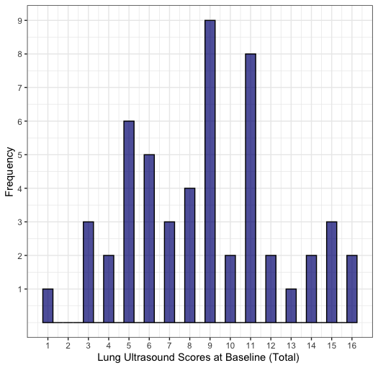
24 hours (n = 52)
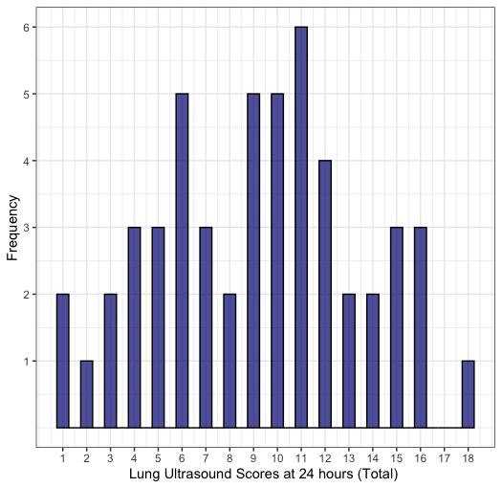
48 hours (n= 46)
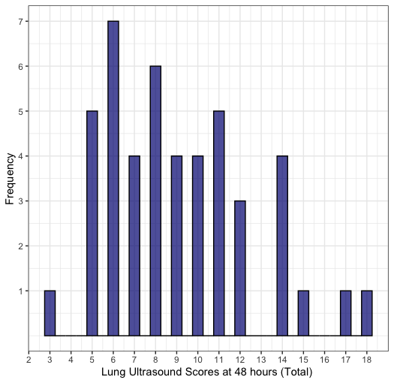

Supplementary Figure 5. Distribution of the change in Lung Ultrasound Scores between baseline and 24 hours and 24 and 48 hours.
Baseline to 24 hours (n = 52)
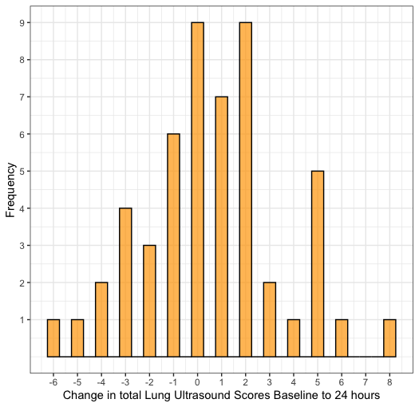
24 to 48 hours (n = 46)
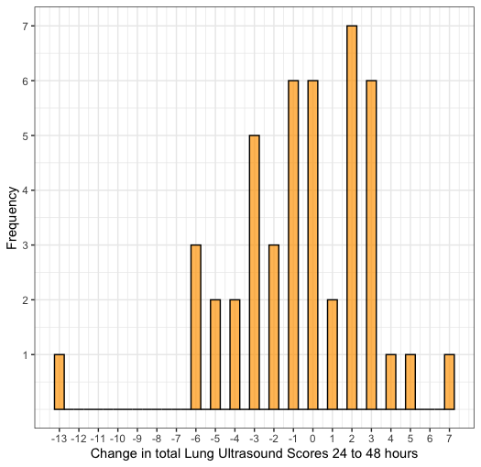

Supplementary Figure 6. Comparison of the lung ultrasound scores for each lung zone at baseline, 24 and 48 hours

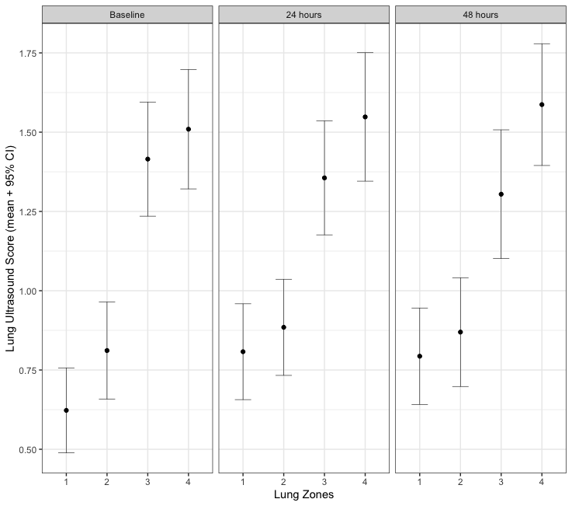
CI confidence Interval: Each lung zone incorporates scores from both left and right lung for each time point. Zone 1; superior in the mid-clavicular line, zone 2; inferior in the mid clavicular line, Zone 3; superior in the mid-axillary line and Zone 4 inferior in the mid axillary line aiming to capture the costo-diaphragmatic angle. n = 1208 individual lung zones

Supplementary Figure 7. Lung Ultrasound Score for each lung zone within each lung at all time points
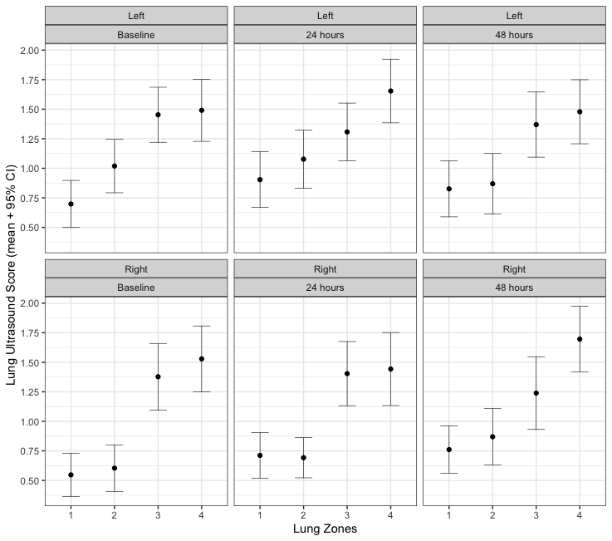
CI confidence interval; Error bars represent the individual 95%CI around the mean; mean lung ultrasound scores were compared between lung zones at baseline, 24 and 48 using linear mixed effects models. In pairwise comparison of estimated marginal means the lung ultrasound score for Zone 2 compared to Zone 1 was 0.1 [95%CI -0.03-0,3];p = 0.12. All other comparisons of lung ultrasound scores showed a statistically significant difference between zones (p<0.02) when accounting for repeated measures within each lung and at each time point. There was no evidence of interaction between zone, lung and time (not reported) n = 1208 individual lung zones

Supplementary Table 4. Mean lung ultrasound scores for each lung zone over the study period (n = 302 lung zones)

Lung Zone | Left Lung | Right lung
Zone 1 mean (SD) | 0.8 (-0.8) | 0.7 (-0.7)
Zone 2 mean (SD) | 1.0 (-0.9) | 0.7 (-0.7)
Zone 3 mean (SD) | 1.4 (-0.9) | 1.3 (-1.0)
Zone 4 mean (SD) | 1.5 (-0.9) | 1.6 (-1.0)

Supplementary Table 5. Linear mixed effects regression analysis for the association between a clinical oedema score and lung ultrasound score

Variable | Unadjusted |  |  |  |  | Adjusted^{b}
 | Coefficient | 95% CIª | p value |  |  | Coefficient | 95% CIª | p value
Clinical oedema score | 0.1 | -0.02 – 0.3 | 0.1 |  |  | 0.2 | -0.01 – 0.3 | 0.06
Covariates
Time (Reference baseline)
24 hour | 0.6 | -0.4 – 1.5 | 0.24 |  |  | 0.5 | -0.4 – 1.4 | 0.27
48 hour | 0.2 | -0.8 – 1.1 | 0.75 |  |  | 0.4 | -0.6 – 1.4 | 0.44
RACHS^{c} (% Risk of death) | 0.1 | -0.4 – 0.5 | 0.81 |  |  | -0.2 | -0.7 – 0.2 | 0.34
Cardiopulmonary bypass (hr) | 0.5 | 0.1 – 1.0 | 0.03 |  |  | 0.7 | 0.2 – 1.3 | 0.01
Peritoneal Dialysis^{d} | -0.4 | -2.3 – 1.4 | 0.64 |  |  | -1.3 | -3.2 – 0.6 | 0.17
Effect estimates represent the mean change in lung ultrasound score for each point change in the clinical oedema score
ª confidence interval
^{b} Effect estimate is adjusted for all other variables in this table
^{c} Risk Adjustment for Congenital Heart Surgery - each unit represents 10 percentage points
^{d} Peritoneal dialysis within 48 hours from enrolment

Supplementary Table 6. Mixed linear effects regression analysis for the association between changes in body weight, fluid balance and lung ultrasound score.

Variable | Change in Body Weight |  |  | Change in Fluid Balance^{b}
 | Unadjusted | Adjusted^{b} |  | Unadjusted | Adjusted^{b}
 | Coefficient [95% CIª] |  |  | Coefficient [95% CIª]
Change in value | 0.4 [-0.02 – 0.7] | 0.3 [-0.1– 0.7] |  | 0.1 [-0.2 – 0.4] | 0.1 [-0.2 – 0.4]
Covariates
Time [Reference 0-24 hour]
24-48 hour | -1.2[-2.5 – 0.2] | -0.7[-2.1 – 0.7] |  | -1.2[-2.5 – 0.2] | -1.1[-2.4 – 0.2]
Lung ultrasound score (time 0) | -0.3 [-0.4 – -0.1]* | -0.2 [-0.4 – -0.03]* |  | -0.3 [-0.4 – -0.1]* | -0.2 [-0.4 – -0.04]*
RACHS^{c} (% Risk of death) | -0.1 [-0.4 – 0.2] | -0.1 [-0.4 – 0.2] |  | -0.1 [-0.4 – 0.2] | -0.1 [-0.4 – 0.3]
Cardiopulmonary bypass (hr) | -0.2 [-0.6 – 0.2] | 0.01 [-0.4 – 0.5] |  | -0.2 [-0.6 – 0.2] | 0 [-0.5 – 0.5]
Peritoneal Dialysis^{d} | -0.8 [-2.2 – 0.5] | -1.0 [-2.3 – 0.4] |  | -0.8 [-2.2 – 0.5] | -0.8 [-2.1 – 0.6]
Effect estimates represent the mean change in lung ultrasound score for each 100gm change in body weight or 100ml change in fluid balance
ª confidence interval
^{b} Effect estimate is adjusted for all other variables in this table
^{c} Risk Adjustment for Congenital Heart Surgery – each unit represents 10 percentage points
^{d} Peritoneal dialysis within 48 hours from enrolment
*P<0.05
**P<0.001

Supplementary Table 7. Change in the clinical edema score, body weight and fluid balance when there was no change in lung ultrasound score (n = 15 time intervals)

Variable | Baseline to 24 hours | 24 to 48 hours
Clinical edema score mean (sd) | 1.6 (3.3) | -2.0 (4.4)
Body weight (%) mean (sd) | -1.4 (3.2) | -3.0 (2.9)
Fluid balance (%) mean (sd) | -2.6 (6.6) | -1.4 (8.7)

R packages used in these analysis

lme4’ (lmer)
lmerTest
emmeans
performance
parameters
merDeriv
psych
Hmisc
Tidyverse
Pheatmap

