SUPPLEMENTARY INFORMATION
Efficacy and safety of sedation with dexmedetomidine in critically ill mechanically ventilated children: a systematic review and meta-analysis of randomized controlled trials
David J. Zorko, MD MSc*¹; Jennifer A. Klowak, MD MSc*^{2,3}; Michael Vu, MD⁴; Yen-Mei Z. Mayer, MB BCh candidate⁵; Alexandra Pysklywec, BASc⁶; Kimberley Lewis, MD MSc^{7,8}; and Karen Choong, BCh MB MSc^{1,8}

*These authors contributed equally as first authors.
¹ Division of Pediatric Critical Care, Department of Pediatrics, McMaster University, Hamilton, Canada
² Division of Critical Care, Department of Pediatrics, Children’s Hospital of Eastern Ontario, Ottawa, Canada
³ Department of Pediatrics, Alberta Children’s Hospital, Calgary, Canada
⁴ Michael G. DeGroote School of Medicine, McMaster University, Hamilton, Canada
⁵ School of Medicine, Royal College of Surgeons, Dublin, Ireland
⁶ Department of Public Health Sciences, Queen's University, Kingston, Canada
⁷ Department of Medicine, McMaster University, Hamilton, Canada
⁸ Department of Health Research Methods, Evidence, and Impact, McMaster University, Hamilton, Ontario, Canada

TABLE OF CONTENTS
Online Resource 1. Search strategies 2
Online Resource 2. Risk of bias summary 6
Online Resource 3. Evidence profile 8
Online Resource 4. Sedation target outcome analysisª 11
Online Resource 5. Sedation burden outcome analysisª 12
Online Resource 6. Forest plots 13
Online Resource 7. Summarized author definitions of adverse events 16
Online Resource 8. Subgroup analyses 17

Online Resource 1. Search strategies
A. Medline (January 25, 2021)
Line | Search | Result
1 | exp Critical Care/ | 59428
2 | exp Critical Illness/ | 30683
3 | exp Intensive Care Units/ | 87957
4 | exp Respiration, Artificial/ | 79160
5 | acute care.mp. | 23298
6 | Critical care.mp. | 75294
7 | Critical* ill*.mp. | 63868
8 | ICU.mp. | 61662
9 | PICU.mp. | 4984
10 | Intensive care.mp. | 185230
11 | Intubat*.mp. | 87506
12 | Ventilat*.mp. | 194962
13 | Respiratory care unit*/mp. | 710
14 | 1 or 2 or 3 or 4 or 5 or 6 or 7 or 8 or 9 or 10 or 11 or 12 or 13 | 524626
15 | exp Pediatrics/ | 59282
16 | exp Child/ | 1940693
17 | exp Adolescent/ | 2063074
18 | exp Infant/ | 1154675
19 | child*.mp. | 2497627
20 | P?ediatric*.mp. | 425102
21 | adol*.mp. | 2147352
22 | Infan*.mp. | 1309864
23 | Teen*.mp. | 31770
24 | Youth*.mp. | 85808
25 | Preschool*.mp. | 938639
26 | Toddler*.mp. | 11834
27 | 15 or 16 or 17 or 18 or 19 or 20 or 21 or 22 or 23 or 24 or 25 or 26 | 4216287
28 | exp Dexmedetomidine/ | 3837
29 | exp Adrenergic alpha-Agonists/ | 162566
30 | dexmedetomidine.mp. | 6610
31 | sedat*.mp. | 80343
32 | Adrenergic alpha-agonists.mp. | 11027
33 | 28 or 29 or 30 or 31 or 32 | 239067
34 | 14 and 27 and 33 | 4724

B. CENTRAL (January 25, 2021)
Line | Search | Result
1 | MeSH descriptor: [Critical Care] explode all trees | 2071
2 | MeSH descriptor: [Critical Illness] explode all trees | 2295
3 | MeSH descriptor: [Intensive Care Units] explode all trees | 3633
4 | MeSH descriptor: [Respiration, Artificial] explode all trees | 6248
5 | MeSH descriptor: [Adrenergic alpha-Agonists] explode all trees | 1132
6 | MeSH descriptor: [Dexmedetomidine] explode all trees | 1756
7 | MeSH descriptor: [Pediatrics] explode all trees | 677
8 | MeSH descriptor: [Child] explode all trees | 56050
9 | MeSH descriptor: [Adolescent] explode all trees | 104026
10 | MeSH descriptor: [Infant] explode all trees | 32106
11 | (acute care):ti,ab,kw | 23795
12 | (Critical care):ti,ab,kw | 10343
13 | (Critical* ill*):ti,ab,kw | 9625
14 | (ICU):ti,ab,kw | 13003
15 | (PICU):ti,ab,kw | 770
16 | (Intensive care):ti,ab,kw | 29159
17 | (Intubat*):ti,ab,kw | 18968
18 | (Ventilat*):ti,ab,kw | 33025
19 | (Respiratory care unit*):ti,ab,kw | 5969
20 | (Child*):ti,ab,kw | 159009
21 | (P?ediatric*):ti,ab,kw | 34719
22 | (Adol*):ti,ab,kw | 137898
23 | (Infan*):ti,ab,kw | 63378
24 | (Teen*):ti,ab,kw | 2788
25 | (Youth*):ti,ab,kw | 7520
26 | (Preschool*):ti,ab,kw | 38841
27 | (Toddler*):ti,ab,kw | 1758
28 | (Dexmedetomidine):ti,ab,kw | 5217
29 | (Adrenergic alpha-agonist*):ti,ab,kw | 888
30 | (Sedat*):ti,ab,kw | 24312
31 | 1 or 2 or 3 or 4 or 11 or 12 or 13 or 14 or 15 or 16 or 17 or 18 or 19 | 96349
32 | 7 or 8 or 9 or 10 or 20 or 21 or 22 or 23 or 24 or 25 or 26 or 27 | 285199
33 | 5 or 6 or 28 or 29 or 30 | 27670
34 | 31 and 32 and 33 | 1187

C. EMBASE (January 25, 2021)
Line | Search | Result
1 | exp intensive care/ | 726411
2 | exp intensive care unit/ | 205845
3 | exp critical illness/ | 30720
4 | exp artificial ventilation/ | 213080
5 | Acute care.mp. | 32831
6 | Critical care.mp. | 58227
7 | Critical* ill*.mp. | 101148
8 | ICU.mp. | 125283
9 | PICU.mp. | 11153
10 | Intensive care.mp. | 373364
11 | Intubat*.mp. | 132049
12 | Ventilat*.mp. | 333231
13 | Respiratory care unit*.mp. | 328
14 | exp child/ | 2692353
15 | exp pediatrics/ | 110290
16 | exp adolescent/ | 1563419
17 | Child*.mp. | 2758095
18 | P?ediatric*.mp. | 658843
19 | Adol*.mp. | 1668537
20 | Infan*.mp. | 927961
21 | Teen*.mp. | 43527
22 | Youth*.mp. | 99832
23 | Preschool*.mp. | 569928
24 | Toddler*.mp. | 15655
25 | 14 or 15 or 16 or 17 or 18 or 19 or 20 or 21 or 22 or 23 or 24 | 4260720
26 | exp dexmedetomidine/ | 12227
27 | Dexmedetomidine.mp. | 12565
28 | Sedat*.mp. | 132578
29 | 1 or 2 or 3 or 4 or 5 or 6 or 7 or 8 or 9 or 10 or 11 or 12 or 13 | 1175530
30 | 26 or 27 or 28 | 138830
31 | 25 and 29 and 30 | 8519

D. Web of Science (January 25, 2021)
Line | Search | Result
1 | TI=(Acute care OR Critical care OR Critical* ill* OR ICU OR PICU OR Intensive care OR Intubat* OR Ventilat* OR Respiratory care unit*) | 196183
2 | AB=(Acute care OR Critical care OR Critical* ill* OR ICU OR PICU OR Intensive care OR Intubat* OR Ventilat* OR Respiratory care unit*) | 472200
3 | TI=(Child* OR P?ediatric* OR Adol* OR Infan* OR Teen* OR Youth* OR Preschoool* OR Toddler*) | 1374783
4 | AB=(Child* OR P?ediatric* OR Adol* OR Infan* OR Teen* OR Youth* OR Preschoool* OR Toddler*) | 1473753
5 | TI=(Dexmedetomidine OR Adrenergic alpha-agonist* OR Sedat*) | 21513
6 | AB=(Dexmedetomidine OR Adrenergic alpha-agonist* OR Sedat*) | 45965
7 | 1 or 2 | 573941
8 | 3 or 4 | 2137889
9 | 5 or 6 | 55524
10 | 7 and 8 and 9 | 1715

E. CINAHL (January 25, 2021)
Line | Search | Result
1 | (MH “Critical Care+”) | 29676
2 | (MH “Intensive Care Units+”) | 62741
3 | (MH “Respiration, Artificial+”) | 34006
4 | (MH “Critical Illness”) | 13036
5 | (MH “Critically Ill Patients”) | 12890
6 | “acute care” | 23140
7 | “critical care” | 56861
8 | “Critical* ill*” | 37657
9 | “ICU” | 38000
10 | “PICU” | 4581
11 | “intensive care” | 107500
12 | “intubat*” | 26213
13 | “ventilat*” | 55633
14 | “Respiratory care unit*” | 220
15 | 1 or 2 or 3 or 4 or 5 or 6 or 7 or 8 or 9 or 10 or 11 or 12 or 13 or 14 | 232859
16 | (MH “Pediatrics+”) | 21406
17 | (MH “Child+”) | 678656
18 | (MH “Adolescence+”) | 538313
19 | “child*” | 814024
20 | “P?ediatric*” | 26234
21 | “Adol*” | 571817
22 | “Infan*” | 441619
23 | “Teen*” | 19389
24 | “Youth*” | 51943
25 | “Preschool*” | 216936
26 | “Toddler*” | 7094
27 | 16 or 17 or 18 or 19 or 20 or 21 or 22 or 23 or 24 or 25 or 26 | 1238519
28 | (MH “Adrenergic Alpha-Antagonists+”) | 2269
29 | “dexmedetomidine” | 1955
30 | “Adrenergic alpha-agonist*” | 1542
31 | “Sedat*” | 23472
32 | 28 or 29 or 30 or 31 | 27529
33 | 15 and 27 and 32 | 1608

F. Clinicaltrials.gov (January 25, 2021)
Line | Search | Result
1 | Advanced search  Other Terms: intensive care OR critical care OR critical illness OR  ICU OR PICU  Age group: Child (birth-17)  Intervention: Dexmedetomidine | 57

G. PICUtrials.net (January 25, 2021)
Line | Search | Result
1 | Indication: CNS-Sedation/Analgesia | 50
2 | Intervention: Dexmedetomidine | 6

Online Resource 2. Risk of bias summary
Study | Randomization process | Deviations from intended interventions | Missing data | Outcome measurement | Data reporting | Overall
Sedation target
Erickson 2020 | Low | High | Low | High | Low | High
Gulla 2021 | Low | Low | Low | Some concerns | Low | Some concerns
Long 2023 | Low | Low | Low | Low | High | High
Sedation burden
Tobias 2004 | Some concerns | Some concerns | Low | Some concerns | Some concerns | High
Garisto 2018 | Low | Some concerns | Low | Low | Low | Some concerns
Erickson 2020 | Low | High | Low | Low | Some concerns | High
Mondardini 2022 | Low | Low | Low | Low | Low | Low
Long 2023 | Low | Low | Low | Low | Low | Low
Delirium
Aydogan 2013 | Low | Some concerns | Low | Some concerns | Lowª | Some concerns
Erickson 2020 | Low | High | Low | Some concerns | Low | High
Long 2023 | Low | Low | Low | Low | Some concerns | Some concerns
Withdrawal
Erickson 2020 | Low | High | Low | Some concerns | Low | High
Mondardini 2022 | Low | Low | Low | Low | Low | Low
Long 2023 | Low | Low | Low | Low | Low | Low
Duration of mechanical ventilation
Aydogan 2013 | Low | Some concerns | Low | Low | Some concerns | Some concerns
Garisto 2018 | Low | Some concerns | Low | Low | Low | Some concerns
Erickson 2020 | Low | High | Low | Low | Low | High
Gulla 2021 | Low | Low | Low | Low | Low | Low
Becker 2023 | Low | Low | Low | Low | Low | Low
Long 2023 | Low | Low | Low | Low | Low | Low
Time to extubation
Prasad 2012 | Some concerns | Low | Low | Low | Some concerns | Some concerns
Husssein 2013 | Some concerns | Low | Low | Low | High | High
Saleh 2016 | Some concerns | Low | Low | Low | Some concerns | Some concerns
Attia 2022 | Some concerns | Some concerns | Low | Low | Some concerns | High
PICU length of stay
Aygodan 2013 | Low | Some concerns | Low | Low | Some concerns | Some concerns
Garisto 2018 | Low | Some concerns | Low | Low | Low | Some concerns
Erickson 2020 | Low | Some concerns | Low | Low | Low | Some concerns
Gulla 2021 | Low | Low | Low | Low | Low | Low
Mondardini 2022 | Low | Low | Low | Low | Low | Low
Becker 2023 | Low | Low | Low | Low | Low | Low
Long 2023 | Low | Low | Low | Low | Low | Low
Hospital length of stay
Erickson 2020 | Low | Some concerns | Low | Low | Low | Some concerns
Gulla 2021 | Low | Low | Low | Low | Low | Low
Long 2023 | Low | Low | Low | Low | Low | Low
Adverse events
Tobias 2004 | Some concerns | Some concerns | Low | Low | Some concerns | High
Prasad 2012 | Some concerns | Low | Low | Low | High | High
Aygodan 2013 | Low | Some concerns | Low | Low | Some concerns | Some concerns
Hussein 2013 | Some concerns | Low | Low | Low | Some concerns | Some concerns
Saleh 2016 | Some concerns | Low | Low | Low | High | High
Garisto 2018 | Low | Some concerns | Low | Low | Low | Some concerns
Erickson 2020 | Low | High | Low | Low | Low | High
Gulla 2021 | Low | Low | Low | Low | Low | Low
Mondardini 2022 | Low | Low | Low | Low | Low | Low
Becker 2023 | Low | Low | Low | Low | Low | Low
Long 2023 | Low | Low | Low | Low | Low | Low
Legend: ª This author was contacted regarding the reported results for this outcome and provided clarified data. This domain assessment was changed from an initial evaluation of “some concerns” to “low,” which also resulted in a change of overall risk of bias assessment for this outcome from “high” to “some concerns.”

Online Resource 3. Evidence profile
Certainty assessment |  |  |  |  |  |  | № of patients |  | Effect |  | Certainty
No. of studies | Study design | Risk of bias | Inconsistency | Indirectness | Imprecision | Other  considerations | Dexmedetomidine | Control | Relative  (95% CI) | Absolute  (95% CI) | Certainty
Sedation target
3 | randomised trials | seriousª | serious^{b} | not serious^{c} | serious^{d} | none | Sedation efficacy was assessed in three trials (n=170 participants). Two trials (Erickson 2020, Long 2023) found that dexmedetomidine, compared to other sedatives, increased the portion of sedation assessments within sedation target. However, CIs of the effect estimate in one trial (Long 2023) included both substantially higher, and a possibility of less, assessments within sedation target. The remaining trial (Gulla 2021) found that dexmedetomidine, compared to midazolam, decreased time and proportion of assessments within sedation target. |  |  |  | ⨁◯◯◯  Very low^{a,b,c,d}
Duration of mechanical ventilation
6 | randomised trials | not serious | not serious | not serious^{e} | serious^{f} | none | 148 | 132 | - | MD 2.18 hours lower  (3.28 lower to  1.09 lower) | ⨁⨁⨁◯  Moderate^{e,f}
Time to extubation
4 | randomised trials | serious^{g} | serious^{h} | not serious | serious^{i} | none | 110 | 110 | - | MD 2.99 hours lower  (4.88 lower to  1.11 lower) | ⨁◯◯◯  Very low^{g,h,i}
Delirium
3 | randomised trials | serious^{g} | not serious | not serious | serious^{j} | none | 29/68 (42.6%) | 33/58 (56.9%) | RR 0.83  (0.64 to 1.07) | 97 fewer per 1,000  (from 205 fewer to  40 more) | ⨁⨁◯◯  Low^{g,j}
Withdrawal
3 | randomised trials | serious^{g} | not serious | not serious | very serious^{k} | none | 19/81 (23.5%) | 23/82 (28.0%) | RR 0.93  (0.55 to 1.59) | 20 fewer per 1,000  (from 126 fewer to 165 more) | ⨁◯◯◯  Very low^{g,k}
Bradycardia
8 | randomised trials | not serious^{l} | not serious | serious^{m} | serious^{n} | none | 31/181 (17.1%) | 7/164 (4.3%) | RR 2.45  (0.90 to 6.65) | 62 more per 1,000  (from 4 fewer to  241 more) | ⨁⨁◯◯  Low^{l,m,n}
Hypotension
9 | randomised trials | not serious^{l} | not serious | seriousº | serious^{p} | none | 20/236 (8.5%) | 4/209 (1.9%) | RR 1.99  (0.80 to 4.96) | 19 more per 1,000  (from 4 fewer to  76 more) | ⨁⨁◯◯  Low^{l,o,p}
Clinically important bradycardia
10 | randomised trials | not serious^{q} | not serious | not serious | serious^{f} | none | 13/255 (5.1%) | 3/228 (1.3%) | RR 1.42  (0.45 to 4.49) | 6 more per 1,000  (from 7 fewer to  46 more) | ⨁⨁⨁◯  Moderate^{f,q}
Clinically important hypotension
8 | randomised trials | not serious^{r} | not serious | not serious | serious^{f} | none | 13/206 (6.3%) | 3/179 (1.7%) | RR 1.35  (0.48 to 3.82) | 6 more per 1,000  (from 9 fewer to  47 more) | ⨁⨁⨁◯  Moderate^{f,r}
PICU length of stay
7 | randomised trials | not serious | not serious | not serious^{s} | serious^{t} | none | 166 | 154 | - | MD 0.2 days fewer  (0.35 fewer to  0.05 fewer) | ⨁⨁⨁◯  Moderate^{s,t}
Hospital length of stay
3 | randomised trials | not serious | not serious | not serious | very serious^{u} | none | 86 | 84 | - | MD 0.53 days more  (2.97 fewer to  4.03 more) | ⨁⨁◯◯  Low^{u}
CI: confidence interval; MD: mean difference; RR: risk ratio

Explanations
a. All three trials have important risk of bias concerns (2 high ROB, 1 some concerns for ROB).
b. The direction and magnitude of effect varied across the different trials. Two trials found that dexmedetomidine, compared to other sedatives, increased the portion of sedation assessments within sedation target. The remaining trial found that dexmedetomidine, compared to midazolam, decreased time and proportion of assessments within sedation target.
c. The patients, intervention and comparators in the included trials all provide direct evidence to the clinical question at hand. We did not downgrade for indirectness considering one trial did not use a validated sedation scale because the certainty of evidence is already very low.
d. Small sample size (n=170). Trials reported variable magnitude of positive effect (higher proportion of sedation assessments within target), with one trial having a wide CI including substantially higher, and a possibility of less, assessments within sedation target. One trial reported decreased time and proportion of assessments within sedation target.
e. One trial (contributing the large majority of weight to the meta-analysis) enrolled participants post-scoliosis surgery with a very short duration of mechanical ventilation and PICU length of stay, in both intervention and control groups. Post-hoc sensitivity analyses excluding this trial did not impact the effect estimate and confidence interval to include a minimal clinically important difference (MD 0.75 hours; 95% CI -13.9, 15.4).
f. The point estimate is consistent with a trivial to no effect, and the upper and lower limits of the CI are also trivial/no effect. However, the overall sample size is small and below optimal information size.
g. All trials contributing data to the analysis have high risk of bias.
h. I2 = 97% (p < 0.001). Three trials demonstrate an important reduction in time to extubation (~3-4 hours) while one trial's result is a trivial/small benefit only (54 minute reduction). Unable to explain inconsistency by trial population (all surgical patients) or risk of bias (no low ROB studies).
i. The overall sample size is small and below optimal information size.
j. Wide CI that includes includes meaningful benefit, to small/no effect. Sample size is below optimal information size.
k. Rated down 2 for imprecision considering the effect estimate CI is wide and includes important benefit and important harm.
l. Most studies at high risk of bias or some concerns for risk of bias; however, no significant subgroup effect was found.
m. Importantly variable definitions of bradycardia, including some trials that did not report their case definition.
n. Rated down for imprecision considering upper end of CI includes harm. The overall event rate is also low.
o. Importantly variable definitions of hypotension, including some trials that did not report their case definition.
p. Rated down for imprecision as sample size is below optimal information size.
q. Analysis included studies with some concerns/high ROB, but no significant subgroup effect was found.
r. While the majority of studies have some concerns/high ROB, they report no overall events and do not contribute to the effect estimate. The studies contributing to the effect estimate have low ROB for this outcome.
s. One trial (contributing the large majority of weight to the meta-analysis) enrolled participants post-scoliosis surgery with a very short duration of mechanical ventilation and PICU length of stay, in both intervention and control groups. Post-hoc sensitivity analyses excluding this trial did not impact the effect estimate and confidence interval to include a minimal clinically important difference (MD -0.28 days; 95% CI -1.33, 0.77).
t. The effect estimate of PICU length of stay is approximately a reduction of 5 hours (a trivial effect), and the CI does not include substantial benefit (as much as an 8 hour reduction) or harm (as much as a 1 hour reduction). However, the overall sample size is small and below optimal information size.
u. The point estimate is consistent with a trivial effect (~12 hours increased hospital length of stay) and the CI includes the possibility of both important benefit (~3 days less) and important harm (~4 days more); therefore, we rated down 2 for imprecision. The effect estimate considers data from a very small overall sample size.

Online Resource 4. Sedation target outcome analysisª
Source | Sedation Target | Summary Measure | Intervention | Control | Estimate of Effect (95% CI)^{b} | Risk of bias
Erickson 2020  n=57 | SBS -1 to +1  (light sedation) | Assessments within sedation target, n (%) |  |  |  | High
Erickson 2020  n=57 | SBS -1 to +1  (light sedation) | a. First 24h | 66/103 (64%) | 48/116 (41%) | 2.5 (9.8, 50.3) | High
Erickson 2020  n=57 | SBS -1 to +1  (light sedation) | b. First 48h | 229/325 (71%) | 181/311 (58%) | 2.20 (1.03, 4.72) | High
Gulla 2021  n=47 | PSCH sedation scale level 4 or 5  (moderate to deep sedation) | Time (hrs) in sedation target, median (IQR) | 20 (6, 28) | 38 (20.5, 66) | p=0.006 | Some concerns
Gulla 2021  n=47 |  | Assessments (%) within sedation target, mean (SD) | 56.5 (28.6) | 67.3 (18.8) | Mean difference  -10.9 (-25.15, 3.25) | Some concerns
Long 2023  n=66 | SBS -1 to +1  (light sedation) | Assessments within sedation target, n (%) |  |  |  | High
Long 2023  n=66 | SBS -1 to +1  (light sedation) | a. First 24h | 76 (44.7%) | 60 (33.7%) | 4.14 (0.48, 35.92) | High
Long 2023  n=66 | SBS -1 to +1  (light sedation) | b. First 48h | 154 (51.7%) | 122 (38.9%) | 6.95 (0.77, 63.13) | High
Long 2023  n=66 | SBS -1 to +1  (light sedation) | c. Total study duration | 597 (71.8%) | 527 (56.1%) | 3.93 (0.62, 25.03) | High
Legend: ªResults describe proportion of sedation scores within study protocol sedation target. ^{b}Odds ratio (95% CI), unless reported otherwise. CI, indicates confidence interval; IQR, interquartile range; NSS, not statistically significant; PSCH, Penn State Children Hospital; SBS, State Behavioural Scale; SD, standard deviation.

Online Resource 5. Sedation burden outcome analysisª
Source | Sedative Exposure Measured | Intervention | Control | Estimate of Effect^{b} | Risk of bias
Long 2023  n=66 | Dexmedetomidine | 16.2 (9.5, 41.9) | 3.4 (1.9, 18.1) | NR | Low
Long 2023  n=66 | Midazolam | 720.0 (203.6, 1260.7) | 2503.2 (1160.6, 6760.5) | NR | Low
Long 2023  n=66 | Midazolam rescue | 123.3 (74.4, 200.0) | 100.0 (74.5, 177.9) | NR | Low
Long 2023  n=66 | Morphine | 1459.2 (711.2, 3866.7) | 2258.2 (1197.8, 4896.2) | NR | Low
Long 2023  n=66 | Fentanyl | 44.6 (24.5, 72.8) | 45.8 (38.9, 73.6) | NR | Low
Long 2023  n=66 | Chloral hydrate (mg/kg) | 30.7 (12.0, 96.2) | 57.1 (15.3, 110.2) | NR | Low
Long 2023  n=66 | Ketamine | 937.5 (500.0, 1943.4) | 759.6 (500.0, 2857.1) | NR | Low
Mondardini 2022  n=40 | Opioid (fentanyl equivalents) | 490 (378.4, 688.0) | 630 (492.0, 893.0) | p=0.103 | Low
Mondardini 2022  n=40 | Midazolam (mg/kg) | 57.2 (27.7, 93.9) | 60.3 (36.2, 99.4) | p=0.870 | Low
Erickson 2020  n=47 | Dexmedetomidine | 47.8 (35.87, 70.97) | 3.51 (2.96, 4.05) | p=0.005 | High
Erickson 2020  n=47 | Midazolam (mg/kg) | 0.17 (0.09, 0.56) | 2.72 (1.16, 5.10) | p=0.002 | High
Erickson 2020  n=47 | Propofol (mg/kg) | 58 (15.65, 67.53) | 15.42 (8.50, 49.25) | p=0.3 | High
Erickson 2020  n=47 | Ketamine (mg/kg) | 0.84 (0.36, 6.21) | 0.12 (0.12, 0.12) | p=0.4 | High
Erickson 2020  n=47 | Morphine (mg/kg) | 1.90 (1.12, 3.96) | 1.55 (1.11, 2.34) | p=0.3 | High
Erickson 2020  n=47 | Fentanyl | 42.2 (25.73, 83.54) | 21.49 (6.55, 53.42) | p=0.4 | High
Garisto 2018  n=48 | Morphine (mg/kg) | 0.79 (0.62, 1.12) | 0.76 (0.55, 1.4) | p=0.92 | Some concerns
Garisto 2018  n=48 | Midazolam (mg/kg) | 2.97 (1.1, 4.6) | 2.77 (1.4, 6.6) | p=0.67 | Some concerns
Tobias 2004  n=30 | Morphine (mg/kg), mean (SD) | 0.25 Dexmedetomidine Group  0.55 (0.38) | 0.74 (0.5) | p=NSS | High
Tobias 2004  n=30 | Morphine (mg/kg), mean (SD) | 0.5 Dexmedetomidine Group  0.28 (0.12) | 0.74 (0.5) | p=0.01 | High
Legend: ªResults describe median (Q1, Q3) cumulative weight-adjusted sedative dose for total study period in mcg/kg, unless otherwise specified. ^{b}As reported by authors. NR indicates not reported; NSS, not statistically significant; SD, standard deviation.

Online Resource 6. Forest plots
A. Duration of mechanical ventilation (hours) forest plot
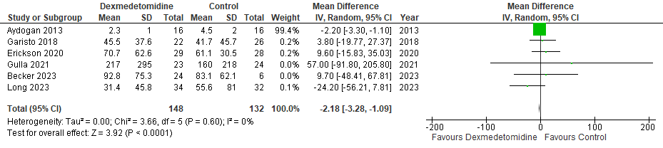

B. Time to extubation (hours) forest plot
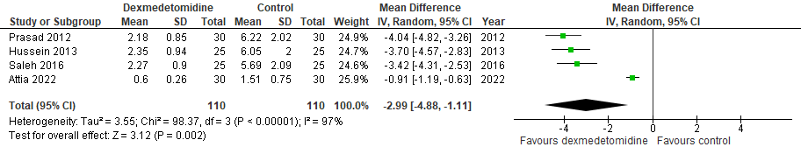

C. Delirium forest plot
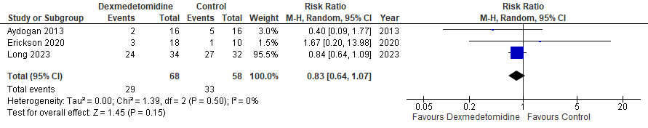

D. Withdrawal forest plot
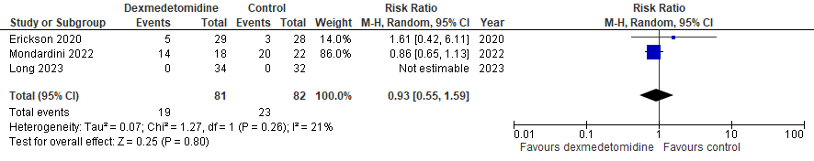

E. Bradycardia forest plot
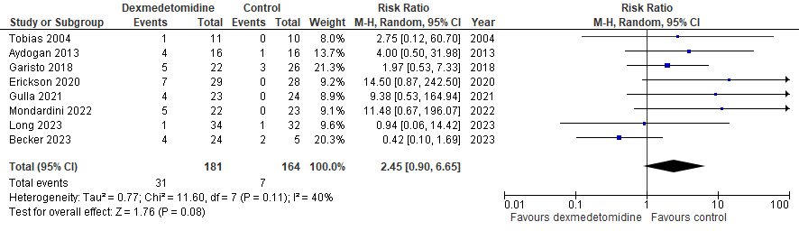

F. Hypotension forest plot
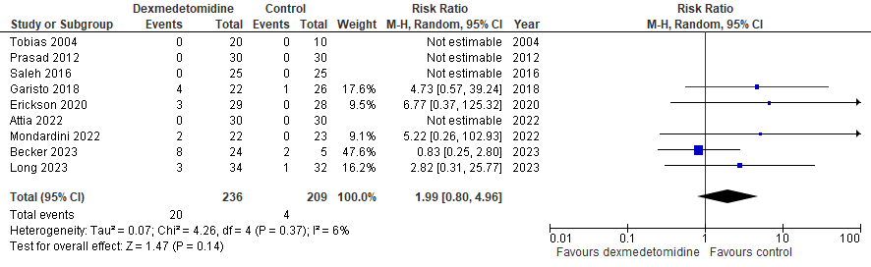

G. Clinically important bradycardia forest plot
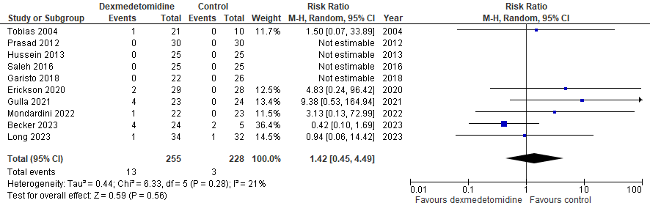

H. Clinically important hypotension forest plot
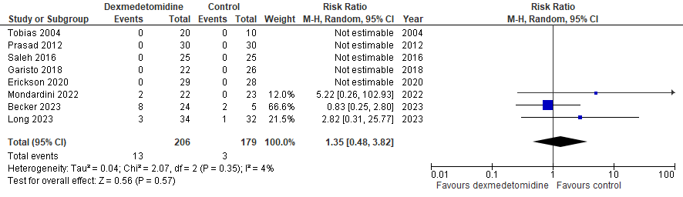

I. PICU length of stay (days) forest plot
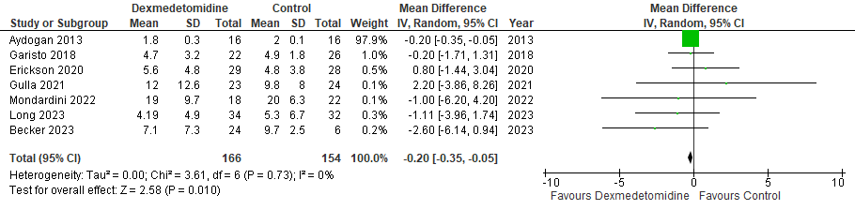

J. Hospital length of stay (days) forest plot
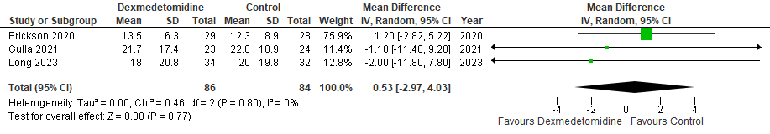

Online Resource 7. Summarized author definitions of adverse events
Source | Hypotension | Clinically important hypotension | Bradycardia | Clinically important bradycardia
Tobias et al.  2004 | NR | Study drug discontinuation | NR | Study drug discontinuation
Prasad et al.  2012 | NR | NR | n/a | Study drug dose reduction, discontinuation, pharmacological intervention, or temporary pacing
Aydogan et al.  2013 | n/a | n/a | ≥20% decrease from baseline pre-operative value | n/a
Hussein et al.  2013 | n/a | n/a | n/a | Study drug dose reduction or discontinuation
Saleh et al.  2016 | NR | Study drug dose reduction or discontinuation | n/a | Study drug dose reduction or discontinuation
Garisto et al.  2018 | ≥20% decrease in mean arterial BP | Pharmacological intervention | ≥20% decrease from baseline value | Pharmacological intervention
Erickson et al.  2020 | ≥2 SD below mean for age | Requiring intervention (e.g. study drug discontinuation) | ≥2 SD below mean for age | Requiring intervention (e.g. study drug discontinuation)
Mondardini et al.  2021 | ≥20% decrease BP from baseline | Study drug discontinuation | ≥20% decrease from baseline value | Study drug discontinuation
Gulla et al.  2021 | n/a | n/a | <60 beats/min | Study drug discontinuation
Long et al.  2023 | ≥2 SD below mean for age, which lead to study drug cessation
Becker et al.  2023 | Study drug dose decrease, discontinuation, fluid administration, inotrope/vasopressor initiation or dose increase |  | Study drug dose reduction, discontinuation, pharmacological intervention, or temporary pacing
Legend: BP indicates blood pressure; n/a, not applicable (i.e. the study did not measure this outcome); NR, definition not reported.

Online Resource 8. Subgroup analyses
A. Patient population subgroup analysis: Duration of mechanical ventilation (hours)
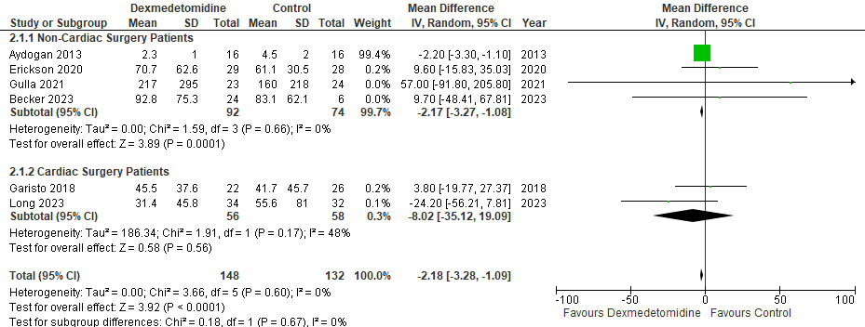

B. Patient population subgroup analysis: Time to extubation (hours)
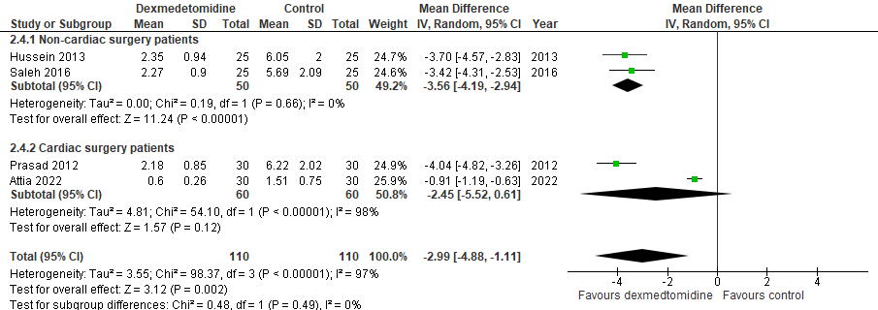

C. Patient population subgroup analysis: PICU length of stay (days)
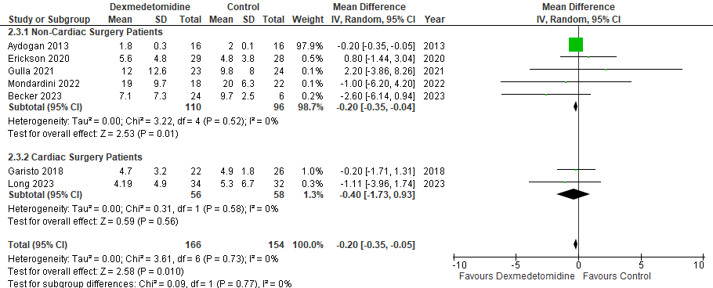

D. Patient population subgroup analysis: Hypotension
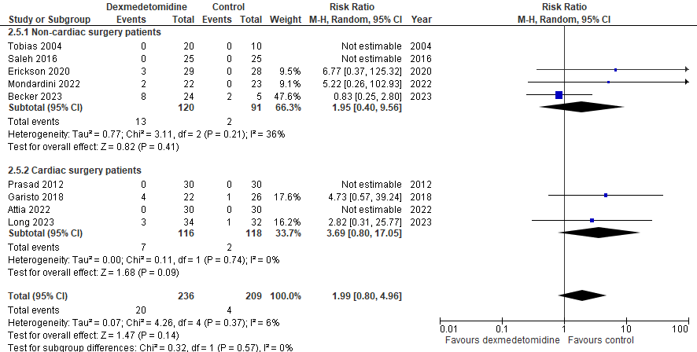

E. Patient population subgroup analysis: Bradycardia
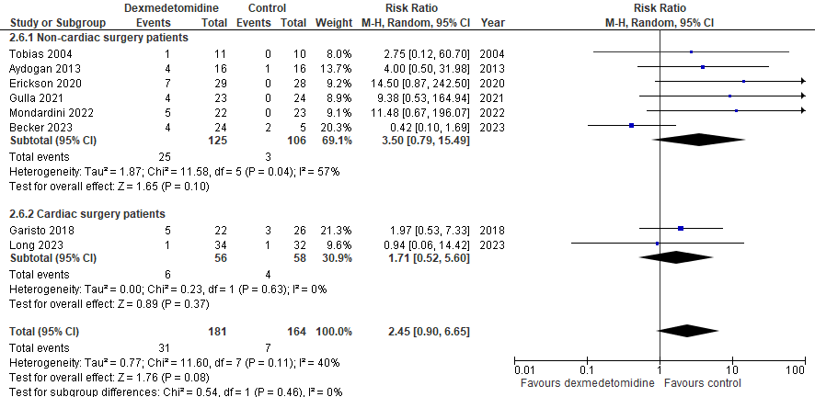

F. Intervention type subgroup analysis: Duration of mechanical ventilation
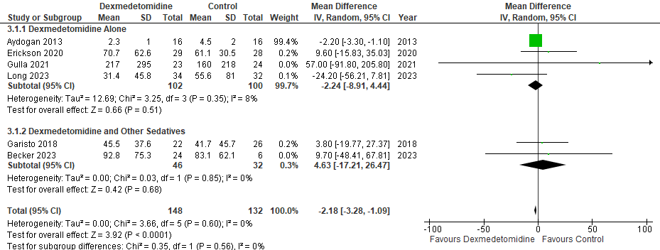

G. Intervention type subgroup analysis: PICU length of stay
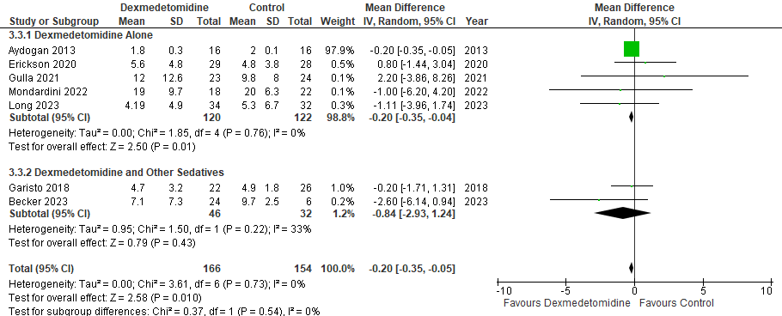

H. Intervention type subgroup analysis: Hypotension
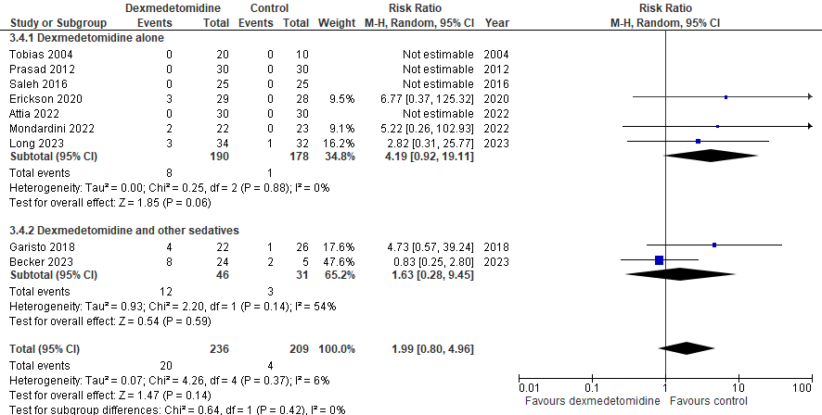

I. Intervention type subgroup analysis: Bradycardia
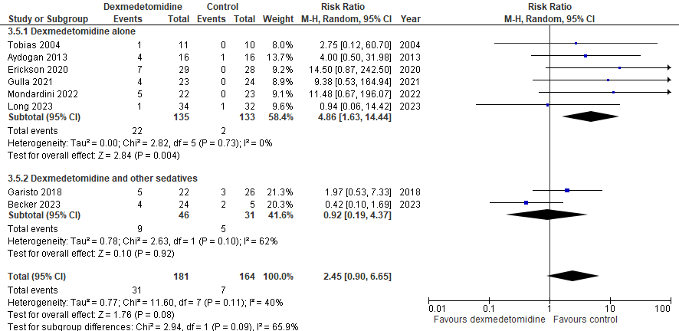

J. Comparator type subgroup analysis: PICU length of stay
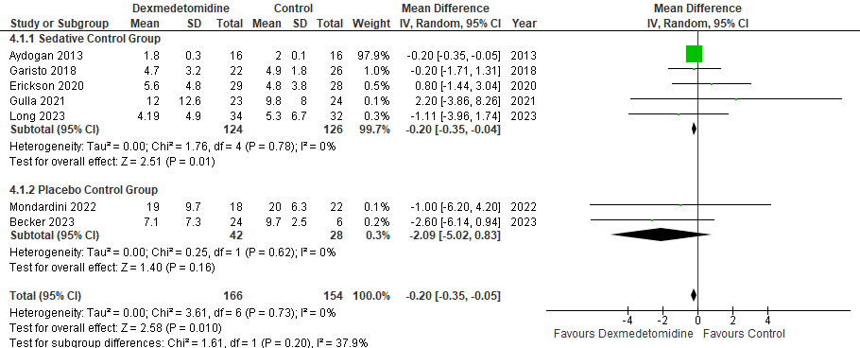

K. Comparator type subgroup analysis: Hypotension
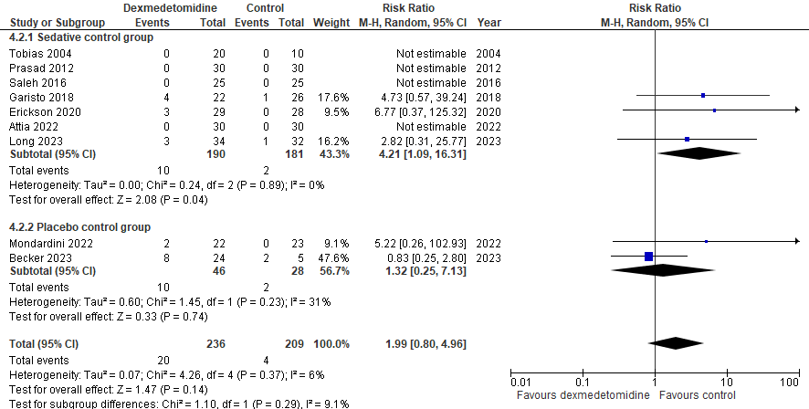

L. Comparator type subgroup analysis: Bradycardia
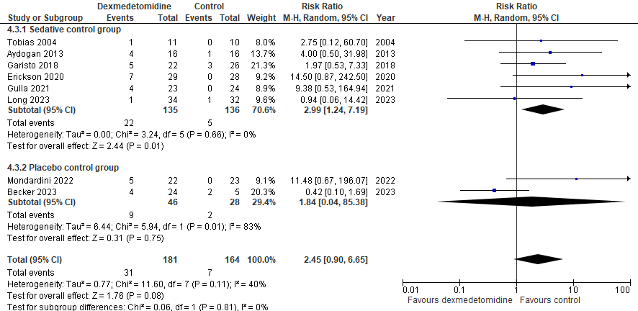

M. Comparator type subgroup analysis: Clinically important bradycardia
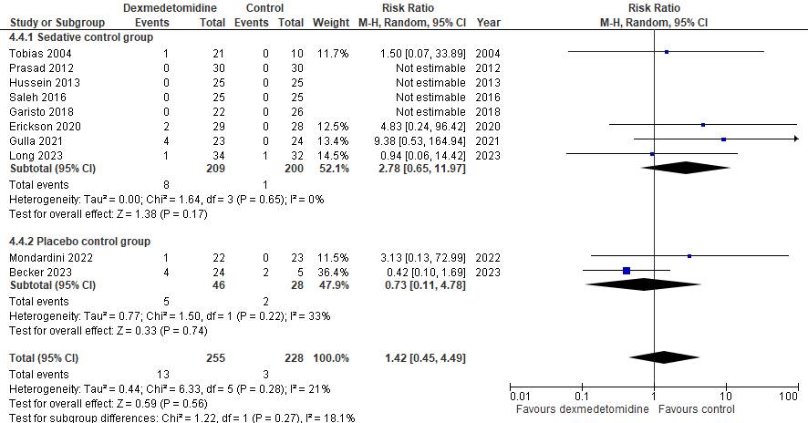

N. Risk of bias sensitivity analysis: Duration of mechanical ventilation
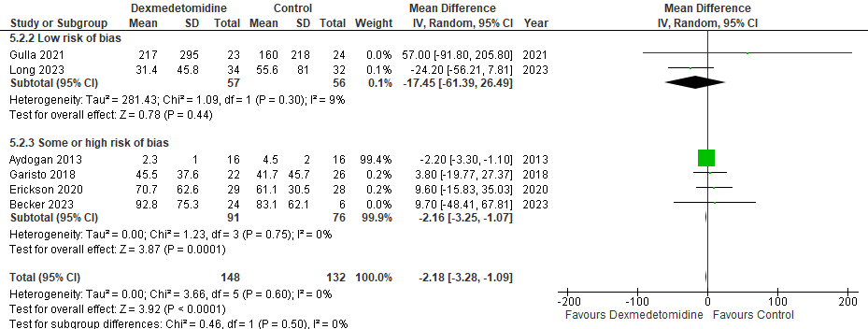

O. Risk of bias sensitivity analysis: PICU length of stay
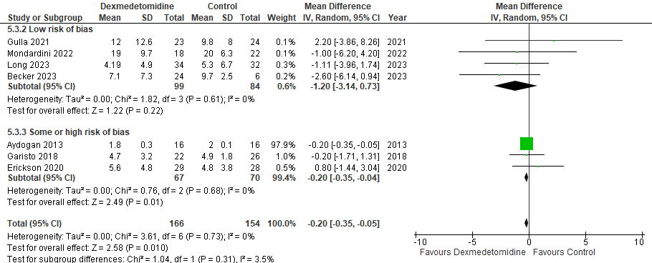

P. Risk of bias sensitivity analysis: Hypotension
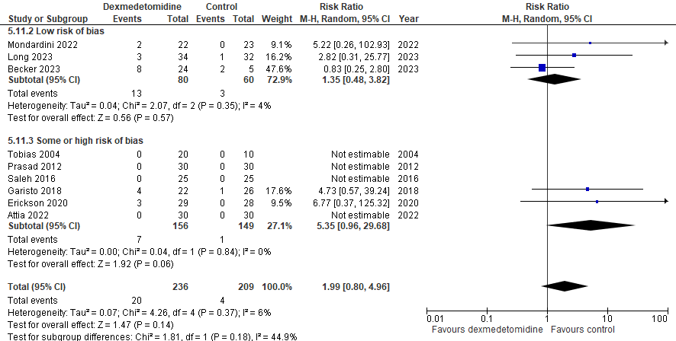

Q. Risk of bias sensitivity analysis: Bradycardia
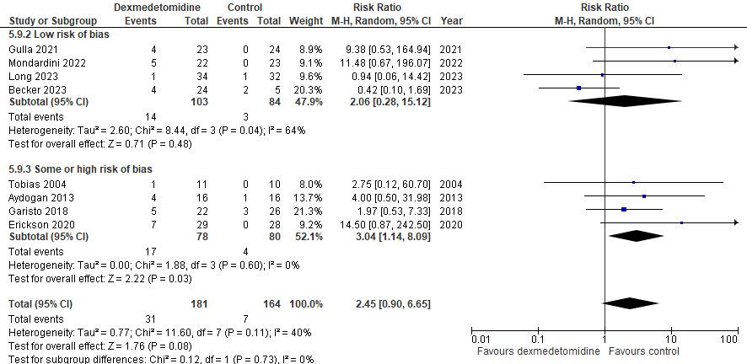

R. Risk of bias sensitivity analysis: Clinically important bradycardia
